Tub-Card-Weav-art - 3/29/17

"Tubular Card/Tablet Weaving: Making Period Cord" by Lady Elena Hylton.

NOTE: See also the files: Intro2CrdWvng-art, Bg-Tab-Weavng-art, DF-Card-Weav-art, Hallst-Tb-Wvg-art, Inkle-Weaving-art, looms-msg, Sq-Lucet-Cord-art.

************************************************************************
NOTICE -

This article was added to this set of files, called Stefan's Florilegium, with the permission of the author.

These files are available on the Internet at: http://www.florilegium.org

Copyright to the contents of this file remains with the author or translator.

While the author will likely give permission for this work to be reprinted in SCA type publications, please check with the author first or check for any permissions granted at the end of this file.

Thank you,
Mark S. Harris...AKA:..Stefan li Rous
stefan at florilegium.org
************************************************************************

Tubular Card/Tablet Weaving:
Making Period Cord
by Lady Elena Hylton

An updated copy of this handout can be found at
https://sites.google.com/site/elenasthreads/card-weaving/tubular-tablet-weaving

An Introduction to Tubular Tablet/Card Weaving:

Tubular tablet weaving is a technique used in the medieval period to make cord and tubes of fabric. The earliest extant examples that I have seen are from 1155 England on a charter by Henry II and 1198 on a reissue of the Magna Carta.^{[1]} More examples of various sizes and for multiple purposes (including rosaries, lacing for garments, and purse strings) are found throughout the rest of the medieval and early renaissance period.^{[2]}

This guide will cover basic instructions on how to create a cord using the card weaving method, as well as how to execute two-holed weaving.

Tablet Weaving Vocabulary:

Warp: The threads on the loom before you start to weave. In tablet weaving, these threads will be the threads that show on the finished piece and create designs.

Weft: The thread on a shuttle which is woven into the warp. The weft is almost completely invisible in most styles of tubular tablet weaving.

Shuttle: An item with the weft wound on it that is passed through the warp, often also serves to beat down the twist in the finished weaving.

Shed: The opening created by the cards where the shuttle passes through.

Beat: Pressing the weft thread firmly down against the already woven sections to create a tight weave.

For more information on the fundamentals of tablet/card weaving, including choosing fiber, warping a loom, and S/Z threading, visit https://sites.google.com/site/elenasthreads/card-weaving/introduction-to-card-weaving

Warping: How Many Cards to Use and How Many Holes Threaded?

The most popular patterns of modern tablet weaving involve using cards with four holes which each have a strand of fiber running through them. However, many other varieties exist using two, three, six, and even eight-holed tablets. There are many extant examples of tubular tablet weaving using only two holes warped, which I have found gives a softer cord that has more space to bend, but four can give a cord with more substance. The more tablets you use the more you create an empty tube of fabric. Silk hollow tubes made in this way are often seen in the 12th and 13th centuries. The ideal number of holes threaded and cards used will vary depending on your desired cord.

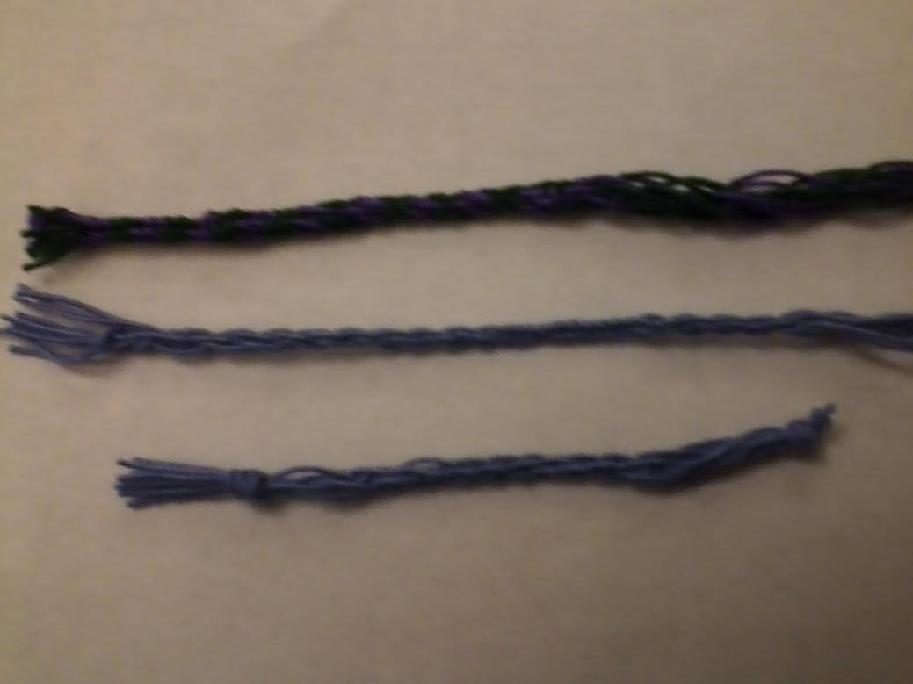
Samples: top is 4 cards, 4 threads each, middle is 4 cards, 2 threads each, bottom is 2 cards,
4 threads each, each using multiple methods for pulling the weft through.

Any warp can be turned into a tube simply by passing the shuttle only through one side and then drawing it tight. There are several examples of patterned cord being created this way. However, different cord types can be created by varying the number of holes warped with cord, the number of cards used, the beat of the shuttle, and how tightly you draw the weft.

Card Weaving Tips: Fiber options & How thick will my finished cord be?

Fiber Options: Wool, silk, and linen are popular period options for tablet weaving and create different effects. A thinner fiber will take longer to weave up, but can create a stunning effect. Silk has a great sheen and easily slides through lacing holes with no stretch, wool can sometimes stretch more or hold more tightly to the dress depending on how fuzzy the yarn is and how much stretch it has before weaving, and linen often has less stretch but grabs the lacing holes more, which can be helpful for gowns where one area has more tension than others (under the bust for example). Crochet cotton is a modern option, but inexpensive and its strength and resistance to pilling/fuzzing makes it a great material to learn on and creates useful results (4 cards with 2 holes threaded makes a great lacing or medallion cord). Serger thread does not have the shine from silk, but can be an inexpensive alternative in a similar thread thickness.

Estimating thickness of cord: An easy way to get a rough estimate of the thickness of your cord is to take the fiber you want to use and look at the total number of strands you are thinking of (number of cards x number of holes threaded). Divide this number by 2 and make that many loops around an item 5-7 inches long (small book, large phone). Then twist this lightly. This will be roughly the thickness of your cord. Example, for a cord with 4 cards of 2 holes threaded (8 total strands), divide the number by 2 to make 4 loops, and then twist them together to get an idea of the finished thickness.

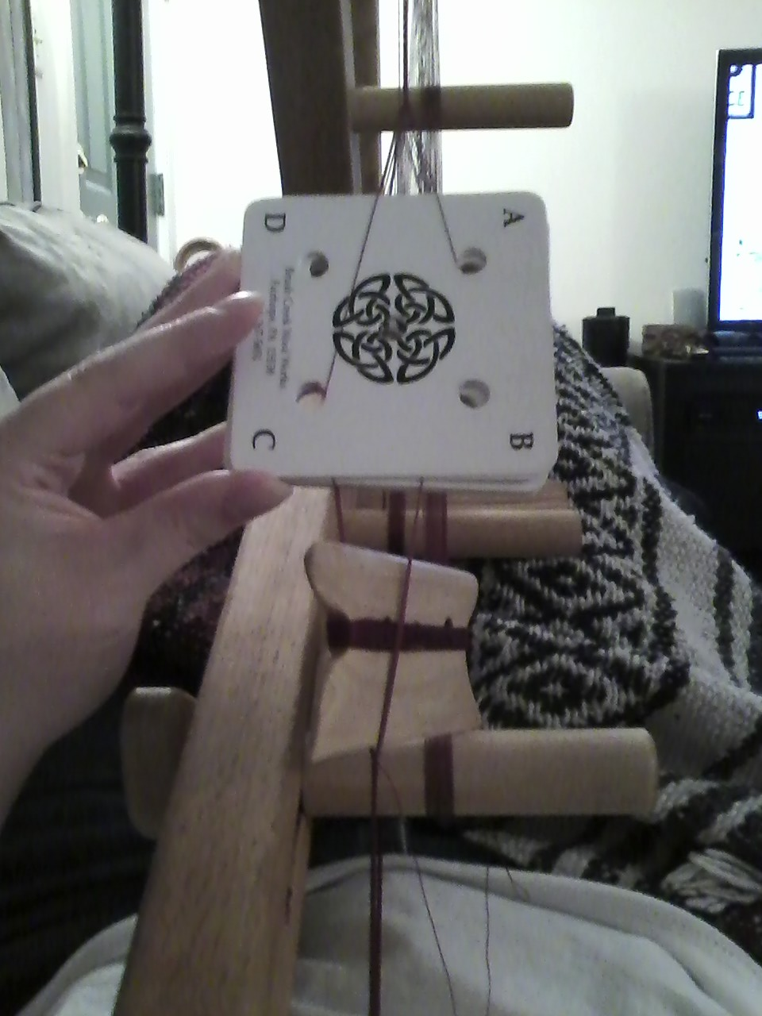

Two-Holed Weaving
Two holed weaving is a wonderful option for tubular tablet weaving because it creates a softer cord (excellent for lacing gowns/points or for using as a drawstring). There are also many extant patterns documented in Collingwood and other sources that make use of two-holed weaving for non-tubular patterns.

The primary difference between how you weave with two holes threaded versus four holes threaded is that with two holes you are always turning the cards a half turn forwards instead of only a quarter turn. This way the threads that were on top at the start of your turn are now on the bottom. Now continue to tablet weave as normal and you are set!

Starting position
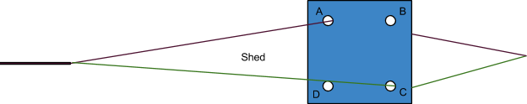

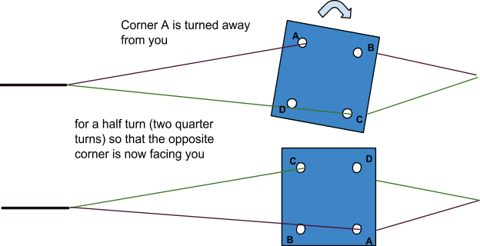

Tubular Tablet Weaving: The Technique:

Traditional tablet weaving calls for passing the shuttle back and forth through the warp after each turn of the cards. To turn a warp into a tube you simply have to keep passing the shuttle through the warp in the same direction, looping the shuttle under the warp in between turns.

How hard you beat your shuttle (how much you press down against the previously woven part) and how tight you pull your weft will both have major impacts on the texture and look of your cord. A harder beat creates a thicker, less soft cord, whereas a softer beat will allow the cord more movement, but can look looser. Fiber choice, the number of cards used, and the number of holes threaded will all also have an impact on the finished cord, so experiment!

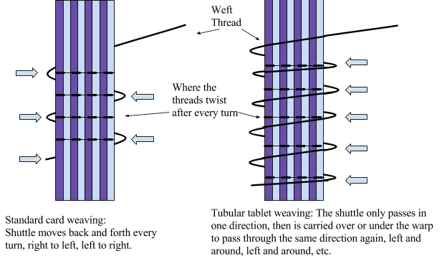

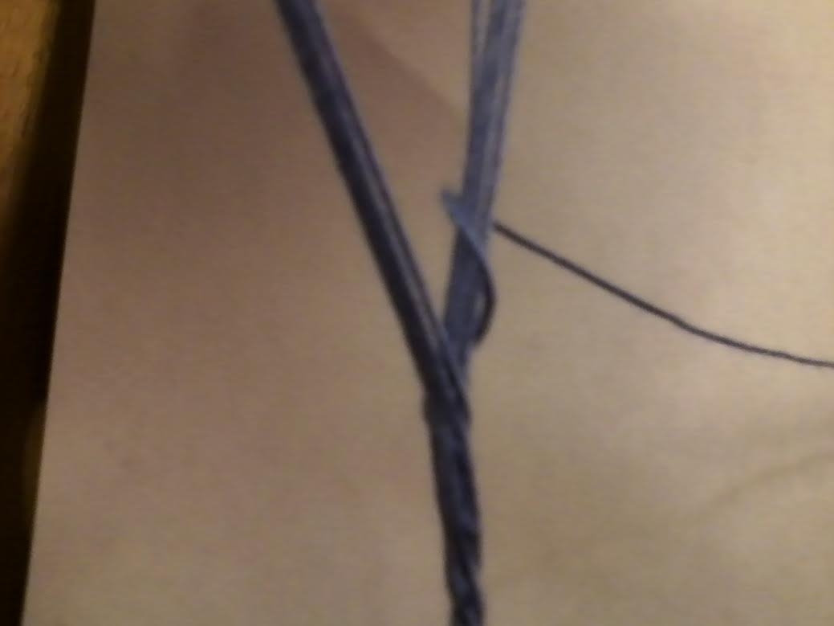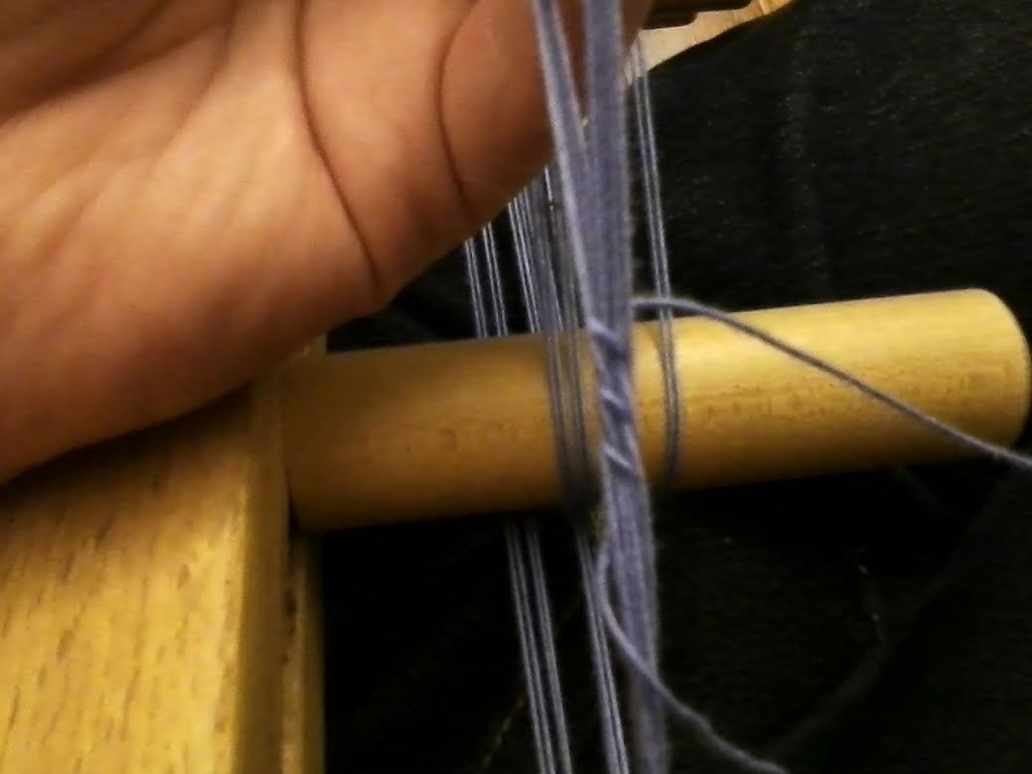
Left: weft crossing through the shed and looping back
Right: Back side of weaving, showing the crossing of the weft

There are several different ways to draw the weaving into a tube. You can finish the entire piece or a large section and then tighten each thread individually, as if you were lacing and tightening a gown. This does give you a lot of control over the tension, but can be very challenging with sticky fibers (such as wool) and for large amounts this can easy add up to a lot of weft needing to be pulled through.

You can also pull every few turns. This is faster for most people, but does not give you the exact tension control that the other techniques provide and is better for cord making where the thinner cord can disguise small tension issues.

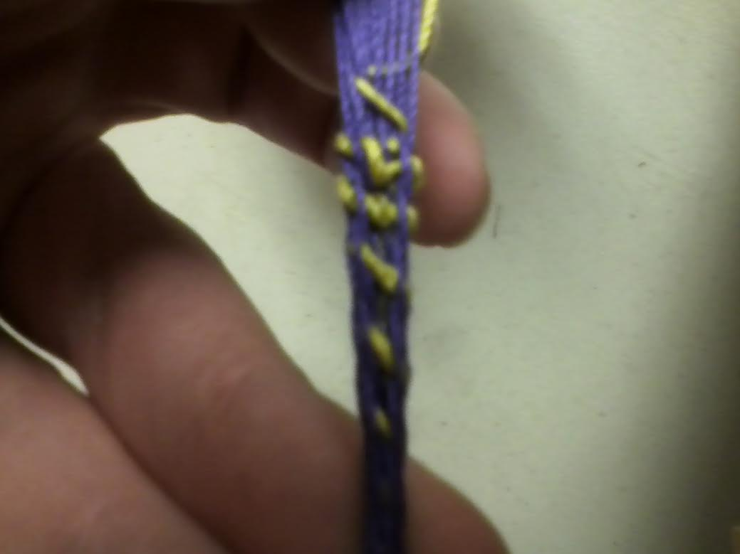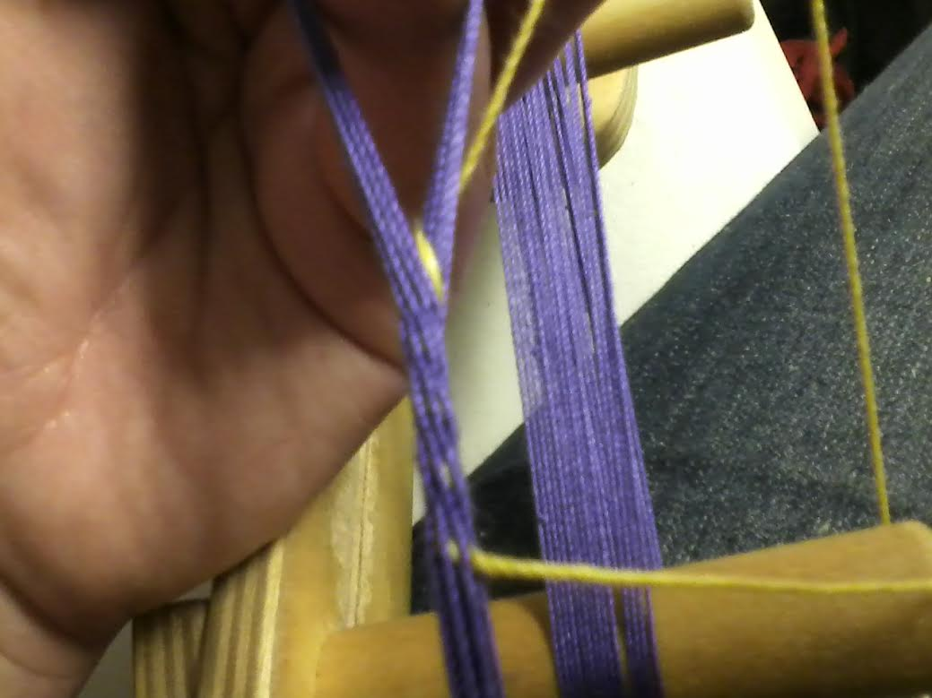
During tightening (left) & when tightened (right).

The last option is to tighten after every pass. This provides more tension control and works well for fibers that are not smooth, but takes slightly more time than pulling every few turns.

Any of these options is valid, experiment and see what works for you!

Tablet Weaving Resources:

Useful Links:
Free Patterns/How-To Guides-

Guntram's Tabletweaving Page
http://www.guntram.co.za/tabletweaving/index.htm
This is an incredible website for patterns, as well as other information on card-weaving.
“Cardweaving Made Easy” at The Renaissance Tailor
http://www.renaissancetailor.com/demos_cardweaving.htm
This page has a lovely guide to a simple and pretty threaded in pattern.
The Cardweaving Riff
http://www.earthguild.com/products/riff/rcdweave.htm
This has instructions for people looking to use the backstrap method to card weave without a loom.
“How to Card-Weave Letters, Numbers, or Designs” at Elena’s Threads https://sites.google.com/site/elenasthreads/card-weaving/double-faced-handout
This is my handout on how to perform double-faced weaving to create letters, runes, or images. The pattern page to accompany it is
https://sites.google.com/site/elenasthreads/card-weaving/my-card-weaving-patterns

Other Resources-
Pine Box Traders - Warping http://www.rocknbead.com/wshed/cardwarppics.htm
The page is designed by a merchant who sells lovely looms, but this specific link provides pictures and instructions on how to warp an inkle or card loom using the continuous warp method.
SCA Card-Weaving Yahoo Group
https://groups.yahoo.com/neo/groups/SCA-Card-Weaving/info
This in an excellent group with many knowledgeable, friendly people and excellent resources in their links and files.

Useful Books:
Collingwood, Peter. The Techniques of Tablet Weaving. This is generally considered to be one of the most comprehensive books on historical tablet weaving, and includes pattern diagrams for many period patterns.
Crockett, Candace. Card Weaving. This is designed more as an introduction to card weaving, but does include period images as well as modern designs for a variety of patterns and weaving styles.
Crowfoot, Elisabeth et. al. Textiles and Clothing c. 1150-c. 1450. Medieval Finds from Excavations in London, 4. London: Boydell, 1992.

Footnotes:

[1] Audrey Henshall, “5 Tablet-Woven Seal-Tags,” The Archaeological Journal 121, no 1: (1964) 162.,
Peter Collingwood, The Techniques of Tablet Weaving (New York: Watson-Guptill Publications, 1982). 367.
[2] Elisabeth Crowfoot, Frances Pritchard, and Kay Staniland, Textiles and Clothing 1150-1450 (London: Boydell Press, 2001), 135.
------
Copyright 2016 by Jeanne Clifton. <jecscififan at yahoo.com>. All images are property of Jeanne Clifton and may not be reproduced individually without permission. Permission is granted for republication in SCA-related publications, provided the author is credited. Addresses change, but a reasonable attempt should be made to ensure that the author is notified of the publication and if possible receives a copy.

If this article is reprinted in a publication, please place a notice in the publication that you found this article in the Florilegium. I would also appreciate an email to myself, so that I can track which articles are being reprinted. Thanks. -Stefan.

<the end>

