Tric-Chainwrk-art - 8/16/17

"Trichinopoly Chainwork - Is It Viking Chain Knitting?" Authored by Lady Apollonia Voss. Illustrated by Lady Þhora "Amber" Ottersdötter.

NOTE: See also the files: Vkng-Wir-Weav-art, Mk-Vik-Brooch-art, metalworking-msg, Norse-msg, Norway-msg, amber-msg, jewelry-msg, Knit-Purses-art.

************************************************************************
NOTICE -

This article was added to this set of files, called Stefan's Florilegium, with the permission of the author.

These files are available on the Internet at: http://www.florilegium.org

Copyright to the contents of this file remains with the author or translator.

While the author will likely give permission for this work to be reprinted in SCA type publications, please check with the author first or check for any permissions granted at the end of this file.

Thank you,
Mark S. Harris...AKA:..Stefan li Rous
stefan at florilegium.org
************************************************************************

You can find more work by this author on her blog at:
http://theknitsmithy.blogspot.com

Trichinopoly Chainwork
Is It Viking Chain Knitting?
Authored By:
Lady Apollonia Voss
Illustrated By:
Lady Þhora "Amber" Ottersdötter

At some point, artisans researching and recreating Viking age, medieval or ancient arts, encounter a modern source that mentions a technique or a type of object that may have been used in period. As the researcher, we are drawn to the object or the idea and hope that it really was used as suggested. This paper shares my journey researching a chain making technique attributed to the Vikings in recent literature.

During my research, I discover that the chain making technique in question is referred to by multiple names by several authors. E arly in my research, I refer to the technique as the knit style as suggested by the author and artist of my introductory book. Later, I choose to adopt the name of trichinopoly chainwork to refer to extant pieces and my own work made utilizing the method discussed.

A second chainmaking technique that I believe produces similar looking object is known as loop-in- loop. I introduce this chain making method to contrast with trichinopoly chain work in the body of this paper and in Appendix1: Loop-in-loop Chainwork.

I first become interested in Viking chain knitting when I was introduced to the book Great Wire Jewelry: Projects and Technique by Irene From Peterson. Figure 1 shows the cover of the book displaying two necklaces and a bracelet created by the author. In between the covers, I was exposed to a beautiful and fascinating technique of jewelry construction referred to as Viking knitting. The author claims that , "Finds in Scandinavia" provide evidence for the use of a structural "looping technique" used by Vikings for jewelry and clothing (Peterson 7 ).

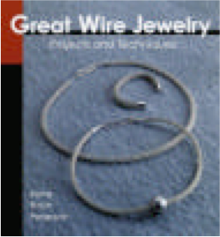
Fig. 1: Photograph of the Book Cover Great Wire Jewelry by Irene From Peterson

I loved the look of the finished product. T he technique produces beautiful hollow tubes of knitted chain. T his book was originally published in what appeared to me to be Danish. I kept the hoping of finding suitable proof of the use of this technique by Vikings. Using Peterson's instructions, I learned how to "knit" with wire as I proceeded to research as many Viking jewelry resources as I could find. Figure 2 is a photograph of my first completed silver chain. Figure 3 is a close up of this chain to better show its detail.

Research Journey Begins

A day's visit to the Smithsonian's outstanding exhibit, Vikings: The North Atlantic Saga, in 2000 brought me nosed-pressed-against-the-glass-close to a hack silver hoard. A hack silver hoard is a large cache of silver objects. The objects can be partial pieces of jewelry or unneeded fragments left by a silversmith or jeweler.

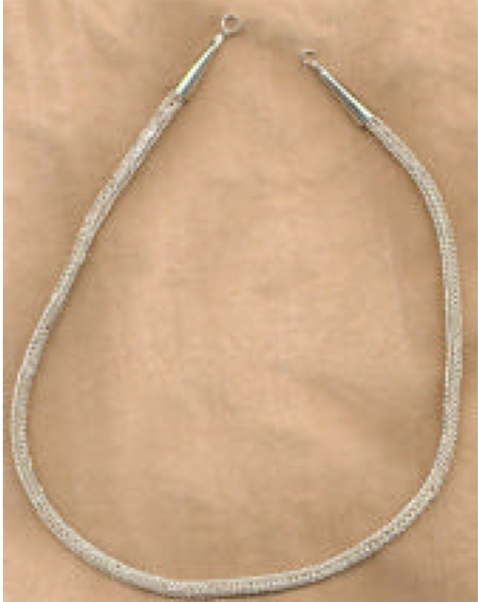
Fig. 2: My First Knit Chain

Within the mass of silver was what appeared to be knit chain. You simply cannot tell from examining the piece from a distance. Another construction technique known as loop-in-loop chain making looks identical to my eye. Up close inspection, preferably with a magnifying glass, is the only way a viewer can determine which construction process was employed to create a piece in question. Please see Appendix 2 for an introduction to the loop-in-loop chain making technique and listing of example extant pieces known to be created utilizing it.

I purchased a copy of the exhibit catalog, by Fitzhugh and Ward, and meticulously reviewed each silver or jewelry photograph within it, in hopes of finding the fragment I had seen. There was indeed a picture of the hack silver hoard I had seen. Unfortunately no additional information about the piece of chain within the hoard could be discerned. I did, however, find something even better: two chains I had not seen in person.

The first, is a 10th or 11th century example of a knitted chain from a Saami Silver hoard from the Lapp people of Lämsä, Kuusamo, Northern Finland. This hoard contains a chain with an axe head pendant that appeared be made in the knit style. The Saami, or Lapp peoples, lived in the mountains of Norway and Sweden and in arctic lands of Finland, Norway, Russia, and Sweden and "were known to interact with their V iking neighbors" (Price 7 0-7 1). Price identifies the axe-head pendant attached to the chain in question as of "Estonian-Baltic design" and may have been traded to the Saami by the Vikings (Price 7 0-7 1).

Subsequently, I learned that Saami hoard including the axe-head pendant neck chain was originally part of the "Viking: The North Atlantic Saga" traveling exhibition however, I was not fortunate enough to have viewed this particular hoard during my visit, since it had previously been returned to its lending museum. Figure 5 is a drawing based on a photograph of the Saami Hoard axe-head pendant necklace by the National
M useum of F inland, the owner of the piece.

There is a second photograph of interest contained within the exhibition catalog (Fitzhugh and Ward 1 9.) This figure entitled "A Viking Hoard" shows a pair of oval brooches, coins made into pendants, pendants made of glass beads strung on wire, separate silver beads, a detailed silver bracelet or perhaps a mounting of some sort, and a length of knit silver chain that may be made in the style in question.

Now I was hooked. There appeared to be some evidence for the existence of knit chains. Further, these chains are somehow related to the Vikings. But are they made in the knit or loop-in-loop technique? You just cannot tell by looking at a photograph. More investigation was needed.

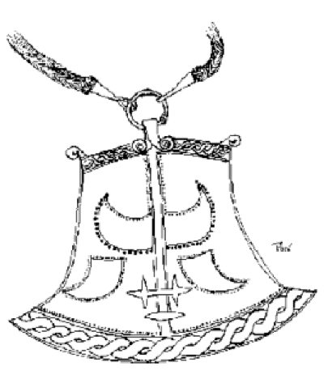
Fig. 5: Saami Hoard chain with axe-head pendant as shown in the National Museum of Finland.

I learned that the chain bearing the axe-head pendant was owned and exhibited by the National
Museum of Finland. Girded with this knowledge, I sought out the museum's website. I looked in every corner of the English version of the site and saw no mention of the axe-head pendant neck chain. The drawing shown in Figure 5 was discovered several years later in a Finnish language only area of the website. Without really expecting a reply, I emailed the curator of the museum with specific questions about the piece as I had seen it in the exhibition catalog and continued my search for other sources.

I had forgotten about the exhibition catalog's photograph of the "Viking Hoard" from the National Geographic Magazine for several years, as I followed other leads. Yes, I have been piecing documentation together for more than six years now. After backtracking over research leads, I was reminded that this one was not followed up. I obtained a copy of the issue containing the photograph at a library book sale. Even after viewing the photograph in its original context, there are no clues as to whether the piece is created in the woven technique or loop-in-loop technique and remains unclassified by me. Unfortunately, during a pre-moving cleaning binge, the issue was thrown away and I have been unable to regain the citation of the article displaying the photograph.

Trichinopoly Chainwork

The first juicy book requested via interlibrary loan arrived. Within it I learned that there were, indeed, more surviving examples of knit chains. Further, the chain making technique had a name—trichinopoly chainwork.

According to the author, James Graham-Campbell (30), the trichinopoly chainworking technique is a made by circular knitting (he uses the word plaiting) with continuous wire. The technique is introduced in the context of two silver pins from Viking-age graves in Scotland. These pins date to the late ninth/early tenth century. One was found with a male and the other with a female. The pin found with the female is from Ballinaby (early tenth century.) These pins are shown in Figure 6. Additional pieces described by Graham-Campbell as being created with the trichinopoly method will reviewed after examination of the construction technique itself.

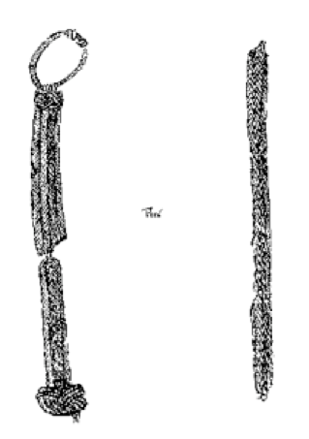
Fig. 6: Late 9th/ early 10th century chain found in
Ballinaby Scotland as shown in Graham-Campbell

Figure 7 is the illustration used by Graham-Campbell to depict the construction of a piece of trichinopoly chainwork contained in the Trewhiddle hoard found in Cornwall thought to be deposited c.868. (Graham-Campbell Fig.17). Graham-Campbell takes the illustration from Wilson and Blunt.

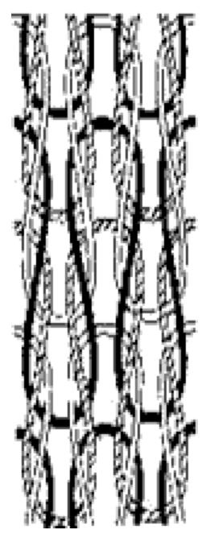
Fig. 7: Construction Detail of Trichinopoly Chainwork
as Shown in Graham-Campbell

The structure of trichinopoly chains as shown by the illustration utilized by Graham-Campbell, appear to me to be a match of the structure introduced by Peterson. His phrase "circular plaiting" (Graham-Campbell 30) could accurately be exchanged for the phrase "structured looping" employed by Peterson in her Viking chainknitting instructions (7).

Figure 8 is one of the drawings, based on Peterson's instructions, I utilize it to teach Viking chain knitting to artisans. Complete instructions are located in How to Knit Like a Viking (<http://userweb.suscom.net/~apolloniavoss/projects.htm#Trichinopoly Chainwork Class
Handouts>)

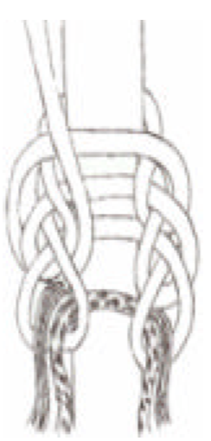
Fig. 8: Viking chain knitting instructional illustration based on Peterson.
Drawn by Þhora Ottersdötter.

This drawing helps to clearly illustrate the similarity of the two techniques depicted. A close inspection of Figures 2 , 3 , 5 , and 6 reveal construction identical to that shown in Figure 7 . Graham-Campbell shares several examples of trichinopoly chains found across Britain. The second being a piece of chain that is part of a 9th century Pictish hoard from Croy (Graham-Campbell Figure 3). Another extant piece of trichinopoly chainwork exists as trim on the rim of a paten coming from a hoard found on the monastic site of Derrynflan, Co Tipperary (30).

Other finds from 9th—10th century Scotland are fragments of chains. Both are noted as coming from hoards. One in Skaill, Orkney and the other Inch Kenneth, Argyll. The first is a silver chain fragment found in Skaill, Sandwich, Orkney. This fragment is, "worked in the trichinopoly technique from a fine wire," and is incomplete at both ends (Graham-Campbell1 21). The second piece mentioned is a silver chain fragment from Inch Kenneth, an island off Mull. It is also incomplete at both ends. Graham-Campbell notes that, "it is made from an exceptionally fine silver wire," in a diameter of 0.01 cm.(100).

I believe that Graham-Campbell proves that knit chains did, in fact, exist in Viking occupied areas during the Viking-Age. He presents definite evidence to support Peterson's claim of the use of the knitting technique among the Vikings. Having sufficiently satisfied my desire to link Peterson's claims to archeological evidence, I adopted the term trichinopoly at this point in my research.

Another Name for the Technique—Braiding Technique

I completely forgot about my note to the National Museum of Finland until I received a message from its curator. Leena Tomanterä is also the author of two seminal works on Viking chains constructed with the technique I am researching, Her message was followed up by a mailing including two reprints of her works (bound copies of journal articles) and a sample chain that she made using the technique!

The works by Tomanterä are essential (albeit hard to locate) resources to consult for tracing this technique and extant pieces. Tomanterä provides documentation for a fabulous array Viking knit objects. She calls the knitted chain style the "braiding technique" not trichinopoly chainwork as Graham-Campbell does (Traces & Braid). Close inspection of Tomanterä's published photographs, descriptions of the extant pieces, and a description of the construction technique have convinced me that the objects are made by the trichinopoly method. I will first examine the construction technique described by Tomanterä and then review the additional extant pieces her works bring to light.

Tomanterä describes the knit technique as being performed "cold" just as Peterson does (Braid 70). Unfortunately, Graham-Campbell does not provide the same level of construction description as Tomanterä to provide a comparison. Metal has a tendency to harden when worked and must be annealed, made soft again through the application of heat, in order to keep it malleable. The technique described by both Tomanterä and Peterson does not make use of annealing, so it is referred to as a cold working technique.

Tomanterä continues her description. Lengths of copper, silver, or bronze wire are looped to, "form spirals like this". One row is formed under the row above by threading the wire under the, "necks of the links of the previous row." When the piece of wire being knit is expended, the end is pushed inside of the tube along with the beginning of the new piece of wire in order to conceal the join. (Traces 265).

This construction description mirrors that of Peterson. To illustrate the similarities I am including excerpts from my article " How to Knit Like a Viking" as my instructions closely follow those of Peterson. The illustrations will make more sense out of context than the text. Even if the instructions appear to be hard to follow as they stand alone, the illustrations should reinforce Tomanterä's description.

Step 9 of Beginning to Knit. You'll knit exactly the same way as you did on your first pass around the dowel. Working right to left, bring the wire over the bottom of a loop and behind the sides of two adjacent loops, then toward you over the bottom of the second loop. (Stevens 4).

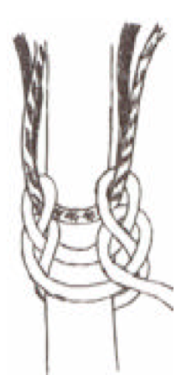
Fig. 10: Viking chain knitting instructional illustration based on Peterson. Drawn by Þhora Ottersdötter.

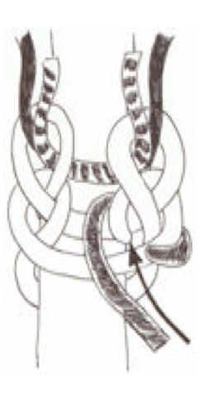
Fig. 11: Viking chain knitting instructional illustration based on Peterson.
Drawn by Þhora Ottersdötter.

Joining a New Piece of Wire. Eventually, you'll run out of wire. When you do, clip the wire where it comes out from behind two "sides" and use the needle or needle-nose pliers to push the stubby part under another were a regular stitch. Cut a new piece of wire about 16" long and make a small hook on one end. Weave the other end back thorough the stitch you just finished, as if you making the same stitch a second time. Make sure your hook catches underneath the stitch you're redoing (to hide it.) Follow the first wire but bring it out under the end of it. Take the wire over the cut off end as you travel to the next pair of "sides" to stitch together (Stevens 6).

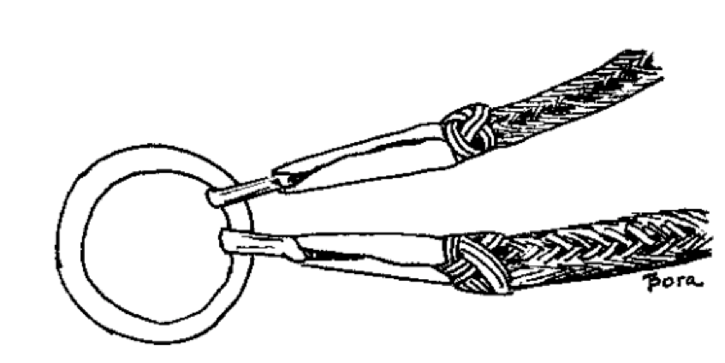
Fig. 12: Typical chain ends and closure. Example from Tomanterä (Traces)

Tomanterä generalizes that the ends and closures of trichinopoly chains are not terribly decorative. It appears that more often then not little artistic attention was paid to the elements that hold the chain closed (referred to as terminals and findings by jewelers). She cites examples of plain ended chains. In some, the connecting ring threaded through the first and last links to join chains together. Longer neck chains appear to be usually capped off by cones of metal. Some display a bit of decorative wire braid wrapped around the chain where it joins the cone. (Traces 268).

Examples of fancy terminals do exist. Animal head terminal sockets are also occasionally found. The Maaria Taskula chain is an example (Traces 269). Likewise a two part spiral closure known as the "Arabian Knot" is found on the Hämeenlinna necklace (Figure 13) and one other neck chain specifically mentioned by Tomanterä (Traces 269).

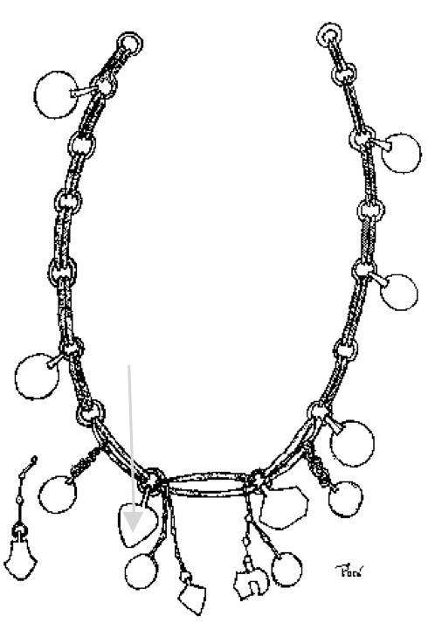
Fig. 13 Danegeld Style Necklace from the Hämeenlinna Linnaniemi Treasure Hoard as shown in Tomanterä (Traces)

To reiterate, based on my inspection of photographs of extant pieces utilizing the trichinopoly chainworking technique (as described by Graham-Campbell) and the braided technique (as described by Tomanterä), descriptions of the methods of construction of each, close inspection of extant pieces in the Smithsonian's traveling Viking exhibit. I conclude that the techniques are one and the same. Further, I am convinced that Peterson's claims of knitted chains being made and used by the Vikings are, indeed, accurate.

In her works, Tomanterä draws attention to well over one dozen existing pieces. Highlights of mentioned objects are as follows: An incredible necklace from the Hämeenlinna Linnaniemi treasure hoard is an example of beauty a simple technique can create. Figure 12 does not do the piece justice. This necklace is from the 11th century and is associated with the Finnish peoples. It is complete in every detail. It appears to be based on the concept of the Danegeld style of necklace (fragments gathered from multiple sources and displayed in a single piece quite possibly as a status symbol), with trichinopoly straight-links being joined by rings with a variety of suspended pendants. In describing this necklace, Tomanterä notes that some of the pendants look to made from objects originating in the east while others were made locally from scrap silver (Traces).

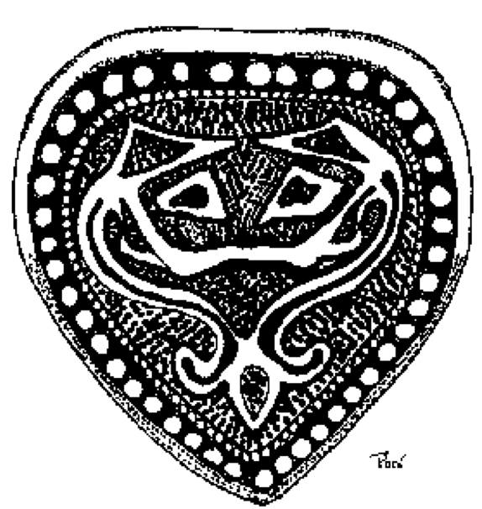
Fig.14 Fox Pendant Detail of the Hämeenlinna Linnaniemi Treasure Hoard Necklace (Traces)

Many neck chains with crucifix pendants are listed by Tomanterä in both of her works. Several chains with crucifix pendants have survived including those in the Donderup, Denmark hoard dating to ca. 1070. The chain in this particular hoard is 8 0 cm long and consists of four rows with a niello crucifix. Niello is an amalgam typically consisting of lead, copper, silver and sulfur which is melted into recesses and then ground down level. It is used to blacken the background of an object to show off its raised or incised decoration. This chain features animal head terminals joined by a ring of knitted wire (Braid 73 ). Three examples of trichinopoly chains with crucifixes can be viewed at the National Museum of Finland's website (<http:/ / www.nba.fi/ natmus/MUSUEM/Opetus/rautakau.htm>)

Chains with pendants possibly serving as amulets have survived. Tomanterä mentions the existence of chains with a Thor's hammer pendant from a Scandinavian find (Braid 72 ). A separate online article from the National Museum of Finland pictures a chain with an axe head pendant. (http://www.nba.fi/natmus/MUSEUM/Opetus/rautakau.htm#Suomalaisuuden%20ja%20saamelaisuuden%20kehitys). As mentioned previously, this chain is featured in the Vikings: The North Atlantic Saga.

The second eye-popping trichinopoly chain piece mentioned by Tomanterä is in the form of a penannular brooch. A Latvian (located in the Balkans) penannular brooch with "poppy-shaped knobs and a covering of several rows of braided wire on the arc" is referred to but without specific references or photographs of the piece in question. (B raid 72).

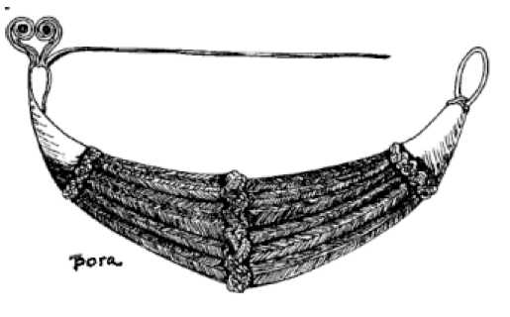
Fig. 15: Penannular Brooch as shown in Geiger. It is possibly the same described by Tomanterä (Braid)

A photograph of an extant piece looking much like the description of the penannular brooch appears in work by Agnes Geijer (Geijer Plate 32). A drawing based on the photograph is reproduced here as Figure 15. Geijer offers little description for the brooch in the photograph, but does credit it as belonging to the Finnlands National museum (National Museum of Finland), where Tomanterä is curator. It is quite likely that the description and the photograph are for the same brooch.

Tomanterä provides additional references to many other pieces in existence. I was frustrated because not enough detail as to the actual location of the find nor photographs of all pieces are provided. So more sleuthing was in order; following the author's citations produced even more results. I was able to trace a clear connection between the textile and metal arts.

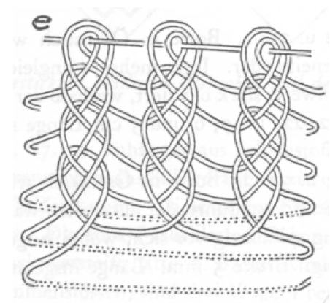
Fig. 16: Ösenstich embroidery technique construction detail as shown in Geiger. The fiber technique appears to be the same as the trichinopoly chain technique as shown by Graham-Campbell.

Trichinopoly Chainwork in Textiles: Birka Finds

Peterson hints at the possibility that the trichinopoly chain making technique was utilized in both metal and wool fiber. In Tomanterä's work, she asserts that the technique is same stitch used in the textile arts. Further, in a personal letter Tomanterä told me that she believes the chain making technique is based on a textile technique, "which is not described in any western jewellery manual with chain making techniques, not even by Theophilus" (Letter ).

In researching the origin of the trichinopoly chain making technique, Tomanterä states that the construction method was used in an Egyptian silk cap dated to the Arabs of the 10th-11th centuries. (Braid 71). She credits Agnes Geijer for the recording of the use of the technique used in, "Estonian folk handicraft in decorative stitch work." (Braid 71). Geijer's work is known to many textile researchers as an excellent resource for documenting Viking fabric construction and embroidery techniques Surprisingly, one of Tomanterä's citations points to it for evidence of trichinopoly chainwork as well.

Geijer provides strong evidence for our chain making technique in both fiber and silver. The technique is referred to as the ösenstich by the archeologist/author. (Geijer 109.) Details as to its construction with needle and thread, including diagrams of variations are presented in her work. Figure 14 illustrated the, now familiar, trichinopoly construction technique.

The textile finds of Birka show several pieces of silver wire trichinopoly chainwork affixed to textiles as edging. Including (Plate 32: piece 1) and (Plate 32: piece 2). Unfortunately the photographs of these pieces are of poor quality, making it difficult to see the details clearly. Other supporting evidence for trichinopoly chainwork as a textile edging comes from The World of Vikings CD-ROM, as explained on Don Willadsen's (another SCADIAN artisan's) website and Peter Beatson's, Kaftan article available at a Varangian Guard recreation website.

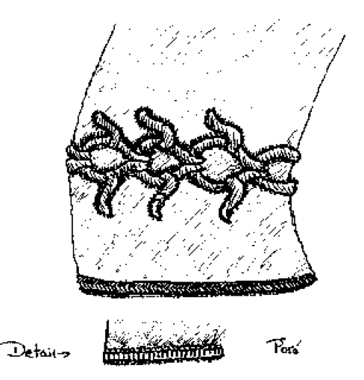
Fig. 17: Example of the ösenstitch executed in wire used on a10th century silk cuff as shown in Willadsen.

The drawing of the silk cuff shown in Figure 17 is based on a 10th century Swedish garment as shown in Willadesn. He takes his photograph from York. To my eye, the edging looks like the ösenstitch as described by Geijer, which, again in my opinion is synonymous with the trichinopoly chain construction style. This evidence sufficiently proves to me the crossover textile and metal technique used in fiber and in metal to adorn it garments.

There are a few pieces of trichinopoly chainwork from the Birka finds without a textile backing. One is the beautiful penannular brooch shown previously. Another is a teardrop shaped piece. Several fragments and finished pieces in this shape are pictured(Geijer Taff 31).

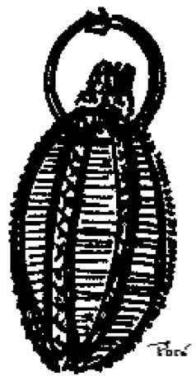
Figure18 shows the sharpest photograph of the most complete teardrop included in Geijer.

It appears to me that the teardrops utilize the ösenstitch/trichinopoly technique in metal and were either originally affixed to fabric or were separate objects entirely. Based on my personal German translation, it seems there is some debate as to the use of the teardrop shaped pieces. They may have been earrings. They may have been attached to head coverings. They may have been something else. I suspect that they are the sykerö hair-pieces mentioned by Tomanterä in Braid.

Tomanterä introduces hair ornaments referred to as sykerö hair-pieces found in a Karelian burial. Karelia is a republic within the Russian federation. It lies between Finland and Russia. Tomanterä describes the knitting of the piece as, "beginning in the middle" with the conical form, "achieved by gradually shortening the distances between the loop rows." (Braid 71). I believe that this description bears a striking resemblance to the Figure 18. In fact, I judge the description to be referring to the piece pictured.

Helene Jacobs, aka Baroness Betha of Bedford in the SCA, has worked out a very good set of instructions to recreate the teardrop pieces. She has created earrings based on the extant tear drop piece. Figure 19 shows my first attempt in using Betha's instructions to create a teardrop of my own.

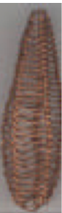
Fig. 19: My recreation of the teardrop shape.

Dating the Chains, Geographical Distribution & Gender

Tomanterä tells us that the earliest finds employing the trichinopoly technique in metal were from the 9th century (corroborating Graham-Campbell's assertion) and that the majority of the finds cannot be dated accurately. Only those pieces found in coin hoards can be given a rough date. Of those found with coins, most are dated to the very end of the 10th to the end of the 11th century (Braid72). Tomanterä does, however, list one 15th century crucifix from Drammen, Norway. "The chain is of relatively thick strongly drawn wire and has five rows. At the ends of the chain are filigree ornamented gilded mounts joined to a U-shaped holder. T he artifact is an encolpion crucifix. (Braid 75 ).

Map 1 on the following page, from Tomanterä , shows the distribution of the braided ornaments in the 1100s. Combining the mapped locations with those of the pieces mentioned by Graham-Campbell, you can clearly see a wide geographical dispersion covering the lands most would consider to be Viking. These locations include: Scotland and the Scottish islands, Ireland, Finland, Britain, Norway, Denmark, Kerlia, and Sweden.

Now that I was convinced of the Viking's use of trichinopoly chainwork for jewelry and garments, I began to wonder who wore the pieces. Men? Women? Both? Tomanterä's evidence points to trichinopoly neck chains as being male adornments. She notes that most of the burial finds containing crucifixes placed the chain on the neck of a man (Braid). Looking at the subject matter of other existing chain pendants (ie. Silver hoard from Lämsä, Kuusamo, the flat, axe head amulet from Northern Finland for example) further support her hypothesis. Thor's Hammers and axe heads certainly seem to be a male oriented symbol.

On the other hand, a long chain "from Birka has been found...with oval convex brooches" (Traces 16). Oval convex brooches are generally associated with women and are seen holding together apron dresses. Additional support for women wearing trichinopoly chainwork comes again from Tomanterä . She tells us that a pendant was found around the neck of a woman's skeleton. With this same skeleton, a silver 'sykerö' hair-piece was found by the head pointing to a conclusion that the hair-pieces were a woman's ornament (Traces 16).

The fabulous Hämeen linna treasure necklace appears to be a women's treasure as well. Tomanterä suggests that this necklace's use of amulets attached by chains is modeled after, "needle holders or perfume bottle of Persian origin" (Traces 16). Perhaps this necklace combines the display of wealth as Danegeld necklace does with the concept of the feminine chatelaine. This is just a supposition on my part.

Graham-Campbell shows us that a silver pin and chain came from the grave of a woman and a man buried in Ballinaby. This further shows that both sexes wore or used a variety of objects made in the trichinopoly style. Unfortunately, the remainder of the extant pieces have not been associated with males or females, as far as I am aware.

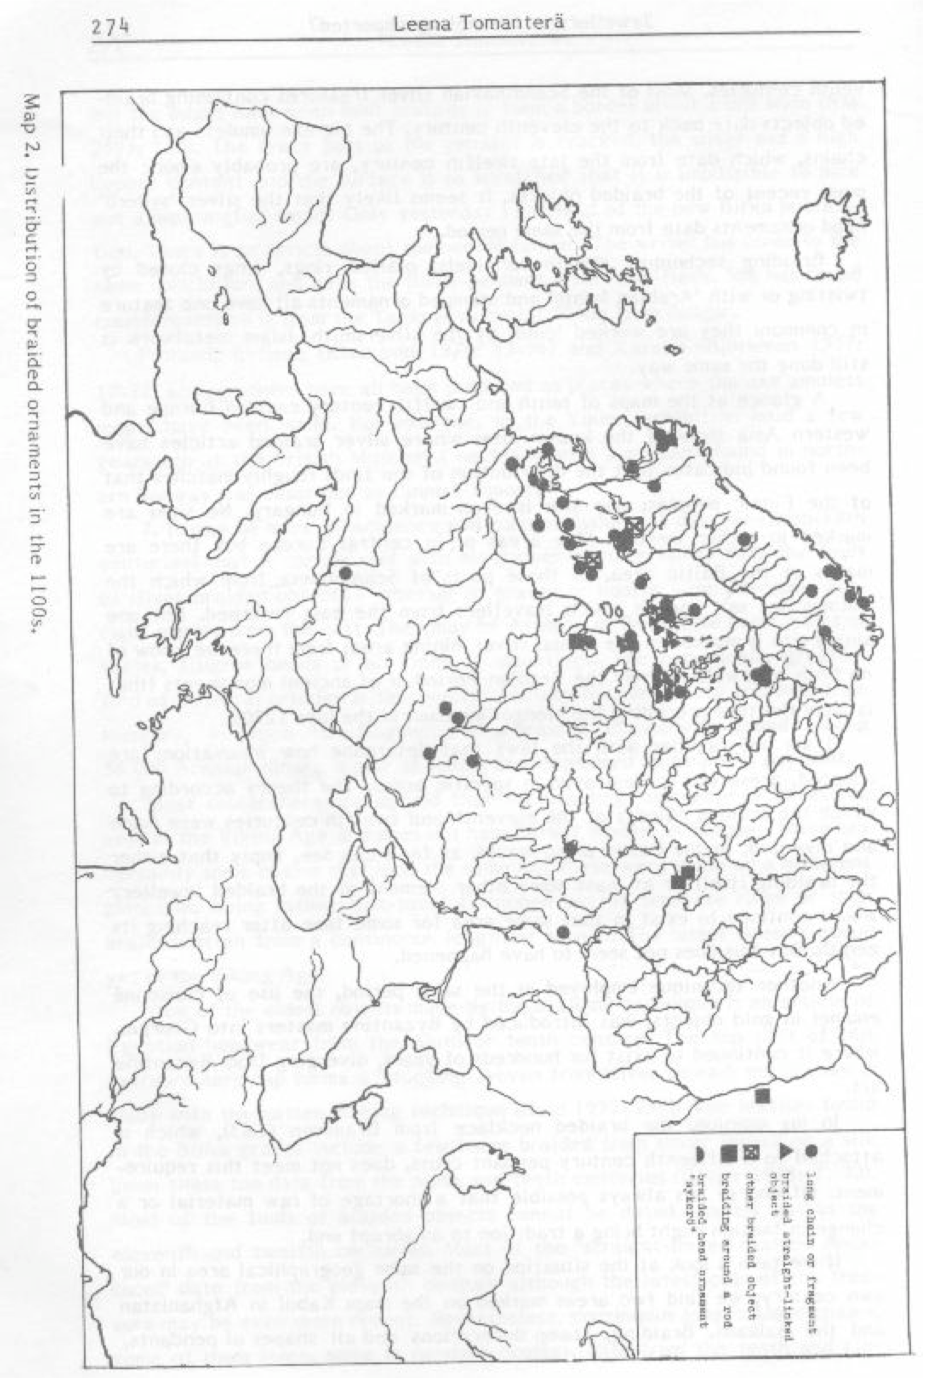
Map 1: Distribution of Trichinopoly Chainwork Pieces in the 1100s as Shown in Tomanterä (Traces )

Conclusion

The similar structure of all three construction examples presented from Graham-Campbell,
Tomanterä, and Geijer are probably referring to the same technique. Extant pieces are available from the right time periods in a variety of geographical locations where Vikings were known to live. Evidence in the form of Birka textile finds and an Egyptian cap link the trichinopoly chain making technique to textiles, showing a crossover in mediums. In the end, it is possible to prove Irene Peterson's claim.

The sharing of my journey to document Viking Chain Knitting shows the cycle of investigation that most SCAdian artisans undergo in order to prove a technique or object was truly used in period. The process continues and truly is never complete as more finds are discovered, barriers to obtaining books or articles are removed, and more clues surface. Do not let the prospect of research be daunting. It can be a labor of love as well as a continuing process.

Works Cited

Beatson,Peter. Kaftan. 27 October 1998. 30 April 2004.
<http://users.bigpond.net.au/quarfwa/miklagard/Costume/Rus/Trader/kaftan_text.htm>.

Fitzhugh, William, and Elisabeth Ward. Vikings: The North Atlantic Saga. Washington D.C : Smithsonian Institution Press, 2000.

Geijer, Agnes. Birka III: Die T extilefunde A us D en Gräbern. U ppsala. 1 938.

Graham-Campbell, James. The Viking Age Gold and Silver of Scotland (AD 850-1100).

Over Wallop, Hampshire, Britain, National Museums of Scotland, 1995.

Jacobs, Helene. Woven Wire Earrings. 30April2004. <http://baronessbetha.tripod.com/ wireweavingearrings.htm>

National Museum of Finland. RAUTAKA US I5 00 eK r.-1300 jKr. National Museum of Finland. 20 April 2004.
<http://www.nba.fi/natmus/MUSEUM /Opetus/rautakau.htm#Suomalaisuuden%20ja%20saamelaisuuden%20kehitys>.

Peterson, Irene From. Great Wire Jewelry: Projects and Techniques. Ashville, NC : Lark Books, 1998.

Price, Neil S . "Shamanism and the Vikings?" Vikings: The North Atlantic Saga. Ed. Fitzhugh and Ward. Washington D.C: Smithsonian InstitutionPress, 2000.70-71.

Stevens, Lora-Lynn. "How to Knit Like a Viking." Appendix 1 of A Research Journey: Trichinopoly Chainwork Is It Viking Chain Knitting? Pentathlon Entry. Society for Creative Anachronism. 2004.

Tomanterä, Leena. "Braid, weave, and 'foxtail" Fenno U gri et Slavi 1983: Papers Presented by the Participants in the Soviet-Finnish Symposium 'Trade, Exchange and Culture Relations of the Peoples of Fennoscandia and Eastern Europe' 3 May 1983. Helsinki: Suomen Muinaismuistoyhdistys-Finska Fornminnes Foreningen.1984.pp.70-76.

—- . Letter to the author. 11 June. 2001.

—-. "Traces of The Central Asian Culture in the North," Sumalais-urgilaisen Seuran

Toimituksia Mémoires De La Société Finno-Ougrienne. 194. Helsinki 1986. pp. 263 -278.

Willadsen, Don.10th Century Danish Woven Wire Arm Ring. September 2001.
<http://bjornsson.crosswinds.net/sca/danr_as/woven-arm-ring/woven-arm-ring.htm#_T oc9609788> .

Wilson, D .M . and C .E . Blunt. 1961 "The Trewhiddle hoard." Archaeologia. 97, 75-122.
York Archaeological Trust and the National Museum of Denmark The World of the Vikings" , (CD - ROM). 1992
------
Copyright 2005 by Lora-Lynn Stevens (author) and Maggie Ahrens (illustrations), <apolloniavoss at suscom.net>. Permission is granted for republication in SCA-related publications, provided the author is credited. Addresses change, but a reasonable attempt should be made to ensure that the author is notified of the publication and if possible receives a copy.

If this article is reprinted in a publication, please place a notice in the publication that you found this article in the Florilegium. I would also appreciate an email to myself, so that I can track which articles are being reprinted. Thanks. -Stefan.

<the end>

