Time-Keeping-art - 11/24/09

"A Brief History of Time Keeping" by Viscount Sir Corin Anderson (KSCA, OP).

NOTE: See also the files: clocks-msg, sundials-msg, Sandglass-art, Watches-art, bells-msg, calendars-msg, time-art, A-Gear-o-Time-art.

************************************************************************
NOTICE -

This article was submitted to me by the author for inclusion in this set of files, called Stefan's Florilegium.

These files are available on the Internet at: http://www.florilegium.org

Copyright to the contents of this file remains with the author or translator.

While the author will likely give permission for this work to be reprinted in SCA type publications, please check with the author first or check for any permissions granted at the end of this file.

Thank you,
Mark S. Harris...AKA:..Stefan li Rous
stefan at florilegium.org
************************************************************************

This article was first published in issue number x of "Cockatrice", the A&S newsletter of the Kingdom of Lochac.

A Brief History of Time Keeping
by Viscount Sir Corin Anderson (KSCA, OP)

Some individuals amongst our ancient and medieval ancestors devoted a great deal of effort and ingenuity to developing and improving methods of measuring time. They employed both mechanical devices, relying largely on the work performed on a mass by gravity, and celestial devices that relied upon the regularity of the rotation of the earth about the sun and its own axis.

When studying the development of time keeping it is also illuminating to ask the question why time keeping devices were even considered necessary at all. A largely rural and agricultural society would have managed to obtain all the information they needed about time from the position of the sun. It is certainly easy enough to notice when the sun rises, sets and is at its zenith. This provides, at the least, a universal clock that shows the time of morning, noon and night.

Even as late as the thirteenth century there are examples of daily practices being governed in the absence of time keeping devices. The charter of the fullers of Paris in the thirteenth century stated that they started work "as soon as it was possible to recognise a man in the street", and ceased work "when the first hawkers of wine past by". In Islam, a time for ritual prayers was fixed by Muhammad to be "when it is still possible to see the place where an arrow falls".

One clue as to the early importance of the measurement of time comes from ancient Greece and is concerned with the notion of the equivalence of periods of time. It is a very simple observation that a pot full of water that has a hole in the bottom will leak until it is empty. From there it is not so great a leap to discover that two identical pots with identical holes will leak water at the same rate.

This is where the idea of equivalence comes in to play. If two identical pots leak at the same rate then one of the pots, refilled and emptied twice or more, measures out equivalent periods of time. This principle of equivalence led to the development of what is considered to be the most ancient of mechanical time keeping devices, the clepsydra or water clock.

In its simplest form the clepsydra was a clay pot with a hole in the bottom. The name clepsydra is derived from the same roots as the two modern words 'kleptomania' and 'hydrate'. Its literal translation is 'water thief'. Such clepsydrae were used in the assembly of ancient Athens during arbitration and trials. To help ensure a fair hearing each plaintiff in a case would have as much time to speak as the time taken for the water to run from a clepsydra.

Plato, in his work Theaetetus, has Socrates say: "In the leisure spoken of by you, which a freeman can always command: he has his talk out in peace, and, like ourselves, he wanders at will from one subject to another, and from a second to a third,--if the fancy takes him, he begins again, as we are doing now, caring not whether his words are many or few; his only aim is to attain the truth. But the lawyer is always in a hurry; there is the water of the clepsydra driving him on, and not allowing him to expatiate at will".

Socrates himself faced the clepsydra when accused of corrupting the youth of Athens, although it seems more likely that the attack on Socrates was due to his biting satire targeted at Athens aristocratic elite. In the end he was convicted and executed by being forced to drink hemlock.

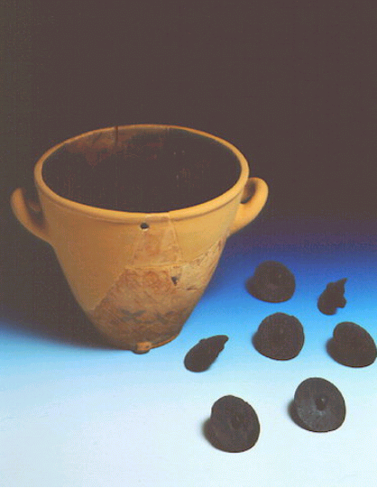

Clepsydra from the Museum of ancient Agora

One problem with the simple clepsydra was that the rate of flow of the water from the hole depended on the height of the water above it. The higher the water the more pressure and therefore the faster the flow. This meant there was no simple way to measure the passage of time in relation to the volume of water that had run from the clepsydra.

A solution to this problem discovered by the ancients was to place a second container with a hole both near the top and bottom to collect the water expelled by the first. The water level in the second container would rise to the level of the top hole and then escape, maintaining a constant height, and hence pressure, above the lower hole. Since the rate of water flow from the lower hole of this second container was constant the passage of time could now be directly related to the volume of water collected in a third container positioned below the second.

To facilitate the easy reading of this volume the ancients developed ways of connecting the volume of water collected in the third, or collection, container to the position of a pointer on what we would recognise today as a clock face. One method of doing this was to attach a string to a float in the collection container, which was then wrapped around a pulley. The other end of the string was connected to a weight while a shaft connected the pulley to a pointer.

As the water level in the collection container rose, so too would the float. This would cause the weight at the other end of the string to fall and the pulley, with the attached pointer, to rotate. The circumference of the pulley could be set so as to make the pointer revolve once every day.

To the modern mind this arrangement contains all of the elements required to measure the kind of time with which we are familiar. We now break up the 'day' into 24 equal hours, which includes both a sunlit day and the following night. In our current system of reckoning, the time of sunrise and sunset varies throughout the year, being 6 AM and 6 PM respectively only at the two equinoxes.

The ancients Greeks, on the other hand, considered the day and night as being quite distinct and divided the day into 12 equal parts and the night into 12 equal parts. Using this system of 'unequal' hours the sun rose at 6 AM every day and set at 6 PM every night.

This method of dividing the day and night each into 12 equal parts resulted in the day time hours being longer than the night time hours in summer with the opposite being true in winter. The Romans adopted the use of these unequal hours from the Greeks around 291 BC. In one of his epigrams the Roman M Valerius Martialis (c AD 40 – 102) refers to "less than and hour – and that not of summers length". In fact the length of the unequal hour varies from 49 to 71 minutes from winter to summer. The Christian bible has another illustration of this system in the words of Jesus to his disciples, "Are there not twelve hours in the day? If any man walk in the day, he stumbleth not, because he seeth the light of the world (John 21 9)".

Having a clepsydra or other device that measured unequal hours would offer a number of advantages. For example, such a clepsydra would give advance warning of the coming of dawn so that labourers could be roused and readied for work prior to sunrise and so take the greatest advantage offered by the daylight hours.

Ctesibuis of Alexandria invented such a clepsydra in 135 BC. Instead of a clock face the clepsydra Ctesibuis devised had a rising pointer that indicated the time on a rotating drum. The drum had a separate line for each hour that ran around its circumference. The drums circumference was divided into 365 days and the position of the hour lines varied to reflect the changing length of the unequal hours throughout the year. In simpler models the drum could be turned by hand each day but more complex versions used the water from the daily emptying of the collection chamber to drive a water wheel and series of gears that automatically advanced the drum.

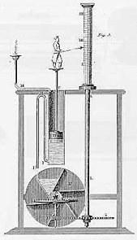

Clepsydra with drum for unequal hours (from 'Ress's Clocks watches and Chronometers', 1819)

The adoption of unequal hours by the Christian church as a means of determining when to pray led to their continued use in Europe into the medieval period. It was customary for monks in monasteries to come together to pray at predefined times. These set times, or offices, varied throughout the medieval period and also from monastery to monastery. Despite this variation they were all based on unequal hours with offices timed to coincide with sunrise, noon, sunset, midnight and the times directly in between.

The word 'cannon' means literally 'measuring rod' or figuratively, 'rule' or 'discipline'. The rules that governed the times at which a particular Christian order was required to pray became known as the 'canonical hours'. One example of these canonical hours is given below:

Nocturnae | The night office, divided into three night vigils roughly corresponding to 9 PM, midnight and 3 AM
Matins | First light, considered part of the night office
Prime | Sunrise, the first day office
Tertia | Midmorning
Sexta | Noon
Nona | Mid Afternoon
Vespers | Sunset
Compline | Last light

Although it was certainly possible to use a clepsydra to determine the time when these offices occurred, and it seems likely that clepsydra were used for this purpose until the invention of mechanical clocks, the use of clepsydra suffered from several drawbacks.

One problem was that it was difficult to make a clepsydra that was accurate to the minute over a period of 24 hours. This would mean that over time the clepsydra would drift out of time, running either fast or slow. Secondly, a clepsydra required careful attention to ensure that reservoir was refilled and the collection chamber emptied at regular intervals. If the reservoir ran dry or the collection chamber overflowed the measurement of time would be interrupted.

The chronicles of Jocelin of Brakelond, an abbot, described in 1198 another reason why a clepsydra might fail: "For in the same hour the clock fell before matins", this signal apparently occurred at an opportune instant, serving to draw attention to a serious fire which had begun to consume the platform carrying the shrine containing the relics of St Edmund the Martyr. Jocelin's narrative then continues: "our young men therefore ran for water, some to the well, some to the clock; others with great difficulty extinguished the violence of the fire with their cowls".

Because of these failings it was necessary to devise devices that could determine the time by other means and to use these devices to reset the clepsydra as required. One of these devices, used to tell the time at night by the position of the stars, takes it name from the canonical night offices and was called a 'nocturnal'.

Ancient astronomers in the northern hemisphere noticed that, while all other stars change position during the course of the night a single star, Polaris or the 'pole star', seems fixed in the centre of the sky. Stars close to Polaris seem to rotate around it in the same way that an hour hand rotates around the centre of a 24-hour clock face. The reason that Polaris seems fixed is that it lies almost directly on the axis of the earth's rotation, also called the North Celestial Pole. This fact, along with one other particular complication, enables the reading of the time from the angle between Polaris and any other nearby star. The particular complication in reading the time in this way arises from the difference between solar and sidereal, or star, time.

Solar time is measured by the position of the sun relative to the surface of the earth. Sidereal time, on the other hand, is measured by the position of the surface of the earth in relation to the fixed stars. Imagine that, on the 1st of January, a particular star is directly overhead at midnight. Three months later the earth will have advanced through one quarter of its orbit around the sun. This change in position relative to the sun means that the same star is now directly overhead at sunrise. Three months later the same star is overhead during the middle of the day and is, of course, invisible.

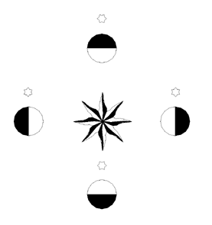

The mismatch between solar and sidereal time causes the position of the stars to precess by a little less that one degree per day. This means that the angle that a particular star makes with the pole start at midnight on one night will be about one degree more at the same time on the following night.

The medieval nocturnal consisted of a back plate, somewhat like a circular mirror with a handle, that had the divisions of a calendar marked around its edge. A second, somewhat smaller, disk was pivoted through the centre of the first with hollow spindle that allowed the user to sight through the nocturnals middle. The second disk was marked around its edge with the divisions of a 24 hour clock and also had a number of projecting points representing the positions of a particular set of stars. The third and final part of the nocturnal was a ruler that also pivoted around the central spindle.

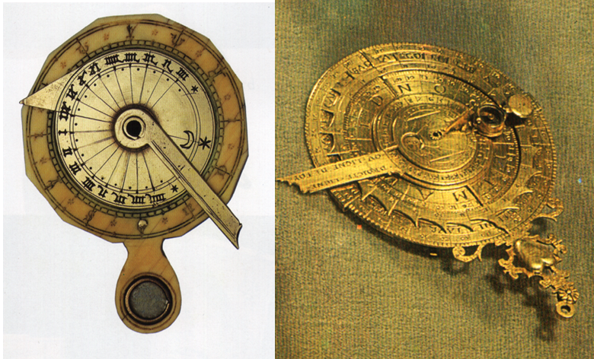

Nocturnal, ivory and brass, 16th century; Nocturnal, gilt copper, before 1582

To use a nocturnal, one of the star pointers on the second, or hour, wheel was selected and set to the current date on the first, or calendar, wheel. The action of rotating a star pointer on the hour wheel to the current date compensated for the precession of the stars. Polaris was then sighted through the hole in the spindle and lined up the ruler with the star that was used to set the date. The time could then be read from the position where the ruler intersected the markings on the hour wheel. With such a device as a nocturnal to hand it was possible to dispense with the clepsydra for reading the time on clear nights and rely on the water clock only in the instances where cloudy conditions made the use of the nocturnal impossible.
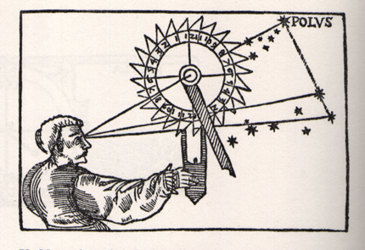

Illustration from manual describing the use of the nocturnal

The calculations required to develop the nocturnal depended on the accurate recording of the positions of the stars overs long periods of time. These recordings were collected into star catalogues from which it was possible, by the use of trigonometry, to devise almanacs. Such almanacs tabulated the elevation above the horizon, or altitude, and the compass direction, or azimuth, of the brightest stars as they appear at different times and from different locations during the course of a year. Since the interval of time covered by almanacs could be as small as a minute and the number of different stars and latitudes for which the calculations were tabled quite large, almanacs were hefty tomes often running into many hundreds of pages and multiple volumes.

Despite their inconvenient size almanacs were invaluable for navigation at sea as they enabled the altitude readings from a number of stars to be cross-referenced to make the discovery of a ships latitude possible. Where latitude was already known, as is more readily the case on land, an almanac can be used to tell the time from the altitude of the stars. This ability to the find the time at night from the stars using an almanac becomes more important as you move towards the equator and Polaris becomes no longer visible. Without sight of the pole star the use of the nocturnal described earlier is no longer possible.

One instrument used to measure the altitude of the stars is called an astrolabe. In its simplest for the astrolabe consisted of a disk that was graduated at its edge with a degree scale. A ruler with a pinhole sight at either end, the alidade, was pivoted at the centre of the disk. A ring at the top suspended the astrolabe so that when held there gravity would make it lie perpendicular to the horizon. To measure the altitude of a star involved holding the astrolabe by the ring and adjusting the alidade until the star was visible through the sights. The altitude of the star could then be read from the intersection of the alidade and the graduated edge of the disk.

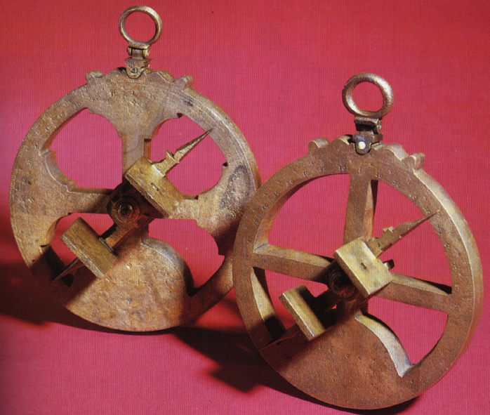

Portuguese mariners astrolabes, dated 1605 and 1616

The word astrolabe is derived from Greek and literally means 'star catcher'. The origins of the astrolabe are unknown but it is certainly an ancient device. Plato wrote of a device he used to devise his star catalogue that was almost certainly a form of astrolabe.

The inconvenience of carrying around a bulky almanac so as to make use of an astrolabe to tell the time led to the development of the 'planispheric astrolabe'. A planispheric astrolabe was, in essence, a simple mechanical calculator that could be used to derive the position of a small number of stars, usually ten to twenty, from knowledge of the current date and time. Alternatively, the current date and the altitude of a star could be used to derive the time. The mathematics required to devise planispheric astrolabes were known in 150 BC and Arabic examples from 900 AD still survive.

A planispheric astrolabe consisted of disk, called the 'mater', with a raised rim or edge, called the 'limb' graduated with the divisions of a 24 hour clock. Inside the limb sat one of a number of removable plates called 'tympan'. The tympans were engraved with a series of altitude and azimuth (compass bearing) lines. These lines, also called almucantar, are stereographic projections of the lines of altitude and azimuth of a particular latitude as viewed from the pole. A different tympan was required for each latitude.

Over the plate sat the 'rete', or net, which was a mostly open disk that had pointers representing the position of particular stars. The rete also incorporated an offset circle, which was graduated as a calendar and represented the plane of the earths orbit around the sun, also known as the circle of the ecliptic. The rete was pivoted through the centre of the astrolabe disk so that it could be rotated. On top of the rete and also attached to the pivot was a ruler. The back of the astrolabe mater was graduated with a degree scale like a simple astrolabe and provided with a pointer or alidade to enable the measurement of star altitudes.

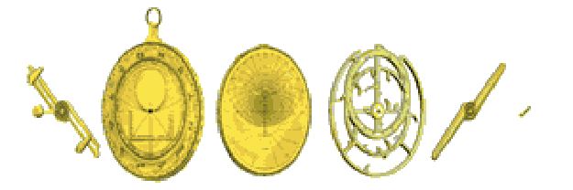

Parts of the astrolabe, from left; pin, alidade, mater, tympan, rete, rule, horse

To use an astrolabe to tell the time required choosing one of the stars represented on the rete that is currently visible and take a sighting to determine its altitude. Once the star's altitude has been determined the rete is revolved so that star's pointer lines up with the altitude line on the plate that corresponds to its elevation. The ruler on the rete is then aligned with the date on the circle of the ecliptic and the time read off from where the ruler intersects the hours marked on the limb of the mater.

The planispheric astrolabe works by translating between sidereal and solar time. Rotating the rete so that a star pointer matches its observed elevation determines the angle of the rotation of the earth relative to the fixed stars, i.e. it calculates the current sidereal time. The combination of the sidereal time and the date allows for the determination of the current solar time in a manner that is identical to the working of the simpler nocturnal.

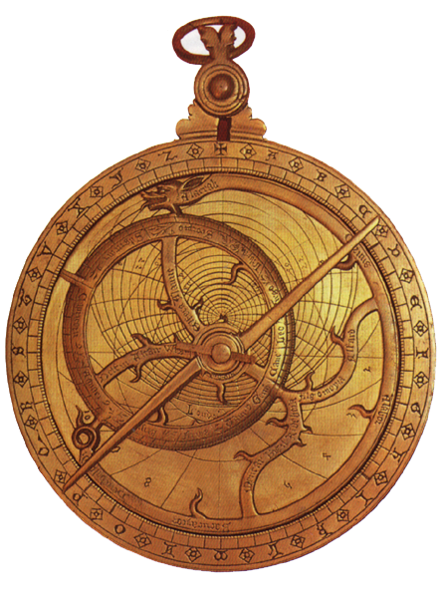

English astrolabe c. 1320

The planispheric astrolabe could also be used to tell the time of day from a measurement of the suns altitude. To measure the suns altitude the alidade is adjusted until the light coming through the upper sight falls onto the lower sight, eliminating the need to look directly into the sun. The rete is then rotated so that the current date on the circle of the ecliptic is lined up with the appropriate altitude line. The ruler is then lined up with the current date on the ecliptic circle and the time read from the limb of the mater.

Although the astrolabe was able to determine the time of day from the position of the sun there existed a whole class of simpler devices that performed the same function. We know these devices collectively as sundials.

Vitruvius, a contemporary of Julius Caesar (who is perhaps more famously known for his treatise on the construction of ballistae), bemoaned the fact that he could not invent new types of sundials since the field was already exhausted. He lists a dozen or more types, giving the names of their inventors. The details of these sundials are unknown but it is fair to say that, even judging only by surviving examples, sundials existed in a greater variety of forms than any other period timepiece.

Sundials are the oldest devices used for measuring the passage of time. The earliest surviving example of a sundial, a stone fragment in a Berlin museum, dates from about 1500 BC. Herodotus, who lived in Asia Minor and Greece around 450 BC, tells us "It was from the Babylonians that the Greeks learned about the pole, the gnomon and the twelve parts of the day". Sundials had become so common in Rome by 200 BC that the comic dramatist Plautus condemned in verse "the wretch who first ... set a sundial in the market place to chop my days to pieces".

Vitruvius, a contemporary of Julius Caesar (who is perhaps more famously known for his treatise on the construction of ballistae), bemoaned the fact that he could not invent new types of sundials since the field was already exhausted. He lists a dozen or more types, giving the names of their inventors. The details of these sundials are unknown but it is fair to say that, even judging only by surviving examples, sundials existed in a greater variety of forms than any other period timepiece.

In general terms, a sundial marks time by using the shadow cast by the sun over a straight rod or edge, called the gnomon to measure the position of the sun relative to the earth's surface. The word 'gnomon' is derived from a Greek word meaning 'one who knows'. Although sundials vary greatly they all have two features in common, a dial marked with an hour scale and a gnomon, the shadow of which is used to indicate the time on the dial. One of the earliest types of sundial, and the most mathematically simple, was developed from ancient astronomical devices.

Ancient astronomers used celestial globes, which depicted the heavens in much the same way that terrestrial globes depict the oceans and continents. The celestial globe showed the constellations and their brightest stars and the imaginary circles of the heavens corresponding to the meridians and parallels on the terrestrial globe. For many purposes the body of the globe was omitted and a mere skeleton used instead, consisting of an assembly of rings representing the principle circles of the heavens. Such an assembly came to be called an 'armillary' sphere from the Latin word 'armilla', a bracelet or ring. Since an armillary sphere was a model of the heavens it could be used to demonstrate the regular way in which the sun appears travels around the earth and could, in fact, be used as a sundial.

In its simplest form the armillary sundial consists of two rings representing the equator and the meridian with a rod passing through their common centre representing the earth's axis. The ring of the equator acts as the dial plate and is graduated on the inside with an hour scale. Since the day is divided into 24 parts, each hour line will be set 15 o apart. If the sphere is oriented so that the equatorial ring is parallel to the equator and the axis rod is parallel to the pole, the axis rod will act as a gnomon. The time can be read from were the shadow of the gnomon intersects the hour scale on the equatorial ring.

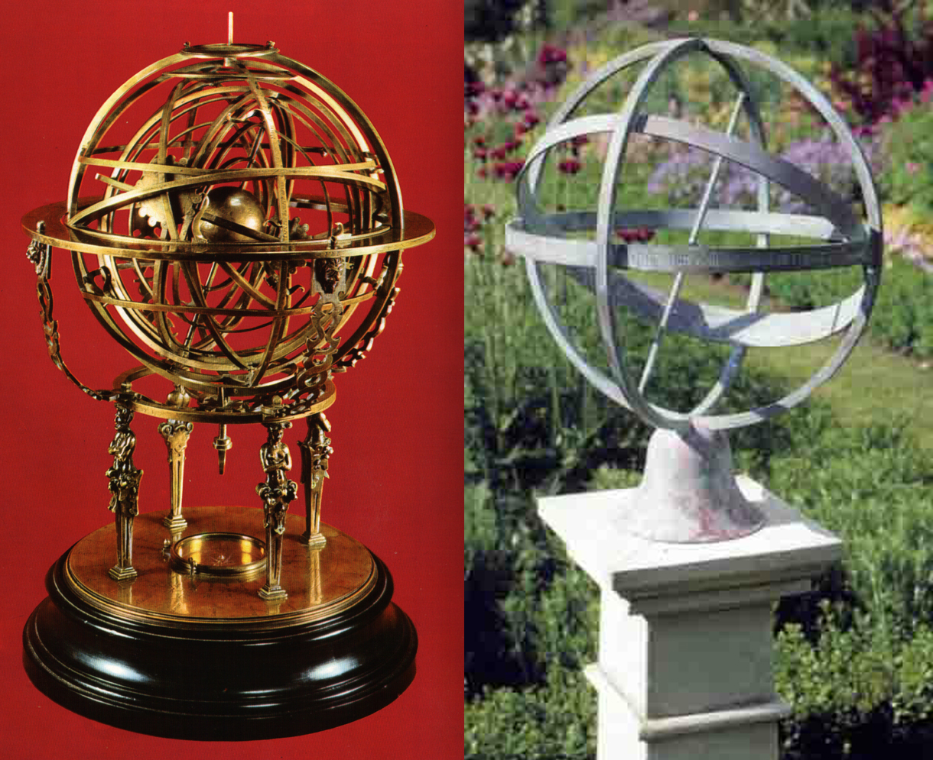

Brass armillary sphere, 1575 (left). Modern armillary sundial (right).

Orienting the armillary sundial so that the equatorial ring is in line with the equator is simply a matter of setting the angle that the gnomon makes with the horizon equal to the latitude of the place where the ring is located. Once the gnomon is set to the correct angle, orienting it so that it points north will bring it into alignment it with the pole.

Sundials that use this method of determining the time of day are called equatorial, or equinoctial, sundials because they measure time by measuring the position of the sun relative to the earth's equator. The words equinoctial means 'equal night' and refers to the equal length of day and night at the equator.

One of the advantages of the equinoctial sundial was that, if correctly oriented, it could be used anywhere on the earths surface. Portable, pocket sized, equinoctial sundials were quite common towards the end of the 16th century. The were most usually made of brass and were equipped with a compass, to align the gnomon to the north, and a quadrant marked with a degree scale that could be used to set the dial plate at an angle suitable for the users current latitude. To provide a reference for their owner's, portable equinoctial sundials often had tables of the latitudes of major cities engraved on their cases.

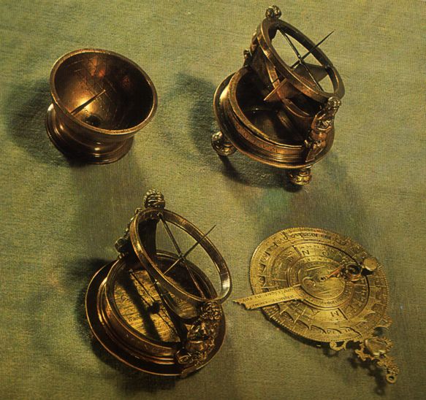

Portable equinoctial dials; top right 1557, bottom left 1575. Also shown are hemispherical dial and nocturnal.

Another common form of sundial, and the type most people are aware of, is the horizontal sundial. The horizontal sundial is so named because the dial plate, rather than being aligned with the equator, is aligned with the horizon. In a horizontal sundial the gnomon is most commonly a triangular plate, the top edge of which is set parallel to the earth's pole. Since the dial plate is at an angle to the earth's equator the number of degrees that the shadow cast by the top edge of the gnomon is not a constant 15 o per hour but varies throughout the day, being greater than 15 o in the morning and evening and less towards midday. Vertical sundials, often appearing on the walls of buildings, work in a fashion that is similar to horizontal sundials. In fact, the angles of the hour lines on a vertical sundial are the same as on a horizontal dial set for the co-latitude (90 degrees minus the latitude) of the vertical dial i.e. a vertical dial set for a latitude of 30 degrees will be the be the same as an horizontal dial set for a latitude of 60 degrees.

In the 15th and 16th centuries a form of portable sundial based on the horizontal sundial was common. The sundial, called a 'diptych' sundial, consisted of a pair of hinged, often ivory, plates that could be set at right angles. Either the horizontal, vertical or sometimes both, plates would be marked with hour lines and a string running through holes in each plate would act as the gnomon. Although most surviving examples of diptych sundials were made for single latitudes, some exist that were built for use in a number of latitudes. These dials had separate, concentric, hour lines for different latitudes. The angle of the string gnomon was adjusted by passing it through different holes depending on the latitude chosen. Compasses were built into the horizontal plate to align the dial with north. A plumb bob was often included to help ensure the dial plate was held level with the horizon.

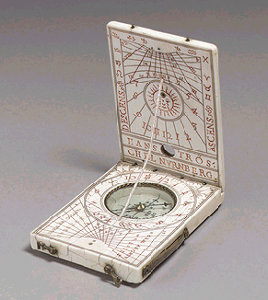

Portable diptych sundial by Hans Troschel the Elder (German, Nuremberg, 1549—1612)

From the time that public sundials began to make an appearance it would have been evident that the walls of buildings make good places to locate them. In the simple case where the sundial faces either due north or south, the equation to determine the angle of the hour lines is fairly straightforward and has only two variables; the time for which the hour angle is to be calculated and the latitude of the sundial. When a sundial is designed for a wall that does not face due north or south then the deviation has to be taken into account, further complicating matters. In addition to this, if the wall is not perfectly vertical the variation from the vertical must also be considered.

By the renaissance the mathematics required to design sundials was well developed and mathematicians of the time considered it a challenge to devise especially complicated sundials. One of the more unusual sundials made during the renaissance were in the shape of polyhedra with a separate dial calculated for each face. One such dial polyhedral dial can be seen in the portrait 'The Ambassadors' and examples with as many as twenty faces still survive.

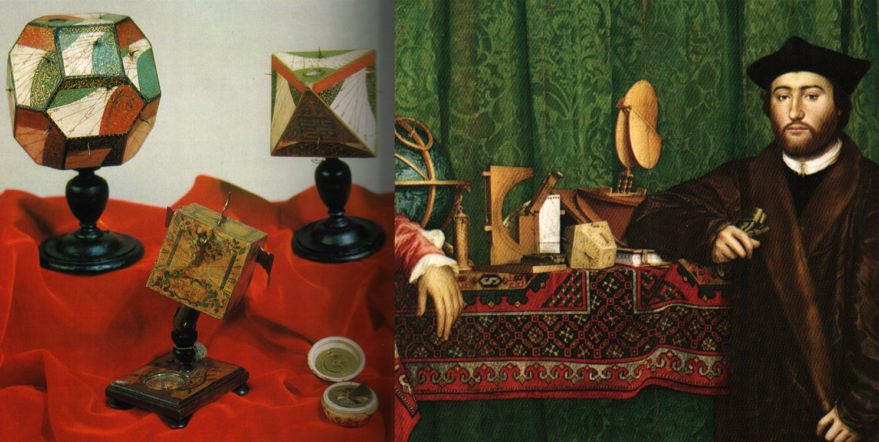

Polyhedral sundials, 1587 (top left & right, left image). Cubic sundial c. 1750 (centre, left image). Detail from 'the Ambassadors' showing polyhedral dial, Hans Holbein, 1533(right image).

Although they are the most ancient of timekeepers, sundials were still commonly used to reset mechanical clocks up until the invention of the telegraph, in the 19th century, enabled clocks to be synchronised using electricity.

The first mechanical clocks began to appear very early in the 14th century. One of the earliest references to what is obviously a mechanical clock comes from Dante's 'Paradisio', written between 1313 and 1321: "And as the wheels in works of horologes revolve so that the first to the beholder motionless seems, and the last one to fly...". It can be expected that Dante would not use a clock as a simile unless he expected that the image would be well known to his readers so it is likely that clocks existed for some time prior to this date.

The oldest surviving example of a mechanical clock is attributed to c. 1350 and the turret clock in Salisbury Cathedral, which operates to this day, can be accurately dated to 1386 as documents that describe it's commissioning still exist.

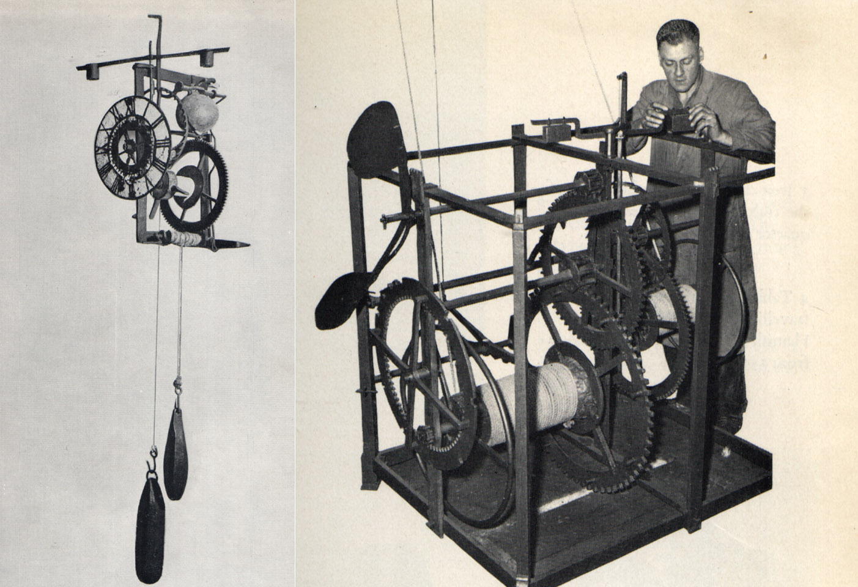

Oldest surviving example of a mechanical clock, German c.1350 (left). Repairs being carried out on the Salisbury Cathedral clock, 1386, which is still in operation today (right).

While it is uncertain exactly where and when the first mechanical clocks were fabricated, it seems likely that they were the product of the monasteries and their drive to more accurately time the observance of the daily offices. Examples of monastic 'alarums', or alarm clocks, still survive. Ecclesiastical artwork, such as the 15th century tarsia below that depicts a monastic alarum grouped with other tools of holy office; also indicate the early importance of clocks in religious life.

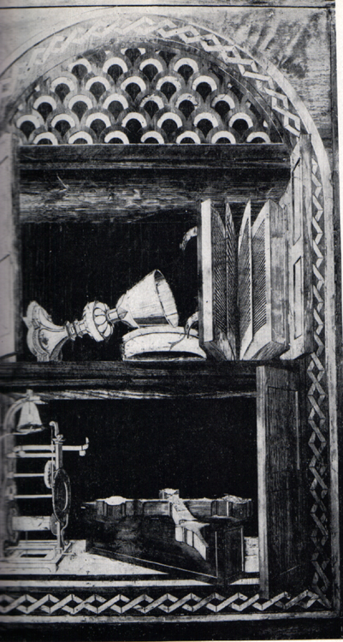

Although initially a product of the monasteries, it wasn't long before public clocks began to make an appearance. A public clock was installed in Padua in 1344, in Genoa in 1353, in Bologna in 1356 and in Ferrara in 1362.

Despite the early prevalence of public clocks, smaller domestic clocks did not become commonplace nearly so quickly. Clocks remained expensive handcrafted items well past the end of the 16th century. While it was possible for a city to gather the funds from public coffers to commission a clock, personal clocks remained beyond the means of all but the wealthiest individuals. Individuals possessing clocks were often proud enough of their acquisition to have them included in their portraits.

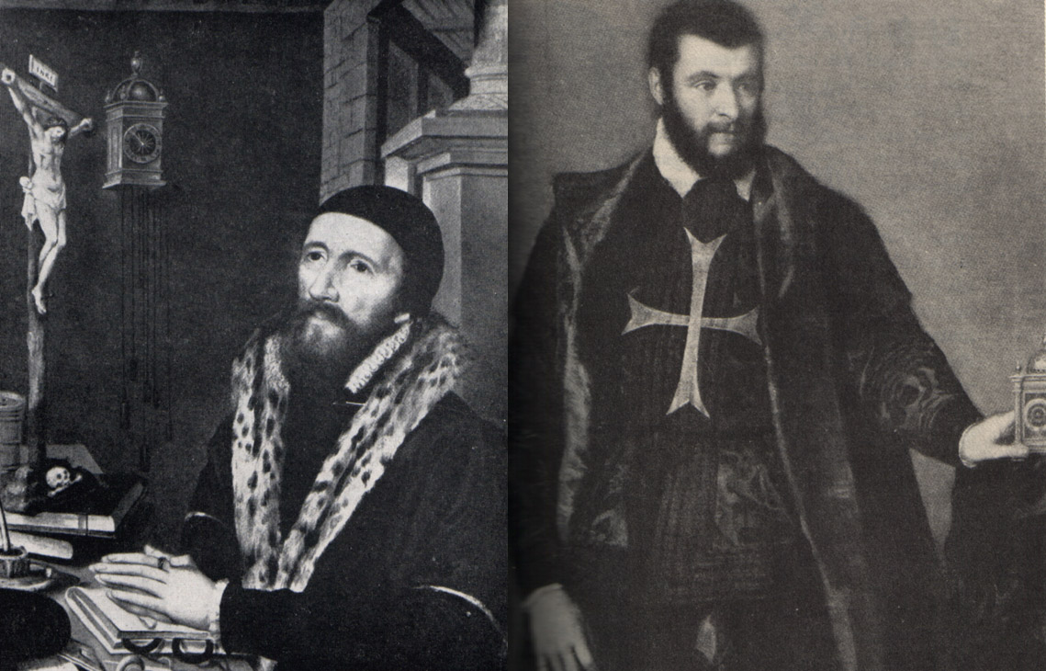

Hanging clock in a painting by Roemerswealde, 1503-67 (left). Unknown Knight of the Order of Malta, Titian c.1550 (right).

Early clockmakers were primarily smiths, especially gunsmiths, and the manufacture of clocks was more of a sideline than a profession. It wasn't until the 17th century that clock making took off as a distinct profession and subsequent advances in manufacturing made clocks available to the middle classes.

The majority of mechanical clocks of the medieval and renaissance were powered by weights suspended by cords or chains. The cord or chain was wound around a drum and as the weight fell it would cause the drum to rotate. Towards the start of the 15th century spring driven clocks also began to appear but they suffered from the problem that as their spring unwound the force it exerted, and hence the speed of the clock, diminished. Various ingenious mechanisms for correcting this were devised but their complication, and hence expense, saw the continued existence of the weight driven clock well past the 16th century.

In the absence of any other interference, the weight or spring of a typical wall clock will unwind in a matter seconds; not particularly useful for measuring time over the course of a day. In order to regulate the rate at which the weight or spring unwound, medieval clocks used a mechanism called a 'verge and foliot escapment'. The word 'verge' is derived form the Latin word 'verga', which means a 'wand' and refers to the upright rod that forms a part of the escapement.

The verge and foliot escapement consisted of three main parts, the crown wheel, the verge and the foliot. The crown wheel, so named because of it resemblance to a crown, consists of a disk with an odd number of pins or teeth set perpendicularly to and around its edge. The verge rod is located in front of the crown wheel and two plates attached to the verge, the 'pallets', engage with the pins at the top and bottom of the crown wheel. At the top of the verge rod is a horizontal arm called the foliot which often has adjustable weights used for calibration.

As the clock's weight or spring unwinds it drives a series of reduction gears that in turn drive the crown wheel. The pin at the top of the rotating crown wheel engages with the top pallet of the verge driving it in one direction. As the verge rotates the top pallet disengages from the top of the crown wheel while the bottom pallet engages with the bottom of the crown wheel, driving the verge in the opposite direction. Since the verge is connected to the horizontal foliot the constant acceleration and deceleration of the foliot slows the rate at which the crown wheel rotates.

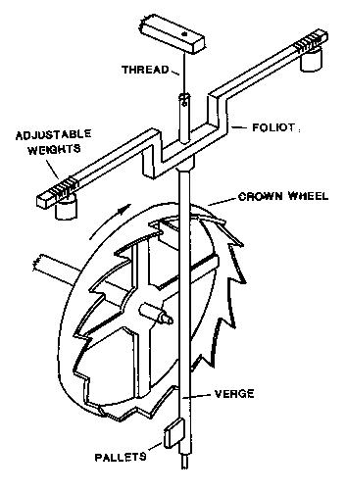

Diagram describing the operation of the verge and foliot escapment.

It was not uncommon for the back and forth motion of the foliot to take a number of seconds. This time multiplied by the ratios of the gear train connecting the crown wheel to the weight or spring allowed this style of clock to run for a day or more before it was required to be rewound.

Clocks that use a verge and foliot escapement are not especially accurate. The oscillation of the foliot is typically chaotic with the period of the oscillation varying in a random fashion. Although the period of individual oscillations is random, the average period could be adjusted by moving the weights on the foliot. Moving the weights closer to the ends of the foliot would slow the average period of the oscillation while moving the weights closer to the verge would speed it up.

The accuracy of a the best verge and foliot clocks is estimated to be in the order of plus or minus five minutes over the course of a day and it is likely that the majority of medieval and renaissance clocks fell far short of even this poor degree of accuracy. Although there are a few examples where a clock built prior to 1600 has been provided with a minute hand, these were rare. One of the few references to clocks with a second hand comes form the writings of Tycho Brahe, a 16th century astronomer who reports being disappointed with their efficacy, but no examples from this or earlier times survive. Clocks whose accuracy could be measured in seconds per day would have to wait until Christian Huygens perfected the pendulum escapement in 1656 (drawings of pendulum escapements, Galileo's for example, existed prior to 1600 but Christian Huygens is credited with turning the invention into a workable device).

Another drawback of early mechanical clocks is that any irregular movement of the clock, such as might occur on the heaving deck of a ship, would seriously interrupt the operation of the escapement and even further reduce the clocks already poor accuracy. Another time keeping device that is far less prone to the effects of random movement, and has for that very reason become associated with navigation at sea, is the sand glass.

Although the sandglass is a very simple device that works in a way that is analogous to the ancient clepsydra, and despite the fact that the glass blowing techniques required to build them were available at least as early as the time of the Roman Empire, they did not seem to have appeared until the near end of the medieval period.

The earliest known representation of a sand glass comes from a fresco in Siena painted in around 1338 by Ambrogio Lorenzetti while the oldest surviving example of a sandglass, dated from 1520, is now in the British Museum.

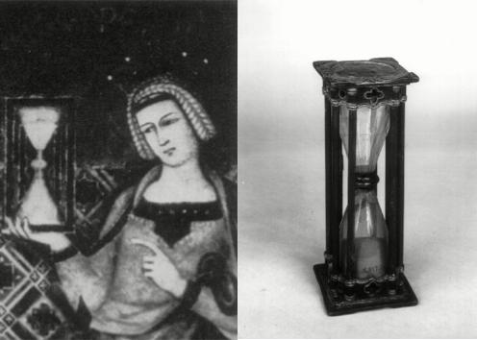

Detail from fresco by Ambrogio Lorenzetti, 1338 (left). Oldest surviving example of a sandglass, 1520 (right).

The sandglass consists of two pear shaped glass flasks, joined at the necks with a perforated brass diaphragm and filled with dry, uniform grained sand. Putty or wax was used to seal the join, which was then bound with cord. The flasks were held together and protected by a reversible wooden frame.

Sandglasses were used at sea to aid in navigation by dead reckoning. To navigate by dead reckoning requires the regular recording of both direction and speed, the movement of a ship can then be reconstructed on a chart from these recordings to make an estimate of its current position. Half hour or hour sand glasses set the interval between recordings while 30 second sand glasses timed the running out of the log line used to determine a ships speed.

Sandglasses were also used to mark time for other activities such as setting the length of church sermons, school classes and legal disputations. They were also used improve efficiency in many manufacturing processes where duration of an operation was critical such as the calcination (oxidation in a furnace) of metals to make pigments.

Because or their simplicity and comparative accuracy, sandglasses were used measure intervals of time in preference to mechanical clocks well into the 17th century and were not replaced on ships until the invention of reliable marine chronometers in the 18th century.

Bibliography

Clocks and Watches 1400 - 1900, Eric Bruton; 1967 Trinity Press
Clocks and Culture 1300 - 1700, Carlo M. Cipolla; ISBN 0 393 00866 5
Weight - Driven Chamber Clocks of the Middle Ages and Renaissance, Ernest L. Edwards; 1965 St Ann's Press
Scientific Instruments 1500 - 1900, An Introduction; Gerard L'E Turner; London 1988; US ISBN 0-520-21728-4
Scientific Instruments in Art and History; Henri Michel; New York 1967
Making Instruments Count; R.G.W Anderson et. Al.; Hampshire 1993; US ISBN 0-86078-394-4
Time and Clocks; H. H. Cunynghame; Detroit 1970; Congress 77-78127
Sundials, Their Theory and Construction; Albert E. Waugh; New York 1973; US ISBN 0-486-22947-5
------
Copyright 2006 by Gerard Tops. <gerardtops at yahoo.com.au>. Permission is granted for republication in SCA-related publications, provided the author is credited. Addresses change, but a reasonable attempt should be made to ensure that the author is notified of the publication and if possible receives a copy.

If this article is reprinted in a publication, I would appreciate a notice in the publication that you found this article in the Florilegium. I would also appreciate an email to myself, so that I can track which articles are being reprinted. Thanks. -Stefan.

<the end>

