WW-Loom-Wts-art - 7/17/18

"Warp-weighted loom weights: Their Story and Use" by THL Hrόlfr á Fjárfelli.

NOTE: See also the files: looms-msg, weaving-msg, weaving-lnks, tapestries-msg, piled-fabrics-msg, mdvl-textiles-bib, Intro-2-Wool-art, Fiber-Survey-art.

************************************************************************
NOTICE -

This article was added to this set of files, called Stefan's Florilegium, with the permission of the author.

These files are available on the Internet at: http://www.florilegium.org

Copyright to the contents of this file remains with the author or translator.

While the author will likely give permission for this work to be reprinted in SCA type publications, please check with the author first or check for any permissions granted at the end of this file.

Thank you,
Mark S. Harris...AKA:..Stefan li Rous
stefan at florilegium.org
************************************************************************

Warp-weighted loom weights: Their Story and Use
by THL Hrόlfr á Fjárfelli.
Of the Dominion of Myrkfaelinn in the Kingdom of Ӕthelmearc.

For entry in the 2018 A&S Pentathlon competition
At the Festival of the Passing of the Ice Dragon
Barony of the Rhydderich Hael, A.S. 52.

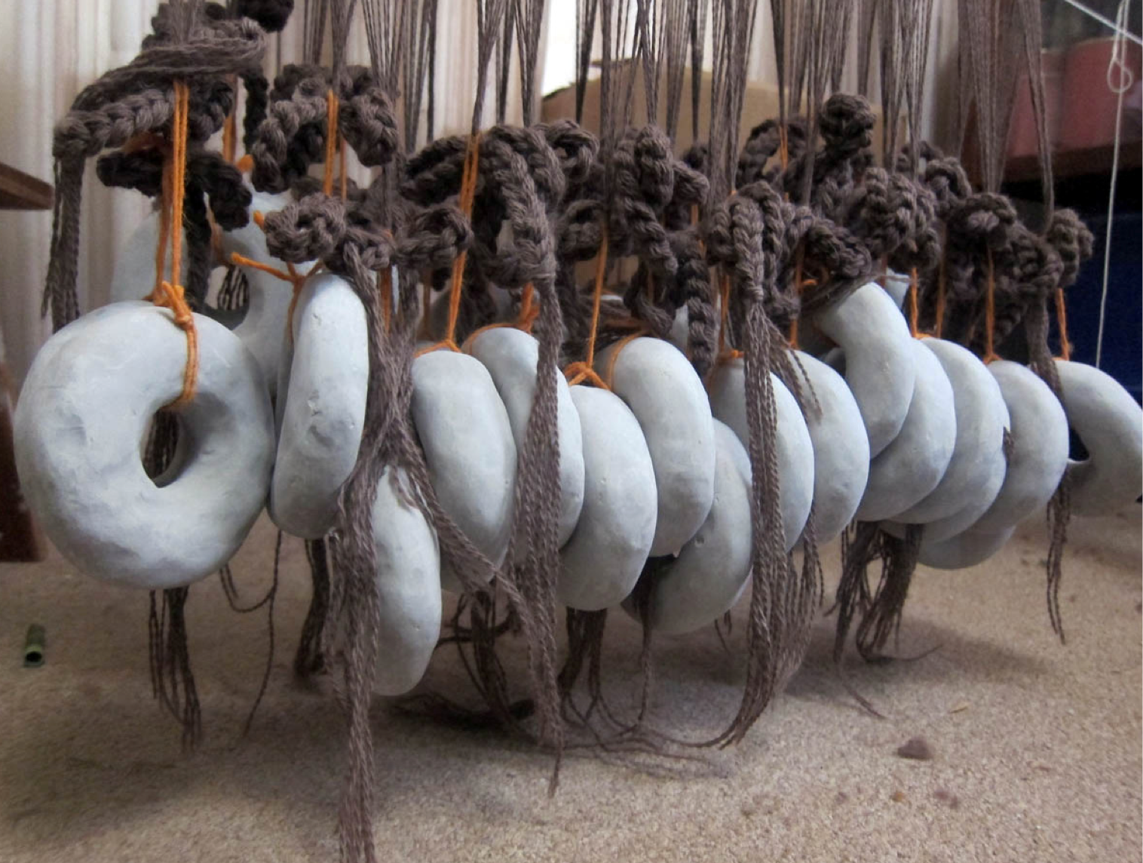

Introduction

In the ancient world there were three main types of looms: a horizontal ground loom and two types of vertical looms1. The older type of loom is the horizontal ground loom, known from paintings and tomb scenes in ancient Egypt. The first type of vertical loom, often called a tapestry loom, is one where the fabric is stretched between two fixed beams, an upper beam and a lower beam, and the weave is beaten down. The second type is the so- called warp-weighted loom, where the fabric hangs from a single beam at the top of the loom and the tension in the warp results from free-hanging loom weights that are tied to the bottom of the warp. The weaving starts at the top beam and continues downwards and consequently the weave is beaten up.

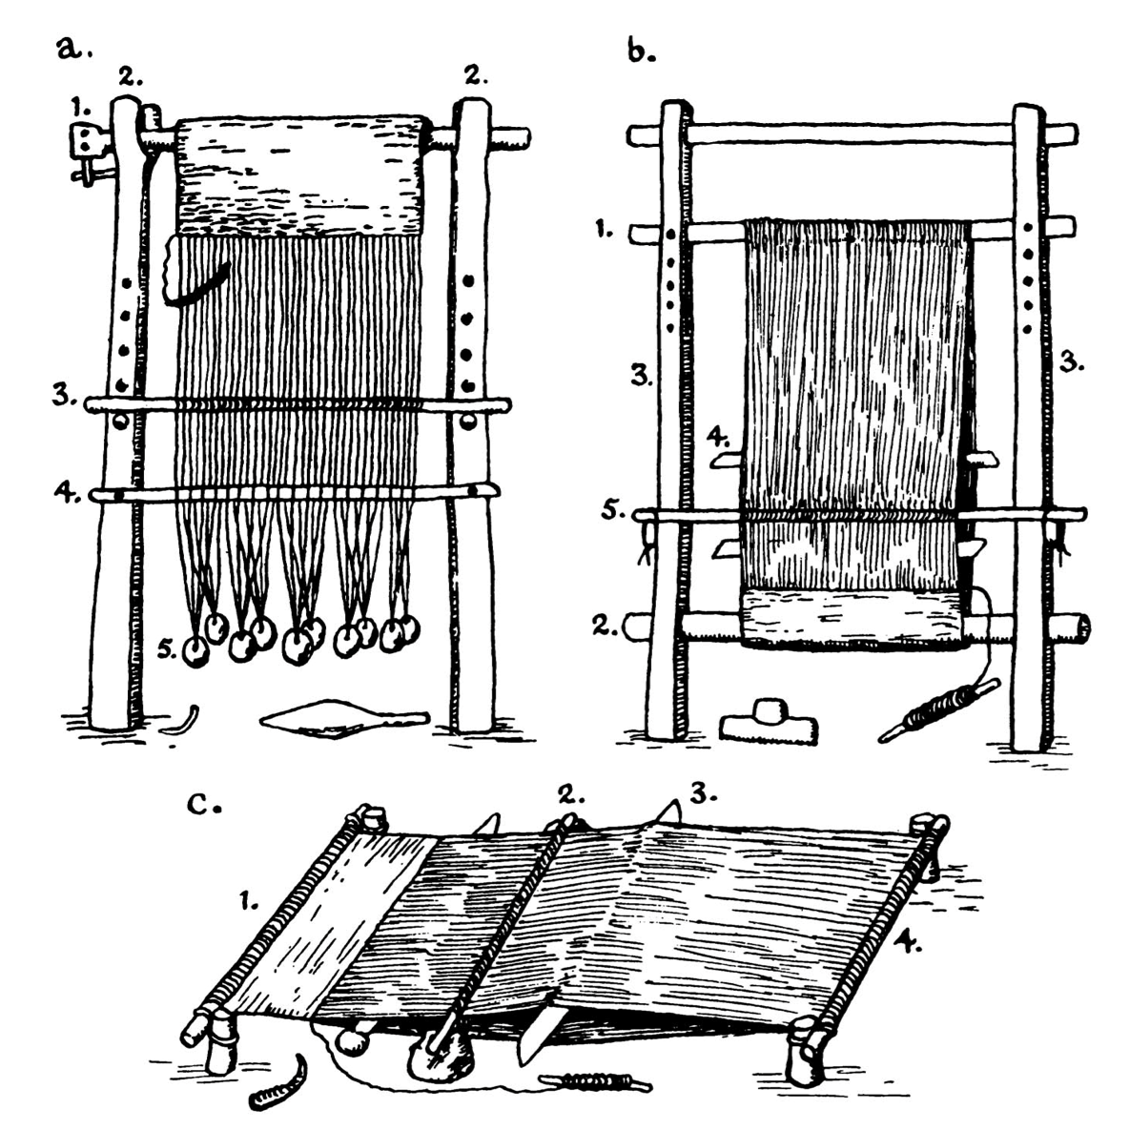
Figure 1: Diagrams of ancient loom types.[2]

With the exception of the loom weights, these types of looms are made completely of perishable materials so it is hard to find any archaeological remains. In fact, as of yet, no remains are found of actual warp-weighted looms from prehistoric times aside from rare evidence of a few incomplete portions of beams, uprights and shed rods.3 This makes the loom weights of great value as indirect evidence from archaeological finds for the use and distribution of warp-weighted looms over the ages.

Figure 2 shows a schematic of the warp-weighted loom setup for plain or tabby weave.4 The top beam or cloth beam (B) rests on nocks attached to two uprights (A). The heddle rod (C) rests on the heddle bar holders (D). The shed rod (E) divides the warp into two equal parts: i) the threads along the front of the shed bar that hang down directly from the cloth beam, and ii) the threads along the back of the shed bar that pass through the heddles, which are tied to the heddle rod. When the heddle rod rests against the uprights on top of the heddle bar holders, the space between the back threads and the front threads creates a shed usually called the natural shed. When the heddle bar rest on the nocks at the ends of the heddle bar holders, the back threads are pulled forward through the front threads to create a space that is often called the counter shed. Finally, loom weights (F) are attached to small bundles of warp threads to provide tension in the warp threads. The warp weighted loom rests against the wall at a sufficiently large angle to create a good shed.

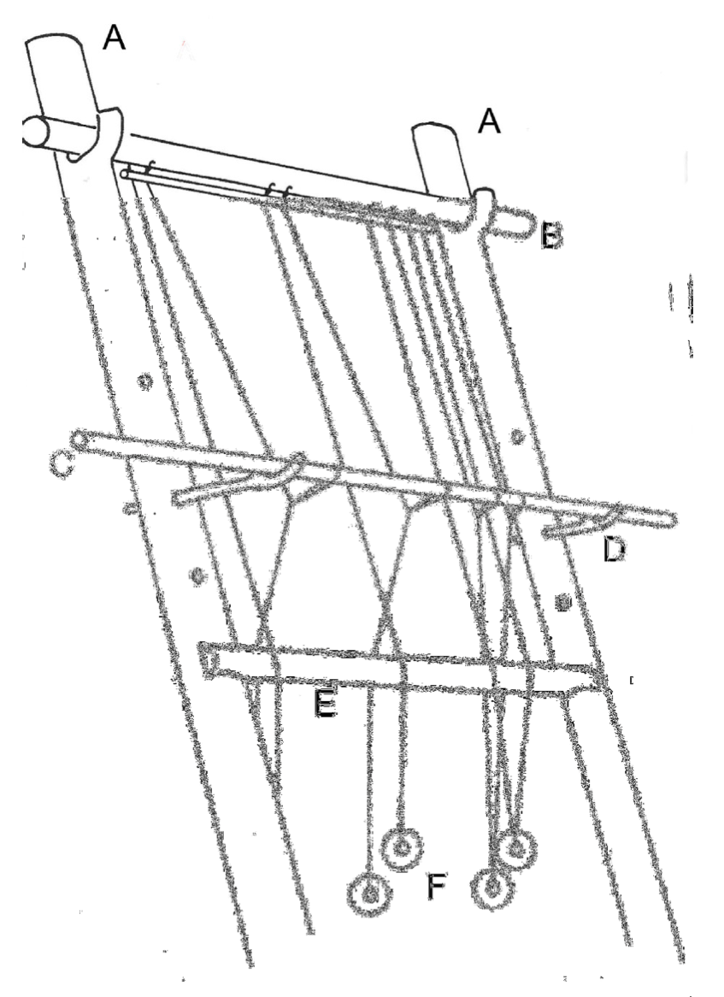
Figure 2: Schematic of a warp-weighted loom.[4]

Loom weights: their (his)story

The unmistakable evidence for the historic use of warp-weighted looms is the ample archaeological evidence of the loom weights that gave the loom its name. The following is a brief summary of Marta Hoffman’s extensive list of historical evidence.5 Among the oldest evidence of loom weights are finds in Asia Minor, the peninsula covering most of present day Turkey. Carl W. Blegen found a great number of clay loom weights at Troy in a level that was dated to 3000-2700 BC. Other finds from a similar time frame were from Anatolia and Megiddo in present day Israel. Kathleen M. Kenyon describes round stone rings that could be loom weights that were found during excavations in Jericho in a level that dates back to around 7000 BC. Some objects of a similar age, found in Ur in Mesopotamia, are also in all likelihood loom weights. As early as the Neolithic and Bronze Age, loom weights are found at many places in Europe all the way to Crimea, Asia Minor and the Mediterranean. There are as of date no loom weights found in Western or Northern Europe dating back to the Neolithic, but that may just be pure chance. Loom weights are found on the British Isles and in Denmark from the Bronze Age onward. From the earliest Iron Age they are found more or less all over Europe, including Shetland. In Scandinavia, loom weights begin to appear in archaeological finds around 200 AD. They are also found in Iceland and Greenland tracing back to their earliest colonization. Other evidence for the warp-weighted loom from the 6th or late 7th millennium BC, not mentioned by Marta Hoffman, was found in Hungary and in Swiss lake dwelling finds dated to the 4th millennium BC.[6]

Loom weights are found in a wide variety of shapes and weights and from very different materials depending on local preference and the availability of natural resources. They range from clay or terracotta in Greece to basalt on the Faroe Islands to granite on Greenland to fired or unfired clay on the British Isles to soap stone in Norway. In fact, soap stone was so commonly used in Norway that its name Kljåstein derives from the Old Norse name for loom weight.7 The distribution of the different shapes and weights has been the topic of several research studies, but the data is invariably incomplete. One problem is that they are known to have been made from river rocks, unfired clay or maybe even bags of sand.7 So it is likely that many are overlooked or unidentified. Another problem with loom weights is that they are not among the objects of great interest to archaeologists; far too many have been found and their form changed little over time so it is of little use in dating finds.8 The many finds do however tell a story of the wide spread use of the warp-weighted loom over a long period of time.

Most loom weights have one or more holes near the top or the center. Notable exceptions are those from basalt and granite that are too hard to drill holes through and a string was used to tie the weight to the warp threads. The weight generally varied from about 150 g in early Greek finds to 1 kg or more for natural rocks and stones, but most were between 500 and 700 g.9

The warp-weighted loom starts disappearing relatively rapidly around 1000 AD in most of Europe. In Anglo-Saxon and Viking era England, warp weights start disappearing from the archaeological record around the year 900 AD. It is thought to have been replaced by the two beamed loom, their use spreading slowly from population centers to outlying villages and hamlets.10 At the start of the 11th century AD, the warp-weighted loom was replaced in most of Northern Europe by a new form of technology, the treadle loom, which probably arrived from the Orient by way of the Middle East.11,12 Several features made the treadle loom not only more efficient than the warp-weighted loom, but capable of producing more exact results.12 There are no finds of loom weights in Denmark following the Viking age, and none in Sweden with the exception of a few isolated finds of medieval loom weights.

However, there are some regions where the warp-weighted loom lasted to a much later date. It persisted in parts of Western Norway and the far Northern Atlantic region until at least around the 16th century AD, when the horizontal loom was already in use in most of Scandinavia. Archaeological finds in Greenland suggest that it was still in use until the early 15th century.13 In both the Faroe Islands and Iceland, the warp-weighted loom was in use until the early 19th century.13 Marta Hoffmann (1974) writes about living history traditions among two Sami communities in the Arctic region of Norway and Finland and one community in Western Norway near Bergen.

The British Isles

The loom weights found on the British Isles from the period between c. 450 and 1100 AD were mostly made from clay (both fired and unfired). The following is mostly derived from an extensive study of the warp-weighted loom in the Anglo-Saxon and Viking Age by Christina Petty.[14] Loom weights found at Flixborough, Lincolnshire, as well as those found at Mucking, Essex and at the Coppergate excavation near York were all made from local clay. The Flixborough site alone, with 40 uncovered structures, yielded over 750 complete loom weights and unnumbered fragments. They were easy to replace and as a result had low intrinsic or symbolic value. This may be the reason why, with rare exception, no loom weights were found in graves in Anglo-Saxon and Viking age Britain. The loom weight usually had an annular or donut shaped form and weighted mostly between 150 and 500 g. The 63 weights which were found in Flixborough had makers’ marks that could be identifiers of the workshop or creator, or perhaps were intended to indicate the mass of the weight. One hundred and forty unfired weights were found in nine irregular rows in Mucking, Essex, possibly being stored or drying for firing or use. A collection of weights in shorter, closer rows found at Upton, Northamptonshire had a wooden bar passed through them, likely a version of a drying rack. The Coppergate excavation yielded 33 examples of loom weights, 31 from Anglo-Saxon levels, all from brick clay in a bun shape between 320 and 550 g15.

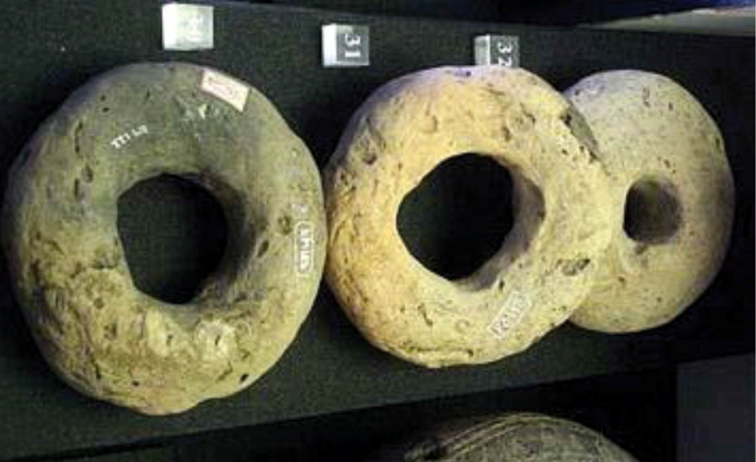
Figure 3: Three Anglo-Saxon era loom weights on display at the Higgans Art Gallery and Museum, Bedford, Befordshire.[16]

Many Anglo-Saxon archaeological sites have brought to light lines of weights in both single and double rows that indicate looms abandoned (very likely not deliberate) with weaving still in progress (Figure 4). A particular nice example is the find from the settlement site at Grimstone End, Pakenham, Suffolk. This 6th century Anglo-Saxon settlement was investigated by Basil Brown and others for the Ipswich Museum in 1953.17 Figure 4 shows a photograph with two 8 ft long rows of equal loom weights, 31 in each row. The rows lay about 20 cm apart at the Western end, but converged towards the East. They were annular shaped with a diameter of 11.5 cm, a hole of 4.5 cm and an average weight of about 500 g each. They were part fired above, but unfired beneath and had begun to decompose into the underlying soil. It is likely that they were originally unfired and used on a loom in working condition when the loom was destroyed by fire. The find is now part of a working exhibit displaying the actual rows of loom weights from the excavation together with a working reconstruction of a warp-weighted loom (Figure 5).

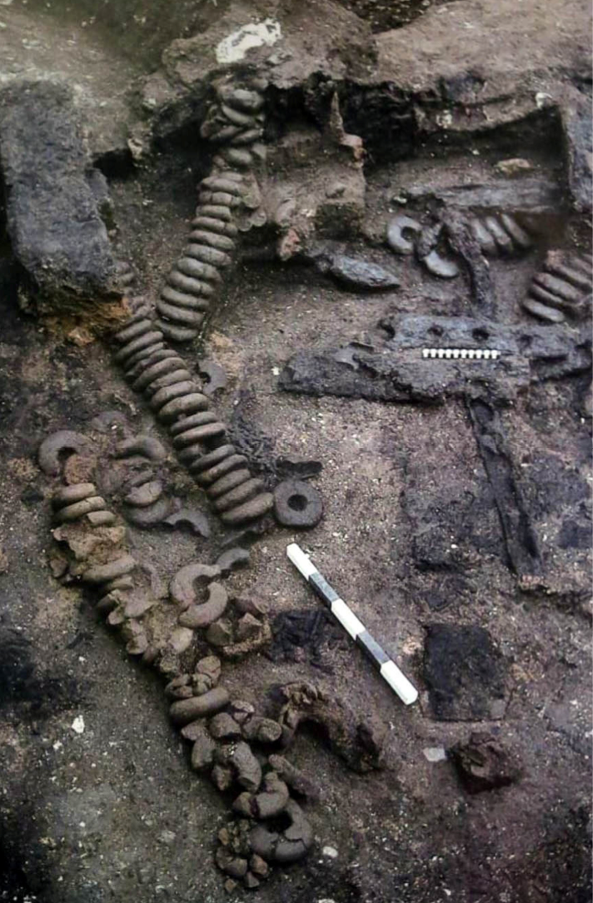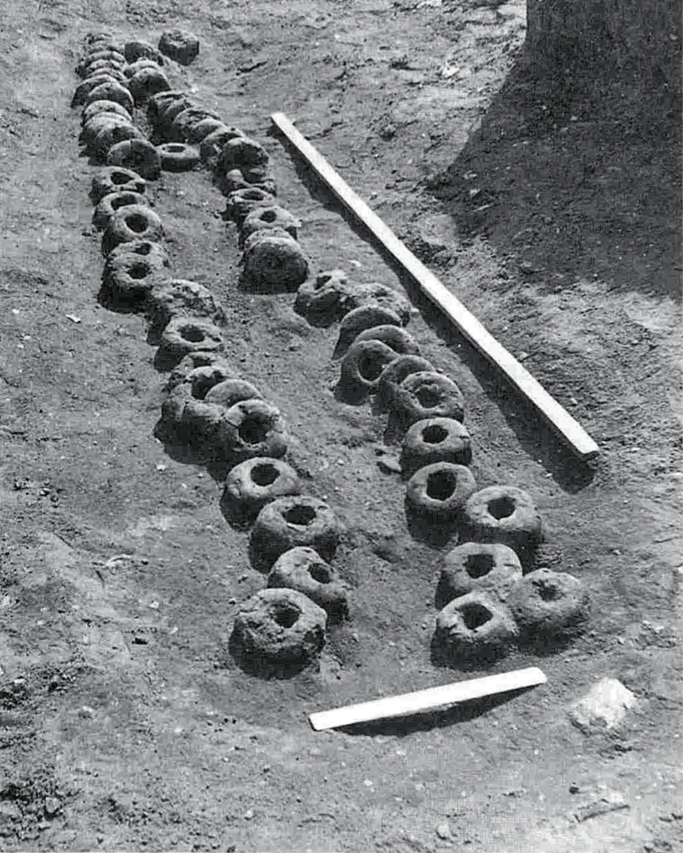
Figure 4: Photographs of several rows of loom weights from the 1975 Dover excavation[18] (left) and the 1953 Suffolk excavation[19] (right).

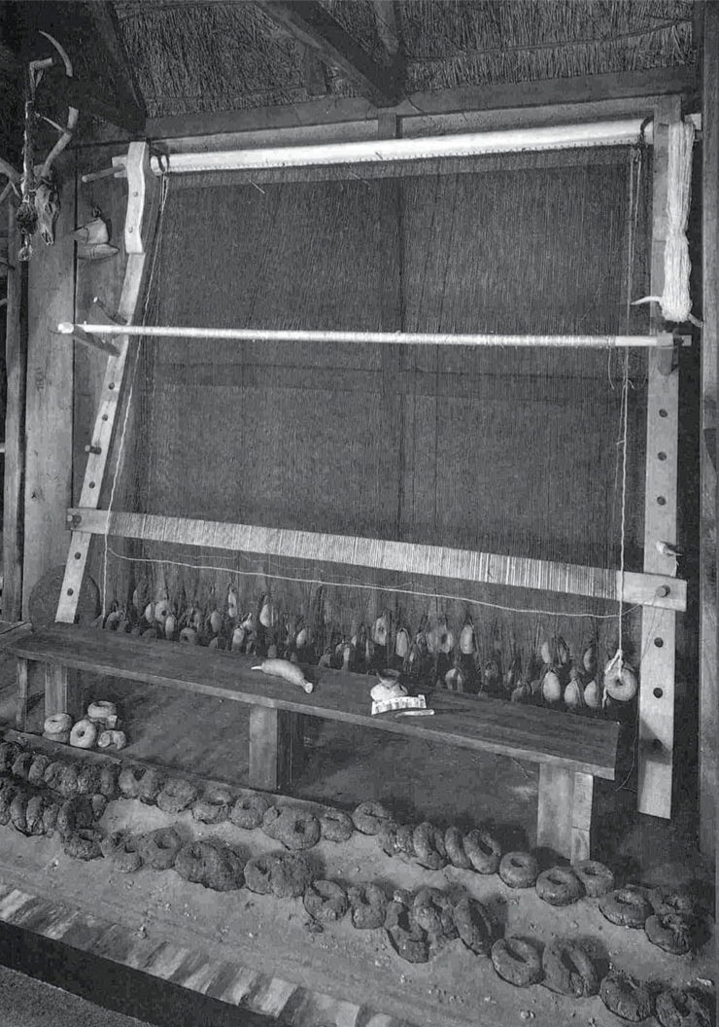
Figure 5: The loom reconstruction, together with the original Pakenham loom weights, as displayed in the Anglo-Saxon Gallery at the Ipswich Borough Museum.[20]

Western Norway

Loom weights are common finds in Viking Age graves. There were usually only a few loom weights in each grave, likely with a symbolic nature, but there are a few exceptions where what appears to be a complete set is present. Jan Peterson’s study of Viking Age tools in 1951 surveys 82 finds of loom weights of the late Iron Age (c. 550-1050 AD).21 They included finds from graves as well as other finds, totaling 449 loom weights in all. Most finds were from two counties in Western Norway, Hordaland and Sogn og Fjordane: 59 finds with a total of 371 loom weights. There were five graves with 20 to 48 weights, two of those (both from Aurland in Sogn) with 28 and 48 weights, respectively, which were in all likelihood complete working sets. The loom weights were of varying shape: rounded, gently sloping, squarish, oval or irregular. The size varied mostly between 8 to 13 cm in length and 5 to 8 cm in width.

A closer look at seven grave finds, three from Hordaland and four from Sogn og Fjordane, reveal seven collections of 10 to 48 loom weights.2121 The graves are all female burials, two from the 9th century and five from the 10th century. All loom weights are made from soap stone. The weights in the first set of three vary mostly between c. 400 and 600 g, 261 and 413 g, and 227 to 398 g, respectively. Those of the second set of four vary between 140 and 450 g, 159 and 414 g, 145 and 427 g, and 230 and 516 g, respectively. These finds illustrate that the loom weights that comprise a set are not necessarily of the same weight. However, the tension in the warp threads can obviously be regulated by varying the number of warp threads tied to each weight.

Decorated loom weights

Loom weights in the ancient Mediterranean world were often stamped, inscribed or decorated. Since loom weights are otherwise hard to date, these decorations can be a valuable tool to date a loom weight or to trace its provenance or its origin, owner or location. András Márton and coworkers (2008) give a detailed description of what one can learn from these decorations for two loom weights in the collection of Classical Antiquities of Museum of Fine Arts, Budapest.[22]

Figure 6 shows the first one, a truncated pyramidal loom weight found in Corinth, Greece. It was made from hard clay, weighted 105 g and measured 68 mm in height, 38x38 mm at the base and 20x19 mm at the top. On the top and on one side are two oval stamps. The stamps represent a female figure, probably Thetis riding a hippocampus. This was a common motif for finger-rings from the Classical period onwards. Further study of the impression date the loom weight to the second half of the 5th to the first half of the 4th century BC.

Figure 7 shows the second one, a conical loom weight, provenance unknown. It was made from clay, brick red in color, weighted 178 g. and measured 97 mm in height with a 45 mm maximum base diameter. The weight appears mold-made and the top and bottom are rounded. The decoration is most likely a human representation derived from a head of Zeus or Apollo. Despite uncertainty of its provenance and the place of manufacture, it certainly dates to the Hellenistic period.

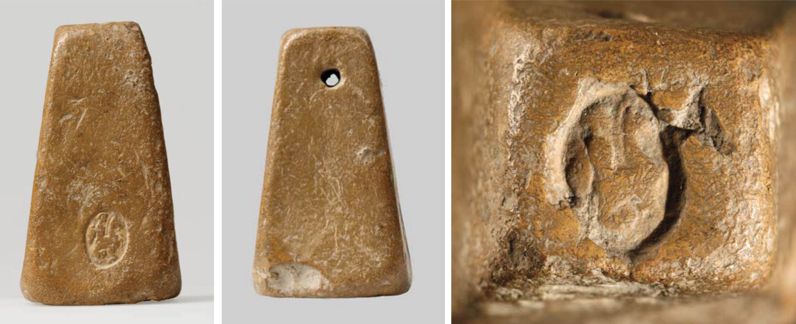
Figure 6: Front, side and top of the loom weight from Corinth.[23]

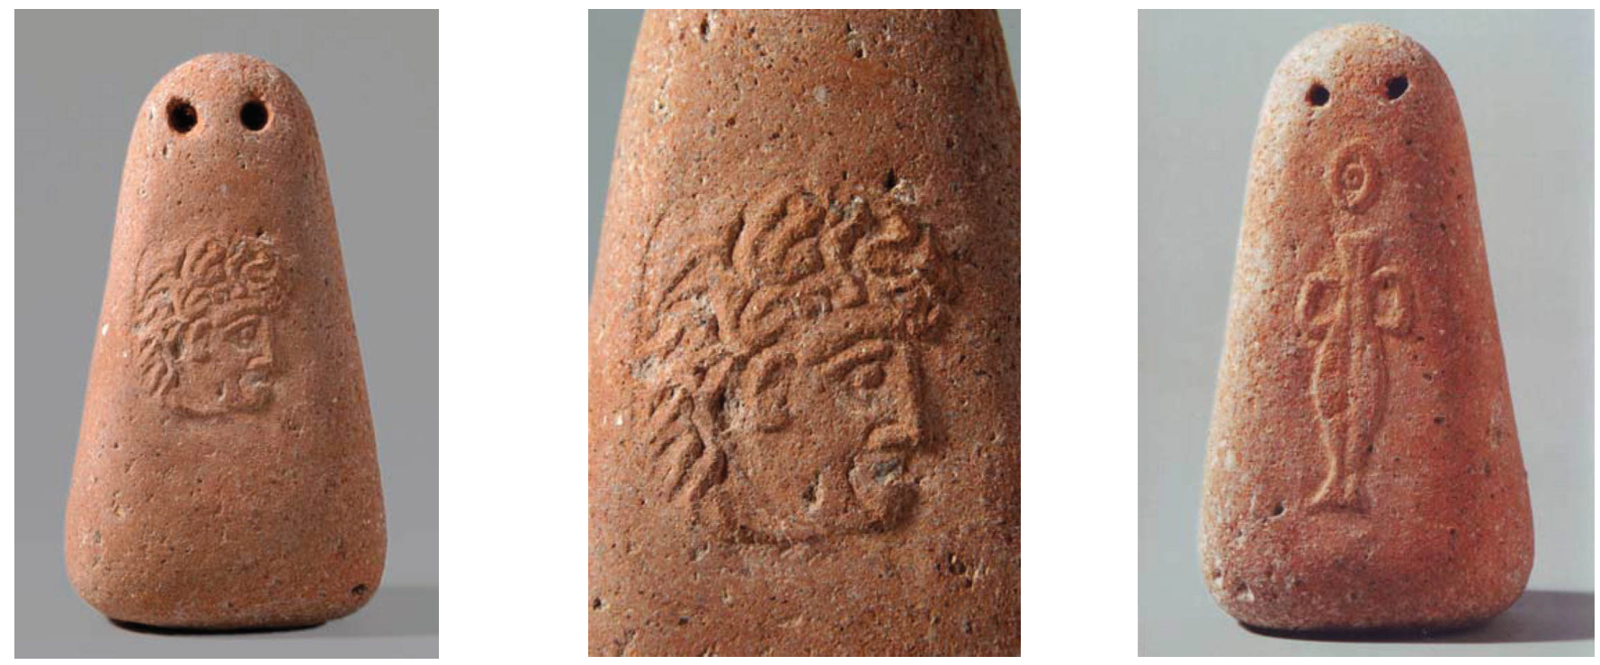
Figure 7: Front, side and top of the loom weight from the Museum of Fine Arts, Budapest (provenance unknown).[24]

Pictorial evidence

There is also a lot of pictorial evidence of the warp-weighted loom and its use. One of the nicest examples is the picture on a small Attic Lekythos, or oil flask, on display in the Metropolitan Museum of Art (Figure 8). The terracotta piece is 6.75 in height and dated to c. 550 to 530 BC. In the center, two women work at a warp-weighted loom. To the right, three women weigh wool. Farther to the right, four women spin wool into yarn, while between them finished cloth is being folded. The weights on the Lekythos loom are beautifully shown, each with its bunch of warps tied into a ring. A similar loom weight with the ring still in position is held by the British Museum. The shape of the weights, a truncated pyramid, is familiar to finds from Hellenistic sites. Out of 793 loom weights found at Olynthus, 208 in terracotta were of this shape.

Another nice example is from a Boetian urn held by the Ashmolean Museum in Oxford, England that clearly shows two heddle bars and two rows of loom weights (Figure 9).


Figure 8: An Attic Lekythos or oil flask, the Metropolitan Museum of Art, New York City.

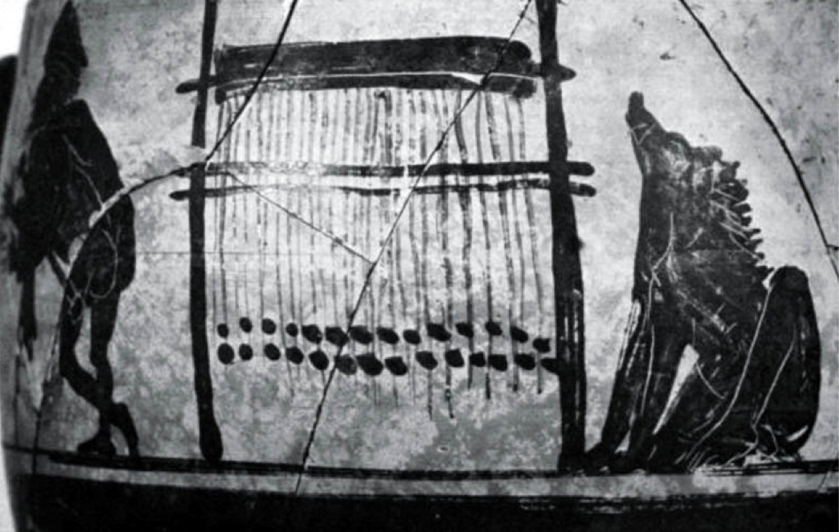
Figure 9: Boetian urn held by the Ashmolean Museum in Oxford, England.

Loom weights: their use

Warp tension

The primary function of loom weights is to provide tension in the warp threads. However, there are many aspects that affect the amount of tension that is needed or desired by each individual weaver. First, there is the type of yarn that is used for the warp. Wool has slightly elastic properties whereas silk and linen do not, altering the tension requirements of the thread from each type of fiber. Second, there are parameters that are related to how the yarn is spun, the thickness of the warp threads, the amount of twist and whether the yarn is plied. A thicker thread will hold more weight before breaking than an otherwise similar thinner thread. The more twist a yarn has the stronger it is, but too much twist will cause the yarn to knot and kink. Adding more tension can help, but add too much tension and you risk breaking warp threads too easily during weaving. Furthermore, hand spinning can result in variations in thickness and twist and the thread is only as strong as its weakest point. Third, there are external conditions that affect weaving, like the local humidity during weaving or whether the weaver sizes the warp threads. Weaving in a humid environment straightens the thread slightly and affects the smoothness of the yarn. It also makes linen more pliable, reducing the risk of warp thread breakage. Finally, there are external factors that can affect the quality of fiber, for example the growth conditions of the flax for linen, or health issues of the sheep that affect the quality of the wool.

All these aspects make it very difficult to come up with generic rules about the right amount of tension. In general the weaver likely will need to do some experimenting when starting a new project. Too low a tension will make it difficult to change the shed, but too high a tension can result in frequent warp thread breakage.

In general thinner threads need less tension than thicker threads. In a series of papers published by the Centre for Textile Research (CTR) of the University of Copenhagen, Denmark, Linda Mårtensson and coworkers established some rough guidelines for the optimal tension for wool based on the weight of the spindle whorl:[25]

• Spinning with a 4 g spindle whorl yields a very thin thread smaller than about 0.3 mm. This thread requires c. 10 g warp tension per thread.

• Spinning with an 8 g spindle whorl yields a thin thread of 0.3–0.4 mm. This thread requires c. 15–20 g warp tension per thread.

• Spinning with an 18 g spindle whorl yields a thread of 0.4–0.6 mm. This thread requires c. 25–30 g warp tension per thread.

• Spinning with a 44 g spindle whorl yields a thick thread of 0.8–1.0 mm. This thread requires c. 40 g warp tension per thread.

They also found that linen yarn spun with the same 8 g whorl requires a similar weight per thread as the yarn made of wool, about 19 g/thread.

I have so far finished one full sized weaving project with store bought 8/2 wool. My initial tension was c. 16 g/thread and that gave a very difficult shed. I doubled the tension to c. 32 g/thread and that wove well. I just started a new project with 12/1 linen for the warp threads. I set the loom up with a tension of c. 16 g/thread, but it is too early in the project to tell if that is suitable.

Choosing the loom weights

The right tension is critical in weaving, but knowing the optimal tension for a given warp thread is only part of the equation. The tension in the warp threads can be varied both by the weight of the loom weight and by the number of warp threads per loom weight. The latter also offers a means to obtain a constant thread tension when the individual weights vary (for example when rocks or stones are used). The fact that it is not the weight of the loom weights but the tension in the warp threads that matters is very clear by looking at the water worn stones from the Faroe Islands loom in the Copenhagen Museum in Denmark. Fine linen was woven on this loom, even thought the stones are among the heaviest loom weights ever recorded, between three and four kilograms each! The only systematic study that I know of that looked at how the shape of loom weights can affect the weaving was performed by researchers of the Tools and Textiles – Texts and Contexts (TTTC) research program sponsored by The Danish National Research Foundation’s Centre for Textile Research (CTR) at the University of Copenhagen, Denmark.[26,27,28] Their findings relating spindle whorl weight to optimal warp thread tension are already mentioned above. They also performed weaving experiments aimed at getting a better understanding of the influence of a loom weight’s thickness on the weave.[26,28] Their loom weights were specifically designed to test only this parameter. They all had an identical weight of approximately 275g, but the loom weights in one set had a thickness of 4 cm, while those in the other set had one of only 2 cm. A header band that is significantly wider than the combined width of the loom weights causes the warp threads to angle inwards. This makes it harder to maintain a constant woven fabric width and the fact that the heddles are closer together negatively affects the quality of the shed. The opposite is true for a header band that is much smaller than the combined width of the loom weights. Changing the shed becomes much easier, but it is still hard to maintain a constant fabric width.

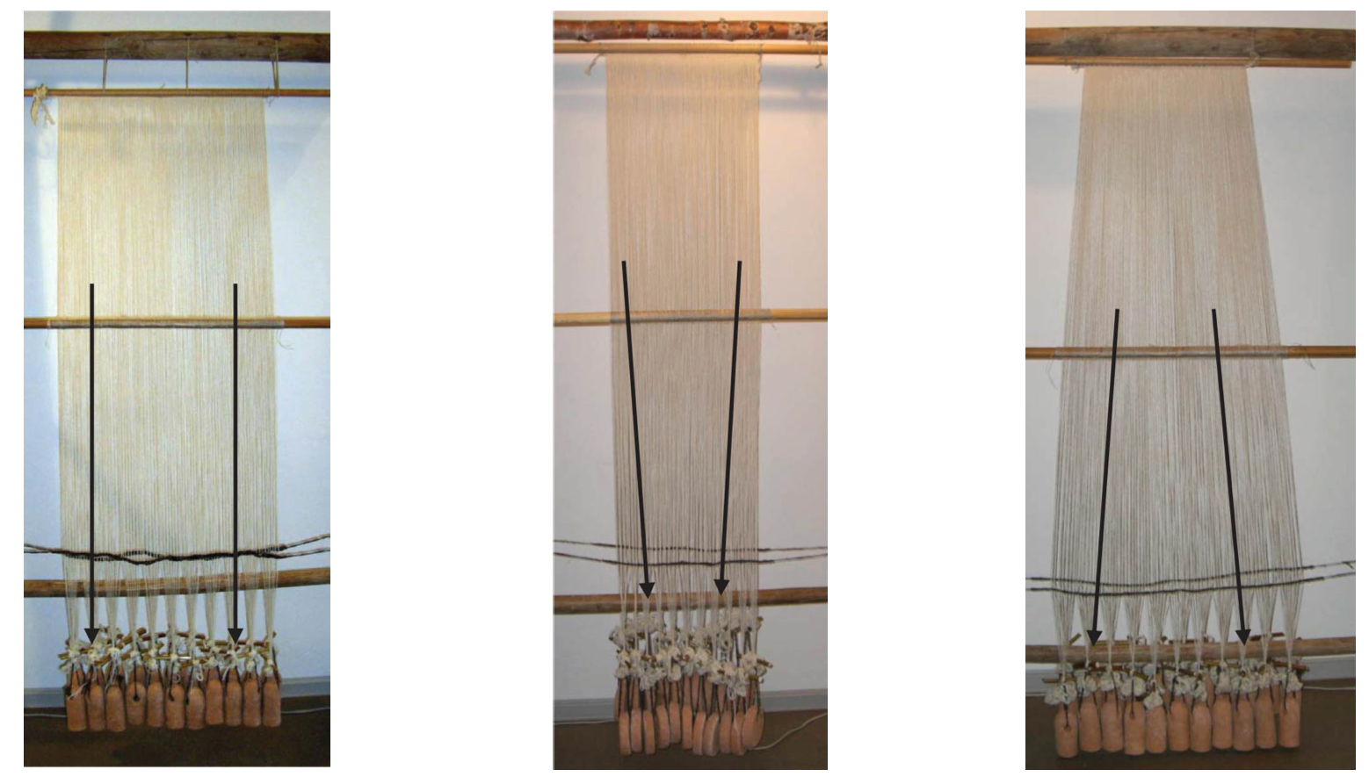
Figure 10: Experiments with different ratios of the header band width to the combined loom weight width, performed by TTTC researchers.[26,28]

Their conclusion was that for optimal weaving, the ideal width of the combined loom weights is slightly larger than the width of the header band.

Richard Firth (2015) gives a set of expressions for the correlations between the tension in the threads, the desired number of warp thread per unit length, the desired width of the cloth and the required number of loom weights.[29] He continues to give a general discussion of the physical properties of the loom weights (size, shape and weight) in the Centre for Textile Research (CTR) database (representing thousands of loom weights) and what those considerations imply for loom setup and the tension in the warp threads.

The experience of modern weavers indicates that the practical limits of number of warp threads per loom weight are between c. 10 and 30.29 Fewer threads per weight necessitate the availability of a large number of loom weights. More threads per weight make it very difficult to maintain a uniform tension. I have found this to be especially true for linen, where its lack of elasticity makes it critical to get very uniform warp thread lengths. Having too many warp threads per loom weight invariably leads to a few very loose ones. These practical limits imply that for a given tension per thread a fabric with a high warp thread count will need narrow weights and one with the low warp thread count will need thicker weights.

I made my loom weights from unfired clay. They are doughnut shaped and about 330 g each with minimal weight variation. Their diameter is c. 10 cm, their thickness c. 3 cm and the hole is c. 3 cm. As mentioned above, my first full sized project was weaving diamond twill with store bought 8/2 wool. The width of the header band was 43 cm and the total number of warp threads was 360, giving a warp count of slightly over 8 per cm. I started out with 20 threads per loom weight. This required 18 loom weights, 9 for the front and 9 for the back, resulting in a combined width of the loom weights of 27 cm and a tension of 16.5 g/thread. Fairly soon after starting weaving, I concluded that the tension was too low resulting in a mediocre shed. I also had trouble maintaining a constant fabric width; it quickly contracted to c. 40 cm after weaving just a few inches. This coincides with the TTTC findings and it would have been nice if I had known about that study at that time. So I doubled the number of loom weights and that solved both problems. The higher tension resulted in a good shed and the added width of the row of loom weights made it much easier to maintain a constant fabric width.

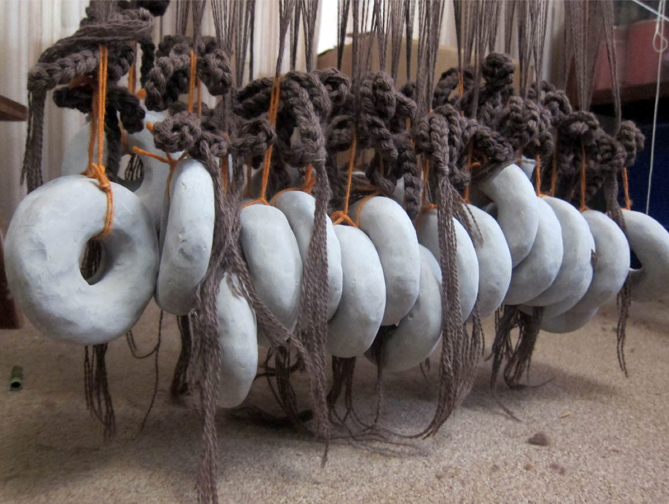
Figure 11: My own set of loom weights: unfired clay dougnuts, about 330 g each.

Organization of the loom weights

Many Anglo-Saxon archaeological sites (like the ones in the Dover and Suffolk excavations discussed above) have brought to light lines of weights in double rows that could be the remains of looms abandoned while weaving was still in progress. Double lines of weights take advantage of the natural shed provided by the loom which is very useful for tabby, or other balanced weaves. Christina Petty (2014) speculates that the single rows of weights could indicate looms that were setup for more complicated weave patterns such as diamond twill, a preferred Anglo-Saxon weave pattern often found by archaeologists, stating that they are more easily woven with a single line of weights.30 However, I do not think I agree with that. Others have suggested the need for four rows of loom weights to weave twill.31,32 Splitting the loom weights in four sets, one for each shed, results in a more uniform tension during weaving. A disadvantage of organizing loom weights in four rows is that of interactions between the weights on the threads of the one and three sheds. I did indeed find that on the one hand it is very beneficial to split the warp threads for the front and the back in two functional groups corresponding to the four sheds that are required to weave twill. It improves the tension in the threads in the different sheds and greatly improves the sheds. However, once the threads are organized with a spacing cord, the two sets of weights in each row can easily be aligned in a single line. So my own, granted limited, experience shows that it is very natural to weave diamond twill with two rows of loom weights in agreement with archaeological evidence.

An intriguing aspect in the context of the organization of loom weights for weaving twill is the use of crescent shaped loom weights, which appear in excavations in central and southern Europe dating from the Neolithic period onwards.[33] Agnete Wisti Lassen (2015) discusses her experiments on the use of crescent loom weights for weaving both tabby and twill. In the latter, the crescent weights avoid the main disadvantage of the four groups of weights suggested by A. E. Haynes,[31] while maintaining the advantage of uniform tension during weaving. Having only one row of weights in the front of the shed rod and one behind avoids the unfavorable interaction when changing to the one and three shed, while tying the four functional thread groups for weaving twill in pairs to either end of the crescent weights maintains constant tension on all threads during weaving (Figure 12, middle). I already made a set of crescent loom weights from unfired clay to find out myself how weaving with these weights compares to that in my current setup (Figure 12, right), both in the weaving efficiency (speed) and in the resulting quality of the weave. I hope to start the experiments soon and report on that at a later date.

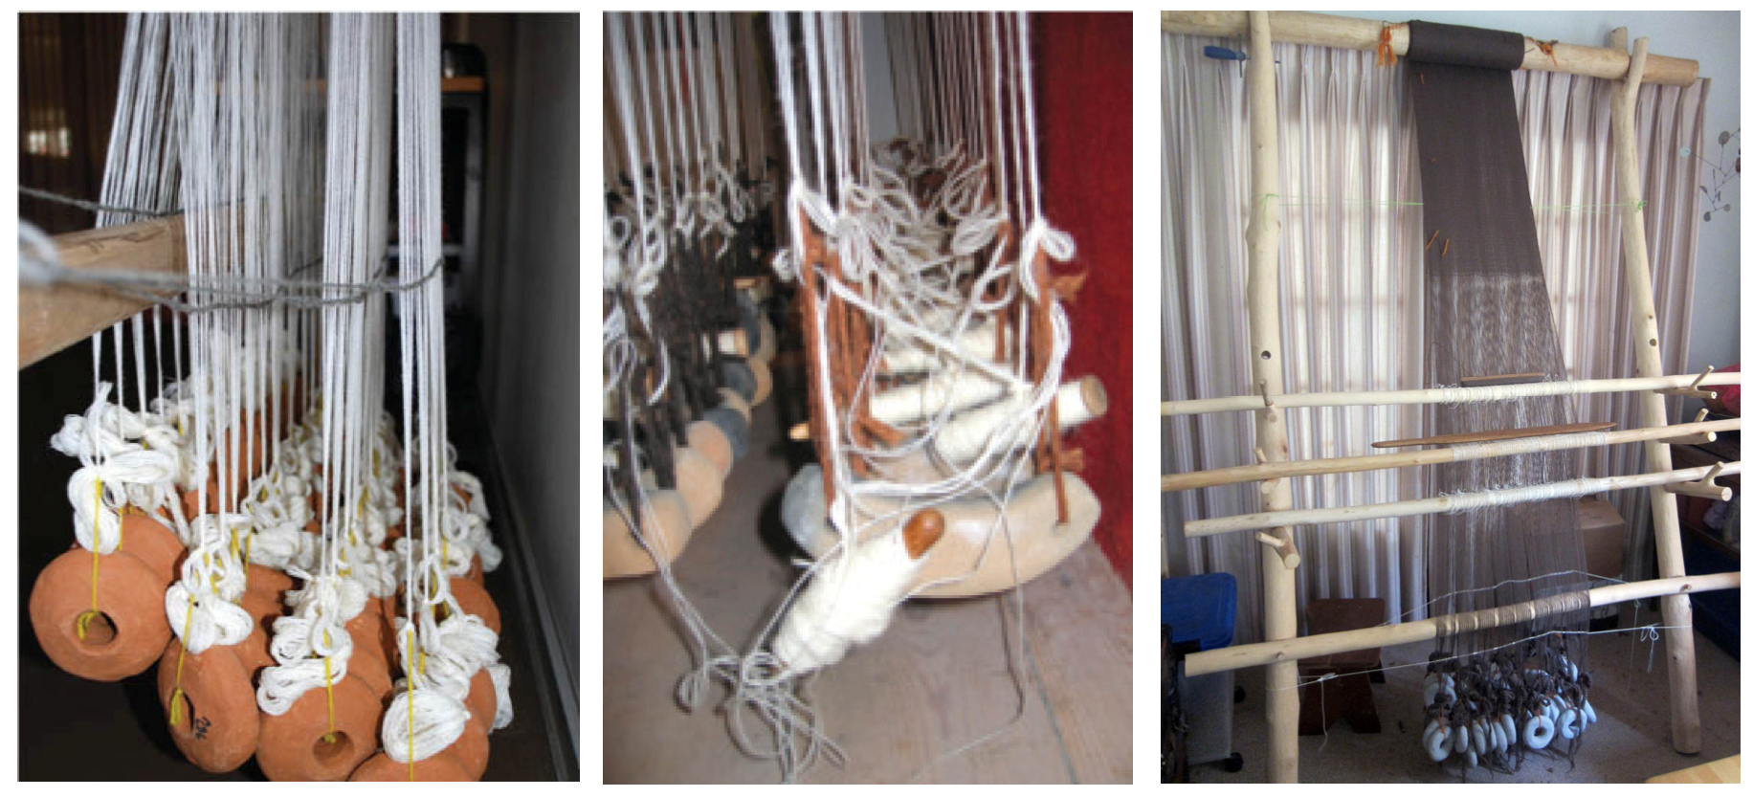
Figure 12: Several setups for weaving twill: with four rows of weights34 (left), with two rows of cresent weights[35] (middle) and with two rows of weights but four functional warp thread groups (right, my own setup).

Footnotes

1 Grace M. Crowfoot (1936/37) Of the Warp-Weighted Loom.

2 Ibid. page 37.

3 Christina Petty (2014) Warp Weighted Looms: Then and Now Anglo-Saxon and Viking Archaeological Evidence and Modern Practitioners, page 21.

4 Thor Ewing (2012) Viking Clothing, page 138.

5 Marta Hoffman (1974) The Warp-Weighted Loom: Studies in History and Technology of an Ancient Implement, pages 17-22.

6 Katherine L. Larson (2011) Norwegian Double-Weave and the Warp-Weighted Loom: The Northern Gudbrandsdal Tradition, pages 5-6.

7 Christina Petty (2014) Warp Weighted Looms: Then and Now Anglo-Saxon and Viking Archaeological Evidence and Modern Practitioners, page 39.

8 Marta Hoffman (1974) The Warp-Weighted Loom: Studies in History and Technology of an Ancient Implement, page 17

9 Ibid. page 20.

10 Christina Petty (2014) Warp Weighted Looms: Then and Now Anglo-Saxon and Viking Archaeological Evidence and Modern Practitioners, page 53.

11 Lise Bender Jørgensen (1992) North European Textiles until AD 1000

12 Katherine L. Larson (2011) Norwegian Double-Weave and the Warp-Weighted Loom: The Northern Gudbrandsdal Tradition, page 6.

13 Katherine L. Larson (2011) Norwegian Double-Weave and the Warp-Weighted Loom: The Northern Gudbrandsdal Tradition, page 8.

14 Christina Petty (2014) Warp Weighted Looms: Then and Now Anglo-Saxon and Viking Archaeological Evidence and Modern Practitioners, pages 38-54

15 Penelope Walton Rogers (1997) Textile Production at 16-22 Coppergate, page 1753.

16 Christina Petty (2014) Warp Weighted Looms: Then and Now Anglo-Saxon and Viking Archaeological Evidence and Modern Practitioners, Figure 17, page 43.

17 Steven J. Plunkett (1999) The Anglo-Saxon Loom from Pakenham, Suffolk.

18 Brian Philp (2003) The Discovery and Excavation of Anglo-Saxon Dover, Plate III.

19 Steven J. Plunkett (1999) The Anglo-Saxon Loom from Pakenham, Suffolk, Figure 70, page 280.

20 Ibid. Figure 69, page 278.

21 Hildur Hákonardóttir et al. (2016) The Warp-Weighted Loom, pages 222-225

22 András Márton et al. (2008) Decorated loomweights in the collection of Classical antiquities of Museum of Fine Arts, Budapest, Hungary.

23 András Márton et al. (2008) Decorated loomweights in the collection of Classical antiquities of Museum of Fine Arts, Budapest, Hungary, Figures 1-3, pages 7-8.

24 András Márton et al. (2008) Decorated loomweights in the collection of Classical antiquities of Museum of Fine Arts, Budapest, Hungary, Figures 4-6, page 9.

25 Linda Martensson et al. (2009) Shape of Things: Understanding a Loom Weight, page 378

26 Linda Mårtensson et al. (2007a) Technical Report, Experimental Archaeology, Part 3 Loom weights.
27 Linda Mårtensson et al. (2007b) Technical Report, Experimental Archaeology, Part 4 Spools.

28 Linda Martensson et al. (2009) Shape of Things: Understanding a Loom Weight.

29 Richard Firth (2015) Mathematical analysis of the spindle whorl and loom weight data in the CTR.

30 Christina Petty (2014) Warp Weighted Looms: Then and Now Anglo-Saxon and Viking Archaeological Evidence and Modern Practitioners, page 48.

31 A. E. Haynes (1975) Twill Weaving on the Warp Weighted Loom: Some Technical Considerations.

32 Eva Andersson Strand (2009) Tools and Textiles – Production and Organisation in Birka and Hedeby.

33 Agnete Wisti Lassen (2015) Weaving with crescent shaped loom weights. An investigation of a special kind of loom weight.

34 Eva Andersson Strand (2009) Tools and Textiles – Production and Organisation in Birka and Hedeby, Figure 6, page 8.

35 Agnete Wisti Lassen (2015) Weaving with crescent shaped loom weights. An investigation of a special kind of loom weight, Figure 4.4.6. page 130.

Bibliography

Andersson Strand, Eva (2009) Tools and Textiles – Production and Organisation in Birka and Hedeby, Proceedings of the Sixteenth Viking Congress, Reykjavík and Reykholt.

Bender Jørgensen, Lise (1992) North European Textiles until AD 1000, Aarhus University Press, Denmark.

Crowfoot, Grace M. (1936/37) Of the Warp-Weighted Loom, The Annual of the British School at Athens, Vol. 37, pp. 36-47.

Ewing, Thor (2012) Viking Clothing, The History Press, Gloucestershire, UK.

Richard Firth (2015) Mathematical analysis of the spindle whorl and loom weight data in the CTR, Eva Andersson Strand and Marie-Louise Nosch (Editors), In: Investigating Textile Production in the Aegean and Eastern Mediterranean Bronze Age, Tools Textiles and Contexts, Ancient Textiles Series, Vol. 21, Oxbow Books, Oxford, UK.

Hákonardóttir, Hildur, Johnston, Elizabeth, and Juuhl, Marta Kløve (2016) The Warp- Weighted Loom, Andersen, Randi, and Martinussen, Atle Ove (Editors).

A. E. Haynes (1975) Twill Weaving on the Warp Weighted Loom: Some Technical Considerations, Textile History 6(1) pp. 156-164.

Hoffman, Marta (1974) The Warp-Weighted Loom: Studies in History and Technology of an Ancient Implement, Robin and Russ Handweavers.

Katherine L. Larson (2011) Norwegian Double-Weave and the Warp-Weighted Loom: The Northern Gudbrandsdal Tradition, Ph.D. thesis, University of Washington, Ann Arbor, MI.

Lassen, Agnete Wisti (2015) Weaving with crescent shaped loom weights. An investigation of a special kind of loom weight, Andersson Strand, Eva, and Nosch, Marie-Louise (Editors), In: Investigating Textile Production in the Aegean and Eastern Mediterranean Bronze Age, Tools Textiles and Contexts, Ancient Textiles Series, Vol. 21, Oxbow Books, Oxford, UK.

Mårtensson, Linda, Andersson, Eva, Nosch, Marie-Louise, and Batzer, Anne (2007a) Technical Report. Experimental Archaeology, Part 3 Loom weights, Tools and Textiles – Texts and Contexts, The Danish National Research Foundation’s Centre for Textile Research (CTR), University of Copenhagen.

Mårtensson, Linda, Andersson, Eva, Nosch, Marie-Louise, and Batzer, Anne (2007b) Technical Report. Experimental Archaeology, Part 4 Spools, Tools and Textiles – Texts and Contexts, The Danish National Research Foundation’s Centre for Textile Research (CTR), University of Copenhagen.

Mårtensson, Linda, Nosch, Marie-Louise, and Andersson Strand, Eva (2009) Shape of Things: Understanding a Loom Weight, Oxford Journal of Archaeology 28(4) pp. 373-398.

Márton, András, Megaw, Ruth, and Megaw, J. Vincent (2008) Decorated loomweights in the collection of Classical antiquities of Museum of Fine Arts, Budapest, Hungary, Archaeological Textiles Newsletter, Vol. 47, pp. 7-11.

Petty, Christina (2014) Warp Weighted Looms: Then and Now Anglo-Saxon and Viking Archaeological Evidence and Modern Practitioners, Ph.D. thesis, University of Manchester, Manchester, UK.

Philp, Brian (2003) The Discovery and Excavation of Anglo-Saxon Dover, Kent Archaeological Rescue Unit, Dover, UK.

Plunkett, Steven J. (1999) The Anglo-Saxon Loom from Pakenham, Suffolk, Proceedings of the Suffolk Institute of Archaeology and History, Volume XXXIX Part 3.

Walton Rogers, Penelope (1997) Textile Production at 16-22 Coppergate, The Archaeology of York, Vol. 17.

------
Copyright 2018 by Rolf Verberg. <hrolfr.a.fjarfelli at gmail.com>. Permission is granted for republication in SCA-related publications, provided the author is credited. Addresses change, but a reasonable attempt should be made to ensure that the author is notified of the publication and if possible receives a copy.

If this article is reprinted in a publication, please place a notice in the publication that you found this article in the Florilegium. I would also appreciate an email to myself, so that I can track which articles are being reprinted. Thanks. -Stefan.

<the end>

