Klosterstich-art - 4/17/18

"Klosterstich - Bilderstich, Brokatstich, Sparstich, Convent Stitch,
Klosterstitch, Nun's work, self-couching technique" by Racaire.

NOTE: See also the files: Couching-art, embroidery-msg, emb-blackwork-msg, P-Emb-Frames-art, emb-linen-msg, p-x-stitch-art, Blackwork-Emb-art, 8-P-Stitches-art.

************************************************************************
NOTICE -

This article was added to this set of files, called Stefan's Florilegium, with the permission of the author.

These files are available on the Internet at: http://www.florilegium.org

Copyright to the contents of this file remains with the author or translator.

While the author will likely give permission for this work to be reprinted in SCA type publications, please check with the author first or check for any permissions granted at the end of this file.

Thank you,
Mark S. Harris...AKA:..Stefan li Rous
stefan at florilegium.org
************************************************************************

You can find more work by this author on her website at:
http://www.racaire.at/

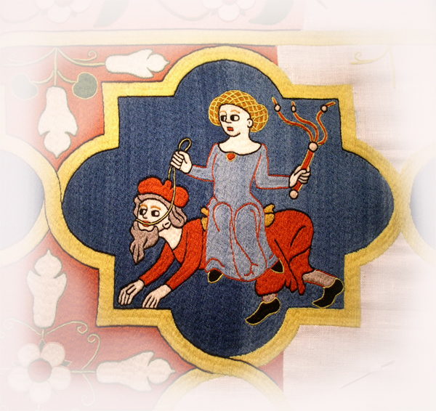

Handout "Klosterstich"
(Bilderstich, Brokatstich, Sparstich, Convent Stitch,
Klosterstitch, Nun's work, self-couching technique)

v. 1.0

by Racaire
Shire Ad Flumen Caerulum, Kingdom of Drachenwald

& many thanks to Tanja Kohwagner-Nikolai
for her kind permission to use the pictures in her book "per manus sororum…",
her kind help, for answering a lot of questions & her valuable hints

& also many thanks to
Mistress Anya Mstyslavyaya and Mistress Jaelle
for correcting my mistakes concerning the English language in this handout

Use of Klosterstich embroidery:

Form:
From the 13th until the 16th century this type of embroidery was mainly used for

> "Wandbehänge" (Wand=wall behänge=hangings)
> "Banklaken" (Bank=bench, laken=sheet)
> "Bordüren" (=borders)

Technique:
Concerning the forms of usage mentioned above the whole light-colored linen fabric background was covered with wool worked in Klosterstich technique.

Exceptions:
-> Swiss:
black woollen background & coloured wool: "Wandbehang v. Bischofszell" (East-Swiss ca. 1525, Historisches Museum, Basel)
…and also including Klosterstich parts worked in silk: Tobias-Stickereien "Tobias u. der Fisch" (end 16th/start 17thc., Textilmuseum St. Gallen)
-> supposedly South Germany:
black woollen background & coloured wool including the light parts highlighted with white linen thread: "Wandbehang mit flachsbrechenden Frauen" (1544, Bavarian National Museum, Munich)

Klosterstich was also used with other techniques -> white work/Opus Teutonicum & Refilsaum (Bayeux tapestry - the Klosterstich was very sparingly used as a filling stitch for areas)

Large areas can be covered very quickly with this technique and there is only little loss of the wool at the back, because the main part of the wool stays on the surface (-> self couching technique, 'Sparstich' (sparen=to save, Stich=stitch). A very beautiful woven effect and a compact surface can be achieved with this technique.

Geographical area of usage:
The technique was very common in the convents of Northern Germany (lower Saxony).

The use of wool and Klosterstich for large-sized wall hangings was less popular in Southern Germany, and only a few examples from this region have survived - for example:
"Wappen-Teppich"(Oberrhein, about 1320) ;"Maltererteppich" (Freiburg, about 1320/30);
"ein Antependium mit Passionsszenen" (Franken?, about 1450);
embroidery "mit der Anbetung der Hl. Drei Könige" (Franken or Schwaben?, about 1460)
fragment "Darstellung des Marientodes" (Franken or Schwaben?, about 1460)

- concerning some surviving pieces from Southern Germany, it is not clear if the piece was produced in a convent or not. The materials used, the sizes & the style show a clear difference to the pieces from Northern Germany.

No large-sized woollen embroideries of this kind have survived from France, England or Italy.

Artwork:
„Mit Nadel und Faden":
The patterns for the cloister Wienhausen were designed by professional artists (who also produced secular artwork to keep the interest of the 'Braunschweiger Herzoghauses' alive). The cloister Lüne was more interested in sacral treasuries, and therefore the patterns for the cloister Lüne were supposedly designed by the nuns themselves.

According to Tanja Kohwagner-Nikolai from the Bavarian National Museum:
Also for the cloister Wienhausen professional artists may not be evidenced (nor for the "Tristanteppiche" either). For as much as this is noticeable because external draftsman and artists are mentioned in the sources for the artwork of other genera from the cloister Wienhausen.

Furthermore a stylistic and iconographic relationship can be established between two Tristan-tapestries and other artwork of Wienhausen, that were stored within the cloister - that leads to the assumption that the design was made by someone within the cloister. On the other hand nuns are mentioned as painters during this time. Some people consider that it is possible that the patterns were designed by external professional artists, but this can't be said for sure.

The nuns, coming from gentry to upper nobility families, were educated enough that there is a high probability that the artwork was done by the nuns themselves.

The patterns had their origin in the patterns of the nearby glass-windows of churches, wall-paintings, paintings, older wall hangings, illuminations, contemporary poetry, ...

The interpretation of the nuns - conversion of a theme, composition of the patterns, doing the outlining at the fabric, the execution of the embroidery, … - could change the original pattern in a very interesting way.

The great appeal of the Klosterstich embroideries from Northern Germany is based on youthful cheerful charisma, the demonstration of contemporary poetry with furthermost attention to detail and narrative power in very alive scenes-sequences. In addition, I think that the bright beautiful colours and the outlines in a bright and divergent colour contrasting the colour of the embroidered sections also add a very special effect to the whole appeal of the pieces.

Different types of design:

I) Medallion (=locket)

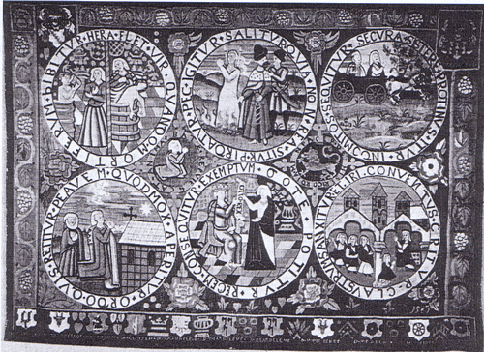
Fischbecker Gründungsteppich (Sift Fischbeck, 1583)
Source of this picture: „per manus sororum…" by Tanja Kohwagner-Nikolai

II) Register (="story" shown in horizontal bands)

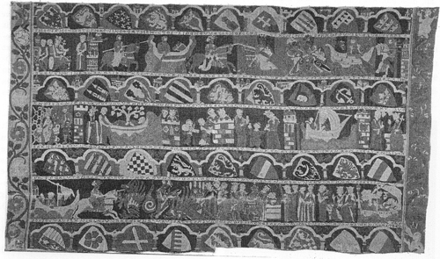
Tristanteppich I (Kloster Wienhausen, about 1330)
Source of this picture: „per manus sororum…" by Tanja Kohwagner-Nikolai

III) Bordüre (=border)

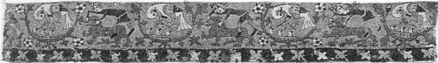
Simsonbordüre (Kloster Wienhausen?, 2nd half of the 14th century)
Source of this picture: „per manus sororum…" by Tanja Kohwagner-Nikolai

IV) Banklaken (Bank=seats, laken=sheets)

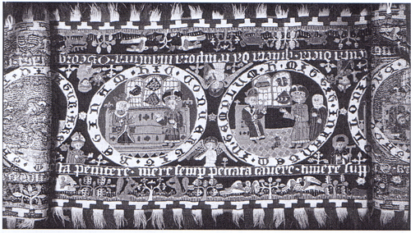
Georgslaken (Kloster Lüne, 1500)
Source of this picture: „per manus sororum…" by Tanja Kohwagner-Nikolai

V) zentrales Bildfeld (=central image area)
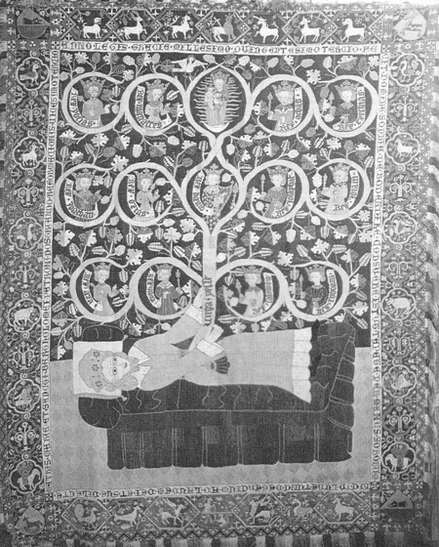
Wurzel Jesse-Teppich (Kloster Lüne, 1503-1505)
source of this picture: „per manus sororum…" by Tanja Kohwagner-Nikolai

VI) eingestellter Kreis (=centered? circle)
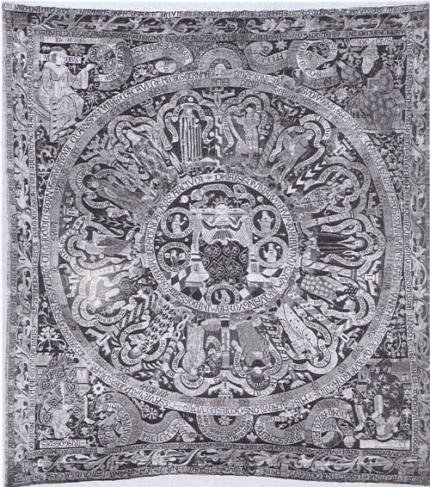
Philosophie- u. Tugendteppich (Kloster Heinigen, 1516)
source of this picture: „per manus sororum…" by Tanja Kohwagner-Nikolai

Klosterstich Technique:

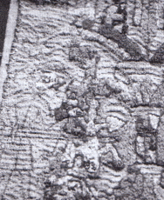
Detail – Kindheitsteppich
source of this picture: „per manus sororum…"
by Tanja Kohwagner-Nikolai

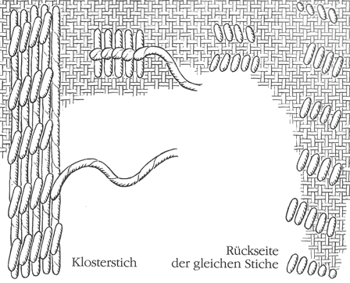
source of this picture: "Kloster Wienhausen - Band III - Die Bildteppiche" by Pia Wilhelm

According to the book "Kloster Wienhausen - Die Bildteppiche":

"Generally the canvas was fixed in an embroidery frame, to avoid a later warpage of the work. The tapestries of the cloister Wienhausen were fully embroidered, at no area the fabric should remain visible like for example at the famous Bayeux tapestry where the linen background fabric knowingly was used as a means of expression. The embroidery was executed in the Klosterstich technique, a common technique for the German picture-carpets from the 13th to the 16th century. This specific stitch gives the surface a distinct closeness, while at the back only small stitches appear that leave blank a lot of linen. In this way a lot of wool was sawed, a fact that was very important concerning the size of the tapestries. The technique is easy to execute and large areas can be covered very quickly because of the thickness of the wool threads. The thread is bounded by the shape of the preparatory drawing (iron gall ink applied with a brush ) - always in vertical direction - as far as the colour of the template lasts, laid from top to the bottom & couched on the way back to the top with small and nearly vertical couching stitches. Both kinds of stitches are executed with the same thread: the stuffer thread is leaded from the top to the bottom and with couching stitches it takes its way back to the top again. In this way a harmonious closed surface can be achieved and the tapestry gets his animated structure. Seldom the stuffer threads in between are laid in another direction than the vertical, following the form they model casually faces or other small parts or sections. This can especially be seen at the Tristan-Teppich I. Also the outlines are worked in Klosterstich. Where two embroidered sections meet, a small break occurs, that is covered with the outline."

my interpretation of the technique:

I try to lay my couching stitches with the twist of the thread and I make longer stitches on the surface and smaller stitches on the back to avoid wasting more thread than necessary, and because I think that, this way, the couching thread nearly disappears. To be able to work this technique very fast I prefer to work the couching stitches from the outside (without embroidery) to the inside (the embroidery) - not like shown in the picture from the cloister Wienhausen. Furthermore I use Stem Stitch for the outlines because this technique is easier and faster to use for the outlines than the Klosterstich.

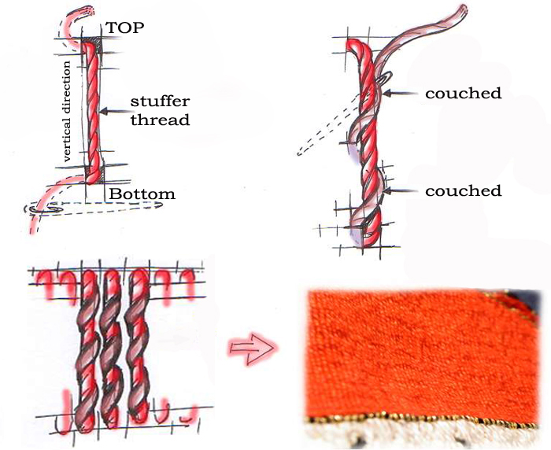

According to Mrs. Kohwagner-Nikolai –
two (vertical) directions for working this technique are possible:
- laying the stuffer thread from bottom to top and couching it in a downward movement
- laying the stuffer thread from top to bottom and couching it in an upward movement

Both directions were tried out several times in the restoration workshop and both directions also could be detected at the objects (independently concerning the workshop). The technique used depends if the embroiderer is right- or left-handed, which is easier for him/her to work, and at the S- or Z-twist of the wool (to avoid 'bubbles').

more facts for your decision concerning the outlines:

"Kloster Wienhausen - Die Bildteppiche": 'Also the outlines are worked in Klosterstich.'

"Das Stickereiwerk": page 37 - '185/186, Farbtafel IX "Maltererteppich"… Klosterstich und Stielstich…' (Stielstich = Stem Stitch); page 37 - '187, Rücklaken "Wappenteppich"…Kloster-, Stielstich (für die Gesichter' = for the faces)
Bibliography:

Books: „per manus sororum…" Tanja Kohwagner-Nikolai
Niedersächsische Bildstickereien Verlag Martin Meidenbauer (www.m-verlag.net)

im Klosterstich (1300-1583) ISBN-10: 3-89975-082-9
ISBN-13: 978-3-89975-082-9
„Das Stickereiwerk" Marie Schuette, Sigrid Müller-Christensen
Verlag Ernst Wasmuth Tübingen 1963

„Mit Nadel und Faden" Marianne Stradal, Ulrike Brommer
…durch die Jahrhunderte Heidenheimer Verlagsanstalt - C. F. Rees GmbH
Aus der Kulturgeschichte vom
Sticken, Stricken und Häkeln
„Die textilen Künste" Leonie von Wilckens
Von der Spätantike bis um 1500 Verlag C. H. Beck
ISBN: 3-406-35363-0

„Kloster Wienhausen - Pia Wilhelm
Band III - Die Bildteppiche" Kloster Wienhausen

„Tristanwandteppich - Herausgegeben von der Celleschen Zeitung in
Kloster Wienhausen - 12 Farbre- Zusammenarbeit mit dem Kloster Wienhausen
produktionen mit einer Einführung"

Kloster Wienhausen An der Kirche 1, D - 29348 Wienhausen
kloster.wienhausen@arcor.de Tel.: 0049/ (0) 5149 / 1866-0 und 1866-10
www.wienhausen.de Fax: 0049/ (0) 5149 / 1866-39

„Bildstickereien des Mittelalters Horst Appuhn
in Kloster Lüne" Die bibliophilen Taschenbücher Nr. 377
Harenberg Edition
ISBN: 3-88379-377-5 <1980>

„Kloster Lüne - Textilmuseum Christian Pietsch – Klosterkammer Hannover
im Evangelischen Damenstift" Kunstverlag Weick - Passau
Weick-Kunstführer Nr. 32.012.96
ISBN: 3-930602-13-X

Kloster Lüne Am Domänenhof, D – 21337 Lüneburg
www.kloster-luene.de Tel.: 0049/ (0) 4131-52318
Fax: 0049/ (0) 4131-56052

„Mittelalterliche Textilien Jutta Eißengarthen
aus Kloster Adelhausen im Adelhausenstiftung Freiburg im Breisgau
Augustinermuseum Freiburg"

Augustinermuseum Gerberau 15, D – 79098 Freiburg im Breisgau
augustinermuseum@stadt.freiburg.de Tel.: 0049/ (0) 761 201 - 2531
www.museen.freiburg.de Fax: 0049/ (0) 761 201 - 2597

Internet: "historical needlework resources" http://medieval.webcon.net.au

------
Copyright 2010 by Racaire. <ego at @racaire.at>. Permission is granted for republication in SCA-related publications, provided the author is credited. Addresses change, but a reasonable attempt should be made to ensure that the author is notified of the publication and if possible receives a copy.

If this article is reprinted in a publication, please place a notice in the publication that you found this article in the Florilegium. I would also appreciate an email to myself, so that I can track which articles are being reprinted. Thanks. -Stefan.

<the end>

„Mit Nadel und Faden – Kulturgeschichte der klassischen Handarbeiten" by Marianne Stradal & Ulrike Brommer
„per manus sororum…" by Tanja Kohwagner-Nikolai – chapter: Entwurf und Vorzeichnung
„Mit Nadel und Faden – Kulturgeschichte der klassischen Handarbeiten by Marianne Stradal & Ulrike Brommer
„per manus sororum…" by Tanja Kohwagner-Nikolai - chapter: Entwurf & Vorzeichnung der Klostersticharbeiten, page 31

