DF-Card-Weav-art - 11/26/16

"How to Card Weave Letters, Numbers, or Designs" by Lady Elena Hylton.

NOTE: See also the files: card-weaving-msg, Intro2CrdWvng-art, Hallst-Tb-Wvg-art, Inkle-Weaving-art, looms-msg, weaving-msg, Intro-2-Wool-art, P-Emb-Frames-art.

************************************************************************
NOTICE -

This article was added to this set of files, called Stefan's Florilegium, with the permission of the author.

These files are available on the Internet at: http://www.florilegium.org

Copyright to the contents of this file remains with the author or translator.

While the author will likely give permission for this work to be reprinted in SCA type publications, please check with the author first or check for any permissions granted at the end of this file.

Thank you,
Mark S. Harris...AKA:..Stefan li Rous
stefan at florilegium.org
************************************************************************

How to Card Weave Letters, Numbers, or Designs
by Lady Elena Hylton

Updated as needed; most recent version will be at
https://sites.google.com/site/elenasthreads/cardweaving/doublefacedhandout

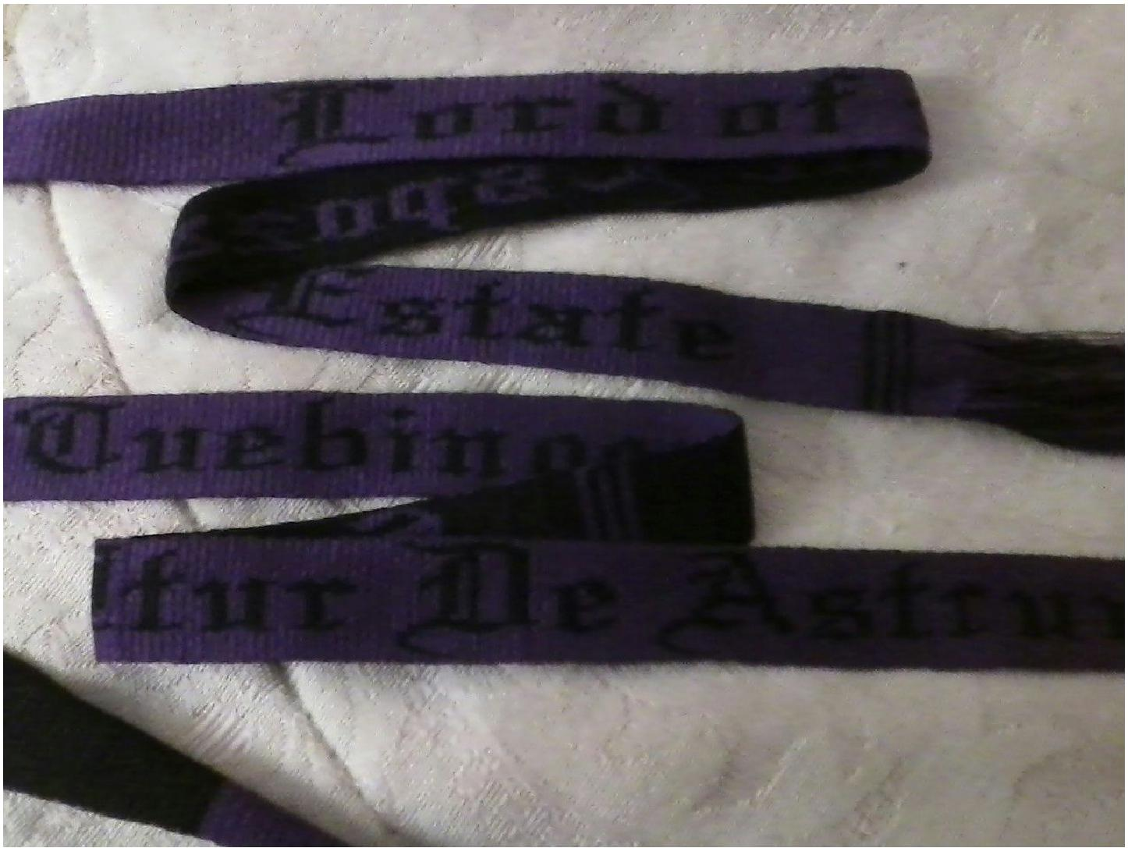

Section One: Disclaimers!

On Periodness:

This specific method of doublefaced weaving is possibly period, possibly not, but will definitely allow you to weave your own favors, belts, or trim in any pattern you wish. There are some excellent books on the history of this craft that better look at period techniques, please see the recommended resources in the end.

On Weaving Techniques:

In order to focus on learning this technique we are ignoring making selvages with continuously forward/backward turning cards. Feel free to add this to your next project, but it will be ignored in these instructions.

Also, while some designs will look better S/Z alternated or the first half S and second half Z or vice versa, and there are some advantages to using these threading patterns, to simplify for this lesson we are leaving all threaded in a single way. Different patterns will look better with different threading layouts, either look at what is recommended for your pattern or experiment and see what effect you like the best.

If you have a loom that allows you to use the continuous warp method to warp your loom I highly recommend this, as it drastically reduces the time it takes to start weaving. For more information on this warping technique, please see the recommended resources at the end of this handout.

For ease of reading many of the pictures in this handout are of a mini loom with only 14 cards warped with crochet cotton. While this does not create a great finished product and such few cards are mostly only used while learning, it shows the placement and movement of the cards quite well in photographs.

Finally, card weaving and tablet weaving are two terms for the same technique, and are used interchangeably throughout this handout.

Now onto the fun part...

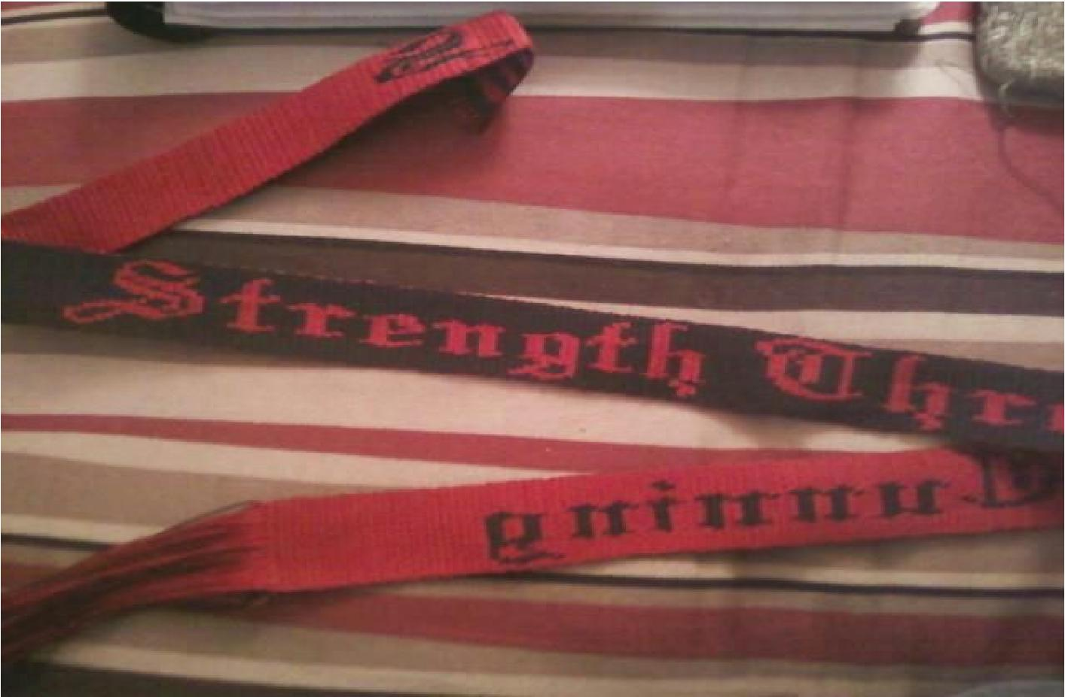

Section Two: Starting to Weave Designs

Loom Setup:

Your loom should be set up with however many cards are needed for your pattern, with A and B warped in one color and C and D warped in a contrasting color. I sometimes start my weaving off by getting the weft going in a standard 4 turns forward, 4 back pattern to make sure my tension and everything looks good. (Once you have the hang of this type of weaving you can go straight into the pattern which allows you to have a fringe on your finished product if you like, but getting the tension situated by weaving a few stripes may get you started a little easier.)

When you have the weft in place and have removed most of whatever twist that you built up in the warp, you are ready to begin.

Pick which of your two colors you want to be your base color. This will be the background for your weaving. For the images below, black is our background and yellow will be our pattern threads.

To make life easier, set up your threads so that you can easily see the card holes (A B C D).

The basic pattern to start with is simply two turns forward, two back. Start with your base color facing you on the loom the start position is essential

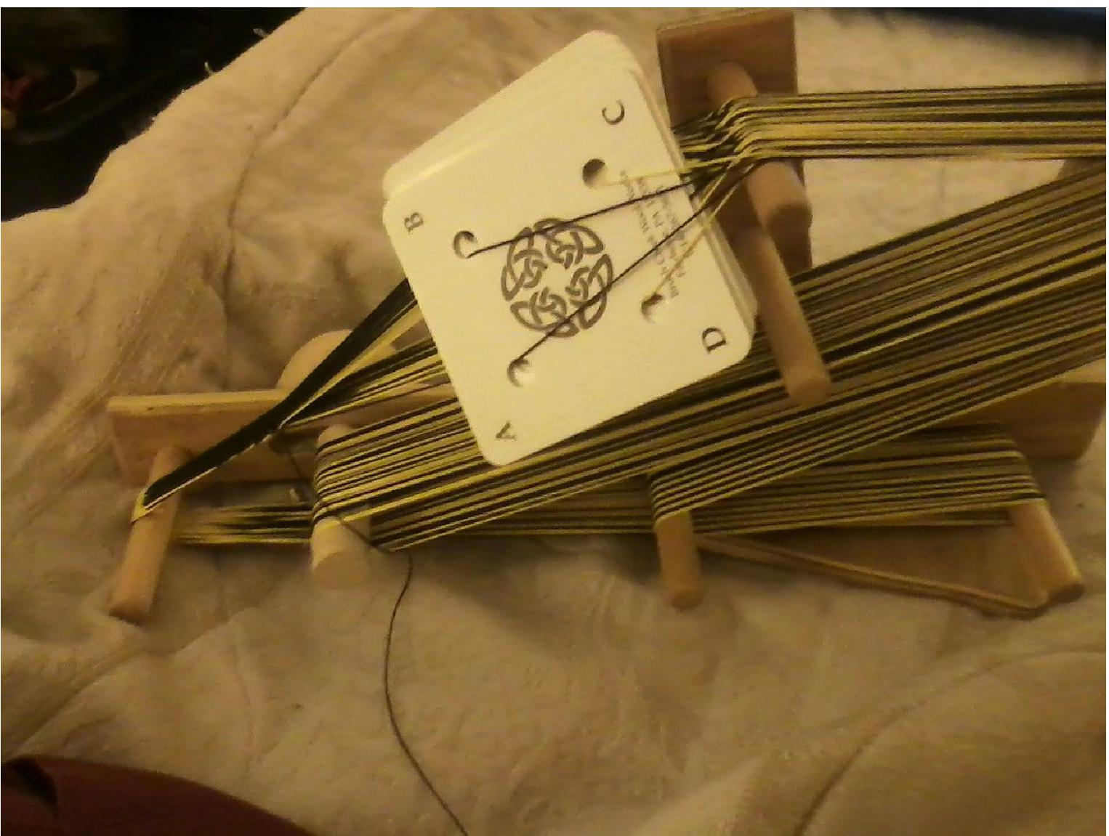

The base color here is black, so A & B, the two holes with black warp threads, are facing towards you.

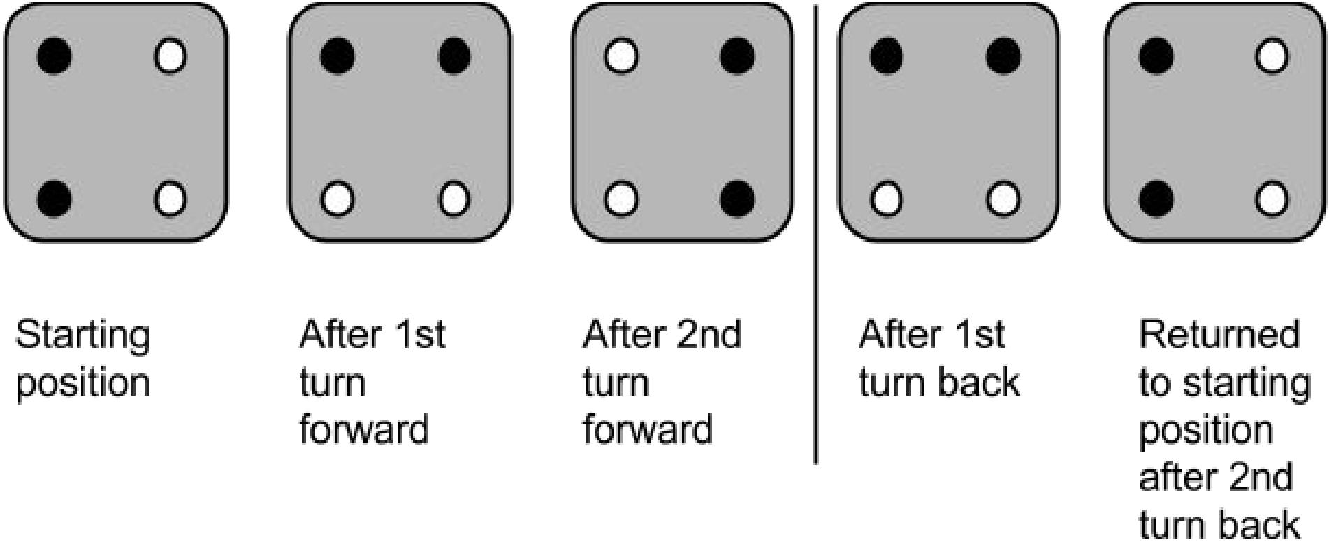

Repeat with several sets of two forward, two back.

You should have a solidcolor band on your loom now

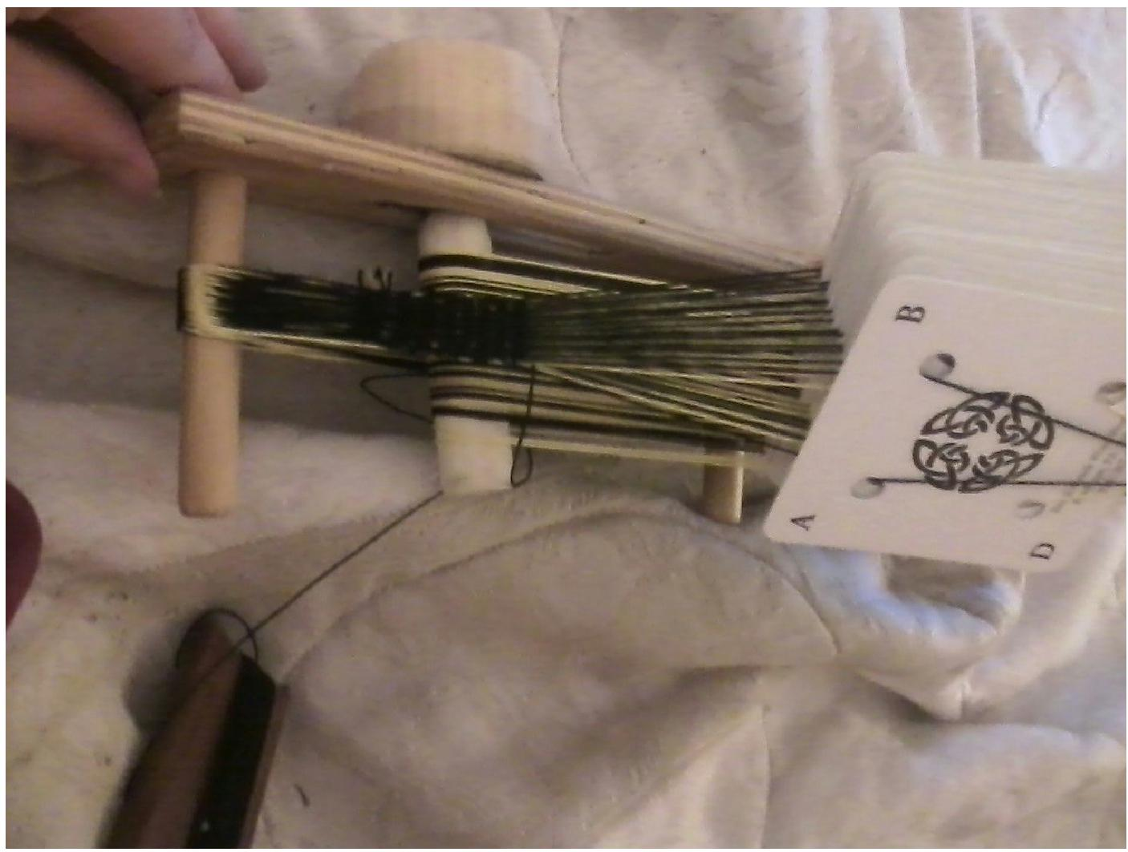

Troubleshooting! If you have stripes or a solid band in the wrong color then either your turn pattern got thrown off somewhere or you started in the wrong position. Double check your starting position and check the card positions as you go against the pictures above. Don't worry, you'll get it!

Repeat this until you become comfortable with the pattern of two forward/two back and it begins to feel natural. This can also be used later on to create blank space to serve as belt loops, spaces between words, or to simply stretch out smaller designs over a larger space.

This doubleweave technique is always done in blocks of two. Each square of a pattern diagram represents two turns of the cards either forwards or back. You will see why soon.

Troubleshooting! At some point you will get distracted and not be able to remember when your two background colors are on top if you should be going forward next or back. This will happen and it is totally fine! Send the shuttle through if you have not yet, and then turn the cards in either direction. If it is correct, it will look like the rest of the weaving and you can simply continue on from here.

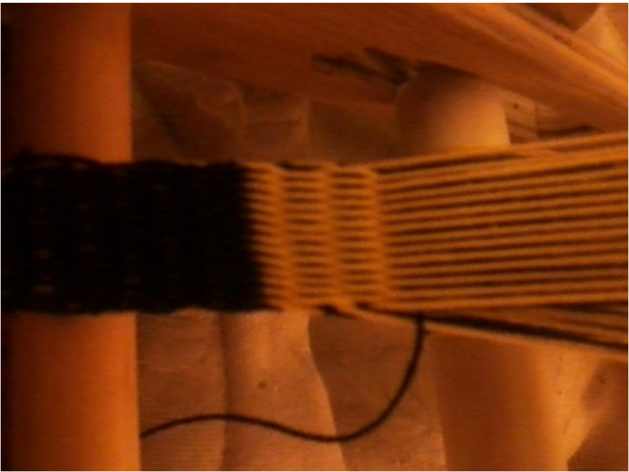

I switched colors here to better demonstrate the placement of the threads. See how each set of threads crosses over each other with no long floats? This was the correct direction, so I can simply continue weaving.

If it looks like the threads are moving over an extra weft or two (it will look like longer lines usually, see below) then you need to move the cards twice in the opposite direction without sending the shuttle through. This puts the cards back into the correct order and you are ready to begin your sequence again. Card weaving works because all four of the threads in each card have to go over and under the weft threads. Missing a direction leaves floaters, which are the longer lines that you are spotting.

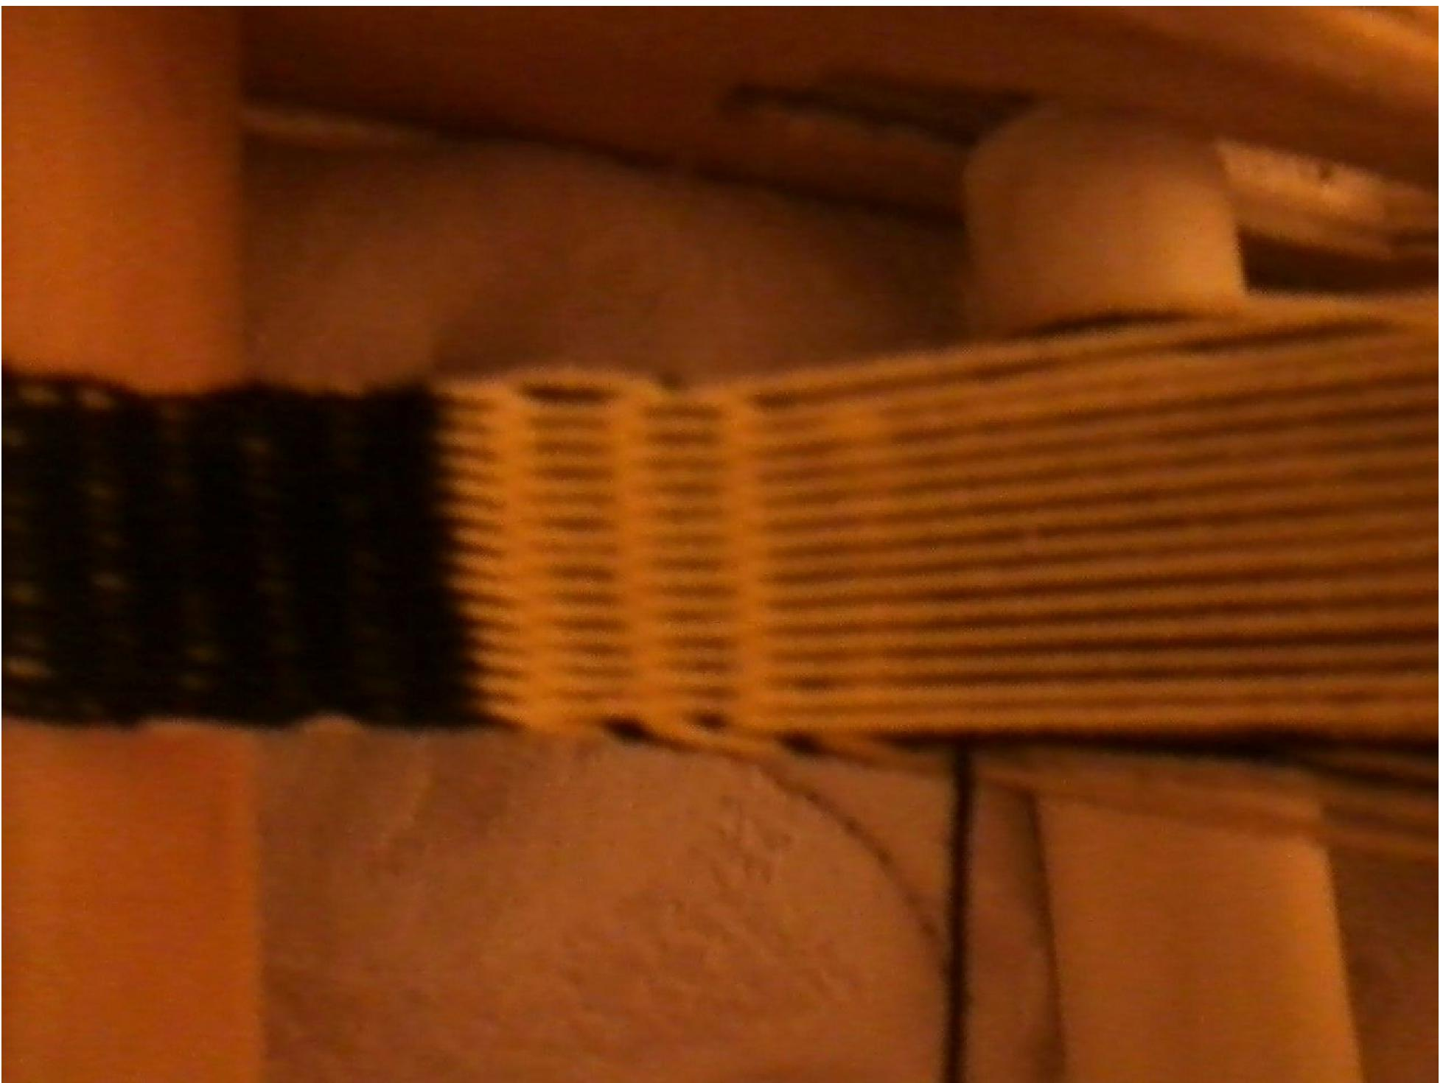

See how far up the black weft thread is, with very long floaters leading up to it? This was turned forward and then backward instead of in a set of twice forward or twice backward. Because of this some of the warp threads never crossed under the weft, leaving the long floaters.

Once you are very comfortable with the basic weaving pattern we can start adding designs. We are going to start simple. Complete the two forward, two back pattern you are currently on, so that your last two turns moved backwards.

Whatever number of cards you have, leave the first two cards on one side and last two cards on the other side alone, and move the center cards about two inches closer to you. Now you have two "packs" of cards, your background card pack which we left alone and your pattern card pack which we moved.

Troubleshooting! The space between the two sets of cards will depend on the size of your cards and your comfort keep the two sets of cards far enough apart to easily tell the difference, but not so far apart that they start to catch on each other when you turn one set or try to move cards from one set to another. Usually this will be about half the width of the cards.

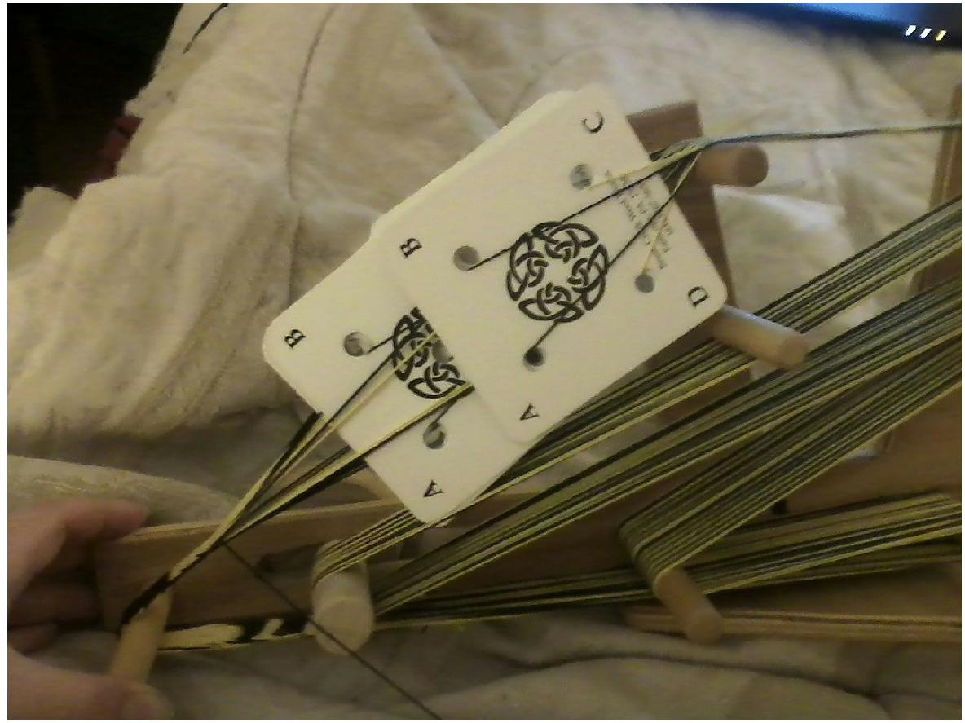

Here is a comfortably spaced pack (though the cards are somewhat big for the miniloom).

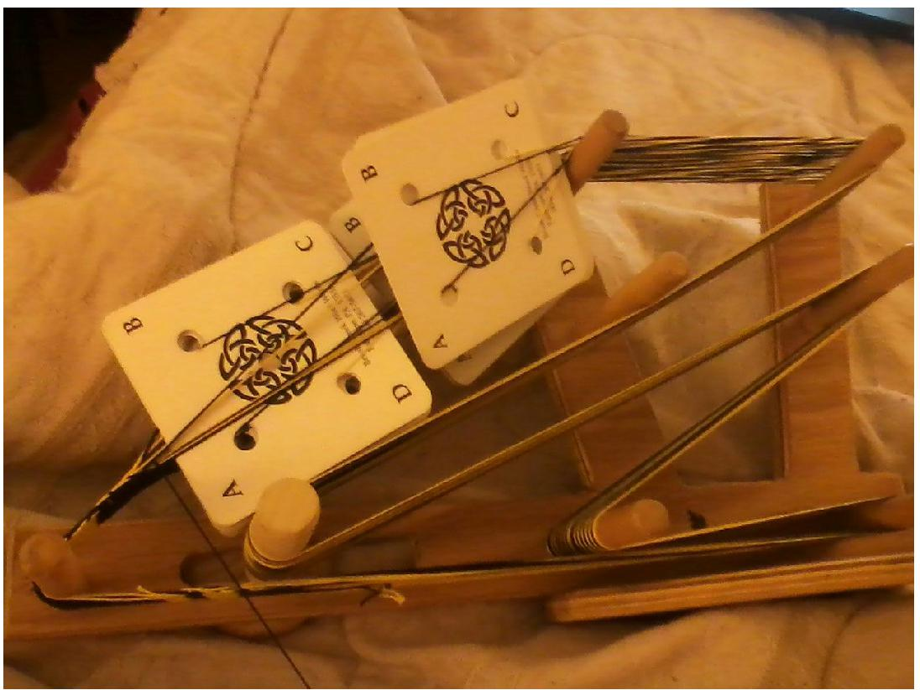

If the packs are too far apart they will catch on the other warp threads when they are turned. Try out some positions and see what works for you.

We ended our last set by moving two cards backwards, so our background cards will be moving forward next. Turn your background pack (the outside cards we left alone) 1 turn forward. It should still leave your background threads on the top of the pattern. Do not send the shuttle through yet!

Now we create the pattern. Turn your pattern card pack backwards 1 turn. Now you should have a small border of your background color framing a block of your pattern color. Send the weft through.

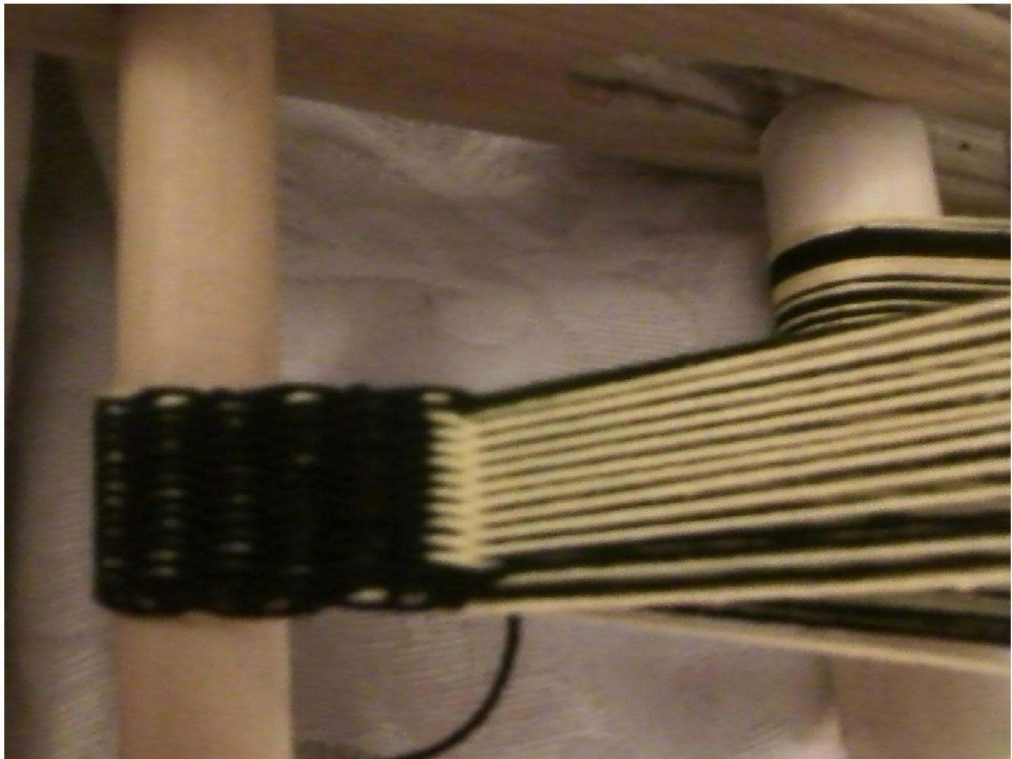

Now we finish our pattern block. Move the background cards (outside edges) forward again one turn, move the pattern cards (center cards) backwards one turn, and send the shuttle back to your starting side.

We have now completed one full pattern block! This is what would be represented by one column or row in most pattern books. You will note that the cards are all in the same position. This is why this style has to be worked in sets of two we need the cards to all be in the same position so that we can move them from the pattern pack to the background pack or vice versa if the pattern calls for it.
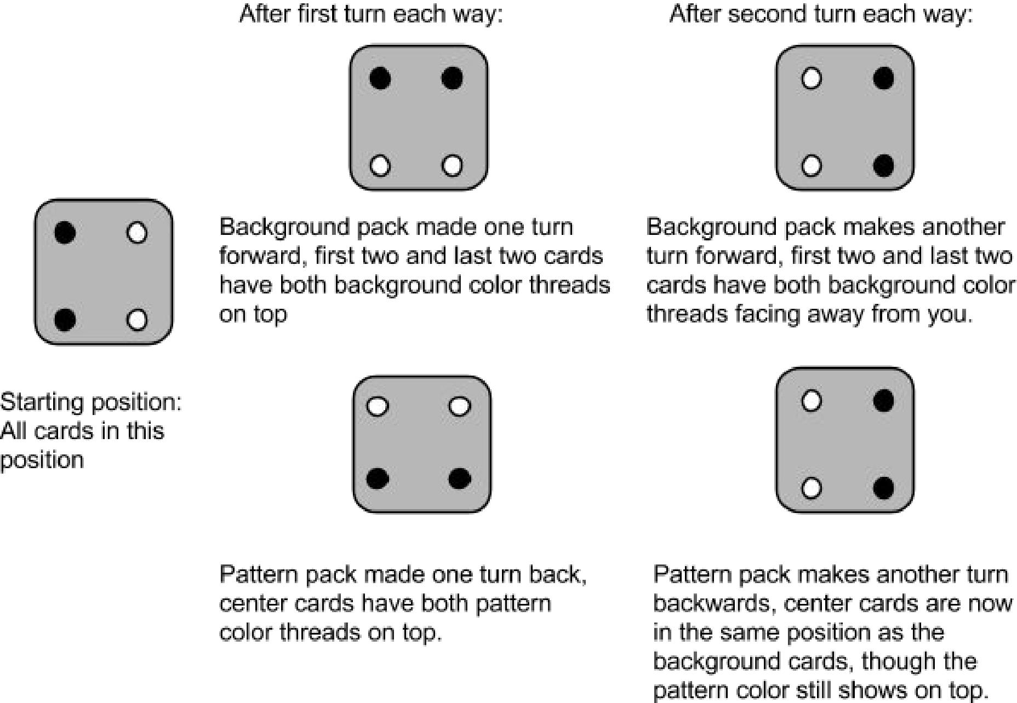

Now, slide the pattern pack back into position with the background pack. Turn the entire deck backwards one turn, send the shuttle through, turn backwards again and send the shuttle through again, and you have now come back to the starting position.

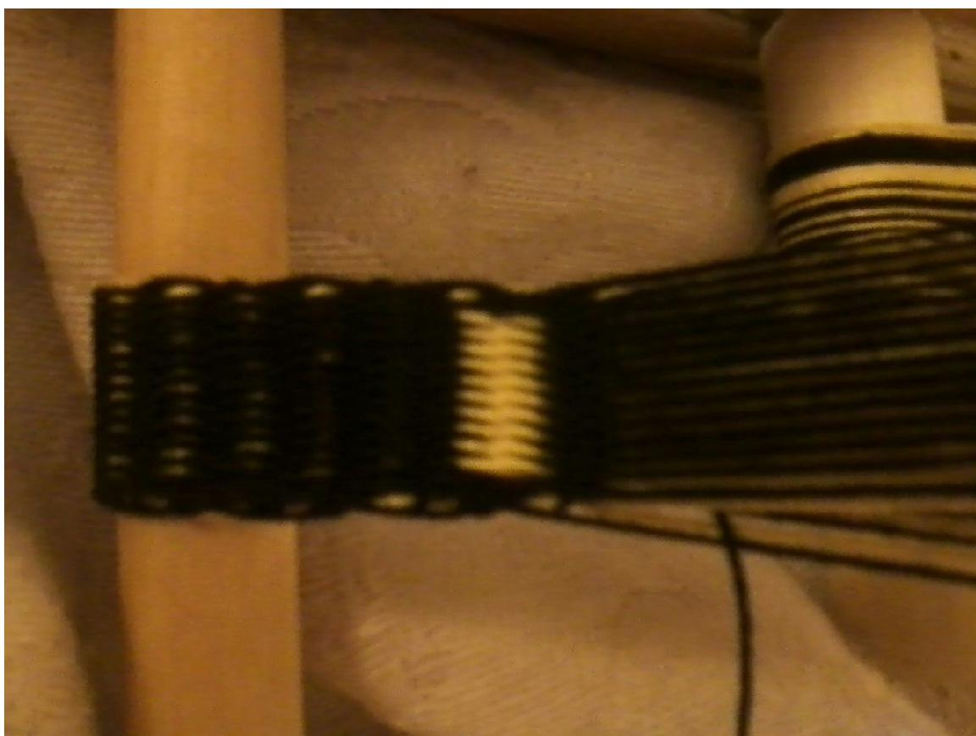

You should now have a small stripe on your background. You just created a pattern! Now we are going to take this technique and try it again to make some different patterns.

Pick your center two cards and pull them back to create your pattern deck. Make one complete pattern block by turning the background deck forward and the pattern deck back two turns each.

If your loom is warped with 24 cards or more: After each set of two turns forward or back, move 2 more cards on each side of your center pattern pack into the pattern deck.

If your loom is warped with 23 or fewer cards, move 1 card on each side of your pattern pack into the pack.

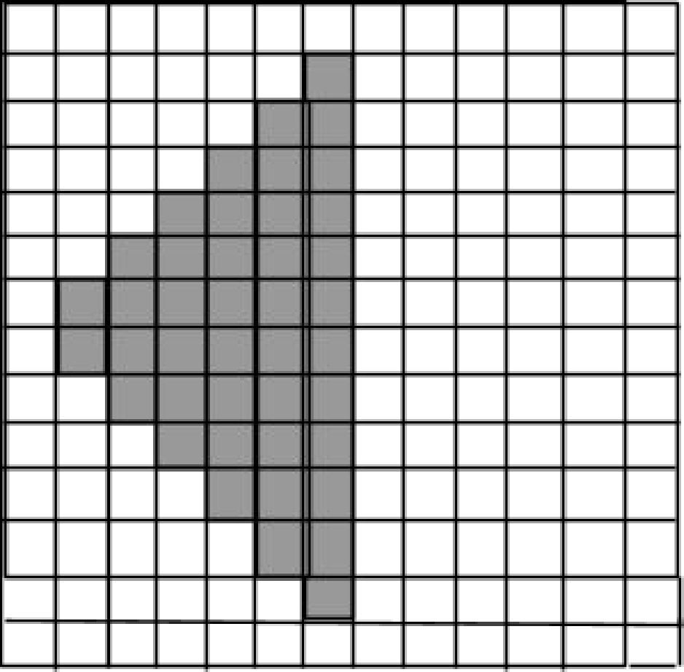

This the pattern you would follow with a 14card pattern.

Continue to follow the pattern of adding cards to your pattern deck until:

If you have 24 or more cards in your warp, you get to the last 2 cards on either side (4 total cards) in your background pack.

If you have 23 or fewer cards in your warp, you get to the last 1 card on either side (2 total cards) in your background pack.

Now you should have a triangle on your band.
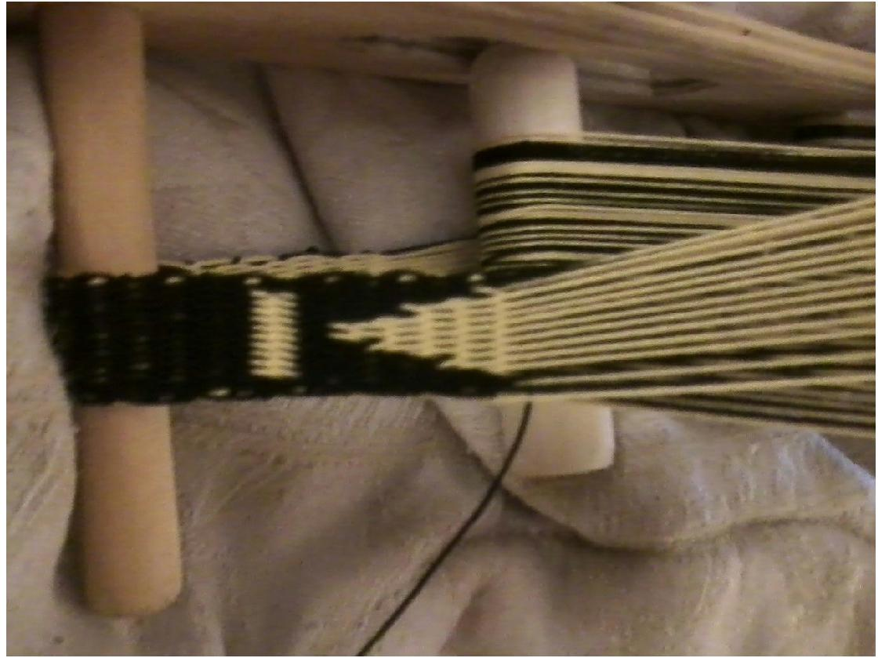

Note the uneven diagonal line? Doublefaced weaving when using few threads handles straight lines best. Like the pixels of an image, the more threads on your warp the smoother your lines (especially diagonal lines) can be.

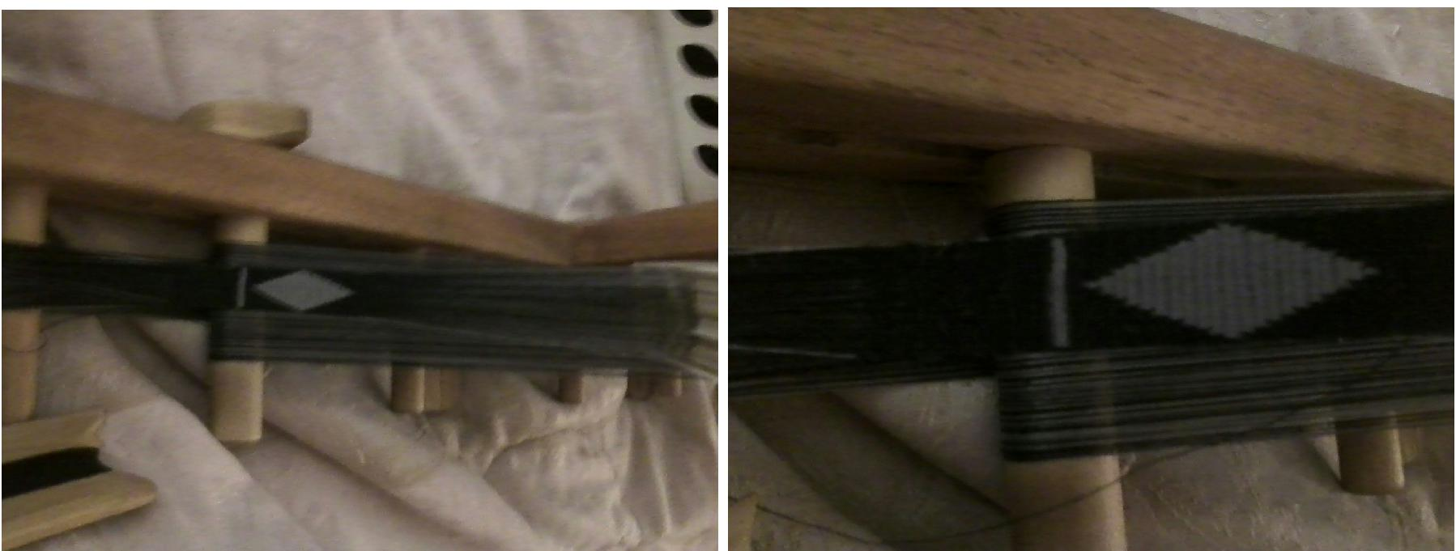

A loom warped with 46 cards of sewing thread gives a neater and more gentle diagonal line.

Next we are going to turn this into a diamond by dropping the same number of cards from the pattern pack each round of two turns until we get back to our center two cards.

Troubleshooting! depending on the number of pattern blocks it took to get here your background deck may need to move backward on the next turn instead of forward. If the two threads of background colors are both facing towards the section you have already woven so far on the loom you should turn forwards, if the background colors are both facing the opposite side towards the rest of the warp, then you should turn backwards.

Following the same pattern of forward 2 turns, back two turns, drop the same number of cards each block from your pattern deck as you had added before (2 if you have a 24card warp or more, 1 if less)

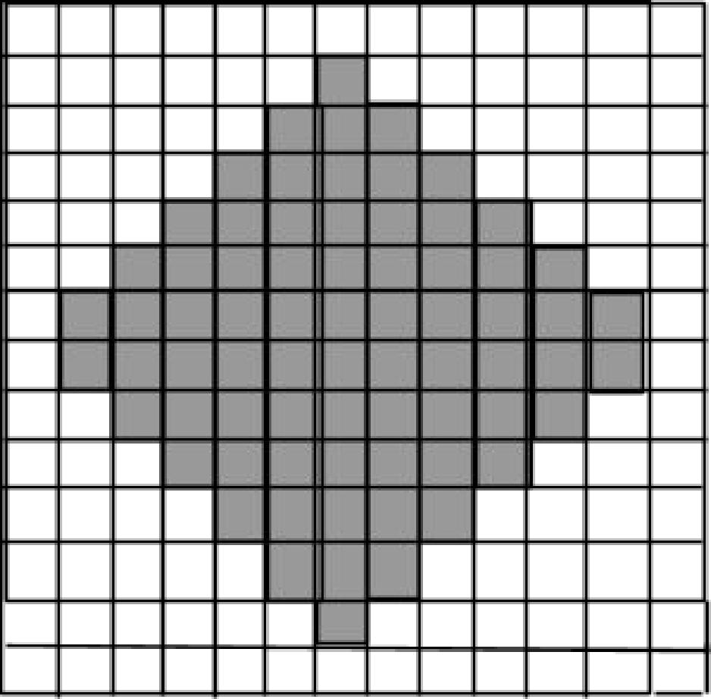

Once you get down to the last two cards, complete the pattern block with them, and then push them back into the background pack so that all cards are back in a single pack. Now weave several rows of plain background by following the twoturns pattern.

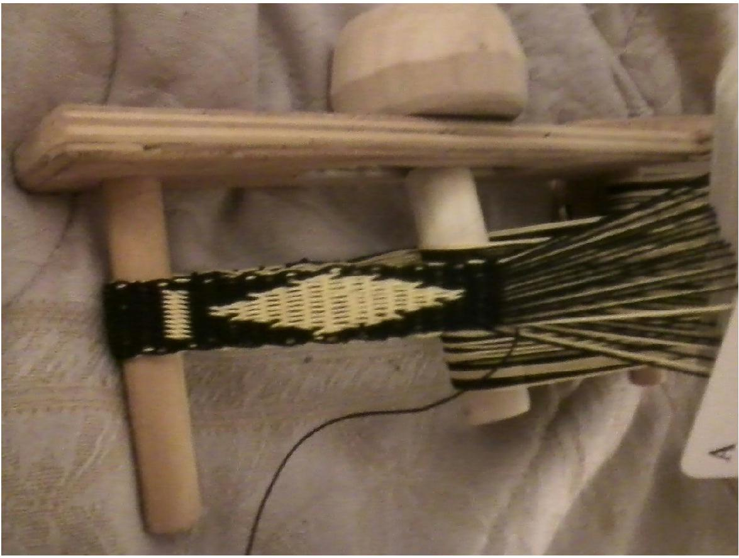

You will note that the diamond is very elongated compared to the pattern design. This will vary depending on the threads you are using and how hard you beat your weft as you weave.

Troubleshooting! Make sure you keep the background pattern going the correct direction. If you turn and your pattern color comes up instead don't worry, just do not send the weft through and turn the cards twice in the opposite direction (it should now look correct) and then send the shuttle through. Turn in that direction a second time to complete the pattern block.

You have now created a small line and a diamond, well done! You have successfully completed the basics of doublefaced tablet weaving. If you look at the underside of your band, you will notice that it is the exact reverse of the colors on the front. Hence the name, doublefaced tablet weaving.

If this was a little challenging, try some other geometric patterns first, such as making boxes, rectangles, or stripes before going on to the patterns attached to this handout, or repeat the lines and diamonds until you become very comfortable moving the cards between the background and pattern packs.

Now to picking or making your own patterns!

3. Pattern Options

Disclaimer:

I have included both my own patterns that I have created and one pattern created by another SCA member. Each pattern lists at the bottom of the page who created it and where it can be found if it was not created by me. Many amazing people in the SCA create patterns and place them on the internet for free and are easily accessible. Please see the recommended links at the end for many gorgeous patterns freely available to tablet weavers, or do a google search to find what you are looking for.

I never buy patterns. You can almost always either find something you are looking for online for free, or simply draft it yourself (see later in this handout). Cross stitch, cut work, and other patterns created by filing in a grid can also be used for tablet weaving, so do some google searches and see what you can find!

How to Weave a Design from a Pattern:

As you may have different numbers of cards on your warp depending on the pattern you choose in the future, I will not be giving stepbystep directions for a specific pattern, but rather explain how to follow doublefaced patterns in general.

Once your pattern is selected, you will need to decide which orientation is easier for you to follow.

I like to move in columns from left to right. I often weave letters, so this lets me easily visualise the design I am making. In the next image, I start with column 1 with all of my cards weaving a background line. Then I move my center two cards into a pattern pack for column two, and so forth.

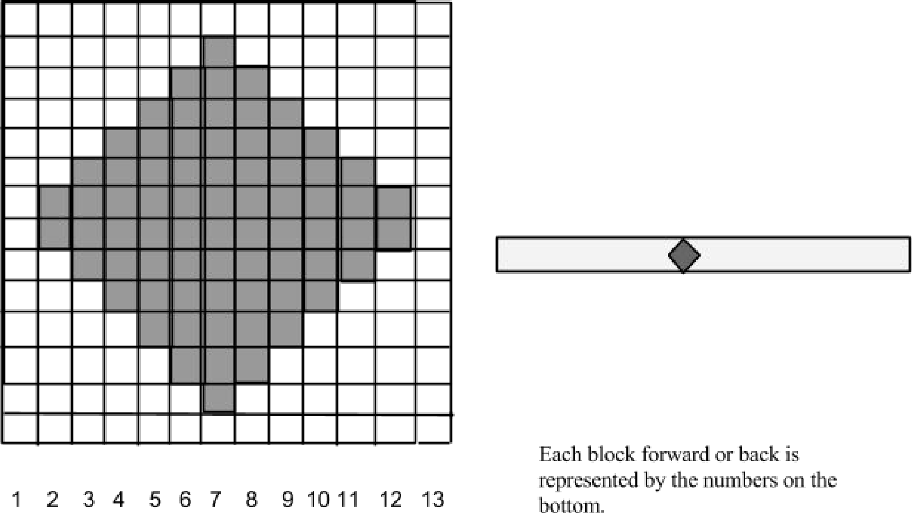

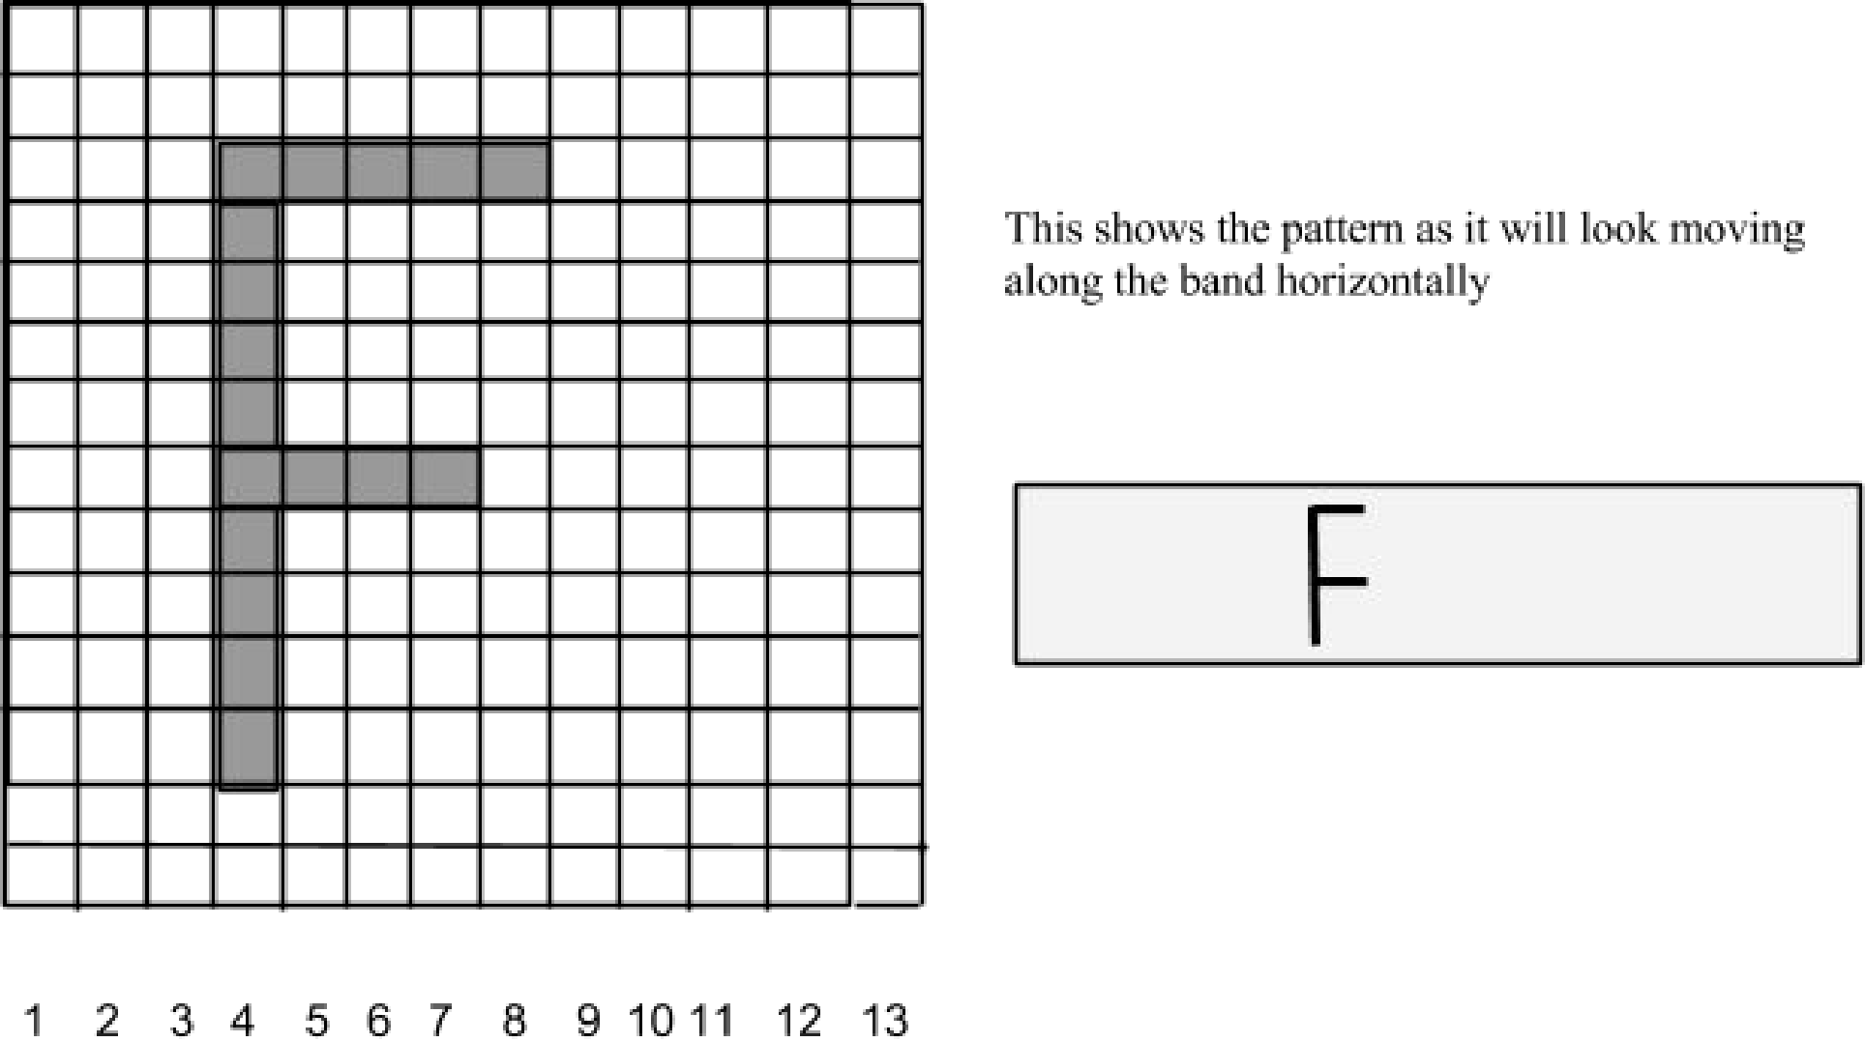

Some people prefer to view their chart moving up the band. This is the view from when the loom is on your lap, so this makes more sense for some.

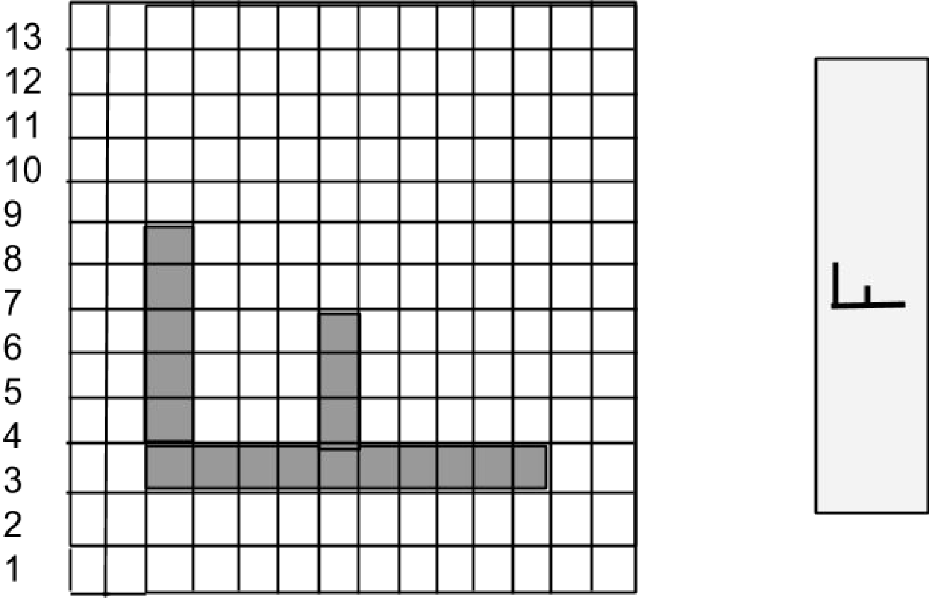

All of the patterns included here are oriented to be read from left to right, but as they are graphs you can simply turn them to read vertically if that makes more sense for you.

Choosing a Pattern:

For today, some of your choice of a pattern will depend on the warp of the loom you brought to class. The patterns are divided up based on the number of cards they require to be woven. You can alter this somewhat by leaving larger borders on the sides of your pattern (weaving a 20card pattern on a 24card warp means you will add two extra blank spaces on the top and bottom of the pattern or use them to create selvages if you like).

If you are still somewhat new to tablet weaving intricate designs and find constantly moving the cards around the packs to still be a little overwhelming, I highly recommend starting with some of the smaller designs. I still get lost in my weaving sometimes, and it is a lot easier to figure out what happened if you are on a small 12card pattern with easy to follow lines rather than a 42card one.

If you have woven patterns such as the Ram's Horn or Snartemo and are used to following a pattern diagram and moving cards individually from pack to pack, this will probably come a bit easier to you and you can most likely start with a larger pattern.

Troubleshooting! If you start a pattern, it all turns into a blotchy mess and you want to throw it all away and never try again, DON'T! It happens to the best of us. Take a breath and reset the whole thing with your entire card pack all in the same position facing you, and start again weaving a basic blank band. Scale down to a simpler pattern until it feels comfortable, and then go back to that big gothic lettering you are dying to do. Weaving is like any other skill, it takes time and practice to build the muscle memory in order for it to feel natural. You can get there, it just takes time.

A pattern pack of different designs is attached to choose from, or you can create your own on the graph paper if you are feeling adventurous.

Creating a Pattern:

There is blank graph paper attached as well for you to create your own pattern. Simply choose how many cards you would like to use for your pattern and mark the borders on your graph paper, one square for each card. Then, shade in the squares to make your pattern. Once you have your pattern complete, use it as we did the pattern above. Every dark square represents a pattern card turned twice, and each light square is a background card turned twice.

Remember, the dimensions of your design will depend on the fibers you are using and how tightly you beat your shuttle as you weave. The pattern will usually stretch out between 1.53 times as long along the warp as it is high, so keep this in mind when designing your pattern.

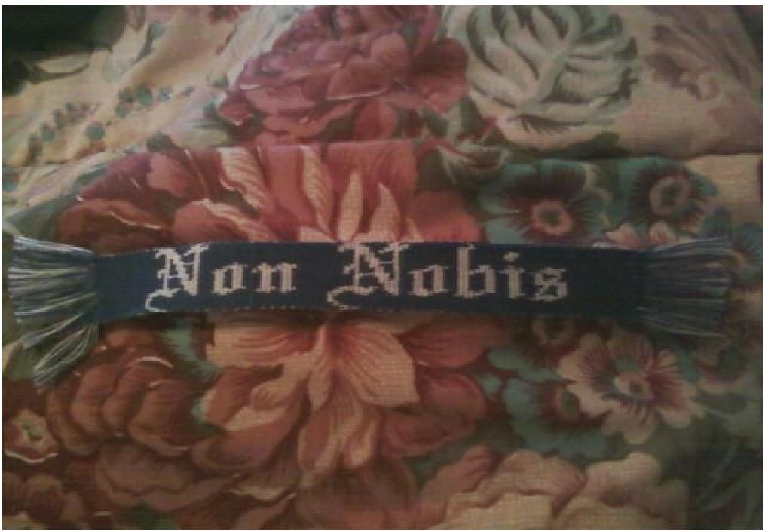

4. Other Information Reproduction of this Handout:

Feel free to copy or post this handout for your friends or other weavers, but please contact me at jecscififan at yahoo.com for permission before using it to teach/present at any official SCA or other class/event. All images, graphs, and instructions are my own creations and I would like to know where they are ending up. Likewise, please only copy this packet as entire pages with the copyright symbol and my contact information attached. If you are interested in using any of my images or graphs for other purposes please contact me for permission first. An electronic copy of this handout can be found at https://sites.google.com/site/elenasthreads/cardweaving/doublefacedhandout
and the pattern pack can be found at
https://sites.google.com/site/elenasthreads/cardweaving/mycardweavingpatterns

Thank you.

Resources:

Disclaimer Number 2: I did not receive any compensation for listing any of these resources, nor is this a comprehensive list. These are simply what I have found to be the most useful/helpful to me and my friends who cardweave.

Useful Links:

Free Patterns/HowTo Guides

Guntram's Tabletweaving Page
http://www.guntram.co.za/tabletweaving/index.htm

This is an incredible website for patterns, as well as other information on cardweaving.

Eve's Weaving Double Faced Patterns
http://www.geocities.ws/evethejust/doublefaced.html

This contains quite a few double faced patterns for different numbers of cards.

J.L. Maclaren String Theory/Knotwork
http://www.jlmaclaren.com/stringtheory.php

This contains numerous geometric, animal, and other miscellaneous patterns for double woven designs.

http://www.jlmaclaren.com/knotworktutorial.php
This is an excellent tutorial on how to design knotwork patterns. It is specifically made
for doublefaced tablet weavers and includes numerous hints and tricks, but could also
work for crossstitch or any other graph design if your interests stretch that way.

Poore House How To Create Your Own Tablet Weaving Patterns
http://www.poorehouse.com/projects/howtopattern.shtml

Another tutorial, this page gives one way to convert images into tabletwoven patterns.

Other Resources -

Pine Box Traders Warping
http://www.rocknbead.com/wshed/cardwarppics.htm

The website belongs to a merchant listed below, but this specific link provides pictures and instructions on how to warp using the continuous warp method for some types of looms.

SCA CardWeaving Yahoo Group

https://groups.yahoo.com/neo/groups/SCACardWeaving/info

This in an excellent group with many knowledgeable, friendly people and excellent resources in their links and files.

Useful Merchants at Pennsic:

Egil the Loomwright a.k.a. Pine Box Traders This is where I have purchased all of my looms and also where I first learned how to cardweave. The man who runs this makes beautiful fullsized looms, as well as minilooms which are excellent for travel or if you are not sure you want to commit to a full loom. He also teaches lessons regularly on how to cardweave where he provides all of the materials for free. Excellent person for lessons or for materials.

Useful Books:

Collingwood, Peter. The Techniques of Tablet Weaving. This is generally considered to be one of the most comprehensive books on historical tablet weaving, and includes pattern diagrams for many period patterns.

Crockett, Candace. Card Weaving. This is designed more as an introduction to card weaving, but does include period images as well as modern designs for a variety of patterns and weaving styles. It does also include instructions for doublefaced weaving, but several people have found them to be challenging to understand.

Staudigel, Otfried. Tablet Weaving Magic. This book is dual lingual in German and English, and contains extensive information about numerous tablet weaving techniques, including double face and twill.
------
Copyright 2015 Jeanne Clifton a.k.a. Elena Hylton This work may be reproduced without permission only for noncommercial purposes and in its entirety. All images are property of Jeanne Clifton and may not be reproduced individually without permission. For all other uses please contact me at jecscififan at yahoo.com.

If this article is reprinted in a publication, please place a notice in the publication that you found this article in the Florilegium. I would also appreciate an email to myself, so that I can track which articles are being reprinted. Thanks. -Stefan.

<the end>

