Wr-Birch-Bark-art - 11/18/17

"Writing on Birch Bark" by Sofya Chyudskaya Smolyanina, OP.

NOTE: See also the files: Birch-Brk-Wrt-art, paper-msg, parchment-msg, wax-tablets-msg, Rus-Handbook-art, Char-Drw-Stks-art, P-Papermaking-art.

************************************************************************
NOTICE -

This article was added to this set of files, called Stefan's Florilegium, with the permission of the author.

These files are available on the Internet at: http://www.florilegium.org

Copyright to the contents of this file remains with the author or translator.

While the author will likely give permission for this work to be reprinted in SCA type publications, please check with the author first or check for any permissions granted at the end of this file.

Thank you,
Mark S. Harris...AKA:..Stefan li Rous
stefan at florilegium.org
************************************************************************

You can find more of this author's work on her website at:
https://medievalstuff.wordpress.com

Writing on Birch Bark
by Sofya Chyudskaya Smolyanina, OP

From the 11th to 14th centuries, the people of Novgorod had an unusually literate culture for its time. Men, women, peasants, and even children knew how to read and write, and they used slips of birch bark for business and personal correspondence.

Messages on birch bark were typically short, written on the inner, smoother side of bark strips – 5-15 inches by 1-5 inches on average. They usually name the writer, then the recipient, followed by a statement and a clear ending. Many writers began with a cross as a way of blessing. There was no punctuation or capitalization.

The birch bark was prepared for use by being boiled in water to make it pliable (Lobatcheva et al). However, in my experiments in rendering birch bark that I had purchased online, hot, non-boiling water curled up the bark like cinnamon.

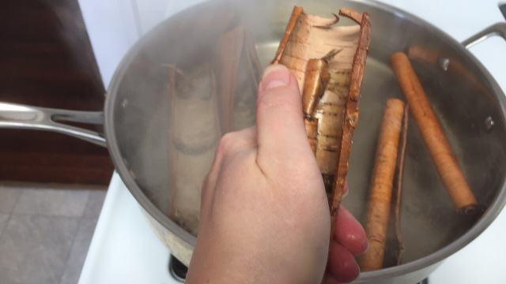

More experiments will be needed to determine how to reproduce "boiled" bark as it might have been rendered in period.

What DID work was simply soaking the bark for at least a few hours, with better results from soaking overnight. The pieces I ordered online were pretty thick, so soaking enabled me to peel them apart into thinner strips — thus giving me more pieces to work with.

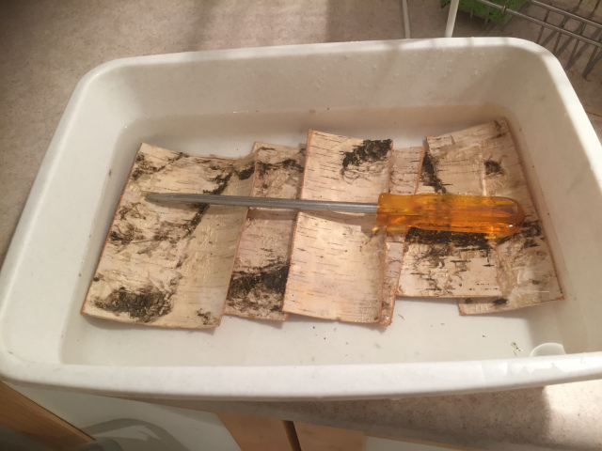
Soaking birch bark. The screwdriver is used as a weight, since the pieces want to float. This method wasn't terribly effective, and after taking this photo I switched to some blocks of soapstone I had lying around.

The thinner the strip, the more flexible it is, too, and easier to curl, fold, or manipulate in other ways. The oldest message found, according to Lobatcheva et al, had been torn into thin strips and tied in a sailor's knot before being thrown away.

Writers pressed letters into the bark with a sharp-pointed pen made from bone or iron – no ink was used. More than 200 of these pens from the 10th-15th centuries have been found in Novgorod.

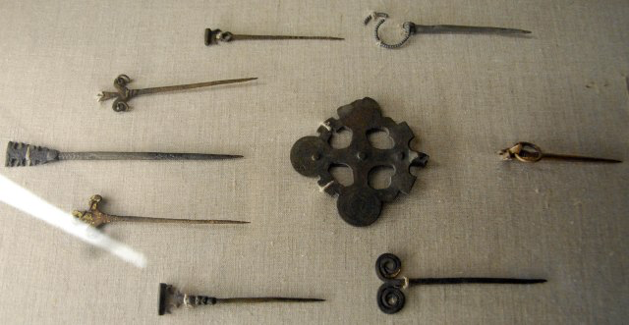
Metal pens from Novgorod (Fuller)

The bark is soft enough that a stylus will leave an indentation without any ink. (Again, thinner strips seem to work better, as the indentations leave a little discoloring in the bark to make the letters easier to see.) I've also found that wooden and brass pens work just as well. A lead stylus will leave a gray mark similar to a pencil.

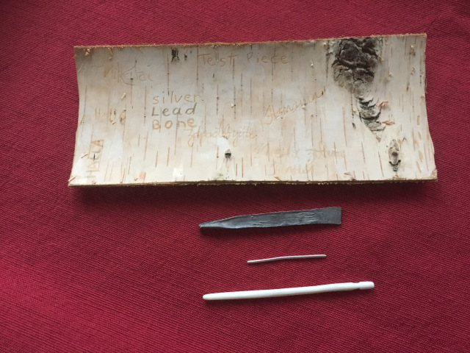
Testing different types of writing material on a thicker piece of bark (from top to bottom): lead, silver, bone.

References

Fuller, Michael J. "Medieval Novgorod: Metal Artifacts." Medieval Archaeological Remains at Velichy Novgorod. Web page with photos from a museum visit. July 30, 2006. http://users.stlcc.edu/mfuller/NovgorodMetalp.html

Lobatcheva, Irina; Bosworth, Amanda; and Lobatchev, Vlad. Letters One Thousand Years Old. Lexington: Parallel Worlds' Books, 2014.

------
Copyright 2017 by Anne McKinney. <sofyachy at gmail.com>. Permission is granted for republication in SCA-related publications, provided the author is credited. Addresses change, but a reasonable attempt should be made to ensure that the author is notified of the publication and if possible receives a copy.

If this article is reprinted in a publication, please place a notice in the publication that you found this article in the Florilegium. I would also appreciate an email to myself, so that I can track which articles are being reprinted. Thanks. -Stefan.

<the end>

