Metl-Wrt-Pens-art - 12/24/16

"A Pen to Seize - Metal pens in period" by Lord Ian the Green.

NOTE: See also the files: inks-msg, Blk-Walnt-Ink-art, iwandpc-msg, quills-msg, writing-inst-msg, parchment-msg, alphabets-msg, calligraphy-msg.

************************************************************************
NOTICE -

This article was submitted to me by the author for inclusion in this set of files, called Stefan's Florilegium.

These files are available on the Internet at: http://www.florilegium.org

Copyright to the contents of this file remains with the author or translator.

While the author will likely give permission for this work to be reprinted in SCA type publications, please check with the author first or check for any permissions granted at the end of this file.

Thank you,
Mark S. Harris...AKA:..Stefan li Rous
stefan at florilegium.org
************************************************************************

A Pen to Seize - Metal pens in period
by Lord Ian the Green

A common question asked by SCA scribes is, "Did metal pens exist in the SCA time period?" The common answer to this is, "No." The explanation being that feathers and reeds were readily available, using metal for pens would have been a waste of resources. I believed this until, in researching ink wells, I came upon incontrovertible evidence that metal pens, in the form of nibs and full pens, existed inside the SCA time period in Europe from at least 100 AD to 1600 AD. Using museum artifacts and evidence from amateur finds, along with artifacts from archaeological digs, I will prove that metal pens existed at least 1500 years of the SCA time period.

A quick note. My research is almost entirely original. I have been able to locate only the sparsest documentation discussing any kind of metal pens in the SCA time period. This is reflected in sources I have used including online collections at world class museums such as the British Museum and other museum collections.

Just like today pens in pre-seventeenth century had many different uses. Pens were used for drawing, lining the page for the writing, and writing. Each use has and had a corresponding metal pen suitable for that work. All of the pens in the museums and those from amateur and professional archaeology finds were made from a copper alloy, occasionally identified as bronze.

In this paper we will be looking at pens by the job they were supposed to be doing. The first group is ruling pens – Also called lining pens as these pens are designed to draw the lines that the scribe would write between. The second group will be drawing pens - Pens designed to draw pictures and figures. The third and final group will be writing pens for writing letters.
RULING PENS
We know that ruling pens, pens used to draw the lines to write on, were used by the ancient Romans. These kinds of pens continue to be used today.

For at least two thousand years, the principal tool for making permanent lines in technical (and other) drawings has been the ruling pen (Figure 15). Essentially, an exposed ink container, relying upon surface tension to retain the draughting fluid, ruling pens are formed by the folding of a single, or the clamping together of a pair of metal leaves, shaped to rest in the hand and gripped between fingers.
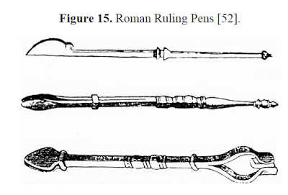
DRAWING PENS

Metal drawing pens have been found in England from during the SCA time period. Drawing pens are used to draw lines as opposed to write words. While they could double to draw guidelines for the writing, that job belonged to the ruling pens mentioned above. Typically drawing pens are used to draw figures, some of which were painted in later, but often were free standing artwork on their own. Drawing pens were also used for ink filigree work in decorating lettering.
This pen dates to the medieval period circa 1400 – 1500 AD. It is a cast copper alloy pen. The writing end is somewhat leaf shaped has four curving, flat foils that taper to a point.

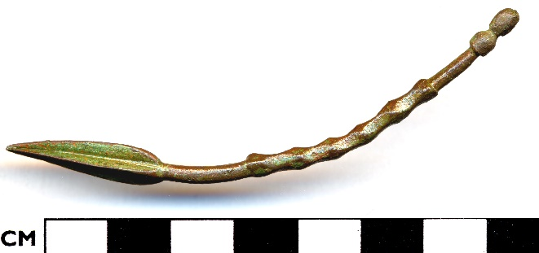
The below three pens are dated early to late 16th century. They do not have the foils of the pen above and the terminal end is missing. They do share the quality of having been bent and the ridging is very similar. It is surmised that the ridging is for a better grip while drawing.
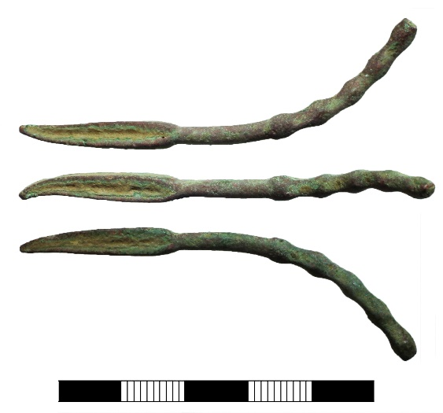

WRITING PENS

The copper alloy writing pens are found in Roman Britain times, which arguably starts in 43 AD and ends definitively in 410 AD when Alaric's Goths sacked Rome. The pens found come in two varieties. In this paper the first group we will discuss is the detachable nib and the second group will are full length pens made entirely from a copper alloy. The metal nibs are shaped very much like modern nibs without reservoirs but the attachment end to hold it to a nib holder varies for reasons unknown. The full metal pens are a shaped piece of copper alloy and then rolled into a tube, sometimes with a split nib and sometimes without.
Detachable Nibs
The first type of metal pen are the detachable pen nibs. The following blurb about a finding of a group of pen nibs in Hungary, is what started my search for metal pens in the SCA time period.

Veliki Preslav - "We found an incredibly interesting and one of its kind set of 11 bronze pen nibs, which used to be put on the pens during the Golden Age of Simeon I of Bulgaria," archaeologist Professor Nikolay Ovcharov announced for FOCUS News Agency, commenting on the findings at the Patriarch Basilica at the palace complex of the Veliko Preslav historical and archaeological reserve. "The pen nibs were used during the time of the literary school of the First Bulgarian Kingdom of Simeon I of Bulgaria. They were in a separate bag and were used for the processing and making of books – not only for writing but also for miniatures – for the best we know that has been happening during the Golden Age of Simeon I of Bulgaria," Ovcharov remarked. "Each of these pen nibs, which are cone-shaped, has different diameter, which means that they were supposed to make different lines of ink – wider, smaller and so on," Professor Ovacharov commented further. "It is something similar to the great novel The Name of the Rose by Italian author Umberto Eco and monk Adelmo, who in the XII-XIII century writes books and illustrates them with wonderful miniatures. Something similar we see illustrated during the Golden Age of Simeon I of Bulgaria," Ovacharov explained.

That is the entire piece. Short and simple, yet so tantalizing. Metal nibs in period? This was published three years ago without pictures. It was unlikely to be an isolated incident of metal nibs in period but without proof of use elsewhere it was a mere anomaly as suggested by the article. I did find more metal nibs and this time with pictures:

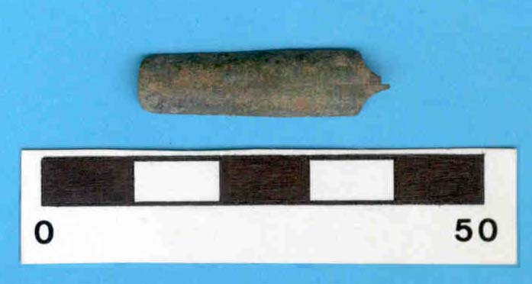
Find A.2000.78.28 Copper alloy pen nib from the medieval period found in Southampton, England.

Here we see nibs with a cross pattern on the distal end from the writing point; much like a flattened Phillips head screwdriver might look.
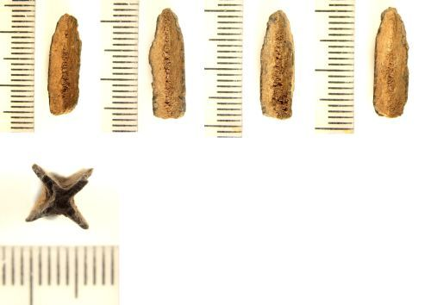
Unique ID: LIN-CDD296 copper alloy pens most likely from the 16th century. Length: 19 mm Diameter: 7 mm
Metal nibs were used in period, but I have only a couple examples that I have been able to find. Yes, they are in disparate places and times which suggests the possibility of widespread geographic and timespan use, but that is all it is, a suggestion. Three finds however lend legitimacy that is otherwise missing.

Full Metal Pens
The second type of pen were the full length copper alloy pens.

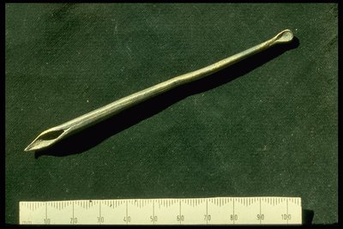

ID no: 82.145/2 Location: On Display: Museum of London: Medieval London: Writing and Printing Dated to circa medieval period (500 AD to 1500 AD)

This pen has an oblong formed "scoop" on the end opposite the split writing nib. This scoop is absent is some of the pens and present in others. A period reproduction of this pen created by Master Aethelstan Aethelmearson* has shown that this scoop is excellent for procuring ear wax, an important ingredient in some period binder and pigment recipes.

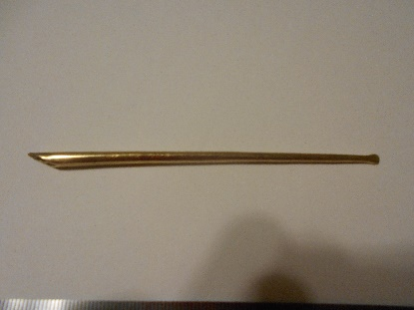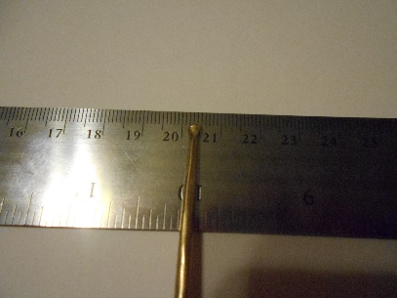
Aethelstan's reproduction pen "Scoop" end of Aethelstan's reproduction pen.

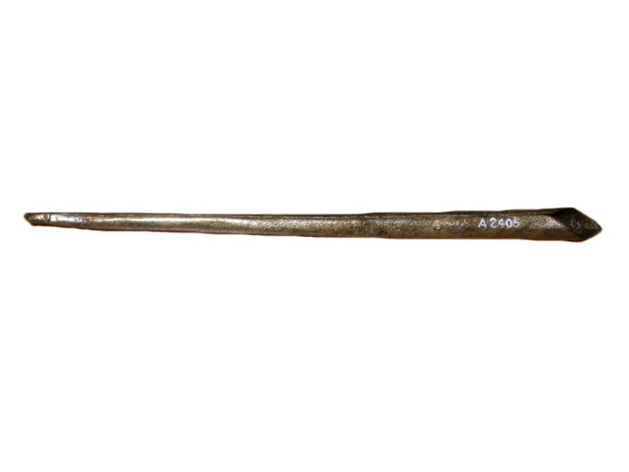
ID no: A2405 Location: On Display: Museum of London: Medieval London: Writing and Printing Dated to circa medieval period (500 AD to 1500 AD)
This pen is missing the scoop as well as a split nib. Both of these pens are described by the Museum of London as "Medieval pen made from a sheet of copper alloy that has been rolled into a tube. The tube is wider at one end, which has been cut into a point for writing."

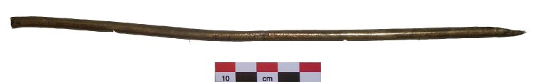
This pen is held by the British Museum and is museum number 2005,0402.33 Described as a "Copper alloy tubular pen with split nib" from the "Culture/Period: Romano-British." It is 245 mm long, making it roughly twice as long as the other pens shown. The length is similar to another Romano-British pen in the possession of the British museum.

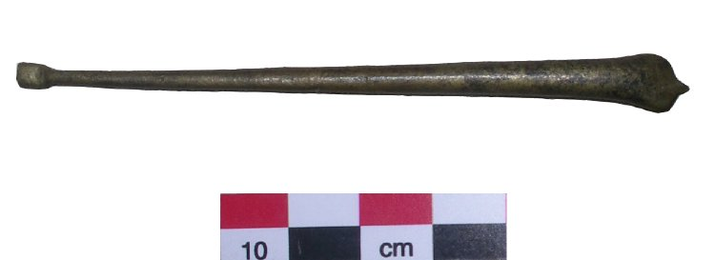
Museum number1865,1220.21, copper alloy pen split nib, Romano-British era. This pen also exhibits a "scoop" on the end distal to the writing nib. Exact measurements are not provided by the British Museum for this piece. It seems to be roughly 2/3 the length of the above Romano-British pen immediately above.

These two extant pens firmly establish full length metal pens made of copper alloy, being present and presumably in use by the Romano-British people as early as the mid first century and no later than the early fifth century. Other museums also have such pens.

The German Museum Köln Romano-Germanisch museum has four such pens on display. Seen here as part of a larger display they are marker 13. The museum "is an archaeological museum in Cologne, Germany. It has a large collection of Roman artifacts from the Roman settlement of Colonia Claudia Ara Agrippinensium, on which modern Cologne is built." Roman occupation there closely mirrors that of Romano-Britain.

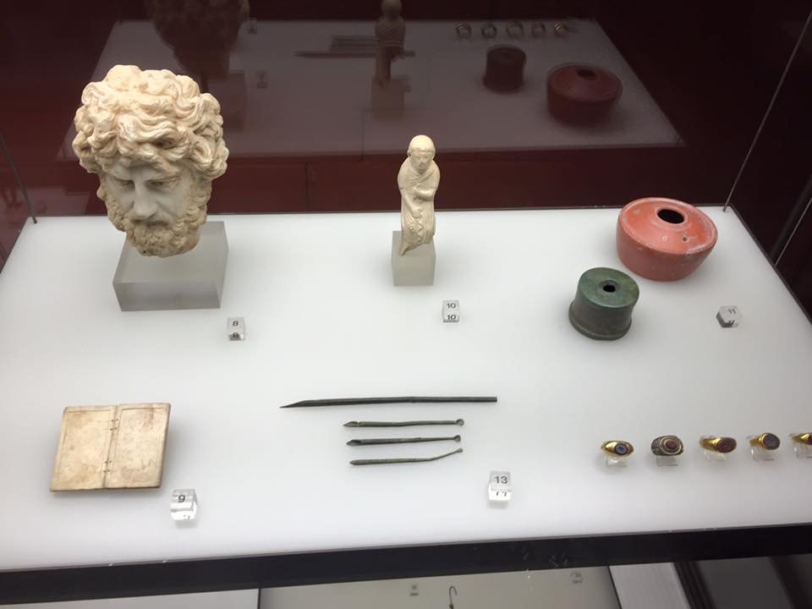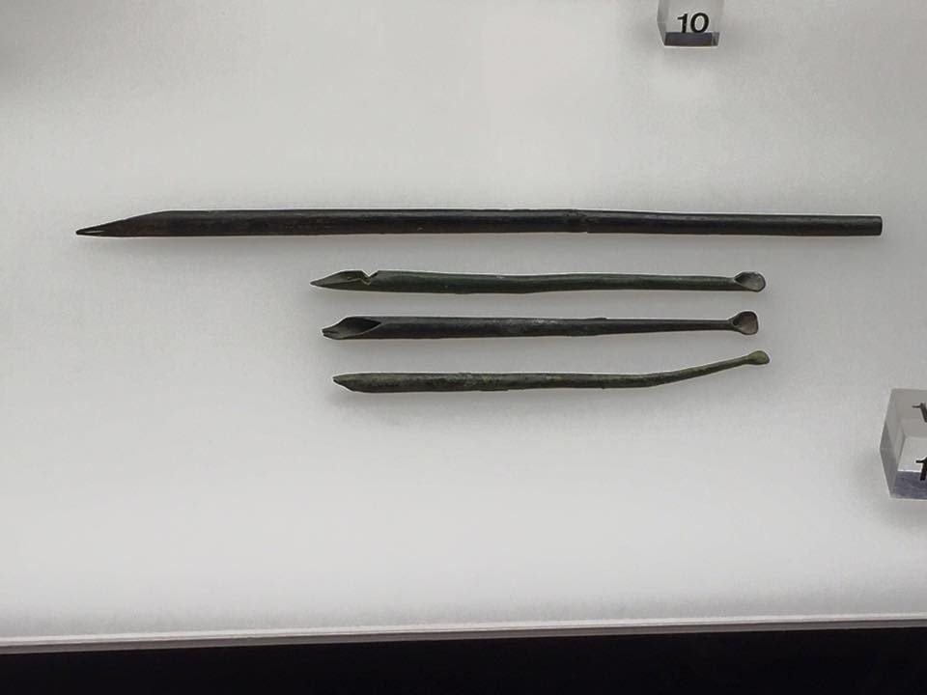

We see that three of the pens are roughly the same length and one is much longer.

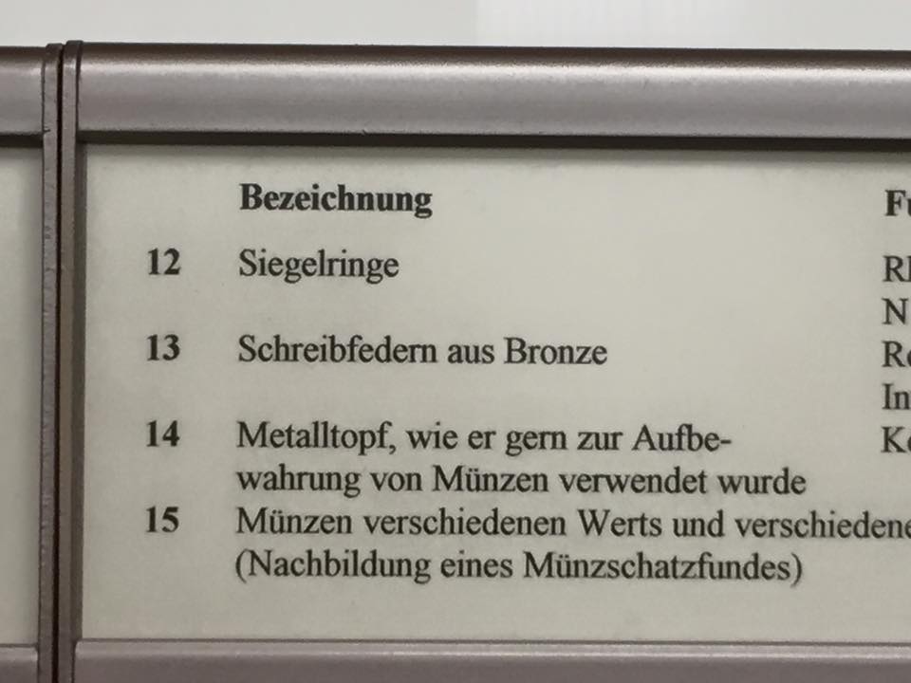

Marker 13 is listed as "Schreibfedern aus Bronze" translated into English as "Bronze writing pen." This establishes that in at least two disparate places between the 1st and 5th century, Romans had, and were presumably using, copper alloy pens.
We also see that these two pens, each in different places, were shaped roughly the same. (Those pens being the British Museum piece museum number 2005,0402.33 and the long pen of marker 13 in the Köln Romano-Germanisch museum) We also see that the shorter pens in the Museum of London and the British Museum medieval period and Romano-Britain greatly resemble the shorter Romano-German pens from the German museum.

Did copper alloy pen use end with the middle ages? No.

This stunning piece is from the British Museum and is dated to 1565-1575.
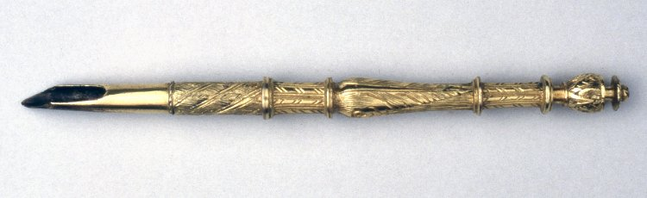

It is gold gilt with a copper alloy base. Created by Bartholomew Newsum, clock maker to Elizabeth I. It is part of the earliest known set of drawing instruments in their original case, the collection of which is magnificent to behold.

With pens of varying purposes having been found in disparate places and times throughout the SCA time period, covering Britain to Germany to Hungary and from the first Century to the very end of the 16th century the conclusion is inescapable: metal pens made from copper alloys were used in the SCA time period. However their use and manufacture spread, we know the pens were anything from plain copper alloy pens to gilded, gorgeous works of art.

REPRODUCTIONS

As a bonus two metal workers offered to make reproductions of these pens. This was entirely unexpected. They both asked that I use the prototypes they made and to provide them feedback about possible modifications. I jumped at the chance to use a reproduction of these pens. I am not a metal worker but I am an experienced scribe who modifies his own modern metal nibs for better more precise work. I was honored and extremely excited to accept these offers.
I received three of the pens from two different makers.

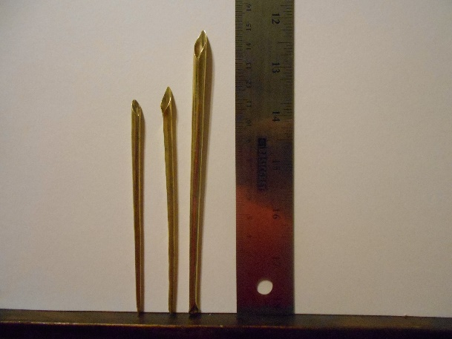

Master Athelstan and THL Gerald Loosehelm made these pens.

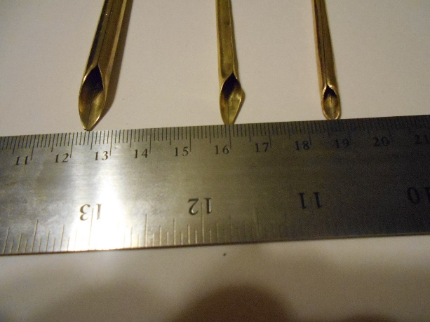

Nicely shaped and very well done prototypes that needed some tweaking.

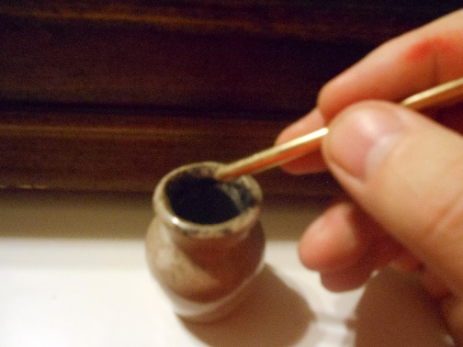
Dipping into a period style inkwell to get period style iron gall ink, the ink stayed in the pen. The pen was able to put ink on the page without just blobbing it all on. So the design was valid as a test object.

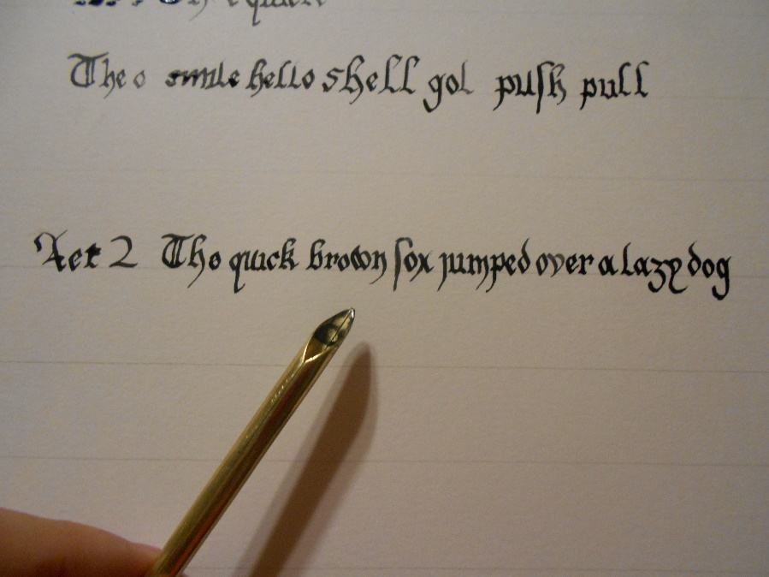
As a new tool, it took some getting used to, but I was able to reproduce a passable calligraphy sentence, thin lines and all. I found that the metal pens were superior to writing with a well-shaped reed pen. Unlike modern metal nibs and quill pens, there is no flex using these reproduction pens, thereby allowing the scribe to push as well as pull the pen without fear of splattering ink across the page.

I made a couple minor modifications. Using crocus cloth (iron oxide cloth instead of sand paper), I shaped the tips to be more angled and crisp, which greatly increased how well the pen wrote. I also filed the shoulders into a more rounded shape like a quill pen and some of the period copper alloy pens.

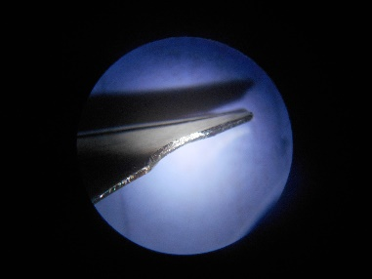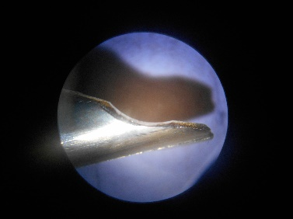

These modification allowed me to control the ink flow from the pen which resulted in better formed letters.

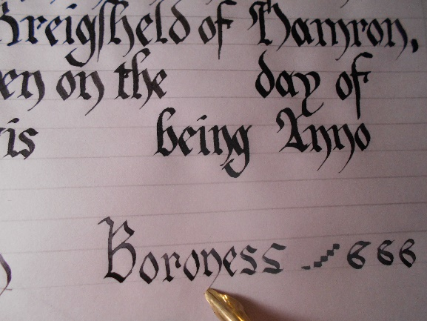

Further testing on one of the reproduction pens has shown that the brass pens are more resistant to the period style iron gall ink than modern steel pens are. If you leave iron gall ink on a modern steel nib over time that steel nib will corrode and develop pits in the metal. I left iron gall ink on THL Gerald Loosehelm's pen for three weeks before cleaning it. Other than being stained a bit by the ink there are no other detectable changes to the brass reproduction pen. This might explain why the period metal pens are all made from copper alloys instead of other metals that were available at the time. Further and more rigorous testing would be needed to test the exact differences.

CONCLUSION

Copper alloys were used to form and create metal pens from the 1st century AD to the end of the SCA time period of 1600 AD. Testing of modern reproduction pens shows that they very likely wrote comparably to quill pens and better than reed pens. Research also suggests that copper alloys may have been used throughout this time period in part due to being resistant to damage from the ink over time. Full length metal pens seem to have been more common to survive than detachable nibs. It is impossible to tell which were more commonly used at this point in the research. The pens were found in England, German and Hungary. The design of the pens did not vary much despite time and place variables. This may be due to having a common progenitor in the Roman Empire or simply that the job of writing is the job of writing regardless of where you went in Europe. There is no doubt that metal pens were used in the SCA time period and as such are valid for being researched and used by scribes in the SCA.

Endnotes:

[1] Buildings 2013, 3, 357-379; doi:10.3390/buildings3020357 ISSN 2075-5309
www.mdpi.com/journal/buildings/ "The Undisciplined Drawing" Alessandro Zambelli Pg 374

[2] Ibid Pg 375

[3] Hayward Trevarthen, C (2007) DOR-173638: A MEDIEVAL PEN Web page available at:https://finds.org.uk/database/artefacts/record/id/180545 [Accessed: Dec 24, 2015 5:06:36 AM]

[4] Broomfield, M (2014) SUR-CBD5AE: A MEDIEVAL PEN Web page available at:https://finds.org.uk/database/artefacts/record/id/619779 [Accessed: Dec 24, 2015 4:48:15 AM]

[5] BBC C 2014 ROMAN BRITAIN Web page available at: http://www.bbc.co.uk/history/british/timeline/romanbritain_timeline_noflash.shtml [Accessed: Jan 2, 2016 10:50 PM]

[6] Patrimudia's Indi-Uni Archeologie & Anthropologie Website Available at: http://www.archeolog-home.com/pages/content/01-octobre-2012-news-bath-veliki-preslav-tullos-hill-ancrum-fontaine-notre-dame-kathio-alep.html [Accessed 1/3/2016 12:35 AM]

[7] Southhampton City Council Archaeological Database Website Available at: http://www.southampton.gov.uk/archaeology/view.asp?acc_num=A.2000.78.281 [Accessed 1/3/2016 12:47 PM]

[8] www.finds.org Find Database Website Available at: https://finds.org.uk/database/artefacts/record/id/176060 [Accessed 1/3/2016 1:01 AM]

[9] Museum of London Collections Web page available at: http://collections.museumoflondon.org.uk/online/object/29605.html#sthash.aFGRi3HI.dpuf [Accessed: January 2, 2016 11:01 PM]

[10] Museum of London Collections Web page available at: http://collections.museumoflondon.org.uk/online/object/36055.html#sthash.P2pVIW1g.dpuf [Accessed: January 2, 2016 11:19 PM]

[11] Ibid, Ibid 6

[12] British Museum Collections Web page available at:
http://www.britishmuseum.org/research/collection_online/collection_object_details.aspx?assetId=658662001&objectId=1362159&partId=1 [Accessed: January 2, 201 at 11:28 PM]

[13] Ibid

[14] British Museum Collections Web page available at: http://www.britishmuseum.org/research/collection_online/collection_object_details.aspx?assetId=633717001&objectId=810252&partId=1 [Accessed at 1/2/2016 11:35 PM]

[15] Wikipedia "Romano-Germanic Museum" Website located at: https://en.wikipedia.org/wiki/Romano-Germanic_Museum [Accessed at 1/3/2016 12:07 AM]

[16] Köln Romano-Germanisch museum, photographs provided by Photographic Credit and Copyright held by: Sunshadow Photography F. Page Steinhardt, Proprietor P.O. Box 346 Syracuse, NY 13214 (315)480-4993 Email: page at sunshadowphoto.com

[17] The British Museum Collections Online. Website available at: http://www.britishmuseum.org/research/collection_online/collection_object_details.aspx?assetId=438710001&objectId=54948&partId=1 [Accessed 1/3/2016 12:25 AM]

Bibliography – "A Pen To Seize"

BBC C 2014 ROMAN BRITAIN Web page available at: http://www.bbc.co.uk/history/british/timeline/romanbritain_timeline_noflash.shtml [Accessed: Jan 2, 2016 10:50 PM]
http://www.britishmuseum.org/research/collection_online/collection_object_details.aspx?assetId=658662001&objectId=1362159&partId=1 [Accessed: January 2, 201 at 11:28 PM]
Broomfield, M (2014) SUR-CBD5AE: A MEDIEVAL PEN Web page available at: https://finds.org.uk/database/
"Buildings" 2013, 3, 357-379; doi:10.3390/buildings3020357 ISSN 2075-5309
www.mdpi.com/journal/buildings/ "The Undisciplined Drawing" Alessandro Zambelli
Hayward Trevarthen, C (2007) DOR-173638: A MEDIEVAL PEN Web page available at:https://finds.org.uk/database/

Köln Romano-Germanisch museum, photographs provided by Photographic Credit and Copyright held by: Sunshadow Photography F. Page Steinhardt, Proprietor P.O. Box 346 Syracuse, NY 13214 (315)480-4993 Email: page at sunshadowphoto.com

Museum of London Collections Web page available at: http://collections.museumoflondon.org.uk/online/

Patrimudia's Indi-Uni Archeologie & Anthropologie Website Available at: http://www.archeolog-home.com/pages/content/01-octobre-2012-news-bath-veliki-preslav-tullos-hill-ancrum-fontaine-notre-dame-kathio-alep.html [Accessed 1/3/2016 12:35 AM]

Southhampton City Council Archaeological Database Website Available at: http://www.southampton.gov.uk/archaeology/view.asp?acc_num=A.2000.78.281 [Accessed 1/3/2016 12:47 PM]

www.finds.org Find Database Website Available at: https://finds.org.uk/database/
Wikipedia "Romano-Germanic Museum" Website located at: https://en.wikipedia.org/wiki/Romano-Germanic_Museum [Accessed at 1/3/2016 12:07 AM]

---------------
Copyright 2016 David Roland. <ianthegreen01 at gmail.com> All Rights Reserved. Permission for use and reproduction for personal use to members of the Society for Creative Anachronism granted.

If this article is reprinted in a publication, I would appreciate a notice in the publication that you found this article in the Florilegium. I would also appreciate an email to myself, so that I can track which articles are being reprinted. Thanks. -Stefan.

<the end>

Buildings 2013, 3, 357-379; doi:10.3390/buildings3020357 ISSN 2075-5309 www.mdpi.com/journal/buildings/ "The Undisciplined Drawing" Alessandro Zambelli Pg 374
Ibid Pg 375
Hayward Trevarthen, C (2007) DOR-173638: A MEDIEVAL PEN Web page available at:https://finds.org.uk/database/artefacts/record/id/180545 [Accessed: Dec 24, 2015 5:06:36 AM]
Broomfield, M (2014) SUR-CBD5AE: A MEDIEVAL PEN Web page available at:https://finds.org.uk/database/artefacts/record/id/619779 [Accessed: Dec 24, 2015 4:48:15 AM]
BBC C 2014 ROMAN BRITAIN Web page available at: http://www.bbc.co.uk/history/british/timeline/romanbritain_timeline_noflash.shtml [Accessed: Jan 2, 2016 10:50 PM]
Patrimudia's Indi-Uni Archeologie & Anthropologie Website Available at: http://www.archeolog-home.com/pages/content/01-octobre-2012-news-bath-veliki-preslav-tullos-hill-ancrum-fontaine-notre-dame-kathio-alep.html [Accessed 1/3/2016 12:35 AM]
Southhampton City Council Archaeological Database Website Available at: http://www.southampton.gov.uk/archaeology/view.asp?acc_num=A.2000.78.281 [Accessed 1/3/2016 12:47 PM]
www.finds.org Find Database Website Available at: https://finds.org.uk/database/artefacts/record/id/176060 [Accessed 1/3/2016 1:01 AM]
Museum of London Collections Web page available at: http://collections.museumoflondon.org.uk/online/object/29605.html#sthash.aFGRi3HI.dpuf [Accessed: January 2, 2016 11:01 PM] * Master Aethelstan Aethelmearson is now my Laurel in Ansteorra. At the time of the making of the replica pen he was not.
Museum of London Collections Web page available at: http://collections.museumoflondon.org.uk/online/object/36055.html#sthash.P2pVIW1g.dpuf [Accessed: January 2, 2016 11:19 PM]
Ibid, Ibid 6
British Museum Collections Web page available at: http://www.britishmuseum.org/research/collection_online/collection_object_details.aspx?assetId=658662001&objectId=1362159&partId=1 [Accessed: January 2, 201 at 11:28 PM]
Ibid
British Museum Collections Web page available at: http://www.britishmuseum.org/research/collection_online/collection_object_details.aspx?assetId=633717001&objectId=810252&partId=1 [Accessed at 1/2/2016 11:35 PM]
Wikipedia "Romano-Germanic Museum" Website located at: https://en.wikipedia.org/wiki/Romano-Germanic_Museum [Accessed at 1/3/2016 12:07 AM]
Köln Romano-Germanisch museum, photographs provided by Photographic Credit and Copyright held by: Sunshadow Photography F. Page Steinhardt, Proprietor P.O. Box 346 Syracuse, NY 13214 (315)480-4993 Email: page at sunshadowphoto.com
The British Museum Collections Online. Website available at: http://www.britishmuseum.org/research/collection_online/collection_object_details.aspx?assetId=438710001&objectId=54948&partId=1 [Accessed 1/3/2016 12:25 AM]

