Birchbark-Let-art - 9/19/18

"Pass Notes Like a Russian with Birchbark" by Sofya Chyudskaya Smolyanina, OP.

NOTE: See also the files: Birch-Brk-Wrt-art, Wr-Birch-Bark-art, paper-msg, parchment-msg, wax-tablets-msg, Rus-Handbook-art, Char-Drw-Stks-art, P-Papermaking-art.

************************************************************************
NOTICE -

This article was added to this set of files, called Stefan's Florilegium, with the permission of the author.

These files are available on the Internet at: http://www.florilegium.org

Copyright to the contents of this file remains with the author or translator.

While the author will likely give permission for this work to be reprinted in SCA type publications, please check with the author first or check for any permissions granted at the end of this file.

Thank you,
Mark S. Harris...AKA:..Stefan li Rous
stefan at florilegium.org
************************************************************************

You can find more of this author's work on her website at:
https://medievalstuff.wordpress.com

Pass Notes Like a Russian with Birchbark
by Sofya Chyudskaya Smolyanina |

Description

From the 11th-14th centuries, the people of Novgorod had an unusually literate culture. Men, women, peasants, and even children knew how to read and write, and they used slips of birchbark for business and personal messages. This class explores what we can learn from these letters about the people of medieval Russia and their lifestyle.
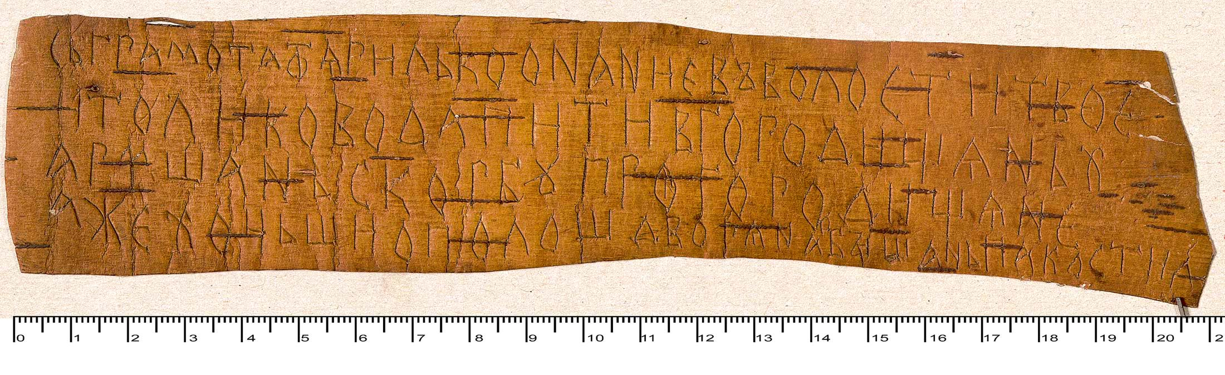
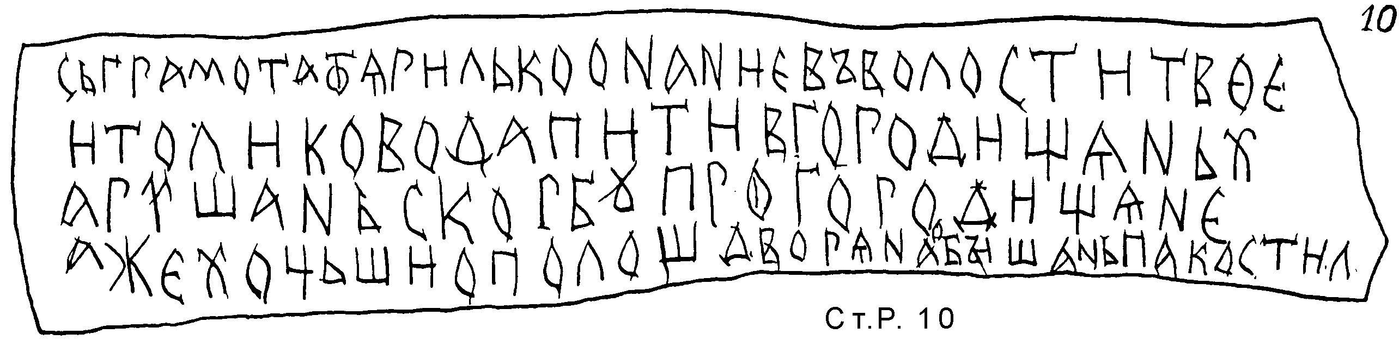

Figure 1: Photo and transcript of a birchbark message, No. 10 Staraya Russa, 1160-1180. (Birchbark Literacy from Medieval Rus: Contents and Contexts)
Translation: "[…] have somebody make […] pearl jewelry in the shape of arrows […] and I bow to you." Postscript: "And buy black canvas and sheathe with lace. Whatever you have spent, Pyatelei [will reimburse] the money."

When and Where

The first birchbark scroll to be discovered was found in a gap between beams of a wooden walkway, crumpled up and covered in mud. If it weren't for characters on the surface that managed to shine through the mud, archaeologists likely would have dismissed it as a bobber for fishing tackle. Enough scrolls have been uncovered since then that we have plenty of evidence that they were used widely, and this has given us ample insight into everyday life.

We have a rough idea of when they were written based on where they were found in the strata of medieval roads. The wooden beams used for pavement have been dated by comparing their tree rings with dendrochronological scales. Novgorodians repaved their roads roughly every 25 years – adding another layer when the dirt on the old pavement got slippery enough to make horses fall. Birchbark scrolls found between two layers of pavement can be dated between the dates when those layers were paved.

Researchers can also date the writing on scrolls based on linguistic features that are similar to those found in manuscripts from those eras. For example, someone writing a book on parchment in the 11th century would have used the same grammar, syntax, and writing style as someone writing a birchbark memo from the same period, because the two scribes were taught the same way.

Of more than 1,200 birchbark scrolls excavated from medieval Russian cities (Novgorod, Staraya Russa, Smolensk, Pskov, Vitebsk, Torzhok, Moscow, and Tver'), 85% were found in Novgorod and were written in the Old Novgorod dialect.

Letters were usually discarded after use, either torn into pieces along the text or cut with a knife or scissors and thrown out to protect the recipient's privacy. These messages survived due to Novgorod's cold, humid climate and high water table. We have far fewer archaeological records after the second half of the 18th century when Catherine the Great ordered the town's soils to be drained.

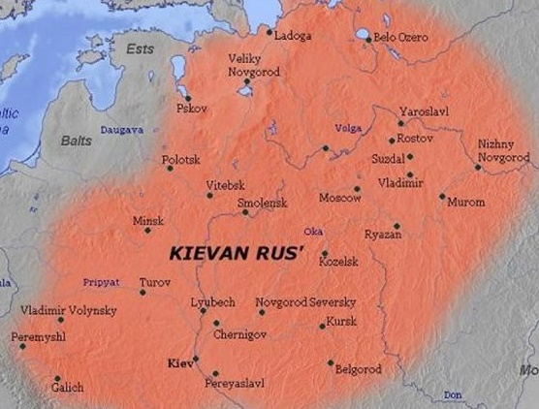
Figure 2: Putting medieval Russian cities on the map. (Wikimedia Commons)

Novgorod fell to Ivan III in 1478. Scholars believe that this was the end of birchbark letters. Ivan III executed or evicted a number of the Novgorod elite and a few severe famines wiped out a lot of other people. Enough people lost their wealth, homes, etc. that the way of life was interrupted – literacy education ended, along with the practice of keeping business notes and sending correspondence. By the time of a 1614 census, the city was practically deserted.

Language and Literacy

Linguistically, Slavs from different tribes in the 9th-11th centuries could understand each other without much trouble. The Old Novgorod dialect was also spoken in Pskov, Perm, and Northern Belarus. It differed from the central dialect spoken in Kiev, Chernigov, Ryazan, Smolensk, Rostov, and Suzdal. This central dialect was closer to the Church Slavonic that became the standard written language. The difference between dialects increased in the 11th-12th centuries but disappeared by the 17th century, after the Novgorod Republic was annexed by the Grand Principality of Moscow. Modern Russian language has features from both dialects (Zaliznyak, Andrey).

Russians wrote in the Cyrillic alphabet, developed by Cyril of Byzantium and his brother Methodius, who were tasked with creating a Slavic alphabet based on the Greek model.

The Sofia First Chronicle tells us that Yaroslav the Wise traveled to Novgorod in 1030 and gathered 300 children of local priests, then put them into a school where they learned from the local bishop. The first students became the earliest birchbark scribes, likely social elites. It became common practice to teach children how to read and write at age seven. The most "famous" example of this education comes from 17 scraps of birchbark lessons and doodles by a seven-year-old boy named Onfim in the 13th century. His drawings look much like a modern seven-year-old's.

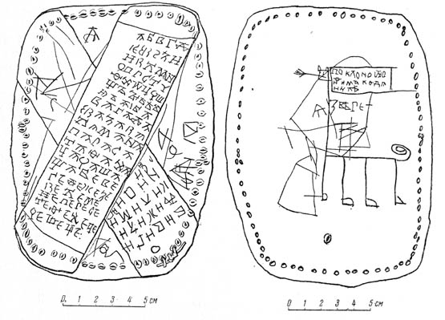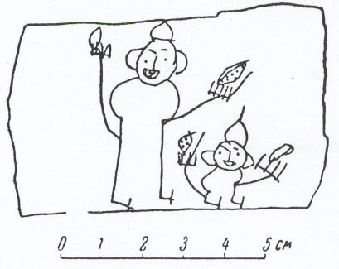
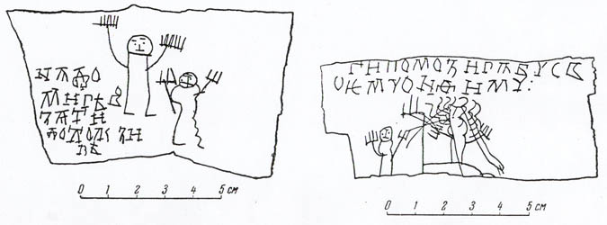
Figures 1-4: Writing and drawings by 7-year-old Onfim, 13th c. Novgorod. Figure 1 shows front and back images of one piece (or two stitched together). One side has his practice lessons, and the other has a picture of himself as a wild beast (complete with the words "I am a wild beast"). The beast is holding a sign that reads "Greetings from Onfim to Danilo." Figure 2, without words, is up to more interpretation – but appears to show a man and boy wearing helmets and holding knives, possibly Onfim and his dad. Figure 3 (left, second row) is a picture of Onfim's parents. Figure 4 shows two children playing around a tree. ("The Art of Onfim: Medieval Novgorod Through the Eyes of a Child.")

Many researchers theorize that wax tablets were used for practice. The Novgorod Psalter, considered "the oldest book in the Slavic world of Russia, Bulgaria, and the Balkan" (Lobatcheva et al), was a type of wax tablet. It dates back to 988 to 1010 and consists of three bound wooden tablets with four wax pages containing Psalms 75-76 and a fragment of Psalm 67 in Church Slavonic.

Writing on birchbark required scribes to press harder, and the results were more permanent – but it made for cheap, convenient stationary, since wax tablets were harder to send back and forth. While parchment was expensive and reserved for important and/or sacred documents, birchbark was plentiful and disposable. People used it for drafts of deeds, domestic notes, and private letters.

Townspeople also read books on parchment. Monastic libraries loaned them out. Letter No. 271 from the 14th century asks for the recipient to send the author something to read.

Literacy spread over the centuries. 95 percent of all discovered birchbark letters were non-religious in subject matter. Women were also literate. Many letters were either written by or addressed to female relatives, based on the names, pronouns, and gendered reflexive verbs in the messages.

A few powerful nobles, like Petr Mihalkovich in the mid-12th century, employed scribes to write their letters for them, but researchers take this to mean that even his servants were literate – and not to assume that Petr himself wasn't. We even have letters written from peasants to other peasants.

The Birchbark

Messages on birchbark were typically short, written on the inner, smoother side of bark strips – 5-15 inches by 1-5 inches on average. They usually name the writer, then the recipient, followed by a statement and a clear ending. Many writers began with a cross as a way of blessing. There was no punctuation or capitalization.

Lobatcheva et al argue that the birchbark was prepared by being boiled in water to make it pliable, though my experiments with boiling bark resulted in curly cinnamon sticks. It's possible that they used more of a cuir bouilli method, or the bark I bought online had been pre-treated with something to interfere with the process.

Writers pressed letters into the bark with a sharp-pointed pen made from bone or iron – no ink was used. More than 200 of these pens from the 10th-15th centuries have been found in Novgorod.

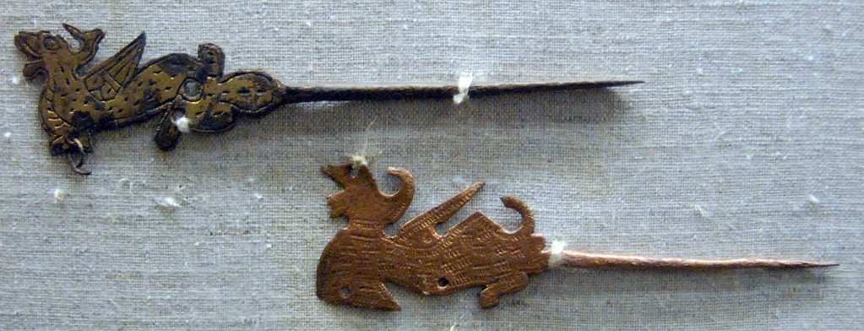
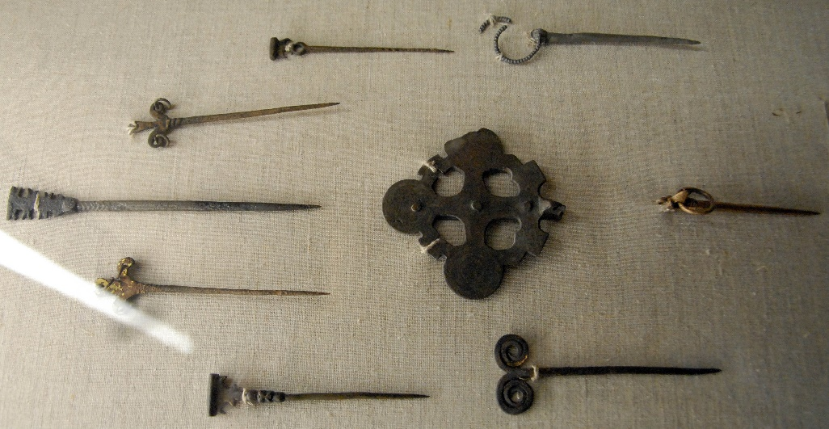
Figures 5-6: Metal pens (Fuller).

The Messages

For the purposes of this handout, I've selected a few choice messages and sorted them by topic. This is just a drop in the bucket compared to the messages that have been excavated and translated.

Clothes:
"A bow from Danil to my brother Ignat. My brother, take care of me, I go naked – no coat, nothing! Send me a red-brown cloak, and I will pay you here whatever its price. Give me a discount – whatever you would find reasonable – for the cost of the cloth. And your wife has not bestowed me with anything. Have compassion, my brother; give me a place at the back: I have nothing to feed on. I bow to you." (No. 765 Novgorod, 1240-1260) [Can Danil be as destitute as he says if he's offering to pay for the cloth? It has to be red-brown, which indicates that the color was in fashion at the time.]

See also: marriage section for povoi message

Crafting:
Inscription made on the bottom of a birchbark basket (No. 957 Novgorod, 11th-12th century): "This basked belongs to Voibuda, and if anyone uses it, put something in it, he will be cursed, and it is written by Shevko." [Presumably Shevko is the person who made the basket in addition to the writing on it.]

"Danilo's basket. Sewed by Petrilo." (No. 1056 Novgorod, end of the 11th century, on a birchbark basket)

No. 644, Novgorod, 1100-1120: "From Nezhka to my brother Zavid. Why do you not send me back what I gave you to smith? I gave it to you, not to Nezhata. If I owe you anything, then send a bailiff. You gave me cloth; if that is the reason why you do not return the forged, then let me know. And I am no longer your sister, if you behave so, if you do not do the work for me! Smith three pendants out of the metal; there are four zolotniks [17 grams] in the two rings." [Nezhka wanted Zavid to make some jewelry for her from two silver rings and was upset that he seemed to have refused.]

See also: image on Page 1 about pearl jewelry and lace

Food / Household:
"[…] make salt fish as is – with guts and all. If you did not salt the susch [fry of percid and ruffle fish] or if you found it by chance from tasting, buy […]" (No. 893 Novgorod, 1120-1150)

"From Mafei to Vinil. Look for ropes for fishing nets, and buy them for five grivnas at your place. Do not hope to get them from here. And ask Petr, 'Where did you lose two loads of susch? Deliver them. If you do not deliver, you will pay one hundred grivnas for the two loads.' The remainder of susch you may keep for food. And certainly buy the fishing net." (No. 30 Staraya Russa, 1180-1200)

"A bow from Kirei to Rostila. Buy me horse meat, burly and good. If you do not come across a good one, buy half [a carcass]." (No. 8 Torzhok, 1160-1200)

"Buy moose hide from Fodor Uroka […] he lives in Slavna – find him." (No. 153 Novgorod, 1175-1200)

Legal issues:
"From Bratyata to my son Nezhil. Go home, son, you are free. If you do not go, I will send a bailiff for you. I have paid 20 grivnas, and you are free." (No. 421 Novgorod, 1120-1180)

"From Kuzma and my children to the headman Raguil. I have given a cow worth one-and-a-half grivna, […] cheese which I bought for a grivna, ten whitefish, and a big piece of meat worth ten kunas to you, and a cow worth a grivna to your clergyman. And I honored your lads and gave them gifts. And you took from me a female slave and a young male slave, both worth seven grivnas, and another female slave worth two grivnas. Though this is okay – God bless you. But why do you pick on me and my children? If someone starts a lawsuit against me (God forbid), he instigates against me and my kids. And you have set your two lads on me and my children because of this. I with my kids […have paid the fine] Out of the money, […] went to the bishop's treasury." (No. 831 Novgorod, 1130-1160)

Penalty for stealing a slave was 12 grivnas: "From Polochek to […] after you took [stole] the wench from Domaslav, Domaslav has taken 12 grivnas from me. Send me 12 grivnas. If you do not send them, I will challenge you in court before the prince and the bishop; then get ready for a bigger loss." (No. 155 Novgorod, 1160-1180)

See the Peasants section for Anna's letter and explanation about churchyard court for commoners, and for Petr's letter to Maria about a land dispute, which was handled through consulting a deed rather than fighting.

Love / Marriage:
"I sent out for you three times. Did you not come to me this Sunday because you are angry with me? And I treated you like a brother! Did I hurt your feelings by sending for you? I see that you did not like it. Otherwise you would have escaped from people's eyes and come to me in a great hurry […] somewhere else now. Write to me about […] I will never leave you […] Even if I unwittingly hurt you, if you start taunting me, you will be judged by God and me." (No. 752. Novgorod, 1080-1120) [Letter with two other fragments missing. Author is a woman writing to a man who apparently argued that he couldn't see her because his relatives would notice he was gone. He may have been a merchant or sailor because after he ripped up the letter, he tied two of the pieces into a sailor's knot.]

"From Milusha to Marena. It would be good for Big Braid to marry Snovid. Marenka! May the bosom quench its thirst! Milusha is telling you: give two grivnas from yesterday." [Analysis by Andrey Zaliznyak: Milusha was a matchmaker hired by Marena/Marenka to find a groom for her daughter, Big Braid. Two grivnas were probably Milusha's service fee. "May the bosom quench its thirst" – wish for newlyweds] (No. 955 Novgorod, 1140-1160)

"A bow from Yanka and Selyata to Yarina. Our boy wants your [bride]. He wants her by the holiday. Please be here urgently. I have promised him my consent, as you told him recently, 'Come – and I will affiance you the same day.' If you do not have povoi with you, buy it and send it. And where I have bread, you will have it, too." [It was customary for the mother of the groom to give the povonik to the bride entering her new husband's house.] (No. 731 Novgorod, 1140-1200)

"From Gostyata to Vasily. What my father gave to me and what my kinfolk added to boot, stays with him. And now, marrying a new wife, he gives off nothing to me. After shaking hands [in token of the new engagement], he has kicked me out and married another woman. Come over, be merciful." (No. 9 Novgorod, 1160-1180) [Gostyata writes to her brother for help after her husband kicks her out of the house and marries another woman.]

"A bow from Oksynia and Onania to Rodivon and my sister Tatiana. Come to town by this Sunday: I will give my daughter in marriage and my sister will be hostess. I bow low to Master Rodivon and my sister." (No. 40 Staraya Russa, 1350-1400) [Oksyinia and Onania lived in Novgorod – the only city that was simply called "town" in birchbark letters. This wasn't just a wedding invitation – traditionally, the parents of the newlyweds weren't supposed to lead the wedding feast, so Oksynia appointed her sister as hostess.]

Money and Measurements:

Silver grivna weighed roughly 204 grams, the weight of a long, silver rod.

Kuna grivna: made from lower-grade silver, weight about 51 grams. In the 11th century, this equaled 20 nogatas, 25 kunas, 50 rezanas, or 150 vekshas. By the 12th century, a kuna grivna equaled 50 kunas (a kuna with its weight reduced by half). In the 13th century, the word grivna was gradually replaced with ruble.

Nogata: coin equal to 1/20 of a kuna
Veksha: smallest currency, = 1/6 kuna. Silver veksha = 1/3 gram silver
Zolotnik: Russian measure of weight, about 4.25 grams
Berkovets: measure of weight = 164 kg
Kad: main unit of dry measure = approximately 840 liters
Osmina: unit of dry measure, i.e., of wheat

No. 238, Novgorod, 1080-1120: "…You gave Nesdich four and a half rezanas, and you gave two kunas to me. Why do you claim that I owe you a grivna and eight kunas? Come to town – I can challenge you at the trial proof with water." [method to determine if someone is a witch]

Peasants / Farm:

"From Negel to Petrok and Yaksha. I co-jointly rented land for 5 years, and now the co-tenants have come and kicked me off. Let Nesluy and the village head judge." (No. 821 Novgorod, 1120-1180)

"From Semnun's wife to Iguchek. Tell the one to whom the cow belongs, 'If you want your cow and come for it, then bring three grivnas.'" (No. 8 Novgorod, 1160-1200) [The cow likely wandered onto Iguchek's field and Semnun's wife gave him advice to collect money from the cow's owner.]

"A bow from Anna to Klimyata. Dear brother, stand up for me before Kosnyatin in my case. Tell him in front of people about his wrongdoing: 'Why are you angry with my sister and her daughter? You held my sister and her daughter responsible and called my sister a bitch and her daughter a whore. And now, after hearing that accusation, Fedor came and kicked my sister out and wanted to kill her.' Dear brother, reconcile with Voeslav and tell Kosnyatin, 'You have accused her, now prove it.' If Kosnyatin says, 'She has vouched for her son-in-law,' then you, dear brother, tell him the following: 'If there are witnesses against my sister, if there are witnesses in front of whom she vouched for her son-on-law, then the fault is on her.' Dear brother, find out what charges and surety Kosnyatin puts on me, and if there are witnesses proving that, I shall not be a sister to you and a wife to my husband. Kill me then; do not wait when Fedor does it. And the money was given by my daughter in front of people, publicly, and I requested a pledge. And Kosnyatin has summoned me to the churchyard, and I have arrived, because he drove off with the words: 'I am going to send four nobles to take the find in silver grivnas.'" (No. 531 Novgorod, 1180-1220) [Possible meaning: Kosnyatin entrusted money with Fedor and suspected that Fedor's family mismanaged the money, lending it without a pledge or witnesses. Kosnyatin insulted Anna and her daughter and summoned them to the churchyard court. When Fedor found out, he beat Anna and kicked her out of the house – leading Anna to ask her brother for help. The churchyard was the court system for commoners – meaning that Anna was likely a literate commoner. The insult from Kosnyatin qualified as a serious crime punishable by a fine according to Yaroslav the Wise's church charter. Anna was within her rights to initiate a counterclaim. Her brother likely acted on her letter, as it was found on the territory of court member Olesei Grechin's homestead.]

"A bow from Petr to Maria. I mowed a meadow, but the people from Ozeritsi took away my hay. Make a copy from the deed of the land and send it here to me, so that I am clear as to where the border of my hayfield is." (No. 53 Novgorod, 1320-1340) [Apparently, the people of Ozeritsi didn't know that Petr had bought the hayfield, considering him an impostor and taking his hay. He didn't ask Maria to call other people for help – he wanted to check his deed himself. This indicates that both Petr and Maria were literate – as were the people of Ozeritsi, or else they wouldn't be able to confirm that he owned the land if he showed them the deed. LITERATE PEASANTS!]

"[…] I am marrying your peasant; I have settled in your village, in the will of God and yours." (No. 356 Novgorod, 1360-1380) [This was a literate peasant notifying a noble that he was marrying a girl in the noble's village.]

Other Cultural Ideas:
"I am no longer your sister" (No. 644, Novgorod, 1100-1120) was a tremendous threat in the 11th century – it goes back to pre-Christian, ancient ideas about renouncing your own family.

"I can challenge you at the trial proof with water" (No. 238, Novgorod, 1080-1120) Method to determine if someone is a witch.

Riddle that was popular from at least 1360-1400 into the 19th c.:
"There is a town between heaven and earth. A dumb ambassador goes there without a path, carries an unwritten letter." (No. 10 Novgorod, 1360-1400) [Town = Noah's ark; ambassador = pigeon Noah sent to find out if the water had receded; unwritten letter = olive branch the pigeon carried as a sign of nearby land]

Mermaid week: festival to celebrate the end of spring, usually at the end of May or early June (1360-1400)

References

Birchbark Literacy from Medieval Rus: Contents and Contexts (INTAS-Project Ref. Nr. 03-51-3867). Rukopicniye Pamyatniki Drevney Rusi. http://gramoty.ru/.

Fuller, Michael J. "Medieval Novgorod: Metal Artifacts." Medieval Archaeological Remains at Velichy Novgorod. Web page with photos from a museum visit. July 30, 2006. http://users.stlcc.edu/mfuller/NovgorodMetalp.html

Lobatcheva, Irina; Bosworth, Amanda; and Lobatchev, Vlad. Letters One Thousand Years Old. Lexington: Parallel Worlds' Books, 2014.

Map of Kievan Rus. Wikimedia Commons, 2010. https://commons.m.wikimedia.org/wiki/File:Kievan_Rus_en.jpg

Paul Wickenden of Thanet. "The Art of Onfim: Medieval Novgorod Through the Eyes of a Child." Text with images based on an article for Tournaments Illuminated #116 (Fall 1995). http://www.goldschp.net/SIG/onfim/onfim.html.

Zaliznyak, Andrey. The Old Novgorod's Dialect. 2004. Zaliznyak is a Russian linguist famous for his specialization in this dialect; he describes about 500 linguistic features that could be used to date birchbark letters.

------
Copyright 2017 by Anne McKinney. <sofyachy at gmail.com>, <https://www.facebook.com/mckinney.anne>. Permission is granted for republication in SCA-related publications, provided the author is credited. Addresses change, but a reasonable attempt should be made to ensure that the author is notified of the publication and if possible receives a copy.

If this article is reprinted in a publication, please place a notice in the publication that you found this article in the Florilegium. I would also appreciate an email to myself, so that I can track which articles are being reprinted. Thanks. -Stefan.

<the end>

