Viking-Bling-art - 5/15/14

"Viking Bling! A Review Of Viking Age Jewelry For Men And Women" by HL HRothgar Thorsson.

NOTE: See also the files: Viking-Beads-art, amber-buying-art, V-Arts-and-A-art, jewelry-msg, finger-rings-msg, brooches-lnks, gem-sources-msg, SCA-Bling-art.

************************************************************************
NOTICE -

This article was submitted to me by the author for inclusion in this set of files, called Stefan's Florilegium.

These files are available on the Internet at: http://www.florilegium.org

Copyright to the contents of this file remains with the author or translator.

While the author will likely give permission for this work to be reprinted in SCA type publications, please check with the author first or check for any permissions granted at the end of this file.

Thank you,
Mark S. Harris...AKA:..Stefan li Rous
stefan at florilegium.org
************************************************************************

Viking Bling!
A Review Of Viking Age Jewelry For Men And Women
by HL HRothgar Thorsson

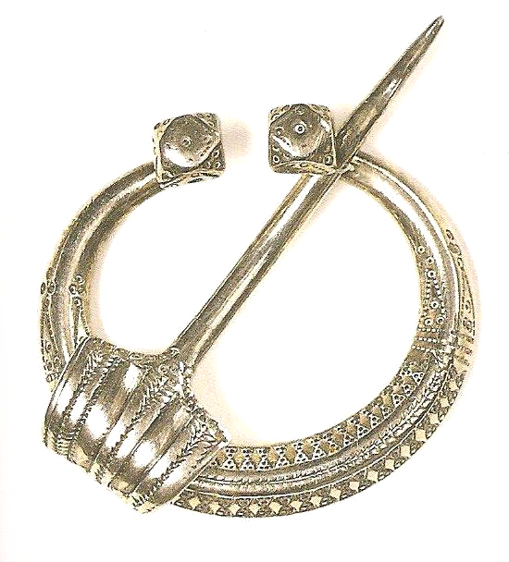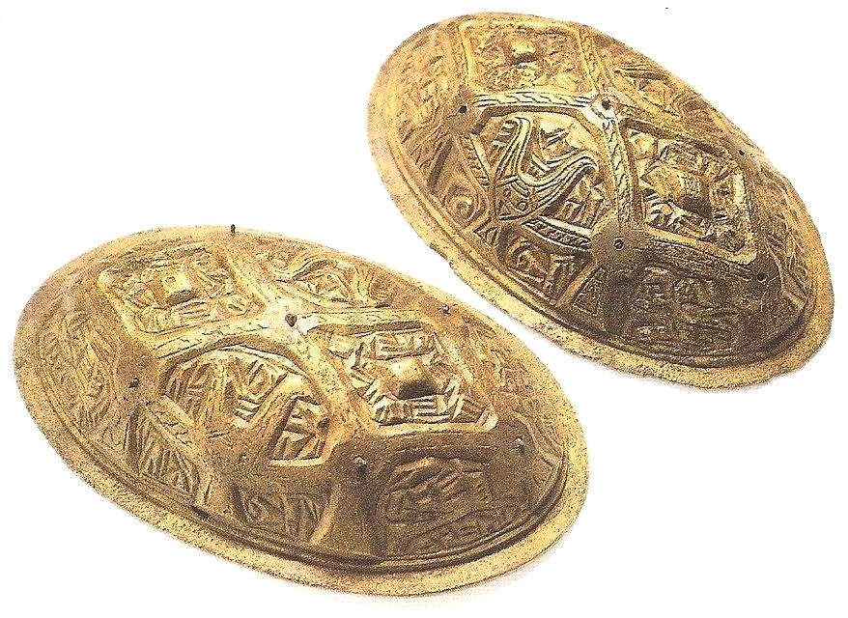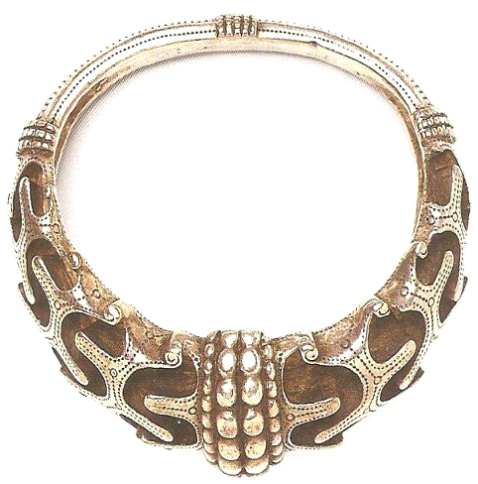

Viking Jewelry - General Information

* Most of our knowledge of Viking jewelry comes from grave finds and treasure buried in hoards.
* More is known about early Viking period jewelry than is known about late-Viking period jewelry. This is because the conversion to Christianity took place around 1000 AD in Scandinavia_ They stopped putting jewelry into graves.
* Designs of Viking jewelry reflected the changing styles of Viking art, usually representing patterns of stylized animals.
* Jewelry was worn by both men and women.
* Jewelry was worn for adornment and for displaying wealth. It also served practical purposes:
a. It was a convenient way of carrying one's personal wealth.
b. It could be used as a means of exchange.
c. It could be used to seal friendships and alliances.
d. It could also serve ordinary, everyday uses like fastening cloaks and dresses.

* The most valuable jewelry was made of gold, but gold was almost always in short supply in Scandinavia. Most jewelry was made of silver or made of bronze and gilded to look like gold. (Gilded - covered in gold leaf.)
* Items of gold and silver jewelry were individually made by highly skilled craftsmen for wealthy customers.
* Cheaper bronze jewelry was mass-produced, usually being cast in clay or stone molds. These would be based on a master copy.
* Most articles of jewelry were functional.
* Most of the silver used in neckrings, armrings, and brooches made in Scandinavia was made from Arabic silver coins.
* All metal other than iron had to be imported into Scandinavia.

Armrings and Neckrings

* Status symbols. Both men and women wore and displayed their wealth in this way.
* Most payments in the Viking Age were made in silver according to weight, so jewelry was a practical way of carrying one's wealth.
* If a smaller amount was needed, the jewelry was simply cut into pieces.
* A variation was called the "Permium Rings". These were Russian in origin that were made of standard weights. They were imported from early in the Viking Age.
* In Scandinavia they were worn as armrings and used as currency.
* These items were often plain and made in standard units of weight so their value could be easily assessed.

Finger Rings and Earrings

* Finger rings were only rarely worn before the late Viking Age. Earrings were hardly worn at all.
* What earrings they had were Slavic in origin. The idea of wearing earrings was very foreign to Scandinavian tradition.

Necklaces

* Colored glass beads were mass-produced for use in necklaces. Beads were also made of amber, semi-precious stone and sometimes were made from gold and silver.
* Necklaces were often hung with souvenirs (odd items picked up from abroad) such as coins and finger rings.
* Amber - semi-precious fossil resin. Often exported. Found on the shores of the Baltic Sea. Soft and easily worked.

Oval Brooches

* The commonest item of Scandinavian Viking Age jewelry were women's bronze oval brooches. (These were seldom made in other metals.)
* Oval brooches were a practical part of women's clothing. One was worn on each shoulder to fasten the overdress.
* In Finland this type of brooch tended to be round instead of oval.
* Oval brooches went out of fashion at the end of the 10th century, to be superseded by fanciful tendril designs of brooches.
* A chain of colored beads was often suspended between the brooches.

Pennanular Brooches

* These were almost exclusively a men's fashion accessory.
* Adopted early in the Viking Age from Irish and Scottish fashions by Viking settlers. It later caught on in Scandinavia and Russia.
* Fastened on the right shoulder with the pin pointed upward, keeping the sword arm free.

Thor's Hammers

* Nearly always worn as pendants.

Trefoil Brooches

* These were Scandinavian versions of a foreign design.
* The trefoil brooches used to fasten women's shawls and cloaks were inspired by the trefoil sword-mounts used in the Frankish Empire.
* These became popular in the 9th century to fasten women's cloaks.

Beads

Vikings obtained their beads by buying them from the great trading towns in Scandinavia such as Birka and Hedeby, inheriting or having them handed down to them, or gathering them while raiding.

Types of beads used by the Vikings:

Flame worked glass could be had from Birka.
Amber from the shores of the nearby Baltic Sea.
Jet, also native to Scandinavia.
Rock crystal, amethyst, and garnet from Europe.
Gold and bronze beads, made locally and imported from abroad.

Surface Decoration On Viking Jewelry

Viking craftsmen would apply silver and gold to the surface of base metals in order to give jewelry a richer, more expensive appearance. Further embellishment was made with the addition of filigree (where fine gold or silver wires are soldered to the surface of the jewelry) and granulation (where small balls of metal are used by themselves or in clusters to form patterns on the jewelry).

Lack of Set Stones in Viking Jewelry

An odd characteristic of Viking jewelry was its nearly total lack of set stones. Gem-setting had been an extremely popular form of ornament in pre-Viking Scandinavia, during which times it was carried out with great skill. It apparently had stopped appealing to Viking tastes in jewelry, and was abandoned (Graham-Campbell; 1980). Cultures the Vikings had contact with, such as the Franks and the Byzantines, continued to use set stones throughout the Viking Age without interruption.

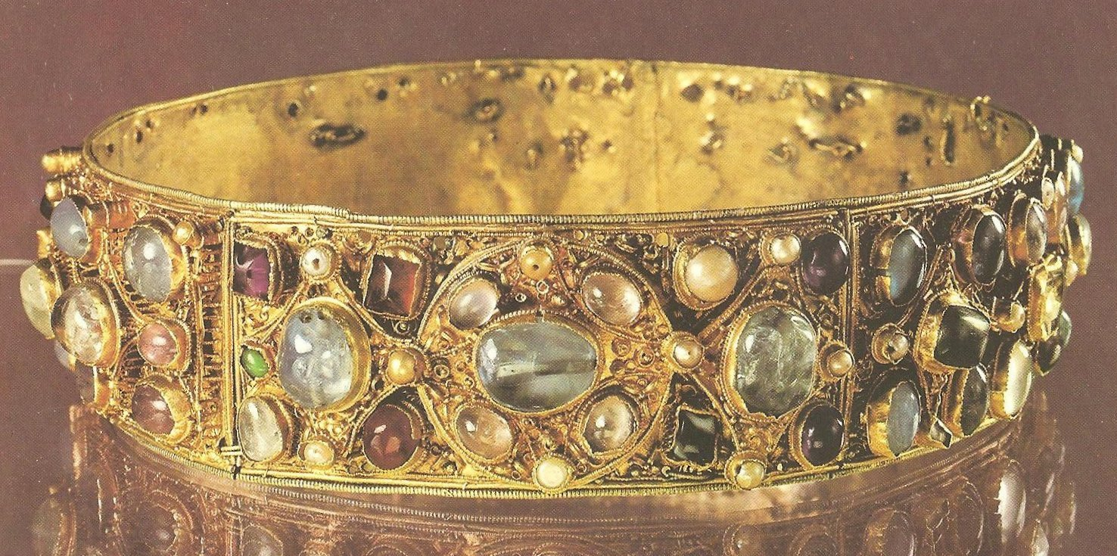
Coronet belonging to Queen Kunigunde of Lichenstein, c.1010, set
with pearls, amethysts, sapphires, and tourmalines. (Mason, 1974)

The Hon Necklace

This is a famous necklace, found in a hoard discovered at Hon, Norway, and dated to the 9th century. This was an extremely rare find, since Viking hoards normally contained mostly silver objects. The Hon hoard, in contrast, contained mostly objects of gold.

The Hon necklace is made of a combination of simple glass beads, carnelian beads and beads of other semiprecious stones, foiled glass beads, and several metal filigree beads. Hanging from the necklace are metal wire rings strung with beads, a golden Islamic coin, and seven gold filigree pendants. The large ring of white beads in front could have served as the necklace's center, leaving the golden pendants and the coin somewhat evenly spaced around the circumference of the necklace.

There is no effort to symmetrically place matching beads equal distances away from the focal point. Rather beads are matched in pairs by size, shape, and tone (light or dark) not only in relation to the focal point, but so that they likewise balance beads 180° around the diameter of the necklace.

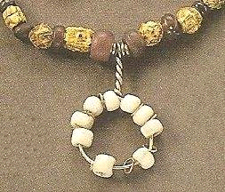
Closeup of the Hon Necklace. (Wilson, 1980)

Bibliography

Wilson, David M.; "The Vikings and Their Origins"; New York, A & W Publishers, Inc 1980 ISBN: 0-89104-184-2 (Wilson, 1980)

Margeson, Susan M,; "Eyewitness Viking"; London, DK Publishing, Inc.1994 ISBN: 978-0-678-86002-0 (Margeson 1994)

Fitzhugh, William W.; "Vikings: The North Atlantic Saga"; Smithsonian Institution Press, Washington 2000 ISBN: 0-56098-995-5 (Fitzhugh, 2000)

Graham-Campbell, James; "The Viking World"; London, Frances Lincoln Limited 2001 ISBN: 0-7112-1800-5 (Graham-Campbell, "The Viking World"; 2001)

Graham-Campbell, James; "The Vikings"; London, British Museum Publications Ltd 1980 ISBN: 0-688-03603-1 (Graham-Campbell, "The Vikings"; 1980)

Mason, Anita; "An Illustrated Dictionary of Jewellery"; New York, Harper & Row, 1974 ISBN: 06012818-6 (Mason, 1974)

Oval Brooches

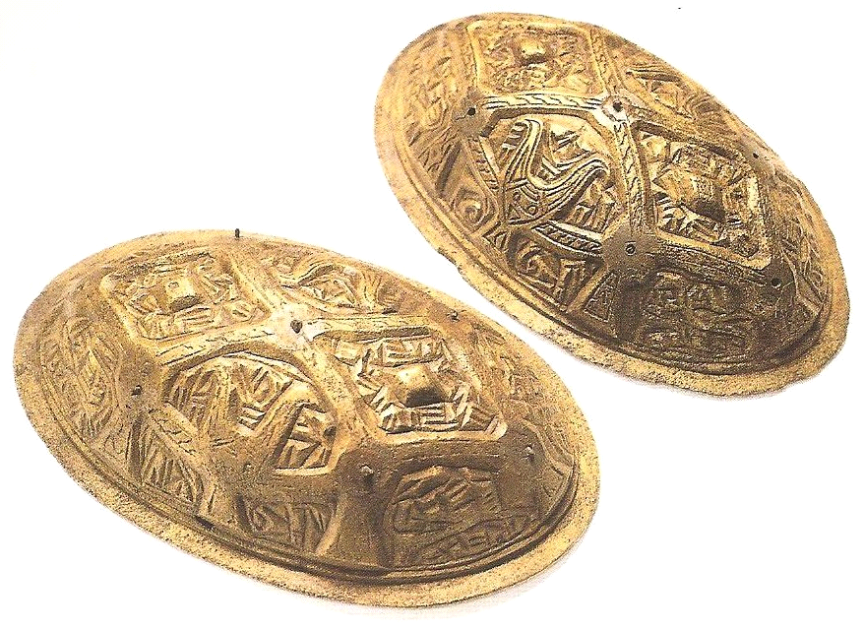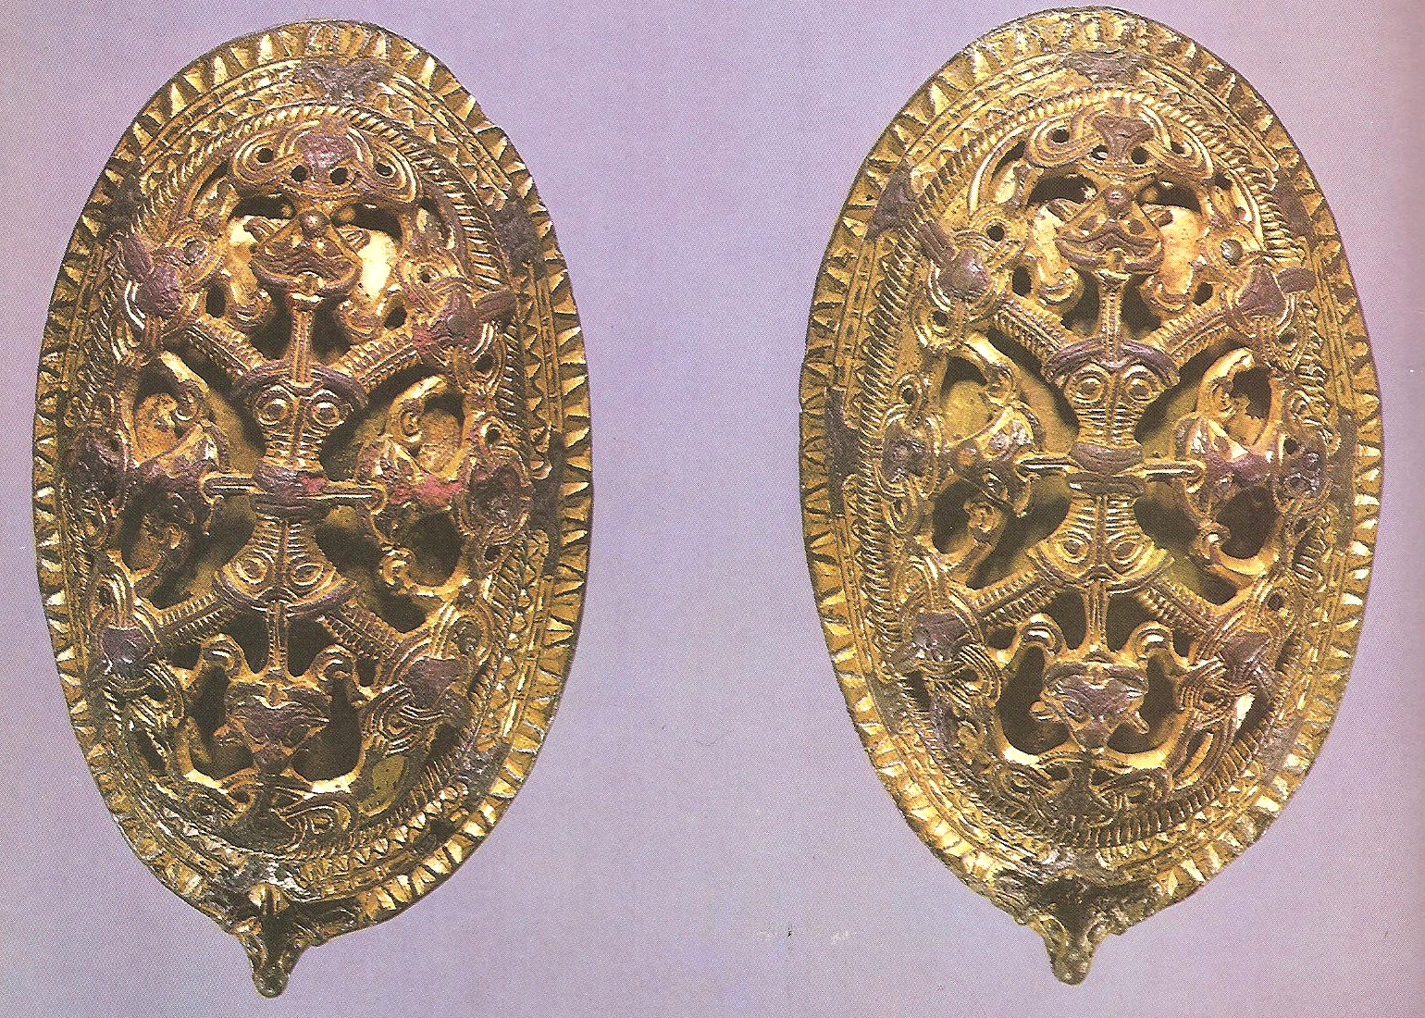

(Fitzhugh, 2000) Viking women pinned their aprons (Graham-Campbell, "The Vikings"; 1980)
to their dresses with oval brooches. More than 50 styles
of oval brooches have been identified.

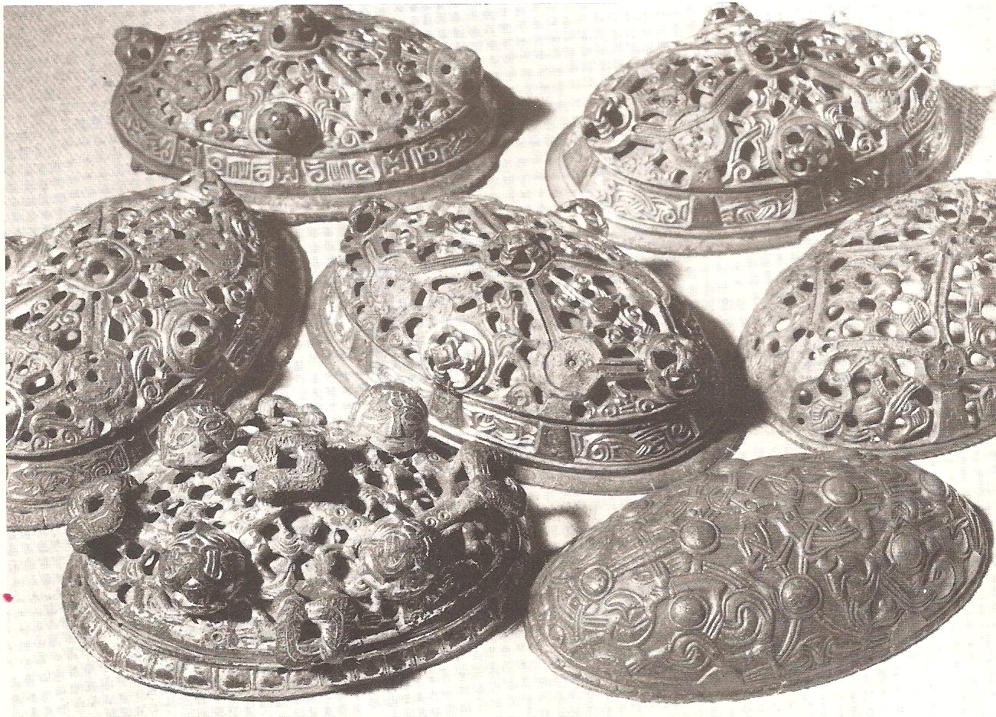
(Wilson, 1980) Oval brooches are the most common form of female ornamentation found from the Viking Age. They were made throughout Scandinavia, and survive in great numbers. Most have been found in graves. Oval brooches were worn in pairs high on the chest, sometime s with strings of beads hung between them. This form of brooch went out of style in the early 10th century, to be replaced by other forms of brooches.

Ringed Pins
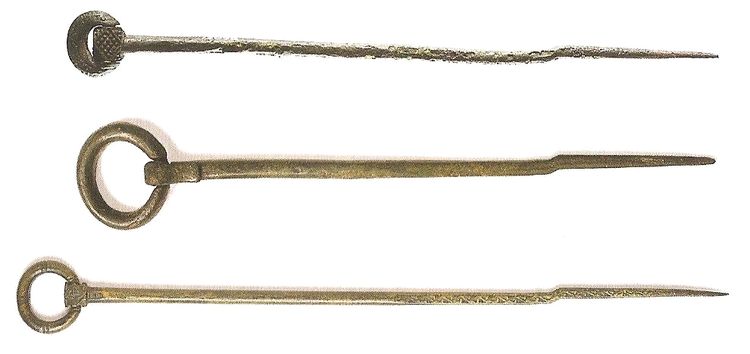
(Fitzhugh, 2000) Ringed pins originated in Ireland and the western British Isles.
These were found in Ireland, Norway, and Iceland respectively, and are thought to
have been made by Viking craftsmen in Dublin after Irish styles.

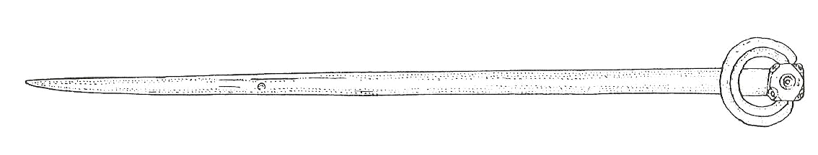
(Fitzhugh, 2000) Faeroe Islands, 10th century from a woman's grave.
Similar pins have been found in Iceland, Norway, and Newfoundland.

Earrings

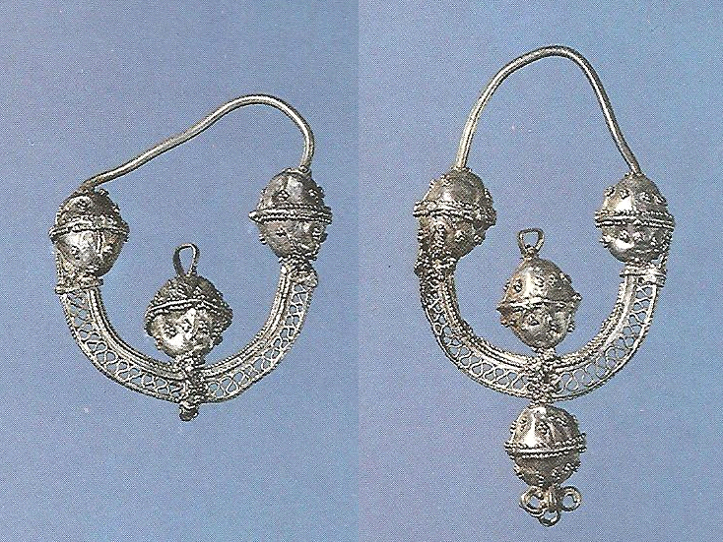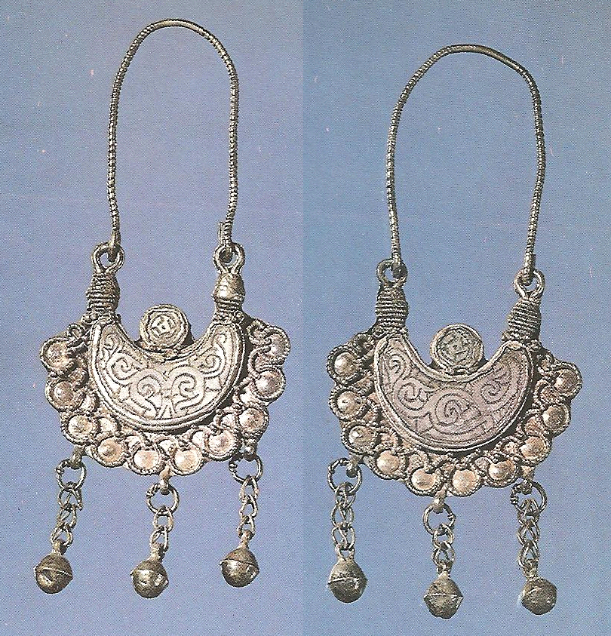

(Graham-Campbell, "The Vikings"; 1980) Earrings imported from western Slav areas.
Found in Sweden, and completely different from native Scandinavian styles of jewelry.
These earrings were made with light openwork, delicate filigree, and embossed shapes.

Box Brooches

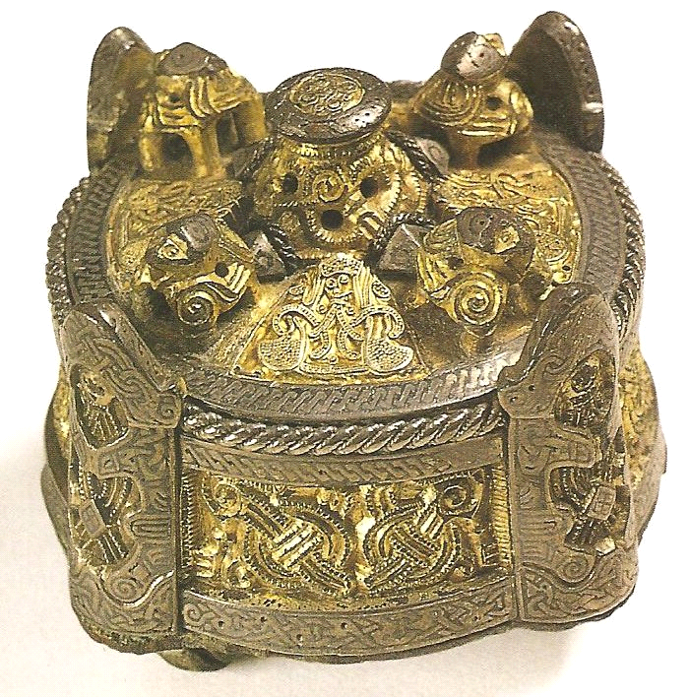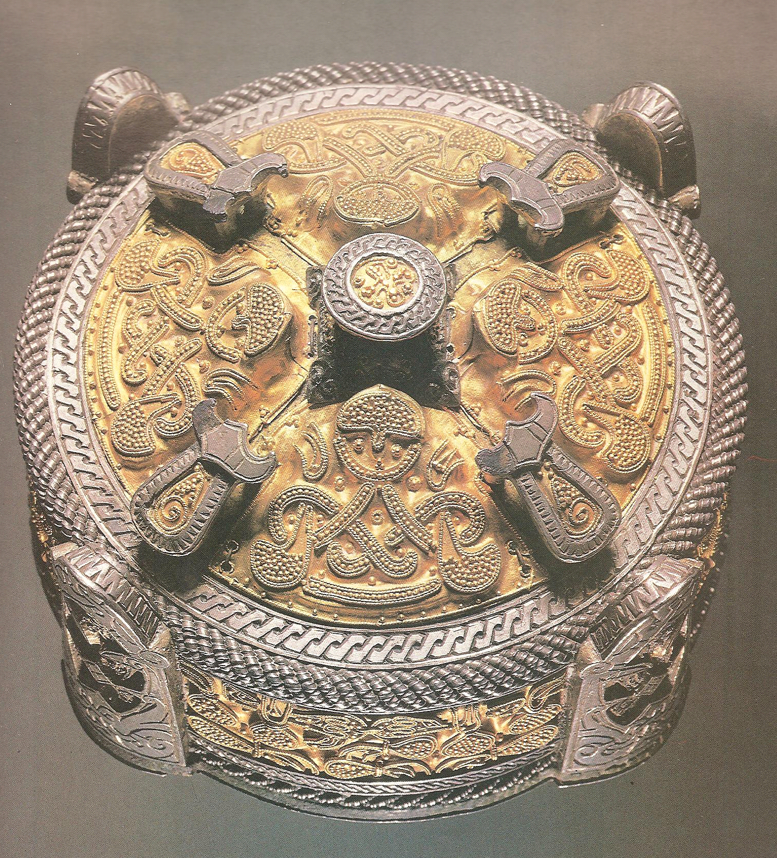
(Fitzhugh, 2000) Gotland 9th century. (Graham-Campbell, "The Vikings"; 1980)
Gotlandic, bronze brooch embellished with
gold, silver and niello.

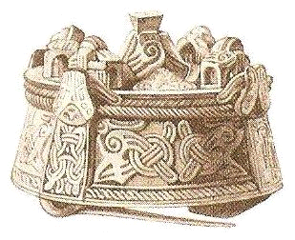
(Margeson 1994)

Beaded Necklaces

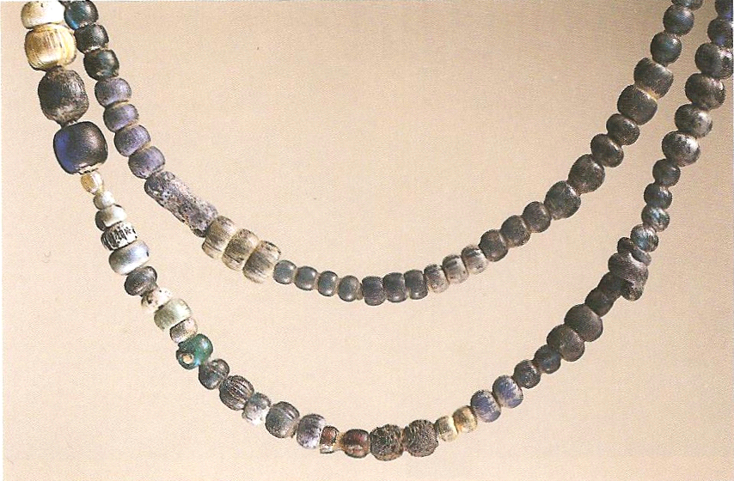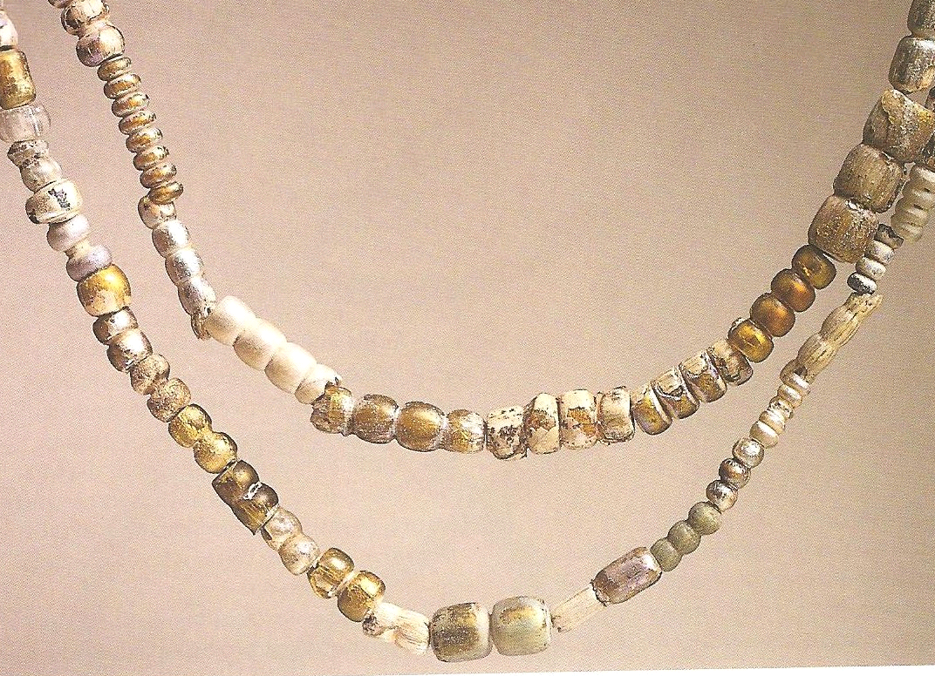

(Fitzhugh, 2000) (Fitzhugh, 2000)
These blue and foil covered glass beads were recovered at Birka, Sweden, and reflect late Viking Age imported styles.

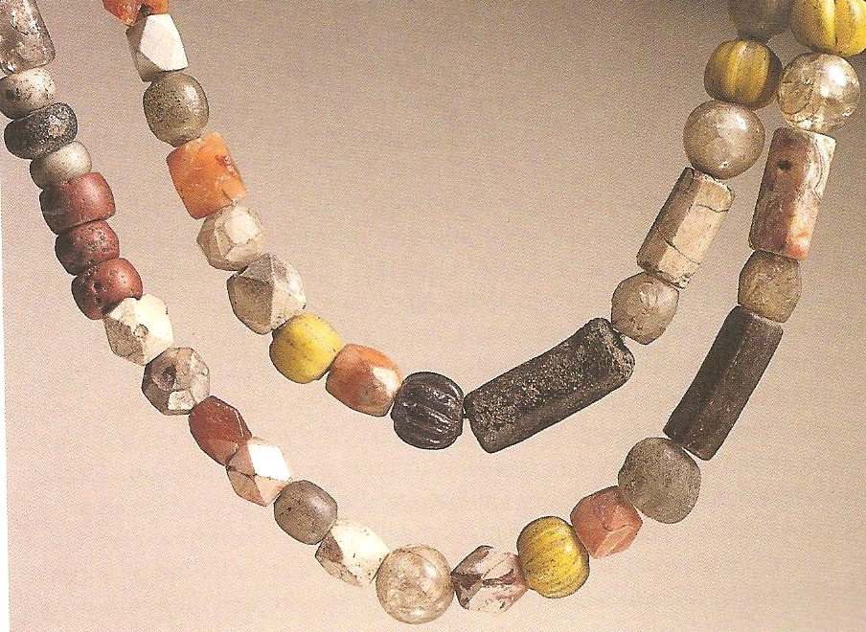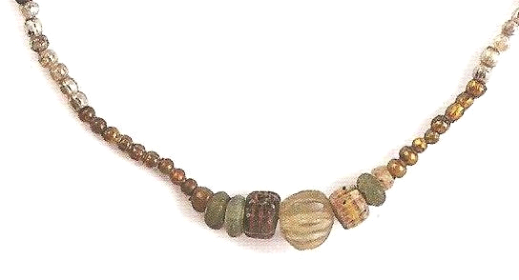

(Fitzhugh, 2000) Found in Gryta, Sweden, this necklace (Fitzhugh, 2000) Iceland 10th century. Glass,
includes glass, crystal and carnelian. These are bronze, and amber bead necklace.
characteristic of older, more traditional Viking styles.

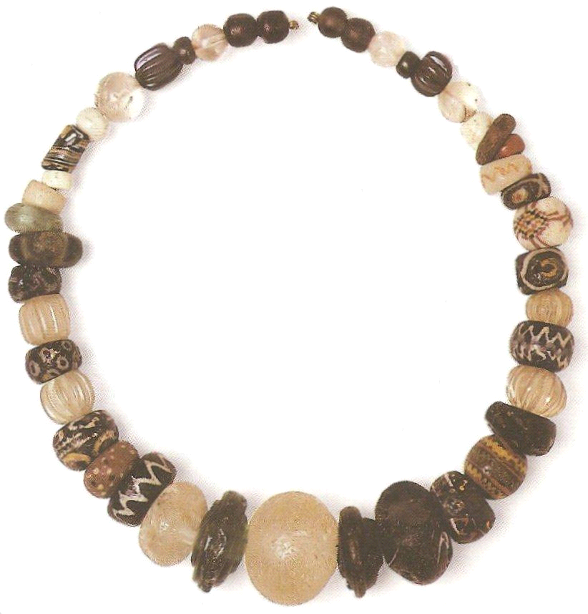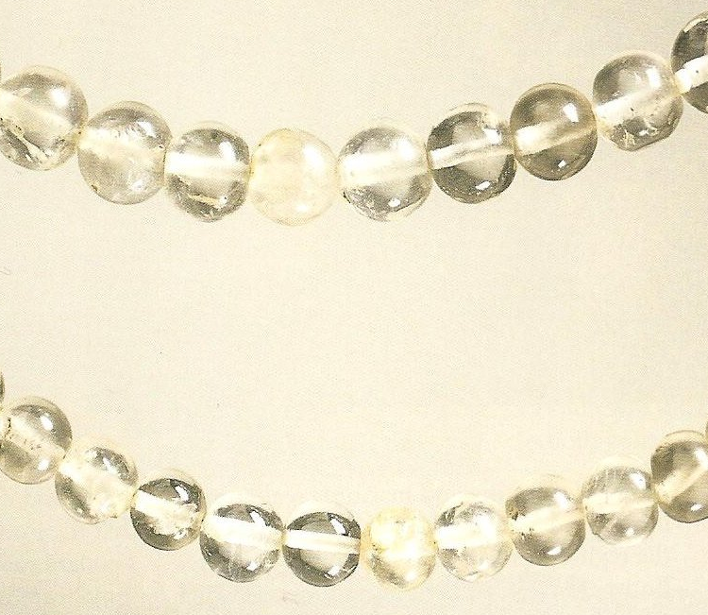

(Margeson 1994) (Fitzhugh, 2000)
Rock crystal _quartz_ bead necklace found in Birka, Sweden. The beads probably originated in the Caucasus, arriving in Viking Age-Sweden via Eastern trade routes.

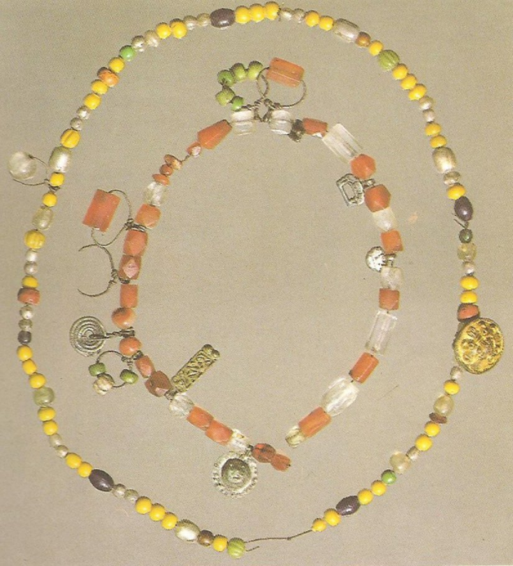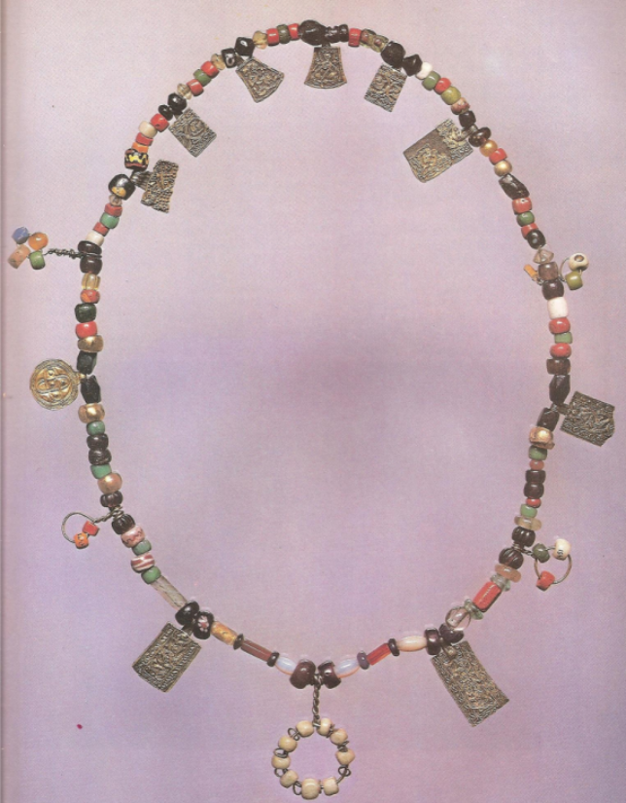

(Graham-Campbell, "The Viking World"; 2001) (Graham-Campbell, "The Vikings"; 1980) Hon, Norway, modern reconstruction.

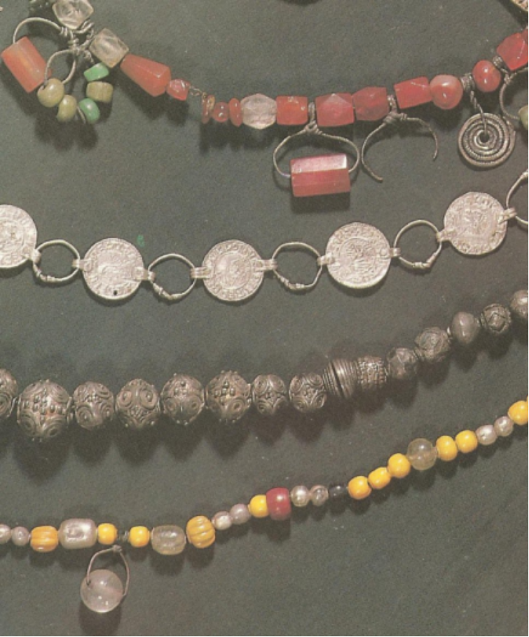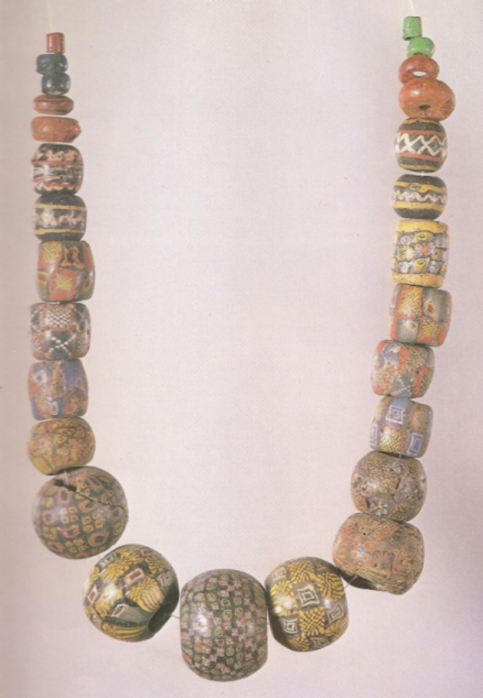

(Graham-Campbell, "The Vikings"; 1980) A variety (Graham-Campbell, "The Vikings"; 1980) A
of Viking Age necklaces, found in Sweden necklace of richly colored glass beads, found
in Eidem, Norway.

Pennanular (Ring) Brooches

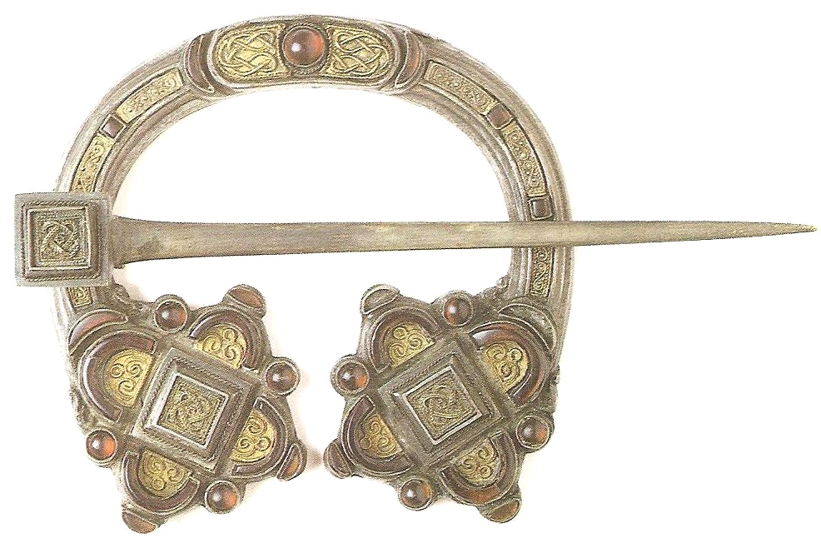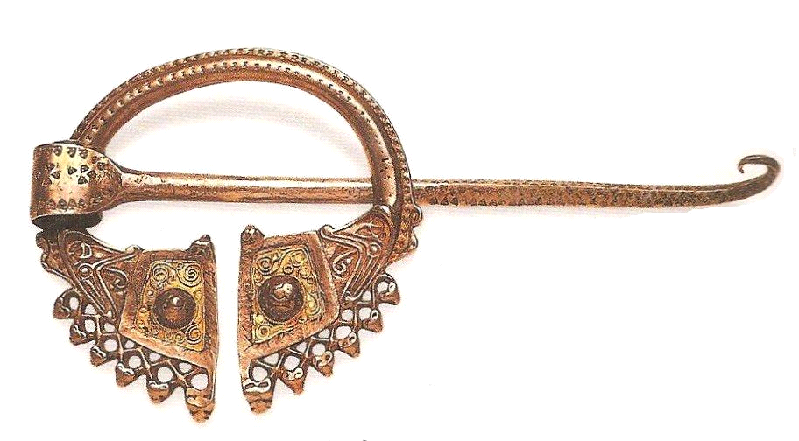
(Fitzhugh, 2000) Irish style pennanular brooch, (Fitzhugh, 2000) Ornate gold and silver brooch.
9th century Irish. Found in Hordaland, Norway. early 9th century. Beautifully made with gold
Found near Kilmainham Island Bridge, Ireland and glass
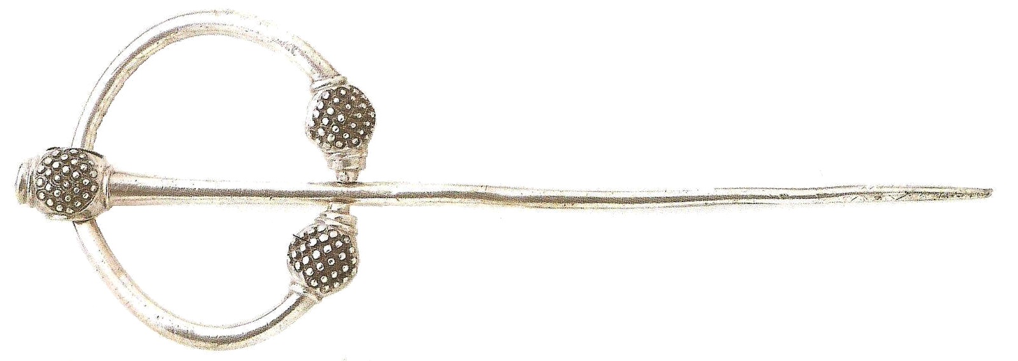
(Margeson 1994)

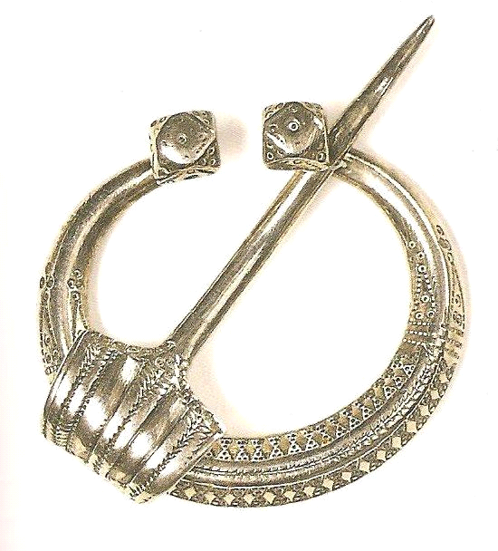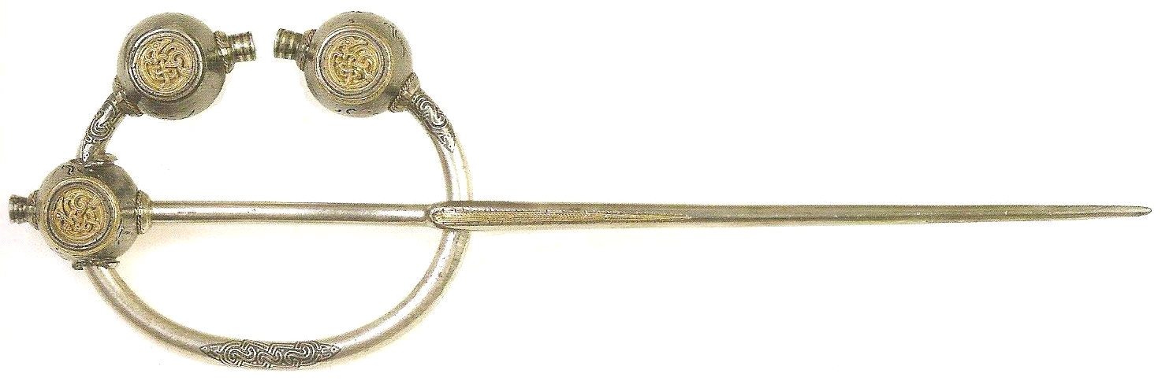
(Fitzhugh, 2000) (Margeson 1994)
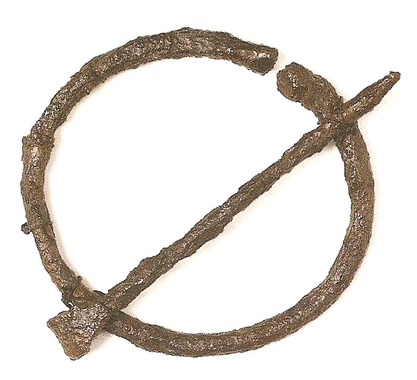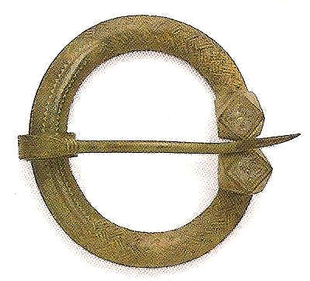
(Fitzhugh, 2000) (Margeson 1994

Neck Rings made from Twisted Gold and Silver
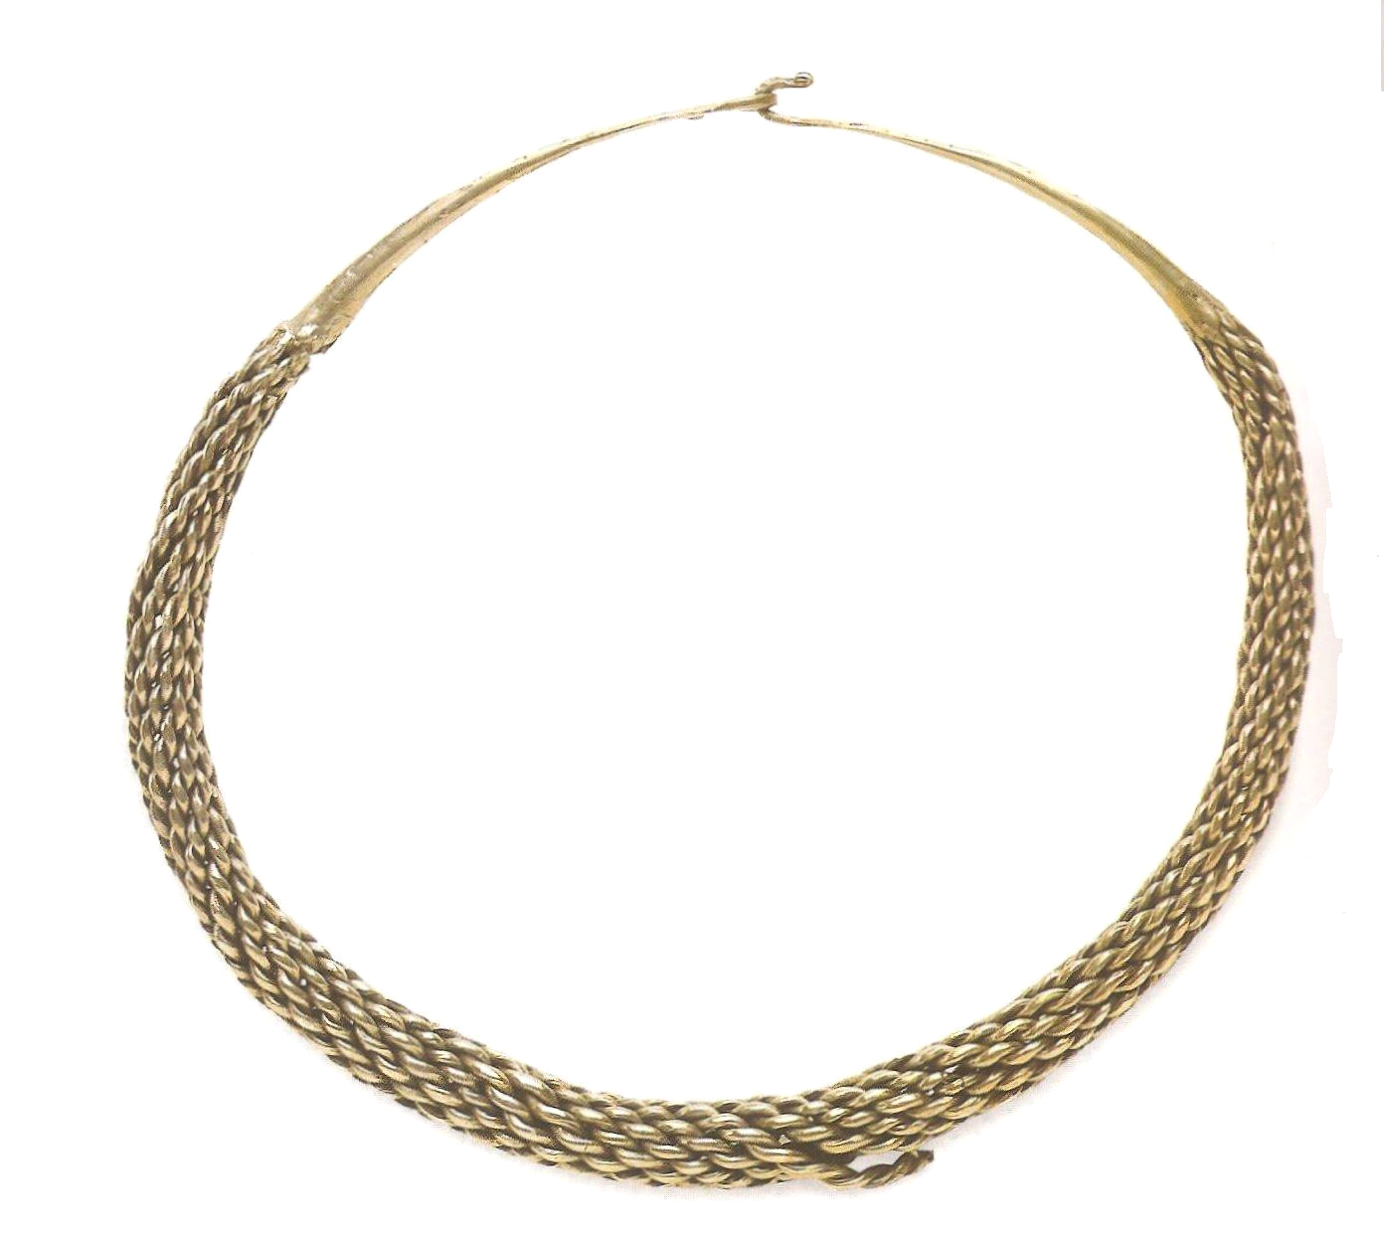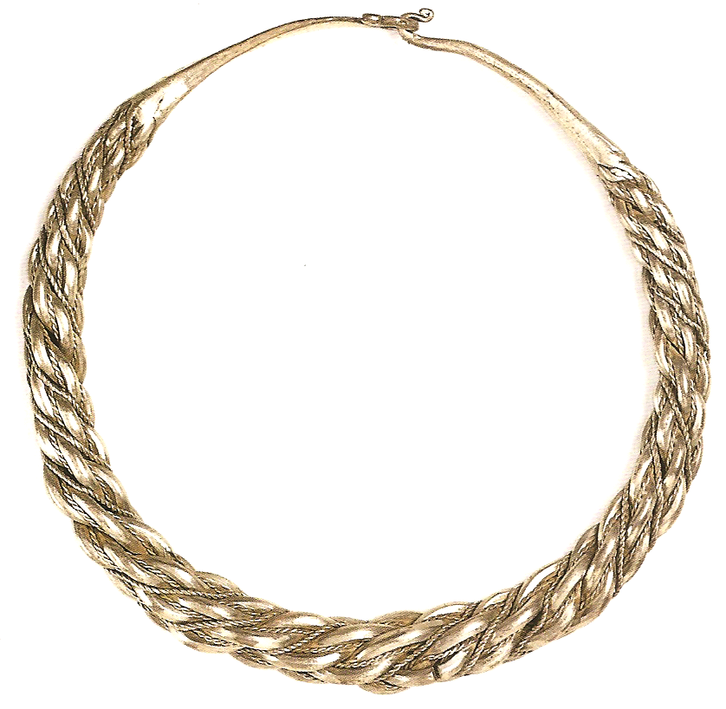
(Margeson 1994) (Fitzhugh, 2000)
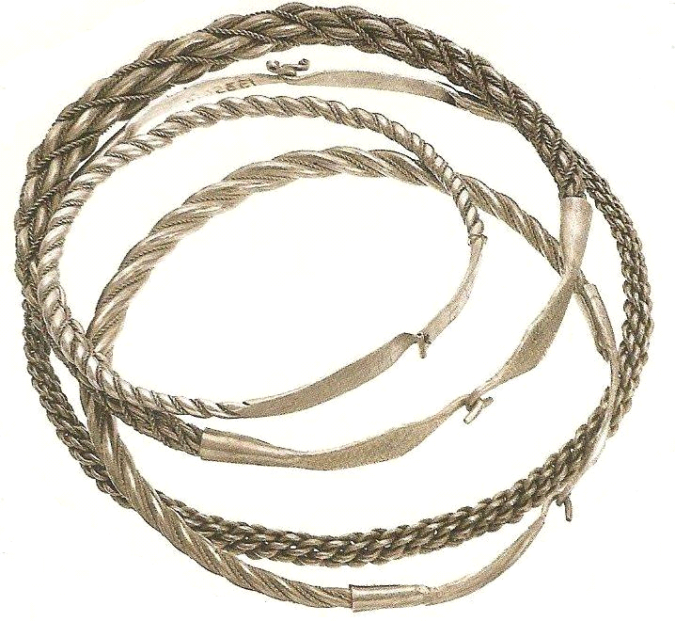
(Fitzhugh, 2000) Neckrings were often made from
melted-down Arab Islamic coins imported to
Scandinavia during the 9th and 10th centuries.

Thor's Hammers
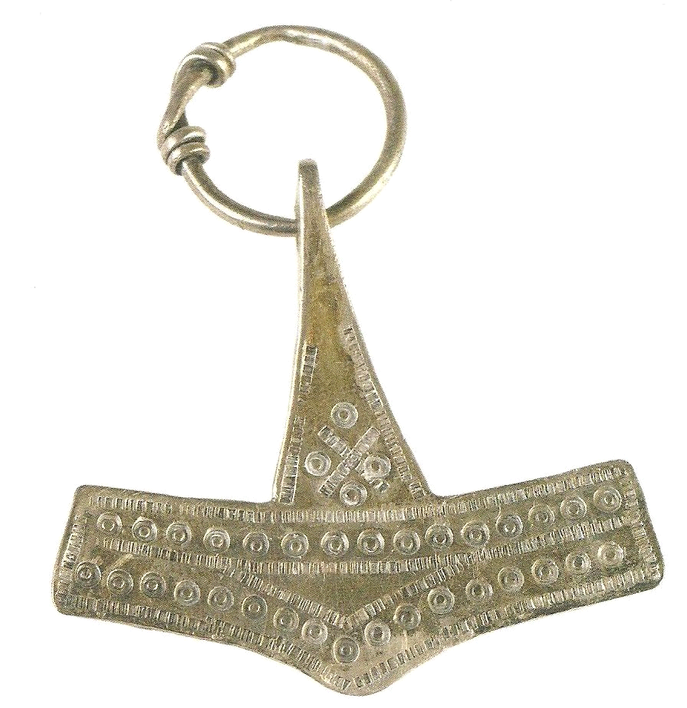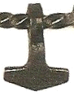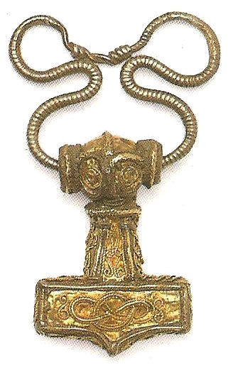
(Fitzhugh, 2000) (Margeson 1994) (Margeson 1994)

have been found in Viking Age graves.
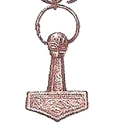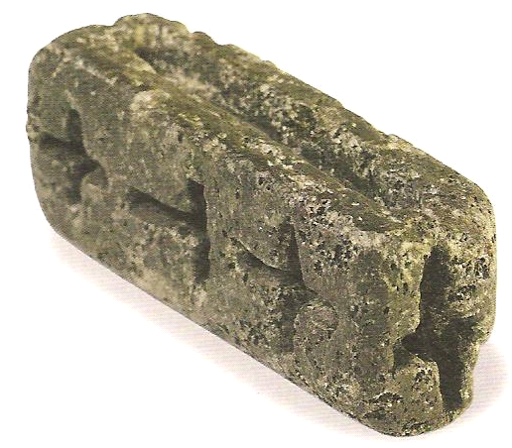
(Margeson 1994) (Fitzhugh, 2000) Jelling, Denmark 10th century. Steatite mold,
with impressions for casting Thor's Hammers and Christian crosses.

Finger Rings
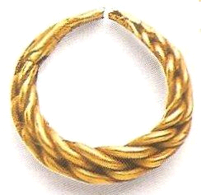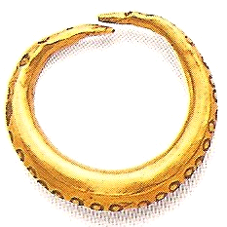
(Margeson 1994) (Margeson 1994

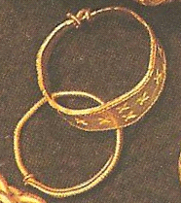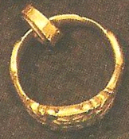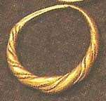

(Fitzhugh, 2000) ( Wilson, 1980)
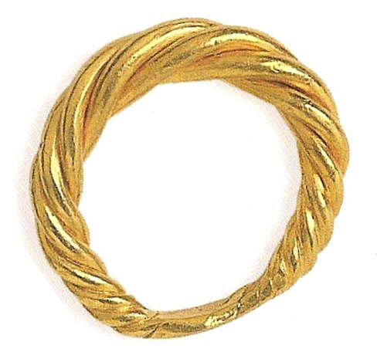

(Fitzhugh, 2000) Viking gold figer ring, Isle of Skye 10th century.

Arm Rings

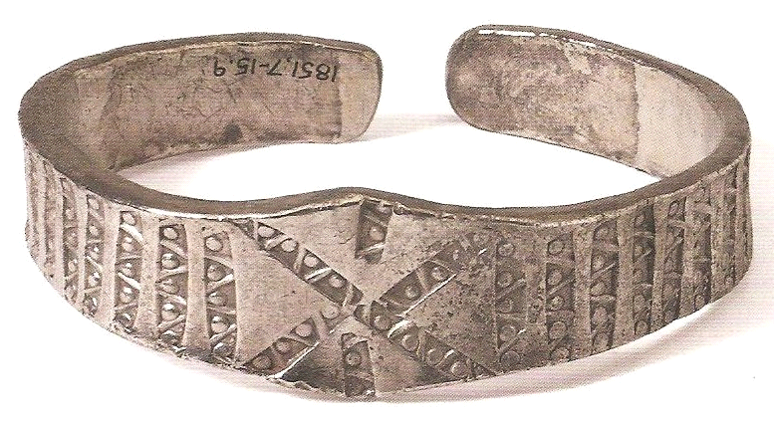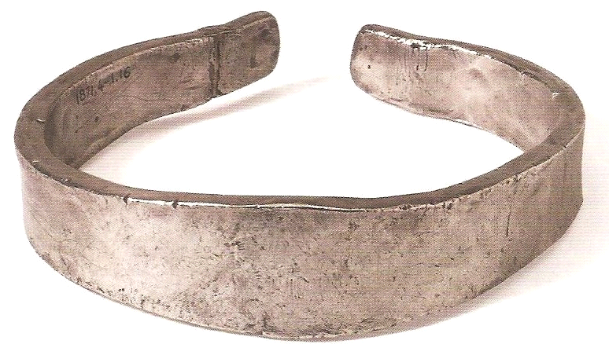
(Fitzhugh, 2000) Norse-Irish Armring late 9th early 10th centuries. Probably made from melted
silver coins, these armrings were just as likely to be cut up or melted down for their weight in silver.
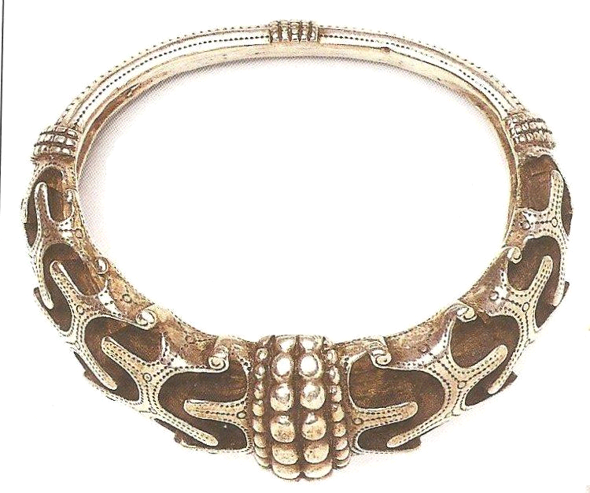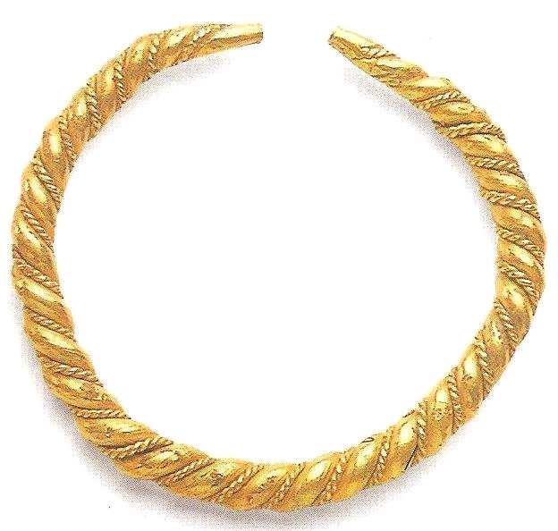

(Margeson 1994) Armring. Denmark. (Margeson 1994)

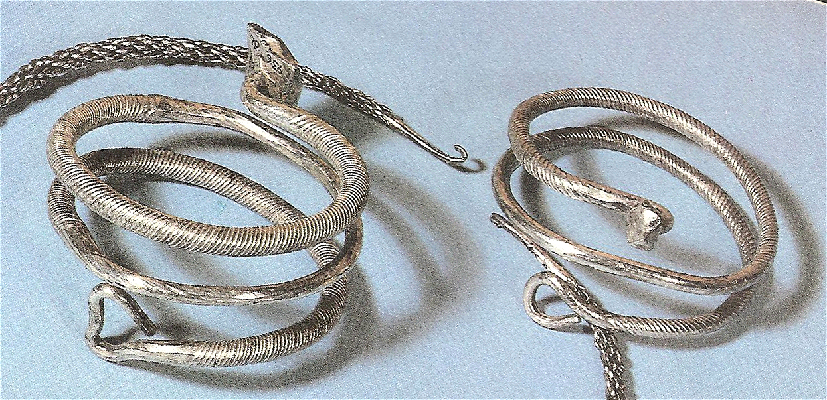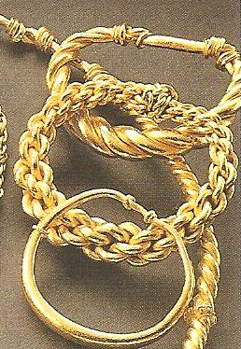
(Graham-Campbell, "The Vikings"; 1980) (Fitzhugh, 2000) Part of
Spiral Armrings, from Russia, found in Oland, Sweden. a hoard found in a bog
in Hon, Norway.

------
Copyright 2008 by James Anlage, 6221 Alfredo Drive West, Jacksonville FL 32244. <hrothgarthorsson at yahoo.com>. Permission is granted for republication in SCA-related publications, provided the author is credited. Addresses change, but a reasonable attempt should be made to ensure that the author is notified of the publication and if possible receives a copy.

If this article is reprinted in a publication, please place a notice in the publication that you found this article in the Florilegium. I would also appreciate an email to myself, so that I can track which articles are being reprinted. Thanks. -Stefan.

<the end>

