Welsh-Ark-art - 4/17/15

"Notes on the design and making of a 14th – 16th Century Welsh Ark,
A Rebated Clamped-Front Chest" by Lord Rhys, Capten gen y Arian Lloer Midrealm.

NOTE: See also the files: caskets-boxes-msg, 6-board-chest-art, caskets-boxes-bib, furniture-msg, Medvl-Chests-art, Trestle-Table-art, Lea-Hardware-art.

************************************************************************
NOTICE -

This article was submitted to me by the author for inclusion in this set of files, called Stefan's Florilegium.

These files are available on the Internet at: http://www.florilegium.org

Copyright to the contents of this file remains with the author or translator.

While the author will likely give permission for this work to be reprinted in SCA type publications, please check with the author first or check for any permissions granted at the end of this file.

Thank you,
Mark S. Harris...AKA:..Stefan li Rous
stefan at florilegium.org
************************************************************************

Notes on the design and making of a 14th – 16th Century Welsh Ark,
A Rebated Clamped-Front Chest
by Lord Rhys, Capten gen y Arian Lloer Midrealm

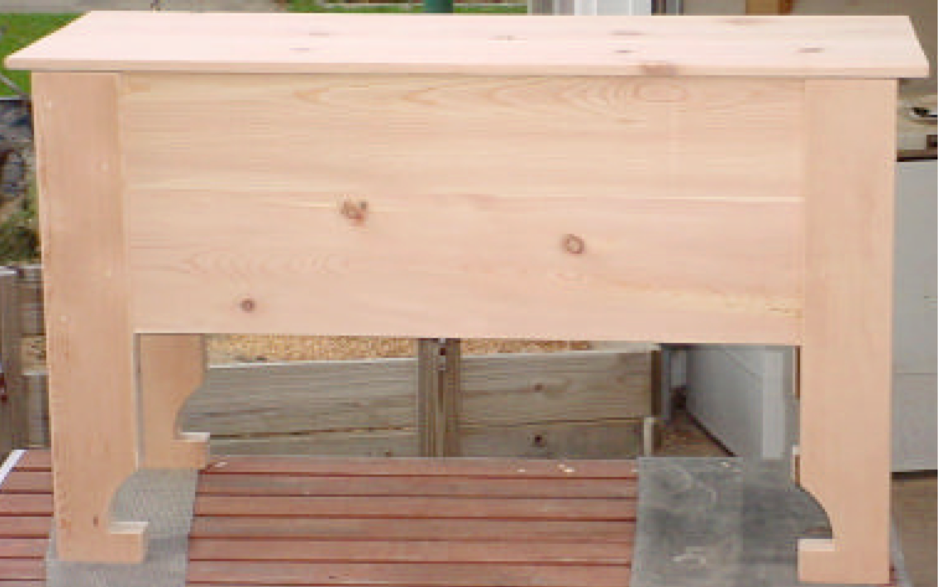

My Good Friends,

One of the main problems my Lady and I have in the SCA is to make our campsite as period as possible, while maintaining the safety of modern standards and staying within the costs of our SCA budget. We have covered coolers in boxes or barrels, built a bed, a table, and bought a pavilion over the last few years. This year's project is new garb boxes for camping events. Until now we have used large plastic tubs that slid out of sight under the bed. We needed something large enough for camping at Pennsic (and we have a lot of garb as we don't like to have to do laundry that week). A secondary plus would be something to use as a table/nightstand for our lantern, clock, eyeglasses and various sundries. A plus of this design is that the lid can be opened even if the ark is flat against a wall or a bed. The term "Welsh Ark" is used by the Abergavenny Museum in Wales.

The Welsh Ark plans shown here do not require a great deal of tools, a circular saw, a router, a jigsaw, a chisel, and a hammer. A table saw, a dado blade for the table saw, a bandsaw, and a few clamps will make things even easier.

It can be made with two sheets of pine plywood for about $60, or glued up boards if you prefer the beauty of solid wood at a higher cost depending on the type and grade of the wood you choose. Pine would be a little more money, while oak would cost quite a bit more. Oak plywood is also available. You can even use recycled wood. The pictures here show an ark made of recycled 1x12 knotty pine boards at a cost of zero. Generally though, recycling wood requires a surface planner which can cost several hundred dollars. Consider the investment though; mine has paid for itself many times over. Old pallets can be a great source of free wood.

The original chest uses nails, but screws are a viable option. If you use screws, try and countersink them and hide them with wood plugs. Handmade nails (or a good fake of handmade) are available online from such companies as Tremont Nail (http://www.tremontnail.com/ ).

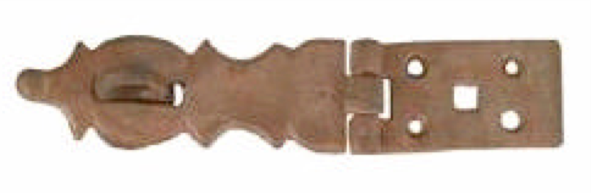
There are other companies that just require a quick web search. Hinges and hasps are also available online, I am going to be using this hasp from Vandyke's Restoration http://www.vandykes.com/ And theses hinges from Lee Valley Tools http://www.leevalley.com

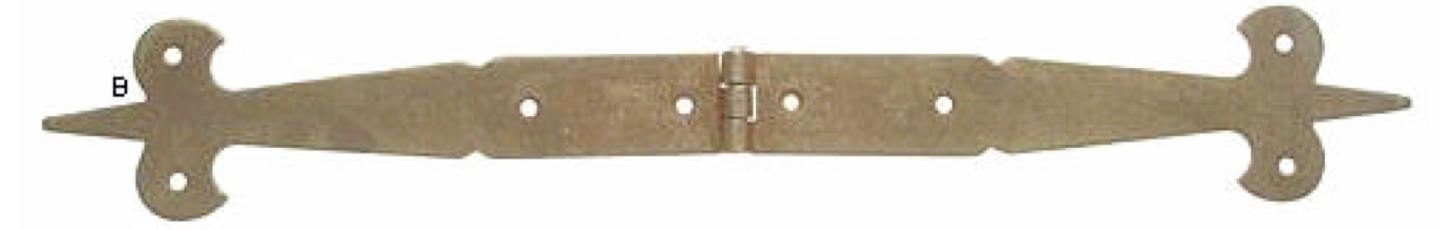

Putting it all Together:

The construction of the chest is actually fairly easy. It is a simple box with legs attached to the outside of the box. The legs can be done with one solid piece of wood, or as I did three pieces with the cut out for the box through two of them before glue-up. After you decide on your materials, you should take the time to prepare them, with glue-ups, planning, and cutting out the pieces shown below. The graphics for all parts are at the end of the plans to make it easier to print them out separately.

Make the box first by attaching the front and back to the sides. Measuring from corner to corner will tell you if the box is square. You should get the same number on both measurements, if not us a clamp across the corners with the longer measurement to adjust to match.

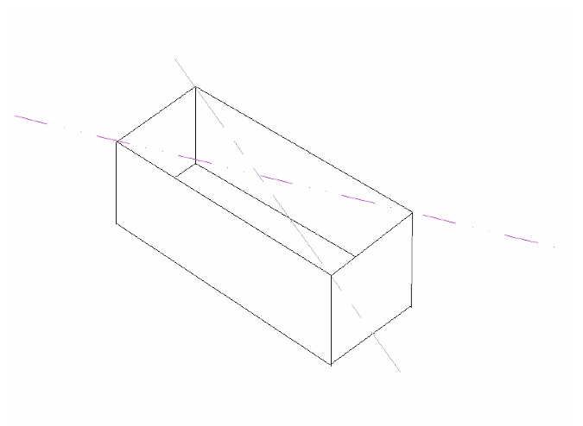

The bottom slides into the rabbets to hide the edge from view on the outside. This is an excellent way to get very clean tight corners inside your box. Attach the bottom permanently.

Next, you attach a leg to each corner and trim them to length. Here is a quick easy tip for leg trimming. First step is to cut them a tad long, 1⁄2" or so. After you have the legs glued up and/or cut out to receive the box measure down from your cutout to the leg length (14") and cut them off still leave a 1⁄4" or so trim room. This will get them pretty darn close. Sometimes I don't need to trim them any further. Then, attach them to the box in a manner you can still remove them, (screws or clamps). Take the ark to a nice flat level location and set it down. Check it for wobbling; this occurs if the legs are different lengths. Use a level to make absolutely sure the box is level and shim (thin wood or cardstock) the legs until there is no wobble and it is level. The take a pencil and lay it flat on the floor and slid it over to a leg and draw a line, keeping the pencil on the floor. Repeat that step at each leg. After that, you just remove the legs and trim to your lines. This will make them all the same length from the chest down to the floor. After the legs are leveled and reattached, trim the tops to match the box, just a bit of sanding if they are really close.

The next step it to add a top. Set the top carefully on the ark upside down and center it side to side. It does not get centered front and back. Rather, it goes even to the back edge of the box, not the legs. This gives you a clearance for opening the lid if the chest is against a wall.

After you get the lid just right, use a pencil to draw a line on the underside of the top where the right and left sides meet it between the legs. Be sure to mark where the legs are also so you can center the stiffener in that opening. This is your alignment mark for the stiffeners. Clamp the stiffeners in place centering them between the legs, but not front to back as the lid is not centered. They need to be on the offset slightly from your line to the outside of the box, about 1/8" to clear the sides easily. After you are satisfied, flip the lid back over and attach the stiffeners through the top.

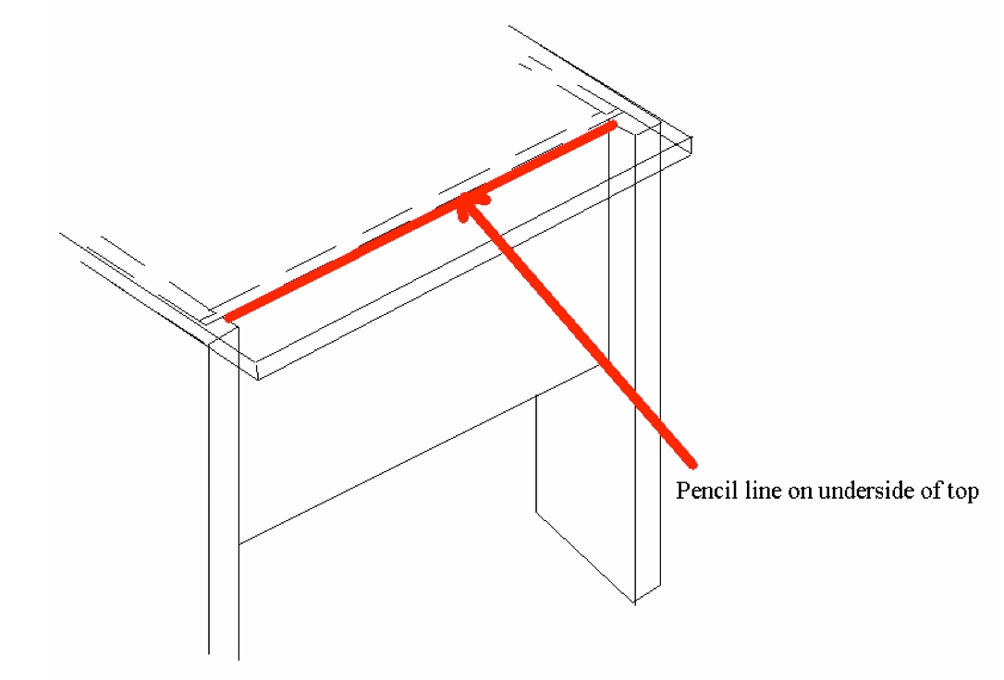

The final step is hinges and hasp. They both are attached to the underside of the lid and the outside of the box. You can either cut a notch in the upper edge of the box for clearance, or let the lid float slightly above the box. I prefer the notch as it allows the lid to seat firmly and not create any undue stress if someone sits on it.

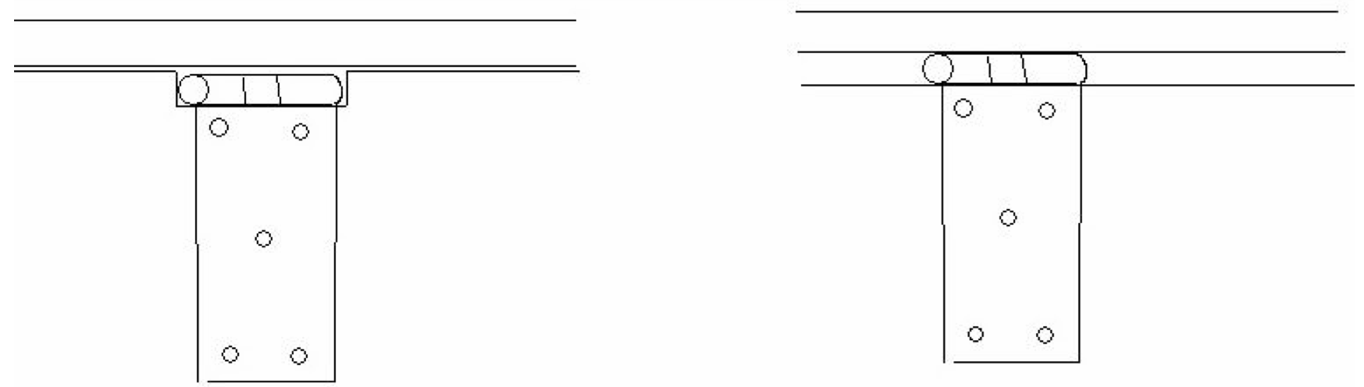

And that is basically it. Sand and finish your new ark as you see fit. I recommend boiled linseed oil and beeswax, but polyurethane also works. Do not put any finish on the inside of the chest if it is for garb. The wood will help absorb water away from the clothes if they are slightly damp.

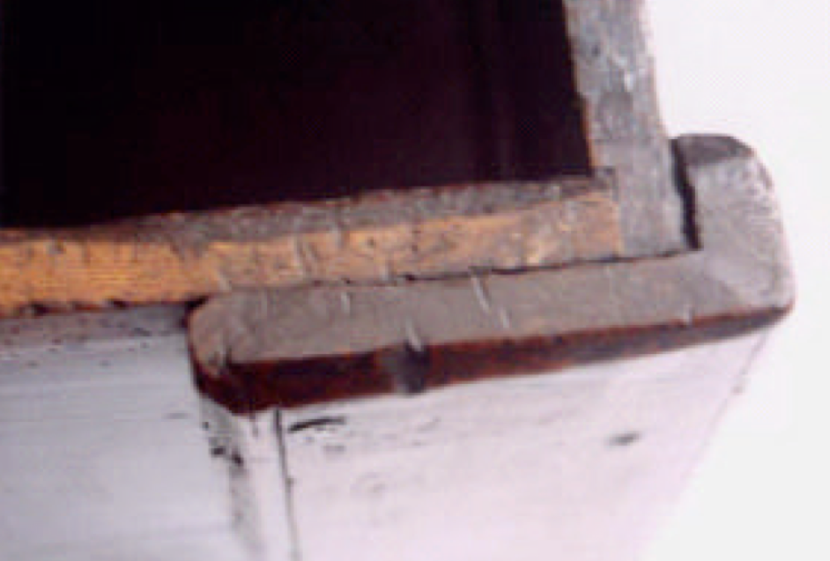
This is the original piece these plans were made from
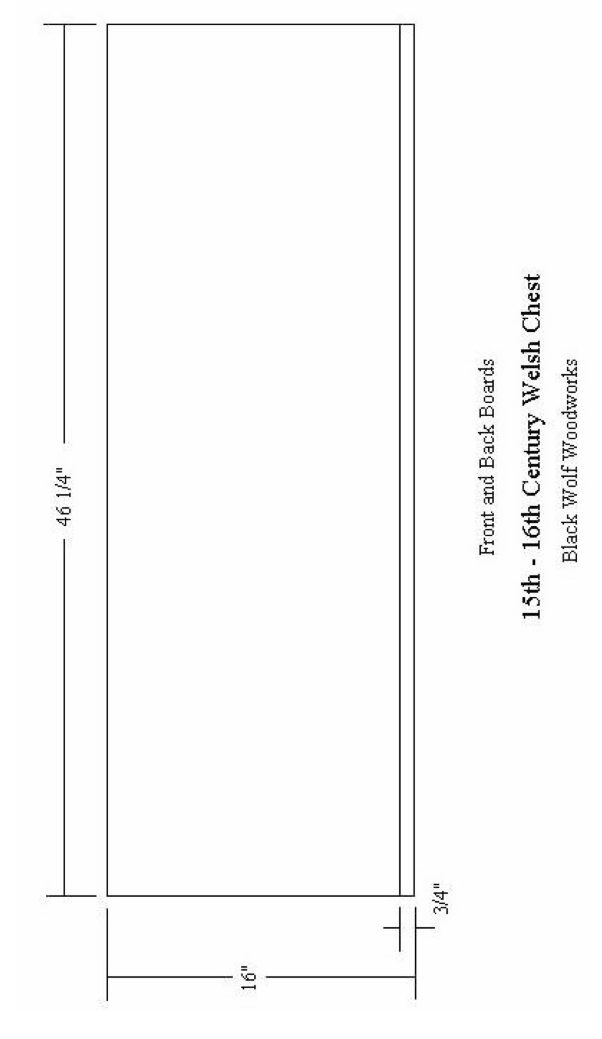
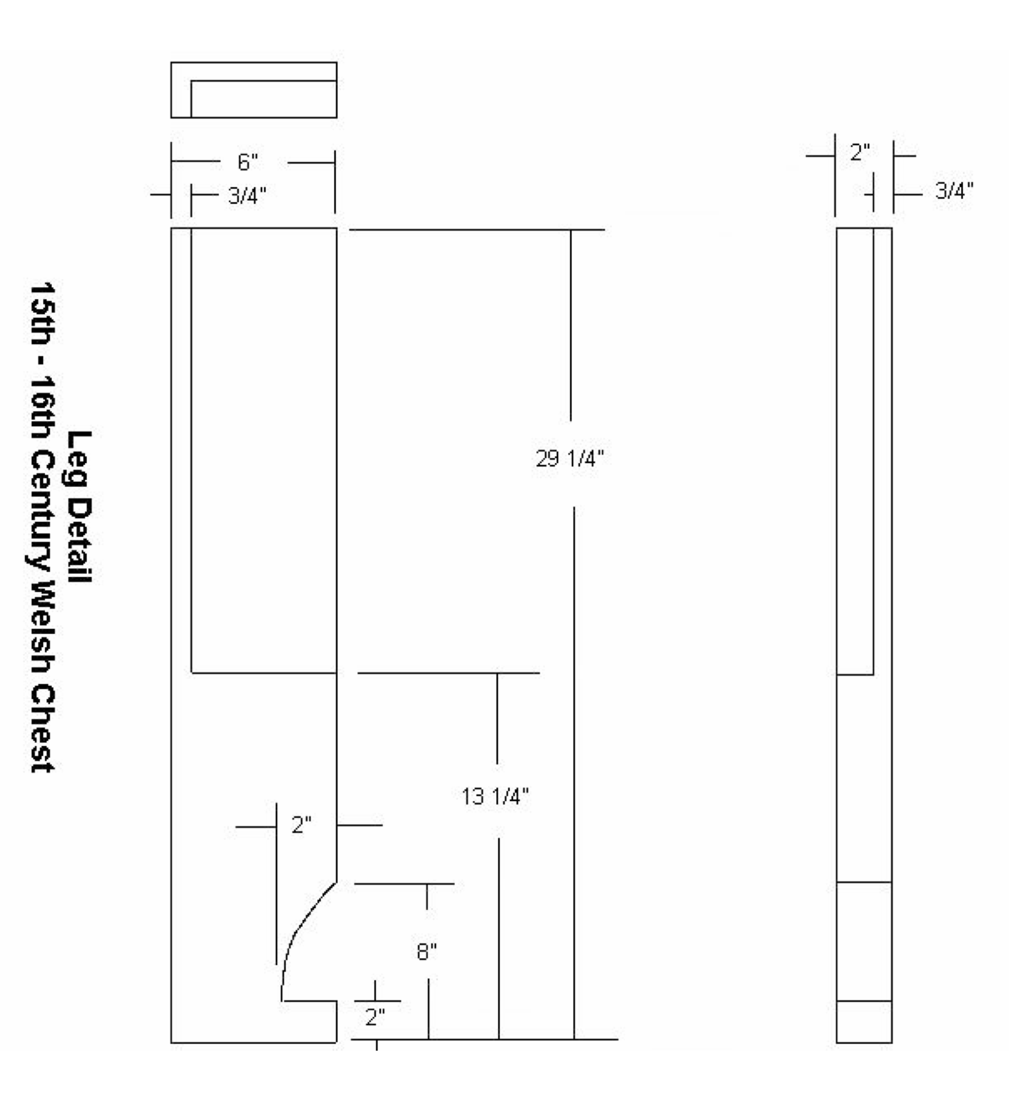
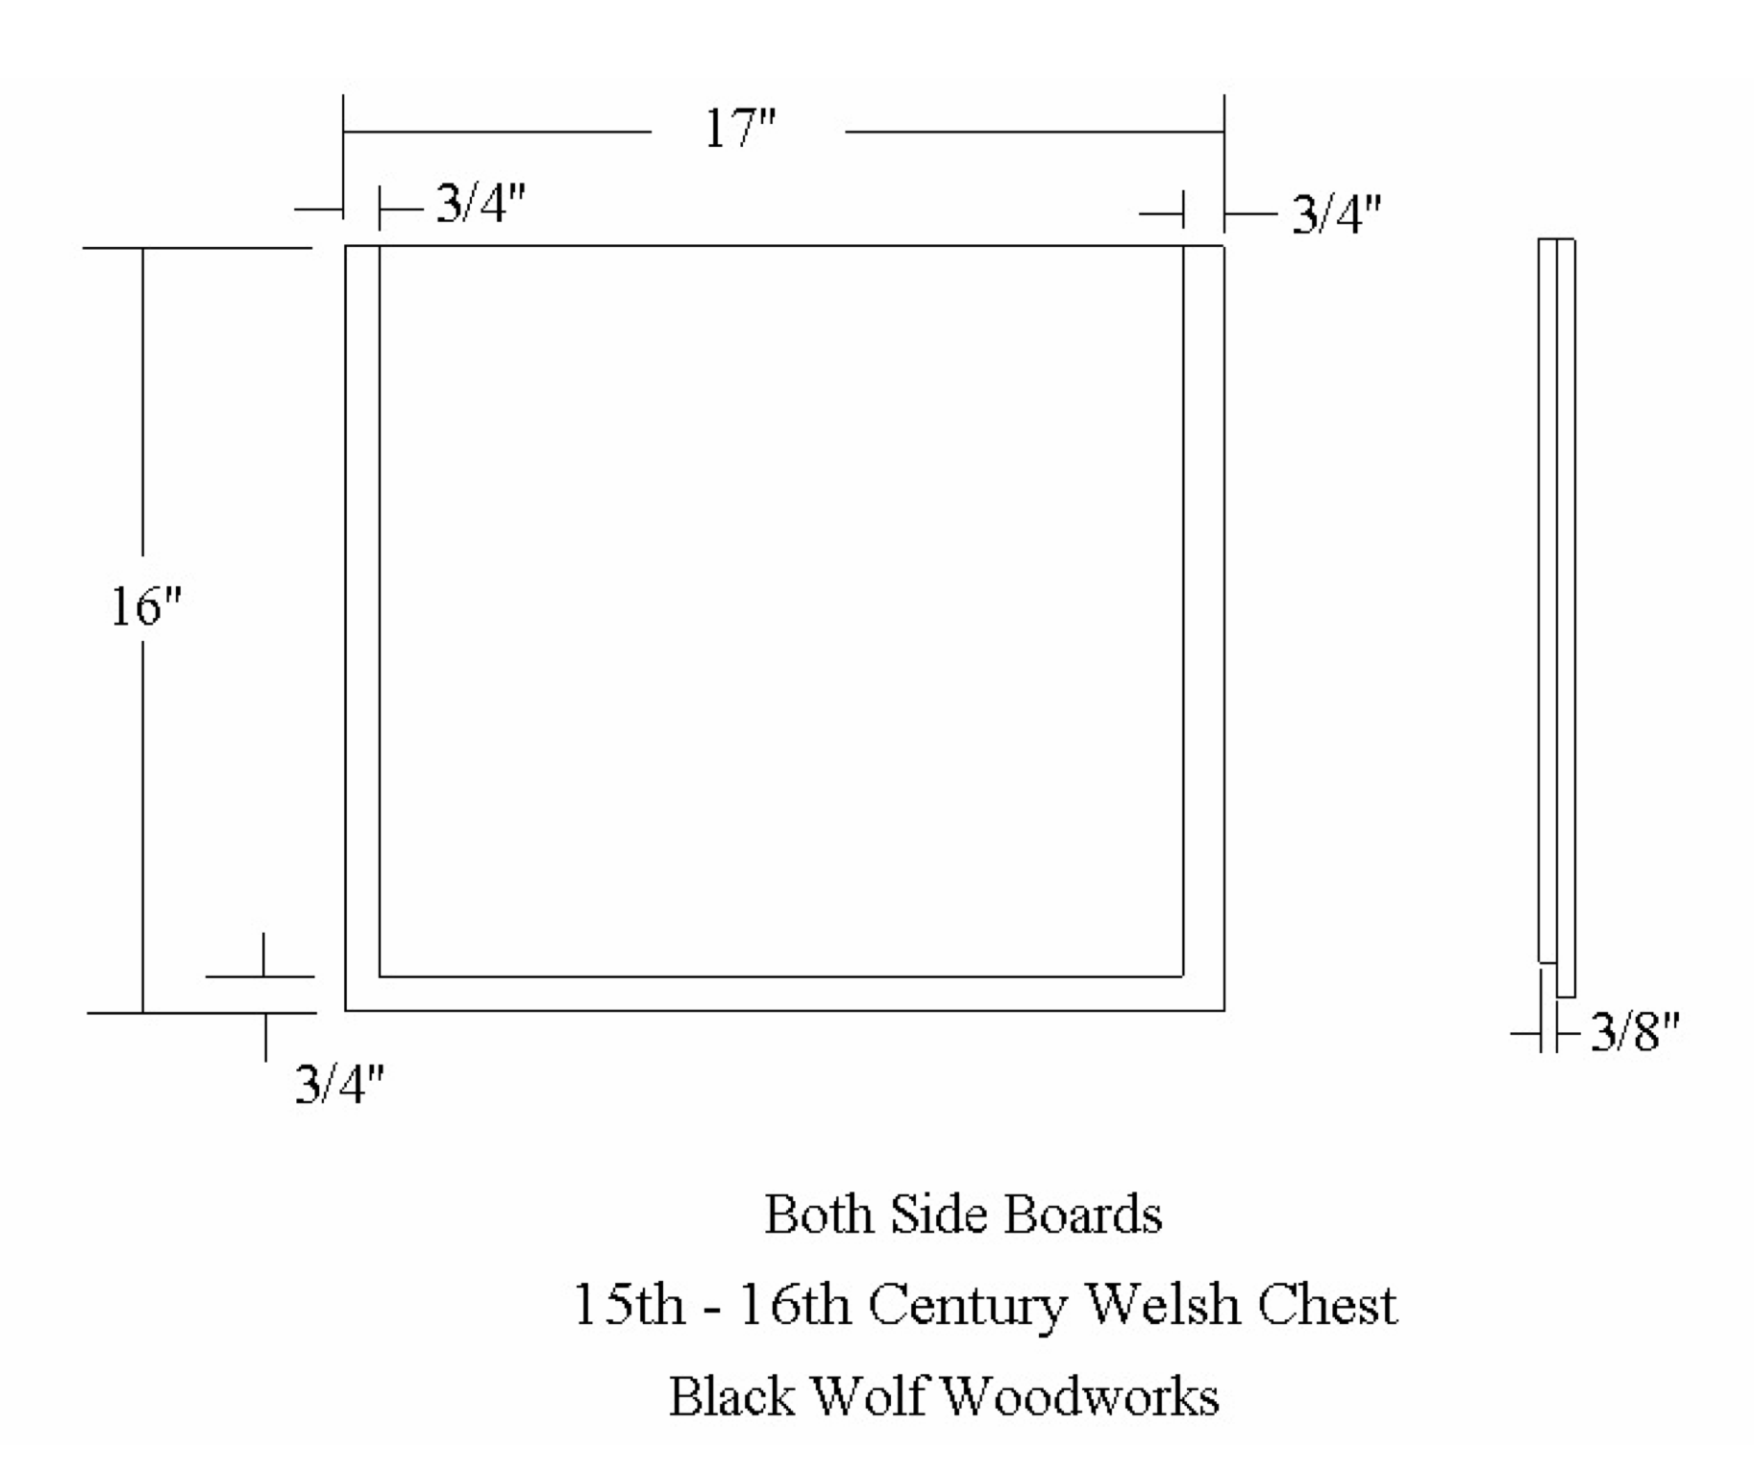
------------
Full permission is granted for publication in any SCA related newsletter or publication provided no alterations are made without notifying Lord Rhys in advance. LordRhys at gmail.com

If this article is reprinted in a publication, I would appreciate a notice in the publication that you found this article in the Florilegium. I would also appreciate an email to myself, so that I can track which articles are being reprinted. Thanks. -Stefan.

<the end>

