Waxed-Linen-art - 11/12/17

"Making Waxed Linen" by HL Giraude Benet.

NOTE: See also these files: beeswax-msg, Workng-Beswax-art, Candle-Making-art, Fire-Starting-art, oilcloth-msg, linen-msg, grafting-msg, burials-msg.

************************************************************************
NOTICE -

This article was added to this set of files, called Stefan's Florilegium, with the permission of the author.

These files are available on the Internet at: http://www.florilegium.org

Copyright to the contents of this file remains with the author or translator.

While the author will likely give permission for this work to be reprinted in SCA type publications, please check with the author first or check for any permissions granted at the end of this file.

Thank you,
Mark S. Harris...AKA:..Stefan li Rous
stefan at florilegium.org
************************************************************************

Making Waxed Linen
by HL Giraude Benet

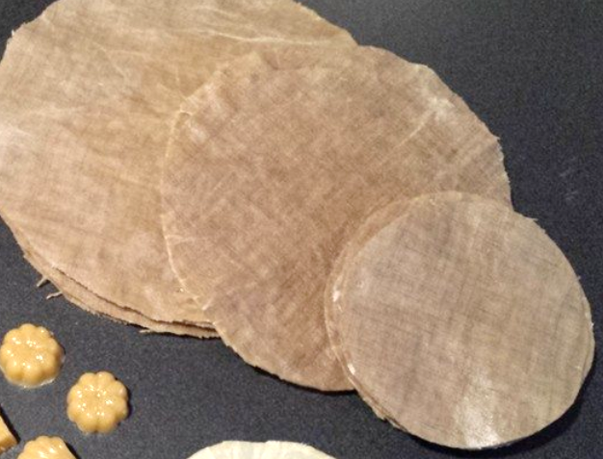

Linen fabric can be made waterproof by impregnating the fabric with beeswax. I am not certain at what point this practice started, but in the Middle Ages and later, waxed linen was used as a protective waterproof wrapping, and used in many of the same ways we would use plastic wrap or other waterproof fabrics. Waxed linen is easy to make, and is hand-washable using soap and warm water. Beeswax has natural anti-fungal and anti-bacterial properties, which may also assist in the preservation of whatever you may have wrapped in it. Since it is fabric impregnated with wax, it is flammable, so avoid using waxed linen near fire or flame (this makes old, uncleanable waxed linen a great fire starter for your camp fire, however).

The Latin word for wax is "cera," therefore waxed fabric was referred to as "cered cloth," sometime shortened to "cerecloth." It is sometimes referred to by its Latin name, pannus lineus ceratus (waxed linen cloth).

The Basic "How To"

Word of warning: As I mentioned above, beeswax is flammable. According to the article on Wikipedia, beeswax melts between 144-147 degrees F, and begins to discolor if heated above 185 degrees F. The flash point of beeswax (the temperature at which it will burst into flame) is 400 degrees F. Never leave melting/melted beeswax unattended over a heat source, and do not use more heat than necessary to achieve a molten state.

Wax is most safely melted using a double boiler system. You can purchase a large stainless steel bowl at a thrift store and suspend this over a large pot of boiling water. When I teach this class in an outdoor setting, I use one of those disposable chafing stands with chafing fuel, always using a large pan of water underneath the pan containing the beeswax. At home I use an electric skillet (purchased from a thrift store) and only use the "WARM" setting, which is enough to melt the wax for use. Again, never, ever leave the wax unattended while you are melting it, especially when not using a double boiler. If you hear the melting wax start to make crackling noises, it's getting too hot.

Once the wax has melted completely, you are ready to dip in your fabric. I generally cut shapes that fit completely in the pan of melted wax, both circles and squares. Lay the fabric on the surface of the wax, and let it submerge and saturate completely. Once it is thoroughly soaked with wax, grab it by the edge with a large tweezer (or two large tweezers if it's a large piece), and slowly remove it from the melted wax. Removing it slowly helps the excess wax to drain off more completely, and avoids having blobs of hardened wax at the edge of your fabric. Hold it up for about 30 seconds to cool, then you should be able to lay it down to finish cooling before you handle it. To avoid having the fabric stretch out of shape, be sure to lift it so that it hangs by either the grain or crossgrain of the fabric, not the bias. The weight of the wax will cause the piece to stretch out of shape if held up by the bias.

Historical Uses for Waxed Linen

Waxed linen was used for many purposes in Europe from Roman times onward. Excavations at a Roman site in Watling Court, London, reveal that a craft worker's quarters had windows covered with waxed linen (Haynes, 339).

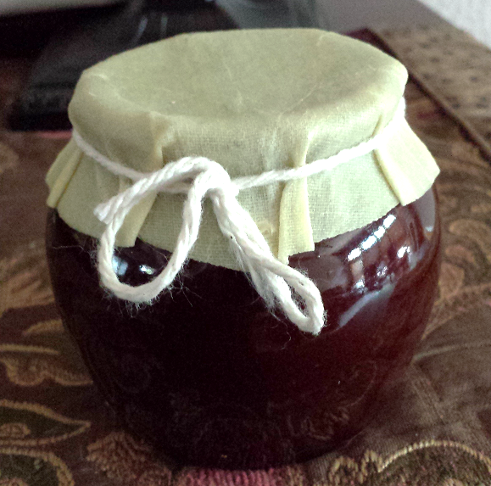

Waxed linen was also tied over the openings of storage jars, which were made with a shorter rim than clay cooking vessels so that a good seal could be made (Potterton, 340).

Waxed linen was also used in horticulture to prepare cuttings for transportation. In the Le Ménagier de Paris from 1393, the author writes "Gardeners say that the seed of rosemary groweth never in French soil, but whosoever shall pluck little branches of rosemary and shall strip them from the top downwards and take them by the ends and plant them, he shall see them grow again; and if you would send them far away, you must wrap the aforesaid branches in waxed cloth and sew them up and then smear the parcel outside with honey, and then powder with wheaten flour, and you may send them wheresoever you will."

The warden's accounts from St. Mary's in Reading in 1558 mention the purchase five yards of "here cloth" (cere cloth) for the altars (Coates, 130). This was used over the bare stone of the altar to prevent condensation from soaking the fine linen altar cloths layered over it.
Waxed linen was used to make an air-tight wrapping to prepare a body for burial, which aided in the preservation of the body (Tarlow, 31). In this context, it is usually referred to as cerecloth.
Works Cited:

Coates, Charles. The History and Antiquities of Reading. London: Printed for the Author by J. Nichols and Son, 1802. Print.

Haynes, Ian P. Blood of the Provinces: The Roman Auxilia and the Making of Provincial Society from Augustus to the Severans. Oxford UP, 2013. Print.

Potterton, Michael, and Matthew Seaver. Uncovering Medieval Trim: Archaeological Excavations in and around Trim, Co. Meath. Dublin, Ireland: Four Courts, 2009. Print.

Power, Eileen. The Goodman of Paris: A Treatise on Moral and Domestic Economy by a Citizen of Paris, C.1393 = (Le Ménagier De Paris). Woodbridge: Boydell, 2006. Print.

Tarlow, Sarah. Ritual, Belief, and the Dead in Early Modern Britain and Ireland. Cambridge: Cambridge UP, 2010. Print.

------
Copyright 2017 by Jill Sibley. <giraudebenet at hotmail.com>. Permission is granted for republication in SCA-related publications, provided the author is credited. Addresses change, but a reasonable attempt should be made to ensure that the author is notified of the publication and if possible receives a copy.

If this article is reprinted in a publication, please place a notice in the publication that you found this article in the Florilegium. I would also appreciate an email to myself, so that I can track which articles are being reprinted. Thanks. -Stefan.

<the end>

