Swt-Potat-Pie-art - 7/18/17

"Lusty Sweet Potato Pie" by Lady Alicia of Cambion.

NOTE: See also the files: pies-msg, potatoes-msg, root-veg-msg, Stufd-Turnips-art, turnips-msg, pastry-technq-msg, fruit-pies-msg, meat-pies-msg.

************************************************************************
NOTICE -

This article was added to this set of files, called Stefan's Florilegium, with the permission of the author.

These files are available on the Internet at: http://www.florilegium.org

Copyright to the contents of this file remains with the author or translator.

While the author will likely give permission for this work to be reprinted in SCA type publications, please check with the author first or check for any permissions granted at the end of this file.

Thank you,
Mark S. Harris...AKA:..Stefan li Rous
stefan at florilegium.org
************************************************************************

You can find more work by this author on her blog at:
https://ladyaliciascookerybooke.wordpress.com/

Lusty Sweet Potato Pie
by Lady Alicia of Cambion

Gather around, children, gather round! Lady Alicia has a story to tell you about Sweet Potato Pie! You see, a very long time ago, Columbus brought Sweet Potatoes back from the New World and he said, "Wow, these are mighty delicious!" And then King Henry said, "Indeed, they are delicious! I shall have them in a pie!" And you get to eat the same kind of sweet potato pie as King Henry did. Isn't that exciting? Now come here so I can give you a pat on the head and send you off to beddie-bye! Toodles!

Are they gone yet?

Good. Because here's the real lowdown on Sweet Potato Pie: Sweet potatoes were considered more than just an exotic New World food. That classic pie spice blend had a very specific medicinal purpose. And why would you want to put sparrows' brains into a dessert? Oh, the real story behind that wholesome, Sweet Potato Pie?

It was basically Tudor Viagra.

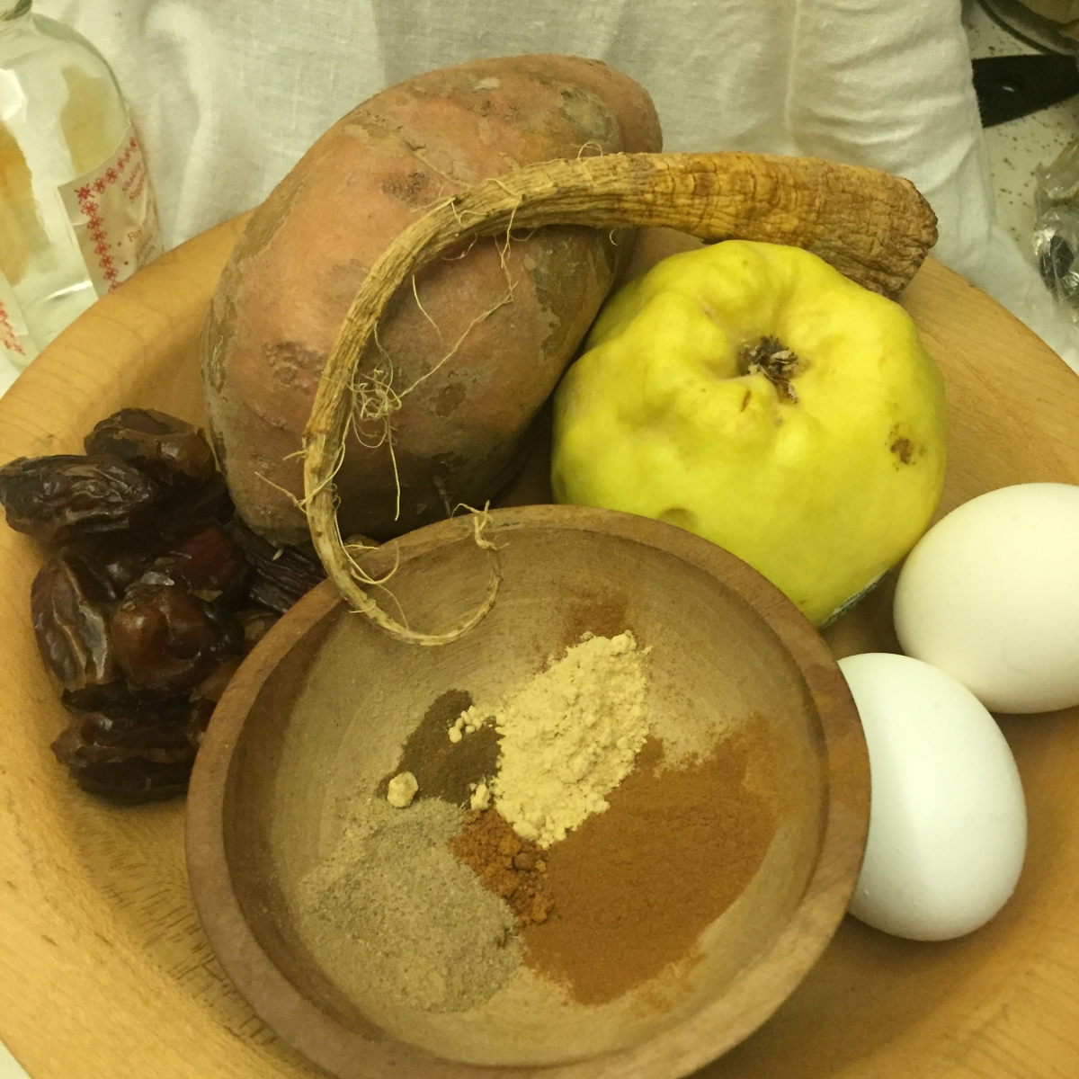
Innocent plate of ingredients? Or seething pile of lust?

Some of that fairy tale I told the kids was true: Spanish explorers did discover the sweet potato in Peru and brought it to Spain. It is believed the sweet potato made it's way to England because Catherine of Aragon missed the vegetable dishes of her homeland and had them brought over,[1] but Henry VIII apparently believed more in its attributed aphrodisiac powers, whether from its rare exoticism or its, thick, elongated shape, so he consumed large quantities of sweet potatoes in pies.[2] Shakespeare's Falstaff (thinking he's about to, let's say, "biblically know" two ladies) in Merry Wives of Windsor,[3] notes "Let the sky rain potatoes…hail kissing-comfits and snow eringoes," all of which were known to the Elizabethans as stimulants to desire. Even Gerard, in his Herball, notes that sweet potatoes are known for "procuring bodily lust and that with greediness."[4]

My, is it getting warm in here?

The earliest available recipe for sweet potato pie is in Thomas Dawson's 1586 The Good Huswife's Jewell:

To make a tarte that is a courage to a man or woman.
Take twoo Quinces, and twoo or three Burre rootes, and a potaton, and pare your Potaton, and scrape your rootes and put them into a quart of wine, and let them boyle till they bee tender, & put in an ounce of Dates, and when they be boyled tender,Drawe them through a strainer, wine and all, and then put in the yolkes of eight Egges, and the braynes of three or foure cocke Sparrowes, and straine them into the other, and a little Rose Water, and seeth them all with suger, Cinamon and Gynger, and Cloues and mace, and put in a little sweet butter, and set it vpon a chafingdish of coles betweene two platters, and so let it boyle till it be something bigge.

Obviously there were earlier recipes than this if Henry VIII was eating sweet potatoes in pies but this is the earliest recipe we have on record. Considering what we know about the reputation of sweet potatoes, however, this particular recipe is definitely not about building up one's courage. To explain this a little better, let me offer a quickie lesson in two ancient medical practices, humoral theory and the doctrine of signatures.

Humoral theory, codified by the Greek physician Galen, determined that the body was ruled by four humors (blood, phlegm, yellow bile and black bile). One kept these four humors in balance by consumption of foods that also had a humoral character (such as hot and dry or cold and wet, etc). So, if you were diagnosed as Melancholic, you had too much black bile (which is cold and wet) so you needed to balance that by eating something hot and dry (like ginger). You were what you ate and ate what you were. And, importantly, if you desired to enhance an aspect, you wanted to eat foods that promoted that aspect.

The doctrine of signatures also dates to ancient Greece and proclaimed that like went to like, so that herbs and other ingredients in a medicinal treatment should be of a shape or form similar to one's ailment or the part of your body that needed attention. For example, many cures for blood diseases contained beet juice, since it was expected that the red liquid would attach itself to and cure the blood. And a hard, protuding tuber…?

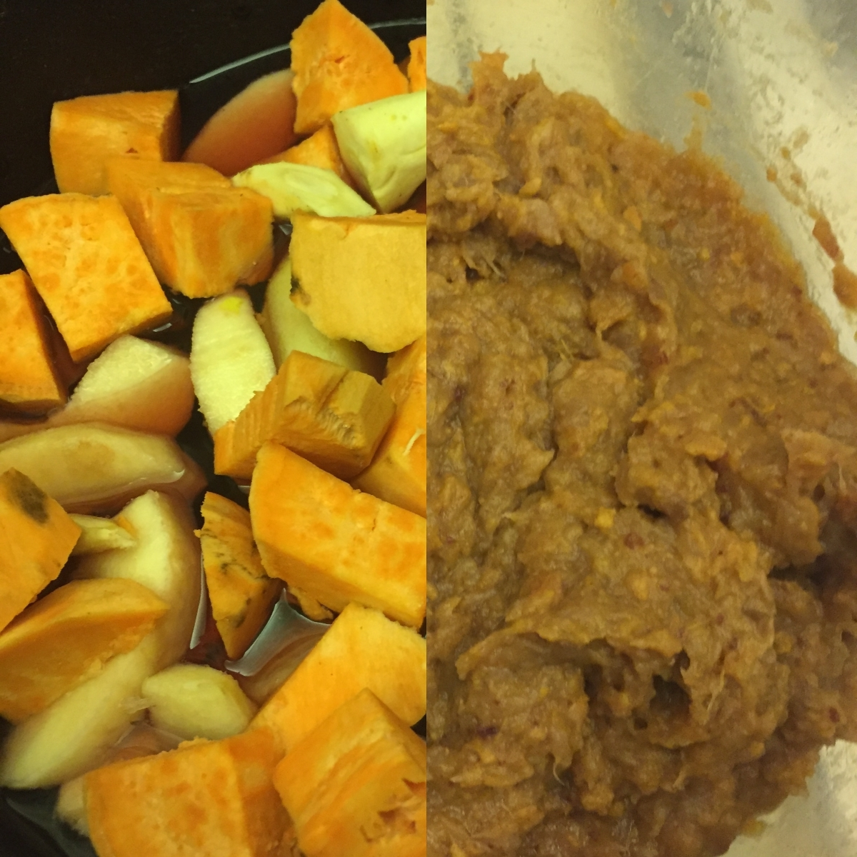
Ingredients before cooking and after being pulped.

Let's get back to Dawson and his pie…

Looking at the fruit and vegetable components, we have sweet potatoes, which we have already identified as an aphrodisiac. Burdock root can be found dried and ground at some herbalists, but it can also be found fresh, a "signature" long, stiff root vegetable (it's similar to salsify, though you can also use parsnips or carrots). Quinces were a popular sweetening agent as were dates, but the latter were also known to have aphrodisiac properties: Gerard notes that dates "procure lust of the body very mightily.."[5]

But that's not all: The spice mix is what we have come to know as a traditional pie spice blend: Cinnamon, ginger, cloves and mace (or nutmeg). All of these spices (and, indeed, the burdock root) are all classified as "Hot and Dry" by Gerard,[6] which corresponds to Choleric in humoral theory. But "Courage" is not an aspect of the Choleric humor. Passion, however, definitely is.

(Think about that the next time you're ordering a Pumpkin Spice Latte!)

Rosewater was distilled from the iconic flower of romantic and passionate love. And those poor cock (ahem!) sparrows – whatever did they ever do to deserve becoming pie-filling? Mythologically, the sparrow was sacred to Aphrodite (Sappho writes about her chariot being drawn by sparrows)[7] so, by association, if you were a Tudor who wanted a little extra boost in the romance department, the brain of a lovebird would seem a good option. As sparrows are difficult to source currently and consuming their brains is of questionable sanitation, I omitted them from the recipe (though if you truly wanted, marrow might make a passable equivalent).

So, here we have a combination of several different aphrodisiacs with a blend of passion-inducing spices as well as other known love elixirs. Doesn't quite sound like something to serve at a pleasant family gathering, now does it?

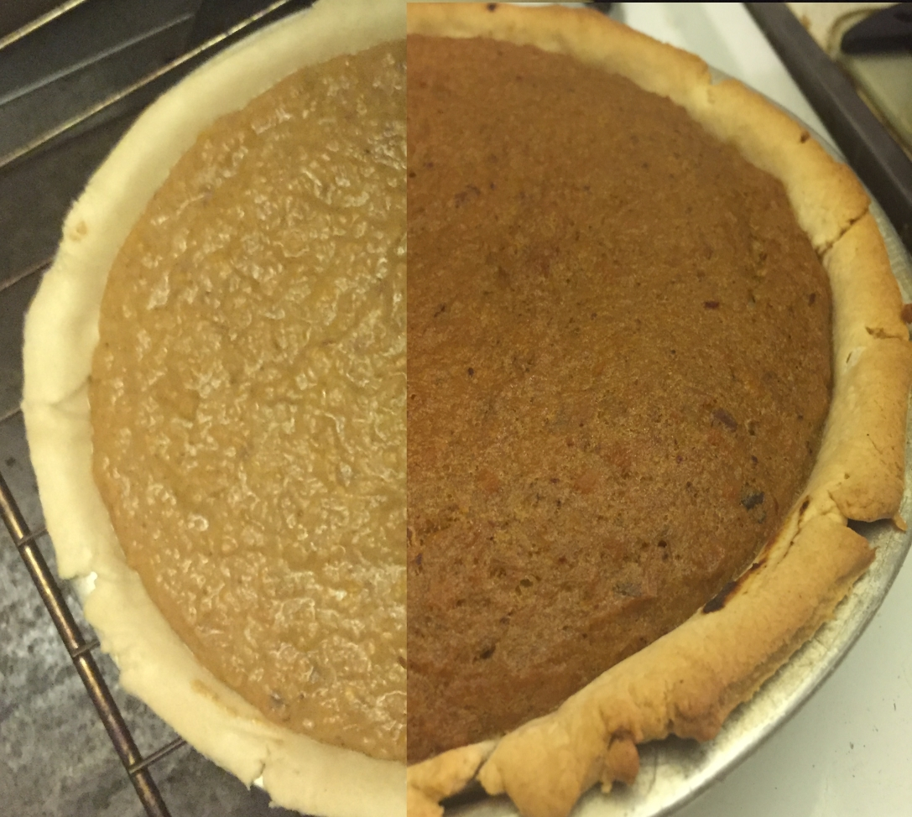

Pie in and pie out, having grown "bigge."

The actual baking process is simple and very similar to a modern sweet potato pie. Peel and cut the potato, burdock, and quince (or equivalents) and boil with the dates in a quart of sweet red wine. When they are very soft and the wine is almost completely absorbed, press though a sieve or a food mill (or food processor) and season with the spices. Add 4 whole eggs (instead of just the yolks, as in the recipe) and enriched with sugar and a tablespoon of unsalted butter. Dawson's recipe, like many of the period, does not specify a pie crust, but the "tarte" in the title would indicate an open-topped pie so I prepared a pie shell and filled it. When baked, it puffed up to "be something bigge."

(Of course, I am assuming here that it is, indeed, the pie that Dawson intends to grow "bigge.")

Happy Thanksgiving!

Sweet Potato Pie

(Adapted from Thomas Dawson's To make a tarte that is a courage to a man or woman from The Good Huswife's Jewell)

1 large Sweet Potato
2 roots of burdock (or salsify, parsnips or carrots)
2 quinces (or apples or a combination of the 2)
1 oz pitted dates
1 quart sweet red wine
1-1/2 t Cinnamon
1 t Ground Ginger
1/4 t ground cloves
1/4 t ground mace
4 eggs
1/2 c sugar
1 t rosewater (or more, to taste)
1T butter

Single pie crust

1. Preheat oven to 350*. Peel and cut into 1" chunks the sweet potato, quinces and burdock root (or equivalents). Add dates and wine. Bring to boil and reduce to a simmer until completely soft and almost all the wine is absorbed.

2. Press through a strainer (or food mill or run through a food processor or immersion blender) until pulp is smooth. Add spices, sugar, rosewater, eggs and butter. Mix until thoroughly combined and butter is melted. Pour into prepared pie shell.

3. Bake until custard is puffed and pie is solid in the center (a toothpick inserted in the middle will come out clean). Allow to cool. The pie will settle somewhat with cooling.

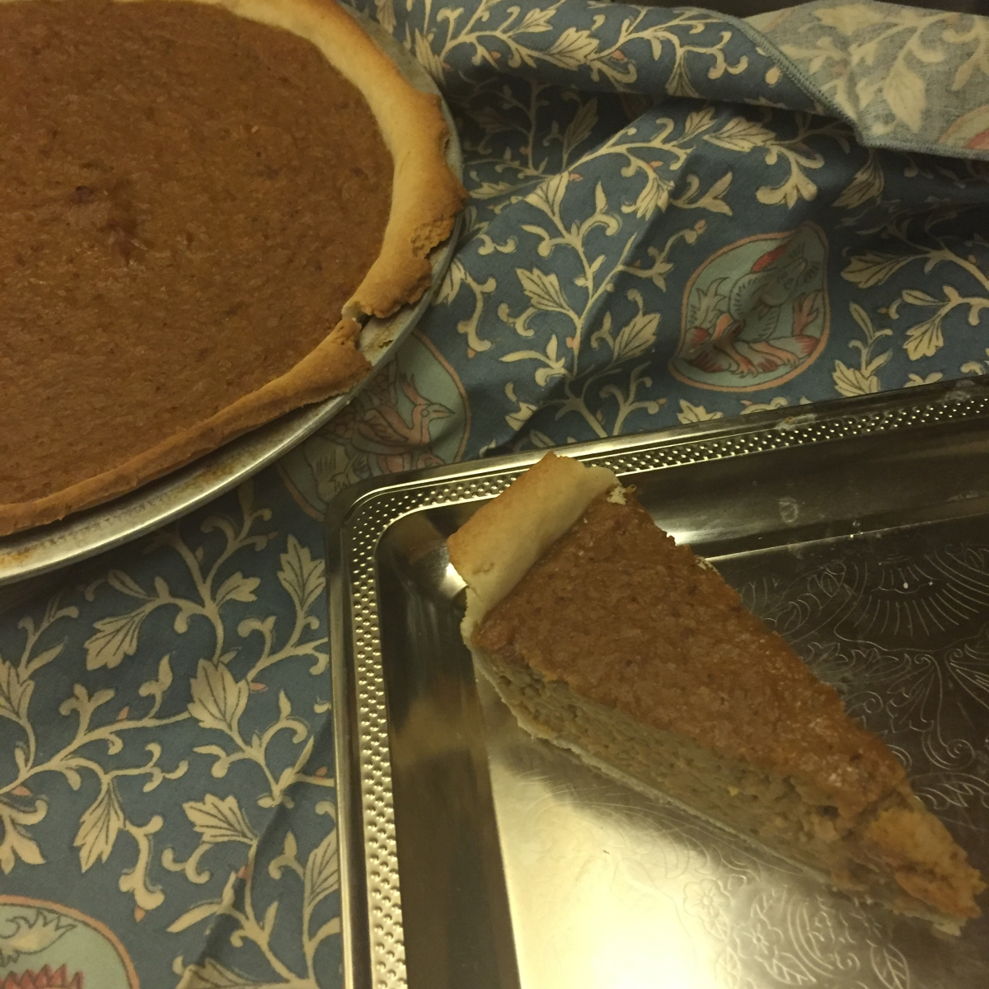
Enjoy! Go forth and cook good food!

Do you know, I fed the rest of that pie to friends of mine at a party (and didn't even tell them about the aphrodisiacs!). No immediate romancing, that I noticed, sorry Dawson!

Footnotes:

[1] Reader, Jon. Potato: A History of the Propitious Esculent. Yale University Press, New Haven, CT. 2009. P 114.

[2] Zuckerman, Larry. The Potato: How the Humble Spud Rescued the Western World, North Point Press:New York, 1998 p. 9

[3] Act V, Scene 5.

[4] Gerard, John. Herball. 1633 Revised Edition.

[5] Ibid

[6] Ibid

[7] See Sappho's "Hymn to Aphrodite"
------
Copyright 2016 by Alicia Fansmith. <ofnoimp at yahoo.com>. Permission is granted for republication in SCA-related publications, provided the author is credited. Addresses change, but a reasonable attempt should be made to ensure that the author is notified of the publication and if possible receives a copy.

If this article is reprinted in a publication, please place a notice in the publication that you found this article in the Florilegium. I would also appreciate an email to myself, so that I can track which articles are being reprinted. Thanks. -Stefan.

<the end>

