Seed-Cakes-art - 3/29/18

"Seed Cakes" by Lady Ysabel de la Oya.

NOTE: See also the files: cak-soteltes-msg, Chastlete-art, fruitcakes-msg, Mad-Hony-Cake-art, pastry-logs-msg, Shrewsbury-Ck-art, sugar-icing-msg.

************************************************************************
NOTICE -

This article was added to this set of files, called Stefan's Florilegium, with the permission of the author.

These files are available on the Internet at: http://www.florilegium.org

Copyright to the contents of this file remains with the author or translator.

While the author will likely give permission for this work to be reprinted in SCA type publications, please check with the author first or check for any permissions granted at the end of this file.

Thank you,
Mark S. Harris...AKA:..Stefan li Rous
stefan at florilegium.org
************************************************************************

Seed Cakes
by Lady Ysabel de la Oya
Shire of Cúm an Iolair & Barony of Forgotten Sea
Queen’s Prize 2016, Kingdom of Calontir

This entry is part to push me out of my comfort zone and part experiment. As for the comfort zone, I am not a much of a baker. I chose a baked good for two reasons. It was not something I knew how to do when I set out to start this project. Secondly, practically, it didn’t need to be kept cold and would be eaten normally at room temperature. I, like many in the Middle Ages and Renaissance, will be bringing these cakes on pilgrimage in my case to Coeur d'Ennui. As for the experiment, will be attempting to cook some of these cakes in a periodish style using my grill and an oven fashioned out of pottery. The experiment was an adventure, but more on that later.
I’m doing three versions of the same basic cake recipe, with slight variations, playing with spices and sweeteners. My cakes were found in two English cookbooks, one from 1591, A Booke of Cookrye, and one from 1615, The English Huswife. I decided to combine both into one redaction. As I am still new to baking, and rarely make cakes that don’t come from a box (I think I’ve done it three times in my life before this) I got a little help on the chemistry of cakes from Gode Cookery.

I decided to play with the sugar and honey a bit. In the Elizabethan times sugar was quite expensive. For those who could afford it, the use of sugar was a way to indulge, and to show off your social standing. Honey, being less expensive, was a much more common sweetener. (1) In my cakes I decided to bake one with all honey, one with all sugar, and one with half sugar and half honey. I’m switching up the star spice in each cake to highlight the differences between the spices.

Before this project I had assumed that cake would have only been found in late period (as my recipes were), but I was happy to discover that was not the case.

Archaeological digs have found evidence of protocakes dating back to premedieval times. These protocakes were flat and compact and resembled what we would call oatcake/bread. In time milk, honey, and fat were added to these baked good, and became much more cake like. For much of the medieval period cake and bread was intertwined, and the first written evidence of cake appeared in the early 14th century. (2)

Cake also appears in the Canterbury tales twice.
Line 670 of the Prologue
“A bokeleer hadde he maad him of a cake.” (3)
Lines 239 and 240 of the Reeve’s tale:
“He half a busshel of hir flour hath take,
And bad his wyf go knede it in a cake.” (4)

This casual mention of cake in the work suggests that cake was well known by this time.

A cake was not something that could have been simply thrown in a stew pot, so a specialized kitchen tool would have been needed to bake one the oven.

Large estates and castles would have bakeries with ovens. Ordinary people, however, did not have their own ovens, but had access to ovens and baking through a few different means. Towns or other communities would often have a shared oven or a baker who would charge to bake premade items. Large portable ovens would be wheeled around and bakers would sell baked goods from these carts. A small oven could be fashioned by surrounding a covered dish or pot with coals. (5)

The spices and sweeteners used in these recipes would have been expensive and would mean that the common people these cakes would have been reserved for holy days. For those at the top of the socialeconomic scale, these cake would have been commonplace. (1) The addition of the alebarm (yeast), fat, and milk would have also added to the expense of baking . (2)

Recipes

From A Booke of Cookrye:

To make Farts of Portingale
Take a quart of life Hony, and set it upon the fire and when it seetheth scum it clean, and then put in a certaine of fine Biskets well serced, and some pouder of Cloves, some Ginger and power of sinamon, Annis seeeds and some Suger, and let all these be well stirred upon the fire, til it be as thick as you thinke needful, and for the paste for them take Flower as finelye dressed as may be, and a goode peece of sweet Butter, and worke all these same well togither and not knead it. (6)

From The English Huswife:
To make spice Cakes
To make excellent spice Cakes, take half a peck of very fine Wheat flowre, take almost one pound of sweet Butter, and some good Milk and cream mixt together, set it on the fire, and put in you Butter, and a good deal of Sugar, and let it melt together: then strain Saffron into your Milk a good quantity: then take seven or eight spoonfuls of good Ale barm, and eight eggs with two yelks, and mix them together, then put your Milk to it when it is somewhat cold, and into your flowre put Salt, Anniseeds bruised, Cloves, and Mace, and a good deal of Cinamon; then work all thgether good and stiff, that you need not work in any flower after, then put in a little Rose water cold, then rubbe it well in the thing you knead it in and work it thoroughly: if it be not sweet enough, scrape in a little more Sugar, and pull it all in pieces, and hurle in a good quantity of Currants, and so work all together again, and bake your Cakes as you see cause, in a gentle warm Oven. (7)

From Gode Cookery:
1 1⁄2 cups unbleached flour
1 cup cracked wheat flour
1 pkg. yeast
1/8 cup warm (100 degrees) ale
1/8 tsp. salt
4 oz. (1 stick) sweet butter
3/4 cup sugar
2 eggs, beaten
1 tbs. seed (crushed anise, caraway, coriander, cardamom, etc. choose something flavorful & pleasant)
1⁄2 1 cup milk

Sift together the flours and salt; set aside in large bowl. Dissolve yeast in warm ale, along with 1/8 tsp. of the flour mixture. Cream together the butter and sugar. Beat in eggs and seeds. Make a well in the flour and add the dissolved yeast. Fold flour into yeast mixture, then fold in the butter. Slowly beat in enough milk to make a smooth, thick batter. Pour batter into an 8" round greased cake pan. Bake in middle of oven at 350 degrees F for 45 minutes, or until a toothpick inserted in the center comes out clean. Let cool slightly before turning onto a cake rack. (8)

I took all three recipes and came up with following. A lot of the cake base is from the Gode Cookery recipe.

My Redaction

1 cup unbleached flour
1 1⁄2 cups whole wheat flour
1 pkg yeast
2 tbs warm ale
1⁄4 tsp whole wheat flour
1⁄4 tsp salt
4oz butter (homemade)
1 cup honey/sugar (separate or combined, different combinations used for each cake)
2 eggs
Spice mix (slightly different mixes were used for each cake)
1⁄2 cup whole milk

Spice Mix

Anise Seed Cake:
2 tbsp anise seeds
1 tsp cloves
1 tsp cinnamon
1 tsp ginger
1 tsp rosewater

Caraway Seed Cake:
1 tbsp & 2 tsp caraway seeds
1 tsp cinnamon
1 tsp ginger
1 tsp cloves
1 tsp rosewater

Cardamom & Paradise Seed Cake:
1 tbsp cardamom seeds*
2 tsp grains of paradise**
1 tsp cinnamon
1 tsp ginger
1 tsp rosewater

*Break up pods in mortar to release seeds
**Measure whole grains, then break up in mortar.

Sweeteners

Anise Seed Cake:
1 cup honey

Caraway Seed Cake:
1 cup white sugar

Cardamom & Paradise Seed Cake:
1⁄2 cup of honey and white sugar each

Dissolve the yeast in ale (I used Blue Moon ale) and stir in the 1⁄4 teaspoon on whole wheat flour. Set in a warm place (a sunny spot outside works well)

Mix together the remaining flours and salt in a large bowl and set aside.

Cream together butter (I made my own out of heavy whipping cream in my stand mixer) with sugar/honey and add spice mix. Beat in eggs.

Add yeast mixture to the flour and incorporate. Stir in sugar/honey & spice mixture. Add milk and combine well.

Bake in a greased 8 inch cake pan in a oven preheated to 350oF for 45 minutes, check for doneness with a toothpick. Then cool.

I did use the stand mixer for butter making, but for the making of the cake batter I used wooden spoons in bowls for all my mixing.

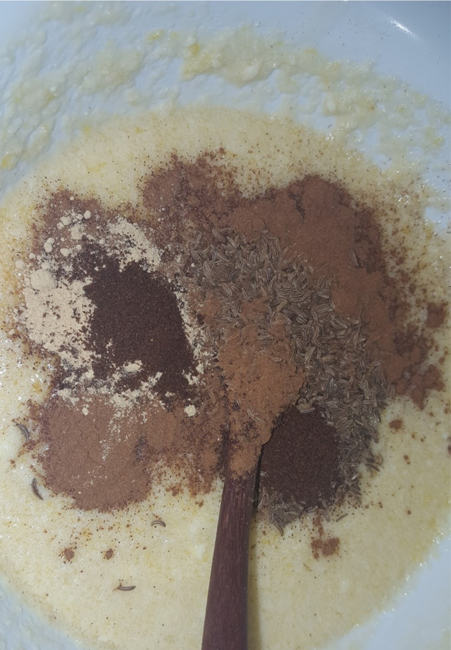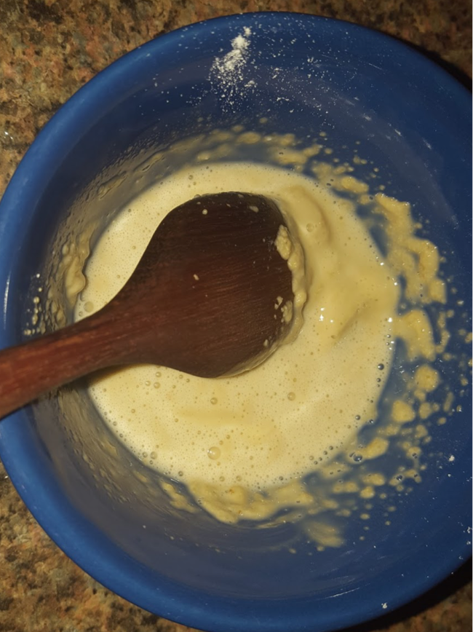
Top Left: Spices added to wet ingredients
Top Right: Ale Barm mixture (ale, yeast, flour)

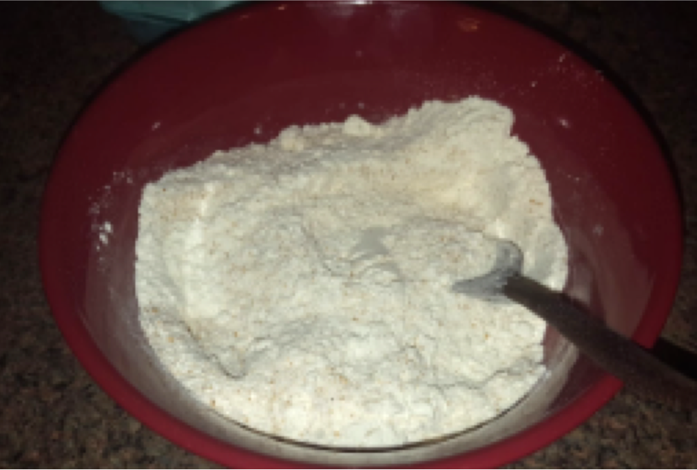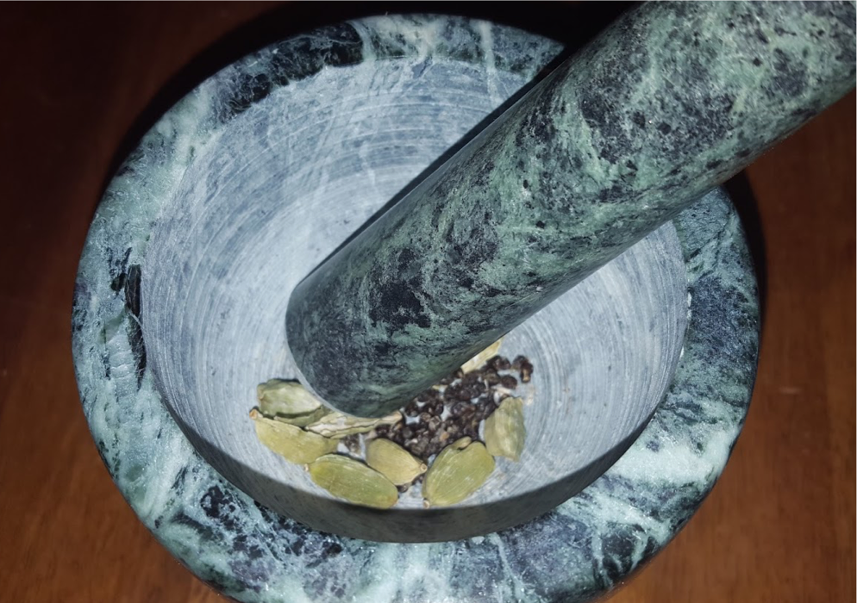
Top Left : Flour mixture
Top Right: Cardamom Pods being crushed

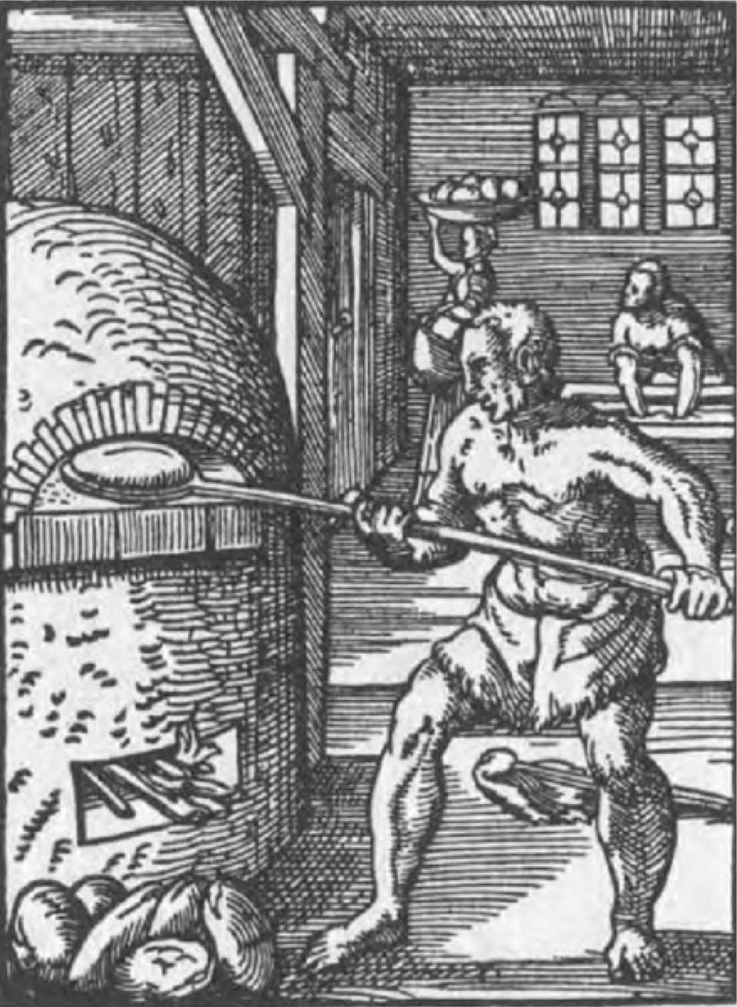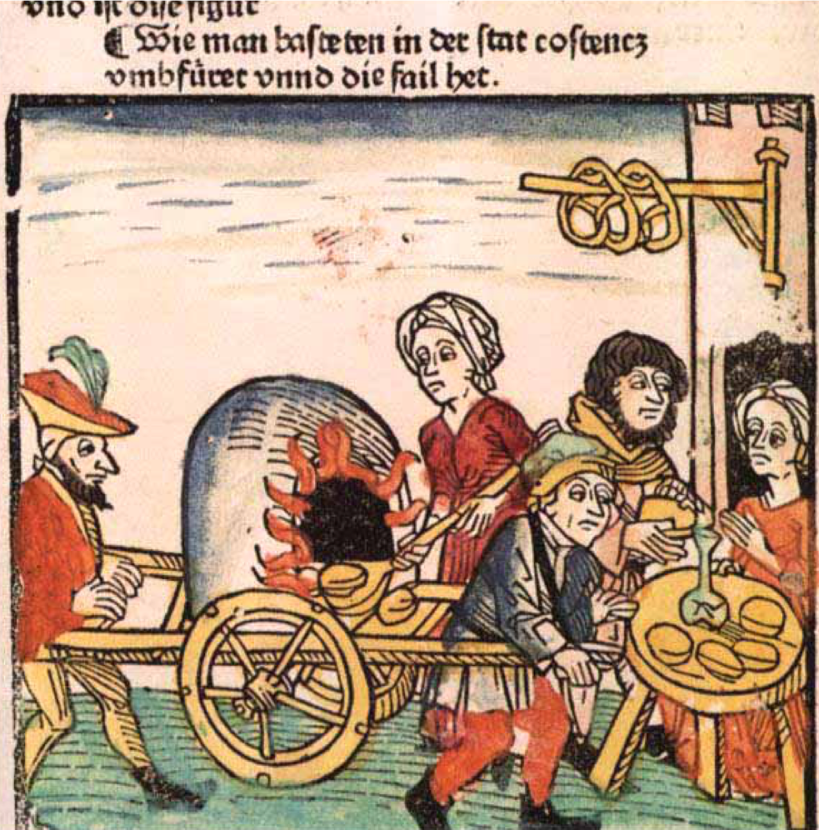
Top Left: 16th Century Baker (9)
Top Right: 15th Century Portable Oven (10)

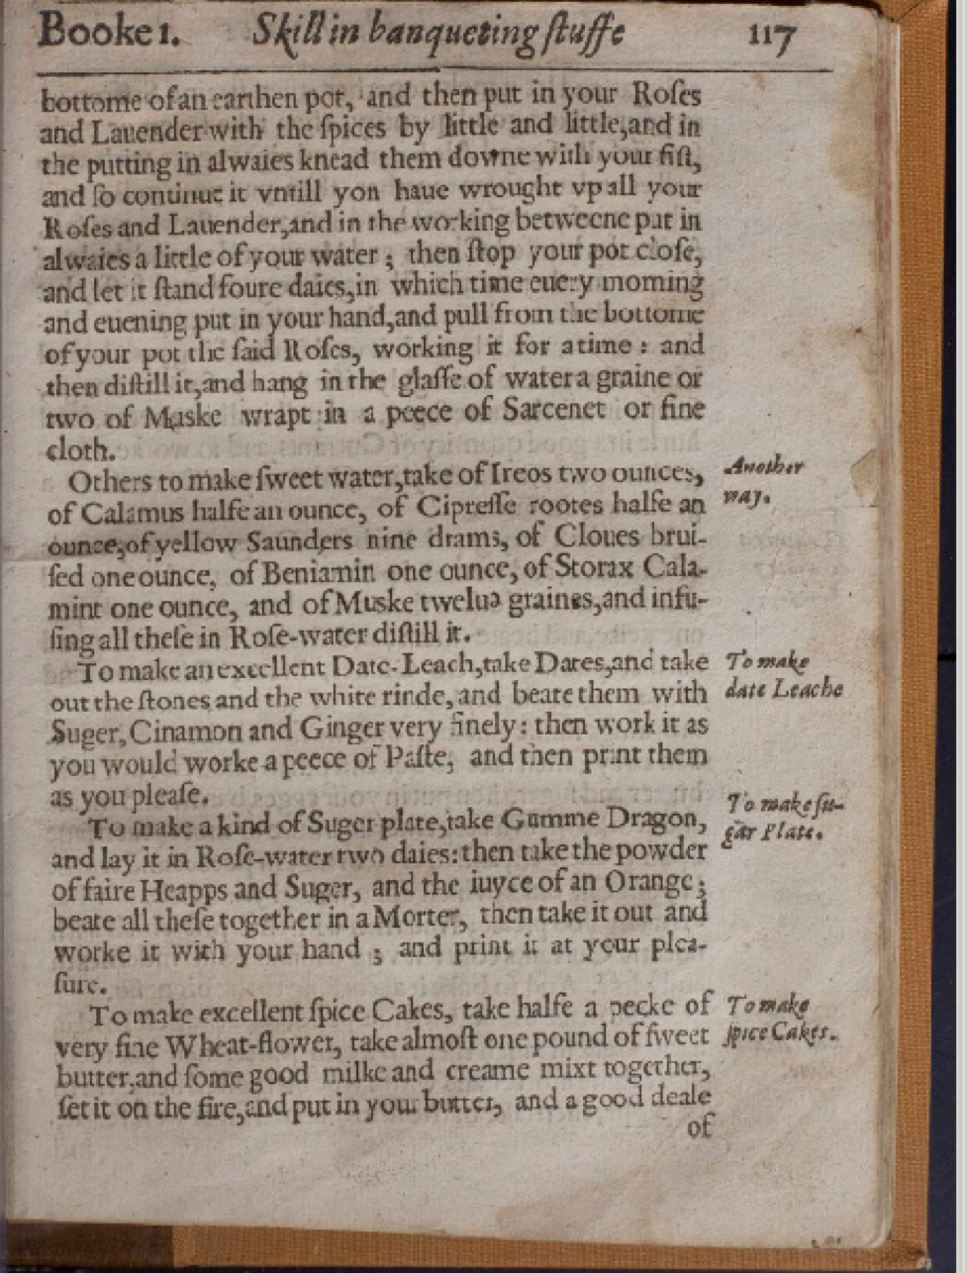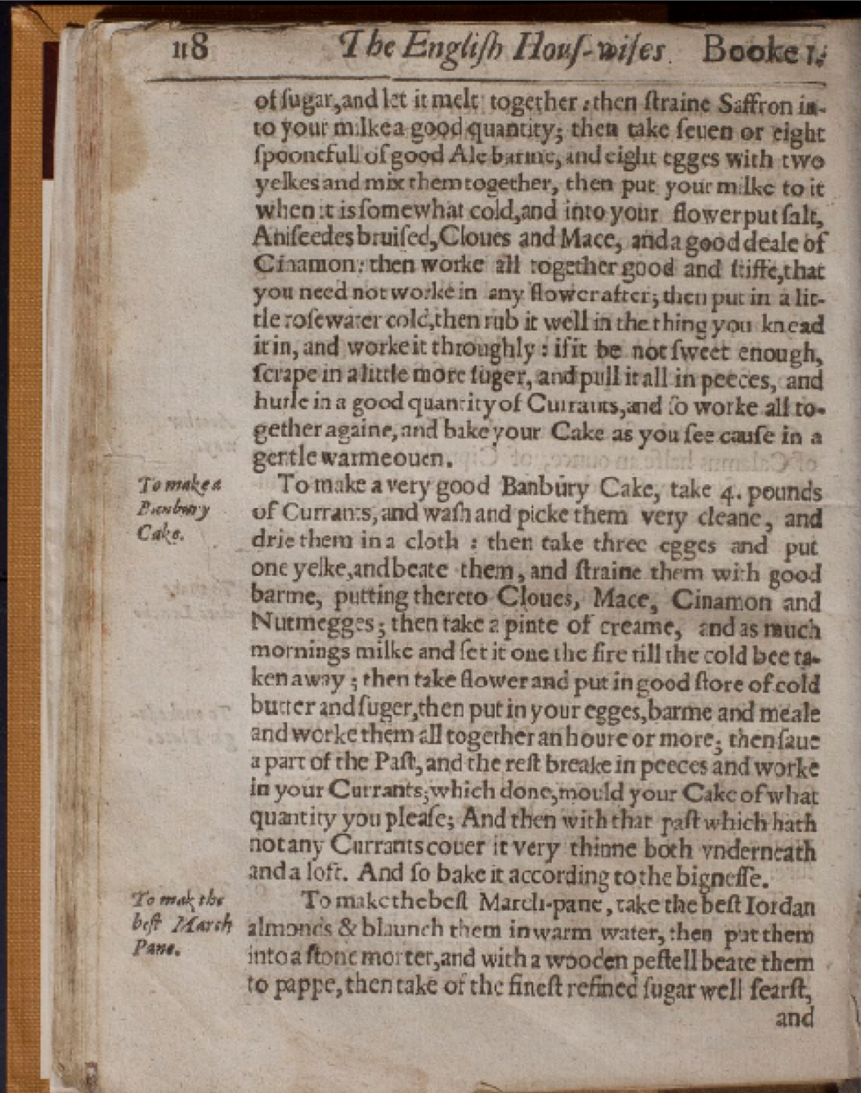
Bottom: Extant English Huswife pages (7)

The Experiment

Part of this project was to attempt reproduce what a home baker could accomplish with a covered pot and coals. I ended up making three attempts, with varying degrees of success. During this time, I was also fine tuning the spice/sugar/honey levels so the cake recepies might vary from what was used in the final cakes.

To my shock and horror, I discovered my favorite local 12th16th century cookpot emporium had shut down on account of it only existing in my fantasies. Instead I turned to terracotta planters. I had mixed results, but I’m mostly happy. After all, I cooked cake in fire!!

First Attempt

The first configuration I tried consisted of two saucers facing each other with a cake pain inside them, on the normal cooking rack of my charcoal grill. I soaked the terracotta in water for two hours.(11) Once my coals were ready and placed the rack on, built the cooking rig, and covered the grill. (Right and Left Below)

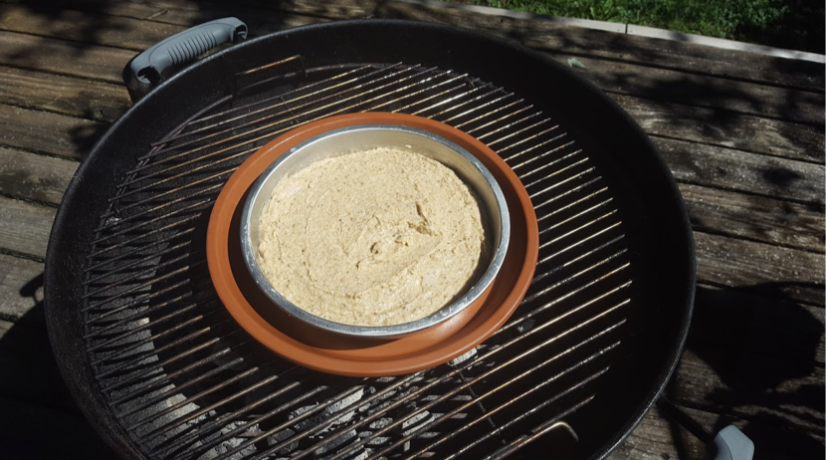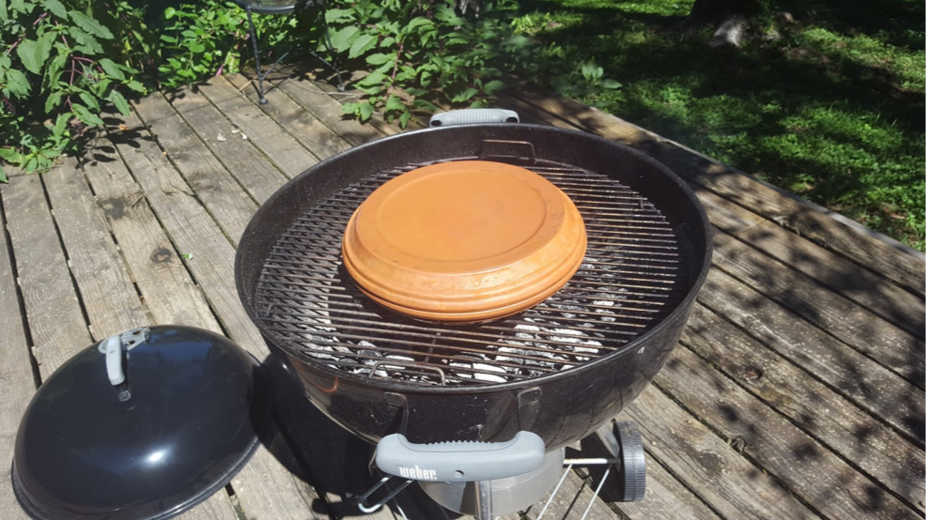

After a very long feeling half an hour I checked on the cake and it was not even close to being cooked. I decided I didn’t have enough heat. Using the same batter (which was pretty much raw) I relit the grill with new coal and reconfigured. I used a metal veggie grilling tray to prop up the baking rig right above the coals. (Below)

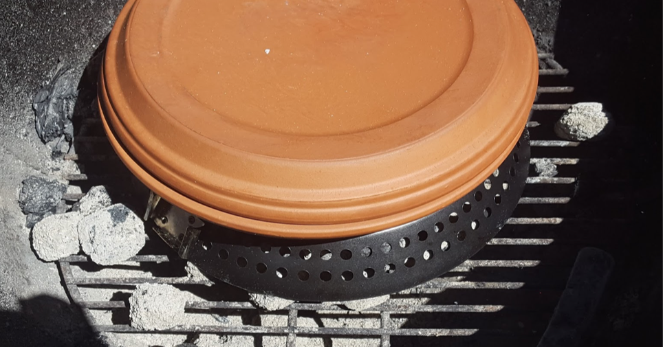

I covered the grill once again and waited for another 25ish minutes. The lid had a slight crack, but was not a full fracture (Bottom Right). After cooling a bit I turned the cake out and discovered it was very burnt on the bottom. After I cut off the burned bottom, I liked the taste and the texture wasn’t horrible. (Bottom Left)

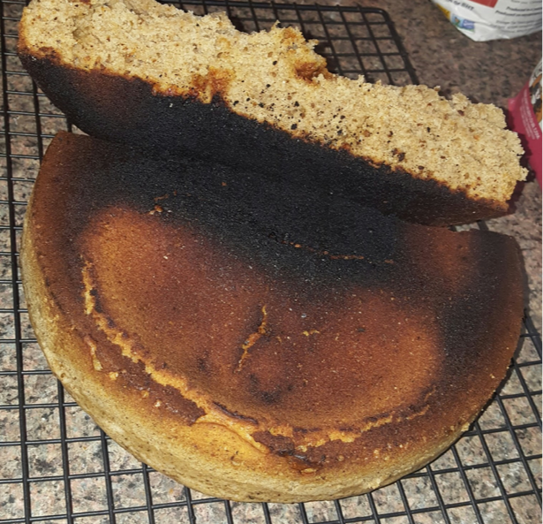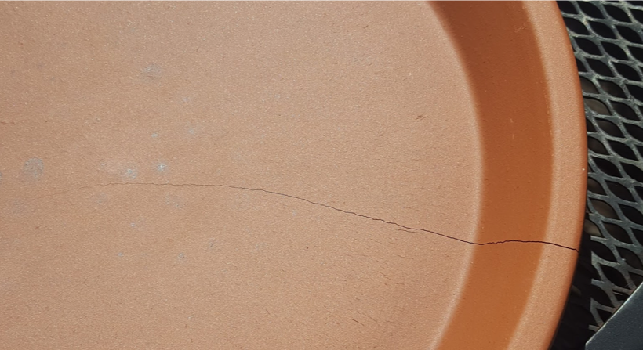

Second Attempt

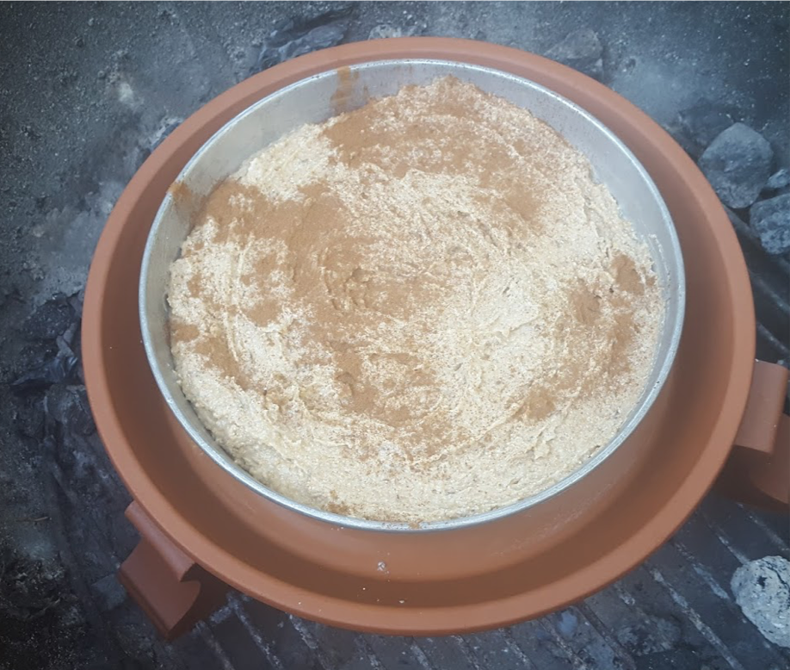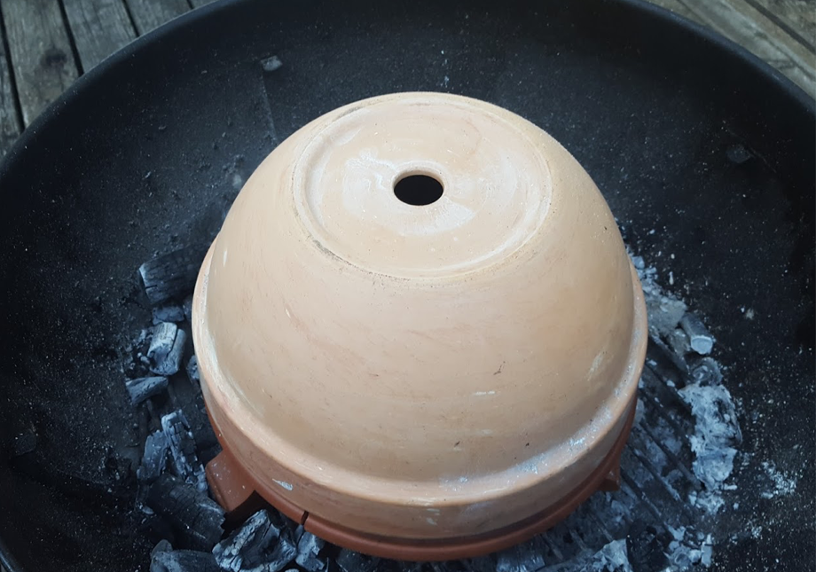

For my second attempt I found these cool feet at the hardware store, and felt they would make a better base to raise my baking rig up than the vegetable griller. I decided to raise the cake a bit from the terracotta, so I put a few metal nuts between the bottom of the cake pan and the terra cotta base. (Below)

I also changed the top saucer out for a terracotta dome. After soaking the terracotta and the coals were ready, I built my rig and covered the grill. (Left Top & Top Right).

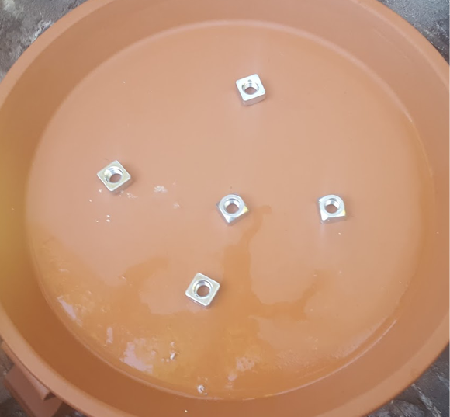

After twenty minutes I checked on the cake and discovered that the bottom saucer cracked completely. I had used a different type of charcoal and it pretty much burned down to very small bits that fell through the grate, so I lost quite a bit of heat. The cake technically passed the toothpick test, but the top still seemed uncooked. I carefully unassembled my cooking rig and placed the cake pan directly on the feet, and covered the top of the cake with the broken saucer and placed a few coals (also had to make additional coals) over it. (Below)

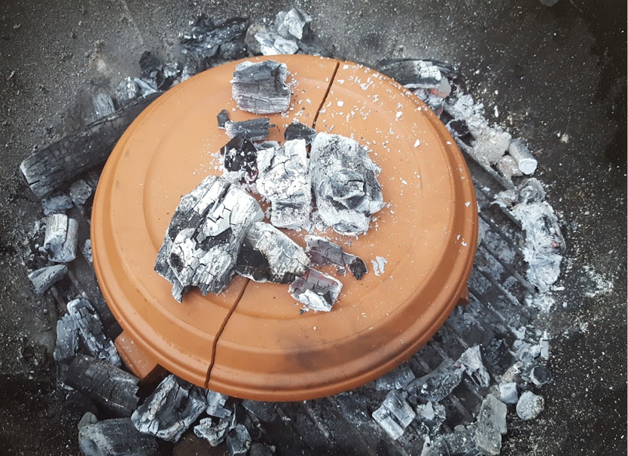

After another ten minutes checked on the cake again, it was better, but not great.
Trying to avoid the mistake from last time I opted to pull it rather than let the bottom burn again. The resulting cake was... odd. It had the consistency of a fuggy brownie, that had gone a bit wrong. Although I actually rather liked it. (Below)

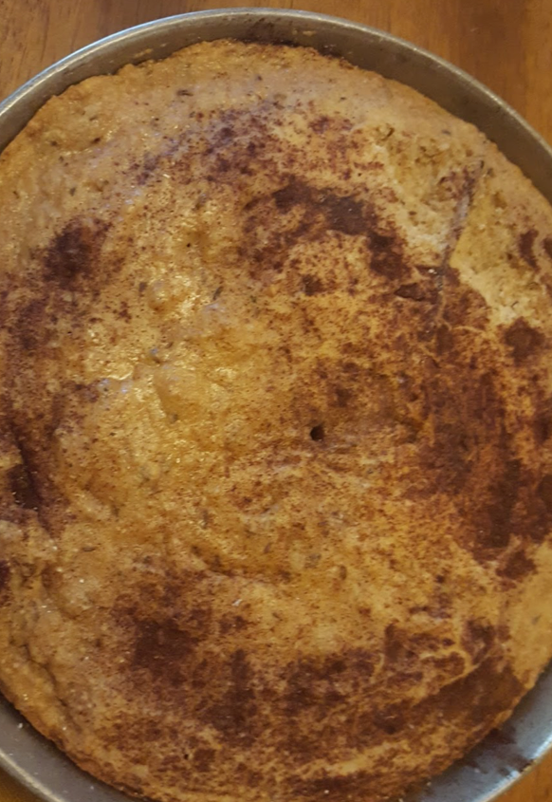

The charcoal I used was natural lump. It was horrible. A quarter of it fell through grate of my chimney starter and another quarter fell through the grill grate.

Third Attempt

In my third (and final) bake I decided to ditch the grill, get charcoal briquets, and set fire to my driveway. I chose my driveway for the obvious fire retardant properties of concrete. It also felt more medieval to me. I also skipped soaking the terracotta. It didn’t seem to help last time.

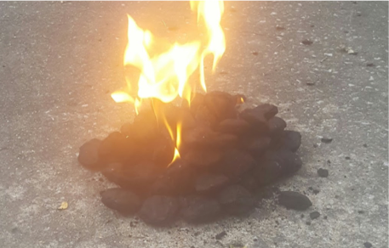

Combining the lessons learned from my previous two attempts, my baking rig consisted of the cake pan sitting on the terracotta feet with the dome over it. (Below)

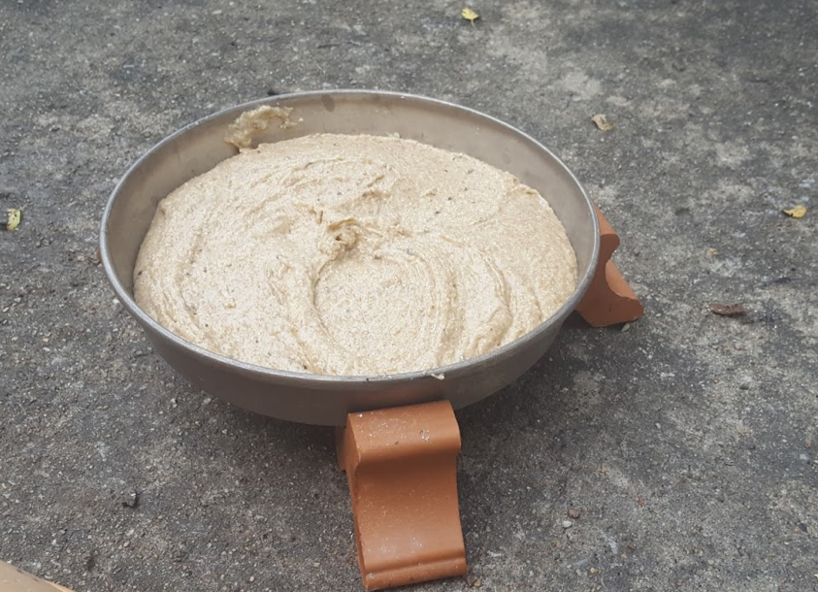

Before I domed the cake I placed a two or three coals under the cake pan. I surrounded the dome with most of the coals, then placed a few on top. (Below)

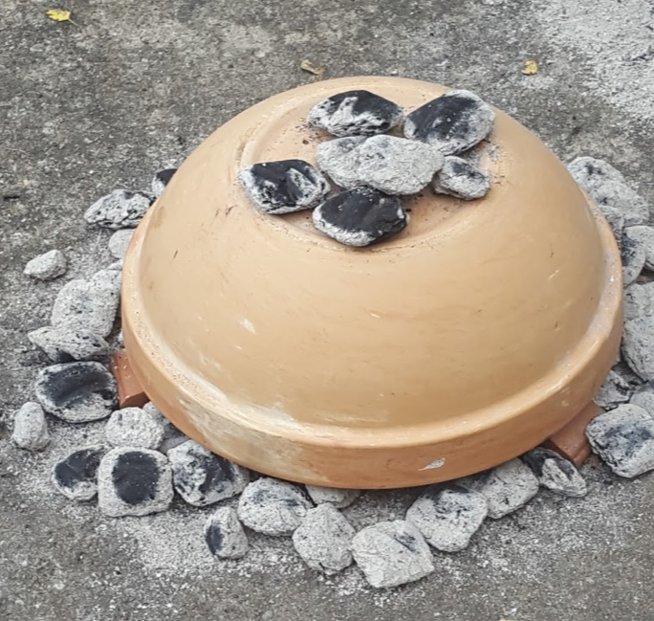

I scooted some of the coals under the rim of the dome, but not under the cake pan. During cooking, the dome did crack, despite my attempts to warm the dome by placing it near the coals while they were being prepared. After twenty minutes I removed the dome and replaced with a saucer, removed the coals from under the cake, and placed them the saucer. (Below)

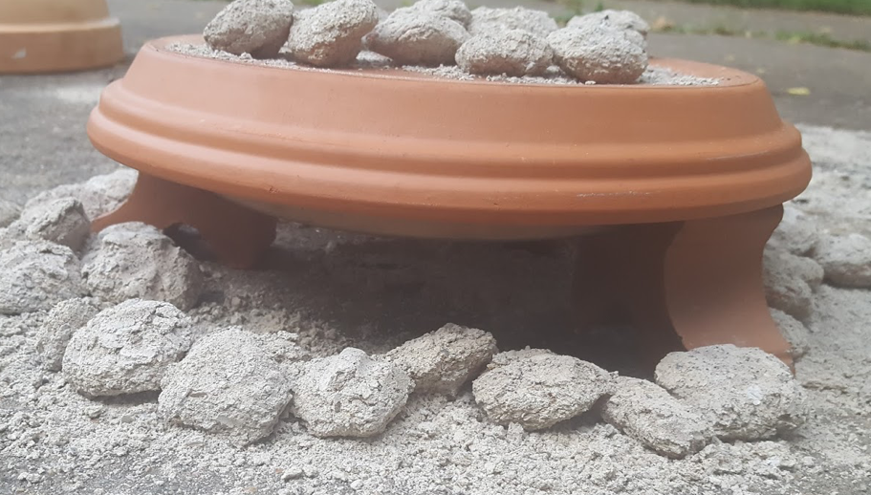

I baked for another ten minutes. The resulting cake passed the toothpick test and looked good. After breaking into it the texture was pretty good (for a driveway cake!) and was only slightly burned on the bottom. (Bottom Right and Left)

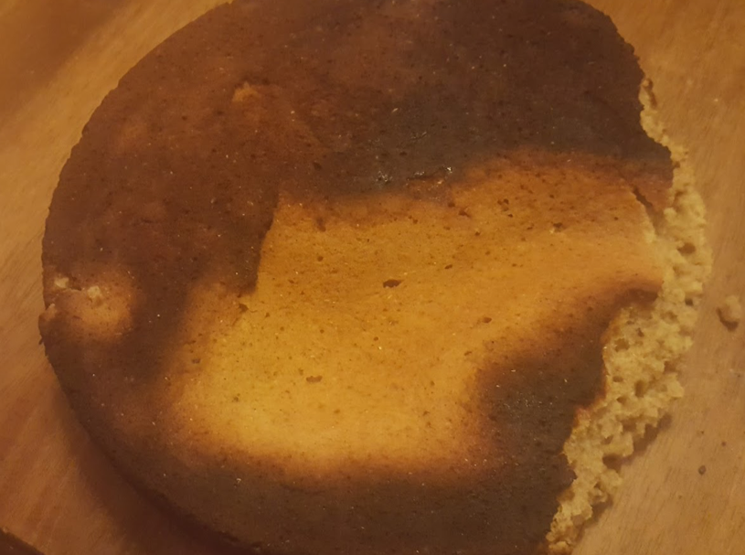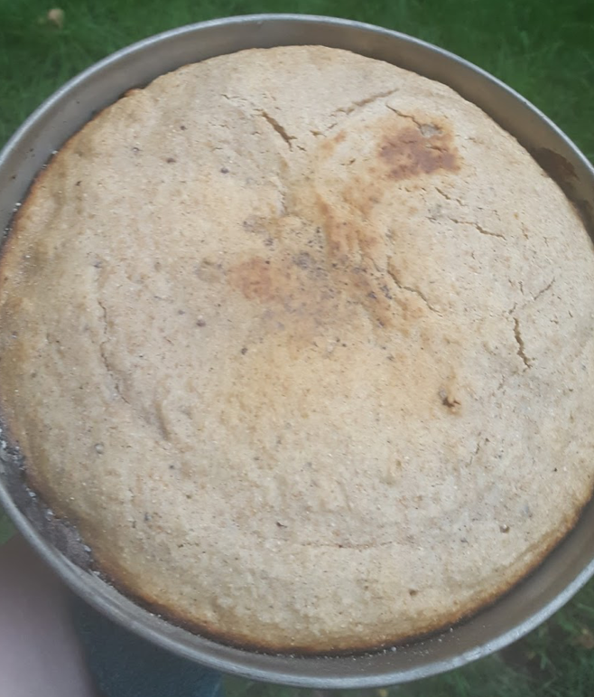

I consider this my most successful bake and was the most fun!

Works Cited

1. Forgeng, Jeffrey L. "Food and Drink." Daily Life in Elizabethan England. Santa Barbara, CA: ABCCLIO, 2009. 16768. Print.

2. Humble, Nicola. "Chapter One: Cakes through History." Cake: A Global History. London: Reaktion, 2010. 10, 1416. Print.

3. "Geoffrey Chaucer (13421400) "The Canterbury Tales", from General Prologue." Web. 11 Sept. 2016. <http://www.librarius.com/canttran/genpro/genpro625670.htm>

4. "Geoffrey Chaucer (13421400) "The Canterbury Tales", from The Reeve's Tale" Web. 11 Sept. 2016. <http://www.librarius.com/canttran/reevtale/reevtale213252.htm>

5. "Life In A Medieval Castle Medieval Food." Castle Life. Web. 11 Sept. 2016. <http://www.castlesandmanorhouses.com/life_04_food.htm#preparation>

6. W., A. "To Make Farts of Portingale." A Book of Cookrye. Very Necessary for All Such as Delight Therin. London: Printed by E. Allde, 1591. Kindle eBook.

7. Markham, Gervase. "To Make Spice Cakes." The English Huswife. London: Printed by Kohn Beale for Roger Iackson, 1615. 11718. LSE Digital Library. Web. 11 Sept. 2016. <http://digital.library.lse.ac.uk/objects/lse:heh898zor/read/single#page/118/mode/2up>

8. "Seed Cake." Seed Cake. Gode Cookery, Web. 11 Sept. 2016. <http://www.godecookery.com/goderec/grec29.htm>.

9. "Der Beck" aus Eigentliche Beschreibung aller Stände auf Erden (1568) <https://commons.wikimedia.org/wiki/File:St%C3%A4nde_Amman_Der_Beck.png>
10. Baker’s portable oven Ulrich Richental, Concilium zu Constanz (Augsburg, 1483) <https://www.loc.gov/rr/rarebook/guide/ra035001.html>

11. Andrews, By A.J. "How to Cook With TerraCotta Clay Pots | LEAFtv." LEAFtv. Web. 14 Sept. 2016. <https://www.leaf.tv/articles/howtocookwithterracottaclaypots/>

------
Copyright 2016 by Michelle Araj. <michellearaj at gmail.com>. Permission is granted for republication in SCA-related publications, provided the author is credited. Addresses change, but a reasonable attempt should be made to ensure that the author is notified of the publication and if possible receives a copy.

If this article is reprinted in a publication, please place a notice in the publication that you found this article in the Florilegium. I would also appreciate an email to myself, so that I can track which articles are being reprinted. Thanks. -Stefan.

<the end>

