Stewed-Camel-art - 12/10/17

"Stewed Camel" by The Honorable Tomas de Coucy.

NOTE: See also the files: Ap-Fools-Rec-art, Blood-Cake-art, eels-msg, liver-msg, Offal-Time-art, tongue-msg, exotic-meats-msg, horse-recipes-msg, marrow-msg.

************************************************************************
NOTICE -

This article was added to this set of files, called Stefan's Florilegium, with the permission of the author.

These files are available on the Internet at: http://www.florilegium.org

Copyright to the contents of this file remains with the author or translator.

While the author will likely give permission for this work to be reprinted in SCA type publications, please check with the author first or check for any permissions granted at the end of this file.

Thank you,
Mark S. Harris...AKA:..Stefan li Rous
stefan at florilegium.org
************************************************************************

You can find more work by this author on his website at:
http://www.sca.noaharney.com

Stewed Camel
by Tomas de Courcy

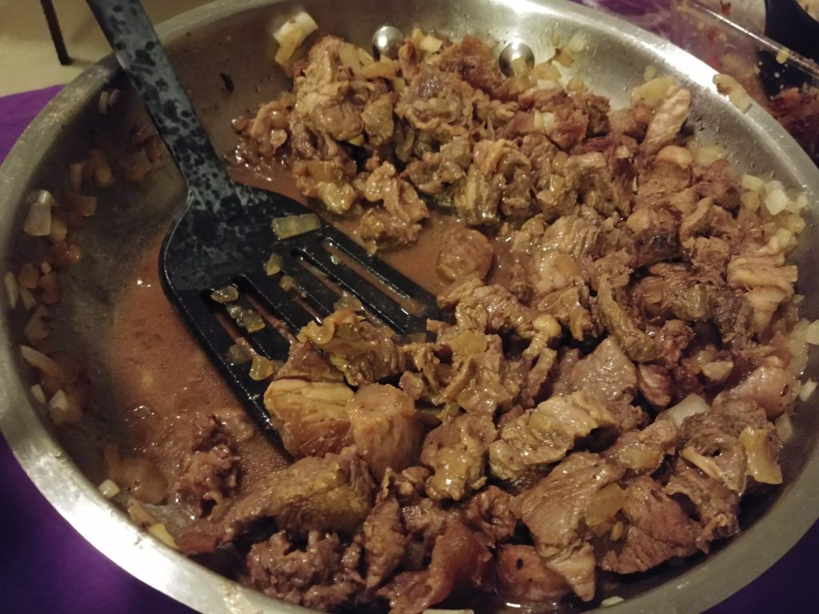

My wife, Her Ladyship Kayleigh de Leis, likes to suggest strange dishes for me to try making. At her recommendation we’re trying camel. Nope, that’s not a typo. Today’s recipe comes to us from Anissa’s Blog, and was originally translated by Charles Perry. Unfortunately I don’t have a copy of A Baghdad Cookery Book (aka Kitāb Al-ṭabīkh by Al Baghdadi), from which this comes, so I don’t have a page number for you.

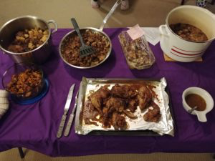
The dishes from Culinary Night, they’re a bit brown as everyone did a protein dish this time

Jazuriyya bi-Lahm Jazur
(aka Stewed Camel)

note: technically Juzar could be mutton or camel, but I just really want to cook camel

Camel rib and leg meat
Camel hump
Onions
Vinegar
Soy sauce
Pepper
Coriander
Caraway
Mixed spices (abzar, probably like the baharat or hawayij of modern Arab cookery)

Slice up the meat and hump as if you were going to make the medieval fry-up called qaliyya. Cook the sliced meat in a pot until it gives up all its moisture, then add onions and the sliced hump and cook everything together until the hump renders its fat.

Add the vinegar, soy sauce, pepper, coriander, caraway and mixed spices to taste (the recipe gives no measurements at all) and continue cooking until everything is done.

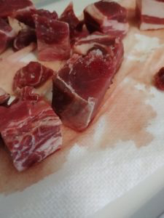
I used pre cubed camel, so I wasn’t able to have nice thin ribbons like I wanted, but I did cut it up a bit smaller than the pieces were originally

The word Charles Perry has translated as Soy Sauce is a barley sauce made in the same way as soy sauce, they’re supposed to be interchangeable (source: Anissa http://www.anissas.com/when-camel-meat-was-fashionable/).

2 lb Camel meat (hump preferred)
2 Onions, diced
2 tbsp red wine Vinegar
1/4 cup Soy sauce
1 tsp Pepper
1 tsp Coriander
1 tsp Caraway
Mixed spices to taste (cardamom, cumin, nutmeg, cinnamon, ginger)
Salt to taste

- Slice camel thin
- Cook till almost browned (if using any hump add it with the onions)
- Add onions cook till translucent
- Mix together spices and liquid ingredients
- Add to meat, cook 5-10 minutes
- Salt to taste
- Serve

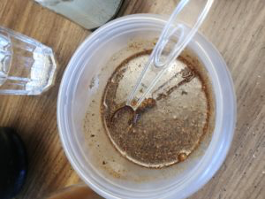
Here’s the sauce/spice mix, and it tastes divine.

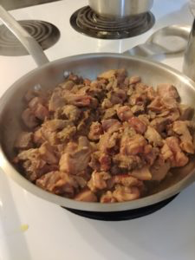
Browning up the camel

The end result was delicious. A great spice/sauce blend and the meat tastes almost like a cross between beef and pork.

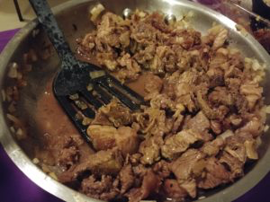
Eat up

------
Copyright 2017 by Noah Arney. <tomas at noaharney.com>. The author will likely give permission for republication in SCA-related publications, but wishes to be contacted prior to any republication.

If this article is reprinted in a publication, please place a notice in the publication that you found this article in the Florilegium. I would also appreciate an email to myself, so that I can track which articles are being reprinted. Thanks. -Stefan.

<the end>

