Dried-Bef-Qan-art - 10/4/13

"Dried Beef for the Qan" by Mistress Ailleagan nas Seolta, OP.

NOTE: See also the files: drying-foods-msg, food-storage-msg, Calontr-Jerky-art, exotic-meats-msg, meat-smoked-msg, pickled-meats-msg, corned-beef-msg.

************************************************************************
NOTICE -

This article was submitted to me by the author for inclusion in this set of files, called Stefan's Florilegium.

These files are available on the Internet at: http://www.florilegium.org

Copyright to the contents of this file remains with the author or translator.

While the author will likely give permission for this work to be reprinted in SCA type publications, please check with the author first or check for any permissions granted at the end of this file.

Thank you,
Mark S. Harris...AKA:..Stefan li Rous
stefan at florilegium.org
************************************************************************

Dried Beef for the Qan
by Mistress Ailleagan nas Seolta, OP

Premise

It is an ongoing process of mine to add to my collection of cookery information and texts from the Dark Ages and the Medieval era. Often, this requires that I borrow books through inter-library loan, as many of the tomes I want are far outside my price range. I was especially happy when a copy of A Soup for the Qan (translated from a manuscript written in 1330) arrived in this manner.

I was particularly excited when I saw this recipe:

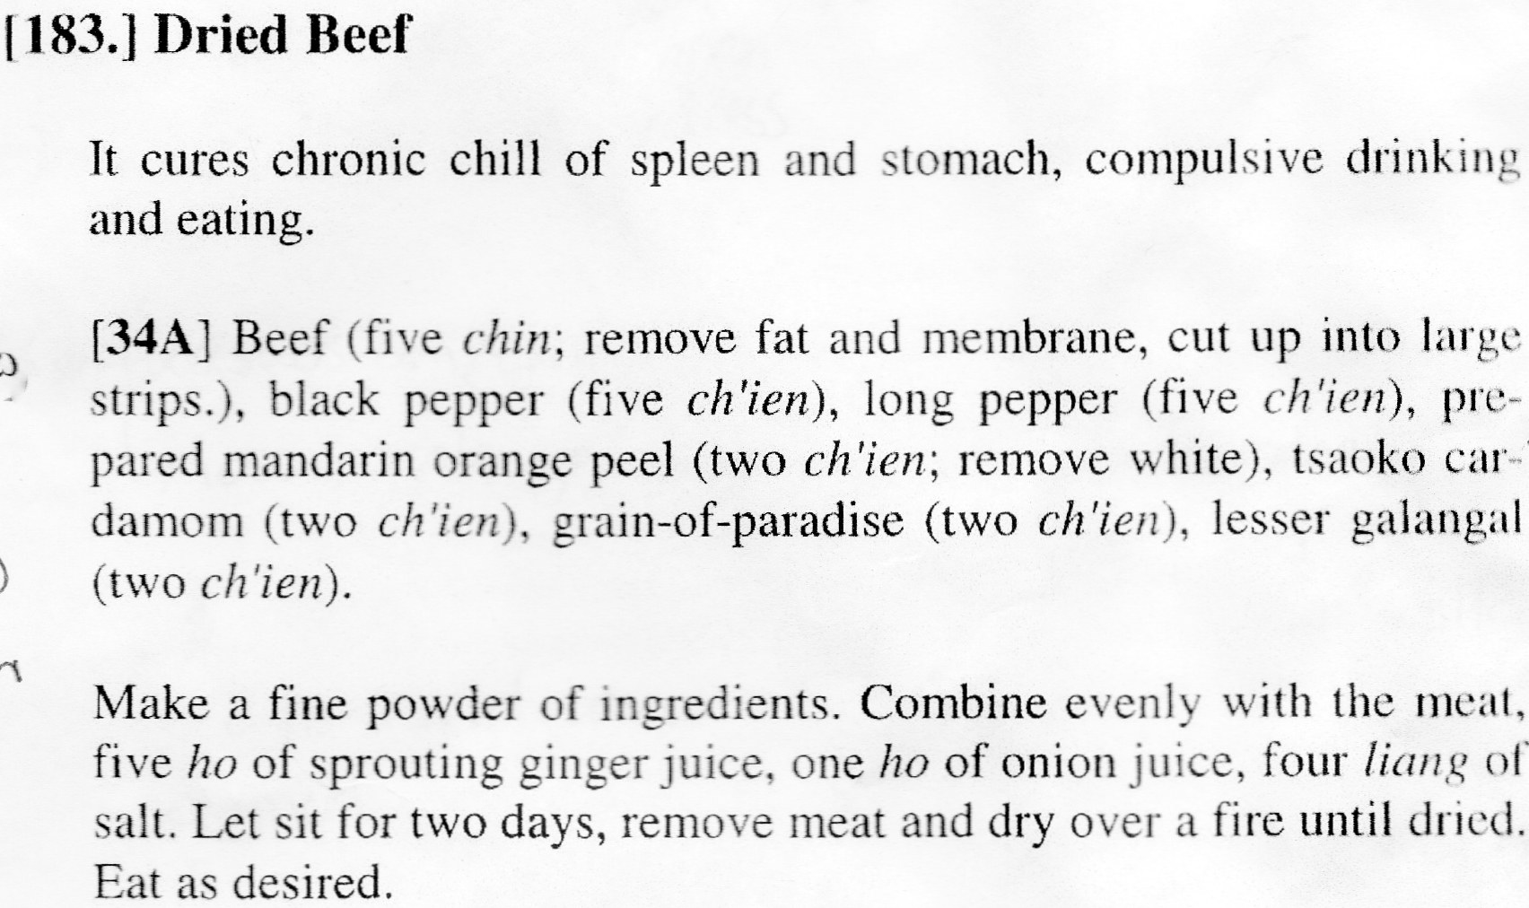

This recipe is a culinary recreator's dream – simple, just a few ingredients (that aren't that unusual or difficult to obtain if you're already into medieval cooking), and a straightforward preparation method. Best of all, it includes measurements!

After a successful trial at Magna Faire, I wanted to research other forms of dried meat that was eaten as-is. Unfortunately, there are almost no other culinary examples. It is fairly universally agreed that Medieval people did dry their meats for preservation purposes, but it is rarely recorded that it was actually eaten in its dehydrated state. The final statement in the above recipe makes it quite unique.

Apicius had a recipe for keeping cooked meat preserved in a pickle, but there was no indication that it was eaten this way.

The Dutch "Koge Bog" from 1616 has a recipe for smoked meat, that describes how "still warm killed" meat should be rubbed with salt and then hung over a beech fire. It had no indication that it was consumed in its dried state.

In Tastes of Byzantium, a recipe for apokti outlines the procedure for soaking a salted pork loin in vinegar, then rubbing it with spices before drying it for several weeks. I chose not to make this recipe because there was no indication that it was consumed in its dried state, and because I was uncomfortable leaving pork to air dry.

There are many references to pastirma or bastirma in Turkish cuisine (the precursor to pastrami), but no real indication of how it was prepared or eaten.

But even without the bonus of a survey of "jerky" recipes, I enjoyed making this recipe very much.

Conversion, Extrapolation, Reduction

The translator's and editor's notes in the text revealed that a liang equals approximately 31.25 grams. A ch'ien is 3.12 grams, or 1/10 liang. Sixteen (16) liang equals 1 chin, which is approximately 500 grams. A ho is 3.17 cubic inches, or 51.9 cubic centimeters, or 51.9 milliliters.

Using a couple of online conversion charts, I was able to create this recipe :

5.5 pounds beef
15.6 grams black pepper
15.6 grams long pepper
6.24 grams mandarin orange peel (with pith removed, as directed) 6.24 grams cardamom
6.24 grams grains of paradise
6.24 grams galingale
259.5 milliliters ginger juice
52 milliliters onion juice
125 grams salt

Five pounds of meat is quite a bit, especially for a recipe I wasn't sure would work. It is for this reason that I prepared 1/5 the written recipe, using this formulation with measurements converted (approximately) to teaspoons:

1.16 pound beef (that's how the steak was packaged)
3.12 grams or 2/3 teaspoon black pepper
3.12 grams or 2/3 teaspoon long pepper
1.25 grams or 1⁄4 teaspoon dried mandarin orange zest
1.25 grams or 1⁄4 teaspoon cardamom
1.25 grams or 1⁄4 teaspoon grains of paradise
1/25 grams or 1⁄4 teaspoon galingale
52 milliliters of 3 tablespoons + 1 1⁄2 teaspoons ginger juice
10.4 milliliters or 2 teaspoons onion juice
25 grams or 5 1⁄4 teaspoons (or 1 tablespoon + 2 1⁄4 teaspoons) salt

Then began the quest for ingredients.
For the beef, I used Milanesa steaks from our grocery. They are thinly sliced and perfectly suited to drying.

I had black pepper, long pepper, and grains of paradise in my pantry already.

The one potential snag I found was the inclusion of mandarin orange peel. Mandarin oranges (citrus reticulata) are the same as tangerines (citrus reticulata), which are a seasonal fruit. It is for this reason that I chose to use dried peel; the fruit was available in late fall and early winter, when I prepared it for Magna Faire, but it would not be available in warmer months. Fortunately, I thought to dry extra zest back in November so I would have it if and when I wanted to prepare the beef in the summer.

This made my daughter very happy – she loves oranges. She ate all the fruit with the agreement that she would save the peel for me. After she finished snacking, I could simply remove the pith (the bitter white part) and leave it in the air to dry.

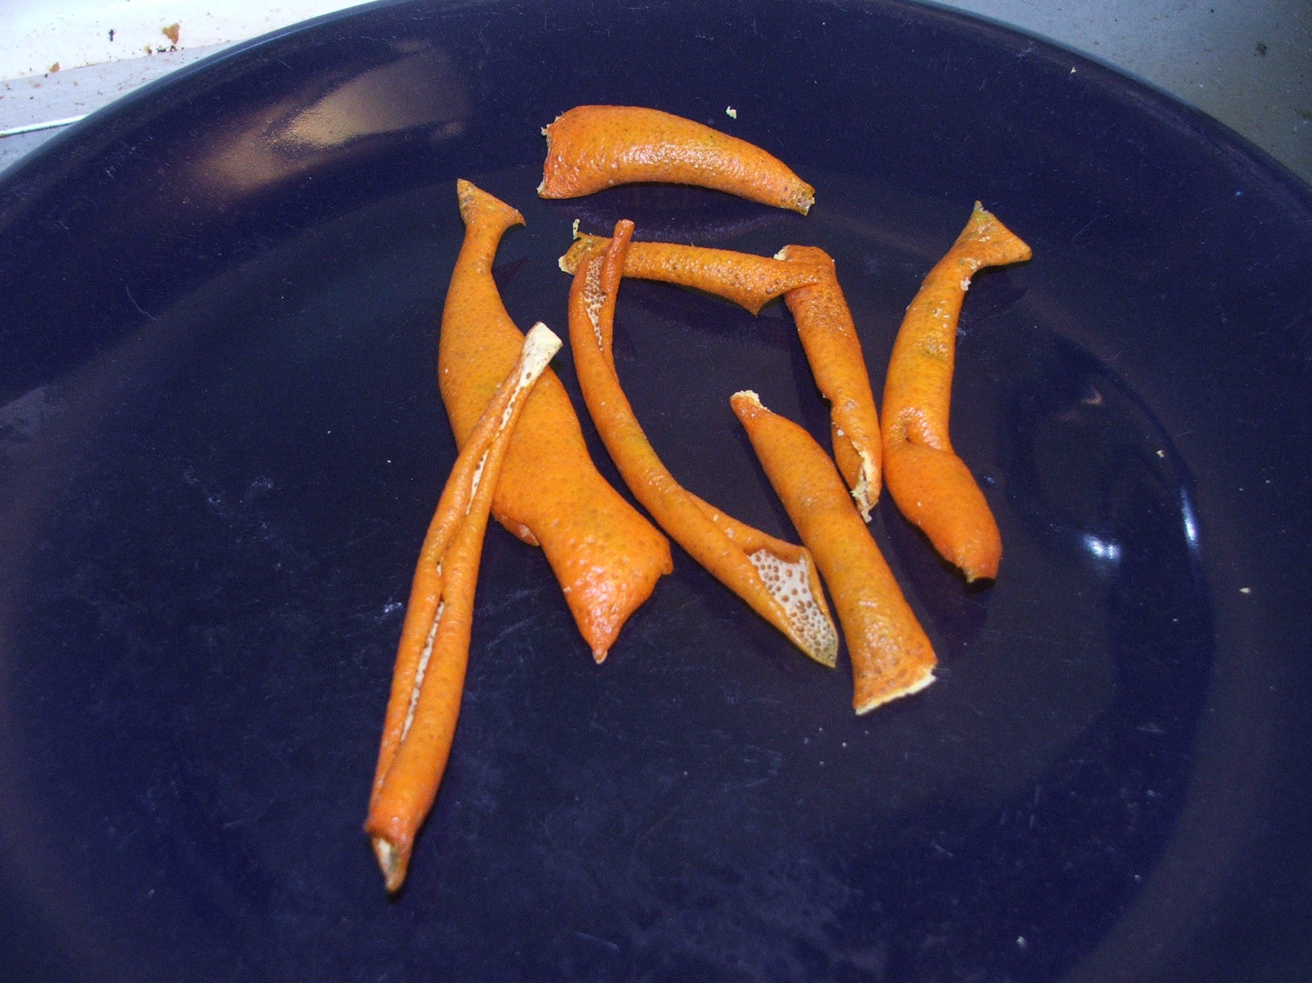

Mandarin orange peel after on day of drying; I left it to dry in the air for a week

Tsaoko cardamom and lesser galingale required a little research.

The Qan text revealed that tsaoko meant "large". The botanical name of this plant is Amomum tsao-ko, which is the name for several varieties of cardamom, including black, brown, red, and white. Fortunately, I already had the brown variety in my pantry.

Lesser galingale has several aliases, and there is quite a bit of misinformation on the internet about which plants are called by this name. I did eventually discover that it is not zedoary, white turmeric, or kencur, but it is the same galingale I had in my pantry. It is also called Chinese ginger, China root, India root, and galangal.

Preparation

I measured the spices into a mortar, then ground them by hand. The fragrance was quite pleasingly aromatic, but very strong.

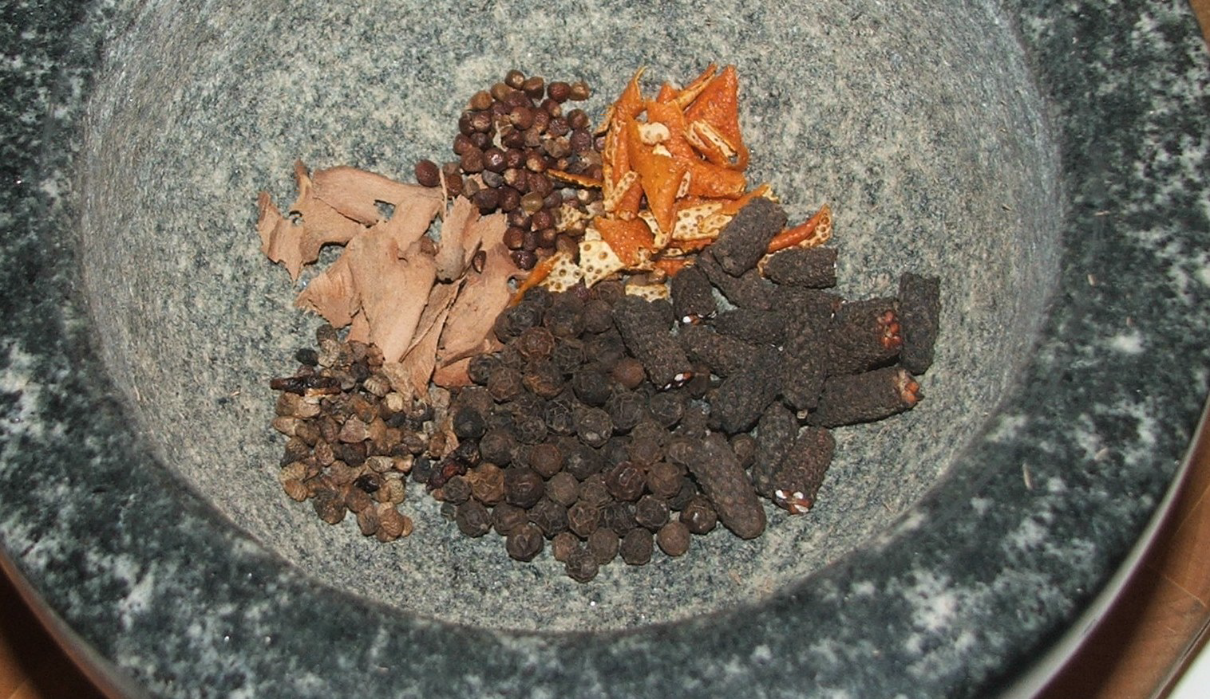

Clockwise from top: grains of paradise, tangerine peel, long pepper, black pepper, cardamom seeds, galingale

Then I grated the ginger to squeeze it for the juice. It took nearly 1⁄4 pound of ginger to obtain the 3 1⁄2 tablespoons of juice I needed.

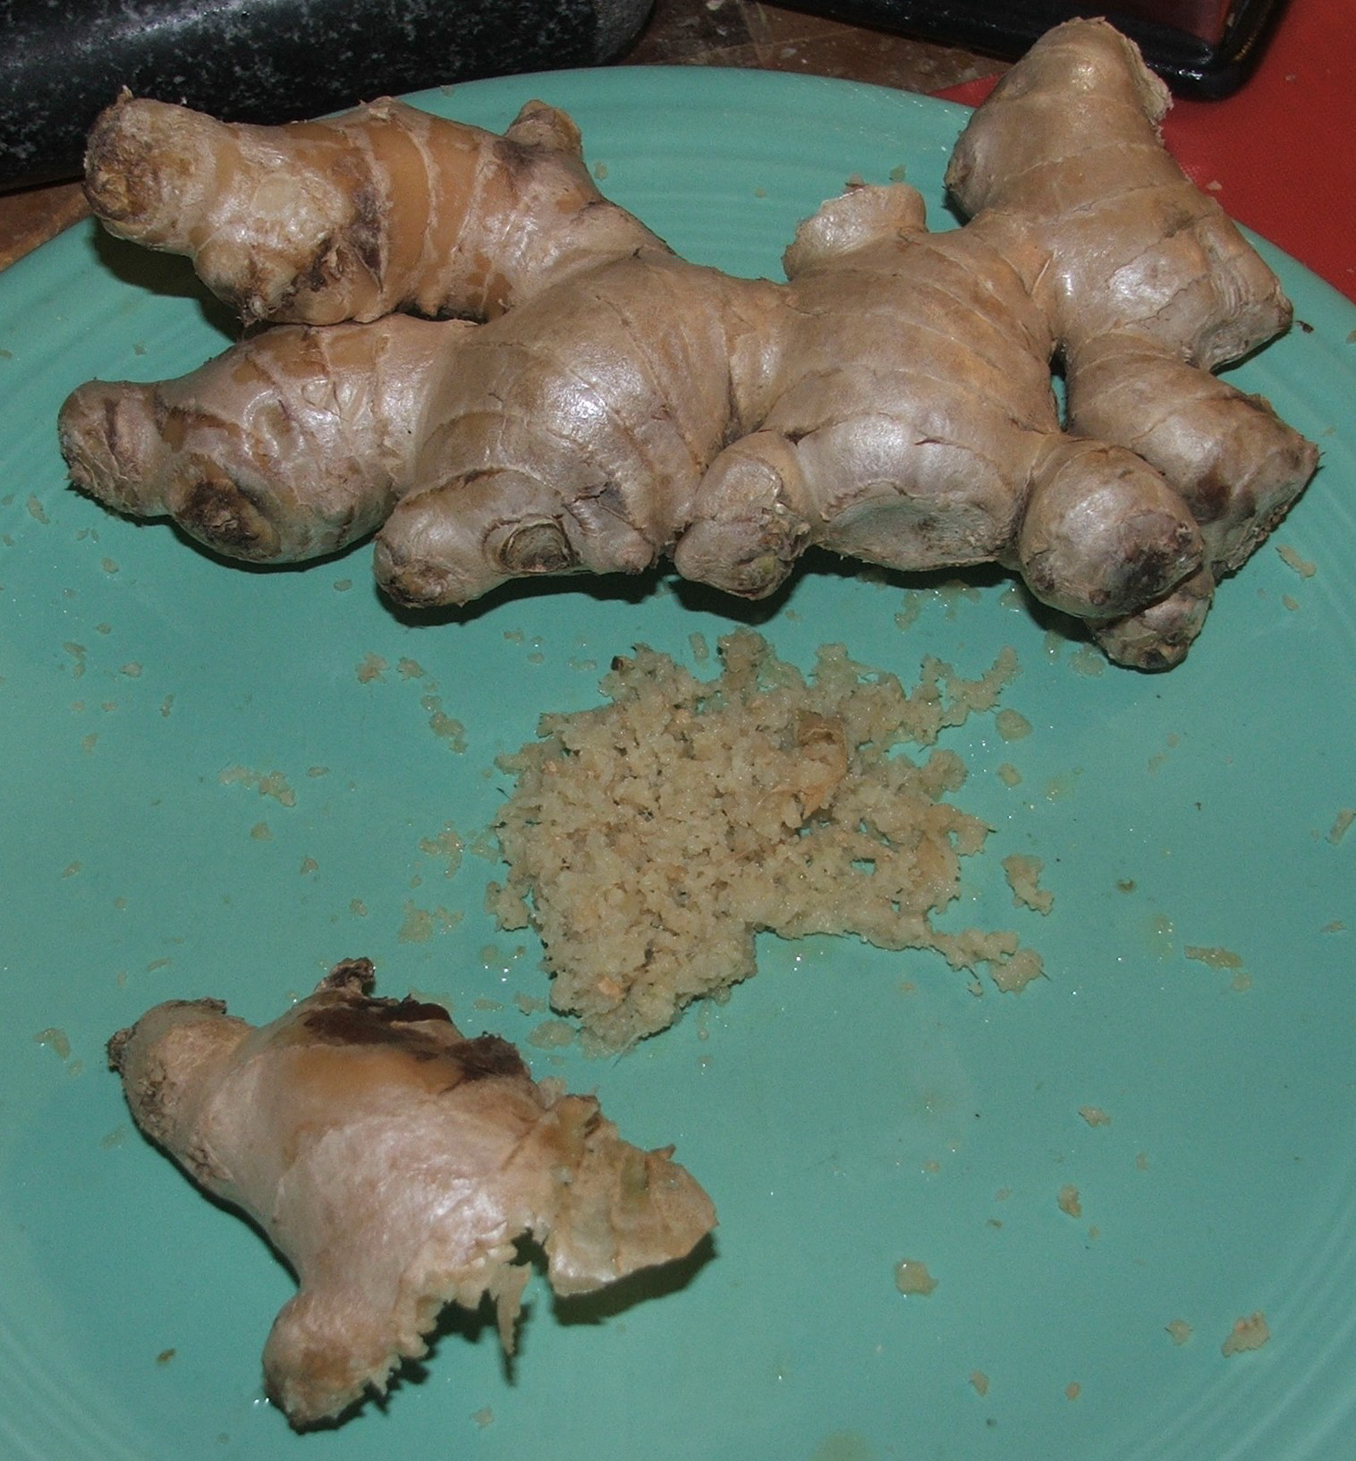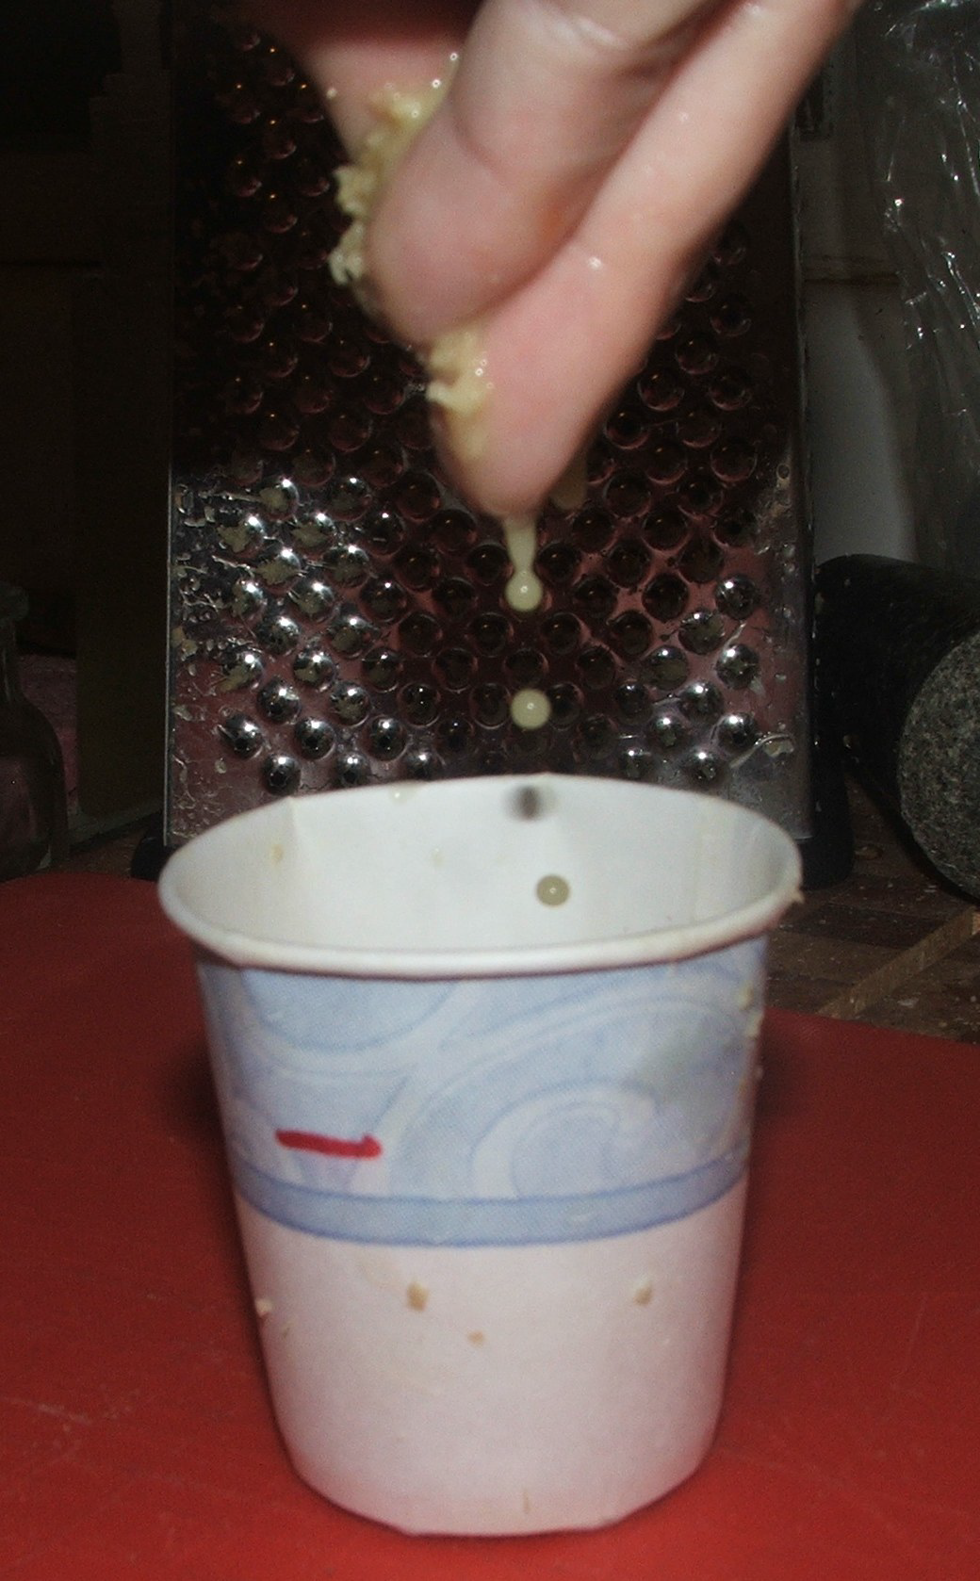

Fresh ginger, some grated Squeezing the grated ginger; the mark on the cup
indicated how much juice I needed.

After I finished juice in the ginger, I did the same with the onion. I need about half a large white onion to obtain enough liquid. (I learned my lesson the first time I made this recipe. For anyone else who wishes to create it, I strongly recommend wearing gloves before juicing the ginger and onion. Otherwise, your hands may be on fire for an hour afterward.)

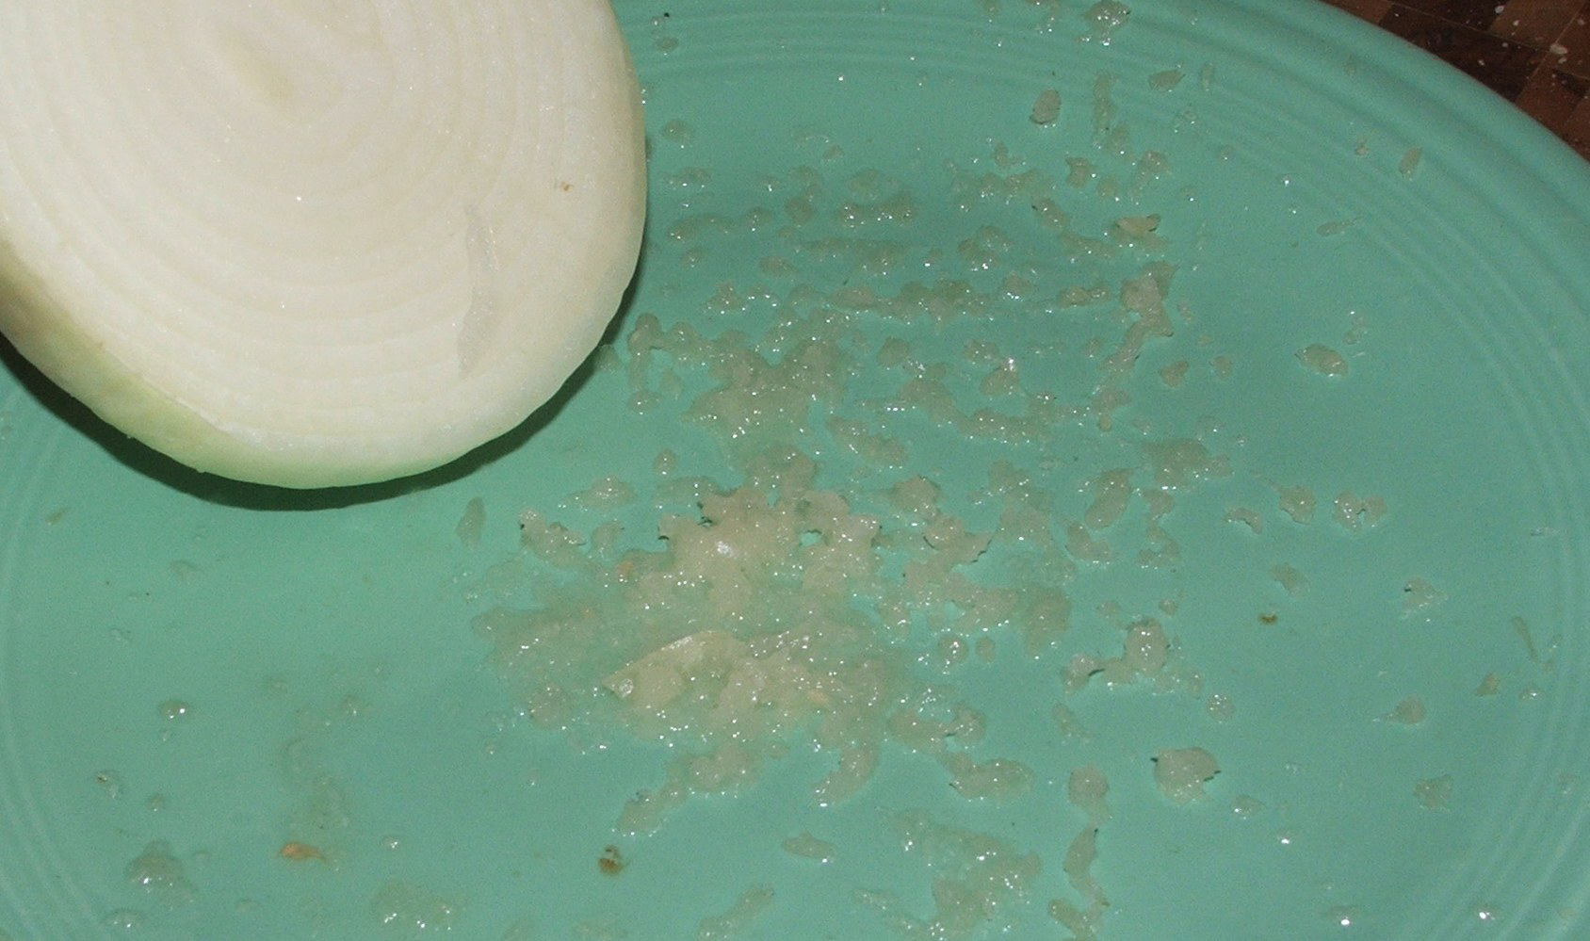

After the spices were ground and the ginger and onion were juiced, I combined them with the salt in a Ziploc bag. (This would probably have been done in a crock or in a pouch made from an animal's stomach, but I have neither.) I cut the beef into strips and added it to the mix. It didn't appear to me that I had enough marinade to thoroughly distribute among all the meat, so I added 1⁄2 cup of water to ensure that all the strips of meat would be coated with the seasoning mixture. It made coating the meat much easier.

Although it was not listed in the ingredients or in the process, I believe adding the water is an acceptable modification. Joan Santanach, the editor of The Book of Sent Sovi, a 14th century Catalan culinary collection, clearly noted that recipes of that era were written by professionals for professionals, so there was an understanding that the reader would have some knowledge of culinary processes and would therefore not need every detail spelled out. [1]

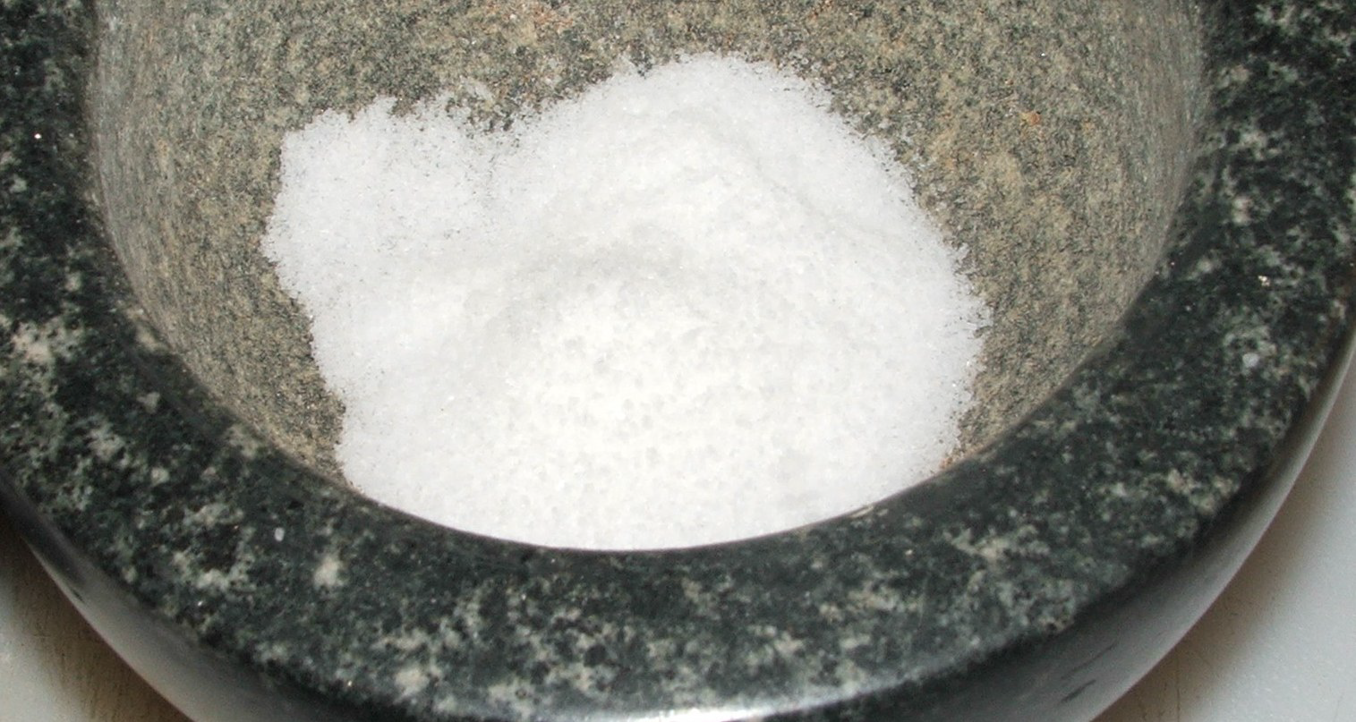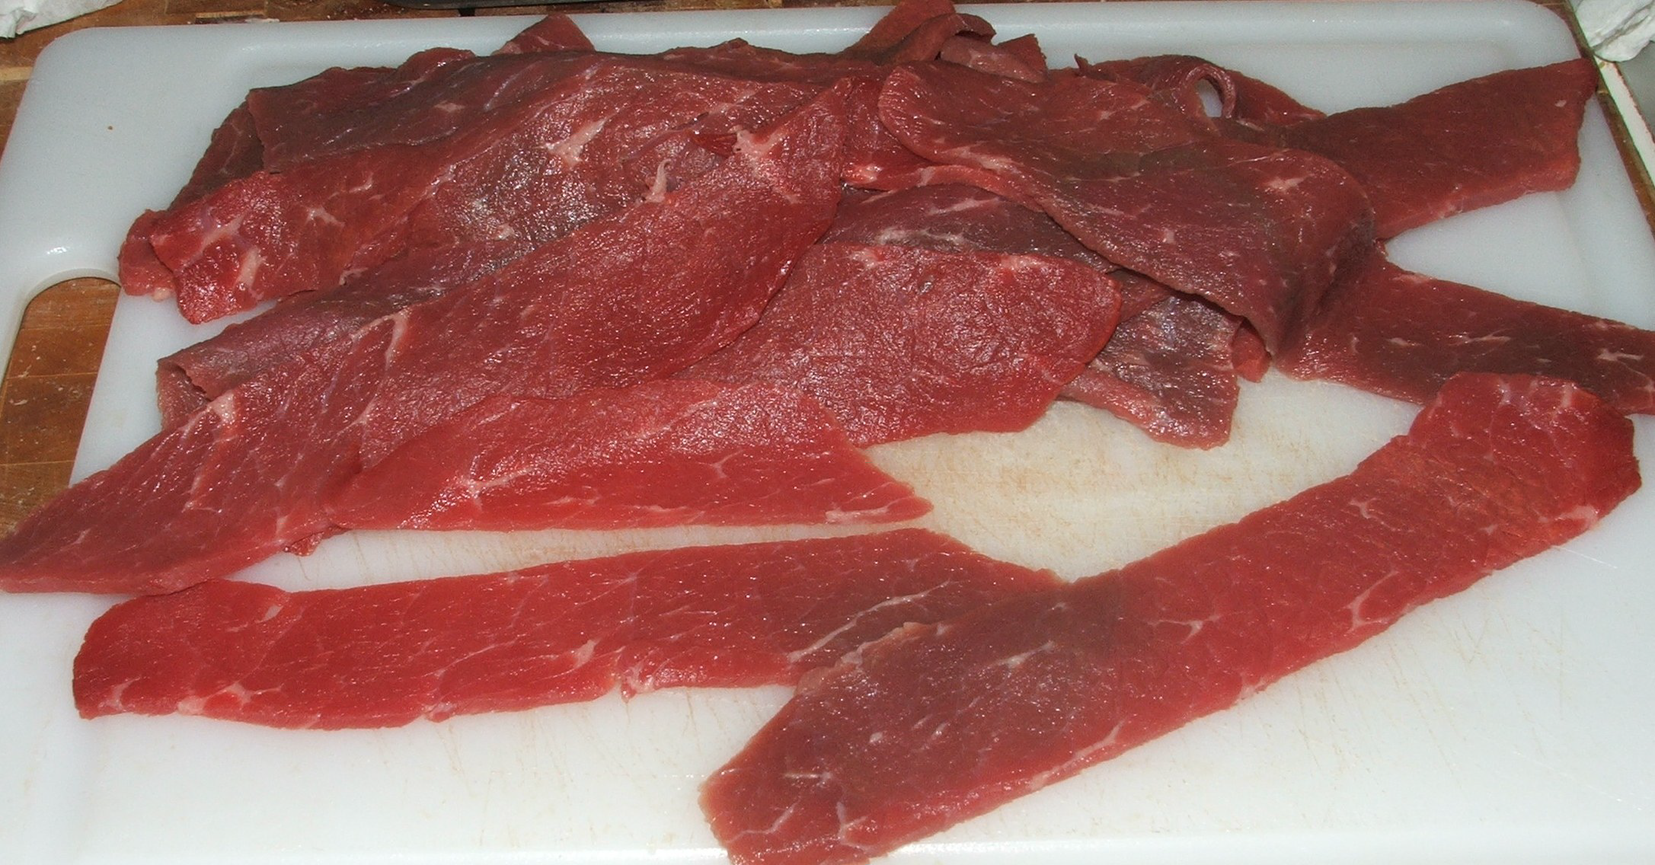

Sea salt mmmmm . . . steak

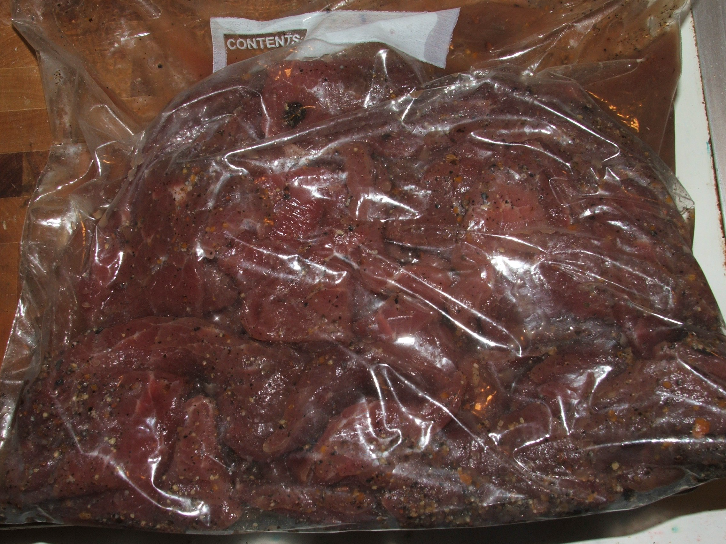

Marinating meat

I left the mixture to soak for two days, turning it occasionally to ensure distribution of the flavorings.

After the meat had marinated for two days, I lightly scraped off the clumps of spices. There was no liquid left in the bag.

We built a fire with wood charcoal (not those sand-based briquette things) and had a large cookout. When the majority of the fire had died down, and the temperature had dropped to about 150 degrees, I laid the marinated meat strips on several racks.

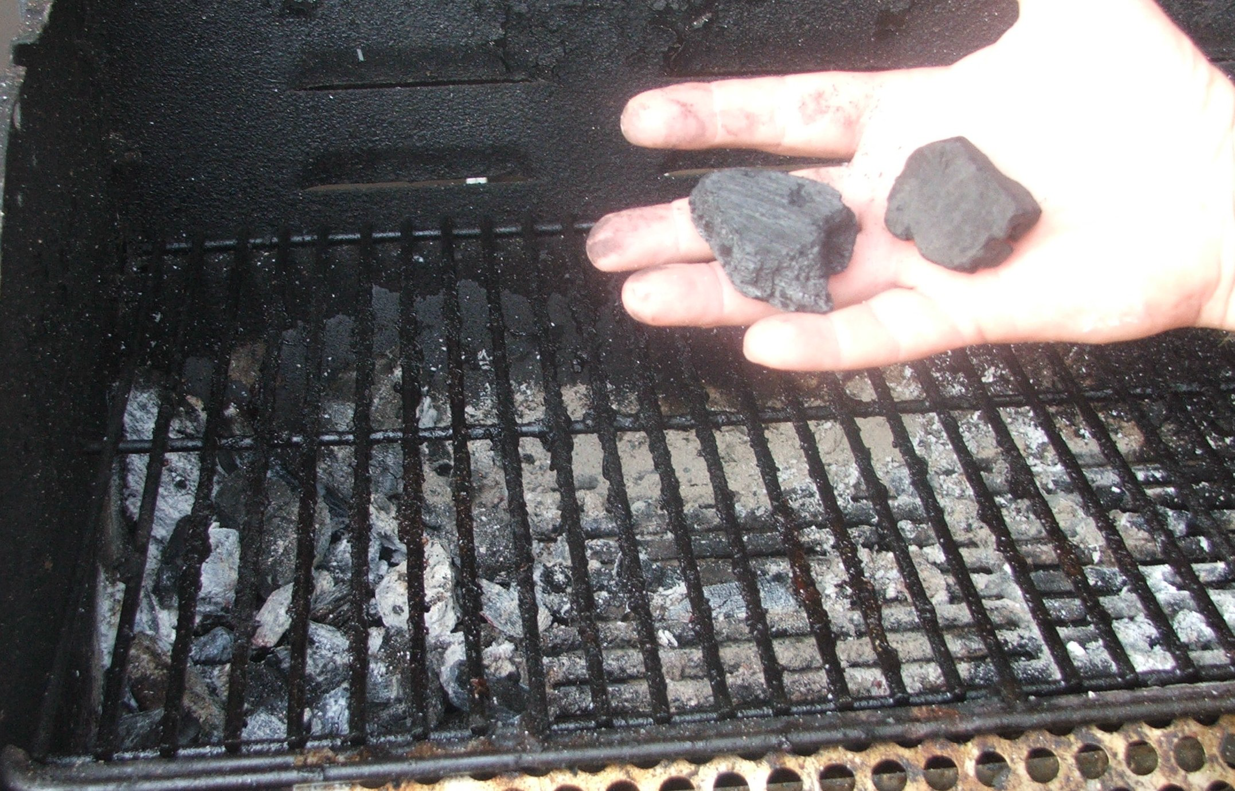

The fire had burned down, and the coals were moved to one end of the grill to create an indirect heat source.

I wanted the meat to dry, not cook.

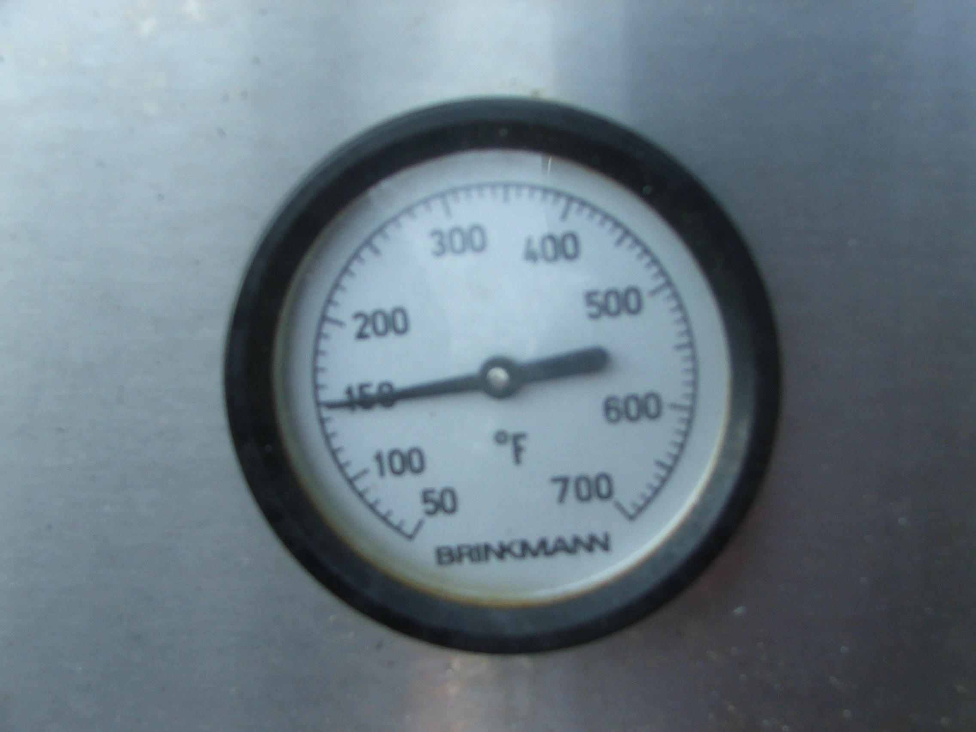

A perfect temperature for smoking and drying

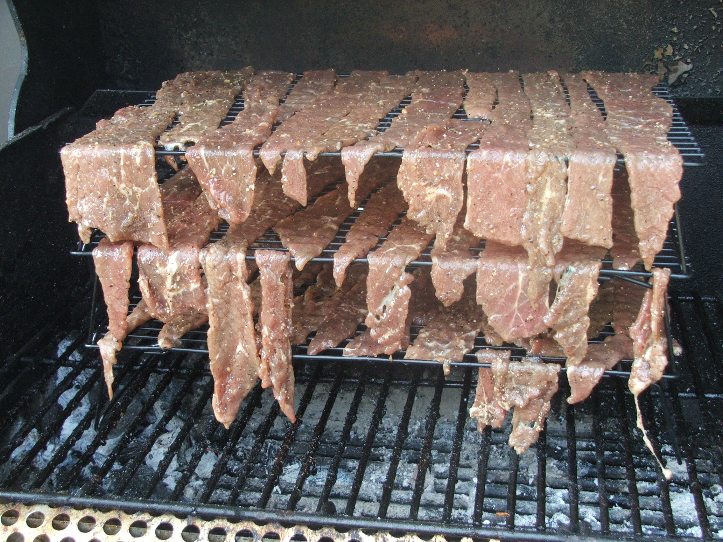

Marinated meat on its racks over the heat source

The lid on the grill was closed, and the temperature was monitored for the next four hours. If it dropped below 140 degrees, another chunk of charcoal was lit and added to the pile of coals. This maintained the proper temperature.

After nearly exactly hours, the strips of steak were thoroughly jerkified.

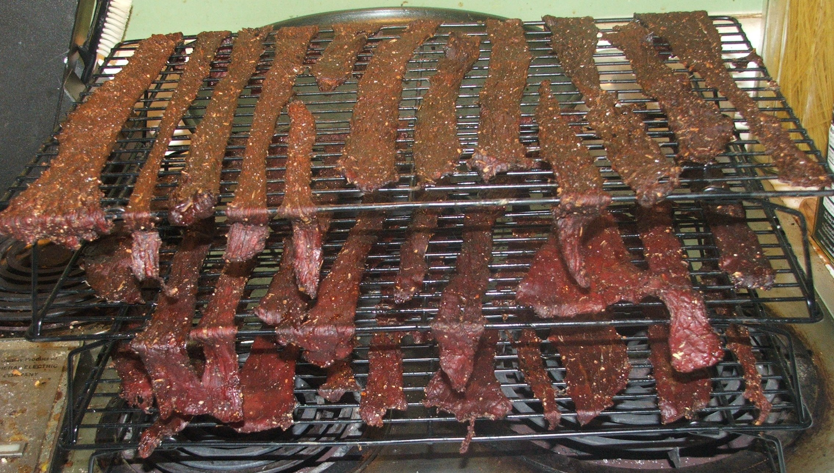

A snack fit for a Qan – Mongolian dried beef jerky

To say the jerky is flavorful would be an understatement. The tangerine is right there in your nose as soon as you taste it. The long pepper (and to a slightly lesser extent, the black pepper) spikes soon after that, and the ginger spreads its heat across your mouth.

It's absolutely no surprise that this was used to cure a "chronic chill". Also, by the virtue of being dried meat that would rehydrate in your stomach, it's easy to see how they believed it would cure compulsive eating.

Footnotes:

[1] Santanach, 13-14

Sources:

Adamson, Melitta Weiss, editor. Regional Cuisines of Medieval Europe. New York, NY: Routledge, 2002.

"Alpinia". www.naturaldatabase.therapeuticresearch.com/nd/Search.aspx? cs=&s=nd&pt=100&id=276&AspxAutoDetectCookieSupport=1. Accessed 12 August 2011.

Buell, Paul and Eugene Anderson. A Soup for the Qan: Chinese Dietary Medicine of the Mongol Era as Seen in Hu Szu-Hui's Yin-Shan Cheng-Yao. London: Kegan Paul International. 2000.

Dalby, Andrew. Tastes of Byzantium: The Cuisine of a Legendary Empire. New York: I. B. Tauris, 2010.

"Gram Conversion Calculator". www.gourmetsleuth.com/cooking-conversions/gram-conversions- general.aspx. Accessed 23 November 2011.

"Koge Bog". http://forest.gen.nz/Medieval/articles/cooking/1616.html. Accessed 12 April 2012. "Metric Conversion Charts and Calculators". www.metric-conversions.org. Accessed 10 August 2011.

Morton, Julia. "Mandarin orange". www.hort.purdue.edu/newcrop/morton/mandarin_orange.html. Accessed 12 August 2011.

Santanach, Joan, editor. Robin Vogelzang, translator. The Book of Sent Sovi: Medieval Recipes from Catalonia. Rochester, NY: Tamesis, Boydell and Brewer. 2008.

Scully, Terrence. The Art of Cookery in the Middle Ages. Rochester, NY: Boydell & Brewer Inc, 2005.

"Tangerine". www.answers.com/topic/tangerine.

Vehling, Joseph Dommers. Apicius: Cookery and Dining in Imperial Rome. NewYork: Dover Publications, 1977.

"Volume Conversion". www.onlineconversion.com/volume.html. Accessed 10 August 2011.
------
Copyright 2012 by Rachel Strange, 717 Versailles Drive SE, Huntsville, AL 35803. glenheather at knology.net. Permission is granted for republication in SCA-related publications, provided the author is credited. Addresses change, but a reasonable attempt should be made to ensure that the author is notified of the publication and if possible receives a copy.

If this article is reprinted in a publication, please place a notice in the publication that you found this article in the Florilegium. I would also appreciate an email to myself, so that I can track which articles are being reprinted. Thanks. -Stefan.

<the end>

