Murri-Project-art - 11/12/16

"The Murri Project - Making and comparing Middle Eastern Condiments with the same name" by Mistress Adrianna Stothard.

NOTE: See also the files: murri-msg, hummus-msg, Ancent-Grains-art, grains-msg, leavening-msg, E-Arab-recip-art, fd-Arabs-msg, Md-Cu-Islmc-Wd-msg.

************************************************************************
NOTICE -

This article was submitted to me by the author for inclusion in this set of files, called Stefan's Florilegium.

These files are available on the Internet at: http://www.florilegium.org

Copyright to the contents of this file remains with the author or translator.

While the author will likely give permission for this work to be reprinted in SCA type publications, please check with the author first or check for any permissions granted at the end of this file.

Thank you,
Mark S. Harris...AKA:..Stefan li Rous
stefan at florilegium.org
************************************************************************

You can find more work by this author at: https://www.pinterest.com/blueyodel/the-murri-project/

The Murri Project -
Making and comparing Middle Eastern Condiments with the same name
by Mistress Adrianna Stothard

What is it?

Murri (also al-murri or almouri) is a condiment used in Middle Eastern cooking. Directions for making it are found in several period sources, including the earliest known Arabic cookbook Kitab al-Ṭabīḫ (Book of Dishes), which was compiled in the tenth century by Abu Muhammad al-Muthaffar ibn Nasr ibn Sayyār al-Warrāq (referred to as al-Warraq). For reasons currently unknown to us, the use of murri fell out of favor sometime around the 13th century and was forgotten until the 20th century when modern scholars began translating period Arabic cookbooks, including the translation of The Book of Dishes, which has been published as Annals of the Caliphs' Kitchens: Ibn Sayyar al-Warraq's Tenth-century Baghdadi Cookbook (Nasrallah, 2007).

The humoral property of al-murri is similar to that of salt (extremely hot and dry); it is considered a laxative and aids digestion; heats up the stomach and liver; and induces thirst when eaten by sick people (Nasrallah, 2007). As such, the use of murri in period was to increase the hot and dry properties of food “[f]or instance, mutton was …cooked with murri (liquid fermented sauce) when rarefying effects and speedy digestion were needed... [t]herefore, to be able to adjust the properties of food to avoid any harm it might incur upon its eater, one needs to familiarize oneself with the natural properties and powers of foodstuffs and dishes, as well as those of the eater and also was served with bread as an appetizer to open the stomach (Nasrallah, 2007).

There are many different versions of murri and I have made three of them for this entry: a version made by the North Africans: al-murri al-maqi lil-maghariba [the infused soy sauce of the North Africans] (Rodison, et al. p. 400); a version made by the Iraqis, referred to simply as: Murri as made by the Iraqis and a version called Byzantine Murri (almori in some references). The North African and Iraqi versions are calendar-time intensive, each taking more than 80 days to develop a usable product; the Byzantine version has been called murri [made] right away or murri in a hurry because it is made in about two hours, start to finish.

How is it made?

North African al-murri

My first attempt at making murri was al-murri al-maqi lil-maghariba [the infused soy sauce of the North Africans], using the translation in The Description of Familiar Foods (Kitab wasf al-at’ima al-mu’tada) found in Medieval Arab Cookery.

The translation of the period recipe into English is specific in the list of ingredients and methods (but not necessarily the amounts) used in the making of North African al-murri.

How to make al-murri al-naqi’ lil-maghariba [the infused soy sauce of the North Africans]. Knead barley, unleavened and without salt, exceedingly well and make it into loaves, each one half an Egyptian pound. Then wrap them in male fig leaves and insert fig tree twigs into them as far as the leaves will permit. Spread them out on barley bran and arrange them side by side in a house which sunlight does not enter, or not much. Then leave it 20 days. Turn it over, top to bottom, and leave it another 20 days. Then you gather them with their rot and leaves and pile them up and leave them 20 days. Then you break off a piece of it, and if you find red veins inside, it is quite ripe. If not, leave it another 20 days. Then take it in any case and clean off the decay with a knife. Gather it and pound it in the mortar or grind in the mill. Then weigh it, and add one-fifth of its weight in table salt and as much dry thyme as salt, and as much milled dry coriander as thyme, and as much as the coriander of these spices: caraway, nigella, fenugreek, anise, fennel, each of these the measure of a fifth: and let the fennel be more. Then you put it in a new vessel, or [one] with a trace of oil, and it should be wide-mouthed. And you put it on the rooftop so that the sun falls on it most of the day, and you put water on it until its consistency becomes like flowing date molasses. You throw into it broken-up carob, fennel stalks, citron leaves and the pith of [bitter] orange branches, of each as much as is abundant, and two or three pine cones, as much as is done; let their seeds have been removed. You stir it with a stick of fig wood with branches, putting its end to the bottom and its root on top and stirring it with the strength of violent heat. And you cover it with a sieve woven of bast and esparto and put a cloth on it to prevent wasps and flies from falling in, for they often love it ardently. Leave it in the sun 40 days. Then you clarify it with a filter and put it up in a clay pot for the sun, shielded with oil. Then, for every 10 Egyptian pounds, you throw in a third of a pound of flour of groats, kneaded leavener. And if you want a third and baked in the bread oven but not completely done. Then break it into crumbs while it is still hot into this raised [sc. Murri] and leave it in the sun for ten days. Strain it and put up in glass vessels sealed with oil. This is the first extraction, and it is the excellent one. If you want to extract another from it, take that which you left before and add water to it and leave it for another 40 days. Then, after straining it, throw in hot bread as you did before, and you leave it 10 days and strain it, and it is the second water. And if you want a third and a fourth, do so. Then keep the dregs and dry them in the shade as loaves, for they enter into some dishes (Maxime Rodinson, 2006).

I wanted my first attempt to follow the instructions as closely as possible (without making the large quantity the original recipe was intended to make) because: 1. I wanted the final result to be as close as possible to what would have been used in period; and 2. I wanted to develop an understanding of why certain instructions are given (Why use barley instead of wheat or oats? Why leave wet barley dough out for 40 days? Why wrap it in fig leave - why not just lay it on fig leaves? Why place dried barley in a jar of water and herbs in the sun for 40 days after you’ve spent 40 days drying it out?).

The essential ingredient for both the North African and Iraqi versions of murri is something called budhaj. The making of budhaj is described in the first section of the instructions for North African al-murri, and is made by grinding barley into a rough flour; adding water to make an unleavened dough; wrapping the dough in fresh fig leaves; and allowing it to dry slowly over a 40 day period. The result is a hardened piece of natural concrete (there’s really no other way to describe it) that has developed an organic greenish-gray coloration (see pictures under budhaj in the pictures section).

I chose to use organic, whole (non-pearled) barley because I wanted something close to what would have been used in period:-barley with the bran still on and without chemical additives. Modern methods of growing barley includes the use of chemical pesticides and genetic engineering of the seed and both are designed to specifically impede the growth of natural yeast in barley.

My Recipe Redaction

Step One: making the budhaj

One pound of hulled (not pearled) barley
Fig leaves
Sticks/twigs from a fig tree
Warm water

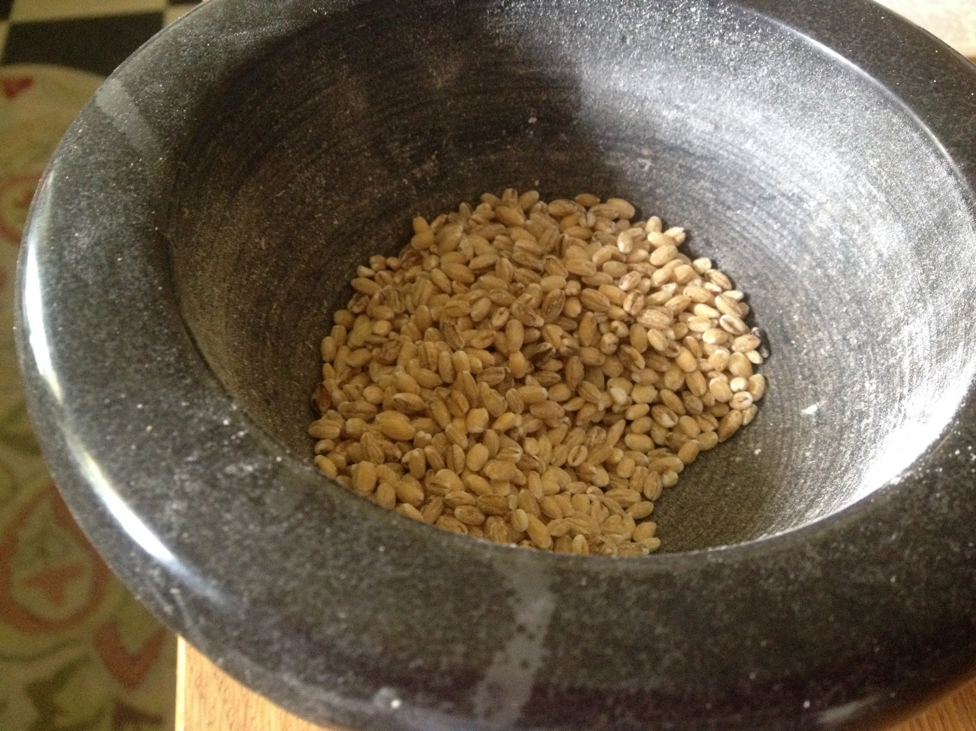
Step1: Making Budhaj. Organic hulled barley with no additives

- Grind the barley into groats. I use a mortar and pestle, grinding about a 1/4 cup at a time (a food processor doesn’t work for this process). After the barley is at groat stage, I grind it once more. This doesn’t get it to the samid (rough flour) stage, but does produce a slightly finer texture.

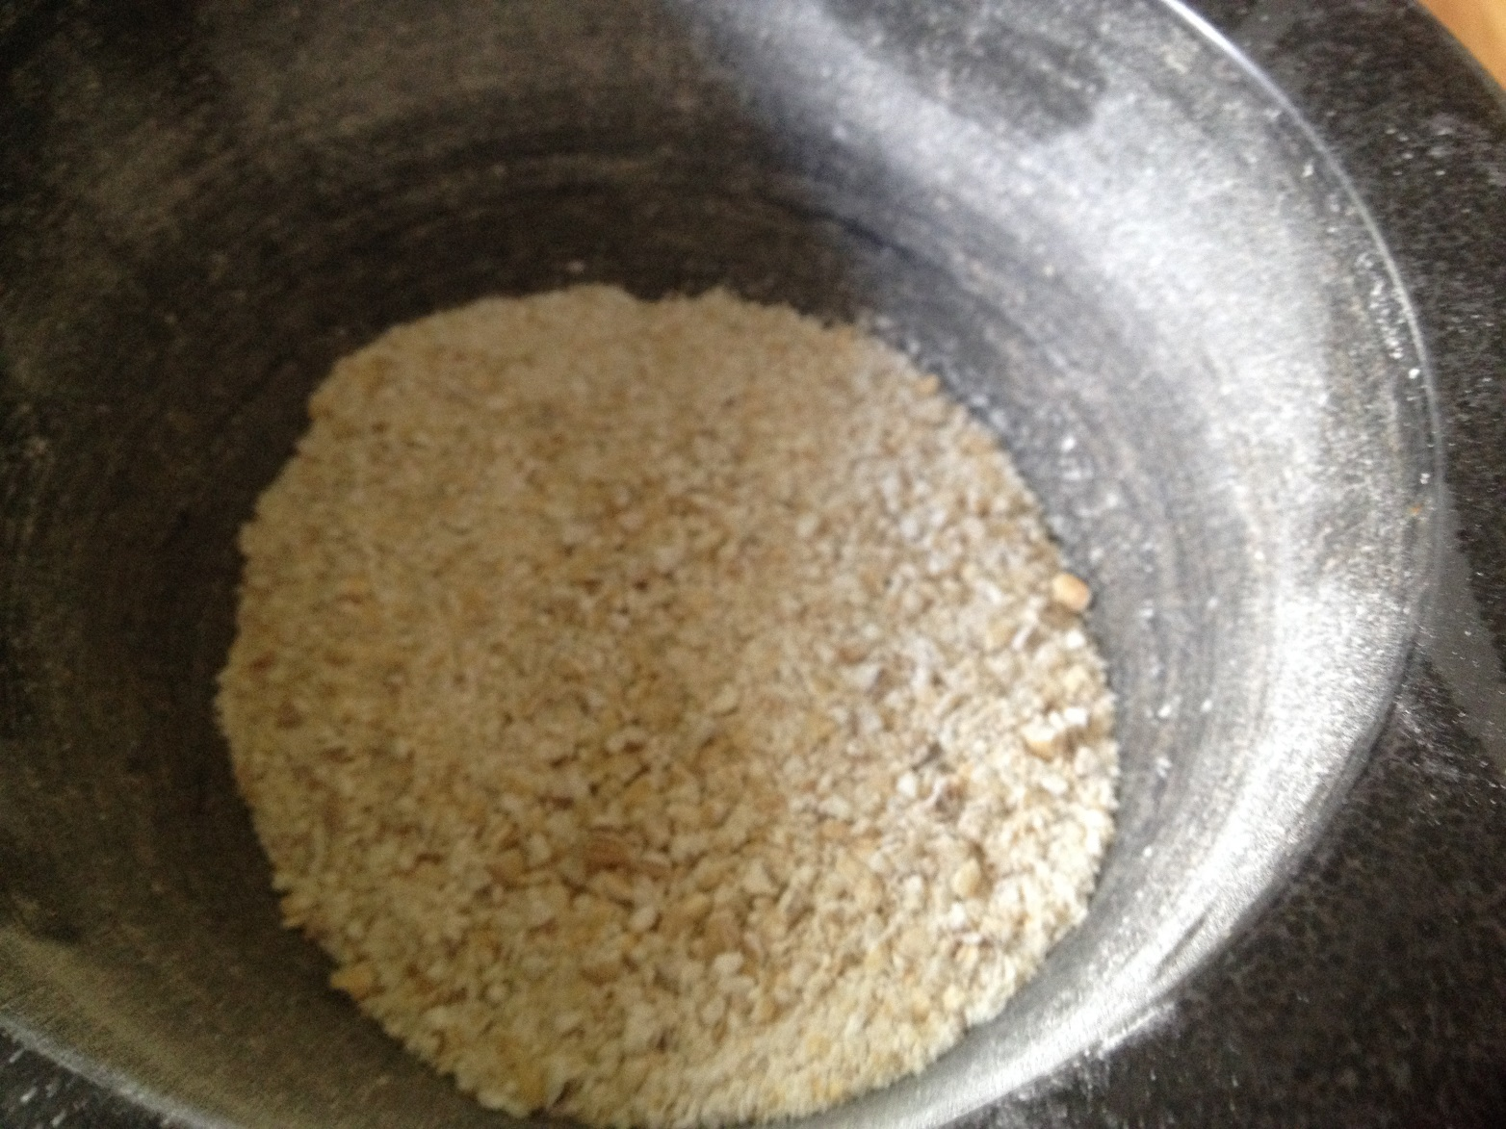
Bsrley after being hand-ground into a rough flour

- Add warm water to the barley; start with about a quarter cup and use your fingers to mix well, rubbing the water and barley together to help the barley absorb the water. Add enough water to produce a watery dough and then let it sit for a couple hours to allow the barley to absorb the additional water. Do this several times until the barley isn’t readily absorbing additional water. This is your unleavened barley dough.

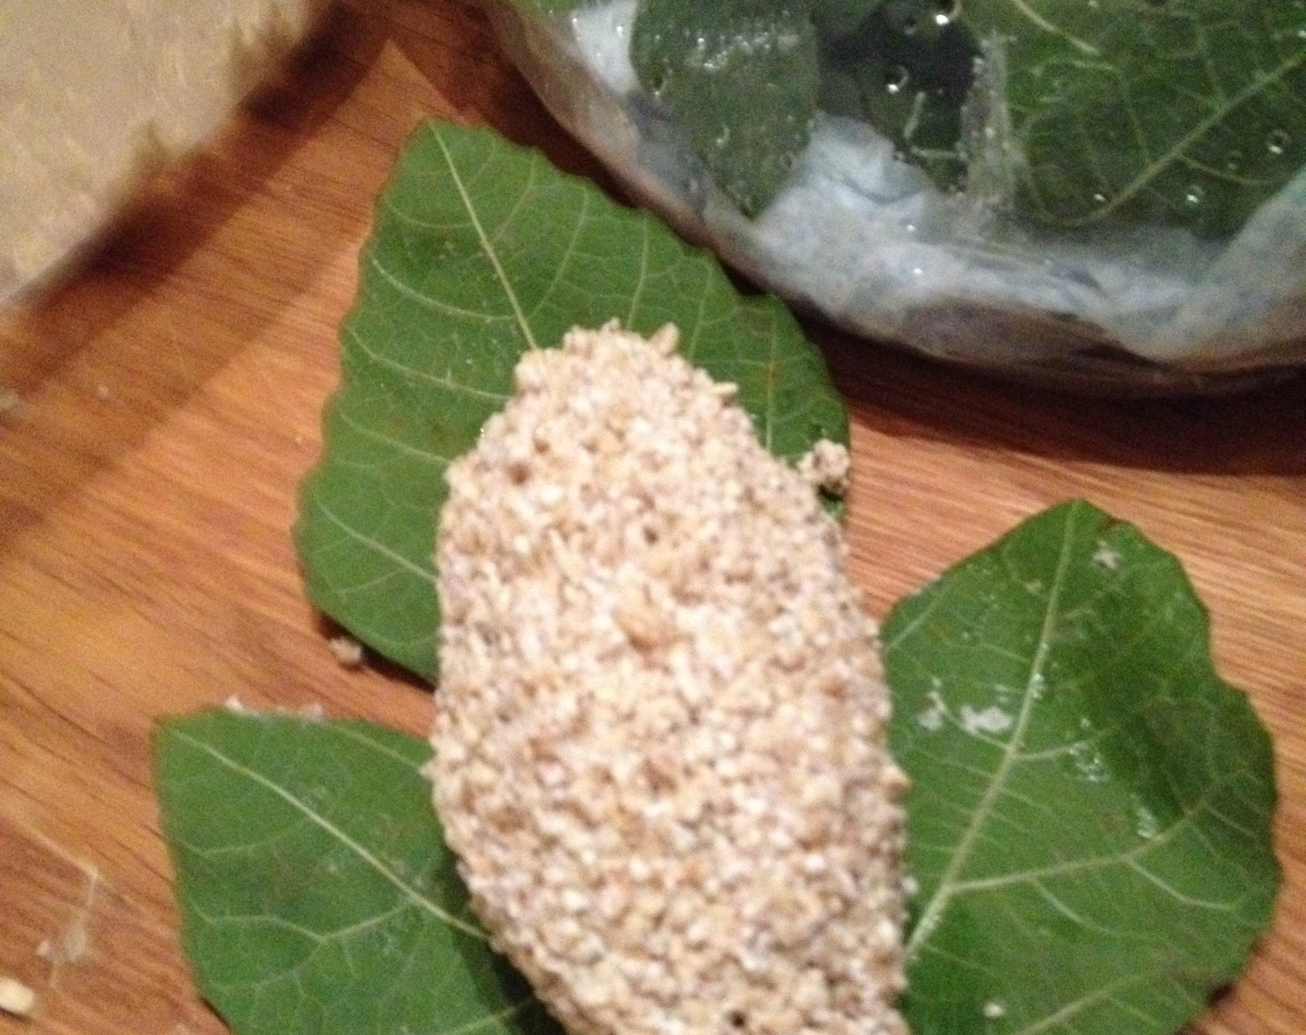
Barley dough with fig leaf

- Divide the barley dough into roughly equal portions and shape them into small loaves. One pound of barley usually yields six small loaves for me.

- Place each small loaf onto a fig leaf. The instructions call for male fig leaves. When looking at the two different types of fig leaves, one has the appearance of a maple leaf and the other an oak leaf with long fingers. Use the one that looks like the oak leaf. Wrap the fingers over and around the barley dough; using as many leaves as it takes to encase the dough in fig leaves. Wetting the fig leaves helps them stick to the dough and to each other. Using a twig or stick from your fig tree, push two or three of them through the barley dough. This is easier to do if you use the male fig leaves because you don’t have to break the leaves to insert the twigs.

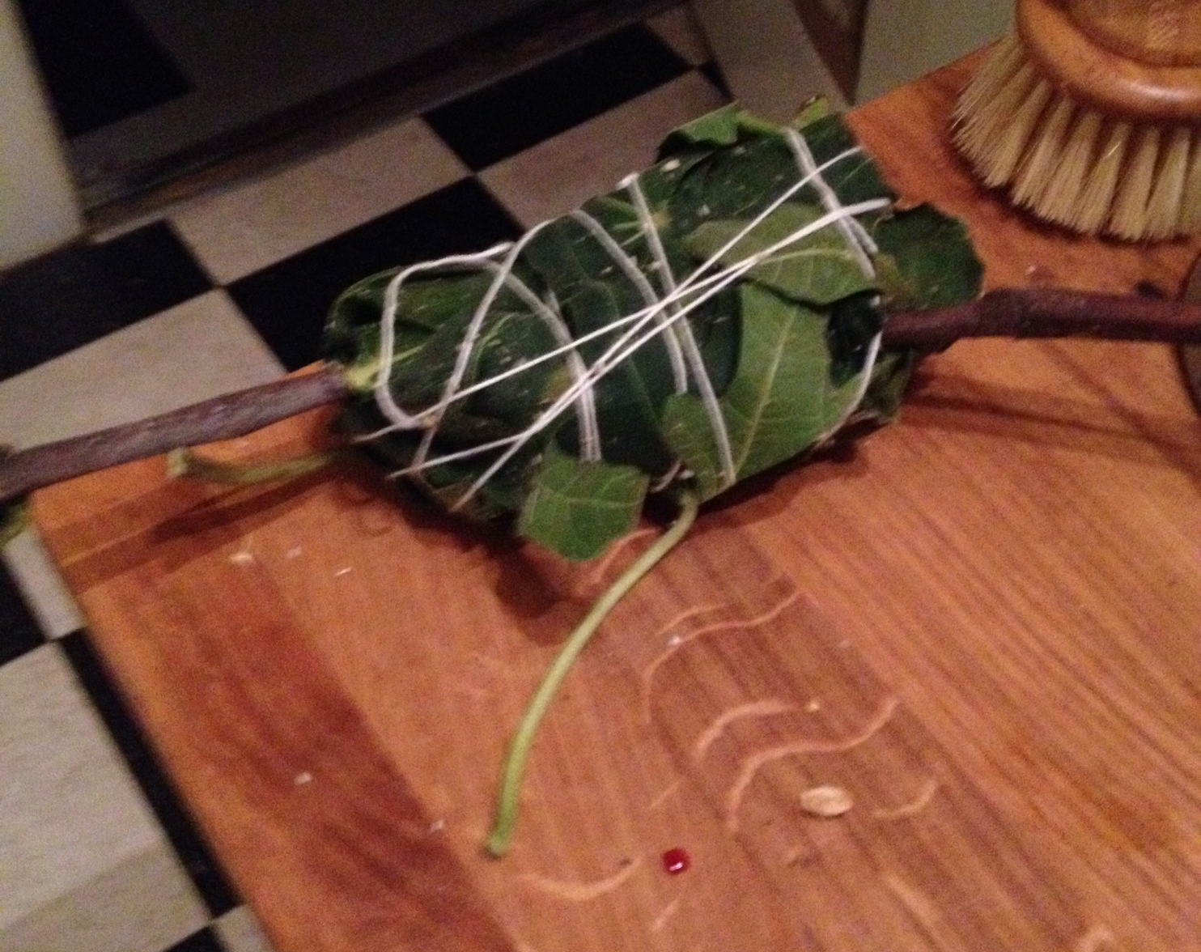
Barley dough wrapped in fig leaves with fig twigs inserted.
The string used was not necessary and was removed after a few days

- Line a cookie sheet, cutting board, or other flat surface with parchment paper and spread barley (whole or crushed) onto the parchment paper. Put the fig leaf wrapped barley dough onto the barley to allow for air flow. Place the cookie sheet in a location with little to no direct sunlight and let it sit for 20 days. Turn it over, top to bottom (this is where the twigs come in handy) and leave it for another 20 days, for a total of 40 days. You can walk away and ignore it, but I like to watch and make notes on how it changes over time.

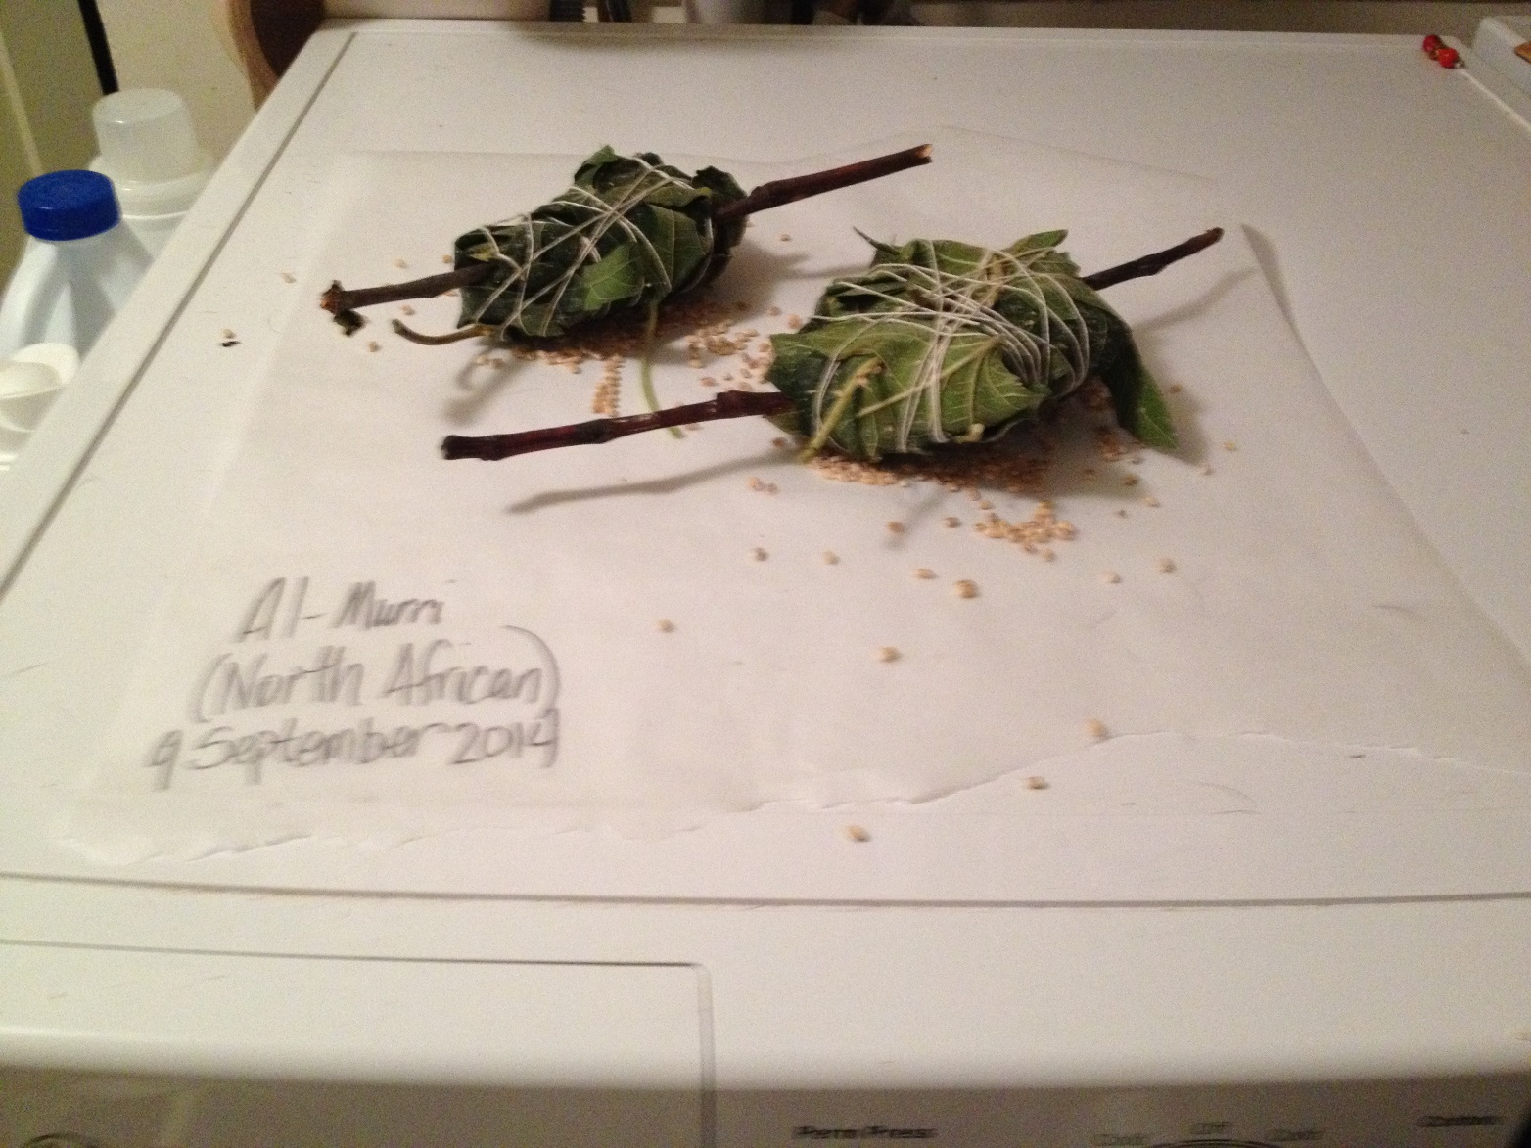
Budhaj is placed on barley (and on parchment paper) and allowed to sit for 20 days before being turned over to sit for another 20 days

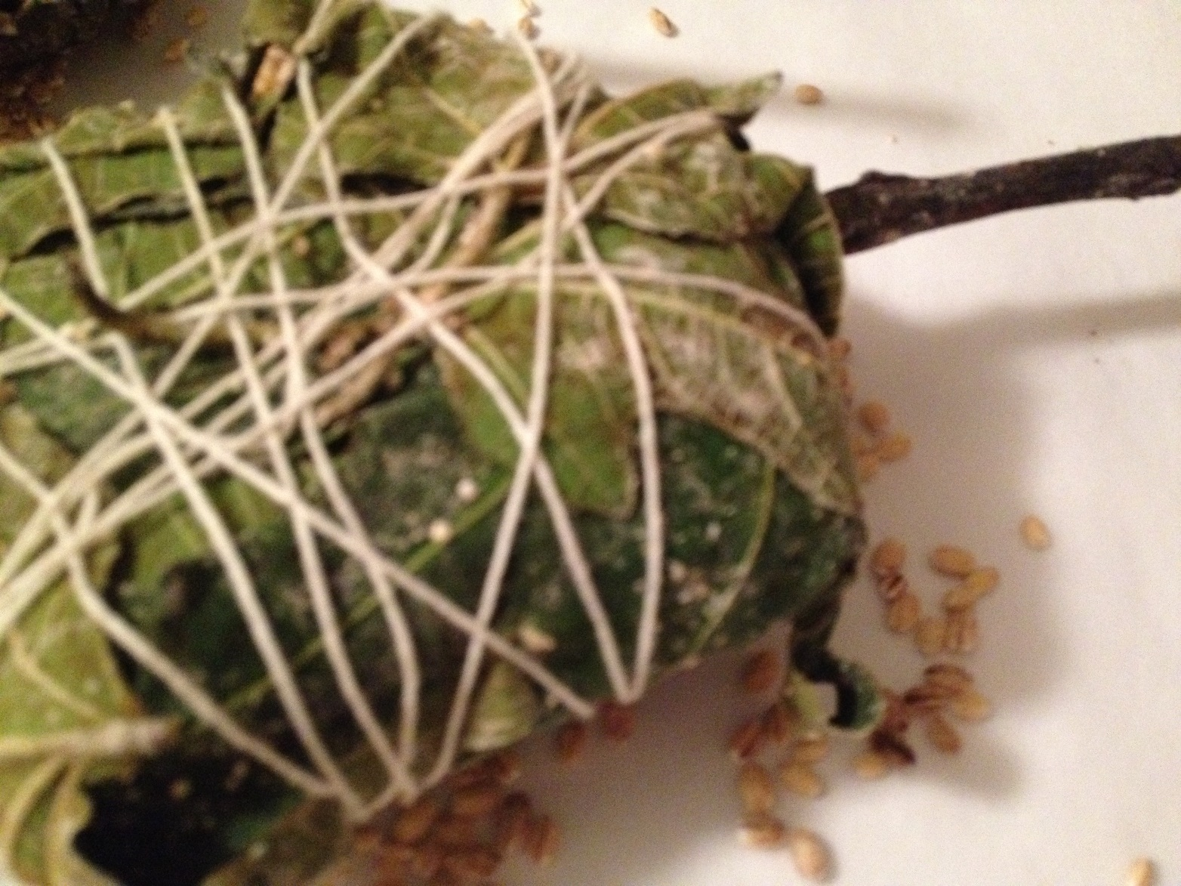
Day two: As the fig leaves begin to dry, a white substance forms

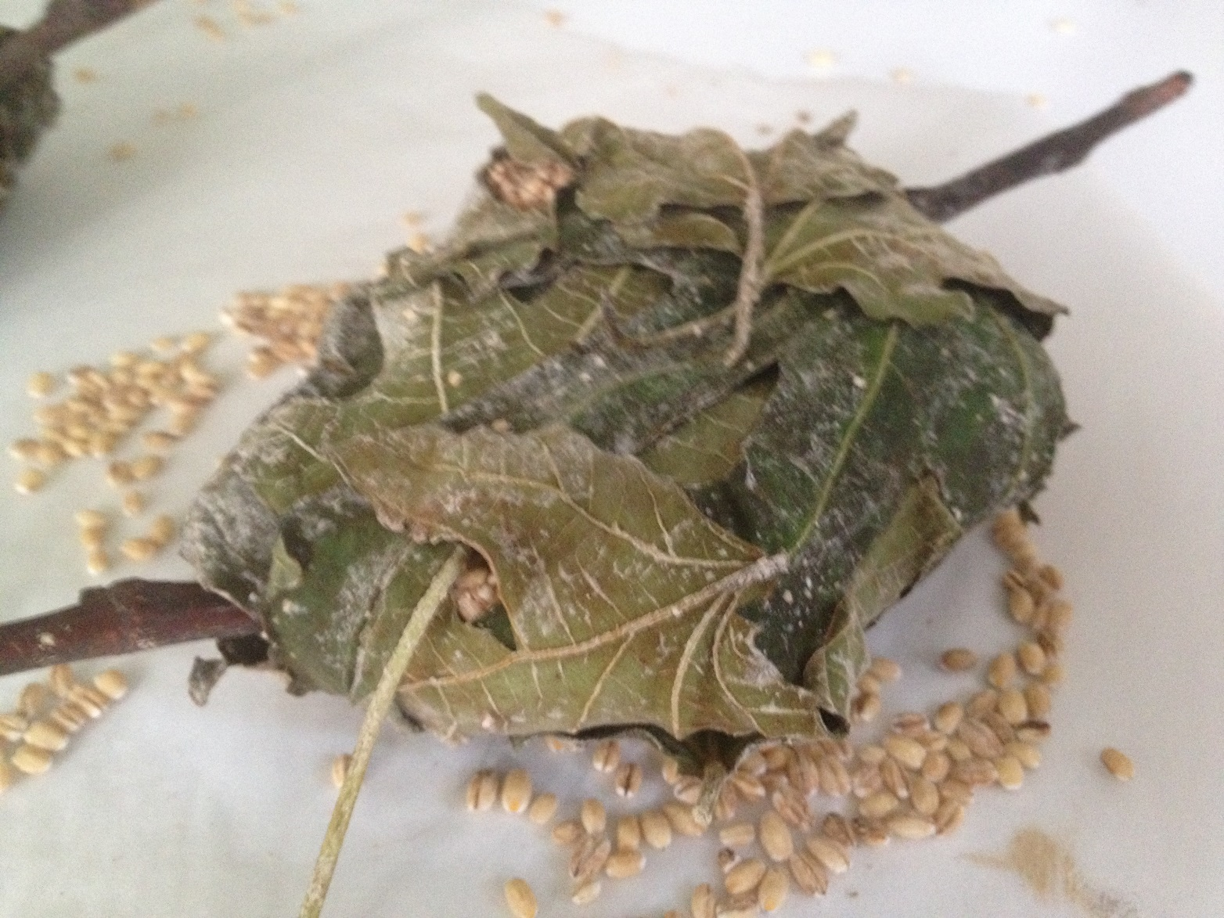
Budhaj after twenty days

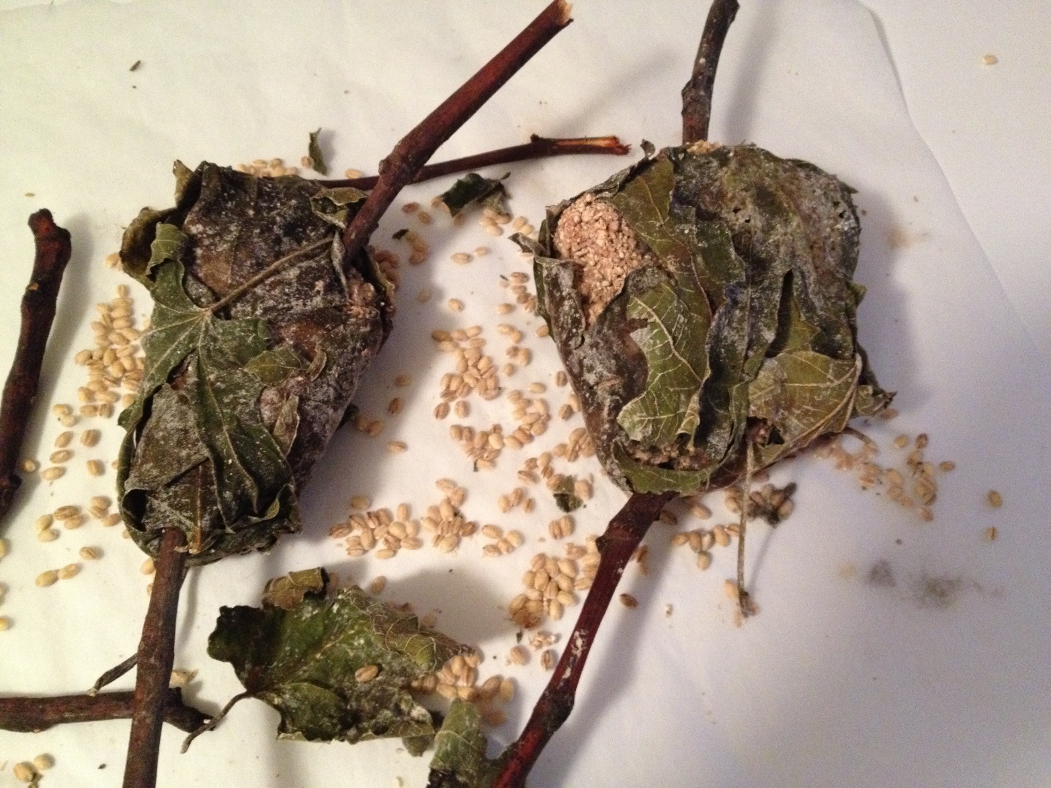
Budhaj after 40 days

- At the end of the 40 days you have budhaj. Budhaj translates to “rotted barley” which is where the rotted barley terminology became connected to murri. I don’t consider the budhaj to be rotted in any way – it neither smells nor looks what I consider rotten.

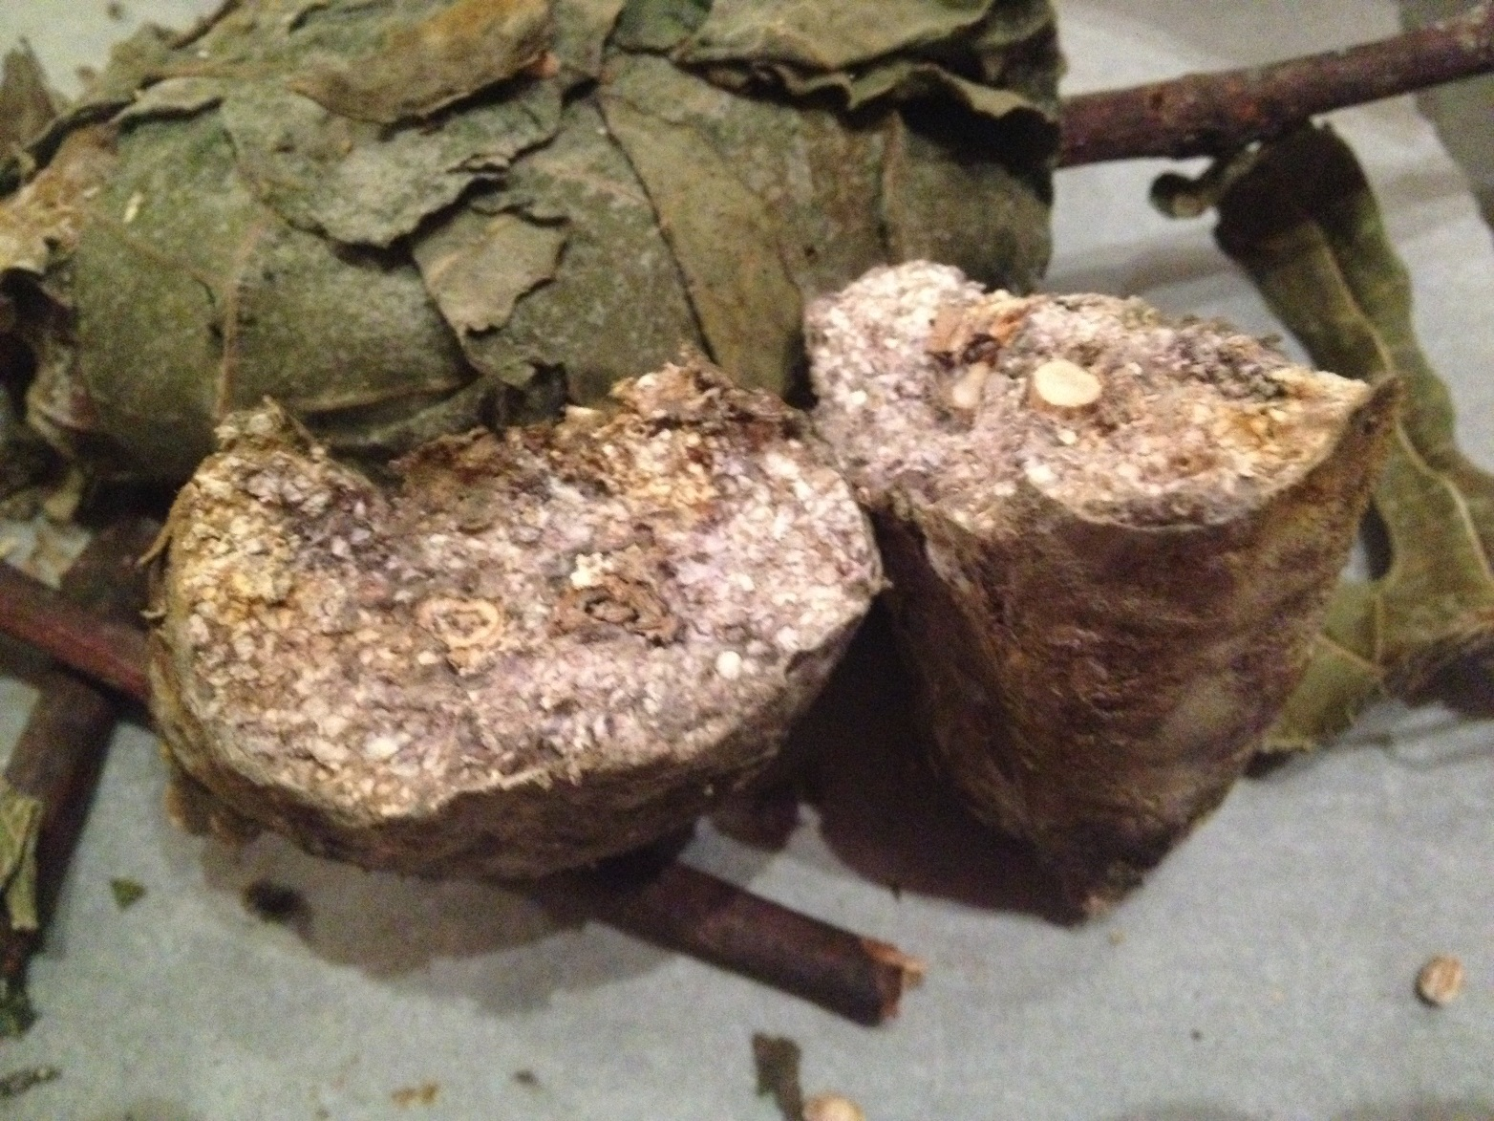
Inside the budhaj - note the pieces of wood as well as the colors of the now concrete-hard dried barley dough

  - After several attempts, I have never seen the ‘red veins’ as described in the translation, so I no longer leave the budhaj much over 40 days to look for it.

Step Two: making the murri

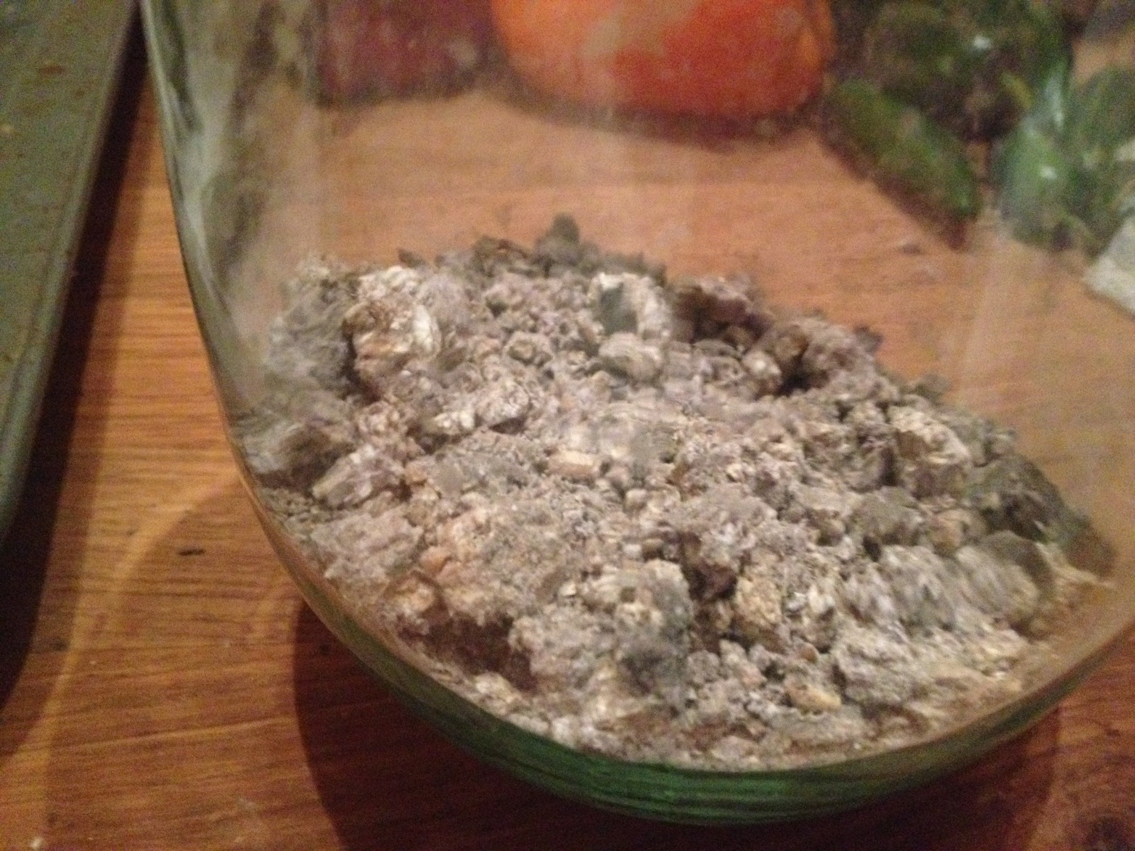
Budhaj, pounded into smnall peices

- Taking three of the six budhaj pieces, remove the loose leaves from them. It is likely that one or two layers of leaves have become one with the barley dough, and that’s fine. The budhaj will be light in weight and very hard. Begin breaking it into smaller pieces. You will need something hard to accomplish this; I have used a marble mortar and pestle but sometimes a hammer is necessary. Remove the wood from the budhaj and continue breaking the budhaj into pea to acorn-sized pieces. I weigh mine to get a sense of how much I have. Three pieces (originally 1/2 pound of barley groats) provide about 4-5 ounces of usable budhaj by weight.

To the budhaj, add the following (by weight):

- 7/8 ounce salt – I use kosher salt because it has no additives; natural, unflavored sea salt would also be appropriate
- 7/8 ounce thyme
- 7/8 ounce ground coriander

- And then the following in amounts that equal 7/8 ounce total (which means each is one-fifth of 7/8 ounce): caraway, nigella, fenugreek, anise and fennel. Then add enough fennel to bring the mixture up to one full ounce. I know this does not seem like a lot, but the herbs and spices are light and it will take quite a bit of volume to equal 7/8 ounce.

- Put everything into a one gallon, wide-mouthed glass jar and add about one quart of room temperature water. There should be enough water to have at least 3-4 inches in the bottom of the jar – add more, if needed (the amount of water used will depend on the diameter of the jar used). The solids will rise to the top of the liquid.

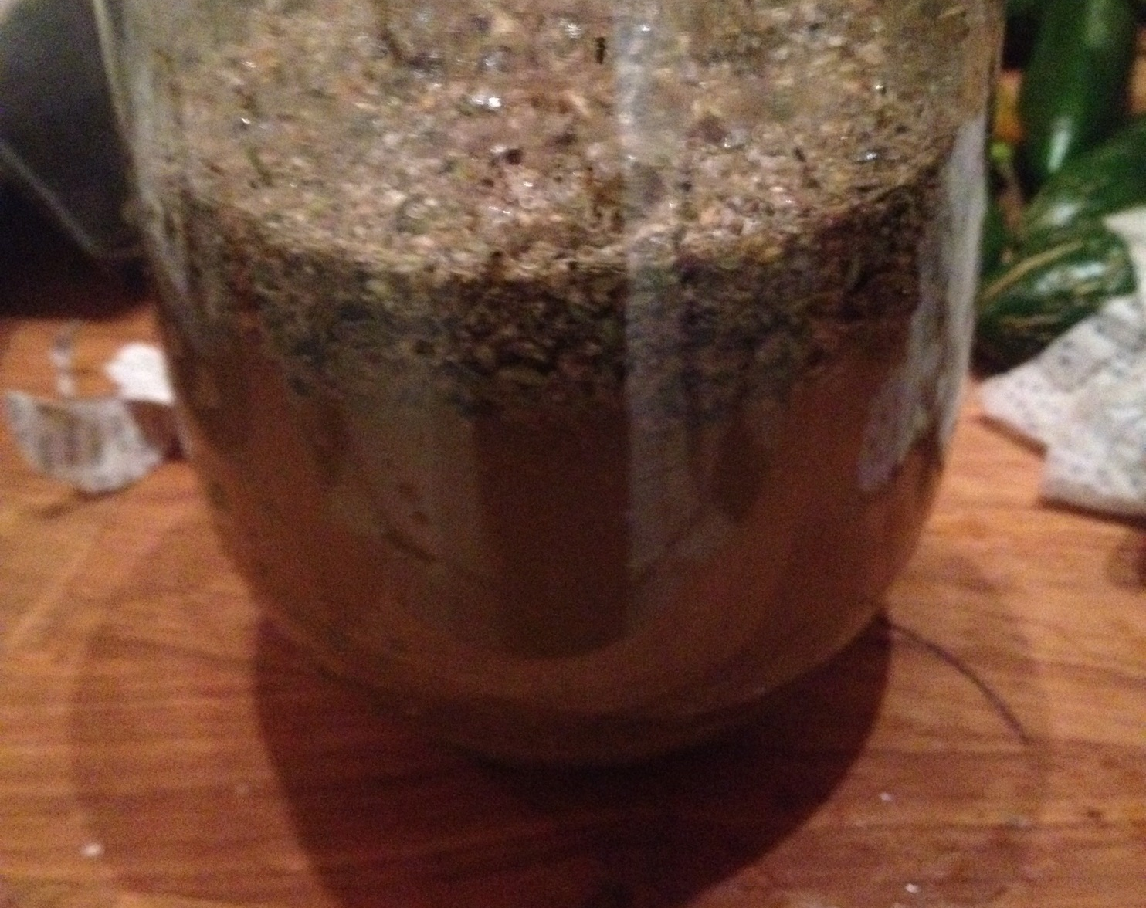
Budhaj with the added herbs and spices; water completes the al-murri solution.
This picture shows how the budhaj and herb/spice mixture floats on top of the water while it aborbs water and eventually sinks to the bottom of the jar

- Put the jar in a warm, sunny spot in the heat of the summer and cover the opening with a piece of loosely-woven cotton (cheesecloth is fine) and secure the fabric to the opening (I use a rubber band). Stir it twice a day, every day, for 40 days with a stick from a fig tree. The instructions say to put it on a rooftop – I put mine on top of a six-foot step ladder.

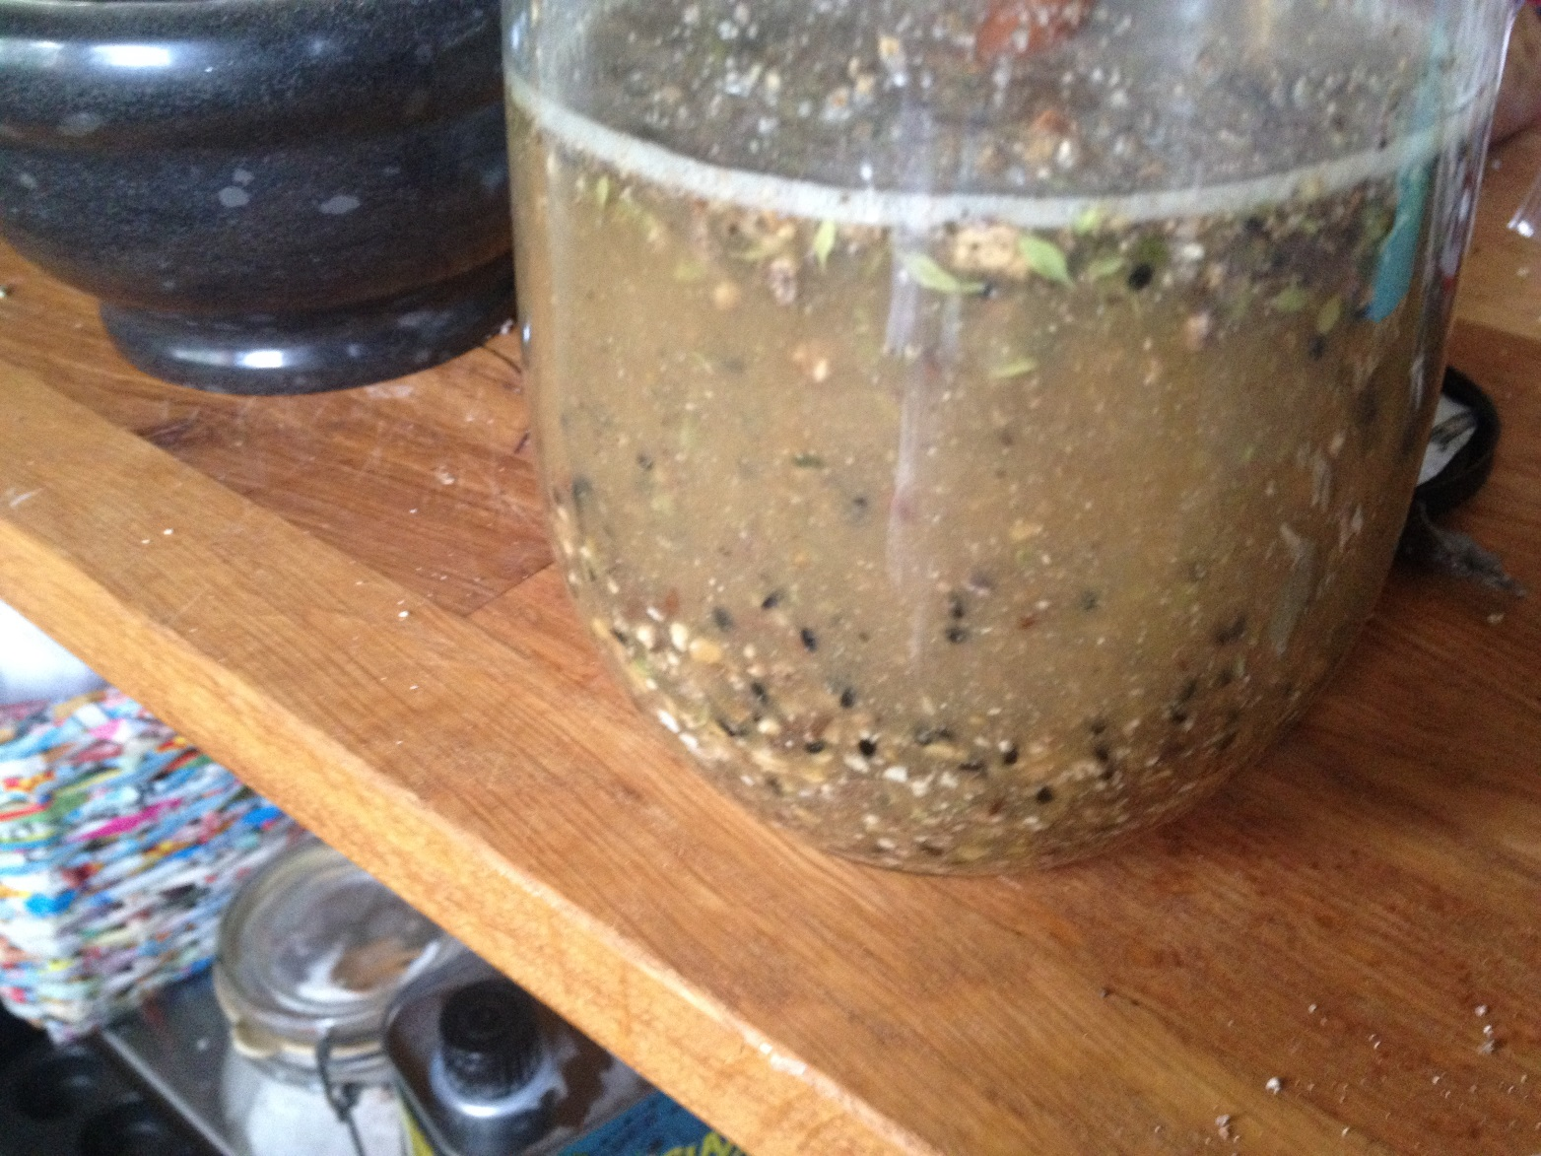
Day two of 40

  - Note: IF you want to produce murri during the darker/colder months, you can place a heating pad in the middle of a folded towel, set the heating pad on low and place the jars on top of the towel to provide consistent heat. The jars still should receive as much direct sunlight as possible.

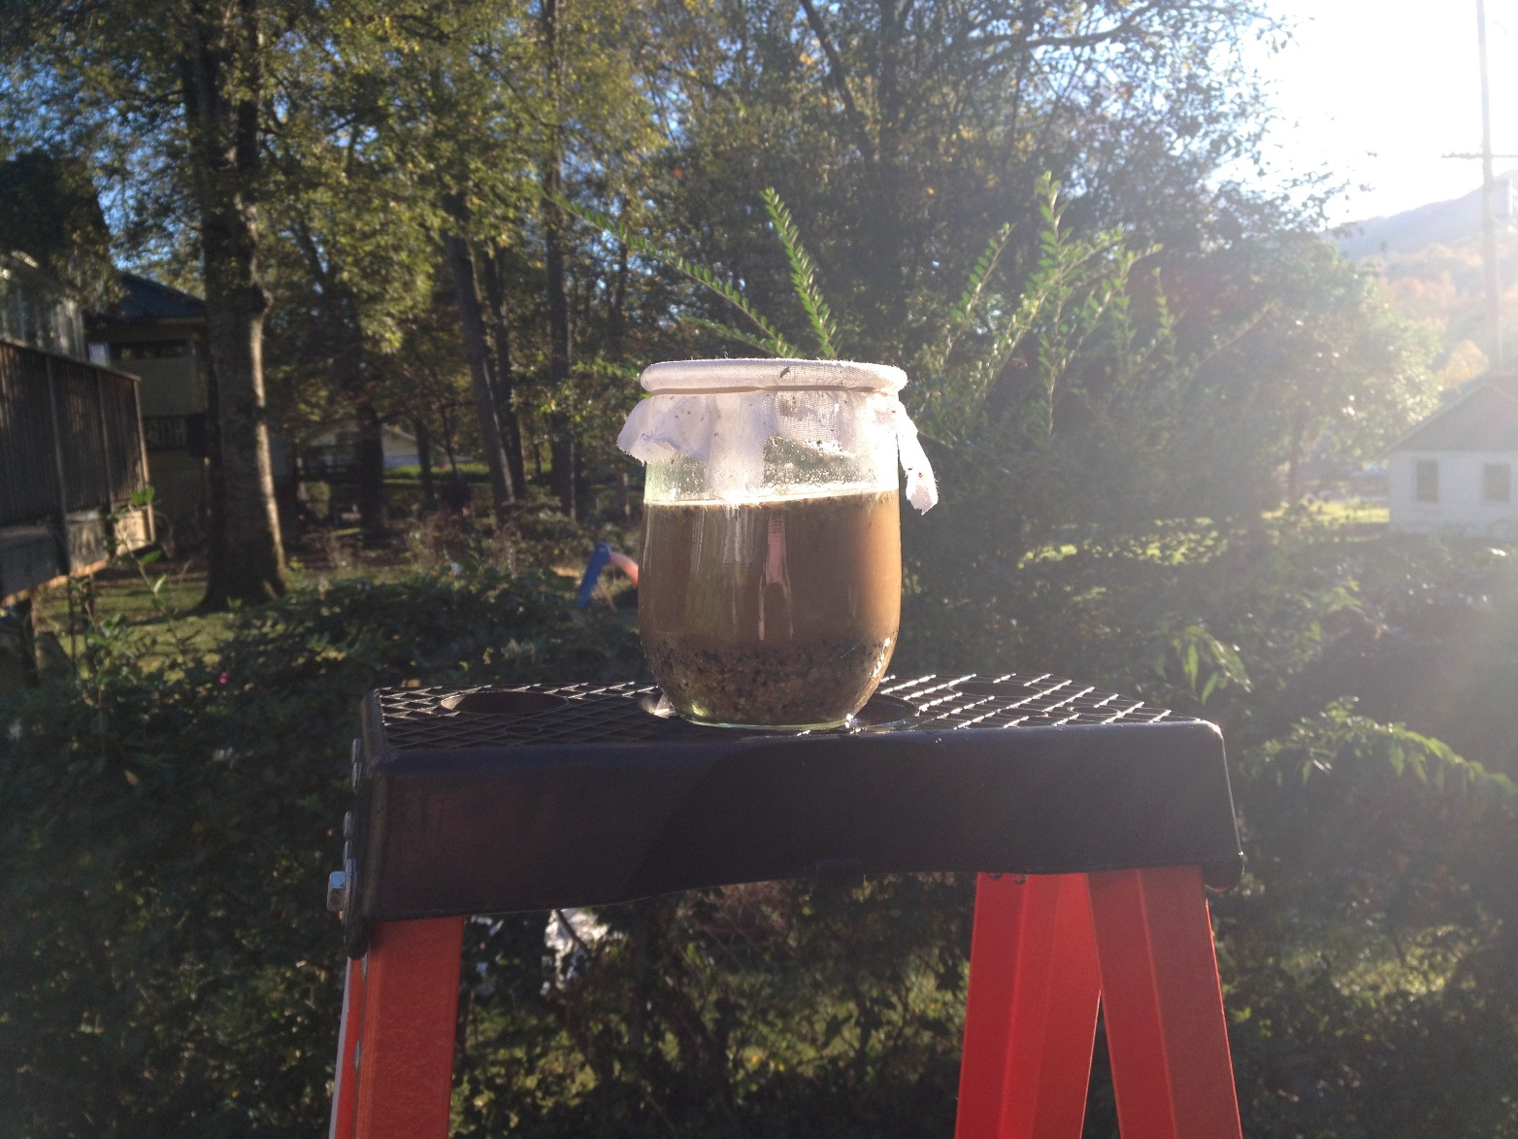
View on top of six foot ladder

- After a couple of days, the mixture will begin to bubble and may sound like pop rocks or Rice Krispies in milk. It’s fascinating. Keep stirring, twice a day, every day, and keep it in a warm, sunny location.

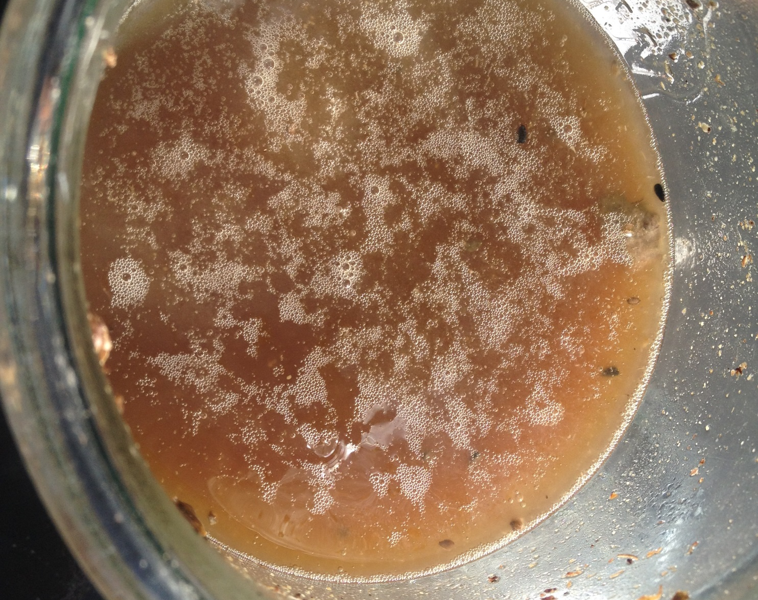
Top view of slow fermentation in process

- After about 20 days, the consistency and appearance will change from a two-part mixture (herbs and budhaj floating on top of the water to resting on the bottom of the jar, with a definite separation between the two) to more of a single entity that is slightly more viscous. It is at this point that I add the carob, fennel stalks and pine cone(s). Since the instructions say to use as much pith of bitter orange bark or citron leaves as are available (and I don’t have access to them at this point), I haven’t made a batch of murri that includes them yet. I also add two quarts of room temperature water along with the carob, fennel and pine cone(s).

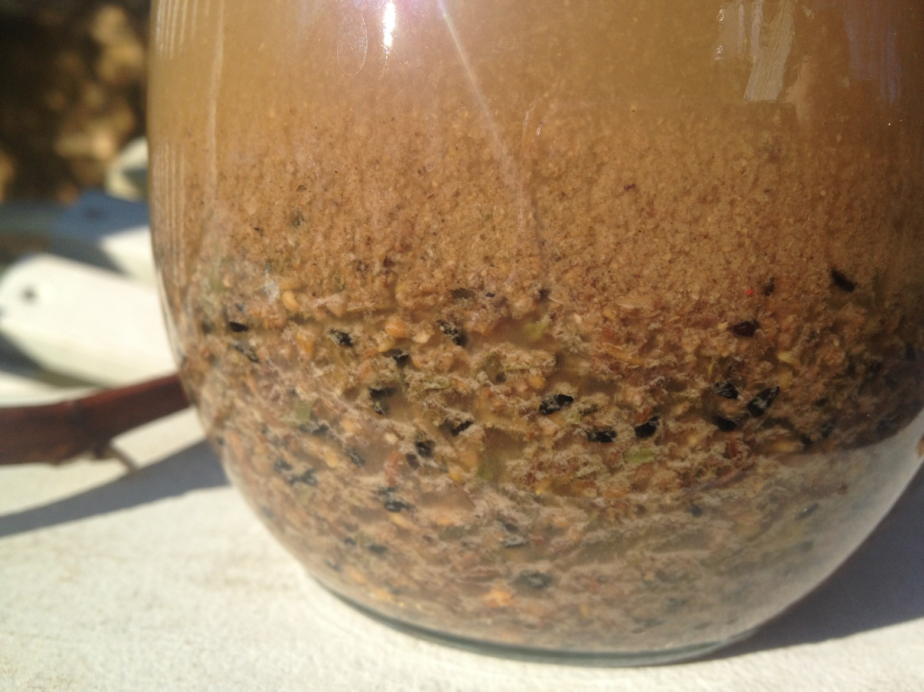
Side view of slow fermenation (anaerobic)

- At some point, an odd, milk-colored, film may form on the top of the murri. It seems to form when I have had three or more days in a row of cloudy weather. I have both skimmed it off and left it on – it doesn’t seem to make a difference in the final product and is strained out when the murri is extracted.

- Keep stirring. Keep it warm. Keep it exposed to as much sunlight as possible.

- After 40 days or more, I begin the extraction process. On the day I am going to bottle my murri, I don’t stir it and allow the dregs to settle on the bottom of the jar. I pour the liquid through a piece of clean muslin into a 2 quart glass measuring cup.

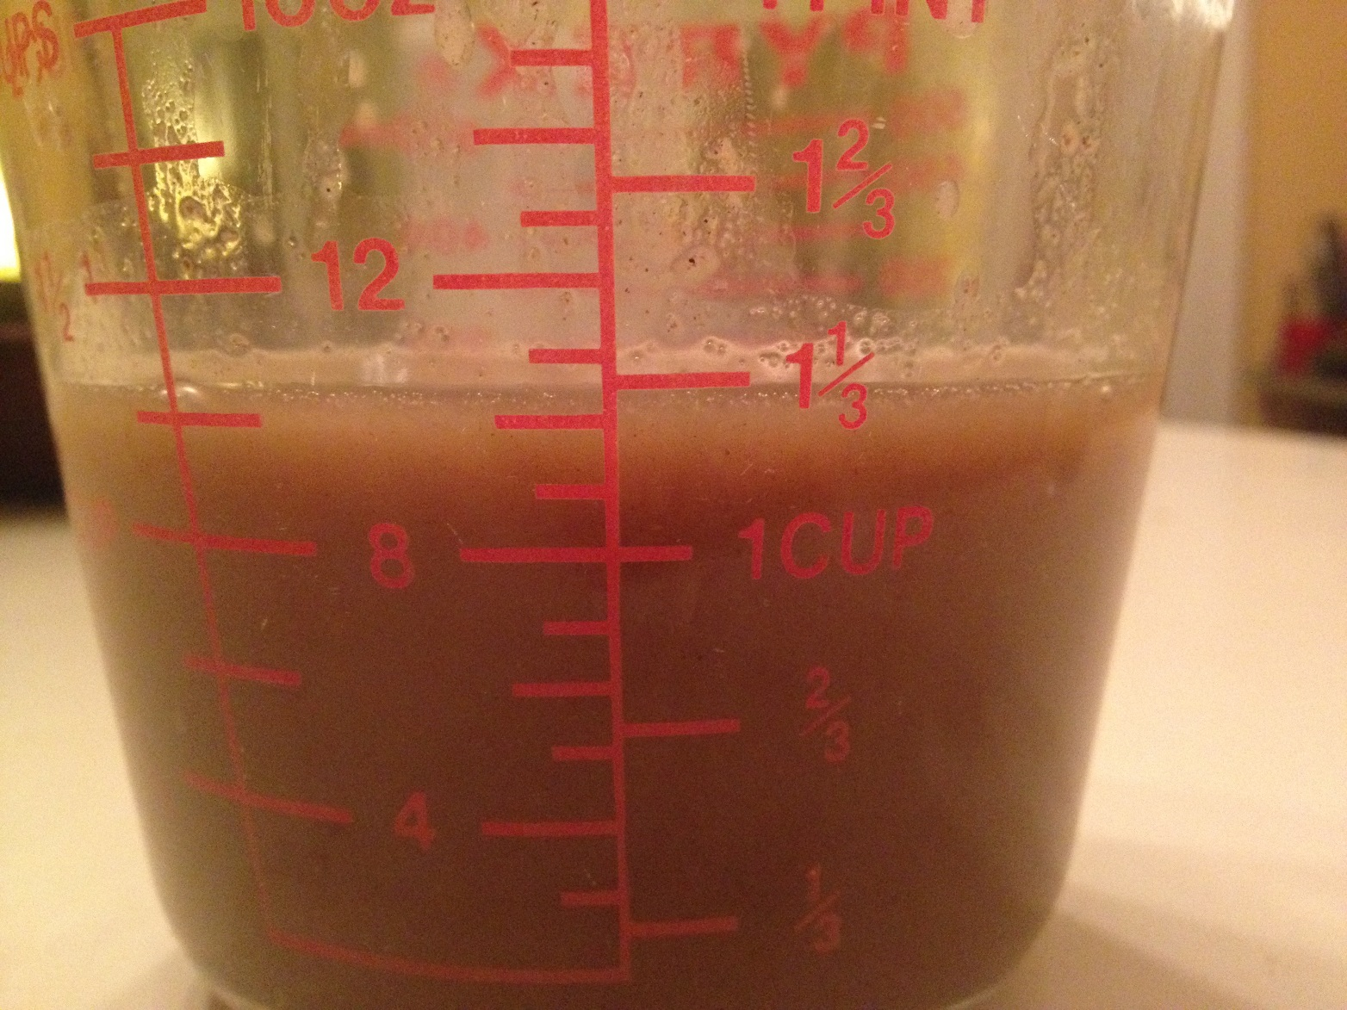
Yield of first infusion was approximately 1 - 1/3 cups

- As difficult as it is, I refrain from pouring the dregs into the measuring cup. This results in leaving otherwise usable murri left in the jar, which is difficult, but necessary, because it is used to start the next batch (Medieval Arab Cookery calls this the ‘second extraction’).

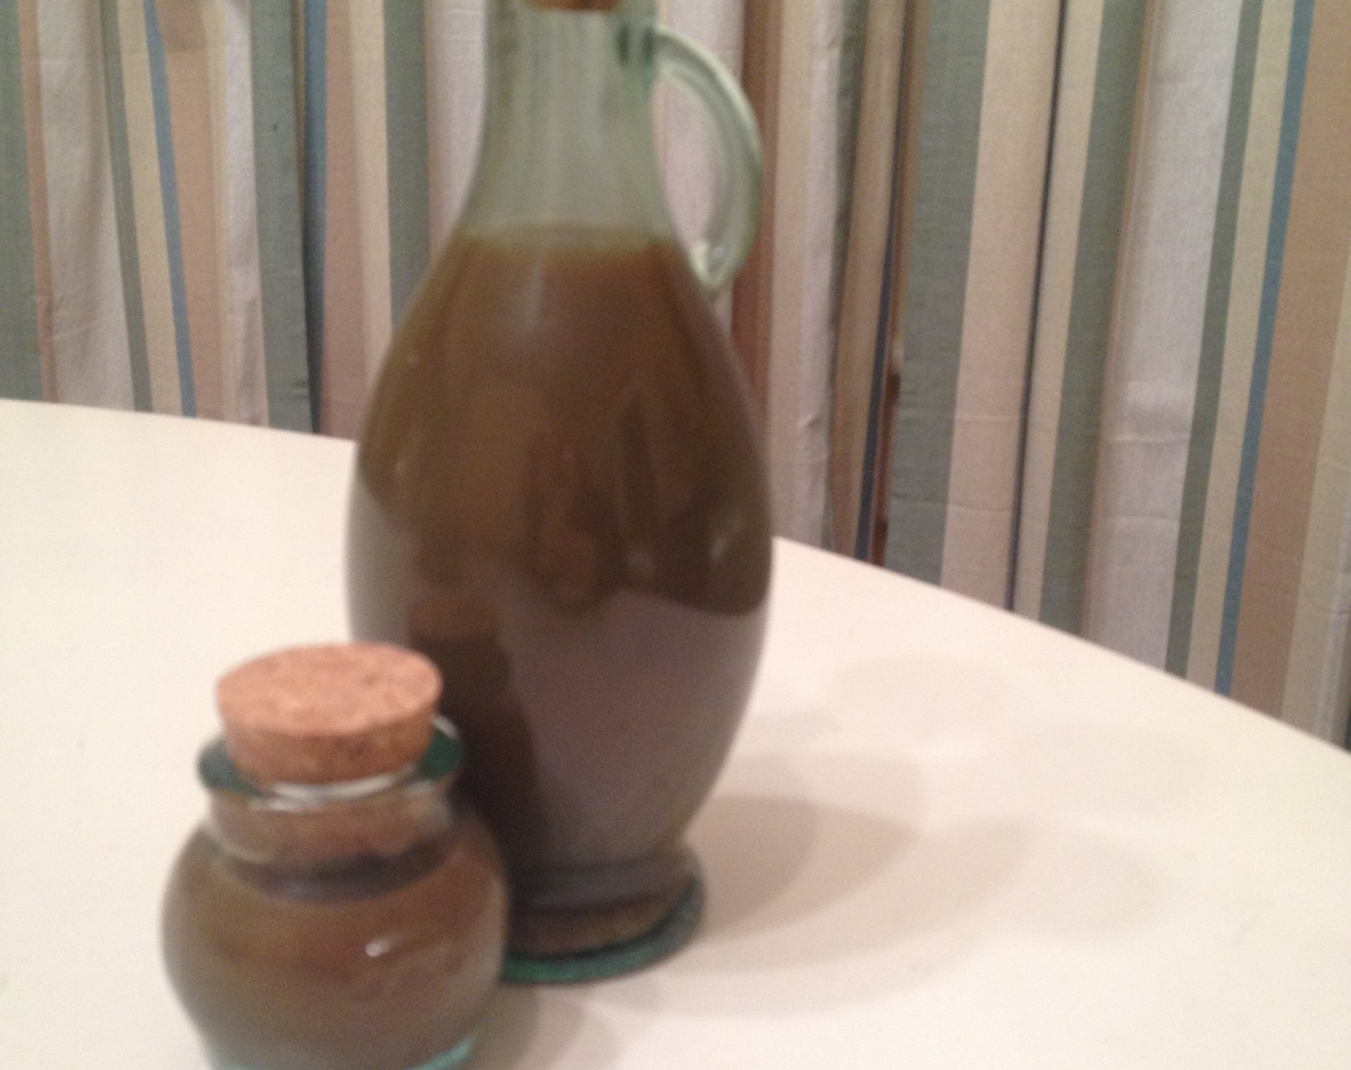
Finished and bottled North African al-murri
This was my first attempt at making murri and the results of this attempt was bottled and aged since October 2014.

The Second Extraction

Then, for every 10 Egyptian pounds, you throw in a third of a pound of flour of groats, kneaded leavener. And if you want a third and baked in the bread oven but not completely done. Then break it into crumbs while it is still hot into this raised [sc. Murri] and leave it in the sun for ten days. Strain it and put up in glass vessels sealed with oil. This is the first extraction, and it is the excellent one. If you want to extract another from it, take that which you left before and add water to it and leave it for another 40 days. Then, after straining it, throw in hot bread as you did before, and you leave it 10 days and strain it, and it is the second water. And if you want a third and a fourth, do so. Then keep the dregs and dry them in the shade as loaves, for they enter into some dishes (Maxime Rodinson, 2006).

The instructions for the second extraction are to add the ingredients prior to draining the first extraction from the murri. It is apparent (to me anyway) that there is quite a bit of live, active yeast in the murri at the end of the first 40 days, when I bottle the first extraction and adding groats. As anyone who has worked with bread starters knows, the addition of groats, leavening and bread is intended to reactivate the natural yeast already in the dregs. Draining the murri first, and then adding the food for the yeast to the dregs makes more sense to me, which is what I have done.

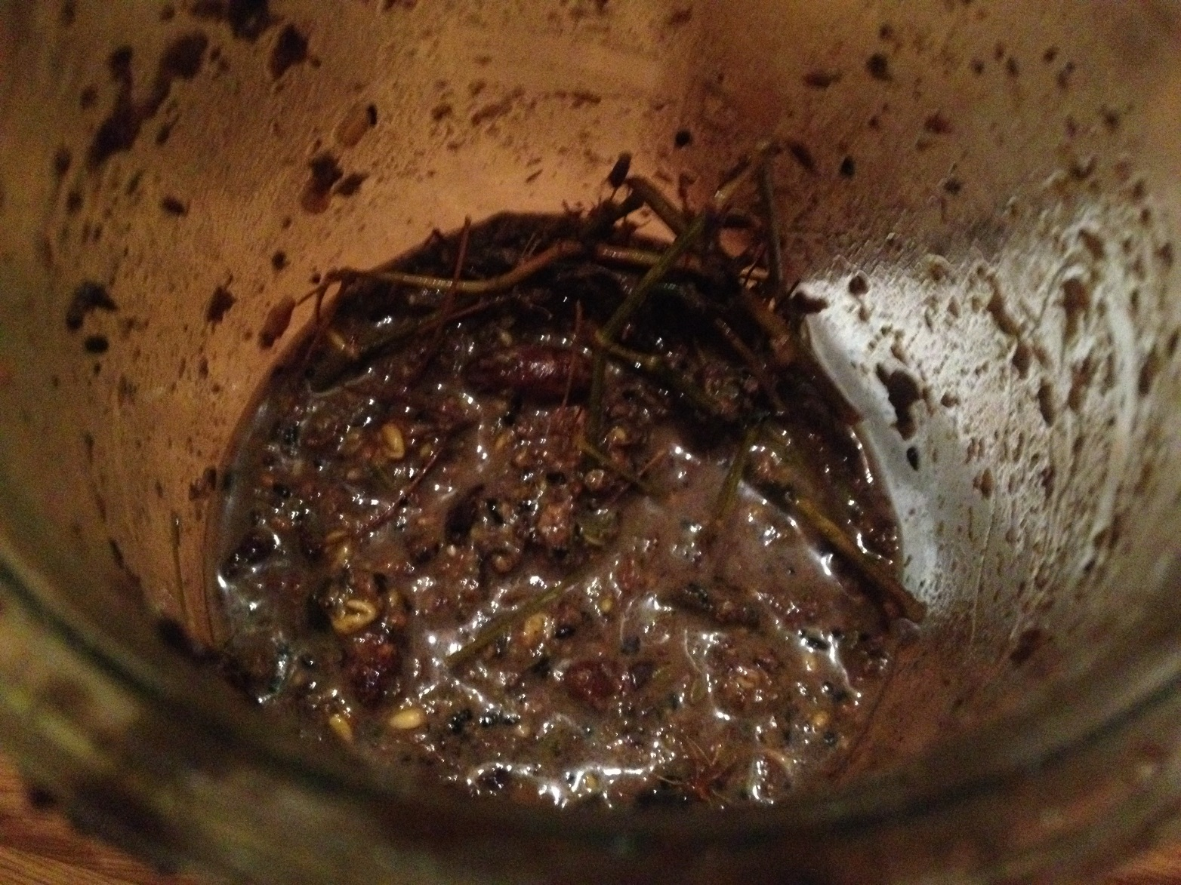
Dregs of North African murri , ready for the second infusion

There are five ingredients that make up the second extraction: the dregs from the first extraction; wheat groats; leavening; bread, still warm from the oven and water.

Groats are roughly ground grains and since the instructions calls for flour grouts, I used hard red wheat berries and ground them into groats in my mortar and pestle and added one quarer cup of flour groats to the dregs from the first extraction.

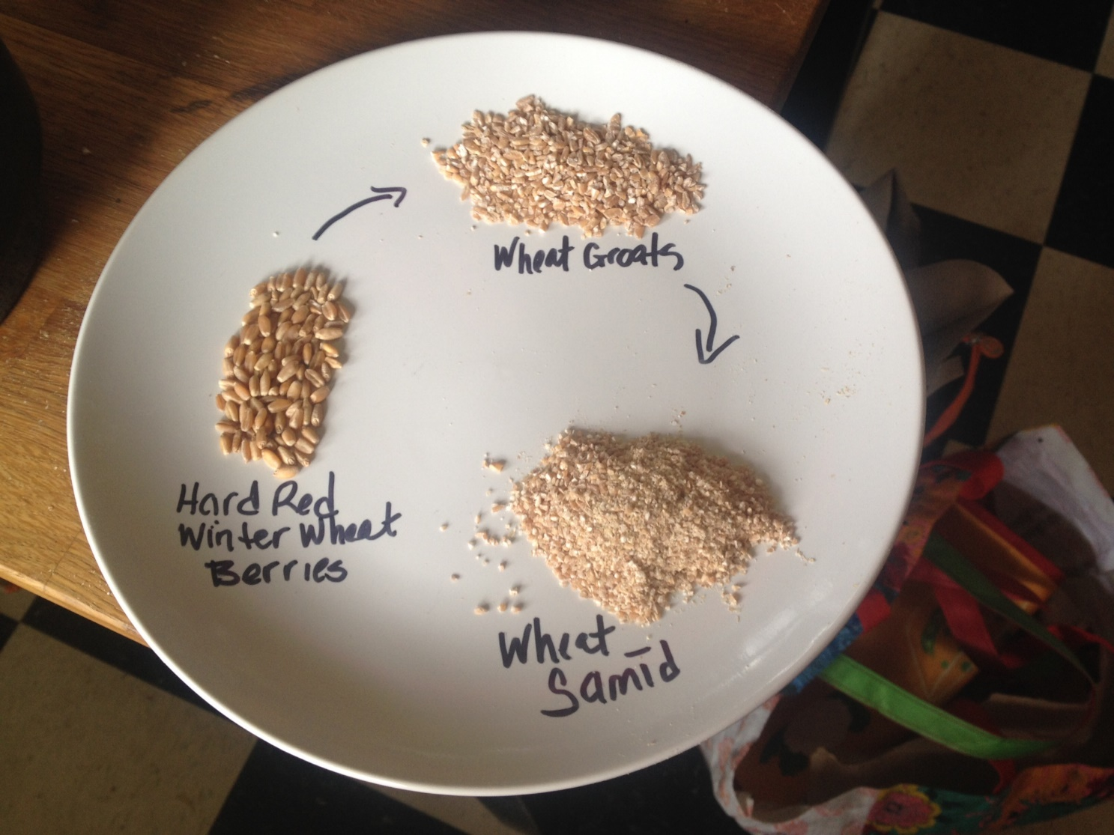
Stages of wheat being ground for the second extraction of North African murri.
Wheat groats were added to the dregs, along with the leavening.
The look of the process for the second extraction is very similar to the look of the first

To make the leavening, I used a tried and true method of developing natural yeast (and one similar to what happens when making the budhaj). I took one quarter cup of barley, ground to a flour, and added warm water to make a dough; rolled the dough into a ball and flattened it slightly; made a depression in the center of the flattened ball about half the depth of the ball; and then scored it into four pieces. This was left in a warm place for three days to allow natural yeast to develop – this is leavening. After three days, one piece of the leavening was crumbled and placed into the dregs of the first extraction of the murri and one piece was used to make bread to add to the dregs.

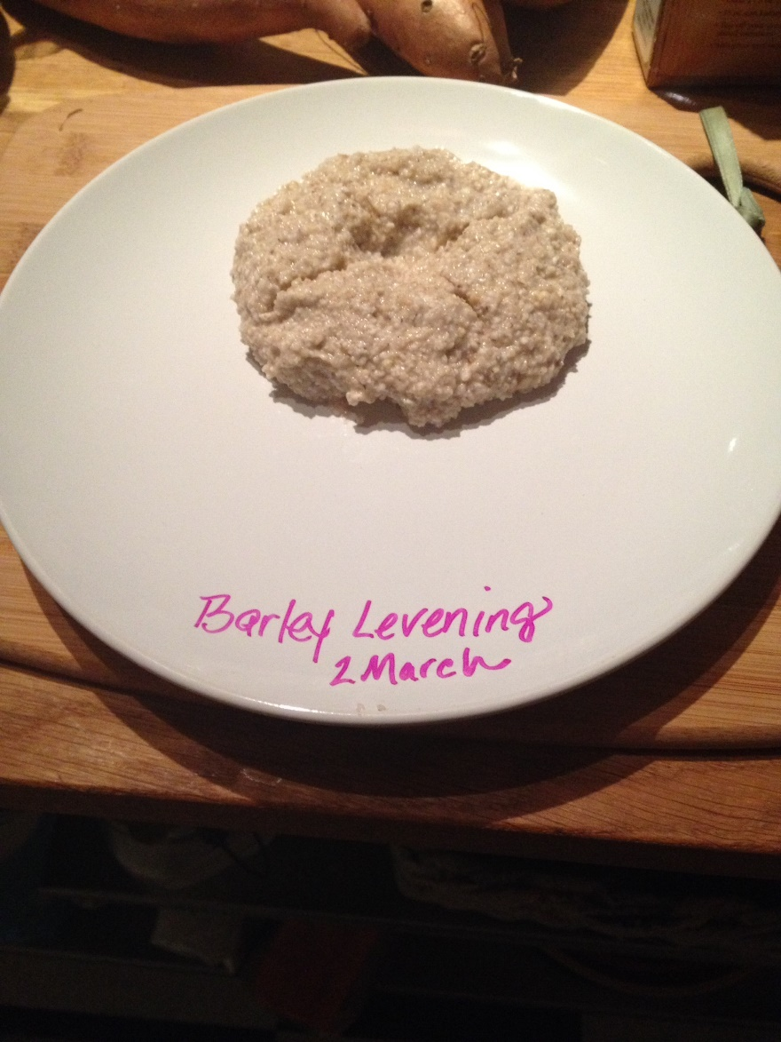
The second extraction leavening being made for the second extraction of the North African murri

To make the bread, I took a section of the natural leavening, salt, and a cup of wheat flour (hard wheat flour groats ground into flour) and mixed them together into a dough using warm water. After the dough was formed, I left it in a warm place for almost 24 hours, covered by a damp towel for added humidity, to allow the natural yeast to develop a usable dough. I put the bread into a warm (300 degree) oven for 2-1/2 hours. After removing the bread from the oven, I crumbled up one fourth of the loaf and added it to the dregs of murri. I stirred it and allowed it to sit overnight before adding two quarts of water to the mixture the next morning.

I kept the mixture in a warm, sunny place (the same location as for the first extraction) and stirred it every day for ten days before straining the second extraction of murri into containers.

Tools Used

The tools used were few – I ground the barley into meal using a mortar and pestle and added water to make the barley dough. Fig leaves were used to wrap the barley dough and fig twigs inserted. I used cotton twine to hold the leaves in place for a couple of days and then removed it once the leaves dried (in retrospect, the twine wasn’t necessary). After the budhaj spent 40 days resting (20 days on each side), I used the mortar and pestle to break it up; placed it and the additional ingredients in a glass jar; covered the jar with a small piece of loose-weave cotton fabric (secured with a rubber band) and used a stick from a fig tree to stir it with. I placed the jar on top of a six-foot ladder to mimic placing the jar on a roof top, as suggested in the instructions. No other equipment was used in the making of the first extraction of the North African al-murri, and with the exception of the six-foot step ladder, all ingredients and methods could have been used in the making of al-murri in period. For the subsequent extractions, I used a modern oven to bake the bread; otherwise I used the same tools that were used to make the first extraction.

After successfully making the North African al-murri, I decided to use the knowledge I gained and try another version – the Iraqi murri was next on my list.

Murri as made by the Iraqis

…rotted barley…and flour of wheat samid, of each 30 pounds. Knead the flour well…without leaven or salt, and bake it and dry it and pound it. Put it and the rotted barley…in a green washtub with 20 pounds of salt, and put with it two cups of fennel and a cup of nigella. Leave it in the sun for 40 days in the heat of summer, and pound it…three times a day, at the beginning of the day, the middle and the end. Sprinkle it with water to cover and leave it for two weeks…and stir it morning and evening. Then when it starts to bubble, leave it until it settles. Then strain it and return the dregs to the vessel and pour another water on them and leave them for two weeks. Then when it bubbles, [the second water] is strained and put …with the first. Then a third water is extracted from the dregs, if you want, and added to the first and second. If it is very salty, throw jujubes into it. Some people put date molasses and honey with it after straining, so that it becomes sweet, such that the date molasses bubbles until it becomes black. And on every pound of it you throw 10 pounds of the murri, and it bubbles. Put saffron, cinnamon and some more good spices with it, and it comes out excellently (Maxime Rodinson, 2006).

My Recipe Redaction

The translation of this recipe in Medieval Arab Cookery contains several footnotes noting passages missing from the recipe (the missing sections are referenced above using ellipses). Since this information is lost, I used my experience with making North African murri to fill in gaps in the process.

- Begin with 4 ounces of budhaj (instructions above in the North African murri section) and break them into pea to acorn-sized pieces.

  - Place into a gallon-sized, wide mouth glass jar and add: 1/4 t. nigella; 1/2 t. fennel seeds and 2/3 cup salt. Set aside.

- Take 1-1/3 cups wheat samid (I used hard red wheat berries and ground them by hand into a rough flour);

Begins with budhaj - the same main ingredient as North African murri
Unleavened bread is added to the budhaj for the toher main ingreditent for the Iraqi murri.
To make the bread, I began by grinding wheat berries into groats and then into samid (a rough flour)

  - add 1/3 cup water to make a bread dough; form the dough into small loaves and bake them in a slow over (200-250 degrees Fahrenheit) for several hours (mine took about six hours at this low temperature).

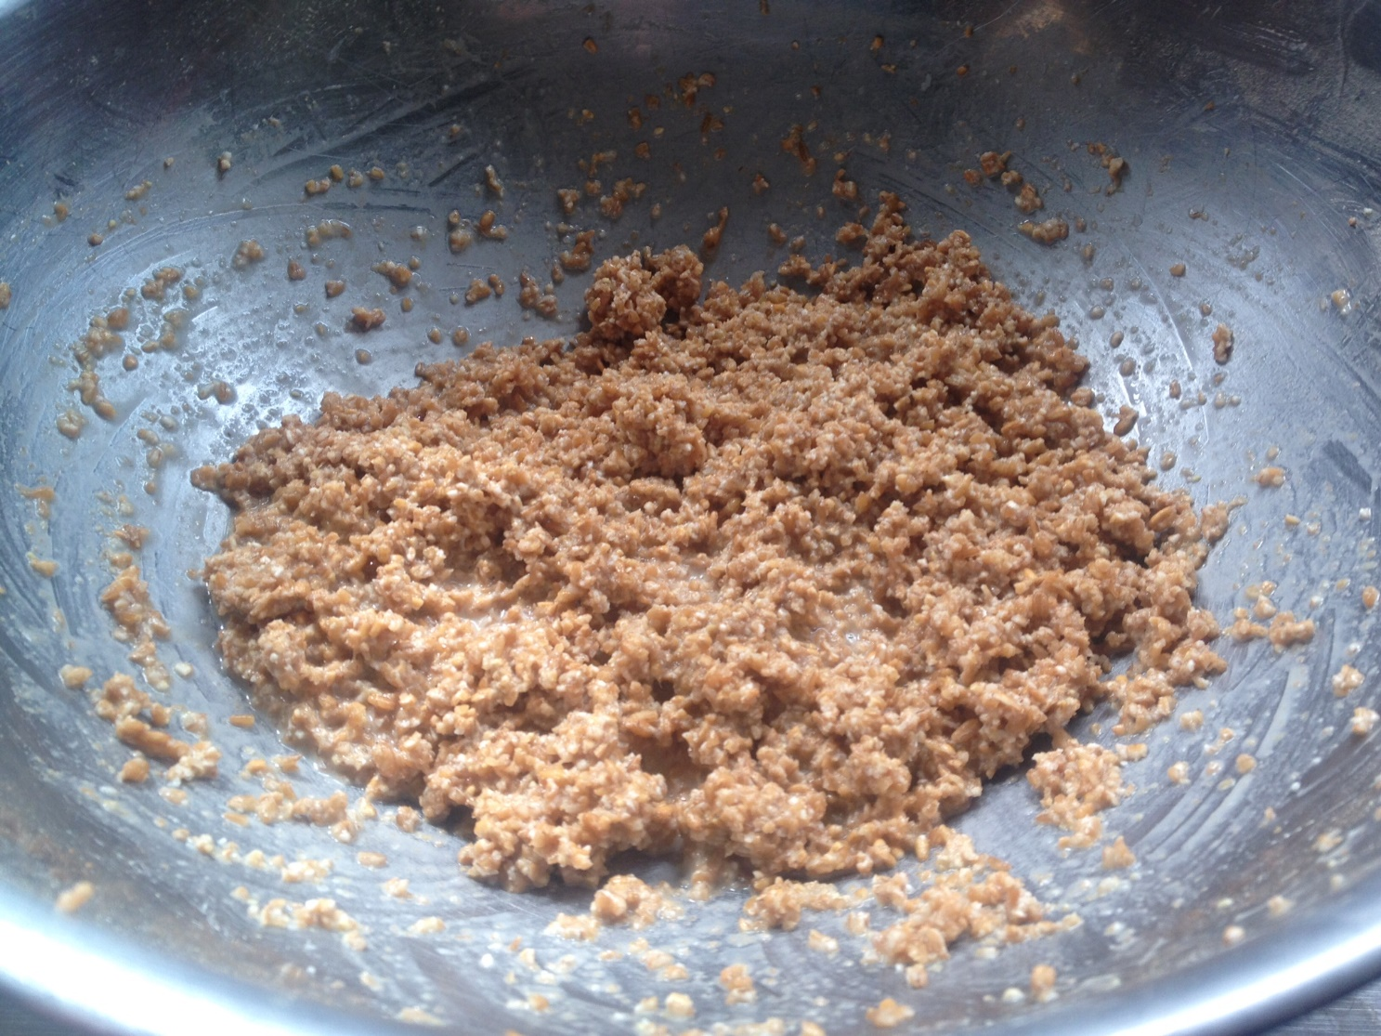
Warm water is added to the samid to make a dough

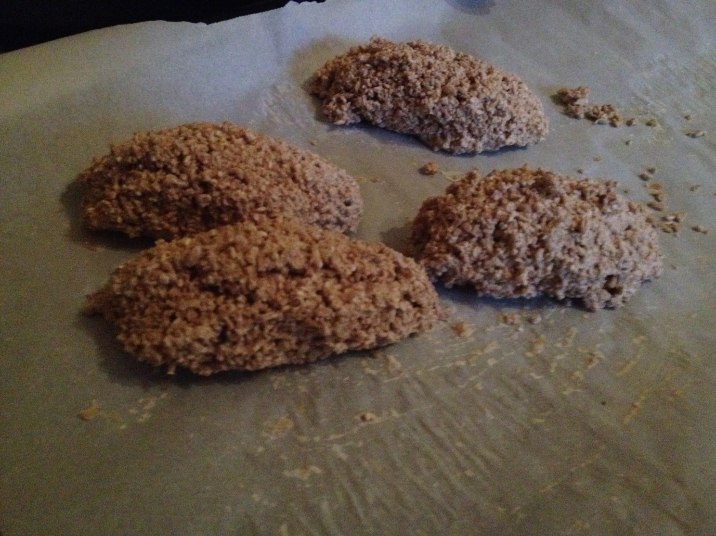
Finished unleavened bread

  - Allow to cool completely; break the bread into pieces and place it into the jar with the budhaj and spices

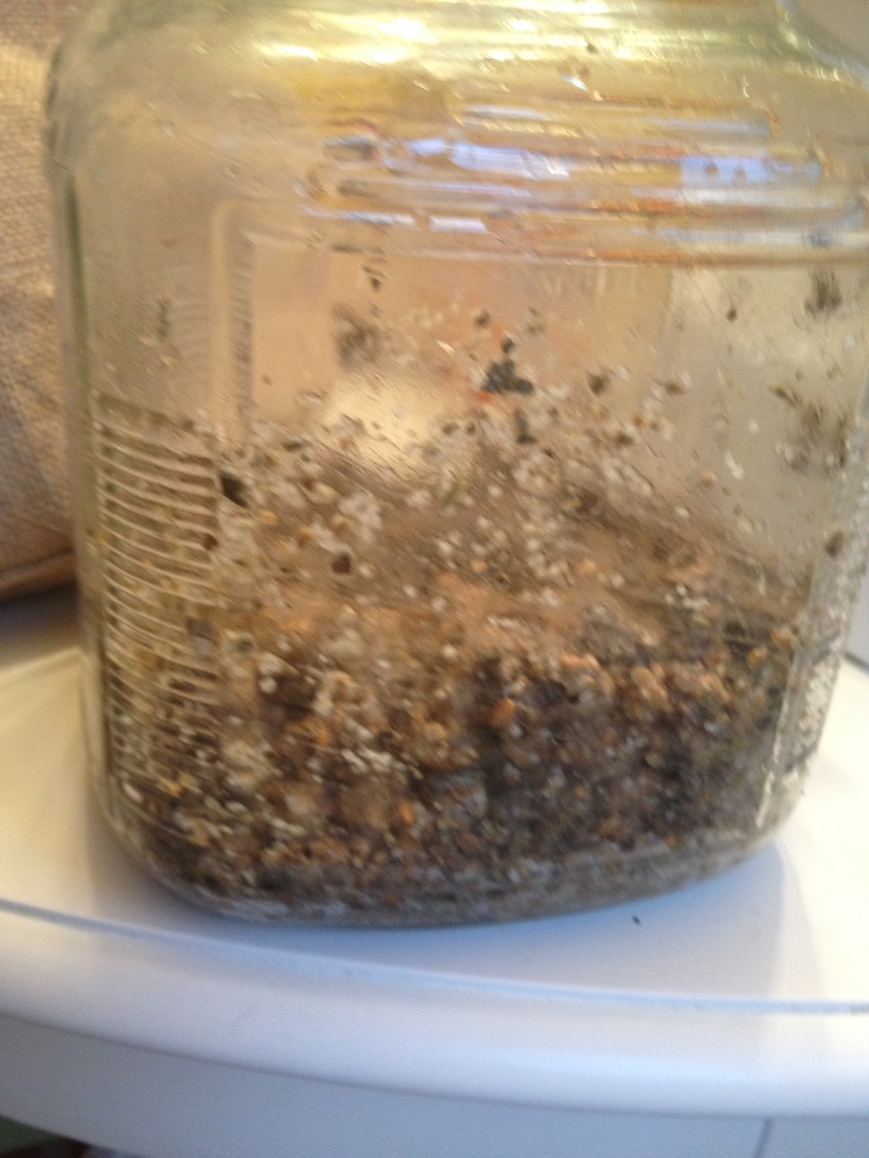
Budhaj, unleavened bread (crumbled), salt, fennel seeds and nigella

- Add a quarter cup of room temperature water to the jar.

- Stir – I use a stick from a fig tree for this – place in a warm, sunny location

- For the first ten days to two weeks, I stir the mixture three times a day and add 1/4 cup of room temperature water to the mixture at the end of every day

- After this time period, I added an additional quart of water.

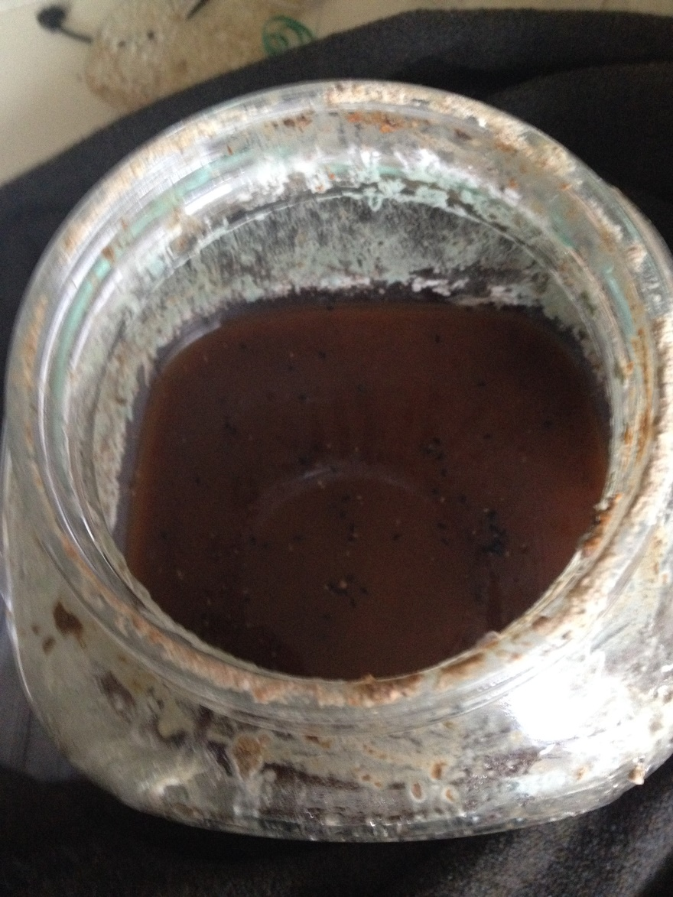
Iraqi murri - at the 25 day mark - two quarts of water is added, which changes the color and viscosity of the murri

This version of murri develops differently than the North African version, which was surprising to me since the ingredients are very similar. Most notably, there was no bubbling and popping that occurred in the North African version.

The color of this version is darker and eventually will turn even darker, with a black tinge to it. At some point it will become closer to black in color than dark brown and it is after this point that the liquid will begin bubbling – I noticed it on the surface at first. Once you see the bubbling (at 25 days for my first batch), there is an additional ten days before the instructions state the murri is ready and at this point, I added another quart of room temperature water.

Keep stirring. Keep it warm. Keep it exposed to as much sunlight as possible.

After an additional ten days the murri is ready to extract. The extraction method is the same method I use for the North African al-murri: On the day I am going to bottle my murri, I don’t stir it and allow the dregs to settle on the bottom of the jar. I pour the liquid through a piece of clean muslin into a 2 quart glass measuring cup.

Strain the liquid again – I usually strain it at least twice more but there will always be sediment in the bottom of your container. Just shake it up before you use it.

I have left samples of the first extraction; second extraction; and a combination of the first and second extractions; plain and with saffron and cinnamon added to each sample.

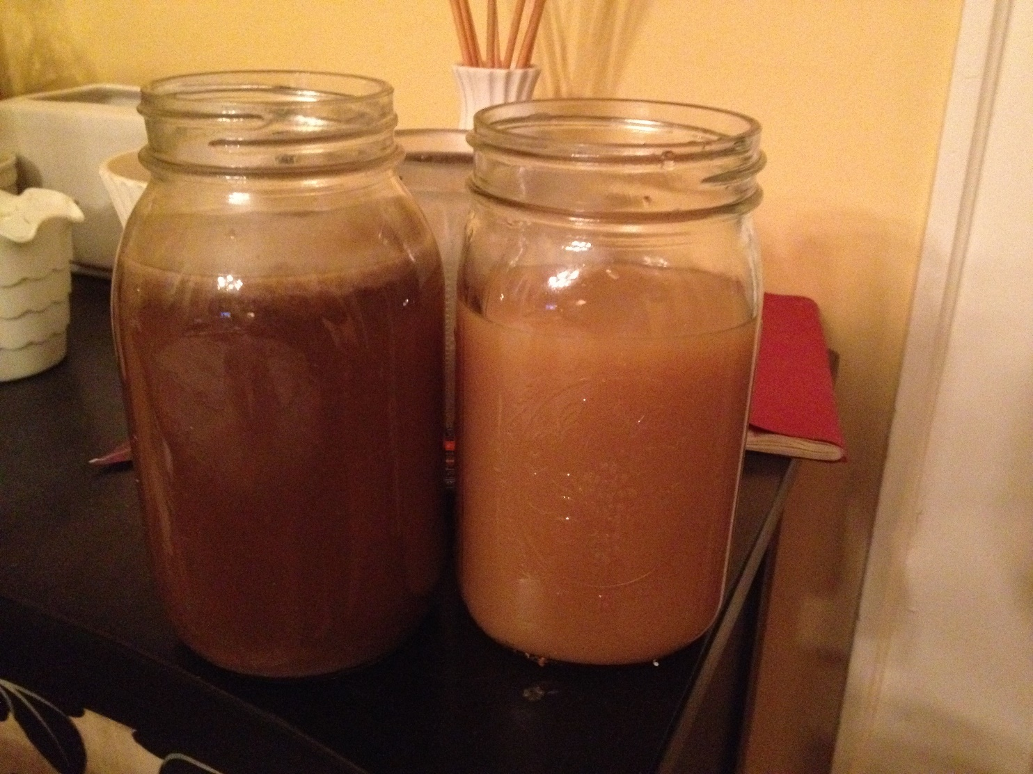
Finished and strained murri - first extraction.
The jar on the right contains North African murri and the jar on the rigth contains Iragi murri

Conclusions/Lessons Learned

-When I began my experiment in making murri, I started with the premise that the worst thing that could happen would be that I either: found a method that didn’t work; that it was nasty and not worth the effort; or I would have something usable at the end. No matter the result, the experiment would teach me something.

I was very fortunate that my first attempt resulted in something usable and tasty.

Encouraged, I decided to try again, with a few changes: a few people who taste-tested the first batch (my brave, trusting friends) commented on the taste of pine or gin so I re-read the translation and determined that I probably added more pine cones than I should have and added fewer in subsequent batches and haven’t had that comment again; and I purchased a scale to get accurate measurements of the ingredients I was using so that I could not only duplicate what I was doing, but also could teach other people to make their own.

-One of the most fascinating realizations I made is that this process provides a method for trapping and slowly releasing wild yeast in a fermentation process that does not result in final product that is alcoholic. This process would have been very important to Arab Muslims, whose religion would have forbidden alcohol. I attempted to document this anaerobic process in pictures, which at times resemble a slow, rolling boil, but I don’t believe still pictures do it justice – it was fascinating to watch.

After identifying this process, I became curious about where in the process the yeast was captured (was it after the water was added to the budhaj or before?) and started another first extraction of murri with the goal of counting how many days would go by before the fermentation process was evident. I didn’t have to wait long – by day two, the familiar yeast bubbles were coming to the top of the liquid and the soda-type fizzing could be seen at the side of the jar. This lead me to determine that wild yeast is developed and trapped during the budhaj drying process, and is most likely the reason for the elaborate process of wrapping wet barley flour in fig leaves and allowing it to dry for 40 days.

- Almost all internet references to using murri in a period recipe suggest substituting either the Byzantine version or watered down soy sauce. I couldn’t determine how people came to this conclusion since; if you don’t know how the original tasted, then how do you know what would be an appropriate substitute? It wasn’t until I read the L.A. Times articles on murri that I found the original reference to soy sauce by Charles Perry, who was writing for a mundane audience (Perry, Rot of Ages: a medieval rotted sauce lives again, 1998). In my opinion, soy sauce as a substitute for either the North African or Iraqi murri works only to the extent that it adds the taste of salt and perhaps a small fraction of what we call umami, but is lacking so much of the depth of flavors in murri.

-As there are few references to anyone actually making a non-Byzantine version of murri in modern times - and all of those references are from the same person (Charles Perry) - I purposefully did not read those references until after I had made several batches on my own and I’m glad I did not because the process I developed using my own interpretation of the translated recipes was very different from the process he used.

-Which brings me to the most important lesson I learned from this project: just because an ‘expert’ says something, doesn’t necessarily make it so. When I first began researching murri, every reference to the long version was accompanied with at least one warning against even the attempt at making it. It was either carcinogenic (Perry, Medieval Near Eastern Rotted Condiments, 1987) ; incredibly difficult and time consuming (Perry, Rot of Ages: a medieval rotted sauce lives again, 1998) ; or just plain old nasty and not worth the effort (Perry, Medieval Near Eastern Rotted Condiments, 1987) (Perry, Rot of Ages: a medieval rotted sauce lives again, 1998). Even the translation of the main ingredient (budhaj) as ‘rotted’ would, and probably has, discouraged many from the attempt.

I am here to proclaim that none of this is the case. The claim of murri being carcinogenic, while persistent, has been retracted; while it does take quite a long time to make calendar-wise, the hands-on effort required is minimal and the process is simple; and the taste is so different from anything I have tasted previously that it is definitely worth my effort.

In 1987, Charles Perry (who was one of the first people in the modern era to bring attention to these condiments) wrote the following in his presentation at the Oxford Symposium on Food & Cookery (Perry, Medieval Near Eastern Rotted Condiments, 1987):

It would take considerably more experimentation, and the courage to taste these strange and definitely unhealthful substances to get a clearer idea of what these medieval condiments were like. At any rate, one thing is sure: of all the medieval foods, these are the least likely to experience a revival.

I am taking on the challenge of bringing about a revival of this medieval food. Not only will I be making murri again, I am teaching and encouraging others to make it too.

Follow my murri project on Pinterest at: https://www.pinterest.com/blueyodel/the-murri-project/ or contact me at blueyodel1 at earthlink.net

Bibliography

Friedman, D. (1992). Cariadoc and Elizabeth's Recipes: Introduction. Retrieved from Cariadoc's Miscellany: www.pbm.com~lindahl/cariadoc/recipes_introduction.html

Friedman, D. (n.d.). David Friedman.com.

Maxime Rodinson, A. A. (2006). Medieval Arab Cookery. Devon, UK: Prospect Books.

Nasrallah, I. S.-W. (2007). Annals of the Caliphs' Kitchens. Leiden, The Netherlands: Koninklijke Brill.

Perry, C. (1987). Medieval Near Eastern Rotted Condiments. Oxford Symposium on Food and Cookery - Taste Prroceedings (pp. 169-177). Oxford, UK: Prospect Books, Ltd.

Perry, C. (1998, April 01). Rot of Ages: a medieval rotted sauce lives again. Los Angeles Times. Retrieved from LATimes.com.

Perry, C. (2012, September). Anonymous Andalusian Cookbook. Retrieved from http://italophiles.com/andalusian_cookbook.pdf

unknown. (2012, May 4). Buhaj with another murri recipe. Retrieved from Medival Spanish Chef: http://www.medievalspanishchef.com/2012/05/budhaj-with-another-murri-recipe.html
------
Copyright 2015 by T.J. Vestal. <blueyodel1 at earthlink.net>. Permission is granted for republication in SCA-related publications, provided the author is credited. Addresses change, but a reasonable attempt should be made to ensure that the author is notified of the publication and if possible receives a copy.

If this article is reprinted in a publication, please place a notice in the publication that you found this article in the Florilegium. I would also appreciate an email to myself, so that I can track which articles are being reprinted. Thanks. -Stefan.

<the end>

