Roman-Cuisine-art - 2/24/15

"Roman Cuisine" by Master ibn Jelal.

NOTE: See also the files: Roman-Recipes-art, fd-Romans-msg, olives-msg, Olive-Cul-Hst-art, garum-msg, Roman-Wales-bib, Caligae-Boots-art.

************************************************************************
NOTICE -

This article was submitted to me by the author for inclusion in this set of files, called Stefan's Florilegium.

These files are available on the Internet at: http://www.florilegium.org

Copyright to the contents of this file remains with the author or translator.

While the author will likely give permission for this work to be reprinted in SCA type publications, please check with the author first or check for any permissions granted at the end of this file.

Thank you,
Mark S. Harris...AKA:..Stefan li Rous
stefan at florilegium.org
************************************************************************

You can find more work by this author at: http://www.renfence.com.au and
http://members.iinet.net.au/~richard.cullinan

Roman Cuisine
by Master ibn Jelal

Introduction

This set of notes was originally written for a talk I gave at Bunch of Classes in 2005, which was a collegia day for the Sydney chapter of the SCA. For the class I discussed the material here, as well as brought redacted versions of the sample recipes at the back for people to try. The redacted recipes I chose were all dip type recipes, which made it easy for people to try a little bit of each on a wafer or cracker. For the wafers, I used a thin bread type cracker since it resembled lagnum.

Why study Roman cooking?

Roman cooking is one of the earliest cuisines that we can document, and it was also the progenitor for a lot of the regional Mediterranean cuisines that we have today. It also is fascinating to look at the progenitor of Italian cuisine, and to realise that the modern Italian cuisine whilst retaining some of the ideals of the Roman cuisine, has become completely identified with ingredients introduced after the fall of the Roman Empire, as well as becoming reliant on ingredients sourced from the New World. The Italian classics such as pizza, pasta, polenta and risotto are all unknown during the Roman period, and the humble

tomato that we so strongly identify with Italian food wasn’t introduced from the New World until the 16th Century.

For reenactors, it is also a way of expanding our understanding of our medieval forebears. Roman cuisine, Apicius especially, was of interest to medieval cooks and scholars themselves. This Classical Times worship was a large part of the medieval mindset, and became even more pronounced in the Renaissance.

We also know from our primary sources, that Roman cuisine was an outgrowth of Greek cooking. This is a great boon to the reenactor of Ancient periods, as well as becoming a great indicator for Byzantine Cooking, which most probably merged and continued the great cuisines of both the Greeks and Romans. Unfortunately, the resources available to us today for the Byzantine cuisine is practically non-existent.

Sources and References

Contrary to popular belief, there are many resources for Roman cuisine outside of the famous Apicius recipe collection. I’ve divided the resources into listings of whether they are primary (ie period manuscripts) or secondary sources (ie translations and interpretations).

Primary
The following resources and descriptions have been taken from Grant pp 157 – 159.

Anthimus (c. AD 450-520)
A doctor from Constantinople who wrote a medical and culinary treatise in northern France when on a diplomatic mission to King Theuderic of the Franks. English translation and commentary by Mark Grant, Anthimus: On the Observance of Foods, Totnes 1996.

Aristophanes (c. 457-385 BC)
A playwright in Athens. The popularity of his works later led to commentaries being written to explain his rich vocabulary and political allusions. Some of the comments take the form of recipes. There is no English translation of the Greek text of these commentaries.

Athenaeus (c. AD 170-230)
Author of The Deipnosophists, which can be translated as The Partying Professors. This work uses the literary device of a conversation at an imaginary dinner party to discuss food and related subjects. There is an English translation in the Loeb Classical Library by C.B. Gulick, Cambridge, Massachusetts/ London 1927-41.

Bassus (tenth century AD)
Supposed author of an agricultural manual known as the Geoponica or Country Matters, composed of extracts from earlier writers. The Greek text is available in the Teubner (Leipzig) series, but no English translation exists at present.

Cato (234-149 BC)
Author of many books, the only one that still survives being his On Agriculture. This gives advice on the planting of crops, as well as listing numerous recipes for pickles and simple cakes. The Loeb Classical Library has an English translation by W.D. Hooper and H.B. Ash, Cambridge, Massachusetts/London 1935. There is also a new translation with a brief commentary by A. Dalby, Totnes 1998.

Columella (first century AD)
A Spaniard from Cadiz who owned estates in Italy. He wrote his On Agriculture between AD 60 and 65. There is an English translation by E.S. Forster, E. Heffner and H.B. Ash in the Loeb Classical Library, Cambridge, Massachusetts/ London 1941-55.

Galen (c. AD 129-200)
Personal physician to the emperor Marcus Aurelius and the prolific writer of medical texts that were to form the basis of western medicine until the beginning of the nineteenth century. English translations of the books that discuss food can be found in P.N. Singer, Galen: Selected Works, Oxford 1997 (The Thinning Diet) and Mark Grant, Galen On Food and Diet, Princeton forthcoming (On the Powers in Foods, On Barley Soup).

Heidelberg Papyrus
This fragment of a Greek cookery book was found in the dry sands around the ancient city of Oxyrhynchus in Egypt. The Greek text is included as an appendix to the Teubner edition of Apicius On the Art of Cooking by C. Giarratano and F. Vollmer, Leipzig 1922.

Hesychius (fifth century AD)
Author of a dictionary of terms used by ancient Greek writers. There is no English translation of this work.

Oribasius (c. AD 320-390)
The author of a digest of medical knowledge, based on quotes and paraphrases of earlier writers. The first five books deal with food and drink. There is a French translation of the whole of the Greek text by C. Daremberg and U. Bussemaker, Paris 1851. Books 1 and 4 only have been translated into English by Mark Grant, Dieting for an Emperor, Leiden 1997.

Pliny (c. AD 23-79)
Served as a senior officer in the Roman army and fleet. Author of the magisterial Natural History which encompasses everything from geography to plants and rocks. An English translation is available in the Loeb Classical Library by H. Rackham, W.H.S. Jones and D.E. Eichholz, Cambridge Massachusetts/London 1938-62.

Pollux {second century AD)
Professor of rhetoric at Athens some time after AD 178 and author of a dictionary. The Greek text is available in the Teubner series, but there is no English translation of this work.

The Suda Lexicon
Suda means 'fortress'. This encyclopaedia of ancient literature was composed in the tenth century AD. There is a Teubner edition of the Greek text, but no English translation.

(not listed by Grant)

Apicius
This text was probably compiled in the 5th Century AD. Current scholarship believes the anonymous author used the name of the famous Roman Gourmet Marcus Gavius Apicius, known from the reign of Emporer Tiberius (14-37 AD) to provide credence to the collection. Apicius himself may have written the first two books, but the collection over time had other dishes integrated with it, to form the now famous 10 book collection De re coquinaria. The collection has survived due to various editions from two 9th Century manuscripts, which in turn are believed to be derived from 4th or 5th Century compilations, as judged by the Latin style. Various editions are available.

Petronius
He wrote the famous Cena Trimalchionis (Trimalchio's Feast), which is the centerpiece for his Satyricon. His satire is priceless but distorted view of the current Roman etiquette and tastes, even though it does provide the famous distorted view of Roman Feasts. He was a contemporary of Columella and Apicius.

Secondary

American Heritage. The Horizon Cookbook. Garden City, NY: Doubleday & Co., 1968. Aresty, Esther. The Delectable Past. New York: Simon and Schuster, 1964.

Apicius, De Re Coquinaria http://www.thelatinlibrary.com/apicius.html (Online version of the Latin text of Apicius)

Apicius, The Roman Cookery Book. Translated by Barbara Flower & Elizabeth Rosenbaum. Peter Nevill, Ltd, London & New York: 1958.
(This one is recognised as the best English translation around.)

Apicius, Cookery and Dinning in Imperial Rome translated by Joseph Dommers Vehling; 1977 re-print (Probably the most readily available version. Good for giving an idea but has quite a few translation errors.)

Barber, Richard. Cooking & Recipes From Rome To The Renaissance. London: Allen Lane, 1973.

Bober, Phyllis Pray, Art, Culture, and Cuisine: Ancient And Medieval Gastronomy University of Chicago Press, Chicago, 1999

Dalby, Andrew. Siren Feasts, A History of Food and Gastronomy in Greece. Routledge, London & New York: 1996.

Dalby, Andrew. Empire of Pleasures, Luxury and Indulgence in the Roman World. Routledge, London & New York: 2000.

Dalby, Andrew and Grainger, Sally. The Classical Cookbook. British Museum Press, London: revised edition 2000.

Dalby, Andrew. Dangerous Tastes: The Story of Spices. University of California Press, Berkeley & Los Angeles: 2000.

Edwards, John. The Roman Cookery Of Apicius. Point Roberts, WA: Hartley & Marks, 1984.

Faas, Patrick. Around the Roman Table: Food and Feasting in Ancient Rome. Translated by Shaun Whiteside. Palgrave Macmillan, New York and Hampshire UK: 1994, 2003.

Giacosa, Ilaria Gozzini. A Taste of Ancient Rome. Translated by Anna Herklotz. University of Chicago Press, Chicago and London: 1992.

Grant, Mark, Roman Cookery - Ancient Recipes for Modern Kitchens London: Serif, 1999
(This is a real nice book and has NO recipes from Apicius. Also represents more common food.)

Quayle, Eric. Old Cook Books: An Illustrated History. London: Cassell, 1978. Renfrew, Jane. Roman Cookery: Recipes & History. London: English Heritage, 2004.

Ricotti, Eugenia Salza Prina, Dinning as a Roman Emperor How to Cook Ancient Roman Recipes Today 1998 re-print
Rubel, William The Magic of Fire: Hearth Cooking: One Hundred Recipes for the Fireplace or Campfire Ten Speed Press, 2002

Segan, Francine. The Philosopher’s Kitchen: Recipes From Ancient Greece And Rome For The Modern Cook. New York: Random House, 2004.

Smith, Jeff. Frugal Gourmet Cooks Three Ancient Cuisines. New York: William Morrow & Co., 1989. Solomon, Jon & Julia. Ancient Roman Feasts And Recipes. Miami, FL: E.A. Seemann, 1977.
Wason, Betty. COOKS, Gluttons & Gourmets: Garden City, NY: Doubleday & Co., 1962.

Roman Kitchens

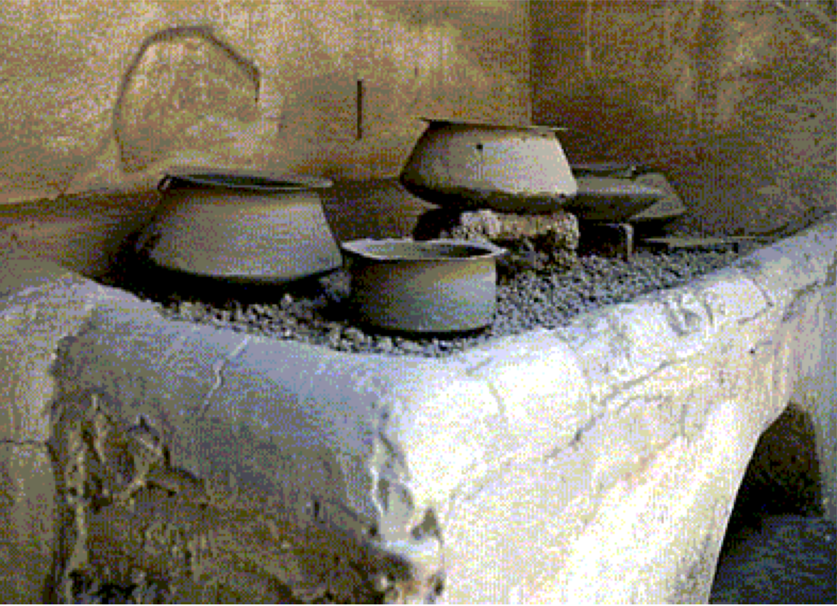
Figure 1 - Kitchen from the House of the Vettii, Pompeii

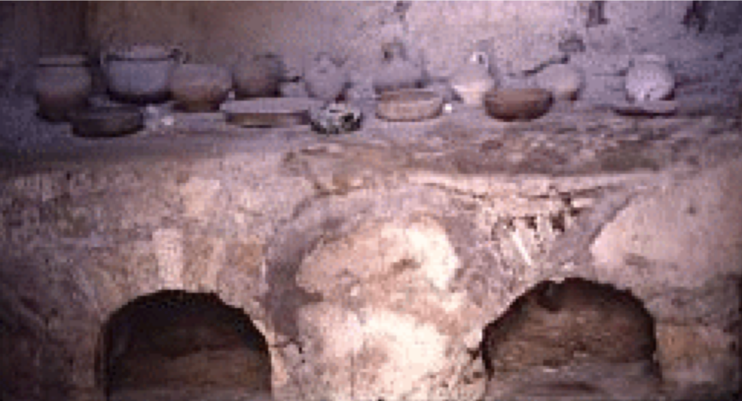
Figure 2 - Oven and cooking pots House of Stags, Herculaneum

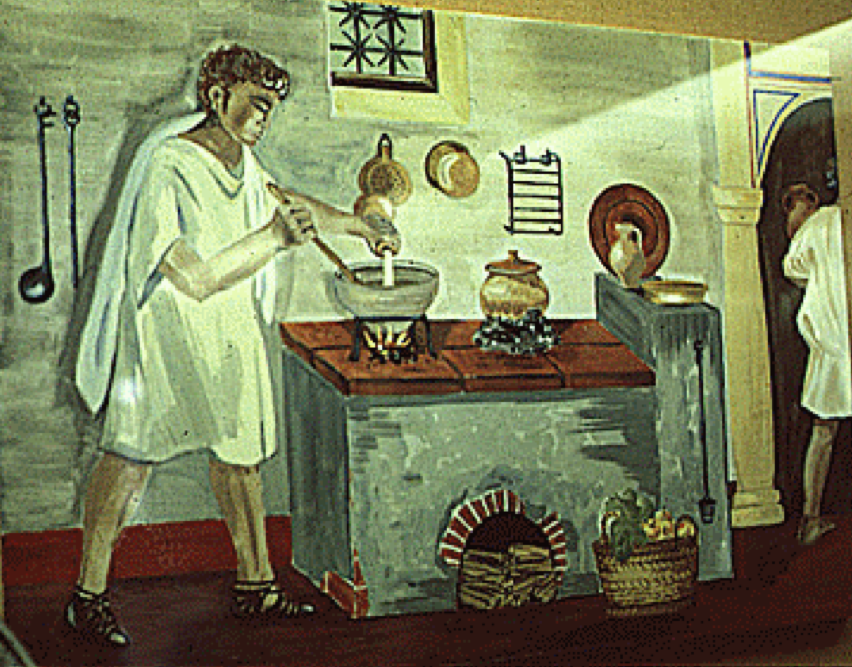
Figure 3 - Drawing of kitchen & slaves cooking Saalburg Museum

The typical Roman kitchen was small, cramped and meals were prepared by slaves, or maybe cooks for hire. (Cooks were not held in high regard.) The cooking surface is a raised shelf, with charcoal or wood being used as the fuel source. Some Kitchens seem to be mostly outside, or may have a small hole to allow the smoke to escape. The opening shown below the shelf is usually for fuel storage, not an oven as might be supposed. Various pots and pans were used, usually with gridirons or tripods as a support, and there are some cases of pot hooks and chains being found.

The preparation of the delicate sauces used in Roman cuisine in this sort of kitchen, shows the degree of fire control that can be utilised by an experienced cook.

Roman Meals

Breakfast

Commonly bread, and maybe dipped in some wine/water. Not a common meal. Some authors mention some form of porridge.

Lunch

Again, not a common meal. Usually bread maybe with cheese, dates, olives, honey or salt. Some enjoyed a vegetable followed by fish or fowl. Mostly eaten along with some wine.

Dinner

Typically the main meal for the day. The authors that spoke of large lunches swapped them with a frugal dinner. Usually eaten around 5pm (The 8th Hour) and was the usual meal to be eaten with guests. Elaborate meals are described, both in the bars and at home. This is the meal which most of our Apicius recipes would have been used in, ie veges, fish, meat dishes followed by desserts.

Rome had fast food or restaurants, which are basically bars. They are called either taberae, popinae, thermopolia, ot tabernae vinariae. Some also had lodgings, collectively were known as cauponae, and were known as either tabernae, deversoriae or tabernae deversoriae. They were not highly regarded, since they also were the haunts of prostitutes.

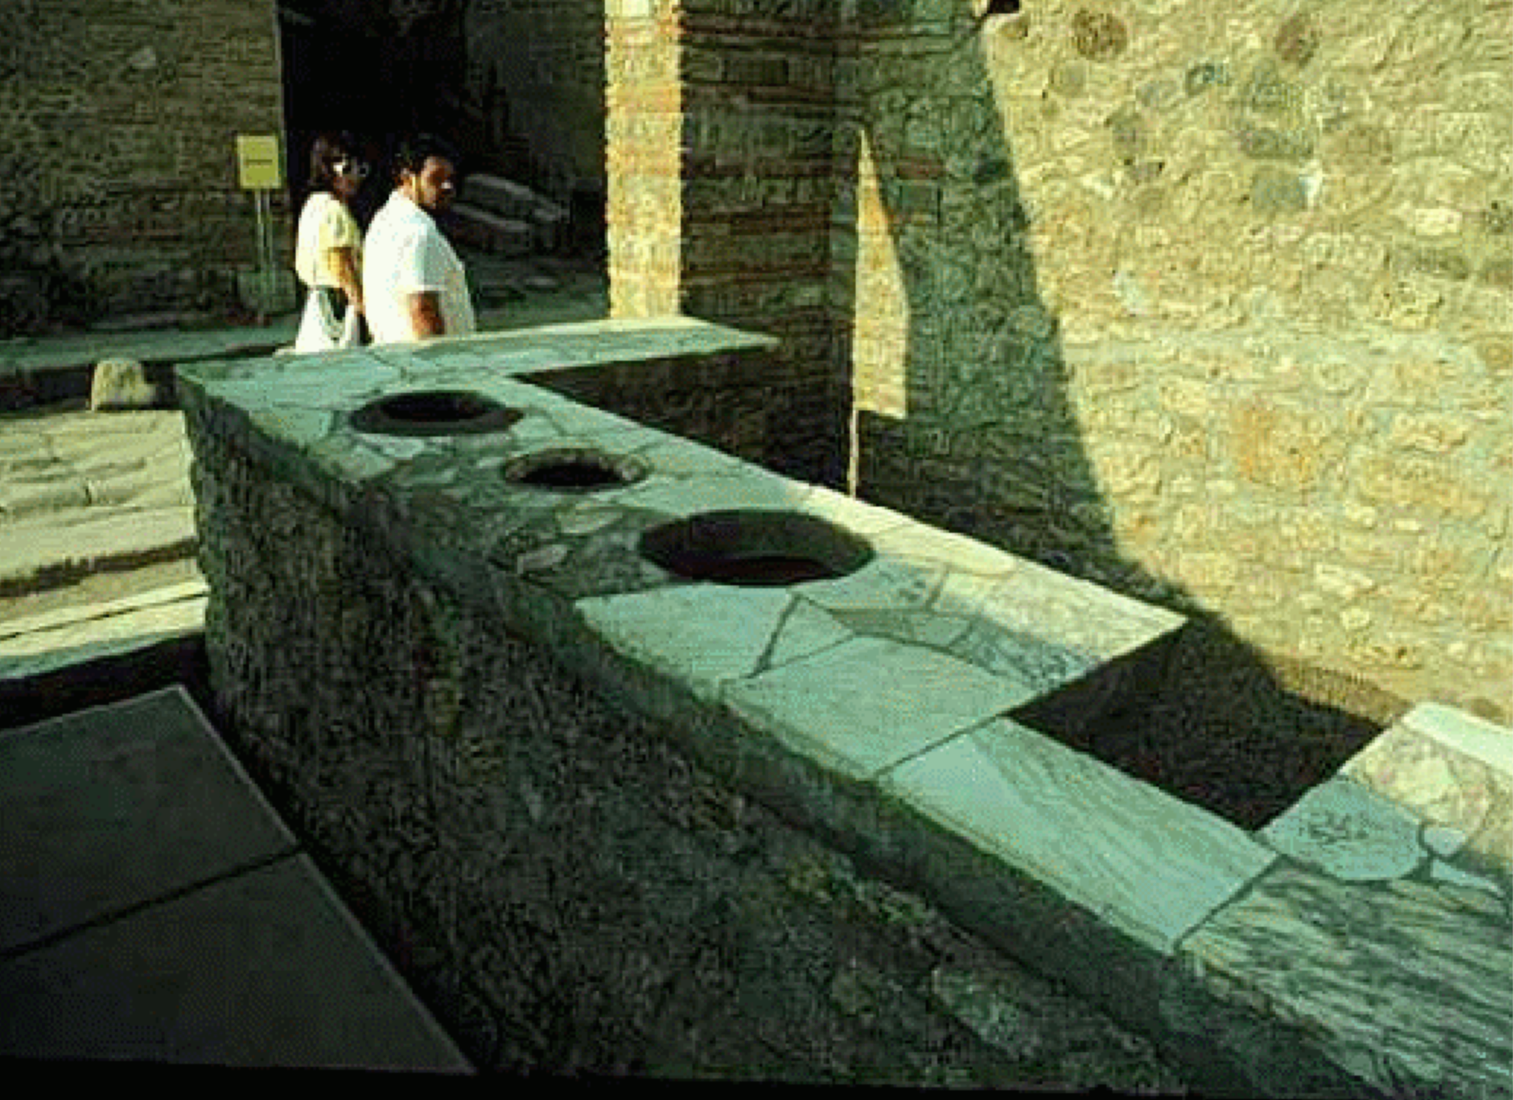
Figure 4 - Pompeii. Thermopolium (bar) #2
Bar food seems to have been bread, fried fish, chicken, ham, eggs, olives, cheeses, sausages and cheap wine.

The Romans do have a phrase which sums up their dinner meals - "ab ovo usque ad malum", which means "from the egg to the fruit". Eggs were a favourite appetiser, and fruit commonly finished the meal.

The usual Roman dinner (cena) was a 3 course menu. The first course was called "gustam" or "gustatio" or "promulsis". The usual fare for this was a selection either eggs, raw or cooked vegetables, salad, mushrooms, salt-cured fish, oysters, shellfish and dormice, consumed with mulsum as the main drink. The second course was called "mensa prima" or "caput cenae", with 2 to 7 dishes depending on the hosts ambitions and means. These courses were based on domestic and game meat, and fish, with wine as the beverage of choice. "Mensa secunda" was the final course, and consisted of sweets and fruits, and sometimes salted dishes, sausages, cheese and even mollusks.

Ingredients

So what ingredients did the Romans use? It certainly wouldn't be recognisable as today's modern Italian cuisine. Tomato, the quintessential Italian ingredient came from the Americas, and hence wasn't known. Potato is another American sourced staple, so again it's non-existent in Roman cooking and hence no gnocci. Polenta, another Italian staple is again another New World food, since it's made from corn. Roman polenta on the other hand was made from spelt wheat, which does give a subtle but different flavour. (Martial 13,48) Not even pasta, the ultimate and most famous of Italian foods was known to the Romans. It didn't come about till the middle ages, and probably via the Middle East, since that's the most probable source for hard wheats such as durum wheat (semolina). Risotto, another typical Italian dish also falls before the evidence. Rice was known to the Romans, but was only used as a starch or thickening agent.

What we are left with however is a surprising rich and varied diet that would still appeal to the modern consumer.

The Mediterranean is a plentiful fishery, especially in Roman times. We have records for the consumption of bonito, sardines, anchovies, mackerel, gilthead, snapper, numb fish, sole, tuna, red mullet, sea bream, scorpion fish, striped mullet, monkfish, halibut, lamprey eel, lobster, squid, cuttlefish, and octopus. There were even fish farms supplying oysters and mussels.

Terrestrial domesticated meat included pig, lamb, goat, chicken, goose, duck, pigeon and doves. An abundance of game meat included wild fowl, hare, boar, partridge, pheasant, deer, roebuck, thrush, figpeckers, snails and frogs. Beef doesn't appear to be common, as cattle were work animals, not food animals. Pig was the main source, being manufactured into many types of products, just as the Italians do today. Products include bacon, hams, sausages of all types, of which Lucanian sausage is just the most famous.

Among the common vegetables eaten were asparagus, leek, onion, beets, cabbage, carrot (not the orange variety), cardoon, rutabaga, squash, cucumber, lettuce, watercress, chicory, endive, and mallow. Pulses consisted of fava beans, lupines, lentils, peas, and chickpeas. Mushrooms and truffles were a known and highly prized delicacy.

Known fruits include lemon, citron, apple, pear, pomegranates, azaroles, quinces, plums, blackberries, mulberries, figs, grapes,

muskmelon, watermelon and dates. Cherries were introduced around the first century BC, and peaches and apricots made an appearance from the first century AD.

Nuts included walnuts, hazelnuts, almonds and pine nuts.

The grains consisted of barley, spelt wheat, rye, oats, millet and panicum. Oats was only used as animal feed, and spelt formed the basis for puls (polenta) or porridge. Dehusked wheat (triticum) became available around the 5th Century BC, and with it came breads, cakes and other flour products.

Sauces

Like the kitchens of today, where we take pre-prepared cooking sauces for granted, the Romans also had several products available to them for cooking. Along with the familiar vinegars, wines and oils, there were also sweetened juice products, and flavoursome salty fish sauces.

Defrutum, Sapa, Caroenum

Defrutum, caroenum, and sapa are all prepared cooking sauces made from reduced must, ie unfermented grape juice that has been reduced in volume by evaporating off the excess liquid. Palladius left us the following definitions for the different types: [XI, xviii]

Now about the preparation of defrutum, caroenum, and sapa. Although all three are made from the same substance, namely from must, the method of their preparation modifies both their names and their properties. For defrutum has its name from "boiling down," and it is ready when it is reduced to a thick consistency. Caroenum is ready when it has lost one-third of its volume with two-thirds remaining, sapa, when it has been reduced to one-third. The latter is improved when quinces are cooked with it and fig wood is added to the fire.

Passum

Passum is a Roman cooking wine, used in a similar manner to defrutum etc. It's a much sweeter wine than defrutum, and used mostly as a sweetening agent in cooking. Columella gives the 2 following recipes, which show the elaborate preparation required for making passum. [XII, 39].

Mago gives the following directions how to make the best possum, and I have made it myself like this. Gather early grapes when they are fully ripe, removing mouldy or damaged berries. Fix in the ground forks or stakes 4 feet apart to support reeds and join them together with poles. Then place the reeds on top and spread your grapes in the sun, covering them at night so that they do not get wet from the dew. Then, when they have dried, pick the berries off the stalks and put them in a cask or wine-jar and pour the best possible must over them so that the berries are completely covered. When saturated put them on the sixth day in a wicker basket and press them in the wine press and extract the possum. Next tread the grape-skins, having added freshest must which you have made from other grapes that were left to dry in the sun for three days. Mix together and put the whole mash through the wine-press, and this possum of the second pressing put immediately in vessels which you seal so that it does not become too rough. Then, after 20 or 30 days, when it has ceased fermenting, strain it into other vessels, seal their lids with gypsum immediately, and cover with skins.

If you wish to make possum from the "bee" grapes gather the whole grapes, clear away damaged berries, and throw them out. Then hang them up on poles. See to it that the poles are always in the sun. As soon as the berries are sufficiently shriveled pick them off and put them without the stalks in a vessel and tread them well with your feet. When you have made one layer of them sprinkle old wine on and tread another layer of grapes over it and sprinkle this also with wine. Do the same with a third layer and, after having added wine, leave for five days. Then tread with your feet and press the grapes in a wicker basket. Some people prepare old rainwater for this, boiling it down to a third of its volume, and then, when they have made raisins in the manner described above, they take the boiled-down rain-water instead of wine, doing everything else in a manner similar to that described above. This process is very cheap where there is plenty of wood, and in use it is even sweeter than the passum described above.

Mulsum

Pyment or unspiced Hippocras depending on which source you follow. Pliny states that mulsum is made by adding honey to a dry wine, since it mixes better with honey. [Natural History XXII, 24, 53 (113-114)] Columella on the other hand gives the following recipe for preparing mulsum. [XII, 41]

Best mulsum. Make in the following way: take right from the vat must called lixivum, which is that which has come out from the grapes before they have been too much trodden, but make it with grapes from vines that grow winding around trees and that have been gathered on a dry day. Take 10 lb. of best honey to three gallons of must, mix thoroughly, and put it in a wine-jar which you seal with gypsum. Have it placed in a storeroom. If you wish to make more add honey in the proportion indicated above. After 31 days the jar should be opened, and the must has to be strained into another vessel, which again is to be sealed and then placed in the smoke.

Garum / Liquamen

Ancient sources contain countless recipes for the preparation of garum, also known as muria or liquamen. The most complete is provided by Gargilius Martialis, a writer from the third century A.D.

Use fatty fish, for example sardines, and a well-sealed (pitched) container with a 26-35 quart/litre capacity. Add dried aromatic herbs possessing a strong flavor, such as dill, coriander, fennel, celery, mint, oregano, and others making a layer on the bottom of the container; then put down a layer of fish (if small leave them whole, if large use pieces); and over this add a layer of salt two fingers high. Repeat these three layers until the container is filled. Let it rest for seven days in the sun. Then mix the sauce daily for twenty days. After that time it becomes a liquid (garum).
-- Gargilius Martialis, De medicina et de virtute herbarum

From "Geoponica" (20.46.1-6), as cited by Robert I. Curtis, Garum and Salsamenta: Production and Commerce in Materia Medica (New York: E. J. Brill, 1991):

The so-called liquamen is made in this manner: the intestines of fish are thrown into a vessel and salted. Small fish, either the best smelt, or small mullet, or sprats, or wolf-fish, or whatever is deemed to be small, are all salted together and, shaken frequently, are fermented in the sun.
After it has been reduced in the heat, garum is obtained from it in this way: a large, strong basket is placed into the vessel of the aforementioned fish, and the garum streams into the basket. In this way the so-called liquamen is strained through the basket when it is taken up. The remaining refuse is alex.
The Bithynians prepare it in this manner: It is best if you take small or large sprats, but if not, wolffish, or horse-mackerel, or mackerel, or even alica, and a mixture of all, and throw these into a baker's kneading trough, in which the are accustomed to knead meal. Tossing into the modius of fish two Italian sextarii of salt, mix up thoroughly in order to strengthen it with salt. After leaving it alone for one night throw it into a vessel and place it without a lid in the sun for two or three months, agitating it with a shaft at intervals. Next take it, cover it, and store it away.
Some add to one sextarius of fish, two sextarii of old wine.
Next, if you wish to use the garum immediately, that is to say not ferment it in the sun, but to boil it, you do it this way. When the brine has been tested, so that an egg having been thrown in floats (if it sinks, it is not sufficiently salt), and throwing the fish into the brine in a newly-made earthenware pot and adding in some oregano, you place it on a sufficient fire until it is boiled, that is until it begins to reduce a little. Some throw in boiled-down must. Next, throwing the cooled liquid into a filter you toss it a second, and a third time through the filter until it turns out clear. After having covered it, store it away.
The best garum, the so-called haimation, is made in this way: the intestines of tunny along with the gills, juice and blood are taken and sufficient salt is sprinkled on. After having left it alone in the vessel for two months at most, pierce the vessel and the garum, called haimation, is withdrawn.

Essentially garum is a high priced salt product, the forerunner of anchovy paste still used today in Mediterranean cooking. Garum is the lacto-fermentation product of salt, fish and strongly aromatic herbs. Liquamen is the expensive liquid portion from the resultant fermentation, and allec (alex) is the slightly cheaper solid residue of that fermentation. Salt or anchovy paste can be used as a substitute, or maybe Thai fish sauce at a pinch. (There are almost religious debates on whether Thai fish sauce is an acceptable substitute.)

Solid Ingredients

Bread

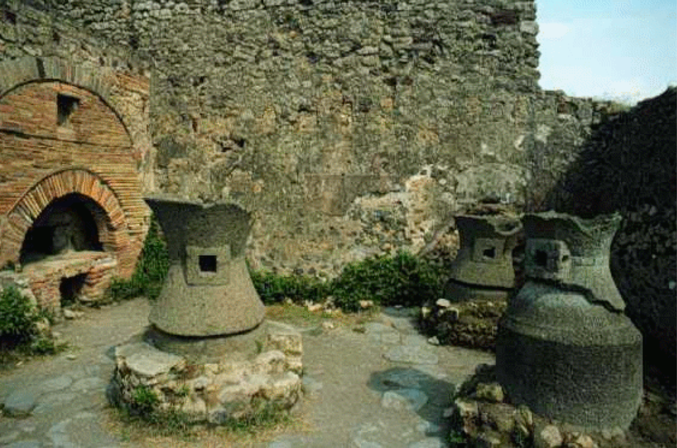
Figure 5 - Pompeii. Pistrinum (bakery). Flour mills

Giacosa gives us an excellent summary of the Roman baking industry. (p16)

The Romans made fine white bread, black bread, leavened bread, flat- bread for sailors, and breads variously flavoured with poppy, anise, fennel, celery, and caraway seeds. The baker (called pistor or triticarius or, when he also made pastries, placentarius) used three types of flour distinguished by the degree of sifting: fine flour (called siligo or pollen), an intermediate type (simila or similago), and a whole-grain flour (cibarium) "from which nothing has been removed," commented Celsus (De medicina 2, 18, 4), hence not sifted at all. The baker could also choose to make leavened or unleavened bread. A type of yeast (fermentum) made in Gaul and Spain from the froth produced during the fermentation of beer (Pliny, Naturalis historia 18, 68) made leavened bread particularly soft and delicate. But according to the Geoponica (a sixth-century compilation of agricultural literature), the best yeast was made with millet: "If a year's supply of yeast is desired, let us mix the froth that rises to the surface in containers of fermenting must with millet flour, blend thoroughly, and form portions of the mixture to dry in the sun. Then we preserve them in a moist place" (Geoponica 2,23).

There were numerous types of bread made and consumed. Charred loaves preserved under ash at Pompeii or Herculaneum show round loaves that were scored before cooking, to facilitate breaking the loaf into segments.

Cheese

Flowers and Rosenbaum, as part of their introduction to their translation of Apicius, brilliantly outline the Roman cheese types, and their methods of production. (pp26-27)

In some of our recipes cheese is mentioned among the ingredients. There was a great variety of Roman cheeses. Apart from Vestine cheese, in the immediate neighbourhood of Rome-which occurs in our cookery-book-Pliny mentions (Nat. Hist. XI, 42, 97 (240-242)) cheeses from the region of Nimes; from the Alps; from the Apennines; Sarsina cheese from Umbria; Luni cheese from the border district between Etruria and Liguria. This latter could weigh up to 1000 lb. Columella's cheese-making recipes give us an idea what Roman cheese must have been like (VII, viii). He mentions thin cheese that is to be sold as quickly as possible, as it does not keep. Hard cheese that keeps longer is made from fresh milk not mixed with water. It is curdled with rennet from Iamb or kid, or with the flower of wild thistle (or artichoke), or seeds of saffron, or with the sap of fig trees. But the best cheeses contain only very little of any of these things. The proportion of rennet to milk must be at least the weight of one silver denarius to the pail. The milk is to be kept at a certain temperature, but not put on the fire. As soon as it has thickened it is transferred into wicker baskets or moulds so that the whey can percolate. One may either let it drain away slowly or promote the draining by pressure. The cheese is then taken out of the baskets or moulds and put in a cool place on clean boards sprinkled with pounded salt. After hardening it is pressed again to make it quite compact. It is once more treated with salt and compressed with weights. Then it is set in rows on wickerwork trays to drain thoroughly. This cheese is suitable for export overseas.

Cheese to be eaten fresh is taken out of the baskets and dipped into salt and brine and then dried a little in the sun. Hand- pressed cheese is made by breaking up the slightly curdled milk, then pouring hot water over it and making the shapes by hand or in boxwood moulds. Columella also mentions smoked cheese, which is first hardened in brine and then coloured in the smoke of apple-tree wood.

Laser / Silphium

Laser is the Roman name for the plant known as Silphium in Greek, which is now thought to be extinct. According to the OED:

A plant of the Mediterranean region, yielding a gum-resin or juice much valued by the ancients as a condiment or medicine; the juice obtained from this plant, also called LASER.
The plant has been variously identified as Thapsia garganica or silphion, and Narthex silphium. It was largely cultivated for export at Cyrene on the north coast of Africa.

Asafoetida was noted by the Romans as a related but inferior laser species, but is however the only substitute available to us today. (Persian origin vs Cyrene origin of the true laser plant) Silphium is probably the first recorded species extinction known to man.

Edwards writes: "This seasoning was probably derived from the Ferula tingitana plant, a species of giant fennel which flourished, but only in a wild state, in North Africa. It was gathered with such zeal by the Egyptians, Greeks and Romans that by the first century AD the plant was extinct on the southern coast of the Mediterranean and had to be imported from what are now known as Syria, Iraq and Iran. Apicius did mention Cyrenaic laser Libyan assafoetida), but I believe this was based on an earlier Greek or Egyptian version of a recipe for laser relish. In modern times, the Ferula tingitana has returned to North Africa where it grows to heights of between six and eight feet."

The following information is from John Tatman Silphium: Ancient Wonder Drug? [http://ancient-coins.com/articles/silphium/silphium2.htm]

Silphium, also known as silphion or laser, is an extinct plant species of the genus Ferula. It was described as having a thick root, a stalk like fennel, large alternating leaves with leaflets like celery, spherical clusters of small yellow flowers at the top and broad leaf-like, heart-shaped fruit called phyllon. Some of the best known representations of silphium are the stylized images used on the ancient coins of Kyrenaika (modern-day Libya). The plant was valued in ancient times because of its many uses as a food source, seasoning for food, and, most importantly, as a medication. Perfumes were made from the flowers, the stalk was used for food or fodder while the juice and root were used to make a variety of medical potions.

Reported medical uses for the juice included remedies for cough, sore throat, fever, indigestion, fluid retention, seizures, aches and pains. The sap was supposed to be able to remove warts and other growths. In addition, Pliny wrote that silphium could be used for a variety of diverse conditions including treatment of leprosy, to restore hair, cleanse retained afterbirth from the womb and as an antidote for poisons. Potions made from silphium were supposedly among the most effective birth-control methods known at the time. Preparations used for birth control included a tea made from the leaves, a "pea-sized" ball of sap mixed with wine and a suppository containing the juice. The timing of administration suggests it probably functioned as an abortifacient similar to preparations made from related plant species.

Apparently, silphium only grew in a restricted area, approximately 125 miles by 35 miles, on the coastal plateaus of Kyrenaika. The Greeks believed the plant was a gift from Apollo which appeared after a heavy rainstorm flooded the area at about the time the city of Kyrene was founded in the seventh century BC. Of course, there is evidence that sliphium was used much earlier in Egypt, Libya and even Greece. Silphium supposedly resisted attempts at cultivation and transplantation, which made it one of the major revenue sources contributing to Kyrenaika's wealth. Pliny described it as "one of the most precious gift from Nature to man." It was considered to be "worth its weight in denarii" during Roman times because of its varied medical uses and scarcity. The plant reportedly became extinct around the first century A.D., perhaps because of overutilization. Other plants, also referred to as "silphium," grow in other locations around the Mediterranean, but were considered to be of inferior quality. As a result, the loss of silphium from Kyrenaika was greatly lamented in Rome.

Representation Of Silphium On The Coinage Of Kyrenaika

(adapted from Robinson ESG. A Catalogue of Greek Coins in the British Museum - Cyrenaica. vol 29. pp ccliii-ccliv. Oxford University Press. London. 1927)

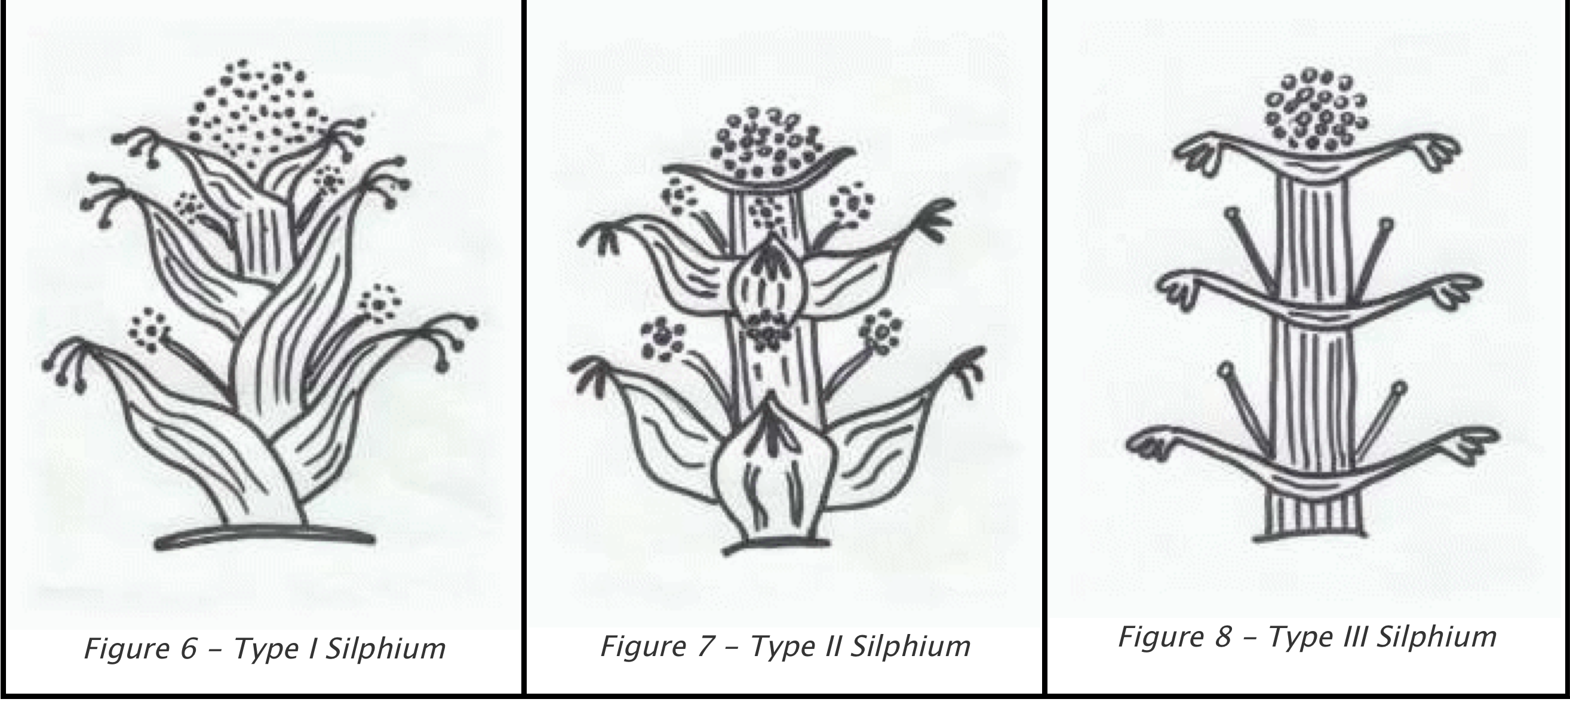

Amulum

Amulum is the common thickening agent mentioned in Apicius. Unlike today where we use corn starch, Roman starch was made from wheat. Cheap commercial "corn starch" available today is usually also made from wheat products, so it should be readily available.

Starch is made from every kind of wheat and fine wheat, but the best comes from three-month wheat. For its invention we are indebted to the island of Chios. And from there comes the variety most highly praised today. It takes its name from the fact that it is made without a mill. Next to that made of the three-month wheat comes that made of the lightest wheat. It is soaked in fresh water in wooden tubs so that the grain is covered, and the water changed five times a day. It is better if this is done also during the night, so that it gets mixed evenly. Before the softened grain goes sour it is strained through linen or through wicker baskets and poured on a tiled floor spread with leaven, and left so as to thicken in the sun. Next to starch from Chios that from Crete is most highly praised, then that from Egypt-it is tested by its smoothness, its light weight, and its freshness-and it has also been mentioned by Cato among ourselves.

Laganum

'Laganon: a type of small cake, dry, made from the finest wheat flour and fried in a frying pan in olive oil' [Hesychius Dictionary]

Laganum appears to be the ancient precursor of pasta, and sometimes used in a similar manner as lasagna. However, the descriptions all confirm that it is a light thin fried dough product, similar to our modern crispbreads. Horace tells us that he ate leeks and chickpeas with laganum. This indicates that they were used as a scoop for these types of foods, as the Romans do not seem to have had many cutleries beyond spoons and knives.

Sample Recipes

These recipes and redactions were taken from the Vehling version of Apicius, which is what I had at the time in 2005.

Apicius #30. Patina De Pisciculis (A Dish of Little Fish) Original Recipe:

Uvam passam, piper, ligusticum, origanum, cepam, vinum, liquamen, oleum. Transferes in patellam. Cum cocta fuerit, acicies in ipsam pisciculos coctos. Amulo obligas et inferes.

Translation:

Take raisins, pepper, lovage, origany (marjoram), onions, wine, broth and oil, place this in a pan; after this has cooked add it to the cooked small fish, bind with roux and serve

(1) Smelts, anchovies, whitebait.
Source: Vehling Translation, Recipe 156, p 111.

Redaction:

Ingredients

1/2 pkt raisins (~250 g) 1 tbl pepper
1 tbl dried marjoram
2 onions
100 mL white wine
500 mL stock (usually chicken)
1/3 cup oil
500 g little fish or flaked fish (cooked) roux (flour and water mix)

Preparation

1. Cook raisins, herbs, spices and onions in wine and stock.
2. When onion cooked, add fish stir and simmer till fish cooked
3. Add roux to bind sauce (Generally not necessary)
Note: This redaction could be improved, as I've used stock instead of Liquamen!

Apicius #70. Aliter Betacios Varronis (Beets a la Varro) Original Recipe:

Varro: ìBetacios, sed nigros, quorum detersas radices et mulso decoctas cum sale modico et holeo vel sale, aqua et oleo in se coctas iusculum facere et potari, melius etiam si in eo pullus sit decoctusî.

Translation:

Varro beets that is black ones of which the roots must be cleaned well, cook them with mead and a little salt and oil. Boil them down in this liquor so that the roots are saturated therby; the liquid itself is good drinking. It is also nice to cook a chicken with them.

Source: Apicius, Book III Recipe 70 - Vehling Translation

Redaction:

Ingredients:

20 - 30 beets
2 bottles mead
1 tbl salt
1 tbl pepper water to cover

Preparation:
1. Peel and dice beets and add to pot
2. Add mead, salt and pepper and enough water to cover 3. Cook till soft then drain and serve into bowls
NOTE: This is feast quantity!

Apicius # 100. Rapas sive Napes (Turnips or Navews) Original Recipe:

Elixatos exprimes, deide teres cuminum plurimum, rutam minus, laser parthicum, mel, acetum, liquamen, defritum et oleum modice. Fervere facies et inferes.

Translation:

Cook the turnips. Squeeze them dry. Crush a good amount of cumin and a little rue; Add Parthian laser or vinegar, stock, condensed wine and oil. Heat moderately & serve

Source: Apicius, Book III Recipe 100 - Vehling Translation

Redaction:

Ingredients:

10 turnips or swedes 2 tbls cumin
1/4 cup vinegar
1/4 cup stock
1/4 cup red wine 1/3 cup olive oil

Preparation:
1. Cook diced turnips in boiling water till soft.
2. Drain liquid and mash turnips with remaining ingredients 3. Serve into bowls

NOTE: This is feast quantity! This redaction could be improved, as I've used stock instead of Liquamen, and red wine instead of sapa! Rue has been omitted, as it can be an abortifacient. I didn't have access to asafoetida to substitute for laser parthicum, so it has been omitted.

Apicius # 184. Aliter Lenticulam (Lentils Another Way) Original Recipe:

Coquis. cum despumaverit, porrum et coriandrum viridem supermittis. ​teres coriandri semen, puleium, laseris radicem, [semen] mentam et rutam, suffundis acetum, adicies melle, liquamine, aceto, defrito temperabis, adicies oleum, agitabis. si quid opus fuerit, mittis. amulo obligas, insuper oleum viridem mittis, piper aspargis et inferes.

Translation:

Cook the lentils, skim them, add leeks, green coriander; crush coriander seed, flea-bane, laser root, mint seed and rue seed moistened with vinegar; add honey, broth, vinegar, reduced must to taste; then oil, stirring until it is done, bind with roux, add green oil, sprinkle with pepper and serve.

Source: Apicius, Book V Recipe 184 - Vehling Translation p128

Redaction:

Ingredients:

2-3 pkts lentils
4 leeks - finely chopped
1 bunch coriander - finely chopped 1 tbl coriander seed
1/2 bunch mint - finely chopped 1/4 cup vinegar
1/4 cup honey
2 cups broth
1 cup red wine
1/4 cup olive oil
roux to bind

Preparation:
1. Cook lentils in water till soft.
2. Drain liquid, and combine with remaining ingredients to form a puree 3. Bind with roux if required then serve into bowls.

NOTE: This is feast quantity! This redaction could be improved, as I've used stock instead of Liquamen, and red wine instead of sapa! Rue has been omitted, as it can be an abortifacient. I didn't have access to asafoetida to substitute for laser radicem, nor to flea-bane, so they've both been omitted.

Last updated on 12 Oct 2012, 12:28:40.
------
Copyright 2012 by Richard Cullinan, <mailing address>. <rcull at ozemail.com.au>. Permission is granted for republication in SCA-related publications, provided the author is credited. Addresses change, but a reasonable attempt should be made to ensure that the author is notified of the publication and if possible receives a copy.

If this article is reprinted in a publication, please place a notice in the publication that you found this article in the Florilegium. I would also appreciate an email to myself, so that I can track which articles are being reprinted. Thanks. -Stefan.

<the end>

