It-Stufd-Lofs-art - 7/1/18

"Italian Stuffed Loaves" by Lord Ogawa Matajirou Ujimori.

NOTE: See also the files: bread-stuffed-msg, S-Stufed-Brd-art, breadmaking-msg, Bagels-art, brd-manchets-msg, cheese-breads-msg, Ital-Fnl-Caks-art.

************************************************************************
NOTICE -

This article was added to this set of files, called Stefan's Florilegium, with the permission of the author.

These files are available on the Internet at: http://www.florilegium.org

Copyright to the contents of this file remains with the author or translator.

While the author will likely give permission for this work to be reprinted in SCA type publications, please check with the author first or check for any permissions granted at the end of this file.

Thank you,
Mark S. Harris...AKA:..Stefan li Rous
stefan at florilegium.org
************************************************************************

Note: More work by this author can be found in his blog at:
http://www.ogawaujimori.com

Italian Stuffed Loaves
by Lord Ogawa Matajirou Ujimori

INTRODUCTION

One medieval resource that I find myself regularly referring to is "The Opera of Bartolomeo Scappi", an Italian cookbook (and more) written by a Master Cook. The book contains a wealth of information on various recipes, as well as ingredient preparation, meal presentation, and much more.

Recently, I found a recipe for a stuffed loaf of bread. I made it on a whim, which provided food for several meals. In preparation for an SCA this weekend, I decided to make the same recipe using smaller loaves, as I am planning to share this with friends.

SCAPPI'S RECIPE

86. To stuff a large loaf of bread. Get a round, two-pound loaf, a day old, and make a round hole in the middle of the bottom crust. Dig out all of the crumb so that only the crust is left, which should be scraped on the outside before the crumb is removed. Have a mixture made up of boiled capon breast ground in a mortar with hard-boiled egg yolks, marzipan paste and mostaccioli, everything mixed with raisins and beaten fine herbs, raw eggs, cinnamon and enough saffron. Fill the loaf and stop up the hole with the crust that was cut out. Put the loaf into a copper stewpot of a suitable size – that is, which is neither too big nor too small – with a fat broth. Cook it slowly for an hour and a half. When the loaf has swollen up and is cooked, pour the broth out of the pot and carefully place the loaf in a dish because otherwise you could not get it out whole. You can cook it differently, as follows. When the loaf is filled, put it into a towel or a piece of filter cloth. With the loaf filled like that and the towel tied up, put it into a cauldron of boiling broth and leave it to cook, though with a light cord attached on the towel so the loaf will not move...

Scully, Terence. The Opera of Bartolomeo Scappi (1570): L'arte et prudenza d'un maestro Cuoco (The Art and Craft of a Master Cook) (The Lorenzo De Ponte Italian Library) (Kindle Locations 10183-10193). University of Toronto Press. Kindle Edition.

MY APPROACH

When making this recipe, I tried to follow Scappi's ingredients and directions as closely as possible, making small changes to account for taste and availability of ingredients.

-"Soup bowl" bread loaves
-Boiled chicken breast (shredded)
-Marzipan
-Mostaccioli (a hard biscuit seasoned with fennel, similar to biscotti)
-Raisins
-Fine herbs (I used an "Italian herbs" blend, supplemented with some additional rosemary)
-Eggs

Once all the ingredients are gathered, it's time to begin stuffing loaves.

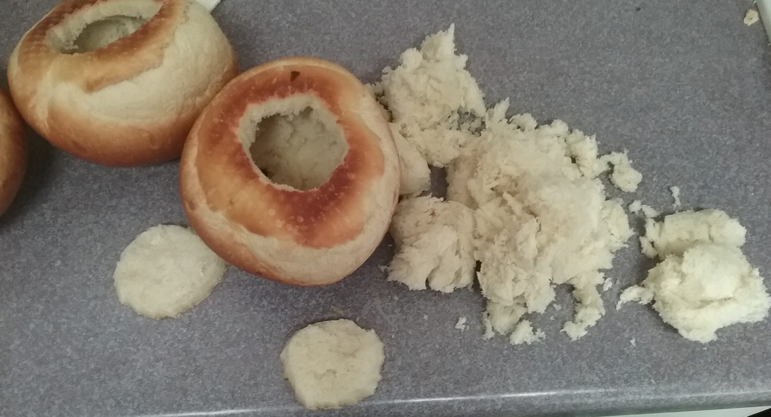
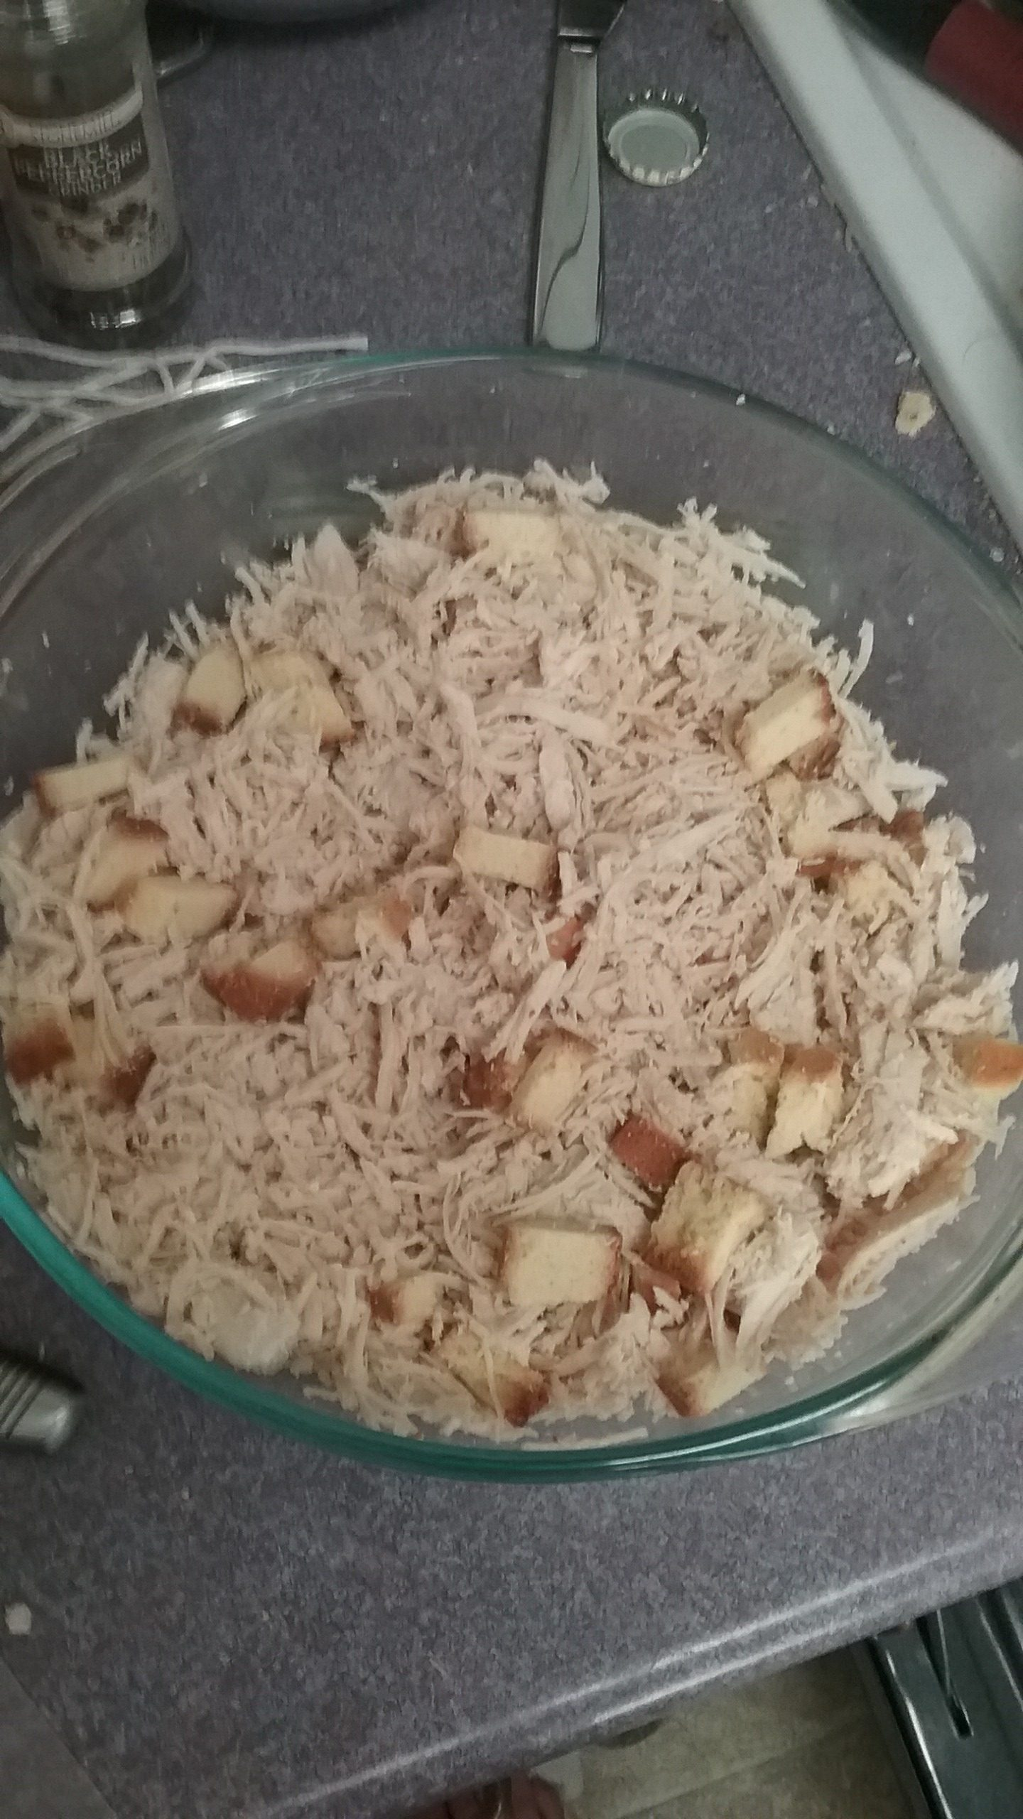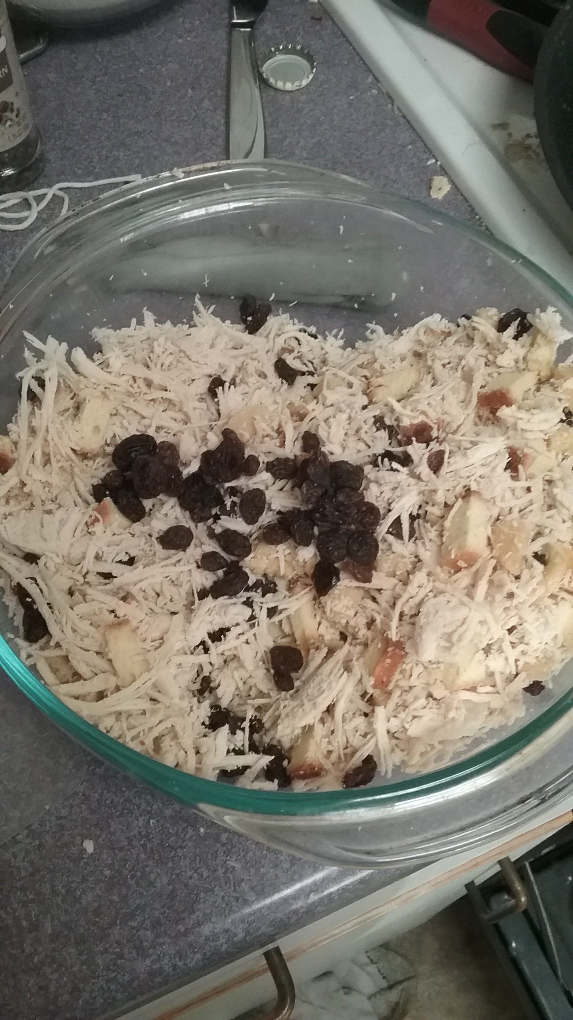
Chicken and biscotti. After adding raisins and marzipan.

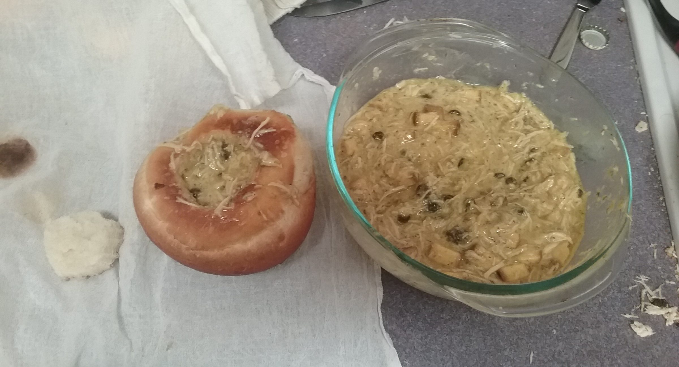
"...everything mixed with...fine herbs, raw eggs..."

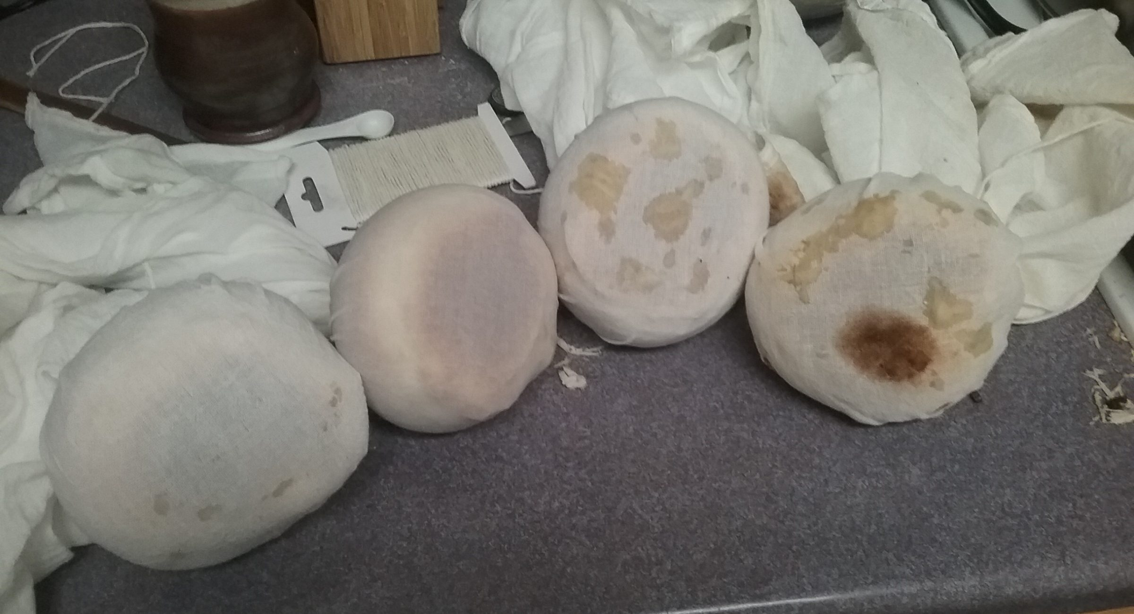
Loaves wrapped in thin, open cloth for boiling. The dark brown mark on the rightmost is from a previous batch.

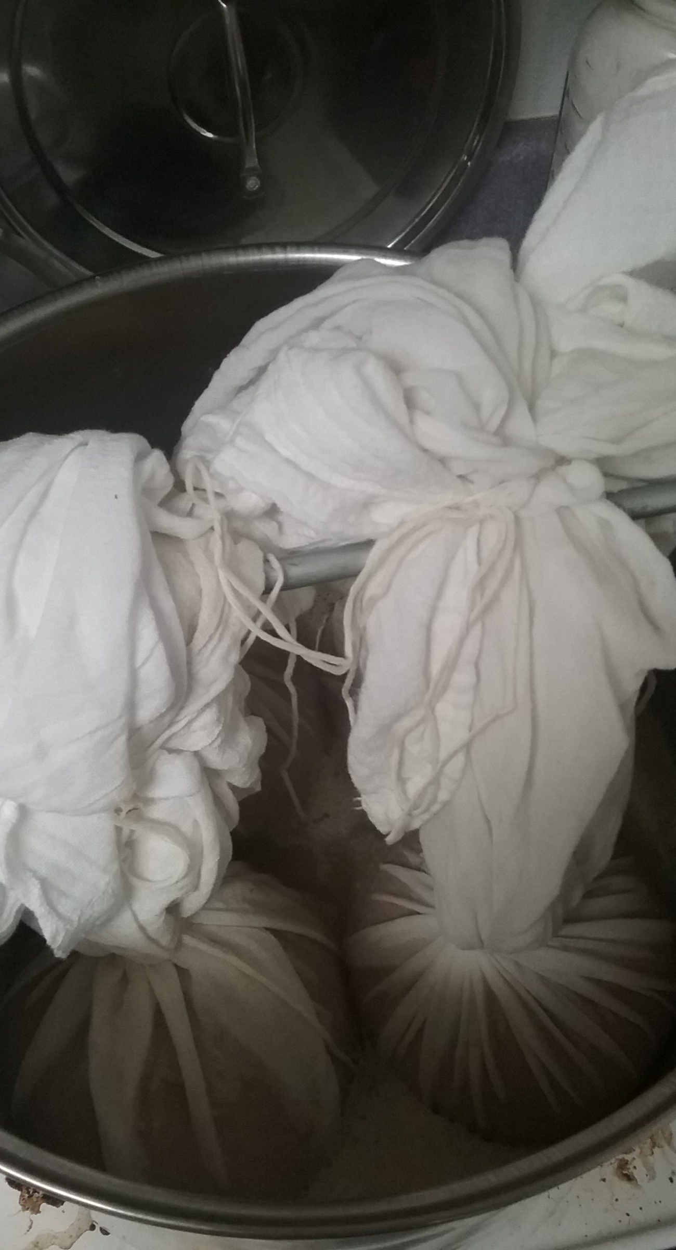
Boiling the loaves in chicken broth.

INGREDIENTS

Short of the omission of the hard-boiled egg yolks for personal taste, the saffron because of cost, and the cinnamon due to absentmindedness, the ingredients are true to Scappi's text.

Because of how I made the stuffing, I did not pre-measure anything, the seasoning was done by eye. Once the stuffing looked good, I considered it finished.

One additional step I took was to put the loaves in the oven for a time after the boil. This was done to add some rigidity to the loaf itself. If these were to be served immediately, I would omit that step.

TASTE AND RECEPTION

The taste of the loaves is a strange, yet pleasant blend of sweet and savory. The herbs help soften the edge of the sweetness, while those sweet flavors provide a strong contrast to the savory.

Those that tried it had similar thoughts, but the overall reception of the dish was positive.

With the "bread bowl"-sized loaves, each would provide a decent meal for about 2 people, 3~4 if there was more provided.

While the flavor profile is a bit foreign to some, it does well to encapsulate the ways food was flavored in the late Middle Ages. Considering that, it would be a very accessible entry point for those who may be wary of medieval cookery.

------
Copyright 2018 by Ethan Taylor. <tanaka.ujimori at gmail.com>. Permission is granted for republication in SCA-related publications, provided the author is credited. Addresses change, but a reasonable attempt should be made to ensure that the author is notified of the publication and if possible receives a copy.

If this article is reprinted in a publication, please place a notice in the publication that you found this article in the Florilegium. I would also appreciate an email to myself, so that I can track which articles are being reprinted. Thanks. -Stefan.

<the end>

