Exotc-Tharid-art - 3/19/17

"The Exotic Tharīd of Ibn Sayyār al-Warrāq" by Magister Galefridus Peregrinus, OP. Fancy Sops. Bread soaked in a meat broth.

NOTE: See also the files: sops-msg, murri-msg, Murri-Project-art, stews-bruets-msg, pomegranates-msg, ovens-msg, chickpeas-msg, goat-msg. lamb-mutton-msg.

************************************************************************
NOTICE -

This article was added to this set of files, called Stefan's Florilegium, with the permission of the author.

These files are available on the Internet at: http://www.florilegium.org

Copyright to the contents of this file remains with the author or translator.

While the author will likely give permission for this work to be reprinted in SCA type publications, please check with the author first or check for any permissions granted at the end of this file.

Thank you,
Mark S. Harris...AKA:..Stefan li Rous
stefan at florilegium.org
************************************************************************

The Exotic Tharīd of Ibn Sayyār al-Warrāq
by Magister Galefridus Peregrinus, OP

A tharīd in its most basic form is simple dish: bread soaked in a meat broth. According to several references in the Ḥadith, it was reputed to be the Prophet's favorite dish (e.g., Ṣaḥīḥ al-Bukhārī: v. 7, 65: 329-331). Numerous tharīd recipes appear throughout the cookbook corpus of medieval Islam, several of which I have prepared. None of the many tharīd recipes I have examined are of the basic bread and broth variety; all of them are substantial meat or poultry stews. This particularly recipe, one of twelve listed in al-Warrāq's chapter on the dish, is interesting because of its use of fruit extracts as the primary means of enhancing the flavor. The recipe includes only two additional ingredients that enhance the flavor (cilantro and onion), and uses neither salt nor murrī, both of which are nearly ubiquitous in other tharīd recipes. Rather, the cook is directed to sprinkle a bit of sugar over the dish immediately prior to serving. Below is the recipe, taken from Nasrallah's translation of al-Warrāq, Annals of the Caliphs' Kitchens:

Another tharīda, exotic (gharība)
Pound together, pomegranate seeds, zabīb (raisins), and some water. Press the juice [through a strainer] down into a green-glazed bowl (ghadāra) and pour it into a clean pot. Add soaked chickpeas and cilantro.

Wash meat pieces and add them to the pot along with chopped onion. Let the pot cook until meat is done.
Make soft dough ('ajīn raqīq). Put some clarified butter into a washed soapstone pot (burma) and put the prepared dough in it. Cover the pot and bake it in the tannūr until bread is done. Take it out of the pot, lightly strike it with your hand (uḍrubhā) [to break it a little and put it in a bowl]. Ladle the broth and meat all over the bread. Give it a dusting of Sulaymānī* sugar and serve it, God willing.

*Hard sugar candy. In such dishes, it is pounded and used.

Phrases in square brackets are explanatory interpolations by the translator and are not present in the original Arabic. According to Nasrallah's glossary, a "green-glazed bowl" was simply a large deep bowl suitable for both kitchen and table use. I have substituted and ordinary glazed stoneware bowl for this step. A tannūr is a very simple oven, open at the top with coals at the bottom. Such ovens have been used for millennia throughout the Old World. Bread could be baked by placing flattened dough on the inside walls, or (as in this case) in some kind of baking pan placed on a support inside the oven. Usage of this second sort can be closely emulated by an ordinary kitchen oven.

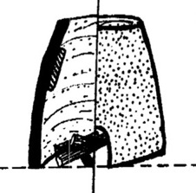
Tannūr oven

Several of the ingredients listed admit to more than one interpretation. The pomegranate seeds could be fresh or dried, and the meat could be lamb or goat. Additional variations are possible with regard to the bread.

Most likely a sourdough, the bread might have been baked into a brittle wafer, breaking easily to pieces when struck, or it could be a firm-crusted loaf, such that the crust would crack easily when struck. The butter in which the bread was baked could be from cows or goats. It is likely that the bread was made with stone ground flour, bolted (i.e., passed through a screen) to remove the bran, since whole grain breads were relatively uncommon in upper-class medieval Islamic cookery.

My initial experiments were with our household sourdough, prepared with commercially available bread flour. I then transitioned a portion of the sourdough to bolted flour, which took several days. Breads in the medieval Islamic world could be made with grains other than wheat, but wheat was the default. The phrase "'ajīn raqīq" literally means "thin dough," so I varied the thickness of the dough from a somewhat thin batter to a very soft and moist dough. The dough was never heavy enough to form a traditional loaf; rather, it would always spread out on the bottom of the pot to form a loaf varying in thickness from ¼ in – 1 in. I ultimately settled on dough the consistency of a thick pancake batter. Photos of the bread baking process are attached.

I have used nearly all of these variations in preparing this tharīd. In my view, the best mix of flavors comes from using fresh pomegranate seeds with goat meat for the stew and goat butter for baking the bread. I also chose to use a thick batter to make a crisp, pancake-like loaf that breaks easily into pieces for lining the bowl. Lamb as the meat also works well, but is not quite as flavorful as the goat. I have prepared the recipe several times on a kitchen range and once using a wood/charcoal fired stove of type common in the Mediterranean during the classical and medieval periods. Images of the tharīd cooking on this stove are attached.

Redacted recipe

Tharīd:
1/2 - 2/3 c dried chickpeas
1/3 - 1/2 c seedless raisins
Arils (seeds) from 1 pomegranate
4 – 5 sprigs fresh cilantro
1 medium large onion, chopped
1 1/2 - 2 lbs lamb or goat meat, cut into chunks
Sugar for final seasoning

Bread (makes two 8" flat loaves):
2/3 c sourdough starter prepared from bolted stone ground whole wheat
2/3 c water
1 c bolted flour
1 – 2 T Clarified goat butter

Prepare the bread in advance. Mix sourdough starter with water and stir, then mix in flour. Cover and set aside to rise until volume doubles. Preheat oven to 450F. Warm the soapstone pots, melt the butter, and add enough to each pot to completely cover the bottom. Add half the dough/batter to each pot, spreading it out to about 8". Cover pots and place in oven, baking for 45 minutes.

Soak chickpeas for at least 8 hours. Bruise and peel the soaked chickpeas (doing so makes them cook faster). Place chickpeas into cooking pot.

Crush raisins on cutting board with back of spoon, place in bowl with 1/2 c water. Place pomegranate seeds in cheesecloth and squeeze juice into bowl with raisins. This process works best if done with several small quantities of seeds. Place squeezed seeds in same bowl and stir. Strain the liquid through cheesecloth into the pot containing the chickpeas. Mince the cilantro into the pot.

Rinse chunks of meat and add to pot with chopped onion. Let cook over medium low heat until chickpeas are done, about 90 minutes. While cooking, make sure enough water is present to just cover the meat.

Line bowl with several pieces of previously prepared bread and ladle tharīd over bread. Sprinkle each bowl with a pinch of sugar.

Reference

Ibn Sayyār al-Warrāq; Nasrallah, N., tr. (2007). Annals of the Caliphs' Kitchens. Leiden: Brill. Recipe is on p. 339

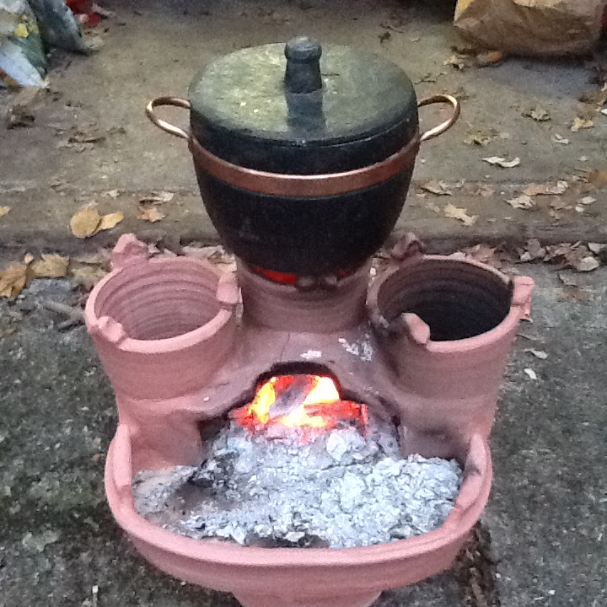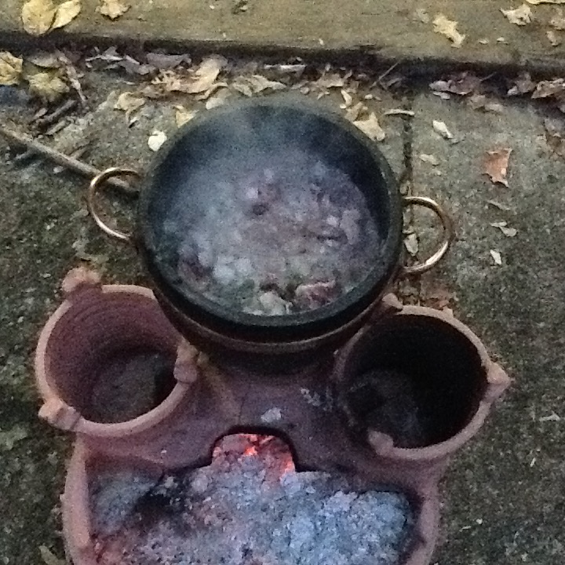
Tharīd cooking on Mediterranean clay stove.

Baking the bread

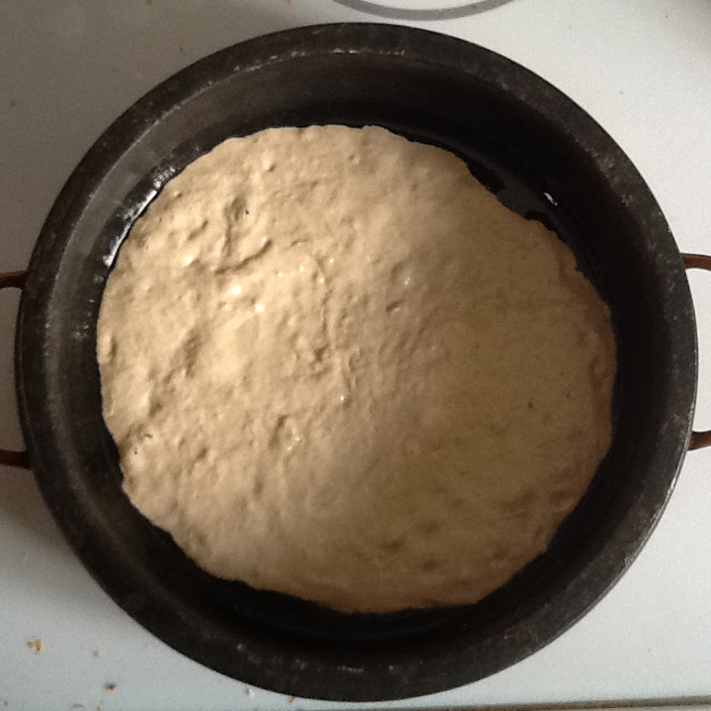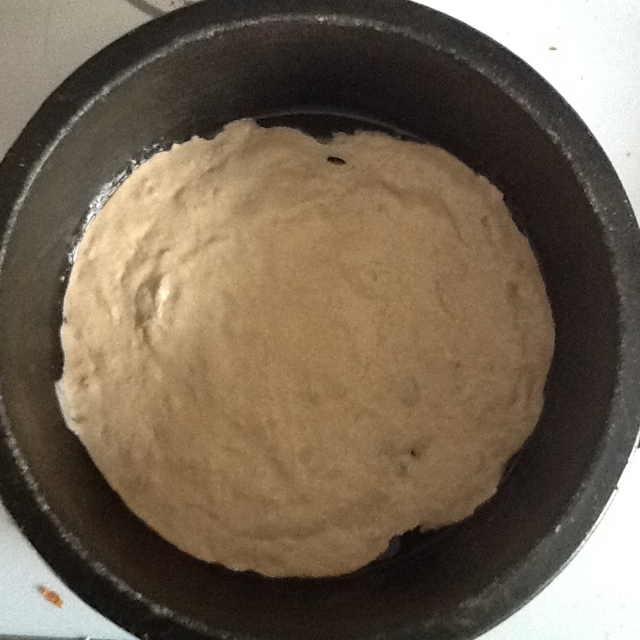
Raw dough in soapstone pots.

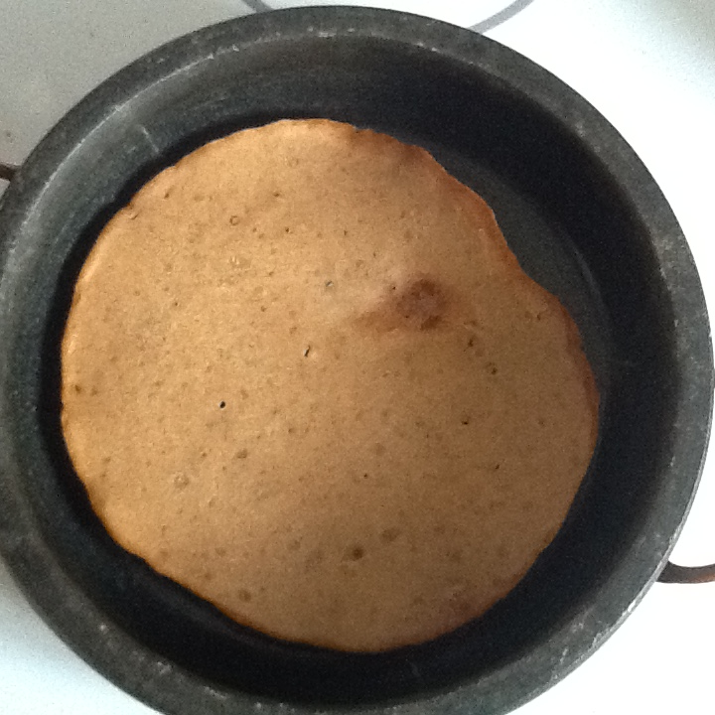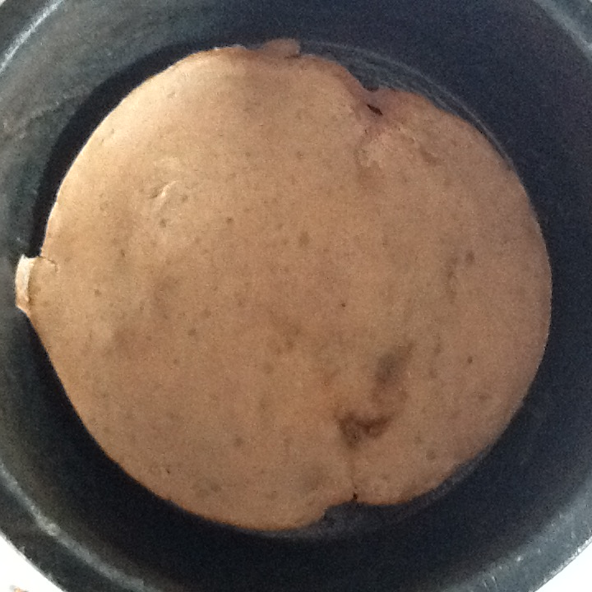
Baked bread in soapstone pots.

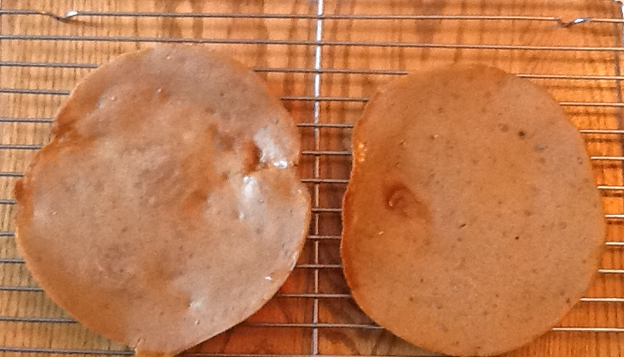
Baked bread, top view.

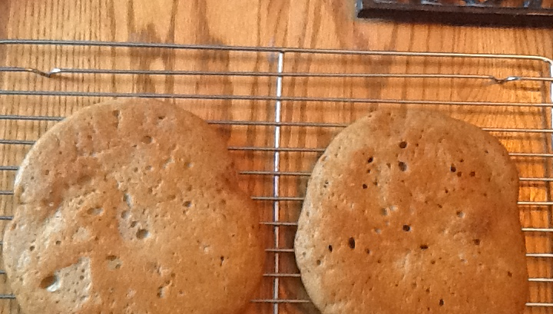
Baked bread, bottom view.
------
Copyright 2016 by Loren D Mendelsohn. 3 Morris Pl, Towaco, NJ 07082. <galefridus at optimum.net>. Permission is granted for republication in SCA-related publications, provided the author is credited. Addresses change, but a reasonable attempt should be made to ensure that the author is notified of the publication and if possible receives a copy.

If this article is reprinted in a publication, please place a notice in the publication that you found this article in the Florilegium. I would also appreciate an email to myself, so that I can track which articles are being reprinted. Thanks. -Stefan.

<the end>

