Norse-Lunch-art - 7/7/17

"Food for War: Lunch for a Norse Persona at Double Wars XXX" by fru Þora Sumarliðadóttir.

NOTE: See also the files: Irish-Vik-fst-art, Icelandic-Fst-art, Picnic-Basket-art, Norse-msg, fd-Norse-msg, stockfish-msg, lamb-mutton-msg, butter-msg.

************************************************************************
NOTICE -

This article was added to this set of files, called Stefan's Florilegium, with the permission of the author.

These files are available on the Internet at: http://www.florilegium.org

Copyright to the contents of this file remains with the author or translator.

While the author will likely give permission for this work to be reprinted in SCA type publications, please check with the author first or check for any permissions granted at the end of this file.

Thank you,
Mark S. Harris...AKA:..Stefan li Rous
stefan at florilegium.org
************************************************************************

You can find more work by this author on her website at:
http://www.morethancod.net

Food for War: Lunch for a Norse Persona
at Double Wars XXX
by fru Þora Sumarliðadóttir

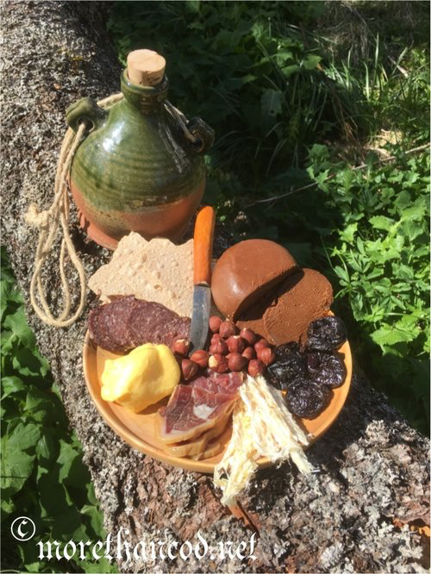
CLOCKWISE FROM KNIFE: BROWN CHEESE, PRUNES, STOCK FISH, FENALÅR (CURED LEG OF MUTTON), BUTTER, REINDEER SAUSAGE, FLAT BREAD, AND HAZELNUTS (CENTER)

This is the other "low-threshold" project I brought to Double Wars. I pulled together a group of food items that would be appropriate for my medieval Norwegian (Norse) persona based on foodway information I have gleaned through the years. The theme is general 'Norwegian', and the sources below reflect a range of time-periods and regions. My persona would have been familiar with these foods, and likely reveled in the abundance and variety available to her for lunching at DW. The following criteria guided the food selection:

- easily accessible for me (purchase at store)
- stable for camping with little/no cooler available
- allow me to share

The Menu

Brown 'cheese'

Goats were an important part of the Norse dairy culture. This cheese is made locally at Aalan farm solely of goat's whey left after the production of true goat's cheese. The whey is then cooked down and caramelizes in the process, creating brown 'cheese'. This is the older type of brown cheese, as opposed to the newer type created in the 19th C by adding cream back into the whey to make the modern 'fløtemysost.' (Store Norske Leksikon).

Prunes

My modern palate dictates having something sweet to balance the other salty foods on the plate. Lingon berries and low-bush blueberries are common here in Lofoten, but are sour and hard when only air dried. Plums have been found in the archaeological record around Bergen in 15th-17th C (Hjelle in Karg, 2007, p. 169). I have used commercially available pitted prunes, and air-dried them for an additional week. This further reduced the water content of a 'soft' prune to one that will withstand travel.

Stock fish

Stock fish (dried cod) was a central commodity for Northern Norway, with the market at Vágar at its center. For my travel food, I have taken inspiration from the report written by Italian Pietro Querini after his ship wreck off of Røst in Lofoten in 1432. He commented that the stock fish was first beaten until 'fibrous', then eaten with butter and spices (Knutsen, 1993, p.32). Interestingly, an Icelandic friend informs me that this is how they enjoy stock fish to this day.

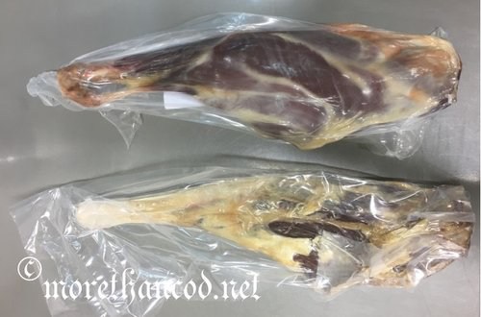
MODERN "WHITE SHEEP" (ABOVE) VS. OLD NORSE SHEEP (BELOW)

Fenalår (cured leg of mutton)

Old Norse sheep, also called Villsau and Northern Short-Tail, are the oldest domesticated breed. There has been an increased interest in the breed, and I was delighted to find fenalår (dried, salted leg) of this breed available in the store. The leg I took to DW was of this breed, however when I needed to purchase more to create the photo above, it was no longer available. On the above plate is fenalår of modern White Sheep. This is easily seen by the presence of more fat around and in the muscle than was present in the Old Norse. The so-called White Sheep have been 'improved' through cross-breading to create heavier, meatier lambs. Look at the photograph of the two legs of lamb– they are approximately of same length, so the animals are of a similar height. However, the Old Norse lamb is slender, a lighter, 'leggier' lamb, and much more agile for moving around in the mountains.

From experience, fenalår keeps best when kept cool and allowed to 'breathe' rather than be kept in plastic. I sewed a bag of coarse linen for protection, then hung it in the cross-draft on the end of my bed. In the first picture (upper right), contours of the water jug and fenalår can be seen hanging from the near end of the bed.

Butter

References to butter can be found throughout the Norse cultural region and timeframe. One example is from Querini (above), another in the payment of church tax in the form of goods, such as butter (Jørgensen, 1997, p. XVIII).

Reindeer sausage

Semi-domesticated reindeer were a resource available in Northern Norway. Reindeer sausage provided some tasty variation to this lunch menu.

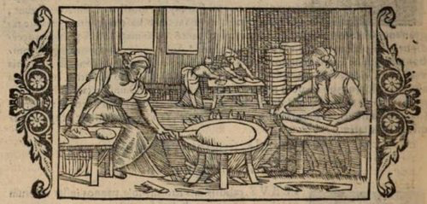
OLAUS MAGNUS (1555)- BAKING FLATBREAD

Flat bread

I opted for a true flatbread, with high rye content. Rye is a commodity in Bergen, certainly from the 12th C on, though the archaeobotanical/pollen records perhaps indicate that it was not an important domestic crop during this period (Hjelle in Karg, 2007, p. 169). Average temperatures and length of season locally in Bø in Vesterålen, just north of Lofoten, suggest that even the hardier barley and oats could be difficult to bring to maturity (Remen, 1983, pp. 9-10), so imported grain would be important.

Ulltveit suggests that the shift from daily baking of bread over the fire to production of shelf-stable flatbread came with the shift from hand querns to small water-driven querns in the 13th-14th C. (2000, pp. 92-93). There may be a case for pushing this date earlier in light of archaeological finds from Oslo (Ulltveit, 2000. p. 92) and Bergen (Tengesdal).

Hazelnuts

Hazelnuts are native to Norway, and the shells are the most commonly found plant food remains in prehistoric and medieval contexts, and were even an export commodity (Hjelle in Karg, 2007, p. 171). Hazelnuts are also present in the digs from Vágar (unpub.). Walnuts could have been another documentable option (Hjelle in Karg, 2007, p. 171).

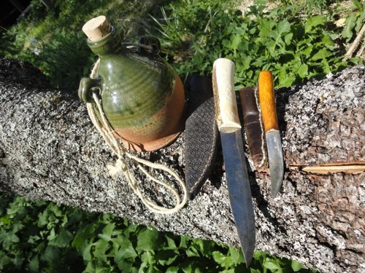
WATER COSTREL, KITCHEN KNIFE, PERSONAL EATING KNIFE (LEFT TO RIGHT)

Equipment

My kit is minimal and functional. I have two knives, the largest with a bone handle was a purchase at my first Double Wars in 1996, serves as my 'kitchen' knife for serving. The smaller is my personal knife, used when cutting my food or buttering flatbread. I keep water in this jug, a costrel in a general style for England/Northern France/Low Countries for 14th-17th C. It was made by Robert Van Rens (Magister Eadric the Potter). Not shown is the linen wax cloth, a commercially produced tablecloth sold by the yard, used to wrap the different foods between meals.

Conclusions

I definitely achieved my goal of creating a tasty lunch for myself, with plenty to share. The fenalår of lamb was especially well received. The linen bag for the fenalår worked well, as did the wax cloth storage for the other food items. I do need to think through a better means of transporting all of the food items as a unit. Something like a basket would have been nice, keeping everything organized as I transported everything from my tent to the day's lunch locale. The fenalår was particularly unwieldly, but absolutely worth the bother.

I have purchased these items at my local grocery store– a great luxury to be living in persona's area. I will continue to pursue foodways and gather more documentation for the next iteration of this travel food project.

Sources:

- Jørgensen, J. G. Aslak Bolts jordebok. Oslo: Riksarkivet. 1997. ISBN: 82-548-0052-9.
- Karg, Sabine, ed. Medieval Food Traditions in Northern Europe. Publications from the National Museum, Studies in archaeology & history, vol. 12. Copenhagen: National Museum of Denmark, 2007. ISBN: 978-87-7602-065-1. In particular, ch. 7, Foreign trade and local production - plant remains from medieval times in Norway / Kari Loe Hjelle.
- Knutsen, Nils M., red. «Mørkets og kuldens rike: Tekster i tusen år om Nord-Norge og nordlendingene.» Tromsø: Cassiopeia Forlag, 1993. ISBN: 82-992199-2-2
- Remen, Geir. Ødetida I Bø og Øksnes: Bosetningshistoria fra Høgmiddelalderen til ca. 1610. Hovedoppgave i Historie. Tromsø: 1983.
- Ottesen, Preben. "Brunost" I Store norske leksikon. (https://snl.no/brunost) accessed 01.07.2017.
- Tengesdal, Sigrun Solbakken. Steikeheller– en del av middelalderens hverdagsliv på Bryggen (http://prosjektbryggen.no/skattkammeret/steikeheller/) accessed 01.07.2017.
- Ulltveit, Gudrun. Korn- og baketradisjoner: Kornets og bakingens kulturhistorie i Norge. Oslo: N. W. Damm & Søn AS, 2000. ISBN: 82-512-0546-8.

External online resources:

- Norsk Villsaulag– Old Norse Sheep breed organization (http://www.villsau.no/)
- Robert Van Rens can be reached on Face Book (https://www.facebook.com/thatpotteryguy/).
- Aalan gård (http://aalan.no/category/ost/brun-geitost/)

Image from Olaus, Magnus. Historia de gentibus septentrionalibus, earumque diversis statibus, conditionibus, moribus, ritibus ... necnon universis pene animalibus in Septentrione degentibus, eorumque natura. Rome: Giovanni M. Viotto, 1555. p. 442. Accessed July 01, 2017. (https://books.google.no/books?id=O9lEAAAAcAAJ&dq=inauthor:%22Olaus+Magnus%22&pg=PP5&redir_esc=y&hl=no#v=onepage&q&f=false)
------
Copyright 2017 by Rachel Steffensen. <medievalcod at gmail dot com>. Permission is granted for republication in SCA-related publications, provided the author is credited. Addresses change, but a reasonable attempt should be made to ensure that the author is notified of the publication and if possible receives a copy.

If this article is reprinted in a publication, please place a notice in the publication that you found this article in the Florilegium. I would also appreciate an email to myself, so that I can track which articles are being reprinted. Thanks. -Stefan.

<the end>

