Game-History-art - 8/31/14

"Is This Game Period?" by THL Dagonell Collingwood of Emerald Lake.

NOTE: See also these files: games-msg, games-cards-msg, sports-msg, Hopscotch-art, Curling-art, wintr-sports-lnks, Horseshoes-art, Hazard-Craps-art, Dwyle-Flonkng-art, Horseshoes-art.

************************************************************************
NOTICE -

This article was submitted to me by the author for inclusion in this set of files, called Stefan's Florilegium.

These files are available on the Internet at: http://www.florilegium.org

Copyright to the contents of this file remains with the author or translator.

While the author will likely give permission for this work to be reprinted in SCA type publications, please check with the author first or check for any permissions granted at the end of this file.

Thank you,
Mark S. Harris...AKA:..Stefan li Rous
stefan at florilegium.org
************************************************************************

NOTE – This article was first published "Ice Dragon", the newsletter for the Barony of Rhydderich Hael.

Is This Game Period?
by THFool* Dagonell the Juggler

* -- As a court jester, I refused to answer to the title of "The Honorable Lord". The royal herald called me into court as "The Honorable Fool" I pointed out that since it had been used in Royal Court and I acknowledged it, it was official. My friends decided that my correct form of address was "Your Foolishness". :)

One of my main interests in the SCA is medieval pastimes. I often get asked whether this game or that game is period. I've compiled a list of common games along with a brief history of its origins.

I've included a few games which I don't get asked about because they're actually in period, even though most people assume they're modern.

Backgammon
Backgammon boards from an Iranian excavation have been dated back to around 3000 BC. Ancient Romans played the game as well, calling it Tabula or 'table'. It's mentioned in a 5th century BC epigram of Byzantine Emperor Zeno. Jeux de tables or 'Game of Tables' appears in 11th century France. In 1254, Louis IX issued a decree prohibiting his soldiers from playing games until their archery scores improved. Backgammon was included in the list of forbidden games. The Spanish Alfonso X manuscript Libro de los Juegos (The Book of Games, 1283) includes rules for many board games including Backgammon. For more information, see
http://en.wikipedia.org/wiki/Backgammon#History.

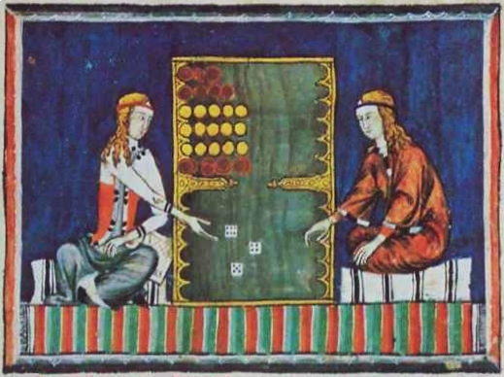
Backgammon illustration from Libro de los Jeugos
(The Book of Games, 1283) commissioned by Alfonso X of Castile

Baseball
It's difficult to document the evolution of ball-and-bat games. A game called Stoolball was played using a bat, a ball and two bases in the 14th century. An illumination from The Romance of Alexander (1344) shows monks and nuns playing a baseball-like game. Scholars believe that both Cricket and Rounders evolved from Stoolball and Modern Baseball evolved from English Rounders. The earliest written reference to Baseball is in a 1744 publication called A Little Pretty Pocket-Book which describes a game with two teams scoring and fielding and striking a ball with a bat and then running around four bases to score. See also Cricket. For more information, see
http://en.wikipedia.org/wiki/Baseball#History.

Basketball
Invented by James Naismith, a YMCA gym teacher, in December 1891 in Springfield Masachusetts. He was trying to invent a game to be played indoors, that would keep his students fit through long New England winters. For more information, see http://en.wikipedia.org/wiki/Basketball#History.

Billiards
Billiards evolved from various outdoor stick and ball games. Percivile Winkle created the game as a ground sport in 1340, it was highly reminiscent of croquet. King Louis XI of France owned the first indoor billiard table. Louis XIV popularized the table version with the French nobility. When Mary, Queen of Scots was executed, her body was covered with a billiard table cover from the palace. By mid-17th century, the ground version had died out in favor of croquet and only the table top version remaind. George Cotton mentions the game in his book The Compleat Gamester which was published in 1674. For more information, see http://en.wikipedia.org/wiki/Billiards#History.

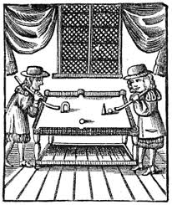
"The Billiard Table" from The Compleat Gamester by George Cotton, 1674

Bocce
Oribase, a Greek physician around 300 AD wrote of a game played by throwing balls at a stationary target. Although he did not give a name to the game, the rules are nearly identical to the French game of Jeu de Boules. It is believed that the game spread across Europe because the soldiers of the Roman Empire played the Italian version, Bocce, for entertainment and exercise. For more
information, see http://www-cs.canisius.edu/~salley/SCA/Games/boules.html.

Bowling
In 1936, British anthropologist Sir Flinders Petrie found a bowling ball and pins in a child's grave in Egypt, dating back to 3200 BC, which would make the game of bowling over 5,000 years old. However, a German historian named William Pehle, asserted that bowling began in Germany around 300 AD. For more information, see: http://www-cs.canisius.edu/~salley/SCA/Games/bowling.html.

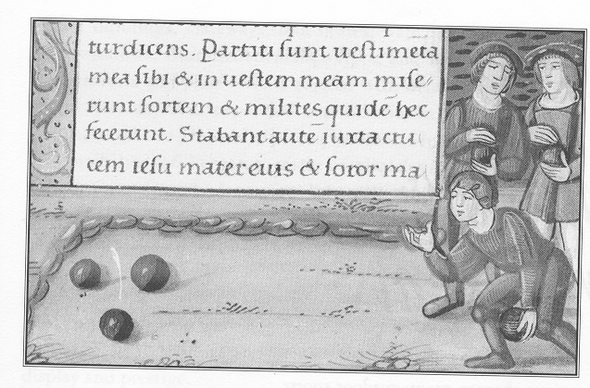
Feather-bowling (Bodleian Library, Oxford, Ms. Douce, 275, f. r12)

Cathedral
The game was developed after 1962 by Robert Moore, a pilot who could see from the air the way Christchurch Cathedral and neighboring building intricately fitted together. He sold the rights to Brightway Products in 1979. For more information, see
http://en.wikipedia.org/wiki/Cathedral_(board_game)#History.

Checkers
Medieval soldiers on the crusades learned to play the Arabic game of Alquerques. When they returned home, they attempted to play the game on a standard chessboard rather than an alquerques board and invented checkers. Checkers is mentioned in Chronique by Philip Mouskat, a Southern French manuscript which dates to 1243 A.D. For more information, see: http://www-cs.canisius.edu/~salley/SCA/Games/alquerques.html.

Chess
Chess is a board game that evolved from Indian and Persian board games of the 5th and 6th centuries. The Spanish Alfonso X manuscript Libro de los Juegos (The Book of Games, 1283) contains multiple chess problems to solve. The definitive book on the subject is HR Murray's
$300, 900 page book, The History of Chess first published in 1913. By comparison, his other publication A History of Boardgames Other than Chess is a mere 280 pages and available for about $100. For more information, see http://en.wikipedia.org/wiki/Timeline_of_chess.

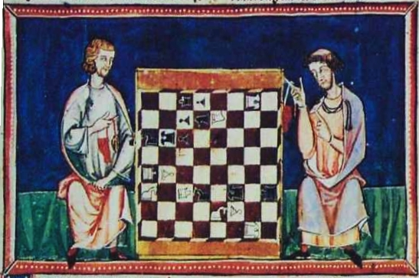
Chess Problem #35 from Libro de los Juegos (The Book of Games, 1283)
commissioned by Alfonso X of Castile

Chinese Checkers
In 1883, while at Harvard, George Howard Monks invented a board game called Halma from the Greek word for 'jump'. It's essentially Chinese checkers on a 16 x16 checkerboard. It was for two (19 pieces) or four (13 pieces) players. The modern board for up to six players was invented in Germany in 1892 and was called Stern Halma, Stern being the German word for 'star'. In 1928, the game was marketed in the United States by Jack and Bill Pressman. The name 'Chinese Checkers' was a marketing scheme designed to make the game more exotic, despite the fact that the game is neither Chinese (American invention) nor Checkers (jumped pieces are not removed from the board). For more information, see http://en.wikipedia.org/wiki/Chinese_checkers#History or
http://en.wikipedia.org/wiki/Halma.

Chutes and Ladders
Snakes and Ladders is an ancient Indian board game as old as Parcheesi. The game made it's way to England and in 1943 Milton Bradley standardized the board and introduced it to the United States as 'Chutes and Ladders'. The imagery of children's playground slides was thought to be more kid-friendly than snakes. For more information, see http://en.wikipedia.org/wiki/Chutes_and_ladders#History.

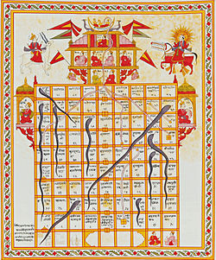
Snakes and Ladders board, gouache on cloth, (India, 19th c.)

Connect Four / Captain's Mistress
Milton Bradley trademarked the game in 1974. Numerous websites state that 'According to legend...' Captain James Cook was allegedly obsessed with the game and his crew dubbed the game "The Captain's Mistress" as a joke. It should be noted that by calling the game 'Captain's Mistress', these same websites can sell you a copy of the game without having to pay royalties to Milton Bradley. If you type "Captain's Mistress game" into Wikipedia it re-directs you to 'Connect Four' but never calls the game by that name. Wikipedia's own entry on Captain Cook fails to mention the game. I have read multiple books on the voyages of Captain Cook, none of them mention the game. Captain Cook's voyages were from 1768-1771, 1772-1775 and 1776-1779, so even if the legends were true, the game is out-of-period. For more information, see http://en.wikipedia.org/wiki/Connect_Four.

Craps
Craps is a simplification of an earlier dice game called Hazard. Sir William of Tyre claimed that he and his fellow knights invented the game of Hazard during the crusades under Charlemagne. They did it to pass the time while laying siege to the castle of Hazarth in 1125. This would imply that the game is named after the castle. The Encyclopedia Britannica however, states that game takes its name from the Arabic words 'al zar', which means simply, 'the dice'. Geoffrey Chaucer makes frequent mention of the game in his Canterbury Tales as an analogy for life, with runs of both good and bad luck. For more information, see: http://www-cs.canisius.edu/~salley/SCA/Games/hazard.html.

Cricket
It's difficult to document the evolution of ball-and-bat games. A game called Stoolball was played using a bat, a ball and two bases in the 14th century. An illumination from The Romance of Alexander (1344) shows monks and nuns playing this game. Scholars believe that both Cricket and Rounders evolved from Stoolball. Prince Edward, son of Edward I (Longshanks) played a game called 'creag' in Kent in 1301. Some speculate that Creag was a form of cricket. The earliest written reference to cricket is in a 1598 court document. For more information, see
http://en.wikipedia.org/wiki/Cricket#History or http://en.wikipedia.org/wiki/Rounders#History or
http://en.wikipedia.org/wiki/Stoolball#History or http://slumberland.org/sca/articles/stoolball.html.

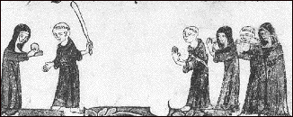
Stoolball illustration from The Romance of Alexander, 1344

Croquet
The 19th century English game evolved from the 17th century Italian game of Pall-Mall (which translates as 'Ball-Mallet'), which in turn derived from the 15th century French game Jeu de Mail ('Game of Mallets'). All are remarkably similar. Jeu de Mail, additionally, may be the fore-runner to Ground Billiards which eventually became our modern tabletop Billiards. For more information,
see http://en.wikipedia.org/wiki/Croquet#History or http://en.wikipedia.org/wiki/Jeu_de_mail or
http://en.wikipedia.org/wiki/Paille_maille.

Curling
Both Scotland and Central Europe claim to have invented the sport. Curling stones dated 1511 and 1551 were found when a Scottish loch was drained. The Dutch painter Pieter Bruegel painted 'Winter Landscape with Skaters and a Birdtrap' in 1565 which shows skaters playing Eisschiessen, an early form of the game. For more information, see
http://www-cs.canisius.edu/~salley/SCA/Games/curling.html

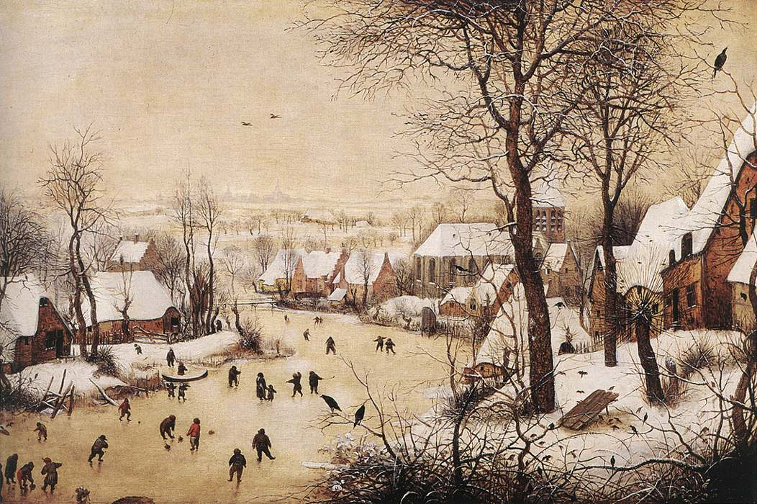
'Winter Landscape with Skaters and a Birdtrap' by Pieter Brueghel (1565)

Darts
Darts may have started with bored off-duty soldiers throwing short arrows or quarrels at the bottom of an old cask or the cross section of a fallen tree. The rings of the tree would have provided the scoring rings of the dartboard. As ancient wood dried, it would have developed cracks, dividing the dartboard into 'sections' . The standard numbered designed was not created until 1896. For more information, see http://en.wikipedia.org/wiki/Darts#History.

Dice
Dice pre-date recorded history. The oldest known dice were found in an archelogical site in Iran. Dice were originally made from the 'knucklebones' of a hoofed animal but were also made from ivory, wood and in modern times, plastic. The Romans were passionate gamblers and often diced during Saturnalia, the winter equinox festival. The bible mentions roman soldiers playing dice at the foot of the cross. For more information, see http://en.wikipedia.org/wiki/Dice or
http://www-cs.canisius.edu/~salley/SCA/Games/knucklebones.html.

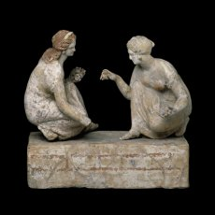 | 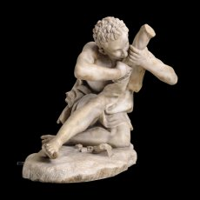
Sculpture of two girls playing dice,  (Greek, c. 330 BC), British Museum | Sculpture of two boys fighting over dice,  (Roman, c. 1st cent. AD), British Museum

Dolls
There have been dolls for as long as there have been children. We find wooden dolls with beaded strings of hair in Egyptian graves from the third millenium B.C. and passing references to little girls making doll clothes in Greek literature. Interestingly, from the 1300's on, dolls were the primary means of spreading French and English fashion designs throughoout the rest of the world. Dolls wearing the latest dresses were sent to local tailors who re-created full-size copies for their clients. This practice continued until the 1700's and the invention of color printing plates. For more information, see: http://www-cs.canisius.edu/~salley/SCA/Games/dolls.html.

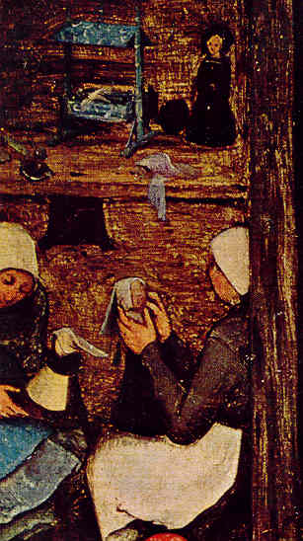
Pieter Brueghel's painting 'Children's Games', (1560, detail)

Dominoes
The oldest known dominoes were found in King Tut's tomb, which date them to Egypt's 18th dynasty (1355 BC). Each tile represents a single throw with a pair of dice, each half corresponding to the pips on one die. However, the game does not go over to Europe until the 18th century. The European style of dominoes adds seven tiles, pairing up a blank half tile with pips for one through six and adding a double-blank tile. For more information, see http://en.wikipedia.org/wiki/Dominoes#History.

Football
Medieval football was called 'Gameball', `game' being the Old English word for fight or battle. The rules were much simpler ... there weren't any! First team to get the ball into their opposing team's goal, wins. The ancient Greeks and Romans played "Harpastum", a game which combines elements of Soccer, Rugby and American Football. The Romans imported this game into England during the time of Julius Caesar; however it wasn't until the Middle Ages that the game really caught on. The ball was a pig's bladder, at first stuffed with dried peas and later inflated with air. We still refer to a football as a 'pigskin' even today, when modern footballs are made from cowhide. For more information, see http://www-cs.canisius.edu/~salley/SCA/Games/football.html.

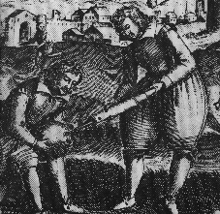
Woodcut of a football being inflated from The Sports and
Pastimes of the People of England by Joseph Strutt, (1801)

Frisbee
The Frisbe (only one 'e') Pie Company was founded in Bridgeport, Connecticut in 1871. They were suppliers to Yale University. Local children and college students discovered that an empty inverted pie tin would fly short distances and used them to 'play tag'. The objective was to hit your opponent with a pie tin without being struck by the other pie tins flying around. The 'modern' frisbee was invented in 1948 by Walter Frederick Morrison who sold the rights to the Wham-O corporation in 1957. Wham-O has trademarked the name and says that the generic term is 'flying disc'. For more information, see http://en.wikipedia.org/wiki/Frisbee#History.

Great Dalmuti
First published by Wizards of the Coast in 1995. It's actually a commercialized, non-standard-deck version of a card game called @$$h*le which Wikipedia says goes back to the late Middle Ages. @$$h*le is usually played as a drinking game and is based on Dai Hin Min, a similar, earlier Japanese card-game where the objective is to be the first player to discard all of your cards. For more information, see http://en.wikipedia.org/wiki/Great_Dalmuti.

Handball
Handball was brought to America by Irish immigrants. Early European references include King James I of Scotland who ordered a cellar window sealed up in 1427 as it was interfering with his play. Town statutes of Galway in 1527 forbid the playing of the game against town walls. For more information, see http://en.wikipedia.org/wiki/Gaelic_handball#History.

Hobby Horse
A child's toy consisting of an imitation horse's head (traditionally carved wood or stuffed fabric) on a stick which the child straddles as he pretends to ride a horse. The toy was made in imitation of a type of Morris dancer where the dancer wears a decorated wire framework around his waist to suggest that he is riding a horse. The actual origins of the Morris dance are lost in antiquity, however the most common theory is that it was based on the Morisco dance of the Spanish Moors and brought to England around 1360 A.D by John of Gaunt, the brother of Edward the Black Prince. For more information, see http://en.wikipedia.org/wiki/Hobby_horse or
http://www-cs.canisius.edu/~salley/SCA/Games/maypole.html or
http://www-cs.canisius.edu/~salley/SCA/Games/morris.html.

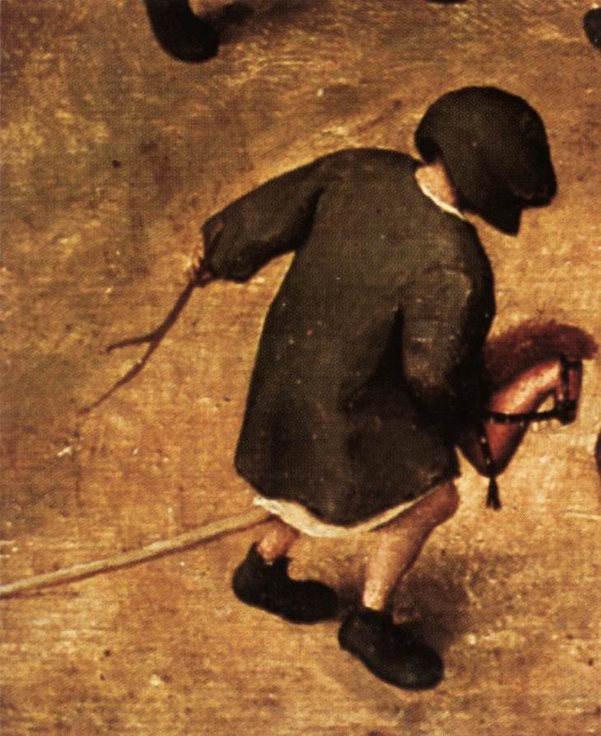
Pieter Brueghel's painting 'Children's Games', (1560, detail)

Hopscotch
Invented by ancient Roman children in imitation of Roman soldiers in training. For more details see: http://www-cs.canisius.edu/~salley/SCA/Games/hopscotch.html

Horseshoes
The National Horseshoe Pitchers Association says that the game of horseshoes dates back to the Roman empire. The game may have started with blacksmith's children playing with old worn out and cast off shoes. For more information, see:
http://www-cs.canisius.edu/~salley/SCA/Games/horseshoes.html

Hula Hoop
Manufactured by Wham-O corporation in 1957, based on historical Australian bamboo exercise hoops. For more information, see http://en.wikipedia.org/wiki/Hula_hoop

Jacks / Knucklebones
The game originated simultaneously in both Ancient Greece and Rome. It was originally played with the ankle bones of a sheep, hence the name 'knucklebones'. For more information, see
http://en.wikipedia.org/wiki/Jacks or http://en.wikipedia.org/wiki/Knucklebones or
http://www-cs.canisius.edu/~salley/SCA/Games/knucklebones.html.

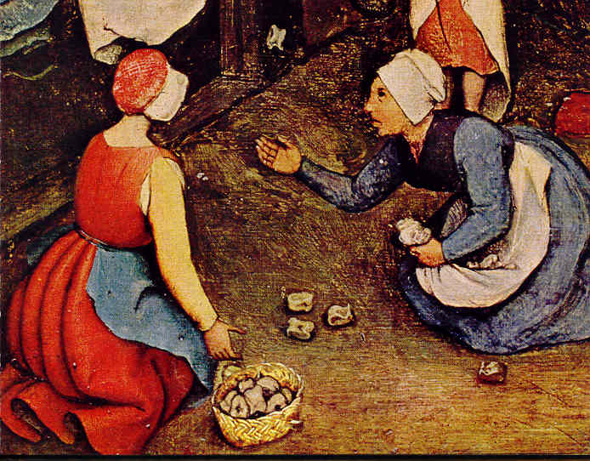
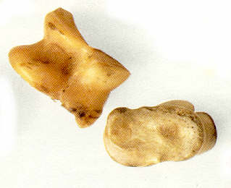
Pieter Brueghel's painting "Children's Games", (1560, detail) Sheep's 'knucklebones'

Kites
It is generally believed that kites were invented 2,800 years ago in China. Silk not only provided the fabric for sailing material, but also a high-tensile-strength cord for flying line. Bamboo provided a strong lightweight framework. By 550 AD, paper kites were being flown. Ancient
Chinese documents indicate kites were used to measure distances and wind speed, lift weights, and signal during military operations. Although windsocks were used during the Roman Empire, it's believed that Marco Polo brought kites to Europe in the late 13th century. For more information, see http://en.wikipedia.org/wiki/Kite#History.

Ladder Golf
The game was invented in the late 20th century. It is known by a variety of names including Ladder Toss, Rat King, Hillbilly Golf, Dangle Ball, etc. To play the game two 'ladders' of three rungs each are set an agreed upon distance apart. Each team had three bolos made from two golf balls roped together. Teams take turns tossing their bolos at the ladders to get the bolos to wrap around a rung for points. Rungs are either 1 point each or 3, 2, and 1 points in either ascending or descending order. Game is to 21 points. Some players play that a bolo on each rung is an additional 10 points. For more information, see http://en.wikipedia.org/wiki/Ladder_toss

Mancala
Mancala boards have been found carved into temple roofs in Memphis, Thebes, and Luxor, indicating the game was played in Egypt as early as 1400 B.C.E. It wasn't known in Europe until the 17th century. The earliest printed European reference is from Golden Trade by Richard Jobson in 1623. For more information, see:
http://www-cs.canisius.edu/~salley/SCA/Games/MancalaXArticle.doc

Marbles
Marbles predate recorded history. Not only have marbles been found in Egyptian tombs as well as Greek and Roman excavations, but also in archaeological digs dating back to the Ice Age on every continent. The Roman poet Ovid mentions marbles. According to Encyclopedia Britannica, Augustus Caesar played with marbles as a child. For more information, see:
http://www-cs.canisius.edu/~salley/SCA/Games/MarblesXArticle.doc

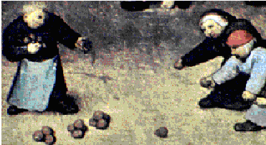
Pieter Brueghel painting "Children's Games", (1560, detail)

Maypoles
The ancient druids of Britain celebrated Beltane around May first. It was actually celebrated on the cross-quarter day, which is the day exactly between Spring Equinox, the day when day and night are exactly equal, and Summer Soltice, the longest day and shortest night of the year. When the Romans occupied the British Isles, they celebrated the five-day feast of Floralia, from April twenty-eighth to May second, in honor of Flora, the Roman goddess of flowers. By the fourteenth century, various aspects of the two celebrations have combined and villages in Southern England are celebrating a spring festival on May first and dancing around the tallest tree in the village or a pole festooned with flowers and ribbons in the village square. Chaucer makes mention of a maypole in his writings. Maypole dancing was outlawed during the Reformation. The festivals were un-Godly with mixed gender dancing, flirting, drinking of alcohol and general merry-making. They were re-instated during the Restoration by Queen Mary and Queen Elizabeth, who both liked them. While the dancing around the May pole was usually a country-style dance with men and women weaving in and out among each other, the concept of holding ribbons and winding them around the pole while dancing is actually post-period. A playwright named J.T.Harris wrote 'Richard Plantagenet' in 1836. One of the scenes had a maypole with long ribbons on stage and the dancers wove the ribbons as they danced. The fad caught on and soon every village was dancing with ribbons around the maypole. The maypole dance was usually done by adults. It isn't until the 1930's that it becomes known as a children's activity. For more information, see http://www-cs.canisius.edu/~salley/SCA/Games/maypole.html.

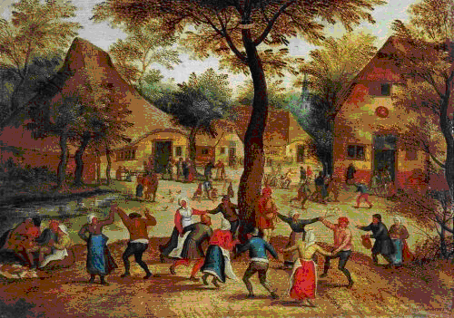 | 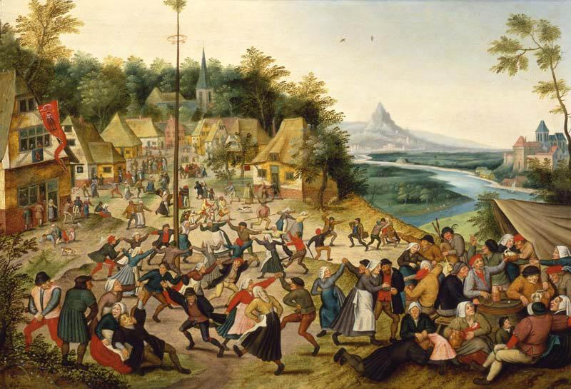
'Village Scene with Dance around the May Pole' by Pieter Brueghel (1634) | 'Dance around the May Pole'  by Pieter Brueghel (1634)

Parcheesi
The name is an Americanization of the Indian (not Native American, from the country of India) game Pachisi. It dates as far back as 500 AD and was often referred to as The Royal Game of India. Indian nobility have been known to play the game on large outdoor 'boards' with costumed servants as pieces. For more information, see http://en.wikipedia.org/wiki/Parcheesi.

Ping-Pong / Table Tennis
The game was created in Victorian Britain sometime around 1880. A row of short books across the center of a long table was used as a net, paddles were either more books or cigar box lids and everything from golf balls to champagne corks were used as balls. The game was called Ping Pong as onometopia for the sound of the balls being struck by the paddles. It was often called 'Wiff-Waff' for the same reason. For more information, see http://en.wikipedia.org/wiki/Ping_pong#History.

Playing Cards
The oldest reference to playing cards is in a Chinese manuscript called 'Collection of Miscellanea at Duyung' which was written in 868 AD. The Chinese development of using sheets of paper rather than paper rolls led to not-quite mass production throughout China. Playing cards migrated to Europe by way of Egypt sometime in the late 14th century with suits similar to modern Tarot suits of Swords, Staffs, Cups and Coins. Suits changed from country to country and court cards were often printed with the then-current rulers. The modern suits; spades, hearts, diamonds and clubs date back to 1480's France. For more information, see http://en.wikipedia.org/wiki/Playing_cards#History.

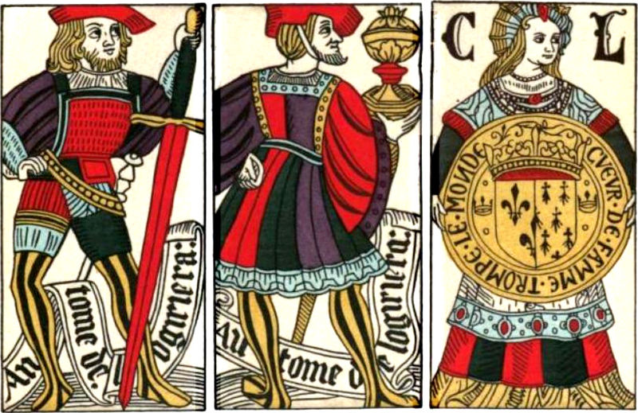
15th century Spanish playing cards

Rock, Paper, Scissors
The 'game' is actually a selection method, normally played to settle minor decisions such as which player goes first, similar to coin tossing or drawing straws. Believe it or not, the game can be documented all the way back to the Later Han Dynasty (c 200B.C. - 220A.D.). For more information, see http://www-cs.canisius.edu/~salley/SCA/Games/rps.html.

Rocking Horse
Wikipedia suggests that while this toy was probably inspired by rocking cradles, wooden jousting horses used by squires to practice in the early Middle Ages and hobby-horses, it does not seem to appear any earlier than the late 17th century. Smithsonian magazine seems to agree with this assessment. For more information, see
http://www.pbs.org/wgbh/roadshow/tips/rockinghorses.html or
http://www.smithsonianmag.com/history-archaeology/happytrails.html.

Roller Skates
The first patent for roller skates was in 1760. The 'modern' roller skate which has the axles on rockers allowing them to easily make turns was invented in 1863. Inline skates were invented in 1980 by a Russian athlete who wanted to train for the Winter Olympics during the summer. For more information, see: http://en.wikipedia.org/wiki/Roller_skates#History or
http://en.wikipedia.org/wiki/Inline_skates.

Rugby
Many different versions of 'football' were played throughout England. Rugby developed as the variant being played at Rugby school, but didn't become standardized until the mid 19th century. For more information, see http://en.wikipedia.org/wiki/Rugby_football#History.

Shuffleboard
The origins of the game are unknown, and multiple countries lay claim to having invented it. Henry VIII prohibited commoners from playing. His expense accounts for 1532 show payment to a Lord William for winning a game against the king. For more information, see
http://en.wikipedia.org/wiki/Shuffleboard#History.

Soccer
Many different versions of 'football' were played throughout England. Soccer developed as the variant being played at Cambridge University, but didn't become standardized until the mid 19th century. For more information, see http://en.wikipedia.org/wiki/Soccer#History.

Stratego
The modern game of Stratego can be traced back to a traditional Chinese board game called "Jungle Game". The two games are remarkably similar down to the two 'lakes' in the center of the game board. Jungle game uses animals instead of soldiers with the lowly Mouse (Spy) being able to frighten the Elephant (General). The game was patented in France in 1908 under the name L'attaque (Attack). Milton Bradley licensed the game for American distribution in 1961. For more information, see http://en.wikipedia.org/wiki/Stratego.

Tag
This is one of the those games that children will re-create whenever more than two of them get together. It's impossible to date when the first game of tag occurred, it may be pre-historic. For a list of variants, see http://www-cs.canisius.edu/~salley/SCA/Games/tag.html. For more
information, see http://www-cs.canisius.edu/~salley/SCA/Games/running.html.

Tennis
The game originated in France in the 12th century, but the ball was struck with the hand. Rackets did not come into use until the 1500's. The game was popular in France and England, but was generally played in an indoor court where bouncing the ball off the walls was a legitimate strategy. Henry VIII was a fan of the game and often placed large wagers. In Shakespeare's play Henry V, the king receives a case of tennis balls from the French prince. For more information, see http://en.wikipedia.org/wiki/Tennis#History.

Tiddlywinks
Invented as an adult parlor game in Victorian England by Joseph Assheton Fincher who filed a patent in 1888. For more information, see http://en.wikipedia.org/wiki/Tiddly_winks.

Tops
A child's toy that relies on gyroscopic (spinning) motion to keep upright. Eventually, the angular momentum (spin) will decrease, the toy will precess (wobble) and fall down. Tops have originated independently in countries all over the world. They are one of the oldest and most easily recognisable items found in archaeological sites. Pieter Brughel the Elder included children playing with tops in his painting 'Children's Games' which was done in 1560. For more information, see http://en.wikipedia.org/wiki/Top.

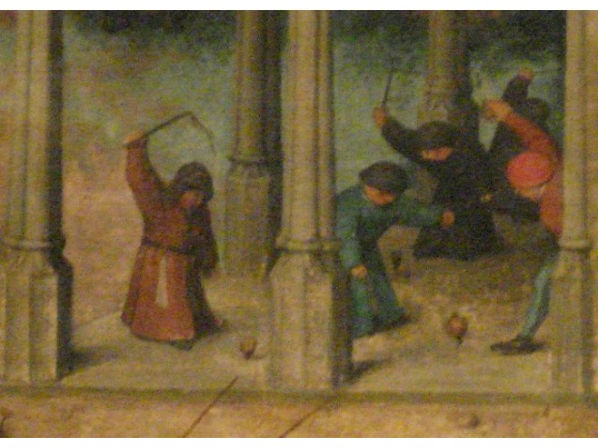
Pieter Brueghel painting 'Children's Games', (1560, detail)

Volleyball
Invented by William G. Morgan, a YMCA physical education director, created the game on February 9, 1895. He originally called it Mintonette. It was designed to be an indoor game for any number of players, as a cross between tennis and handball, less rough than basketball for older players, but still requiring athletic effort. Due to the volleying nature of the game in progress, it was known as Volley Ball (two words) within a year. For more information, see
http://en.wikipedia.org/wiki/Volley_ball#History.

Yahtzee
The game was invented by an anonymous Canadian couple in 1954 who called it 'The Yacht Game' because they played it on their yacht with friends. Two years later, they asked game maker Edwin Lowe to make some sets to be given as gifts to their friends. Lowe agreed to make 1,000 gift sets in exchange for the commercial rights to the game. He filed a trademark with the US Patent Office later that same year. For more information, see http://en.wikipedia.org/wiki/Yahtzee.

Bibliography
Books

Botermans, Jack (trans.) The World of Games: Their Origin and History, How to Play Them and How to Make Them (NY; Facts on File; 1989; ISBN 0-8160-2184-8; 240 pgs, ill.)

DeLuca, Jeff (SCA: Salamallah the Corpulent) Medieval Games (Raymond's Quiet Press; 3rd ed. 1995; ISBN 0-943228-03-4)

Finn, Timothy Pub Games of England, (Queen Anne's Press, 1975)

Gadia-Smitley, Roselyn Dolls' Clothes Pattern Book (NY; Sterling Publishing Co., Inc.,; 1987)

Gomme, Alice Traditional Games of England, Scotland and Ireland (London; Thames and Hudson; 1894; 2 vol.; ISBN 0-500-27316-2)

Grunfeld, Frederic V. (ed) Games of the World: How to Make Them, How to Play Them, How They Came to Be (NY; Holt, Rinehart & Winston; 1975; ISBN 0-03-015261-5; 280 pgs, ill.)
Maguire, Jack Hopscotch, Hangman, Hot Potato, & Ha-Ha-Ha (Simon & Schuster; 1992; ISBN 0-671-76332-6; 304 pgs)

Murray, HJR A History of Boardgames Other than Chess (Oxford, Claredon Press, 1913, 270 pgs)

Murray, HJR The History of Chess (Oxford, Claredon Press, 1913, 900 pgs)

Portman, Paul Pieter Brueghel's Children's Games (Berne; Hallwall Press; 1964)

Reeves, Compton Pleasures and Pastimes of Medieval England (England; Alan Sutton Pub.; 1995; ISBN 0-7509-0089-X; 228 pgs)

Sterling Publishing Family Fun & Games (NY; Sterling Pub.; 1994; ISBN 0-8069-8776-6; 800 pgs)

Websites

atte grene, Wenyeva "Stool ball: a medieval baseball game" Available at:
http://slumberland.org/sca/articles/stoolball.html

"The British Museum" Available at: http://www.thebritishmuseum.ac.uk

"Central Connector" Available at: http://www.centralconnector.com

"Don't Lose Your Marbles!" Available at: http://www.kidsturncentral.com/topics/sports/marbles.htm

du Coeur, Justin "Medieval & Renaissance Games" Available at: http://jducoeur.org/game-hist

"The Elliott Avedon Games Museum" Available at: http://www.gamesmuseum.uwaterloo.ca/

Gaffney, Dennis "Galloping for Rocking Horses" Available at:
http://www.pbs.org/wgbh/roadshow/tips/rockinghorses.html

"Happy Trails" Available at: http://www.smithsonianmag.com/history-archaeology/happytrails.html

"Kid's Turn Central" Available at: http://www.kidsturncentral.com/index.htm

"Marble Collecting" Available at: http://www.marblecollecting.com

"Marbles!" Available at: http://www.centralconnector.com/GAMES/marbles.html

"Marbles History" Available at: http://www.centralconnector.com/GAMES/marbhist.html

"National Horseshoe Pitchers Association" Available at: http://www.horseshoepitching.com

"Online Guide to Traditional Games" Available at: http://www.tradgames.org.uk

"Straight Dope Staff Report - What's the origin of 'Rock, Paper, Scissors'?" Available at:
http://www.straightdope.com/columns/read/1936/whats-the-origin-of-rock-paper-scissors

"Streetplay" Available at: http:www.streetplay.com

"USA Rock Paper Scissors League" Available at: http://www.usarps.com/site/index.php
"Wikipedia" Available at: http://en.wikipedia.org

"World Rock Paper Scissors Society" Available at: http://www.worldrps.com
------
Copyright 2014 by David Salley. <dagonell at hotmail.com>. Permission is granted for republication in SCA-related publications, provided the author is credited. Addresses change, but a reasonable attempt should be made to ensure that the author is notified of the publication and if possible receives a copy.

If this article is reprinted in a publication, please place a notice in the publication that you found this article in the Florilegium. I would also appreciate an email to myself, so that I can track which articles are being reprinted. Thanks. -Stefan.

<the end>

