G-Peasnt-Dnce-art - 10/8/09

"16th Century German Peasant Dance from Period Woodcuts - Two Dances from the Beham Brothers" by Viscountess Elisa von Sophey.

NOTE: See also the files: dance-msg, Maypole-Dance-art, The-Pavan-art, Ital-Ren-Dce-art, Germany-msg, Germany-bib, Landsknechts-bib, peasants-msg, fd-Germany-msg.

************************************************************************
NOTICE -

This article was submitted to me by the author for inclusion in this set of files, called Stefan's Florilegium.

These files are available on the Internet at: http://www.florilegium.org

Copyright to the contents of this file remains with the author or translator.

While the author will likely give permission for this work to be reprinted in SCA type publications, please check with the author first or check for any permissions granted at the end of this file.

Thank you,
Mark S. Harris...AKA:..Stefan li Rous
stefan at florilegium.org
************************************************************************

16th Century German Peasant Dance from Period Woodcuts -
Two Dances from the Beham Brothers
by Viscountess Elisa von Sophey
Principality of Oertha

Revised Class Notes
KWDS 2009, Kingdom of Ealdormere

Wilkommen!

I first discovered German woodcuts depicting dance scenes when I was researching Landsknecht costuming for my husband several years ago. Since then I have been on a quest to bring German dance to the SCA. There are many questions still, though I discover a few interesting new woodcuts and drawings each year. I anticipate more dances and better directions in the future. At some point I hope to do a study of upper class and noble dances, when I am able to acquire enough artwork.

There is an ongoing debate in the art community as to whether these woodcuts are allegorical or representative of actual events. I take the point of view that the artists drew what they knew, so the question of allegory is of little importance. Period carnival plays often employed Hahntanzen, or "cock dances", to show the vulgarity and bawdiness of the unbelievers in contrast to the modesty and good character of the believers. It is possible that a similar attempt is made in these woodcuts.

Both of the dances in this presentation are based on woodcuts by brothers Hans Sebald Beham (often referred to as Sebald) and Berthold Beham. Sebald alone produced over 200 woodcuts, mostly on church-related subjects. The Behams recorded several different church holiday celebrations as well. The Peasant Holiday depiction used in this study is one example. Die Zwelf Monet (The Twelve Months) is one of Sebald Beham's better-known works, with individual panels appearing in a variety of website and books.

Caveats and General Notes on the Reconstruction or,
Why I Interpreted That Step That Way

- The focus of this study/class is on the woodcuts created in the first half of the 16th century in the parts of the Holy Roman Empire that are known today as Germany.

- No names are given for the dances in the original woodcuts, so the traditional name of the woodcut is being adopted as the name for the dance.

- It is unclear whether the woodcuts represent specific choreographies or groups of steps that can actually be done in any sequence. I have chosen to interpret them as sequences since the dancers appear to be in a line, and two of the woodcuts more directly identify sequences, one with numbers alone, and the other with personified names of the months along with numbers. However, paintings of peasants dancing that were created by Bruegel in the later part of the century show the dancers as a group rather than a line.

- Likewise, there is no set music for these dances. I am using tunes from the same time period as the woodcut that include tanz or tantz (German for dance) in their names.

- That said, Germans are known for being precise, methodical and symmetrical. Historical evidence suggests they had the same reputation in period. Reputations may not be perfectly accurate, but they are usually based on something observed. Steps have been added between the pictures so to speak, in order to keep the dances symmetrical and to make them fit typical phrasing in the German dance tunes.

- Timing of the steps is also somewhat unclear. I have chosen to at least initially interpret each panel as 4 counts since most of the dance music seems to be in 4/4 time. Timing was modified from there to fit the specific tune and for symmetry.

- There are no known German written descriptions of the steps or choreographies. The only German dance manuscript from this era actually describes Italian balli, and was sent to Nurnberg from Italy in 1517 by Johannes Cochläus to his employer Wilibald Pirckheimer. It is a description of 15th Century Italian dances, not German dances. See Smith for the transcription.

- Alman is commonly believed to mean German, and the English almans are thought to have some connection to German dances. According to the French text Orchesography by Arbeau, "L'allemande est une dance plaine de mediocre gravité, familiere aux Allemands, & croy qu'elle soit de noz plus anciennes, car nous sommes descendus des Allemands" (The allemande is a dance filled with moderate solemnity, well known to the Germans, and I believe it is one of our most ancient [dances], because we are descended from the Germans.) Arbeau goes on to describe the allemande as three steps followed by a grave or pied en l'air sans sault, or three steps followed by hanging one's foot in the air for a count, but without hopping. It is interesting that many of the steps that appear to be doubles show the forward leg as straight and extended at a 45-degree angle to the ground, similar to what Arbeau calls a grave and we modernly call a goosestep. It is also similar to one common interpretation of the alman double in the Old Measures. There are embraces as well, which recall the Madame Sosilia Alman.

- Likewise the salterello tedesco, which translates to German hopping step, is well known in 15th century Italian dance manuscripts. The salterello tedesco differs from a regular salterello mainly in that it is in 4 counts (mesura quadernaria, 4/4) rather than 6 (mesura salterello, 6/8). Arbeau states the following in his description of the allemande: "Et quand viendra à la troisieme partie, vous la dancerez par la mesme mesure binaire plus legiere & concité, & par les mesmes pas, en y adjoustant des petits saults comme à la Courante." (And when the third part arrives, you dance it in the same rhythym [but] more slowly and stately, and with the same step, adding to it little hops like in the Coronto.)

Die Zwelf Monet (The Twelve Months)
Hans Sebald Beham, 1546

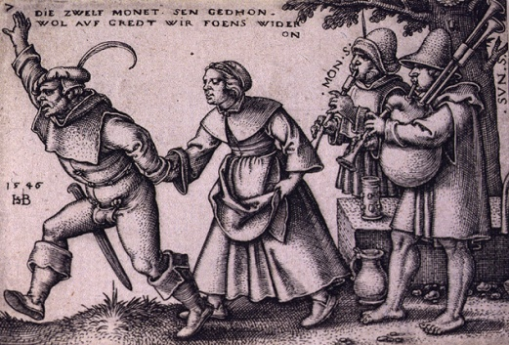

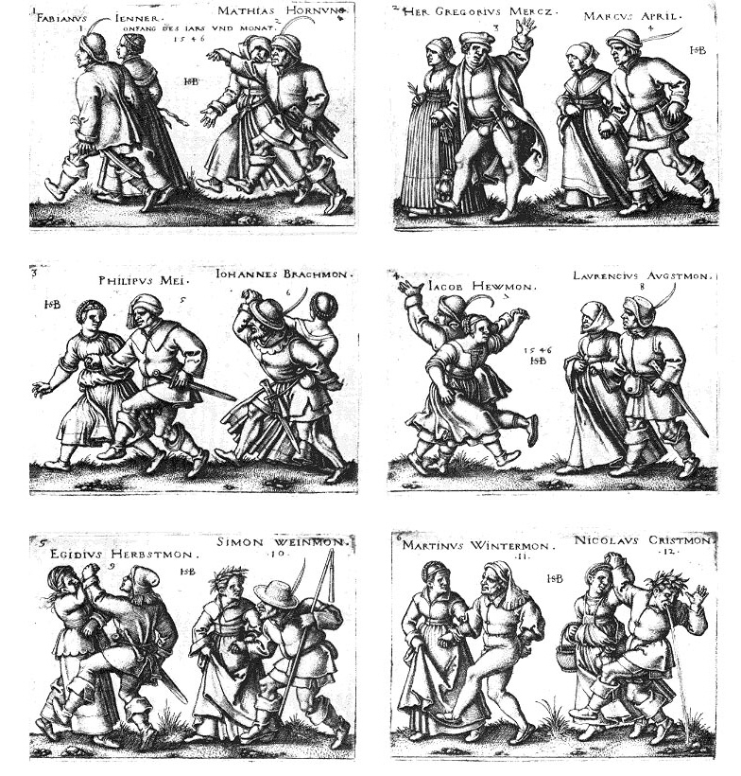
Die Zwelf Monet, my original reconstruction:

Measure | Movement
1 | Alman double forward, starting on the left
2 | Alman double forward right
3 | Alman double forward left
4 | Alman double forward right
5 | Alman double forward left (possibly kicking?)
6 | Raise center arms, and go back-to-back with your partner. Circle clockwise while back-to-back.
7 | Circle counterclockwise while back-to-back.
8 | Double forward, ending face-to-face.
9 | ? Is the dancer left-handed (since his sword is on his right hip)?
10 | Double forward
11 | Double forward (possibly kicking?)
12 | Double forward (possibly kicking?)

Die Zwelf Monet, revised:

Section A |  | 16 counts |  | 4 alman doubles forward
Section B |  | 8 counts |  | 2 alman doubles forward
 |  | 8 counts |  | Clockwise circle back-to-back, ladies lead
 |  | 8 counts |  | 2 alman doubles forward
 |  | 8 counts |  | Counterclockwise circle back-to-back, men lead
Section C |  | 8 counts |  | 2 alman doubles forward, turn to face
 |  | 4 counts |  | Men guide ladies (ladies back up)
 |  | 4 counts |  | Ladies guide men (men back up)
Section D |  | 16 counts |  | 4 salterelli tedesci
Music: | Tantz |  | (by V. Haussmann)

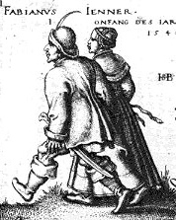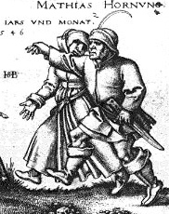

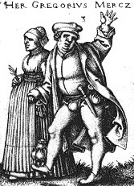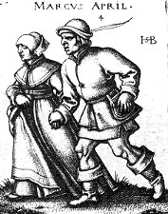

Figures 1 through 4 (January through April) appear to be progressing forward, although there is inconsistency in the form of the movement. Figures 1 and 2 especially show legs extended and relatively straight, reminiscent of the pointing of the toe on the fourth count in the alman step commonly done in reconstructions of the dances from the Inns of Court/Old Measures. Figure 2 seems to be the more energetic representation, with a high handhold at nose level, and with arms straight ahead. This high handhold appears several times in the woodcuts.

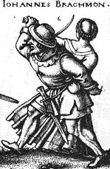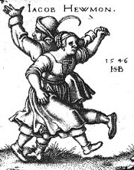

Sections 6 and 7 (June and July) of The Twelve Months, showing the back-to-back figures. Note that the dancers in 7 are not on the same foot or in rhythm with each other. The postures and flow of the clothing indicate clockwise motion in panel 6. The inside hand is still joined, suggesting that the lady is leading. In trials, the man attempting to lead did not work well. There is some evidence from non-dance sources that German women may have been more willing (or found it more acceptable) to take lead roles than other cultures in the same period.

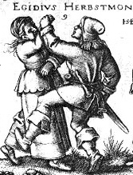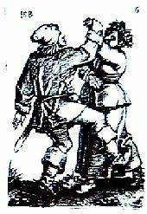

The mysterious figure 9 (left, September).

He appears to be stepping or kicking forward while she is stepping back on the same foot or forward on the opposite foot. I have interpreted this as the gentleman guiding or pushing the lady backwards.

Note that their outside hands are joined rather than the inside hands. It is possible that he is left-handed since his sword is on his right hip and he has his dagger on his left hip, but would that have changed how he danced? Arbeau seems to give a left-hand and right-hand version of the LaVolta. An alternate possibility is that the artist may have reused an image by stamping it and then cutting it in reverse. There are multiple instances when the Beham brothers copied each others' works in that manner. The image on the right is from a 16-panel dance woodcut dated 1537, 9 years prior to Die Zwelf Monet, and is also by Sebald Beham.

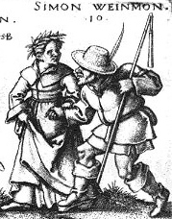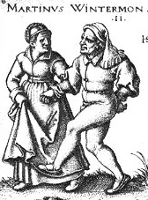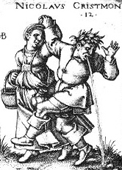

Figures 10 through 12 (October through December) appear to be progressing again. Figures 11 and 12 in particular appear to show the knee more bent than figures 1 through 4, suggesting the possibility of a step more like Arbeau's three steps followed by a pied en l'air sans sault or the Italian salterello tedesco.

Figure 12 is especially interesting. The man is wearing a laurel wreath, which typically suggests virginity, as in this 1522 woodcut (below, top left) by Sebald Beham depicting a couple at their wedding celebration, where the bride wears the laurel and flower wreath. The Church Holiday at Mogelsdorf woodcut also shows three figures, two women and one man, wearing wreaths (top center and right, from 2 different printings). Likewise, the poem that accompanies the Nazentanz (Nose Dance) woodcut tells us that one of the prizes for the worst nose contest was a laurel wreath, implying that the nose might prevent him or her from having a sexual relationship. It is also interesting that the man in figure 12 is vomiting. Showing the last man in the sequence of couples, or someone in close proximity to the dancing, vomiting seems to be a common trait. The same woodcut mentioned in the discussion of figure 9 also shows the last man in a similar condition. In the Peasant Holiday woodcuts, the figure in question is just to the side of the dancers (bottom left). It the Church Holiday at Mogelsdorf woodcut, he is at the beginning of the woodcut, but since the figures face toward the right, he is still behind the dancers (bottom right). You can see the ends of the bagpipes in the upper right-hand corner, signifying the beginning of the dancing part of the woodcut.

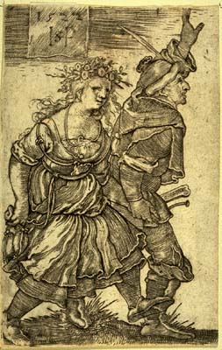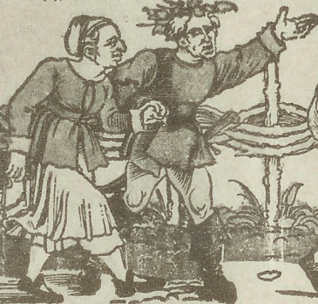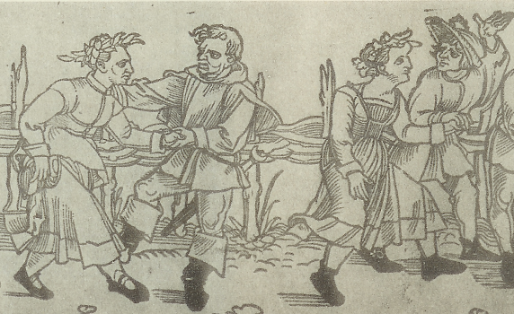

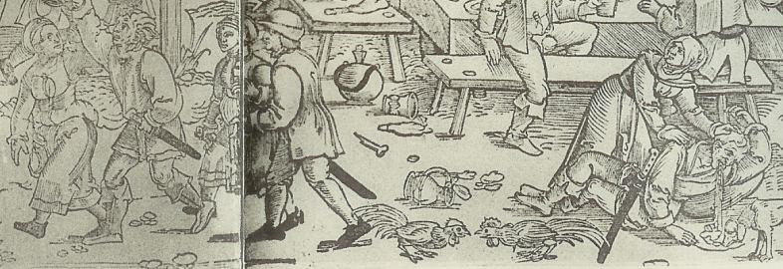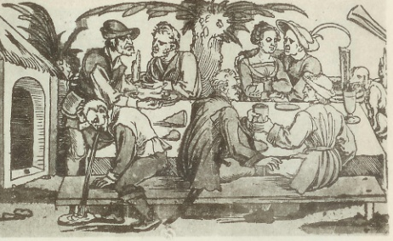

Old Peasant Holiday
Barthel Beham, prior to 1535

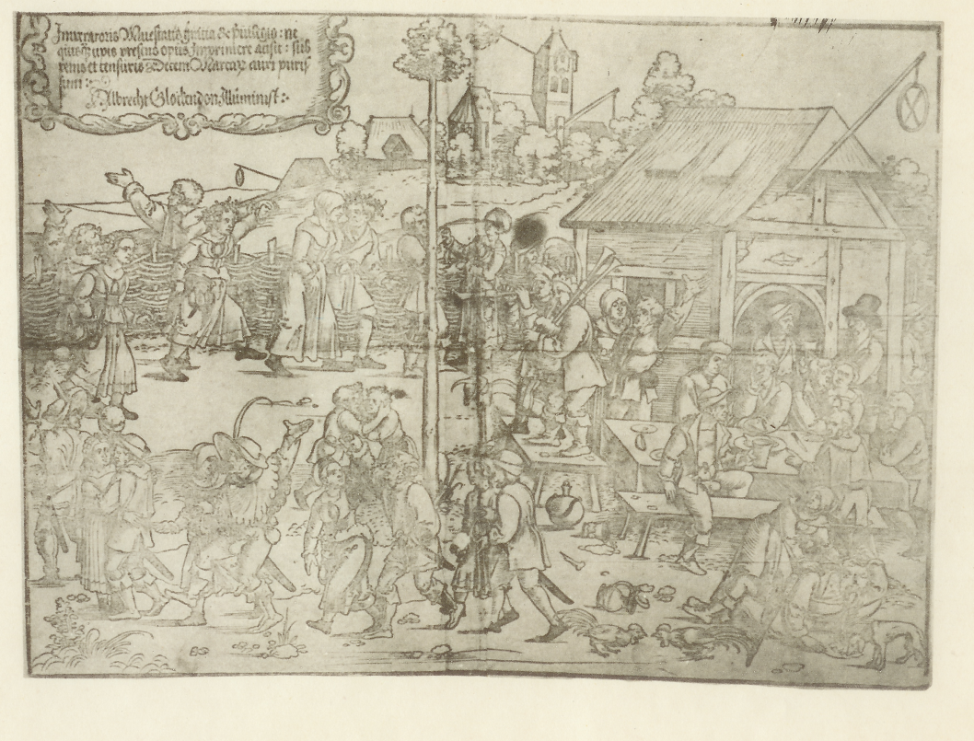
9
8
10
7
6
5
4
3
2
1

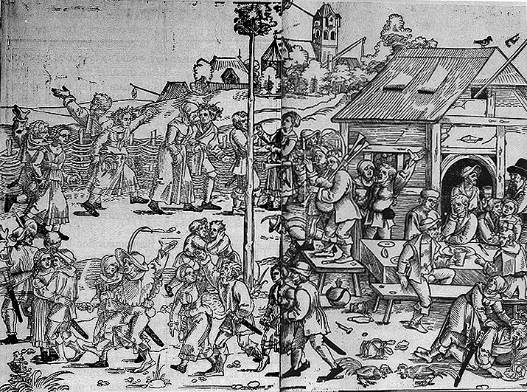

Top: There is no date on this stamping, but the source indicates it may have been made in period. Numbers to correspond to the figures are superimposed on this one since they stand out more. Bottom: A more modern stamping from the same wood blocks. The blacker ink makes the images easier to see.
Old Peasant Holiday, my original reconstruction:

Measure | Movement
1 | Reverence (Arbeau-style), facing your partner and holding both hands
2 | Double forward
3 | Full circle counterclockwise
4 | Finish the circle
5 | Double forward
6 | Embrace
7 | Kicks?
8 | Double forward, raising center arms; may also be a spin-under
9 | Double forward
10 | Embrace

Old Peasant Holiday, revised:

Section A |  | 8 counts | 2 alman doubles forward
Section B |  | 8 counts | Circle counterclockwise
Section C |  | 8 counts | 2 salterelli tedesci forward, starting on the left foot
 |  | 4 counts | Embrace
 |  | 8 counts | 2 salterelli tedesci forward, starting on the right foot
 |  | 4 counts | Embrace
Music: | Tantz Du hast mich wollen nemmen |  |  | (Anonymous)

Note: I used the recording from the 2000 release of Dances of the Renaissance from Deutsche Grammophon/Panorama. The original was released in 1960. This version goes through the music for the above choreography only once, then goes to what sounds like a salterello section.

Unfortunately, the digital images I have are not very high DPI so I am unable to enlarge the figures for better viewing without them getting too grainy to see clearly.

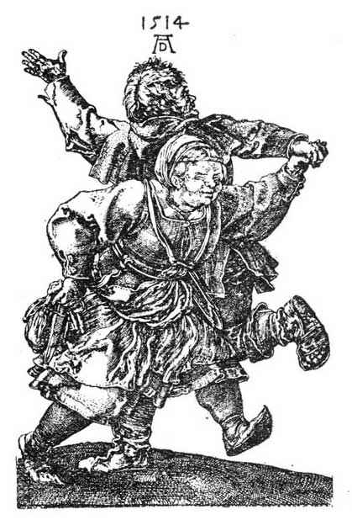

The counterclockwise turn in figure 3 in this depiction (left) shows the same arms-out stance as in Die Zwelf Monet (center). The only real difference is that the two appear to be on the same foot in this depiction. Note the similarity to the woodcut from Albrecht Dürer, dated 1514 (right).

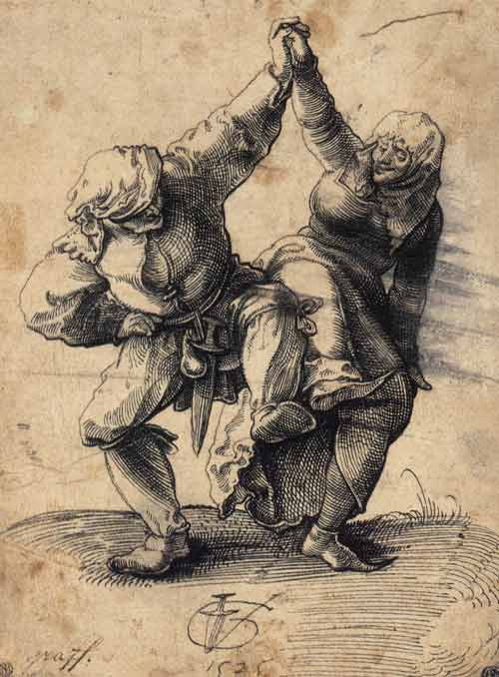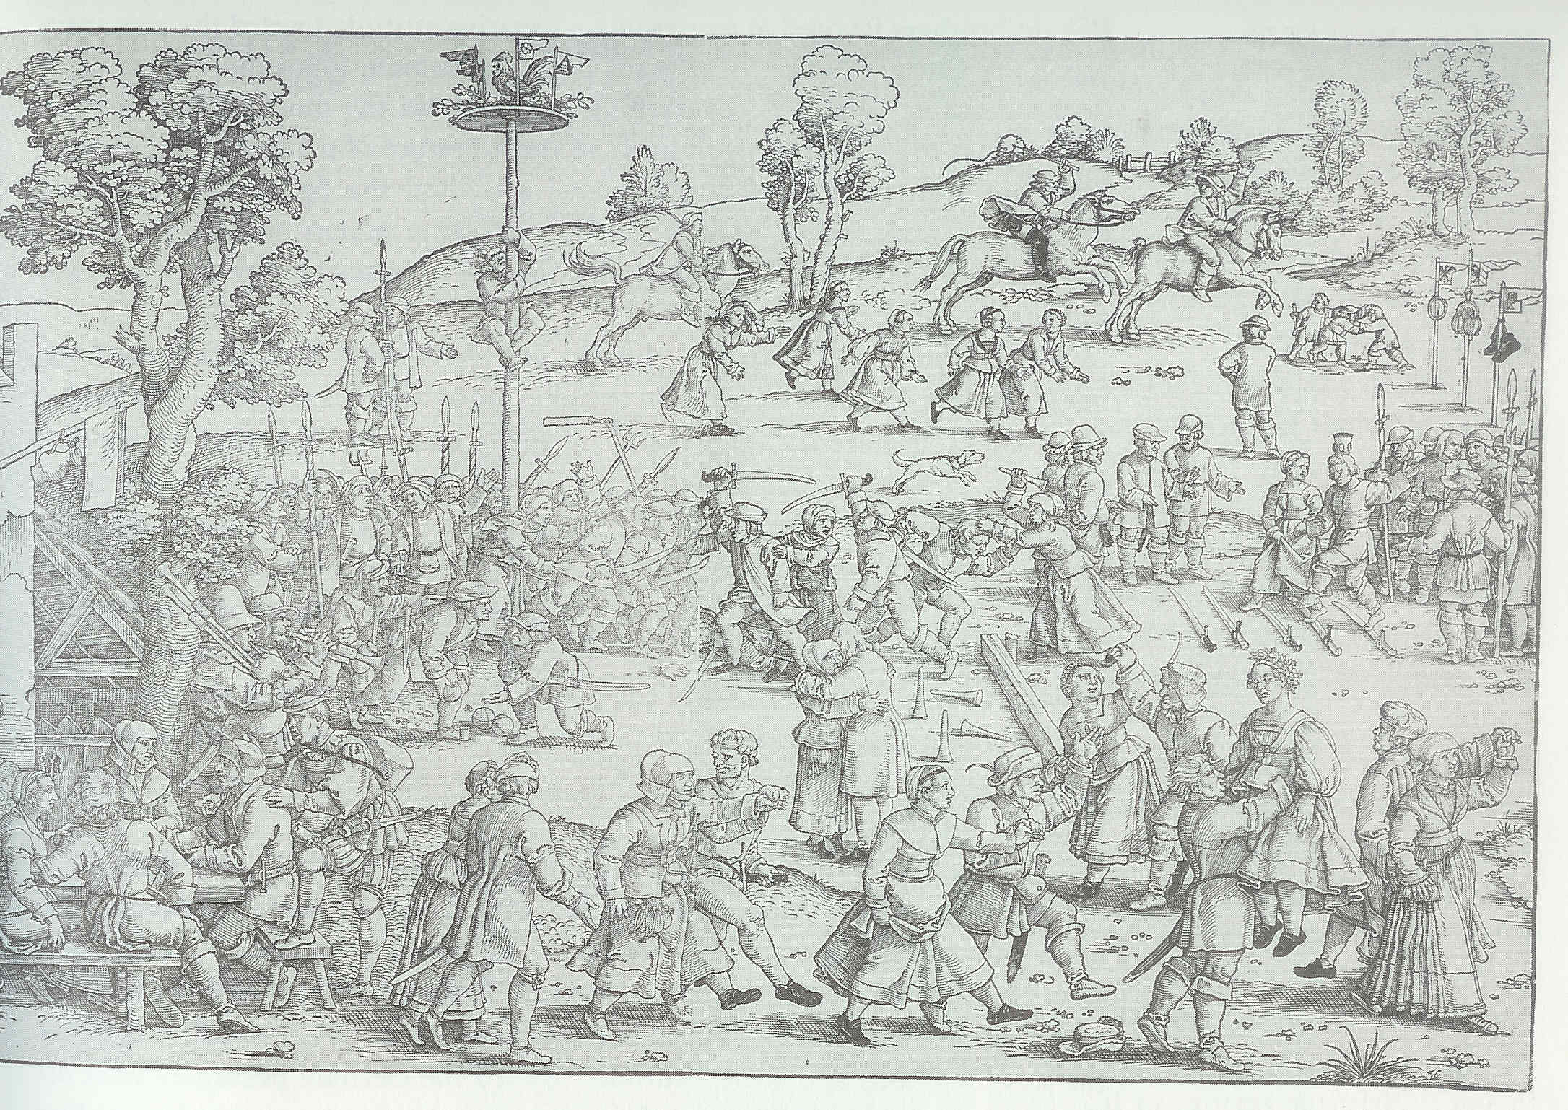

Figure 8 (left) shows a similar high handhold as this 1525 drawing by Urs Graf (center). When Hans Sebald Beham (Berthold's brother) copied the work in 1535, he reversed it and made a few modifications. On the right is Sebald's version of this figure; note that the arms are extended forward rather than held high. They also appear to be kicking the inside feet, which better matches Graf's drawing.

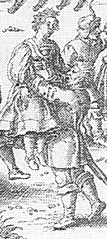

The embrace in figure 6 in this version (left) becomes a lift in Sebald's version (center). There is a third version of this woodcut, undated, that some attribute to Johann Theodor de Brys, even though it bears the characteristic mark of Hans Sebald Beham. Brys maintains the lift for this figure (right), but changes all but one of the above-the-head handholds to extended-in-front handholds.

Acknowledgements

Thank you to those who joined me for the test sessions at Pennsic in 2008 as we tried out various interpretations of some of the pictures, and to those who attended the class at KWDS in 2009 where yet more revisions and changes took place. Thank you also to Gregory Blount for the periodic nudging, suggestions of where to look, and ideas on music, and to my husband and test subject, Karl Helweg, who has patiently listened and tirelessly supported the ongoing project.

Bibliography

Arbeau, T. (1589). Orchesography (1967 ed.). (M. S. Evans, Trans.) New York: Dover Publications, Inc.

Graner, N. (n.d.). Retrieved July 2009, from Orchesographie: http://graner.net/nicolas/arbeau/ (This website is a transcription of Arbeau's Orchesographie. Digital images of the pages of an original copy can be found by searching for Orchesographie at http://memory.loc.gov.)

Kunstmuseum Basel. (2009). Graf, Urs. Retrieved March 17, 2009, from Kunstmuseum Basel: http://www.kunstmuseumbasel.ch/de/collection/virtual-collection/epochen/15-16-jahrhundert/graf-urs.html

Moxey, K. (1989). Peasants Warriors and Wives: Popular Imagery in the Reformation. Chicago: University of Chicago Press.

Rottinger, H. (1921). Die Holzschnitte Barthel Behams: Mit 24 abbildungen auf 21 Tafeln. Strassburg: J. H. Ed. Heitz.

Scherer, V. (n.d.). Durer: Des Meisters Gemalde Kupferstiche und Holzschnitte in 473 Abbildungen. Stuttgart: Deutsche Verlags-Anstalt.

Sebald Beham. (n.d.). Retrieved March 25, 2009, from National Gallery of Art: http://www.nga.gov/cgi-bin/tsearch?oldartistid=200310

Smith, A. W. (1995). Fifteenth-Century Dance and Music: Twelve Transcribed Italian Treatises and Collections in the Tradition of Dominico da Piacenza (Dance and Music Series No. 4 ed., Vol. II: Choreographic Descriptions with Concordances of Variants). Stuyvesant, New York: Pendragon Press.
------
Copyright 2009 by Lisa Marx. <shusmarx at yahoo.com>. Permission is granted for republication in SCA-related publications, provided the author is credited. Addresses change, but a reasonable attempt should be made to ensure that the author is notified of the publication and if possible receives a copy.

If this article is reprinted in a publication, I would appreciate a notice in the publication that you found this article in the Florilegium. I would also appreciate an email to myself, so that I can track which articles are being reprinted. Thanks. -Stefan.

<the end>

