Intr-Leatherw-art - 7/8/18

"Intro to Leatherworking - Making a Belt Pouch" by Lord Dafydd ap Alan.

NOTE: See also the files: leather-msg, leather-dyeing-msg, Lea-Hardware-art, lea-tanning-msg, lea-tooling-msg, Mk-Vik-Brooch-art, HTBuy-Leather-art.

************************************************************************
NOTICE -

This article was added to this set of files, called Stefan's Florilegium, with the permission of the author.

These files are available on the Internet at: http://www.florilegium.org

Copyright to the contents of this file remains with the author or translator.

While the author will likely give permission for this work to be reprinted in SCA type publications, please check with the author first or check for any permissions granted at the end of this file.

Thank you,
Mark S. Harris...AKA:..Stefan li Rous
stefan at florilegium.org
************************************************************************

You can find more work by this author in his blog at:
Blog: http://kraken-leather.blogspot.ca/

Class Handout
Intro to Leatherworking – Making a Belt Pouch
by Lord Dafydd ap Alan

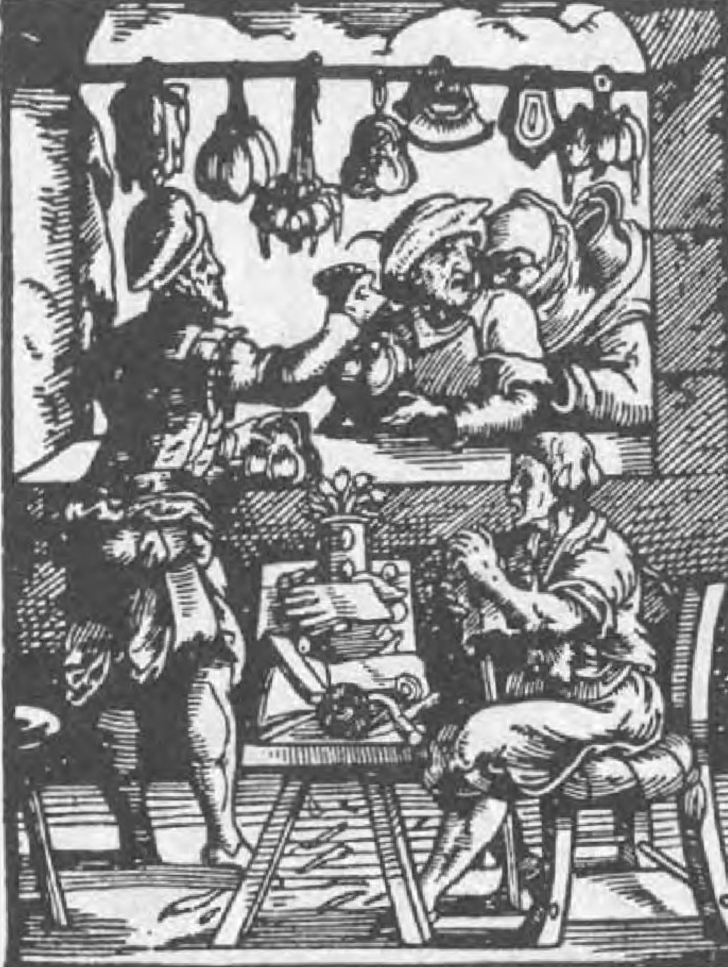
The purse-maker, Das Ständebuch, 1568

Table of Contents

INTRODUCTION

YOUR PROJECT KIT

BASIC TOOLS AND EQUIPMENT

PICKING YOUR LEATHER

CUTTING THE PATTERN

SEWING THE PIECES TOGETHER
SEWING THE POUCH TOGETHER:
ATTACHING THE BELT LOOP/FLAP:
ADDING IN YOUR DRAWSTRING:

EMBELLISHMENTS TO CONSIDER
CLOSURE BUTTON
PUTTING TRIM ON THE BELT POUCH LOOP/FLAP TO CLEAN UP THE LINES
TOOLING/DYING YOUR LEATHER
ADDING AN APPLIQUE, TASSELS OR POUCHLETS
EXAMPLES OF EMBELLISHMENTS

ANNEX 1- DOCUMENTATION

ANNEX 2 - GENERAL RESOURCES

Introduction

Leather was a commonly used material for all kinds of objects throughout the period studied in the SCA. What that means is that, once you learn some basic leatherworking skills, it opens the door for you to make all kinds of useful and period-looking things.

Sure, you could wear a modern belt, but it will look like you’re wearing a modern belt. Why not make your own period looking one instead?

And where are you going to carry all of your modern stuff – car keys, money, membership and authorization cards, gum.....? There are probably no pockets in that garb you’re wearing, so wouldn’t a nice leather pouch be handy?

This class is meant to give you the basics on how to start making your own leather projects. We’ll use a belt pouch pattern as a starting point, so that you can practice the skills and end up with a useful project at the end.

We’ll go over some of the materials you can use, how to choose the right materials, the basic tools and some nice to have ones as well. Then we’ll get started on the project.

Let’s get started!

Your Project Kit

For this class you should each have the following in your kit:

Leather needle
Several pieces of artificial sinew
Two leather pouch pieces
Basic tools and equipment
One belt loop/flap piece
One draw string strip
One hand out (this document)

There are hundreds of different pieces of equipment that you can use for leatherworking, depending on the project you want to do and the effect you want with your leather.

This is just a list of some of the key tools that you’ll want to consider as part of your workshop for basic projects, like making a belt pouch. As you do more leatherworking—things like leather tooling and dying, or armour making—you may want to buy more specialized equipment, but these will get you through most basic projects.

For this class, I’ve pre-cut the leather and punched the holes you’ll need, so really all you’ll need to finish your basic project (barring any embellishments) are a leather needle, some artificial sinew and some scissors.

Basics

Awl
Leather needles
Cutting mat
Good knife/scissors
Artificial sinew, waxed thread etc.
Pattern paper (i.e., rolls of kids craft or butcher paper)
Pencils, markers etc.
Metal ruler

Nice to Haves
Hole punch(es) – Rotary hand punch is recommended
Overstitch wheel
Rawhide/plastic mallet (especially if using hand punches)
Marble slab

Picking your leather

Some basics about leather before we get started.

Most leather that we use comes from cows. That being said, you can also buy pig, goat, elk, moose, deer or really any other type of animal that we use for food. You can also buy more exotic leathers like alligator, ostrich, water buffalo etc. Each type of leather is a bit different and has particular characteristics that might work for various types of projects.

There are basically two kinds of leather that you’ll see most often—chrome tanned leather and vegetable tanned leather. They’re called this because of the tanning process that’s used to make them.

Vegetable tanned leather (often called veg tan or oak tan), is a period technique for tanning leather that uses natural tannins found in various plants. The process takes several weeks, and so the leather tends to be more expensive and a bit less common. The advantages of this type of leather, aside from being period, is that it is the kind of leather that you would use to do leather tooling, and it can be dyed. Veg tan is usually a natural light brown/tan colour.

Chrome tanned leather is a modern technique that uses chemicals to speed up the tanning process, so that skins can be tanned in a matter of hours and days, rather than weeks. Chrome tan skins come in a wide variety of colours and textures, can’t really be tooled or dyed, and are definitely not period. That being said, you can find chrome tan leather that passes the “ten foot rule” (in other words, it looks period from about 10 feet away). It also tends to be less rigid and comes in a broader range of thicknesses, so a lot of the garment weight leather you will find will be chrome tan. Since it also tends to be less expensive, I started out using mostly chrome tan until I got into leather tooling and dying.

Leather thickness is generally calculated in ounces (oz.) when you buy it at the store. One ounce is equal to about 0.4 mm in thickness. You can find leather anywhere from one oz. (very hard to find in veg tan) all the way up to 14 oz., which is heavy leather that would be used for boot soles and armour.

There’s lots of other terminology that applies to picking the right leather for a project. Depending on the project, you may want to use leather from a specific part of the animal or that has specific characteristics. I’ve added some useful information links to the general resources section at the end of the handout to provide some of this more detailed information.

I generally use garment weight (probably about 1-2 oz.) chrome tan leather for these types of beginner projects because of the cost, and because it’s easiest to work with. If you want to know specifically what leather I’ve used for this class, please ask if I didn’t mention it during the class.

Cutting the pattern

Just like when making clothes, before you cut the leather out you need to know what pattern you are using. You can buy some pre-made period and period-looking patterns, or you can design your own pattern based on period paintings and extant examples in museums. Check the resources section at the end of this hand out for sources for patterns.

For this class, I’ve designed the pattern we’ve used based on period artwork, as well as standard pouch designs from the period. Aside from the artwork, my primary resource for documenting the specific construction is a book called Purses in Pieces, which is THE book to have for middle to late period pouches. I highly recommend it as the author, Olaf Goubitz, was artistically inclined and has actually done illustrations to show how the purses would have been constructed and assembled, not just a picture of an artifact.

I always trace my pattern out onto heavier paper, even if I’m using a commercial pattern set, because I don’t want to damage the patterns that I bought. Once you trace out and cut out the pattern, you can go two ways. You could do a mock-up using fabric, or leather scraps, or you can go directly to working with your good leather. In general, if it’s a project I’ve done many times and I know how it goes together, I’ll usually go straight to working on the leather. But, if it’s a new pattern, or if I’m doing a special project that will require expensive leather or a lot of work to assemble, I’ll do a quick mock up first to make sure I’m not missing anything.

Once you’re ready to work with the leather, take your pattern and trace it onto the back of the leather (not on the good side). You trace it on the back so you don’t mark up the visible side of the leather. If your pattern isn’t symmetrical, make sure you trace the pattern correctly, thinking about which side of the pattern should be facing out.

In general, using ink on leather is a bad idea as it will permanently mark the leather. That being said, I ignore that rule all of the time, and just make sure that I work on the back of the leather, and that when I’m cutting the leather I trim the ink off anywhere that would be visible. Otherwise, you could use a pencil or a chalk stick.

For this class, I already cut out the leather pieces according to the pattern for you, so we skipped straight to the next step – sewing the pieces together.

Sewing the pieces together

Once you have all of your pieces cut, it’s “just” a matter of putting them all together. In the case of most basic pouches, that means doing some hand sewing.

You don’t necessarily have to punch holes in the leather in advance, but it sure is easier on your hands. You can use just a basic awl to punch the holes, or you can use a hole-punch and other tools. If you don’t want to punch the holes in advance, you’ll probably need a glover’s needle, which is much sharper than the harness needle I’ve given you.

For this class, I’ve pre punched all the holes to save time but I’ve brought the various tools you can use to punch holes so you can try them out.

There are several stitching patterns that you can use when it comes to hand sewing leather. The first basic stitch pattern, and the one we’ll be using for this project, is what is called the saddle stitch (although I’ve seen it called other things like a running stitch). The saddle stitch can be done with either one needle or two. For this class, we used the single needle saddle stitch.

Here’s a diagram of the saddle stitch pattern using a single needle:
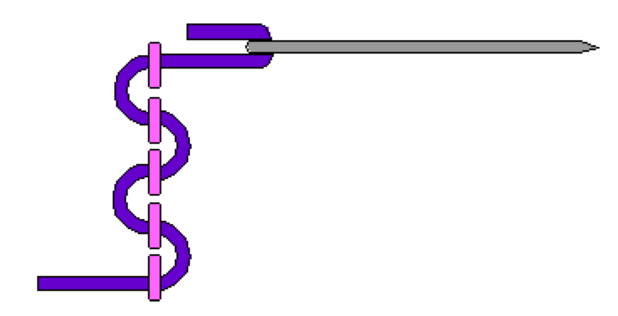
This image is from a cross stitch web site (http://home.comcast.net/~kathydyer/nf_xstitch_tut.html) but shows the pattern well. The dotted line would represent the leather.

Here’s a diagram of the same type of stitch, but using two needles:
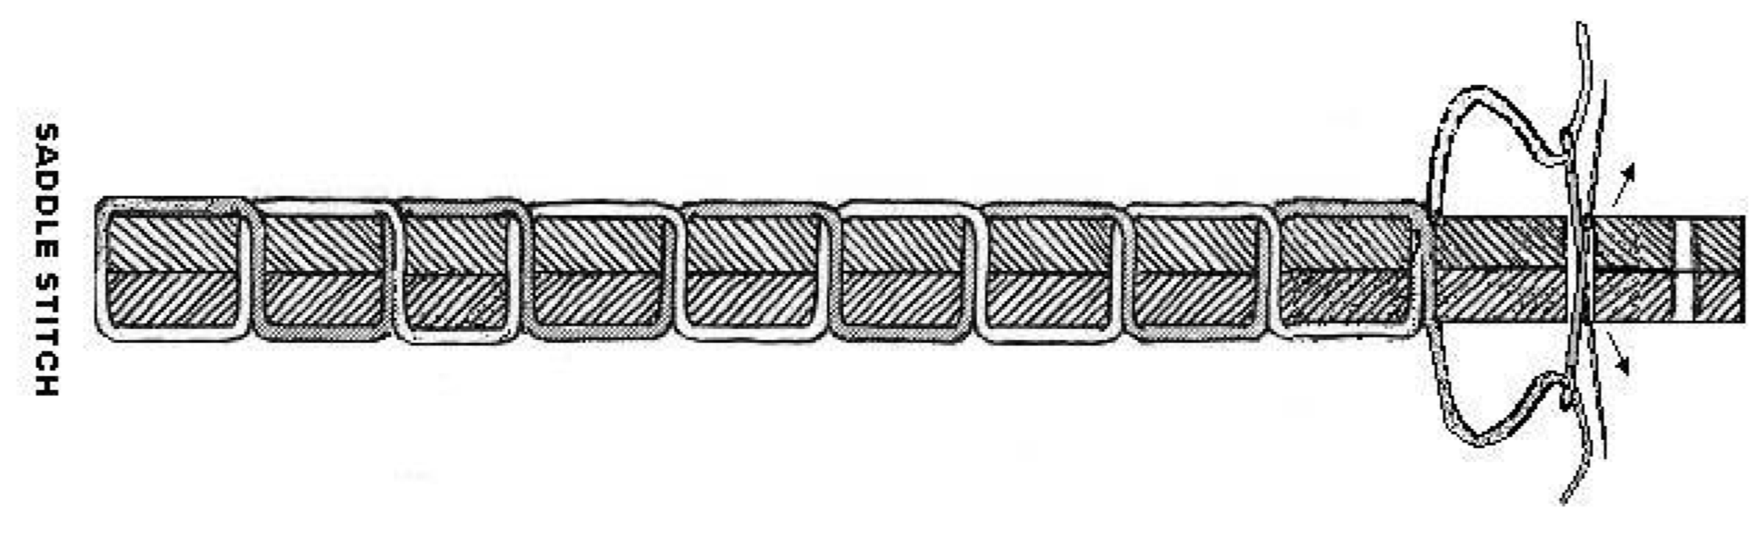
Image from a blog on making bags and fashion accessories: http://bagntell.wordpress.com/2010/02/27/saddle-stitched-handbag/ Sewing the pouch together:

Sewing the pouch together:

Place your pouch pieces so that they are inside-out (so the good sides of the leather are touching). When working on a pouch with single saddle stitch, I usually start sewing from the middle of the bottom of the pouch. That way, if your holes don’t line up perfectly it helps prevent the pieces from getting too misaligned.

Work your way up one side of the pouch to the top, then back down to where you started and tie your thread off. Then you do the same thing on the other side with your second piece of thread.

Once you’ve tied off your thread, turn your pouch back out so that the outside is facing out and you have the body of your pouch done. You should have a nice neat seam all the way along the edges and an opening at the top.

Attaching the belt loop/flap:

An important note before you start this step: if you want to embellish your pouch by adding trim along the outside of the flap (as will be mentioned in the next section), you need to do this before you sew the flap to your pouch.

You’ll see that I’ve pre punched a series of holes in one of your pouch pieces. That’s the back of your pouch. On the flap/belt loop piece, there is a matching set of holes at one end, along with two rows of holes going across the middle. The end attaches to the pouch, while the two rows get sewn together to form the actual belt loop and flap.

You can sew the flap inside or outside of the pouch body. Either way works, but I like to sew it on the inside. Place your flap so that the holes line up between the flap and the pouch, with the “good” side of the flap up against the leather (if sewing the flap to the outside of the pouch, you would reverse this so that the “bad” side of the flap is up against the leather).

Using your saddle stitch, work your way up and down the series of holes along either the left or right edge of the flap piece. Tie off your thread and then do the same along the other edge. Your flap should be nicely attached to the back of your pouch.

Now fold your flap down so that the two lines of holes are on top of each other. This should form a belt loop above the pouch, with the flap pointing down. Using your saddle stitch again, sew up and down the line so that you have a nice clean row of stitches that will hold your flap and belt loop in place. This is also a step where a more ornamental stitch could be used as this row of stitches will be visible on the front of your pouch.

Your pouch is now almost done and should be pretty close to what you would expect a pouch to look like.

Adding in your drawstring:

Adding a drawstring on this style of pouch is super easy (one of the reasons I like this design). All you have to do is cut a series of vertical slits in your leather all the way around the pouch. The most important thing is to have an odd number of cuts, otherwise your drawstring won’t end up with both ends on the outside!

Start by cutting a slit in the middle of the front of the pouch (If using a knife to cut your slits, make sure you put a cutting mat between the layers of the pouch before cutting, otherwise you’ll cut through both sides of your pouch!).

Start your cut about 1 to 1 1⁄2 inches from the top of the pouch and make it about an inch long (the length of the cut depends on the width of your draw string). If you’re using something thinner, like a lace or cord, you could make your cut shorter.

Then, work your way towards the back of the pouch, cutting slits evenly spaced around the pouch, and at the same height as your first cut.

Once you’re done, start weaving your drawstring through the holes. It should end up with both ends sticking out of the first cut you made at the very front of the pouch. Pull it tight and it should cinch your pouch up nicely.

If you’ve misjudged and have the wrong number of cuts, you can fix it by adding an extra cut on the back of your pouch and then re-weaving the drawstring.

Your basic pouch is now done and ready to wear!

Embellishments to consider

There are a number of things you can add to your pouch to make it look nicer, it all depends on what you would like it to look like.

Closure button

One of the simplest things you can add to your pouch is a way to keep it closed. You can use a modern or period button, or you can make a quick button by rolling a piece of leather, punching a hole in the roll and attaching it to the pouch.

Attach the button to the front of the pouch and then cut a corresponding slit in the flap, so that when the pouch is closed and the flap is down, the hole and button will line up. Make sure you don’t sew the button on too tight or you won’t be able to get it through the hole. Depending on your button you may also need to widen your hole, or cut across it to allow the leather to open up enough for your button to go through.

Putting trim on the belt pouch loop/flap to clean up the lines

Putting a trim on your flap and belt loop will not only clean up the lines of your pouch, but also help hide any imperfections in your cutting. It can also make any chrome tan leather less obvious by covering up the tell-tale markings you can see on the cut edges of the leather.

As noted before, this is a step you have to do before you attach the flap to your pouch.

To do this, you need to have some strips of fairly thin garment-weight leather. You need them to be wide enough to wrap around the edge of the leather and have room to punch holes.

Punch evenly spaced holes all the way around your belt loop piece. Then punch the matching holes along both long edges of your thin strips. Make sure you check where the holes need to be punched so that all three rows of holes line up when you wrap your leather strips around the edge of the belt loop piece.

Once all your holes are punched, sew the strips onto your belt loop piece using either your saddle stitch or a more decorative stitch.

Tooling/dying your leather

Another way to decorate your pouch would be to dye or tool your leather. In the case of the pouch we made in the class, this isn’t possible because we’ve used chrome tanned leather, which can’t really be tooled or dyed because of the tanning process used to make it. However, you could make a pouch using the veg tan and in that case it could be done or you could tool another leather piece and applique it to your pouch (see below).

Leather tooling and dying would be something you would most likely do before the pouch has been assembled. We don’t cover these techniques as part of this class, but I’m happy to answer questions afterwards.

Adding an applique, tassels or pouchlets

Period pouches often had this type of ornamentation on them, particularly later in period.

Applique involves sewing a decorative piece of fabric or leather onto the surface of the pouch. This could be something that’s been embroidered, painted or carved/tooled with almost any decoration.

You can also add tassels to pouches, which could be added on the bottom, the top corners, or even on the ends of the drawstring.

Pouchlets are sometimes seen on period pouches as well. These are small pockets (think of it as a small drawstring pouch attached to the front of your larger pouch) that you could use to store coins or small, frequently accessed items.

Examples of Embellishments

Here are some examples of pouches on the Internet showing various types of embellishments:

First, some period artwork examples found through the Larsdatter linkspage (found in the resources section below)

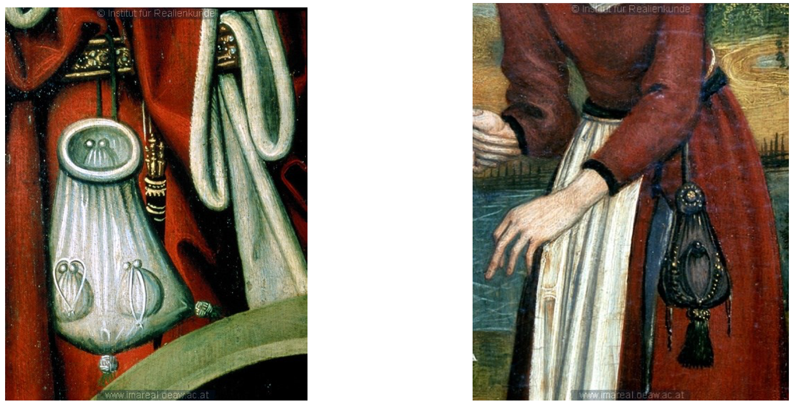

The pouch on left shows pouchlets and tassels, listed as being from The Liberation of St. Barbara by Hans Egkel, c. 1470-1480: http://tarvos.imareal.oeaw.ac.at/server/images/7000149.JPG

On the right is a purse with large tassels and what looks like a button closure and gold embroidery or other ornamentation on it. Listed as being from The Visitation, c. 1490-1500 http://tarvos.imareal.oeaw.ac.at/server/images/7005537.JPG

These next two pouches are from a really amazing leatherworker, Karl Robinson, from the UK (http://www.karlrobinson.co.uk). Some really nice examples and one of the sites I based my design on.

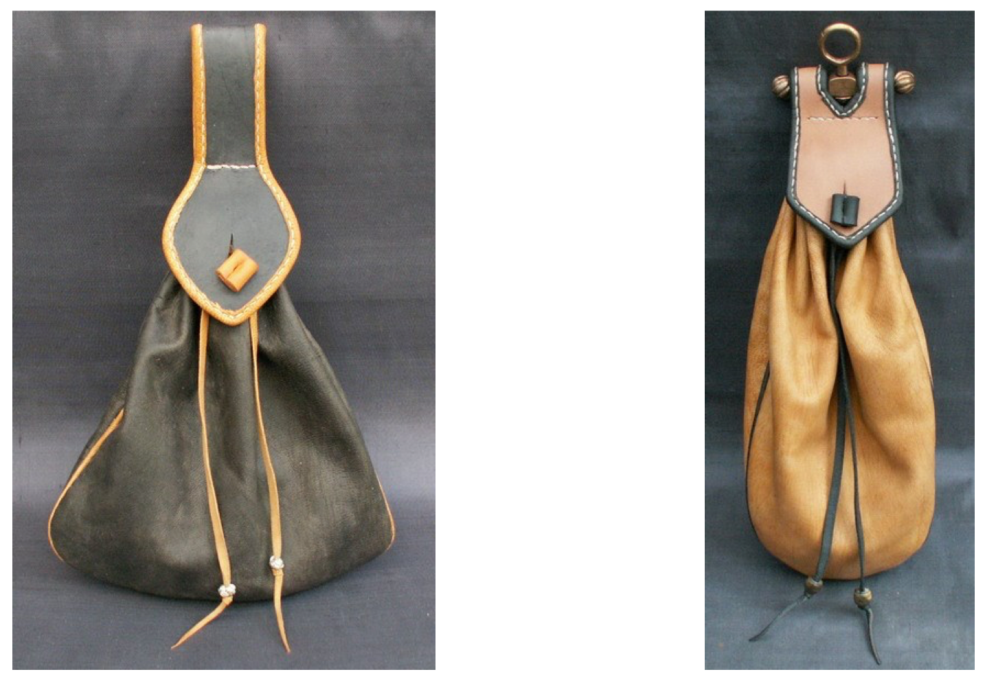

The next two pouches show several examples of embellishments (button closures, trim on the flap, beads on the draw strings and small pouchlets on the front. From a blog: (http://haandkraft.blogspot.ca/search/label/Leatherworking).

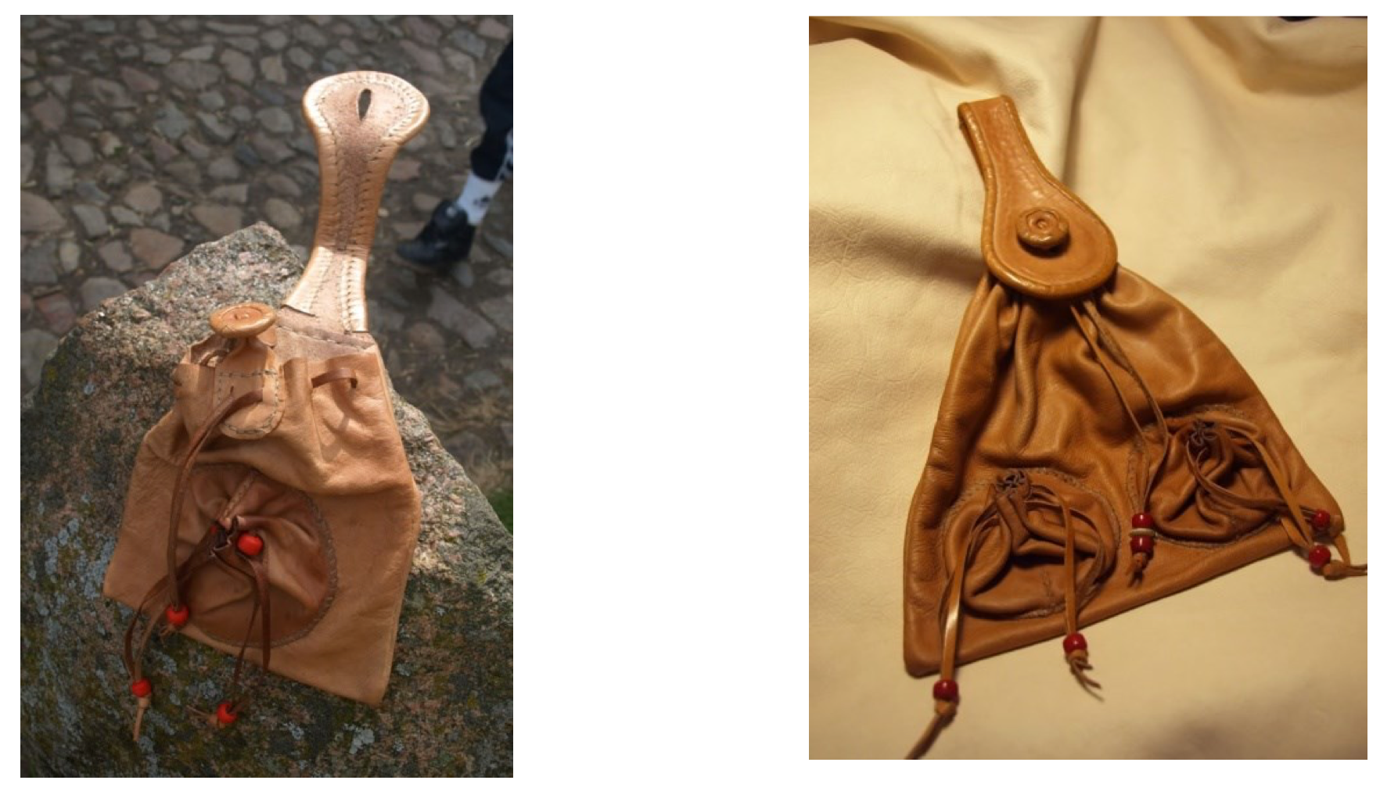

Annex 1 - Documentation

The specific design I used for this pouch is based on a combination of artifacts described and illustrated in Purses in Pieces by Olaf Goubitz, and pouches I found done by other leatherworkers.

The pouch itself has a slightly wider mouth than the base, which is a pouch shape that was seen in period (according to the drawings in Purses in Pieces). The shape I used for this pattern is based on figure D from page 62 of Purses in Pieces. See next page for a copy of the referenced source.

For the specific way I’ve assembled the pouch, I’ve worked off of the really nice pouches done by Karl Robinson (http://www.karlrobinson.co.uk). He’s provided documentation on his site for each particular pouch.

Here is one example, but there are several on his site:
http://www.karlrobinson.co.uk/mens_bags_medium_bag.php

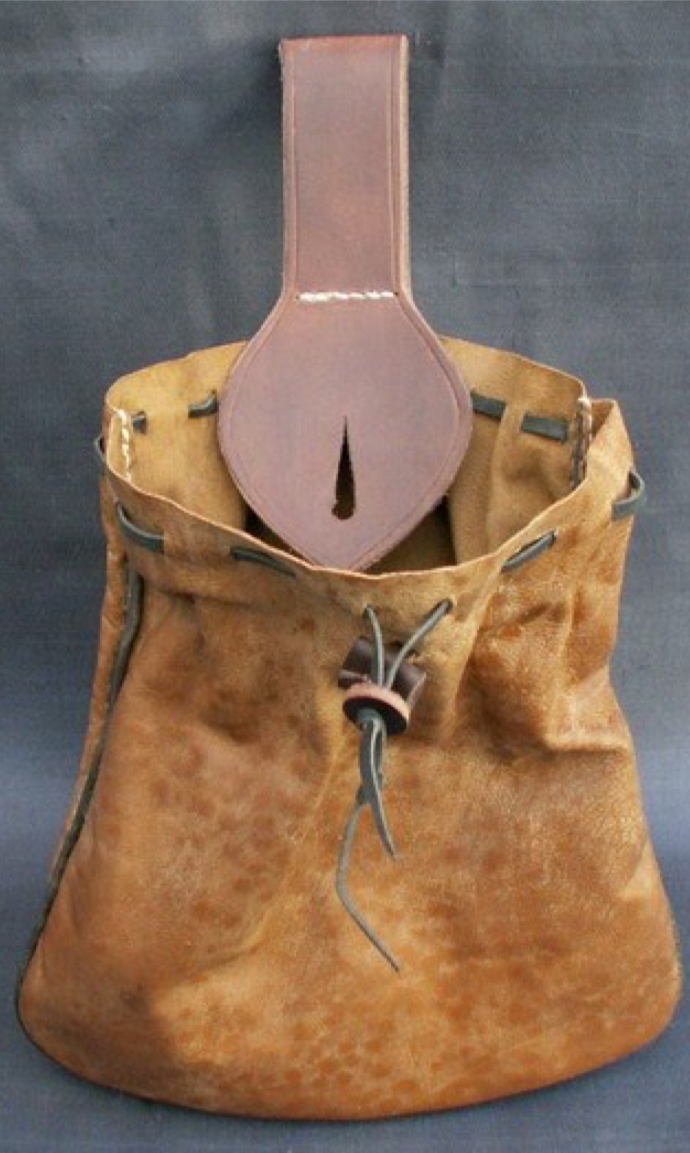

Annexe 2 - General resources

General Leatherworking Info

Leatherworking ABCs from Tandy Leather
http://www.tandyleatherfactory.ca/en-cad/home/infoandservices/leathercraft- abc/leathercraft-abc.aspx

Projects and Guides for Leatherworking from Zelikovitz Leather (local leather store in Ottawa)
http://zelikovitz.com/projects-guides.html

The Art of Hand Sewing Leather by Al Stohlman
http://www.goodreads.com/book/show/2202193.The_Art_of_Hand_Sewing_Leather

Pattern Sources:

Period Patterns #93 – Bags, purses and pouches (Good resource, well documented)
http://www.mediaevalmisc.com/pp-093.htm

Butterick B5371 (Costume patterns – not as fully researched)
http://butterick.mccall.com/b5371-products-10286.php?page_id=916

Historical references:

Medieval and renaissance pouches and purses
http://www.larsdatter.com/pouches.htm

Purses in Pieces
By Olaf Goubitz http://www.oxbowbooks.com/dbbc/purses-in-pieces.html

Dress Accessories, C.1150-C.1450
by Geoff Egan, Frances Pritchard http://www.goodreads.com/book/show/440659.Dress_Accessories_C_1150_C_1450

------
Copyright 2018 by David Gotlieb. <dafydd at rogers.com>. Permission is granted for republication in SCA-related publications, provided the author is credited. Addresses change, but a reasonable attempt should be made to ensure that the author is notified of the publication and if possible receives a copy.

If this article is reprinted in a publication, please place a notice in the publication that you found this article in the Florilegium. I would also appreciate an email to myself, so that I can track which articles are being reprinted. Thanks. -Stefan.

<the end>

