A-Etched-Eggs-art - 2/12/16

"Acid Etched Eggs" by Mistress Kataryna Tkach, O.L.

NOTE: See also the files: pysanky-eggs-msg, eggs-msg, vinegar-msg, Vinegar-art, Workng-Beswax-art.

************************************************************************
NOTICE -

This article was added to this set of files, called Stefan's Florilegium, with the permission of the author.

These files are available on the Internet at: http://www.florilegium.org

Copyright to the contents of this file remains with the author or translator.

While the author will likely give permission for this work to be reprinted in SCA type publications, please check with the author first or check for any permissions granted at the end of this file.

Thank you,
Mark S. Harris...AKA:..Stefan li Rous
stefan at florilegium.org
************************************************************************

Acid Etched Eggs
by Kataryna Tkach

Silverwolf A&S Competition Borealis (Edmonton)
June 2014

Contents

Table of Figures
Introduction
The Recipe
Initial Trial (2002)
Second Trial Set (2005)
Third Trial Set (2014)
Future work
Bibliography

Table of Figures

Table 1: Experimental Attempts to Replicate Hugh Plat's Acid Etched Eggs
Figure 1: Translation:
Figure. 10 Worclaw Cathedral Island
a) Whetstone from layer II / II
b) Fragment of eggs from layers II,
c) Fragment of bone lining from layer II
d) Spindle-whorl, earthenware with green glaze from layer II / III
e) Fragment of the bone comb with openwork okladnica (tine?) from layer II / III
f) Knife copper layer II. (Kóčka & Ostrowska , 1956) 7

Table 2: Work done on acid etched eggs 2005 and 2014

Introduction

This entry comes from my research into pre-1600’s egg decorating techniques while trying to track back the making of Ukrainian pysanky (batik Easter eggs). I first found this recipe in Venetia Newell’s text on the history of decorated eggs across the world, (Newall, 1971). I found Hugh Plat’s recipe on acid etching eggs (Plat, 1594) fascinating for a couple reasons, it uses a resist process that is similar to the batik of pysanky, but does not intentionally dye the eggs. However, I found that the various wine and cider vinegars, depending on how clear they are, do both etch and dye the egg. It’s also worth noting that all modern Ukrainian pysanky dyes are acid (vinegar based) except orange; this may be coincidence or there might be some sort of connection to Hugh Platt’s recipe and the dyes that were used in Ukraine (part of Polish Lithuania in the 16th century).

Although this particular recipe is from England, which at first glance does not appear to have any connection to the Ukrainian egg decorating culture from the time, it seems to hold clues to the broader questions of the methods used to create the pysanky. This of course led me to try to get the recipe to work, so please view this as a series of ongoing experiments rather than one final egg.

The Recipe

There is one detailed account of how to acid etch eggs from "The Jewel-house of Art & Nature" by Hugh Plat 1594:

"32. How to grave any armes, posies, or other devise upon an egg shel, & how to through-cut the same, with divers works & fancies, which will seem very strange to such as know not the maner of the doing thereof. Dippe an egge in suet being molten, first the one halfe, and then the other, holding the same betweene your thumb and forefinger when you dippe it, let the same coole in your hand, and beeing colde, with a sharpe bodkin or some other instrument of iron, worke or grave in the suet what letters or portrature you wil, taking away the suet clean, & leaving the shell bare at the bottom of your worke. Then lay this eg thus engraved in good wine vinegar or strong alliger in a Glasse or stone Pottinger, for some six or eight houres, or more, or lesse, according to the strength and sharpnesse of the Vinegar, then take out the egge, and in water that is blood warme disolve the suet from the egge, then lay your egge to coole, and the woorke will appear to be graven in the shell of a russet color. Saepius probatum. And if the egge lie long inough in the vineger after it is so graven, and sovered in suet as before, the letters will appear upon the egge it selfe being hard sodden, or else if you care not to loose the meate, you may picke out the same when the shell is through graven, and so you shall have a strange piece of work perfourmed." (Plat, 1594)

Initial Trial (2002)

Attempting to follow this recipe for acid etching, I have met with limited success. After trying Plat's method I found that the designs achieved when using straight store bought suet left much to be desired. If the suet was melted until it cleared, and the egg was dipped into the fat and allowed to cool, the layer of fat was too thin to protect the egg from the vinegar. This was over the course of the next few years as I was teaching a class on this technique, tried at different molten temperatures and under many conditions including using a fire to warm the suet in the winter, and allowing the suet to cool significantly (-5C) before trying to etch it, leaving the suet in the sun on a hot day, then taking it into a cellar to cool it; and anything I could think of in between. The results were disappointing and largely the same, the egg was either completely red, or there were no distinguishable images, dipping the egg in molten suet and scratching a design was not working.

When the suet was thicker, no longer clear and more suet like (on its way to cooling); a design could be seen on the egg, but it was not usually the distinct pattern that was drawn. However, if wax, or a combination of wax and suet was used, a clear design would show up on the egg. Wine vinegar would leave a reddish indent where the egg was free of wax. This was most noticeable on farm eggs, which are not washed in bleach and have thicker shells. Commercial eggs are bleach washed before being sent to the stores for health reasons. This washing thins the shells decreasing their uptake of the natural dye in the wine and increases fragility, making them a poor choice for either pysanky or Plat's acid etching. I have still not found a combination with which Suet alone works. Eggs experimented on using by this method can be seen in Table 1.

Table 1: Experimental Attempts to Replicate Hugh Plat's Acid Etched Eggs
Suet Type | Approximate Heat | Result
Beef Suet | Suet Heated until molten | Whole egg turns red
Beef Suet | Suet Warmed in the sun ~  the consistency of butter. | Blotches of red but no  'graven images'
Beef Suet | Suet Warmed, Put on egg  then placed in the  fridge (4C) | Blotches of red but no 'graven images'
Beef Suet | Suet Warmed, Put on egg  then placed out in the  winter (-5C) | Blotches of red but no  'graven images'
Lamb Suet | Suet Heated until molten | Whole Egg turns red
Lamb Suet | Suet Warmed, Put on egg  then placed out in the  winter (-5C) | Blotches of red but no  'graven images'
Lamb Suet from beneath  the tail, High wax content | Suet Warmed, Put on egg  then placed in fridge (4C) | Better then the others but  not images, Still blotchy.  (Egg destroyed in transit)
Beeswax  Red Wine Vinegar | Heated until molten, Put on egg allowed to cool. | Does not melt off in warm  Water  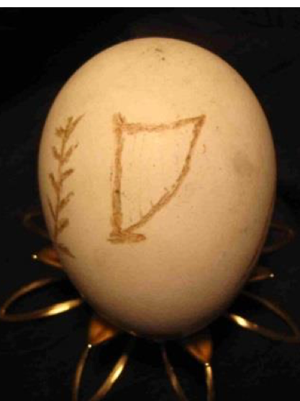
70% Beeswax/ 30% Suet  Mix  Red Wine Vinegar | Heated until molten, Put on egg allowed to cool. | Does not melt off in warm water  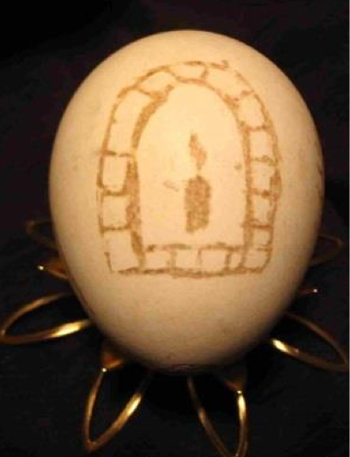

Experimental notes:

1) The higher the acidity of the vinegar the faster the etching.

2) Use Red Wine of Cider Vinegar to get the reddish colour Hugh speaks of.

3) Use farm eggs that haven't been washed, bleached eggs have three issues a) the vinegar responds at a weaker strength (perhaps neutralized by the bleach), b) the dye uptakes is less, c) the egg shell is more fragile. Farm eggs have thicker shells so produce deeper etchings.

Second Trial Set (2005)

I attempted to acid etch a duck egg in 2005 using wax and 50% lab grade acetic acid for 10 minutes. Unbeknownst to me duck eggs have a waxy coat to keep out water, and once disrupted are very porous. This caused the acid to leak inside and ate the shell from the inside out. Any attempt to take the wax off this egg resulted in the egg collapsing. I would have to do this with less concentrated acetic acid and multiple dips if I attempt it in the future (Table 2).

Third Trial Set (2014)

Following Jadwiga Zajaczkowa’s (mka Jennifer Heise) notes on her attempt at the same recipe (Heise, 2002), I got the idea to try painting the suet on thickly rather than trying to scratch it off. There is some indication that perhaps a pin was used to apply the wax to a pysanky based on a couple of finds of eggs or egg shells, one decorated, along with a needle, (Kóčka & Ostrowska, 1956) (Figure 1); so I thought perhaps applying the suet with a pin or a brush might solve the issue regarding getting a reasonable image from Plat’s recipe.

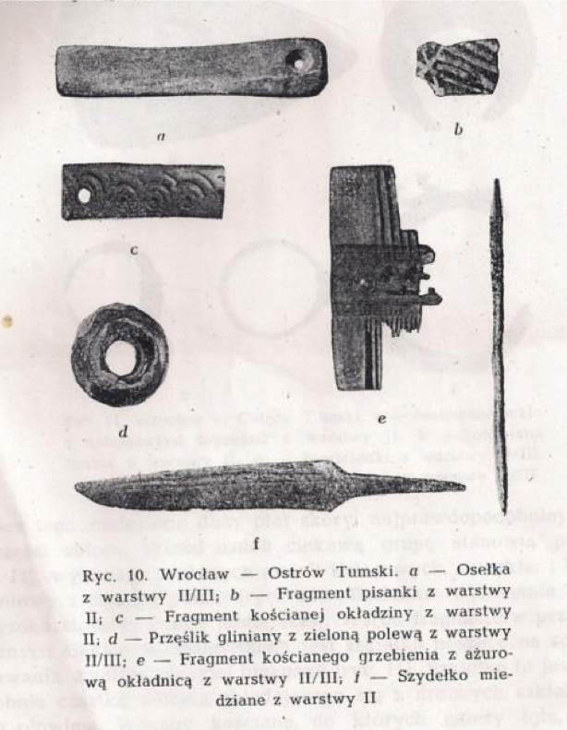
Figure 1: Translation: Figure. 10 Worclaw Cathedral Island a) Whetstone from layer II / II b) Fragment of eggs from layers II, c) Fragment of bone lining from layer II d) Spindle-whorl, earthenware with green glaze from layer II / III e) Fragment of the bone comb with openwork okladnica (tine?) from layer II / III f) Knife copper layer II. (Kóčka & Ostrowska , 1956)

The first problem with applying rather than scratching the suet off was that white suet on a white egg was not visible. To make the suet visible I added just a little tumeric to the suet. In my experience tumeric in large quantities will dye an egg, smaller amounts seem to leave very little colour which can be for the most part rubbed off, but anything to add a touch of colour to the suet will do – charcoal or simply any particulate colour that will not bind to the eggshell and can be rubbed off will do. I simply happened to have tumeric close at hand. This was not part of the recipe, but given that the recipe does not work as written, and that suet was used in cooking it may not have been the nice white suet that is the only sort available from a butcher these days. A slight tinge might have happened when it was being used in a domestic setting.

In any case for the purpose of this experiment I tinged my suet.

I tried using a number of different vinegars again, white pickling vinegar (7% acetic acid), cider vinegar (6% acetic acid), commercially bought red wine vinegar (6% acetic acid), and some vinegar from Onund’s that came from a spoiled batch of wine (Unknown % acetic acid – likely a higher percentage than the others). The white picking vinegar was again an issue, because I couldn’t see how deeply the egg was being etched. So I added tumeric again, but this time got carried away and some got on the egg making it a darker yellow than the amount I added (Table 2).

The results of the etching were immediately more positive, though clearly this would be a technique that takes a bit of practice.

Table 2: Work done on acid etched eggs 2005 and 2014
What was done | Result
2005 work – Duck egg was waxed  and etching using lab grade acetic  acid for 10 minutes. | Over etched. Destroyed the egg. | 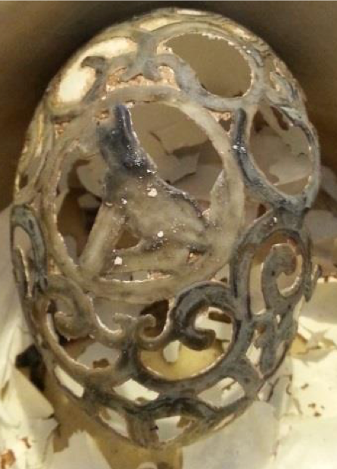
2014 work – Warmed Suet was  painted on roughly, and the egg  was placed in white pickling  vinegar for 5 minutes. Egg was  checked and the lines couldn’t be  seen. Sprinkled some tumeric in to  be able to see where the white  vinegar was working. Egg returned  to the vinegar for 5 minutes | Adding the tumeric caused a  heavy stain in one area of the  egg. The actual etched area is  hard to see and not highly  etched (compared to the  other vinegar tests). | 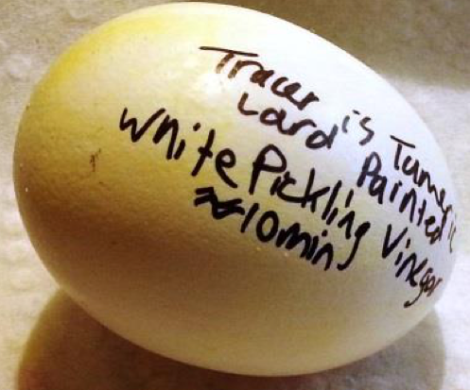
Suet was painted on roughly and the  egg was placed in cider vinegar  for 10 minutes. Pulled out allowed  to dry before the suet was wiped off | A very pale yellow stain on  the etched area. Not much  different than the white  vinegar. | 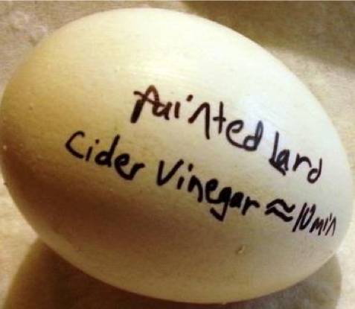
Suet was painted on roughly and  the egg was placed in commercial  red wine vinegar for 10 minutes.  Pulled out and allowed to dry  before the suet was wiped off | A grey-red stain appeared on  the etched area, rubbing the  stained area before it dries  removes the stain. The area  exposed to the vinegar is  minimally etched. Try this  in an overnight egg test. | 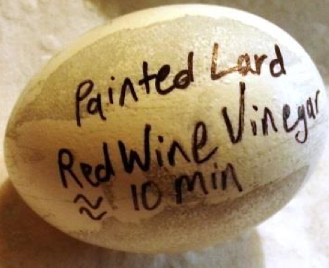
Suet was painted on roughly and  the egg was placed in Onund’s  grape wine vinegar for 10 minutes.  Pulled out and allowed to dry  before the suet was wiped off | A red-brown stain appeared  on the etched area, rubbing  the stain before dry removes  the stain. The area exposed is  the most etched. Decide to  proceed with this for other  egg tests. | 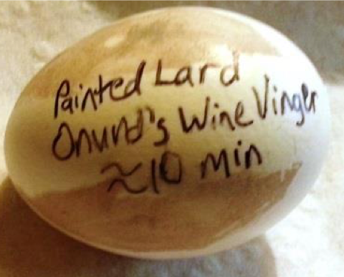
Painted suet on more carefully,  trying to make a design. Egg placed  in Onund’s grape wine vinegar for  two hours. Pulled out and allowed  to dry before the suet was wiped  off. | Brush strokes appeared in the suet  covered area. Found it was  problematic to keep my fingers  out of the large which removes suet  from places I wanted or adds it to  places I don’t. Also it is hard to  paint lines thinly. This works but  does not give crisp lines I would  want to make a design of heraldic  arms. Decide to use wax to do  overnight tests. | 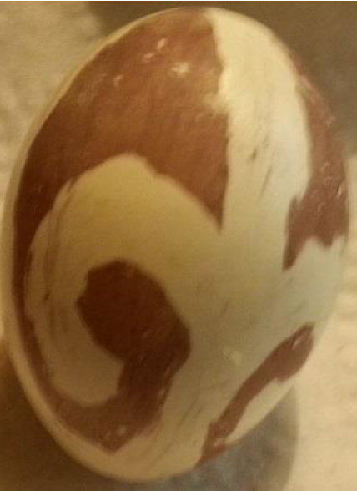
Painted suet on, set egg in  commercial red wine vinegar  overnight. | Suet lifted off the egg, and all marks  were rendered indistinct like the  initial 2002 trials. | 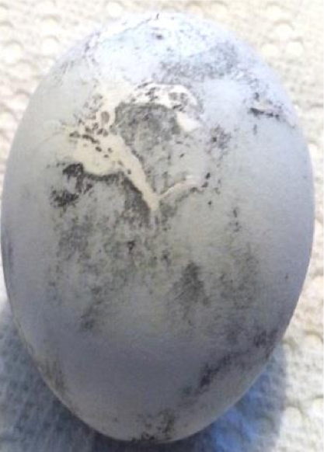
Applying wax to an egg. Used a  kystka rather than a pin in order  to achieve the lines I want on the  egg. |  | 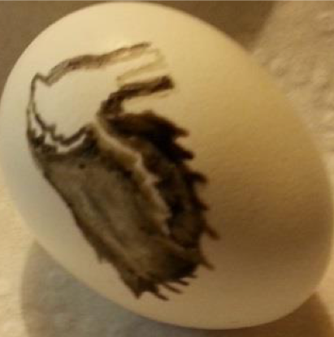
Waxed egg checked after 10 minutes  in Onund’s grape wine vinegar to  see the amount of etching, placed  back in vinegar overnight. This  picture is half way through the  process. | Etching is proceeding well.  Used a pin to clean up some  fine details in the wax by  scratching the wax away.. | 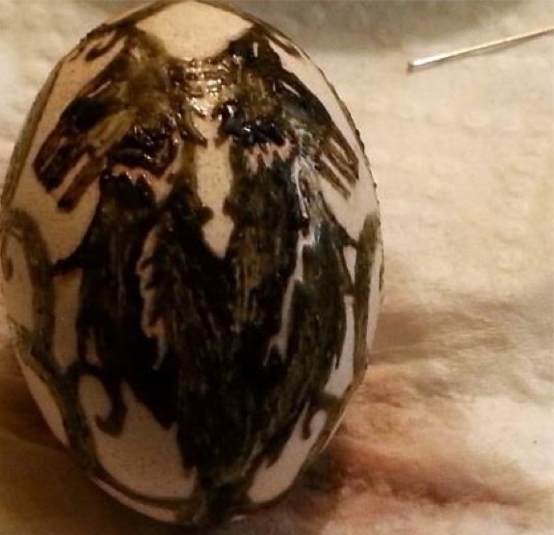
Waxed egg checked the next  morning | Etching has not gotten all the  way through the egg, but is good  enough to allow to dry. | 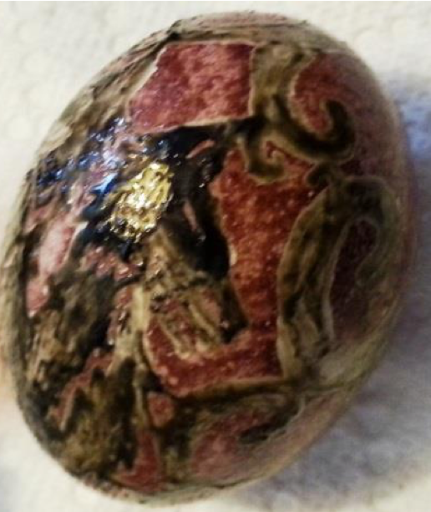
Removed wax from egg, realized  that the rubbed area scratched with  a pin suggested a way of etching  through the egg. Started another  egg. | Egg is mostly a success, though  it didn’t etch through the  whole egg, it did leave a distinct  image. | 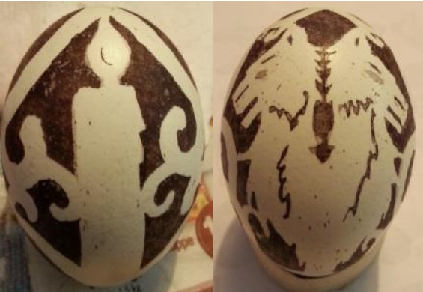
Note: The pictures of the vinegar tests have the word lard written on them. This is because it was Beef fat I cooked and then rendered it (heating it until molten allowing it to stay hot a bit to make sure it won’t grow and then straining it and allowing it to cool again. My mother calls it lard, so that’s what I tend to write without thinking – though the correct term would be Tallow; Lard being pork fat (with a slightly lower melting temperature).

Future work

The newest eggs (above) have still not etched all the way through the shell, and I have started another egg to see if I could do that without over etching. This final egg used wax, not suet, and was dipped multiple times in Onund’s vinegar, scraping off the outer area of the egg with a pin each time, then re dipping. After two days it was noticeable that the vinegar was etching the egg but there was no way the vinegar would actually etch through the egg in the remaining time. Though dipping and scraping the egg with a pin would eventually get through the egg; I pulled out the 50% lab grade acetic acid and dipped the egg in it repeatedly. Unfortunately it did not etch evenly, and one section broke before the rest was ready. At which point I had to stop dipping the egg. Instead I wrapped it with an acid soaked piece of cheese cloth and repeatedly cleaned the egg as I worked. The design on the egg was not particularly stable and eventually the acid etching had to be stopped before it had gotten through the shell.

Modern acid etching often uses muriatic acid, though there are some recipes that use acetic acid, and often the trick is to clean the egg with a toothbrush between etchings.

I would still like to continue my attempts to replicate the period recipe, but until I can determine how to get the suet to stay on the egg for 6 hours, and I’ve had more practice with applying it, any etched eggs will have to be done using wax in order to get a reasonable design on the egg.

Bibliography

Heise, J. (2002). Eggs dyed with period dyestuffs. Retrieved from Jadwiga Zajaczkowa's Page: http://www.gallowglass.org/jadwiga/SCA/eggs/eggdyes.html

Kóčka, W., & Ostrowska , E. (1956). Wyniki prac wykopaliskowych we Wrocławiu na Ostrowie Tumskim w latach 1953 i 1954. Sprawozdania archeologiczne II, 85-95.

Newall, V. (1971). An Egg At Easter: A Folklore Study. London: Routledge & Kegan Paul Ltd.

Plat, H. (1594). The jewell house of art and nature conteining diuers rare and profitable inuentions, together with sundry new experimentes in the art of husbandry, distillation, and Moulding. London: Elizabeth Alsop.
------
Copyright 2014 by Susan Koziel. <kataryna_dragonweaver at yahoo.com>. Permission is granted for republication in SCA-related publications, provided the author is credited. Addresses change, but a reasonable attempt should be made to ensure that the author is notified of the publication and if possible receives a copy.

If this article is reprinted in a publication, please place a notice in the publication that you found this article in the Florilegium. I would also appreciate an email to myself, so that I can track which articles are being reprinted. Thanks. -Stefan.

<the end>

