Wdn-Seal-Lcks-art - 7/16/17

"Wooden seals for tribute bags, from Novgorod" by HL Marya Kargashina.

NOTE: See also the files: commerce-msg, fur-msg, Kiev-Slavery-art, Rus-Handbook-art, Russia-msg, Birch-Brk-Wrt-art, tools-bib, wood-msg.

************************************************************************
NOTICE -

This article was added to this set of files, called Stefan's Florilegium, with the permission of the author.

These files are available on the Internet at: http://www.florilegium.org

Copyright to the contents of this file remains with the author or translator.

While the author will likely give permission for this work to be reprinted in SCA type publications, please check with the author first or check for any permissions granted at the end of this file.

Thank you,
Mark S. Harris...AKA:..Stefan li Rous
stefan at florilegium.org
************************************************************************

You can find more work by this author on her website at:
https://kargashina.wordpress.com

Wooden seals for tribute bags, from Novgorod
by HL Marya Kargashina

Fur collectors and tribute collectors in Novgorod used cylindrical wooden seals to secure and mark bags of fur and other items. I want to try making some of these, as the mechanism is very intriguing.

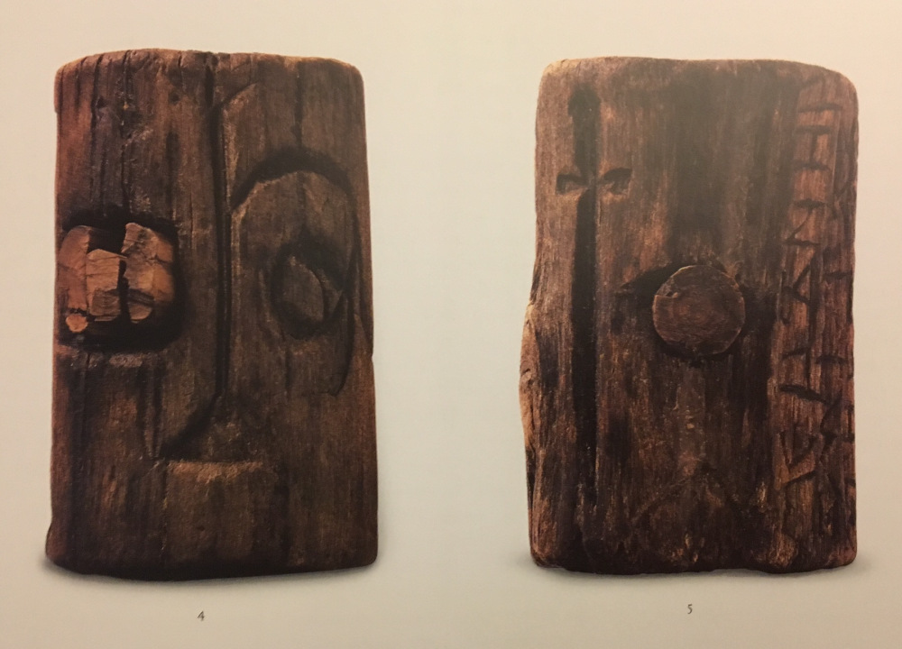
Figure 1. Seal ca 1000. From Petrova et al.

Seal locks, wooden cylinders bored through vertically and horizontally, were used to both secure and mark tribute sacks, usually of fur. (Yanin 2007) They were usually made of thin birch or alder branches, with the bark initially left on. Dimensions are approximately 7-8 cm long by 5-6 cm wide. At least fifty-one have been found in Novgorod, with thirty-eight on the same property, an administrative center. (Yanin 2007)(Noonan & Kovalev) Seal locks are found as early as 970/980, but the bulk of these finds date to the 11th century, with some finds from the12th century. (Franklin, Yanin 2007)

The seals are locked by knotting the ends of the drawstring of a sack, and running both ends of the drawstring through the longer axis groove, centering a second knot, finally driving a peg through the shorter axis groove, cutting it flush and splitting it, thereby retaining the knot. This prevents the bag from being untied without either cutting the drawstring or splitting the lock. Some finds have been found with this string still in the lock. (Yanin 2007, Kolchin) (figure 1, 2g, 3-7)

Seal locks provide their own window into the growth and scope of the Novgorod fur trade.

Pelts were packaged and sent to Novgorod from the northern hinterlands in sacks sealed with these wooden locks, often marked with both owner and the collector or location. Six seal locks with listed locations where the tribute was collected have been found in Novgorod, all from the northwest hinterlands of the Svernaya Dvina, between 520- 900 km distant from Novgorod itself. (Yanin 2007, Makarov 2006) Some squirrel bones were found at Minino, with finds supporting widespread squirrel hunting from the 10tn through the 13th centuries. (Makarov 2012) Cross referencing these finds with names from the birchbark documents allows us to see that Novgorod had begun to assert territorial claims in the northern Dvina in search of fur as early as the 11th century (Makarov 2006)

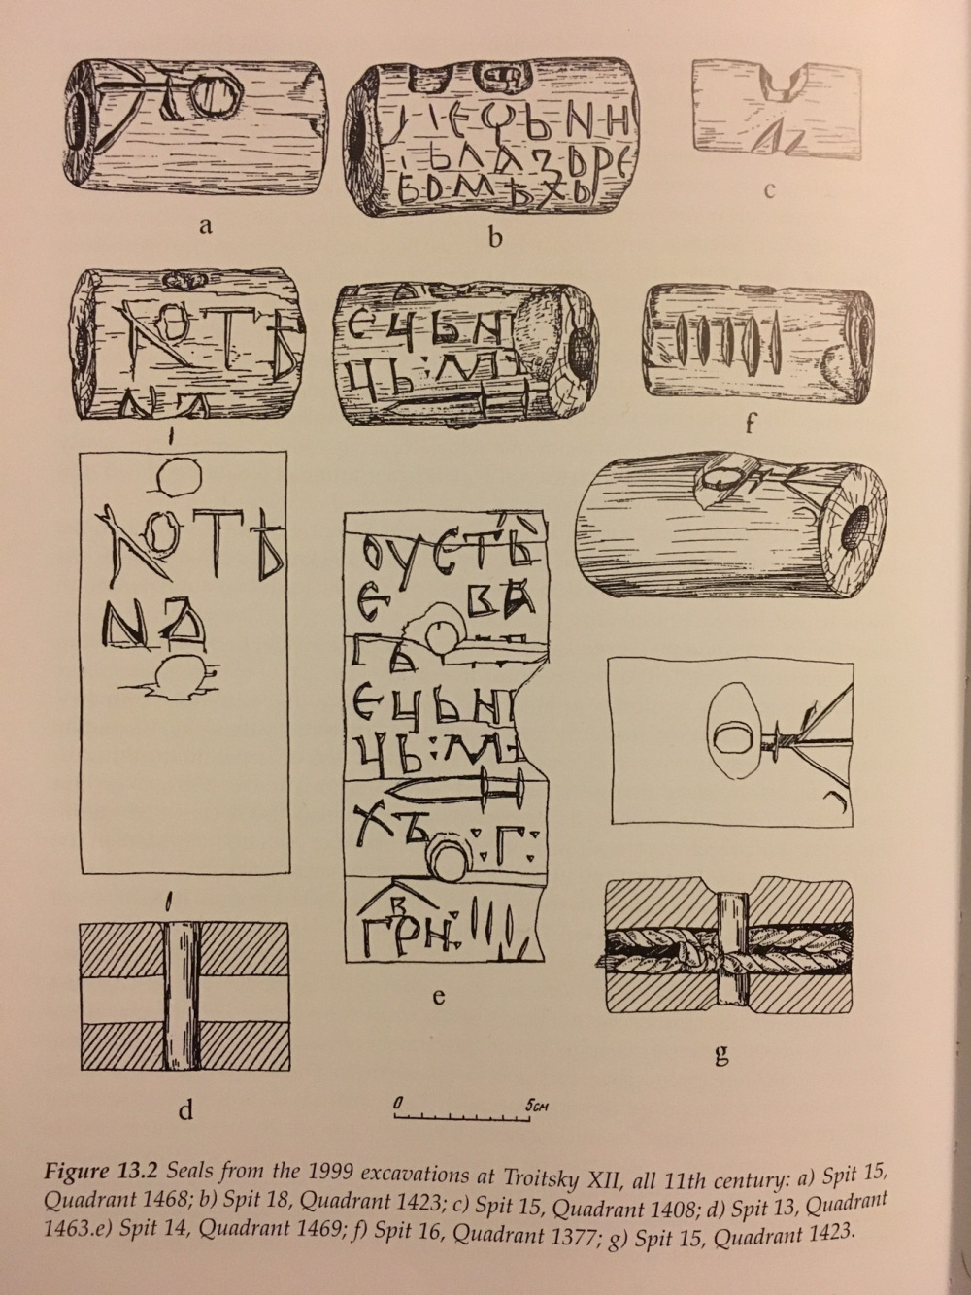
Fig. 2. 11th c seals, from Yanin.

Inscriptions include marks of princes, locations and amounts collected, and names of tribute collectors, with some seal locks being merely notched to indicate a quantity. (Petrova et al, Yainin 2007) Not all are inscribed, but all indicate tribute or fee activity in their context. When inscriptions are present, they name owners, collectors, or administrative officials, or summarize the contents. The inscriptions may include symbols, names or both. (Kolchin, Franklin) Some ten of the seal locks with retained plugs are uninscribed, however these also had lost their bark, and potentially the inscriptions therewith. (Yanin 2007)

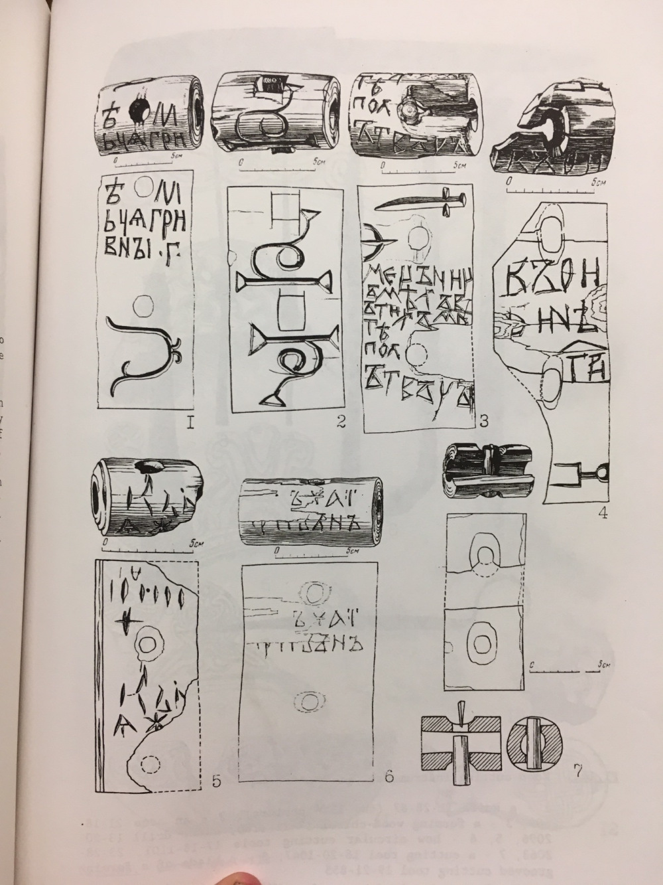
Fig. 3. Seals, with peg cross section. From Kolchin.

The locations of these finds in the residences of the local elite, and their markings indicating their content's status as tribute, allow us to see that tribute was collected by the local landowners, not the Prince directly. (Yanin 2007) Some of the inscriptions refer to individuals appearing in the birchbark charters discussing tax collection, further supporting the local role in taxation, as seen also in the agreement Novgorod maintained with its princes. (Michell & Forbes)

One of these seal locks has five notches cut into it, which Noonan and Kovalev suggest indicates five sorochoks/one sack of fur. (Noonan & Kovalev 2004) (figure 2f) Another pair is labeled 'Khoten', and can be linked to a tax collector named Khoten found in birchbark document 902.

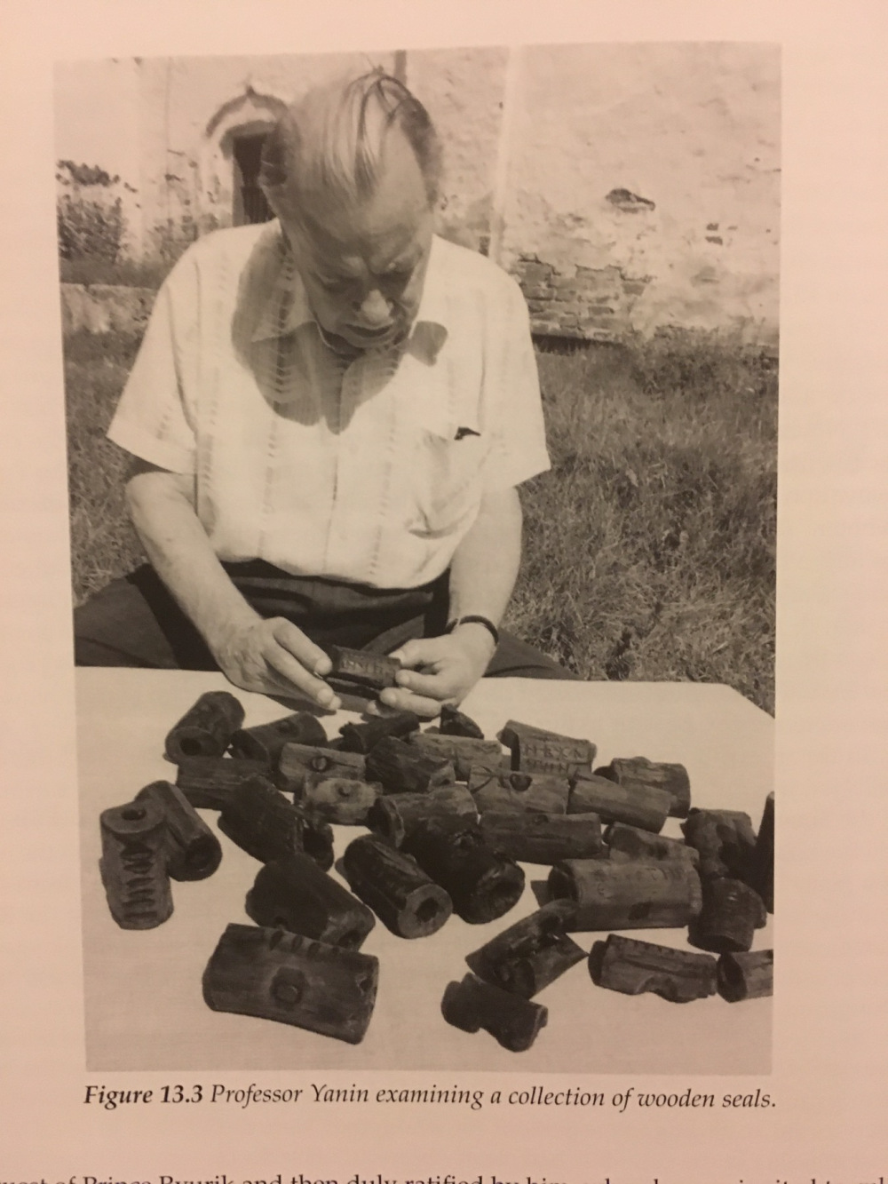
Fig. 4. V. L. Yanin with wooden seals. From Yanin.

I suspect the holes would be bored out with a spoon bit, possibly in longer pieces that could be cut into multiple cylinders.

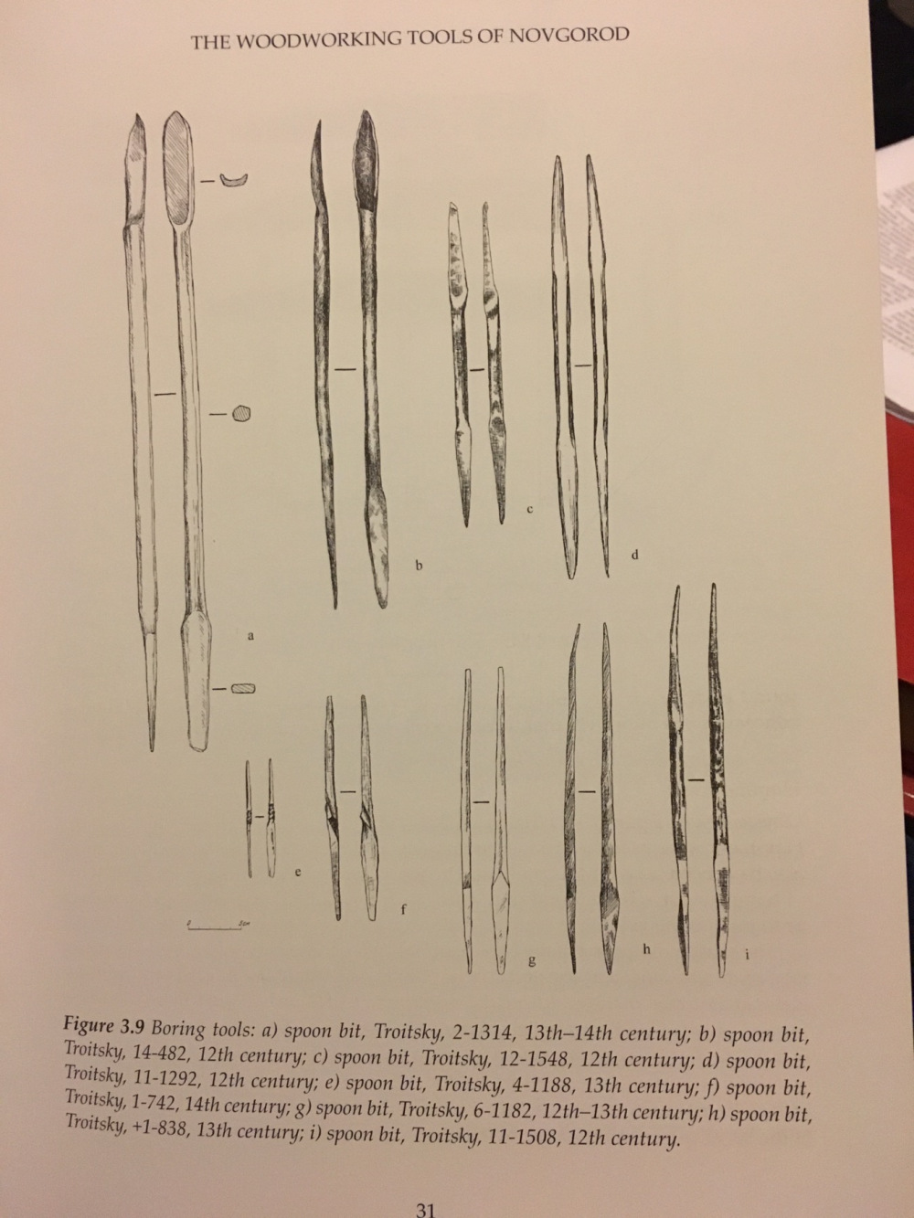
Fig. 5. Spoon bits found in Novgorod. From Brisbane et al 2007.

Excerpted from my paper for An Tir's Kingdom Arts & Sciences Championship 2017, Forty Pelts in a Bundle: Archaeological Evidence for the Use of the Sorochok/Timber Unit in Medieval Novgorod. Paper available in full here:
https://docs.google.com/document/d/14_WmoFrZ1vHnOSE8yDh6GwUW6gDrfAgOVL8WEEXqCwo

Sources:

Brisbane, Mark, and David R. M. Gaimster. Novgorod: The Archaeology of a Russian Medieval City and Its Hinterland. London: British Museum, 2001. Print.

Brisbane, Mark, Jon G. Hather, and Katherine Judelson. Wood Use in Medieval Novgorod. Oxford: Oxbow, 2007. Print.

Brisbane, Mark, N. A. Makarov, E. N. Nosov, and Katherine Judelson. The Archaeology of Medieval Novgorod in Context: Studies in Centre/periphery Relations. Oxford: Oxbow, 2012. Print.

Franklin, Simon. Writing, Society and Culture in Early Rus, C. 950-1300. Cambridge: Cambridge UP, 2002. Print.

Kolchin, Boris. Wooden Artefacts from Medieval Novgorod. Oxford: B. A. R., 1989. Print.

Makarov, N. A. "Cultural Identity of the Russian North Settlers in the 10th – 13th Centuries: Archaeological Evidence and Written Sources." Slavica Helsingensia 27 (2006): 259-81. Print.

Makarov, N. A. "The Economy of the Fur Trade in the Northern Borderlands of Medieval Russia." The Archaeology of Medieval Novgorod in Context; Studies in in Center Periphery Relations. Ed. Mark A. Brisbane. Oxford: Oxbow, 2012. 381-90. Print.
Martin, Janet. Treasure of the Land of Darkness: The Fur Trade and Its Significance for Medieval Russia. Cambridge: Cambridge UP, 1986. Print.

Michell, Robert, and Nevill Forbes. The Chronicle of Novgorod: 1046-1471. London: Camden Society, 1914. Print.

Noonan, Th S., and R.k. Kovalev. "What Can Archaeology Tell Us About How Debts Were Documented and Collected in Kievan R US'?" Russian History 27.1 (2000): 119-54. Web.

Noonan, Thomas, and Roman Kovalev. "The Furry 40's. Packaging Pelts in Medieval Northern Europe." States, Societies, Cultures, East and West. Essays in Honor of Jaroslaw Pelenski. Ed. Janusz Duzinkiewicz. New York: Ross, 2004. 653-82. Print.

Petrova, E. N., C. Griffith Mann, Peter Bray, and Kenneth MacInnes. Sacred Arts and City Life: The Glory of Medieval Novgorod. Baltimore: Palace Editions, 2005. Print.

Thompson, M. W. Novgorod the Great; Excavations at the Medieval City Directed by A.V. Artsikhovsky and B.A. Kolchin. New York: Praeger, 1967. Print.

Yanin, V. L. "The Wooden Seals of Tribute Collectors." Wood Use in Medieval Novgorod. Ed. Mark Brisbane. Oxford: Oxbow, 2007. 203-08. Print.
------
Copyright <year> by Jessica Smith-Carlock. <Kargashina at gmail.com>. Permission is granted for republication in SCA-related publications, provided the author is credited. Addresses change, but a reasonable attempt should be made to ensure that the author is notified of the publication and if possible receives a copy.

If this article is reprinted in a publication, please place a notice in the publication that you found this article in the Florilegium. I would also appreciate an email to myself, so that I can track which articles are being reprinted. Thanks. -Stefan.

<the end>

