Scot-Targe-art - 10/4/13

"The Highland Targe" by Lord Mungo Napier.

NOTE: See also the files: Scotland-msg, Kilts-1590-art, shields-msg, W-T-Shields-art, Shield-Balanc-art, glues-msg, wood-msg, leather-dyeing-msg, leather-msg.

************************************************************************
NOTICE -

This article was submitted to me by the author for inclusion in this set of files, called Stefan's Florilegium.

These files are available on the Internet at: http://www.florilegium.org

Copyright to the contents of this file remains with the author or translator.

While the author will likely give permission for this work to be reprinted in SCA type publications, please check with the author first or check for any permissions granted at the end of this file.

Thank you,
Mark S. Harris...AKA:..Stefan li Rous
stefan at florilegium.org
************************************************************************

AN TARGAID GAIDHEALACH
THE HEILAND TARGE
THE HIGHLAND TARGET

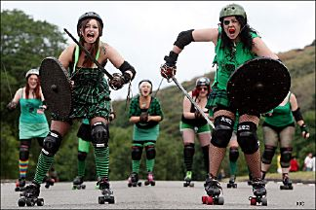
Auld Reekie Roller Girls, Edinburgh. Don't mess with these ladies! (Photo Source: BBC)

by Lord Mungo Napier, Archer of Mallard Lodge

SOME TARGE HISTORY

The Scottish targe is one of the world's most recognizable weapons. These shields are closely associated with the Highlanders, especially with the Jacobite risings, ending with Bonnie Prince Charlie's tragic return during 1745-46. However, the Scottish targe is not exclusively a Highland weapon. Lowlanders also carried the targe in great numbers throughout Scottish history.

Nor is the targe exclusively Scottish. What is probably the oldest surviving targe is actually a "targa", to use the original Frankish term for such shields. This targa was recovered in western Germany from a Merovingian grave dated to around 600 CE. Historian Christopher Rothero claims targes were carried by English infantrymen during Edward I's attempted conquest of Scotland circa 1300. One beautifully decorated targe dating to the 1500s still exists in Ireland

The earliest evidence of the targe in Scotland comes from dark ages Pictish cross stones. Several show mounted warriors carrying bucklers with metal bosses covering holes in their centers. Their two-layer cores were similar to later targes.

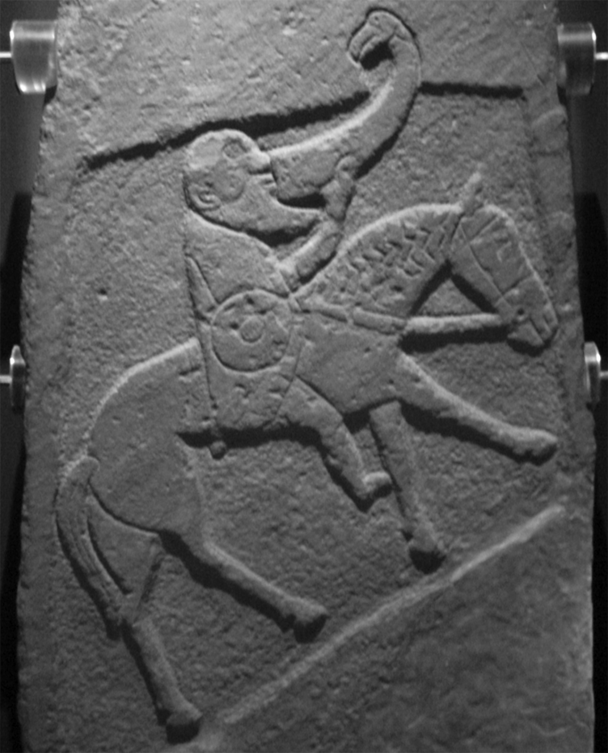
The Pictish Bullion Stone, 10th century, now in the Museum of Scotland, Edinburgh (Source: Wikipedia)

There are no clear descriptions of common Scottish soldiers from the Wars of Scottish Independence (1296-1340) showing targes, however their use by infantrymen is very likely. The only known depictions of Scots infantrymen are illuminations on the Carlisle Charter. Three of the six figures have shields, all Anglo-Norman heater shields. Based on tomb figures throughout the late middle ages, most Lowland Scottish nobles carried Anglo-Norman-style heater shields, which is hardly surprising since many were Anglo-Normans and armed themselves like their English neighbors. Professional soldiers in their garrisons would have likely been armed this way.
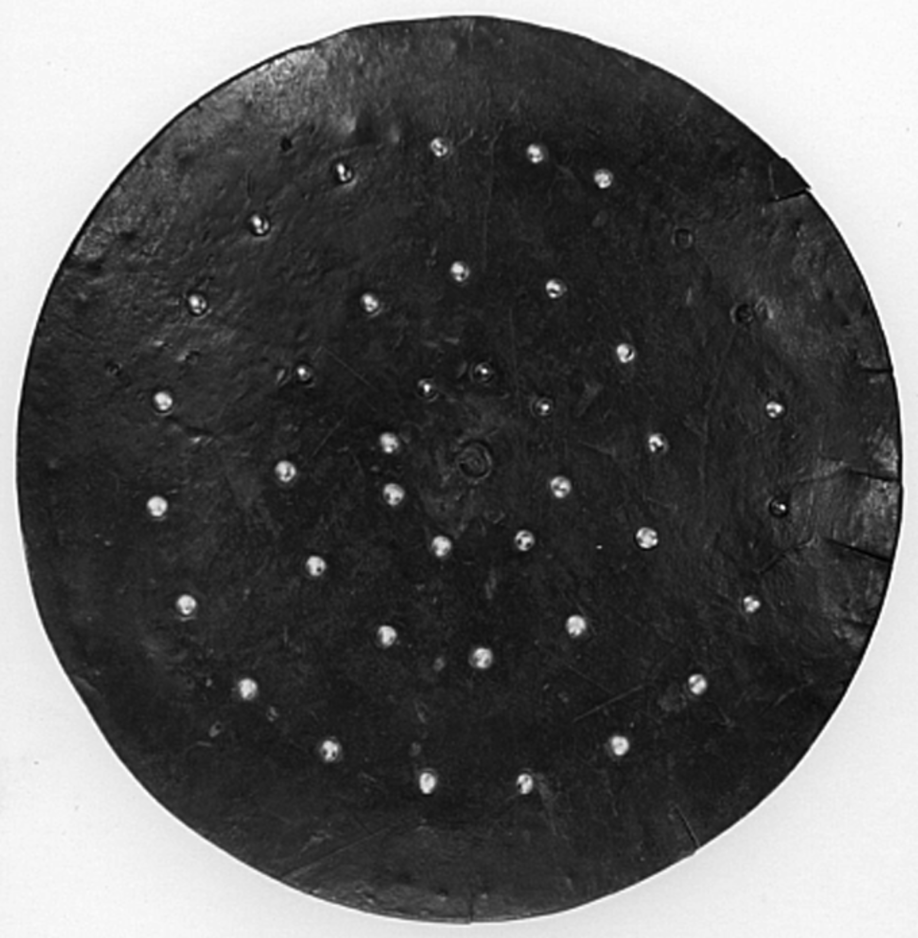
One of the few commoners' targes to survive. (Source: National Army Museum web site).

Scottish Parliaments, under the orders of various kings, passed laws setting down what types of weapons a man was required to own for the defense of the realm. The lowest men in the kingdom, mostly small farmers or craftsmen, were given a choice of simple weapons. Bucklers were specified in 1426, though the law may have meant targes. The word "targe" first appeared in 1456.

Commoners probably made most of their own targes. These might be bare wood (a "targe of burde"), or covered with leather (a "targe of leddir"). These were simple, rugged and cheap. They had little ornamentation, their tacks being mainly to hold the leather cover on, though most targes had at least an attempt at an interesting design. These "commoners' targes" made up the vast majority of all the targes ever carried by Scots up to the Battle of Culloden in 1746.
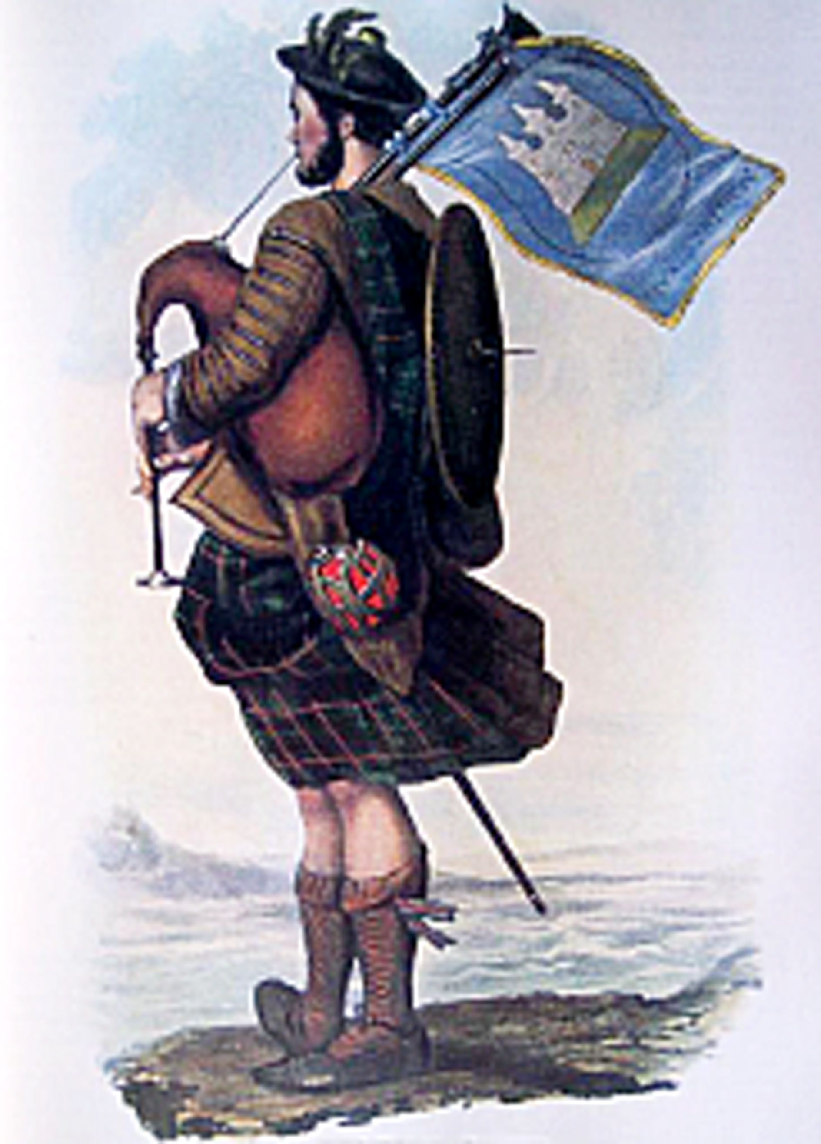

Another type of targe, the "Gentleman's targe", is known from the 1500s, though they might have been in use earlier. These featured elaborate tooling on the face, with Celtic swirls, beasties, and even heraldic devices. Their tacks were arranged in complex patterns, sometimes mixed with plates of brass or even silver. Some had a boss in the center which could be unscrewed and used as a drinking cup, useful for whisky. Gentlemen's targes were made by skilled craftsmen, and could only be afforded by titled lords, clan chiefs, their chieftains, chiefs' champions, and other wealthy men.

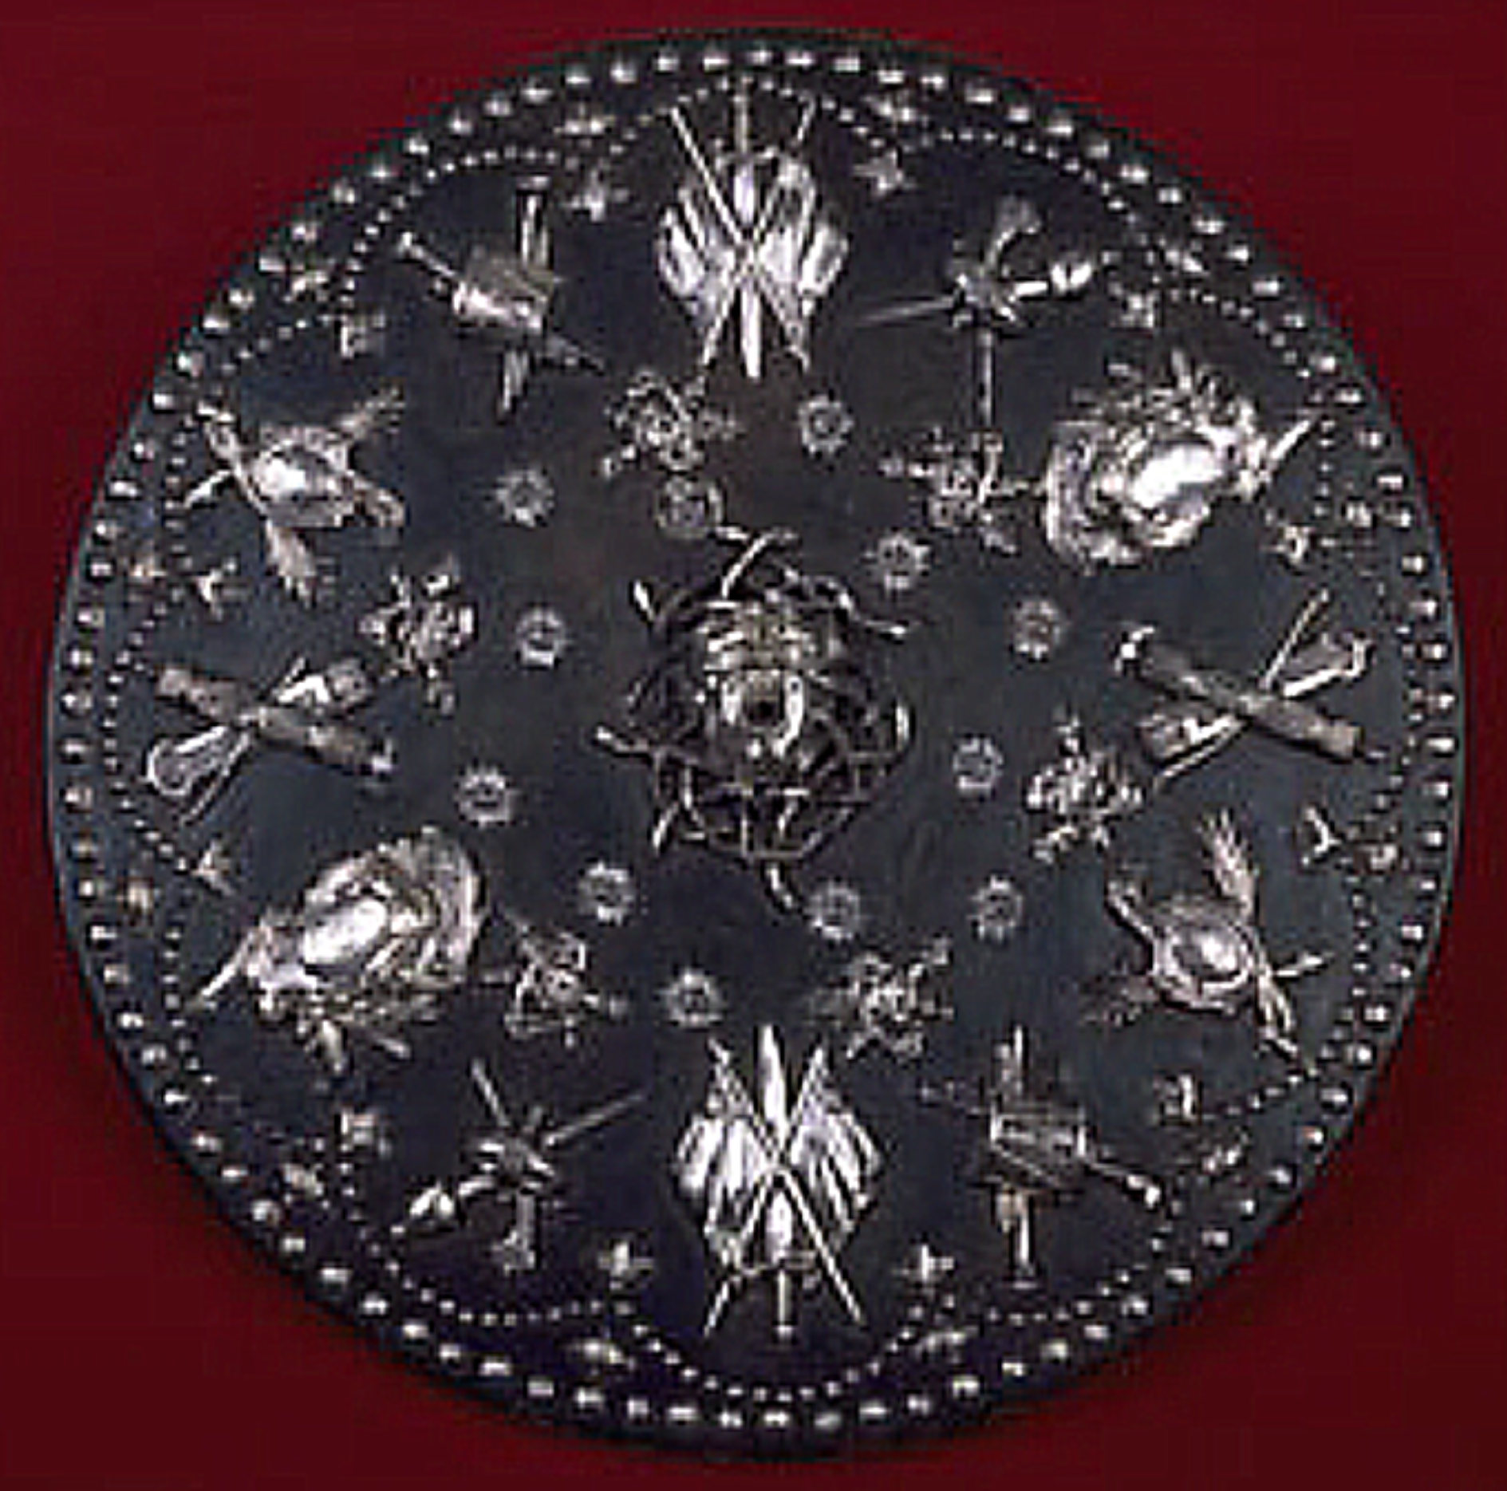
Bonnie Prince Charlie's shield is the ultimate in gentlemen's targes. (National Museums of Scotland web site)

Gentlemen's targes were symbols of rank and authority and were passed on to successors as family heirlooms. Some are still hanging in Scottish castles. If lost in battle, these targes became trophies for the victors, and were kept in officers' messes along with captured flags and other battle honors. At least some of the targes preserved in English museums may be spoils of war. Commoners' targes, on the other hand, would have been heaped into a big pile and burned to keep them out of the hands of those troublesome Scots, which is why so few survive.

MATERIALS AND TOOLS FOR A 19" TARGE

Oak or pine plywood, 2 x 2', 1/4" thick (Lowes or other lumber yard)

"Craft wood", 2 pcs. 4 x 24 x 1/2" (Lowes)

"Craft wood", 6 pcs. 3 x 24 x 1/2" (Lowes)

Leather, enough for one 21 7/8" disk or more (Tandy)

Leather belt, plain, 1 3/8" or wider, 3/64 to 1/8" thick (Rose's Department Store, or thrift shop)

Screw posts, 8 ea., 1/2 or 5/8", aluminum (Lowes) or brass (good luck!)

Decorative upholstery tacks/nails, 200-250 or more, depending on your design; always get some extras (best selection at Lowes, Hancock Fabrics or Joann Fabrics)

Brass Indian candle holder (optional, often found in thrift stores)

Brass escutcheon pins (optional, most hardware stores)
Poster board, at least 22 x 22"
Tracing paper, large sheet at least 19 x 19"
Minwax Polycrylic sealer, "Satin" finish (most hardware/paint stores)
Minwax, Cabot or other stains (most hardware/paint stores)
Yellow carpenter's glue or similar (most hardware/paint stores)
Spray paint, metallic or flat black primer (most hardware/paint stores)

Tools
Saw (electric hand-held scroll saw works well)
Hammer
Scissors, or leather shears, depending on thickness of your leather
Hardware store yardstick
Metric ruler
Large flat-blade screwdriver
Electric drill or drill press, bits of various sizes
Blue painter's tape, 1/2 or 3/4"
Clamps and weights

BUILDING A TARGE: THE PATTERN

Step 1. Begin with a sheet of poster board 22 x 28" or larger. Along both 28" edges, measure exactly 22". Draw a line top to bottom, and cut off the excess so you have a piece 22 x 22" or slightly larger. Next draw diagonal lines across the board to form an X. Draw horizontal and vertical lines across the board joining the exact centers of each edge. You should get this:

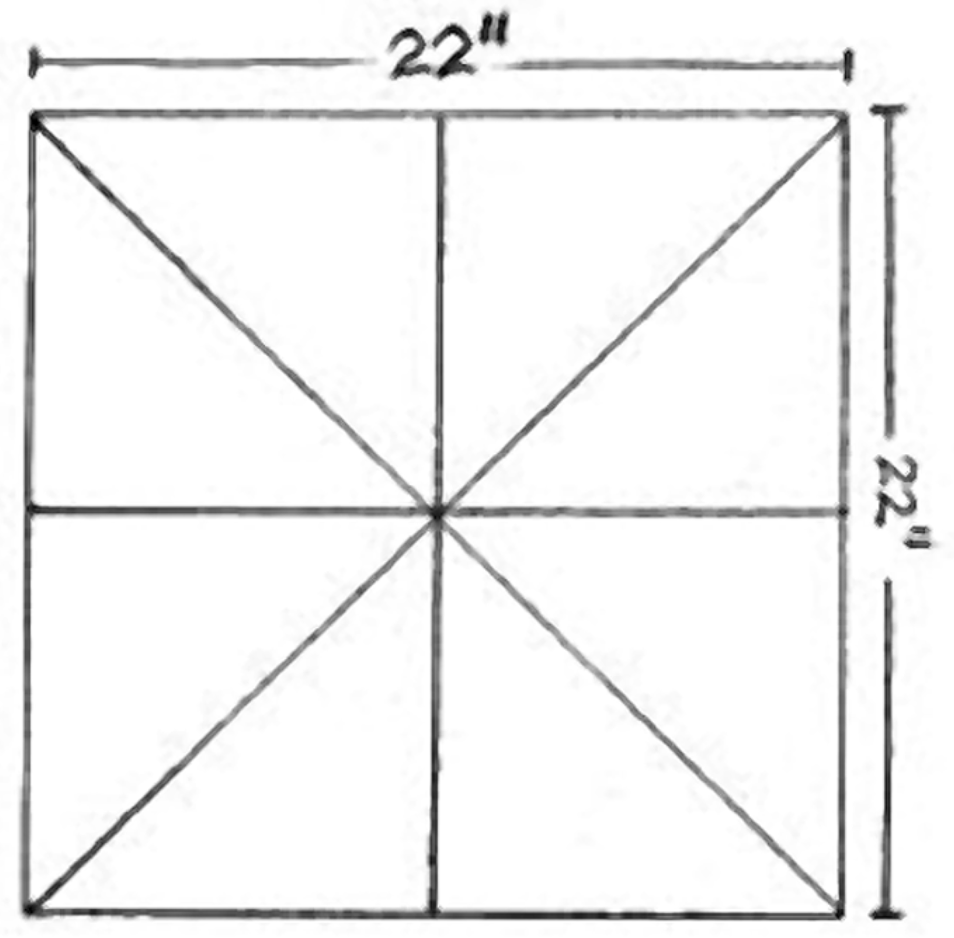

Step 2. On a common hardware store yardstick, drill a 1/16" hole in the exact center at the 1" mark. Drill 3/32" holes in the center at 10 1/8", 10 1/2", 11 1/8" and 11 15/16". Poke a tack through the exact center of your poster board (where all the lines SHOULD cross). Remove the tack and push it back through the hole from the rear. Place your board on the floor with the tack sticking up. Put the yardstick on the paper with the tack going through the 1" hole. Hold a sharp pencil upright in the 10 1/8" hole and spin the yardstick in a complete circle. Repeat for the other three holes.

The inner circle will be where a line of upholstery nails will go around the outer edge of the targe's face. The second ring marks the edge of the targe core, 19", where the leather will be folded to cover the rim. The third ring is where the leather will fold again onto the back of the targe at 20 3/8" (assuming a 5/8" thick core). The final ring is the outer edge of the leather, 21 7/8"
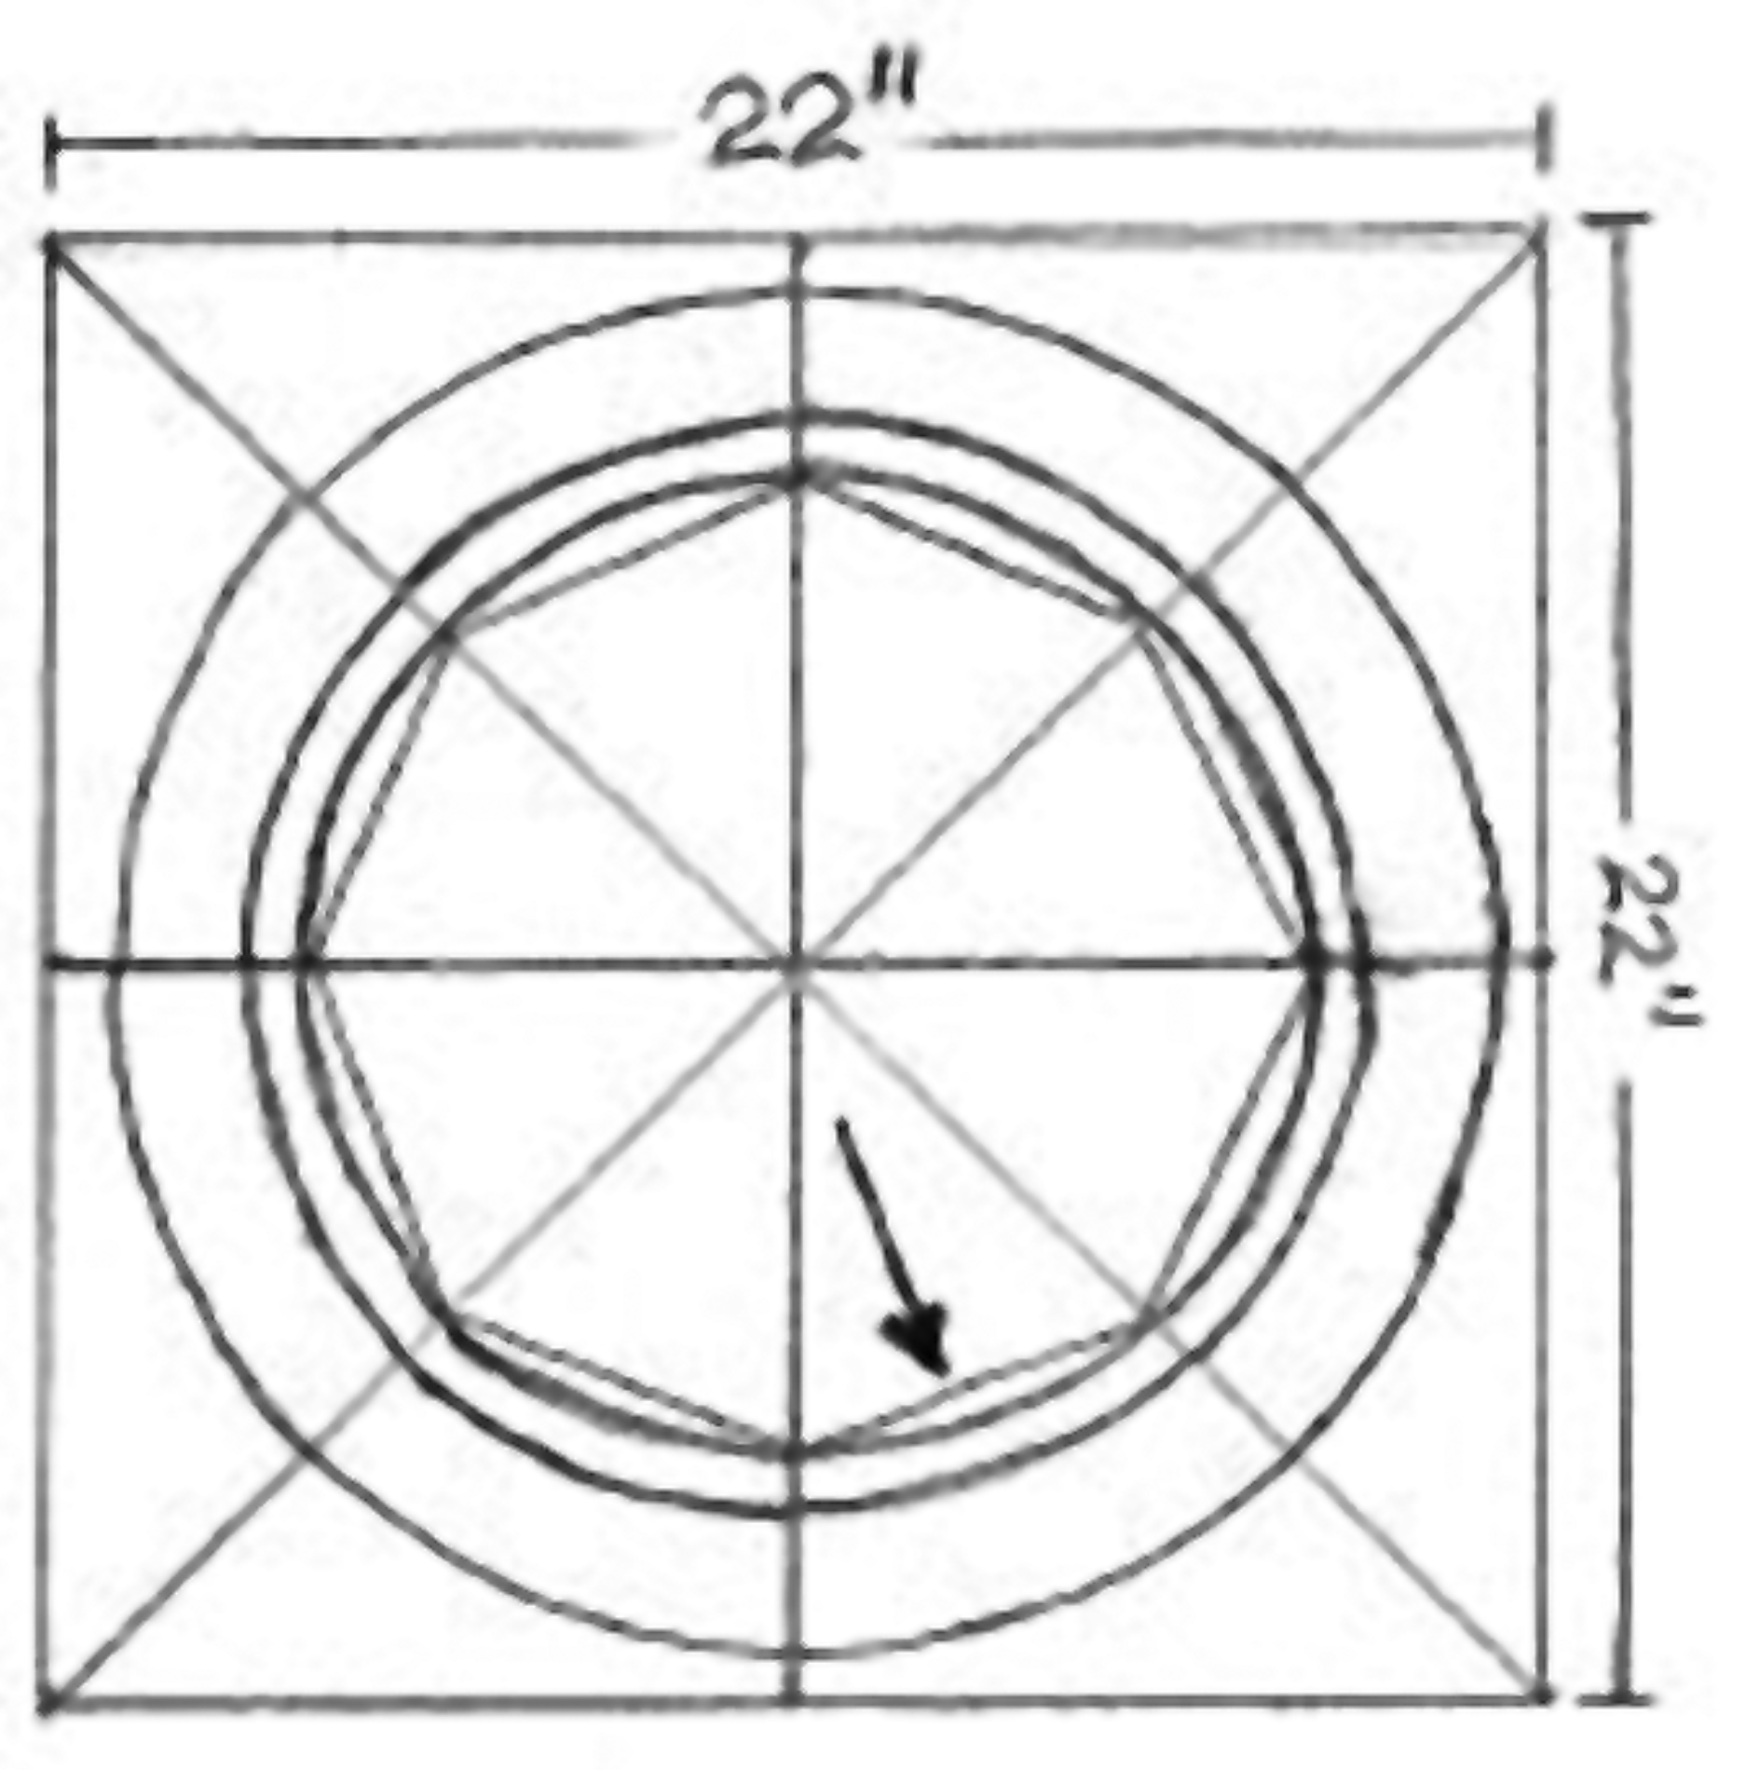

Step 3. Draw a chord across each of the eight segments where horizontal and the adjacent diagonal lines meet the inner circle. This should be 177 mm long. Divide each chord into six segments, each 29.5 mm. You will find using metric measurements here will be much more accurate.

Step 4. Place the yardstick on one of the dividing points of a chord and its opposite point 180 degrees away. As a check, your yardstick should also be next to the targe's exact center point. Draw short lines from the point on each chord to the outer ring. Do not draw lines all the way across the pattern, since this would make laying out the position of the tacks confusing. These lines will divide your rings into 48 segments. (See next page for diagram; sorry.)

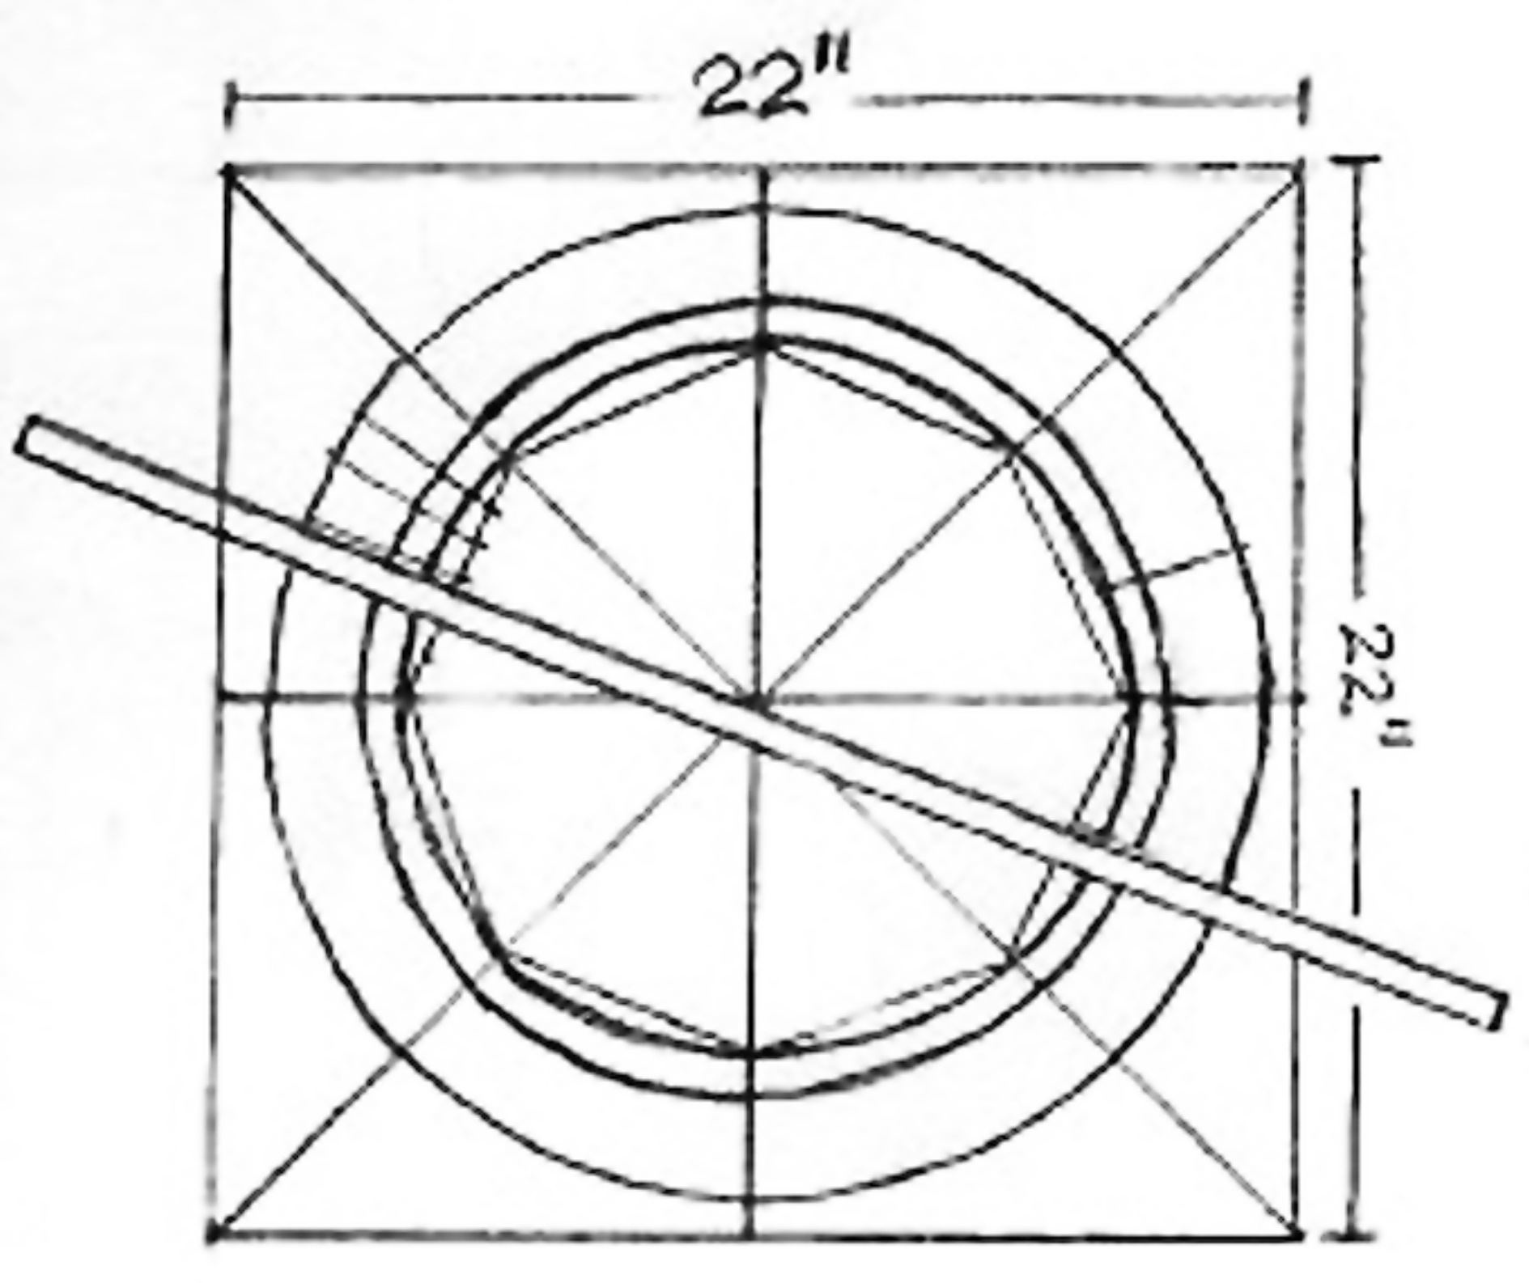

Step 5. Lay out your tack arrangement on the pattern. Mark your tack locations using a Sanford Sharpie marker. Tacks should be spaced no more than 3/4" center-to-center. Try to keep the distance between all your tacks close to the same. You may want to draw more rings as part of your design.

Step 6. Add the outline of your straps. For an average-sized person the strap outlines should be 7 1/2" inches long, and whatever the width of the leather you will use. My usual size is 1 3/8" wide. The hand grip centerline will be about 5" from the edge and will be on the LEFT side for a right-handed carrier (on his left arm). The arm loop centerline will be about 7" from the RIGHT edge. Right and left don't matter if your artistic design is symmetrical. Holes for the bolts should be 5/16" from both the outer edges of the strap footprint, and 5/16" from the ends. These holes cannot be within 1/4" from the location of any tacks. Strap locations, or parts of the artistic design, may have to be moved slightly if there is a conflict.

Step 7. When the layout is complete, cover the pattern with a large sheet of tracing paper. Trace a duplicate copy of your design out to the 19" ring. This tracing paper template will be very useful for positioning the strap bolt holes and the tacks during final assembly.

Step 8. Cut the poster board pattern around the outer ring. Cut each of the 48 lines from the outer ring inward to just short of the 19" ring.

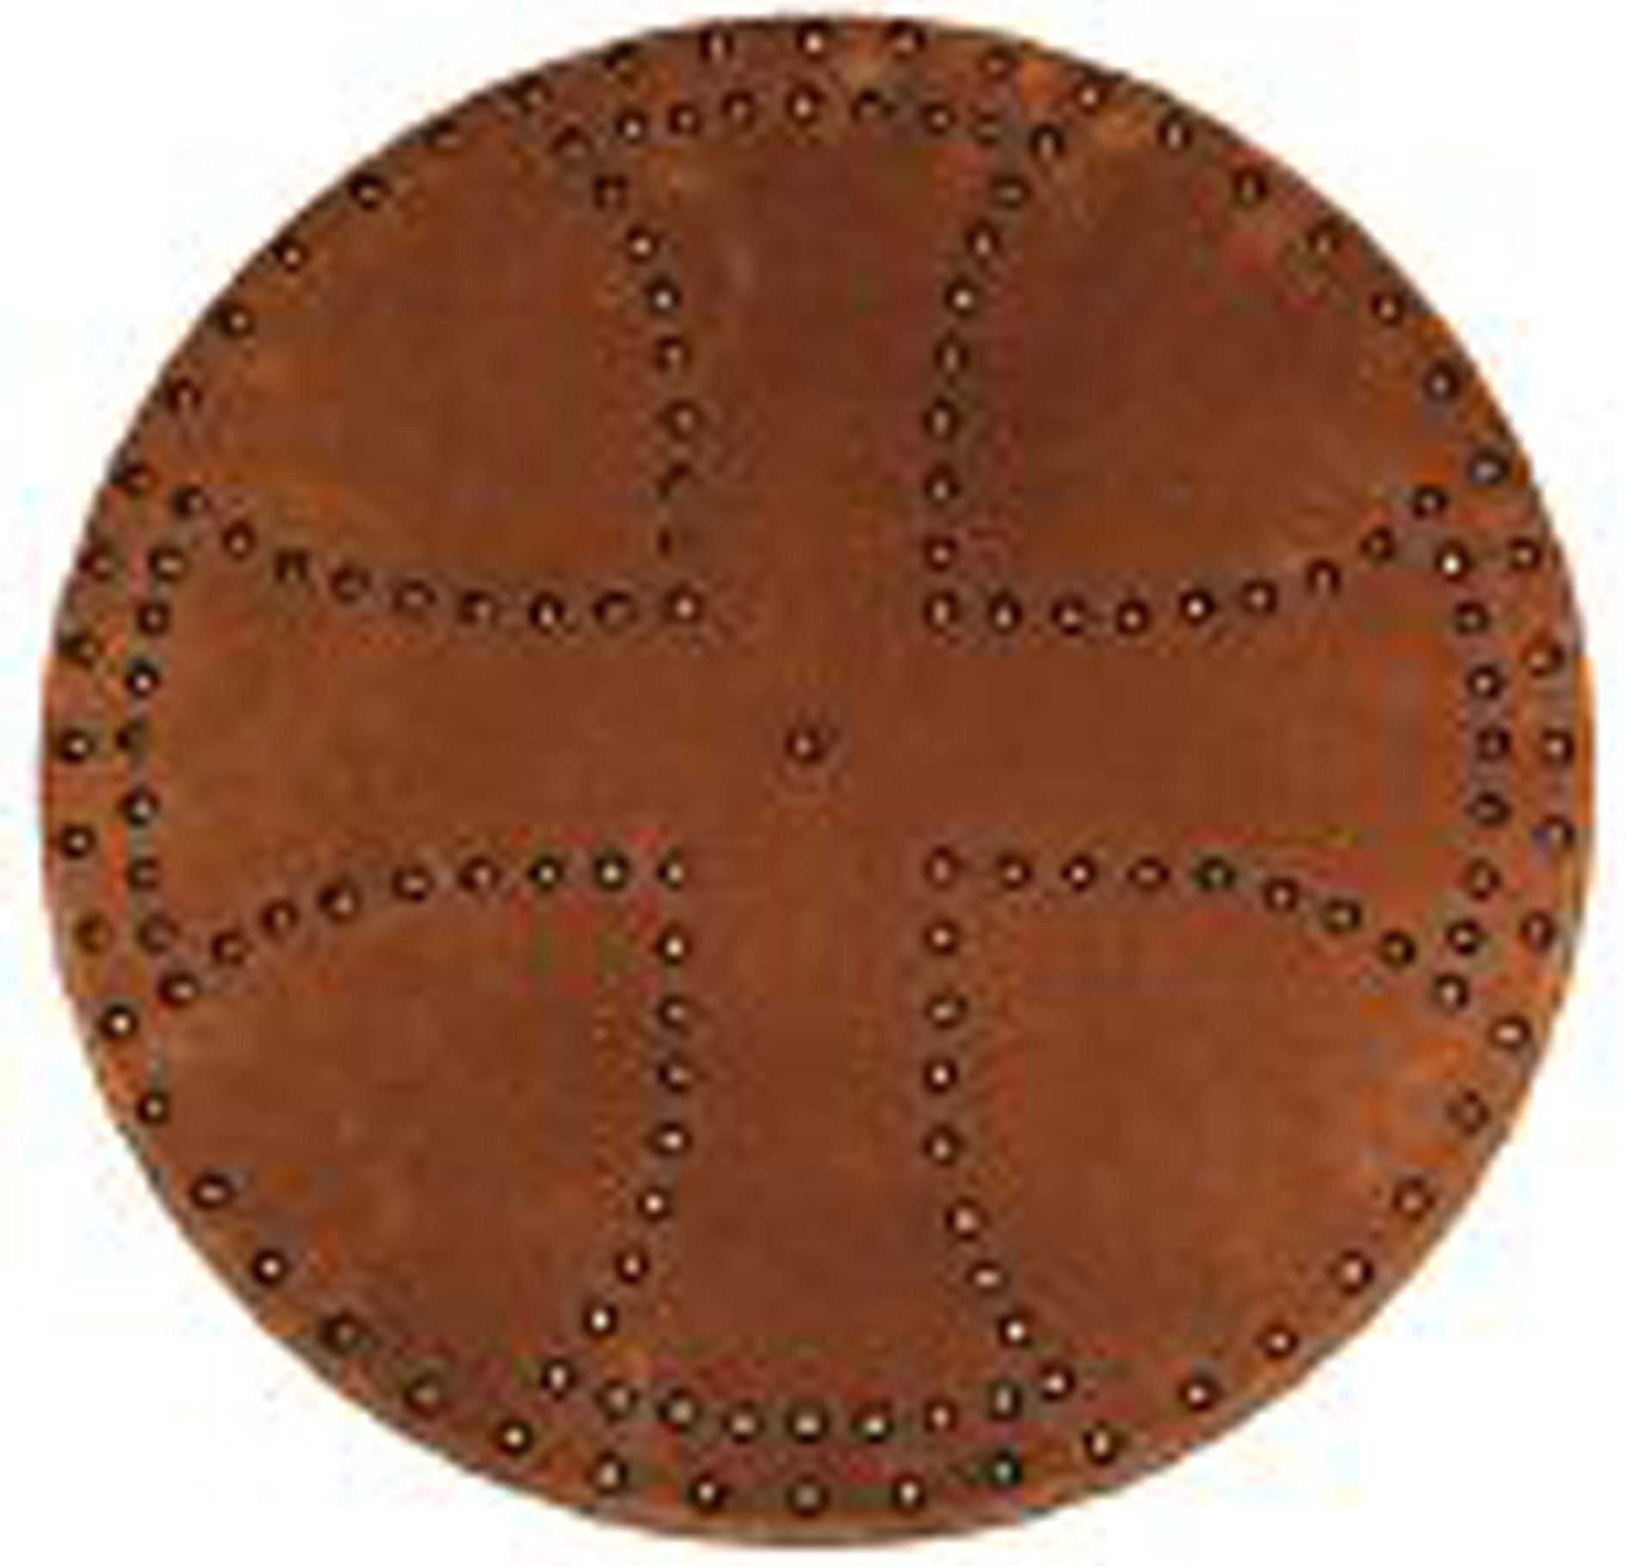
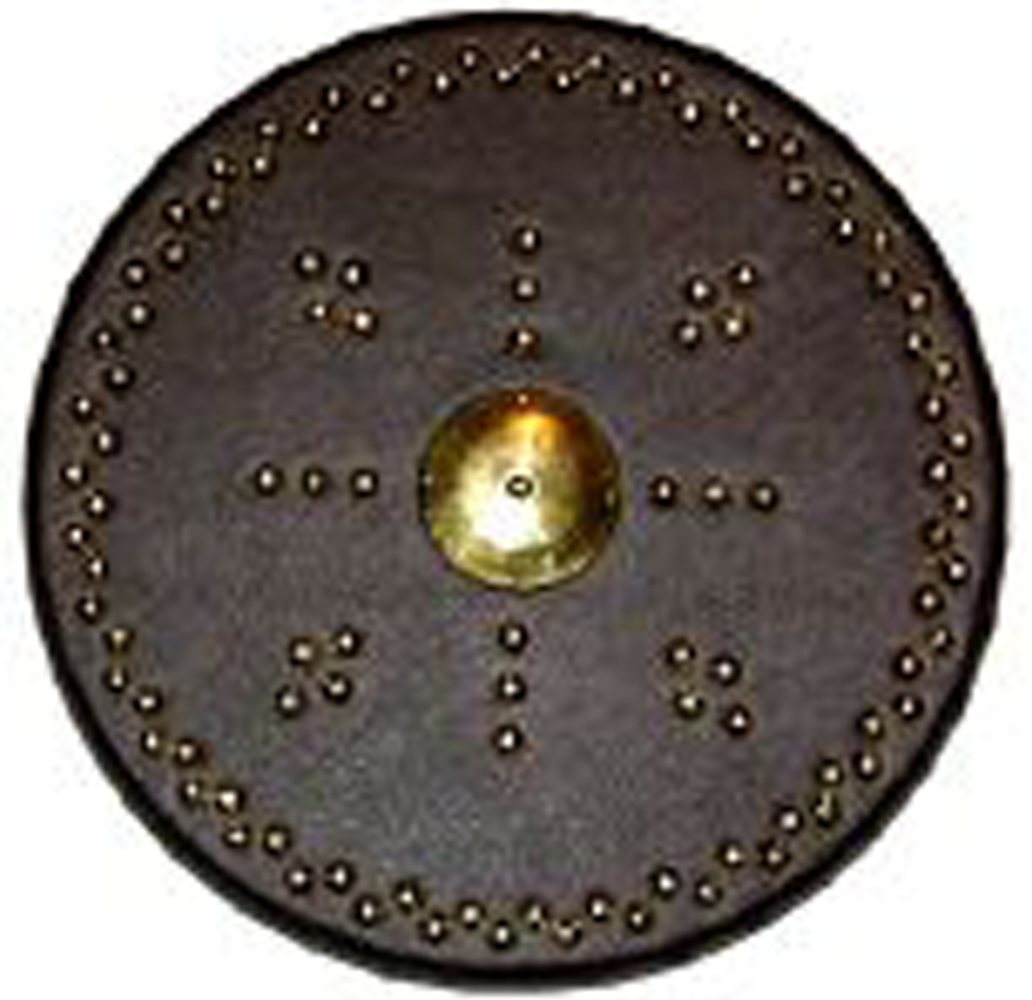
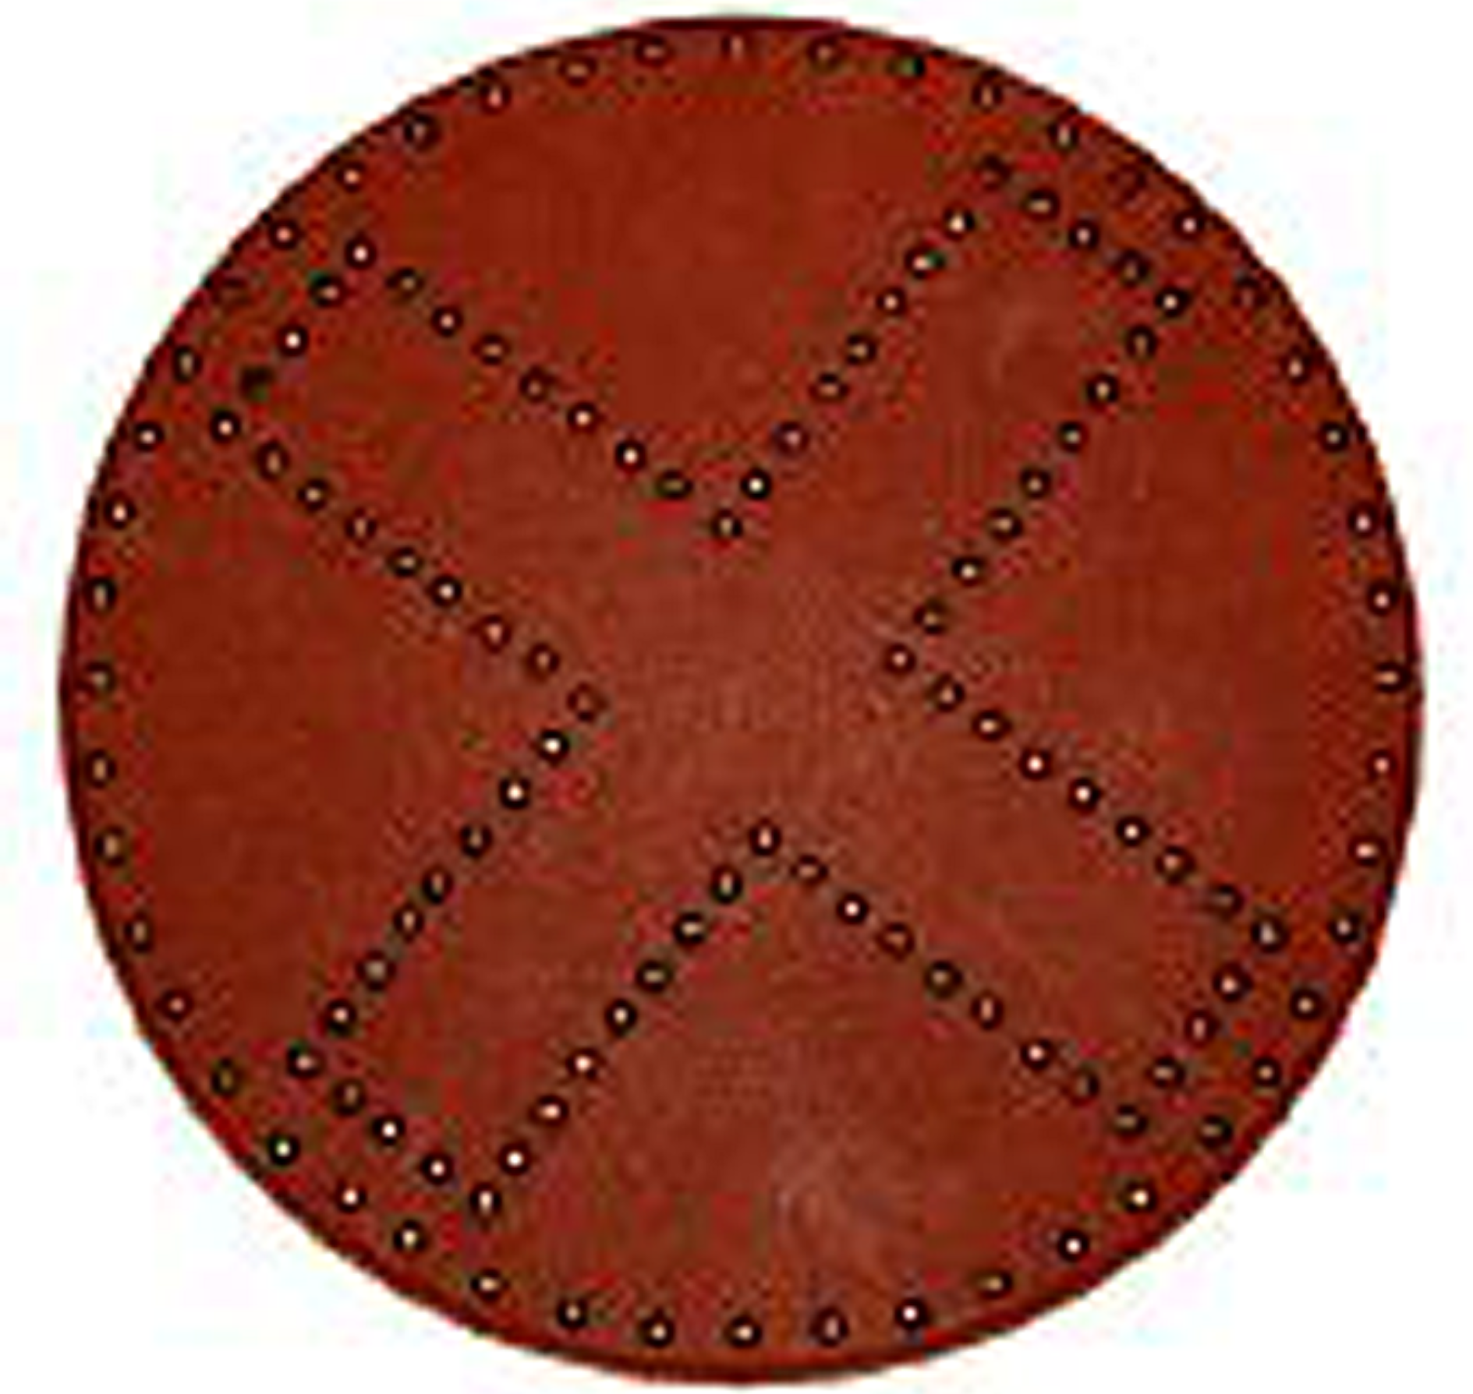

BUILDING THE TARGE: THE CORE

A truly authentic targe would be built with two layers of planks. I suggest 3/8" for both layers. These should be pegged together with wooden dowels, but glue will work for our purposes. This method would be great for an A&S project or for an uncovered targe (a "targe of burde"), but is not necessary with a leather–covered targe for general use. Nobody will ever see the front layer. Brads 1/2" long could be run around the inner edge of the 19" ring for extra strength.

When choosing your wood, keep weight in mind. Saving a few ounces will make a big difference when you are schlepping one of these shields around on your arm all day at an event. A targe 5/8" thick is fine for our purposes. This closely matches the two-layer construction of a replica Saxon shield I examined at the Staffordshire Gold Hoard display. You could go up to 3/4", but may regret it later.

I prefer 1/4", 2 x 2' oak plywood for the face layer. Pine plywood would probably work, but it is just a bit thicker, thus heavier. Birch and lauan warp badly. Buy the flattest piece you can find, and with the fewest knots. I use 1/2" "craft wood" for the back layer. This looks like pine and is imported from New Zealand (available in the ready-cut section at Lowes). It has a very nice grain and is very light. For a 19 or 20" targe you will need two 4" planks (really 3 1/2") and six 3" planks (actually 2 1/2"). Despite adding up to 3/4", the real thickness will be 5/8".

The Merovingian targa has horizontal boards on the front which are visible where the leather has rotted away. Horizontal boards on the front would be stronger against a downward sword or axe stroke. A blow like this would be more likely to split a targe with vertical boards in front.

Step 1. Don't sand your planks. Leave them rough unless you find splinters. Stain only the tops and edges of your planks. Any stain will do. I use both Minwax and Cabot oil stains. Minwax also sells a water-based stain in tubes, though with only a few useful color choices. I apply stain with a soft cloth and rub it into the wood. Wear vinyl gloves and work outdoors or in a properly ventilated paint shop. One coat will pretty much seal the wood. A second coat of another color can be added for accent, though most won't soak in. I often finish with Cabot ebony for an aged look. When the stain is completely dry (24 hours for oils), brush on a coat of Minwax Polycrylic "Satin". This is a dead-flat sealer coat. Don't seal the base of the planks, or the oak face yet. You will get a better glue joint with bare wood.

Step 2. Glue the planks to the oak board. Start with a 4" plank, then six 3" planks, finishing with the other 4" plank. This is a bit wider than your finished targe, but if you use a portable scroll saw you will need some wood on the outside of the blade to support the saw's metal foot.

Use any brand of yellow carpenter's glue, spread on the planks in a smooth layer. Remove any excess glue that wells up between your planks. Use clamps and weights for good contact. I usually do only two planks at a time, and allow them to dry for several hours before moving on to the next pair.

Step 3. When the last planks have dried for 24 hours, you can cut out the disk. Lay out your 19" circle using the tracing paper template, or use the tack-and-yardstick method. Cut with the oak plywood face down, and do not force the saw, which might cause excess splintering along the edge. Some splintering is expected, but will be covered by the leather. Smooth the edges of your disk with a file or rasp.

Step 4. Brush two coats of Minwax Polycrylic "Satin" onto the exposed front of the targe. When dry, brush the cut edges with two coats. This should provide adequate sealing.

Step 5. Next prepare your straps. My straps are from good quality plain belts, usually 1 3/8" wide. I am an average-sized male, just under 5' 9" tall, not overly muscular, and take a men's large glove. I cut my arm straps 11" long, and the hand grips 8 1/4". If you are about my size, this should work for you.

If you are in doubt, cut two strips of cereal box card the same width as your belt. Tack a strip 5/16" from its end to piece of scrap lumber (actually you could use the face or your targe for this, though it is hardly scrap). At 6 7/8" from the first tack, draw a line on the board. Wearing the shirt, jacket or doublet with which you will most often carry your targe, lay your arm on the board. Wrap the strip around your arm 2-3 fingers below the crook of your elbow. Don't pull the strip too tight, since you don't want the finished strap to cut off blood circulation! Tack the loose end of the strip down on the 6 7/8" line.. Draw a line across the strip 5/16" beyond the tack.

Remove the tacks and trim to the drawn line. Punch four small holes in your strip exactly 5/16" from the ends and 5/16" from edges. You now have a template for your arm strap. Repeat with the handgrip using the same dimensions. It should have slight cut-out for comfort along the outer edge. Obviously the arch will not be quite as high as the arm strap, but should be roomy enough not to press the back of your hand to the wood (which can be painful after a while). If you have huge arms and hands, you can make the footprint and straps longer, or if making a targe for a youngster, a bit smaller.

Step. 6. Apply your tracing paper template to the targe face, and punch marks through it at the centers of the eight bolt holes. Draw in the footprints of your straps. Check your templates by tacking them temporarily in place and sliding your arm into the strap and handgrip. DON'T SKIP THIS STEP! MAKE SURE EVERYTHING FITS BEFORE YOU CUT YOUR STRAPS!

Step 7. Cut your belt to the template using a sharp knife. Cut away the outside part of the handgrip. Drill or ream 3/32" corner holes. Clean off any leather "fuzz". Touch up your cuts using liquid shoe polish similar to the belt color and allow them to dry before handling again.

Step 8. Drill 3/16" holes at the eight locations where your strap bolts will go through the targe. Drill from the board side, and don't push the drill, rather let it chew its way through at a slow speed. A drill press is better than a hand-held drill, but not absolutely necessary. Test fit the long parts of the binding posts through the straps. On the plywood side of the face, countersink the bolt hole enough to lower the screw just below the level of the wood. If you don't have a large bit for countersinking, cut it carefully with a sharp knife, stopping often to check the level.

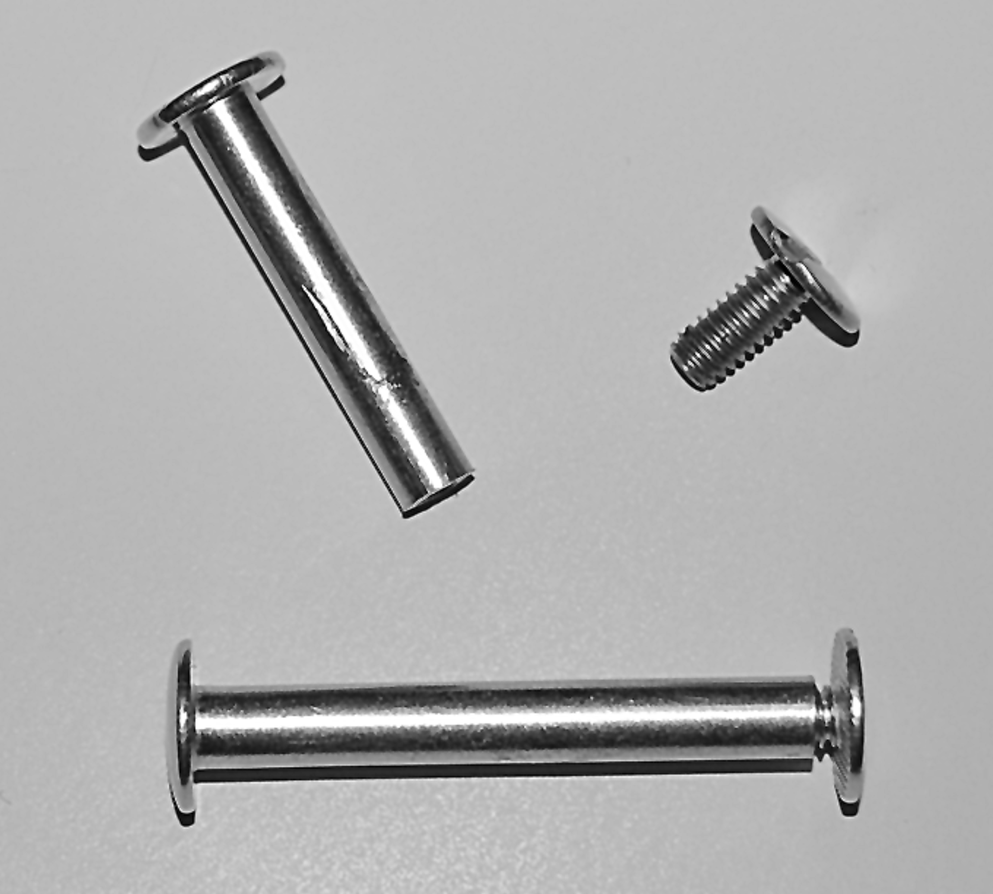

Binding posts or screw posts.

Step. 9. Fit the long part of the binding post through the leather and the back side of the targe. It should sit slightly below the countersunk part of the hole on the front and allow the screw to tighten. If the fit is sloppy or won't screw tightly, remove the screw and bolt. With a hacksaw, cut no more than 1/16" off the hollow shaft. Dress with a metal file. Tighten up all eight bolts.

Step 10. Fill the area around the screws on the face with yellow carpenter's glue to slightly above the wood level. Allow to dry for 24 hours. If the glue is solid, smooth it down to the wood level with a file and sandpaper.

BUILDING THE TARGE: THE LEATHER COVER

You should never buy leather online or by mail order. Leather should inspected in person. Take your template with you, spread the hide out flat to make sure you can get a full 21 7/8" disk (for a 19" targe) from the piece. If possible, spend a bit more for a hide that will yield two or more disks, rather trying to save a few bucks and ending up with one disk and a bunch of useless scraps.

Tandy retail stores will be the best leather source for most of us, unless you have a friend who deals in leather or know an upholsterer who will sell you remnants at a discount. Tandy frequently has sales on their leathers, and will send you a monthly sale bulletin for no charge.

In general, search out softer leathers with a suede texture. Pigskin garment splits are among the most economical. Deerskin is very stretchy, but otherwise great to work with. Soft cowhide may be the most readily available, though it is thicker and needs special leather sheers to cut.

Decorative upholstery nails or tacks are available in a variety of retail stores, though not all are useful for targes. Avoid "daisy" tacks which look absurd on a targe. Lowes offers the Hillman brand, with 3/8" antiqued hammer-oxford, bronze (reddish) and polished brass styles. Dritz Home brand are offered by JoAnn Fabrics and Hancock Fabrics, including 3/8" or 7/16" antique brass (brownish) in smooth and hammered, plus gilt brass also in smooth and hammered. The Dritz line also offers some 3/4" square-head tacks in antique or gilt brass. On-line retailers offer other upholstery tacks in many sizes and finishes, but usually in large quantities with high shipping charges due to the weight. Tandy also offers upholstery tacks, but their spikes are too long for 5/8" targes.

Step 1. Spread your hide flat on the floor or on a table. Place your poster board template on the hide, and position to yield a 21 7/8" disk. Tape at least eight of the small flaps down with blue painter's tape (see below). Cut the leather around the template edge with scissors.

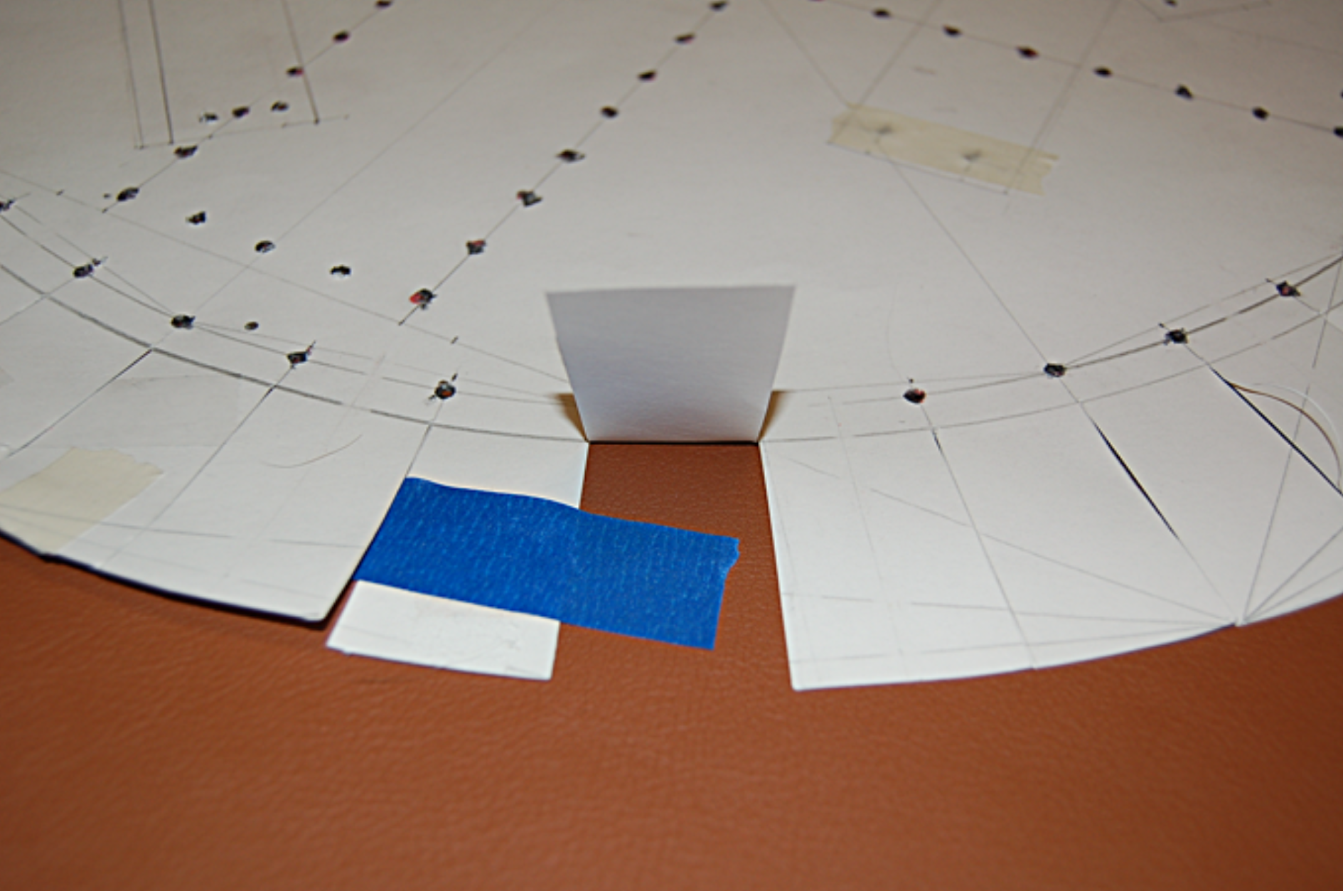

Step 2. Apply blue painter's tape again to eight tabs. Bend the tape over the end of the tab and around to the back of the leather disk. Make 48 cuts between each pair of tabs just short of the 19" ring. Remove all the remaining tape from the leather.

Step 3. Lay your leather disk face down on an old bath towel spread over a counter or floor. Place your core face down on the leather. Measure the overhang on all sides and carefully adjust until the excess is the same all around your core. Pull two tabs firmly up onto the targe

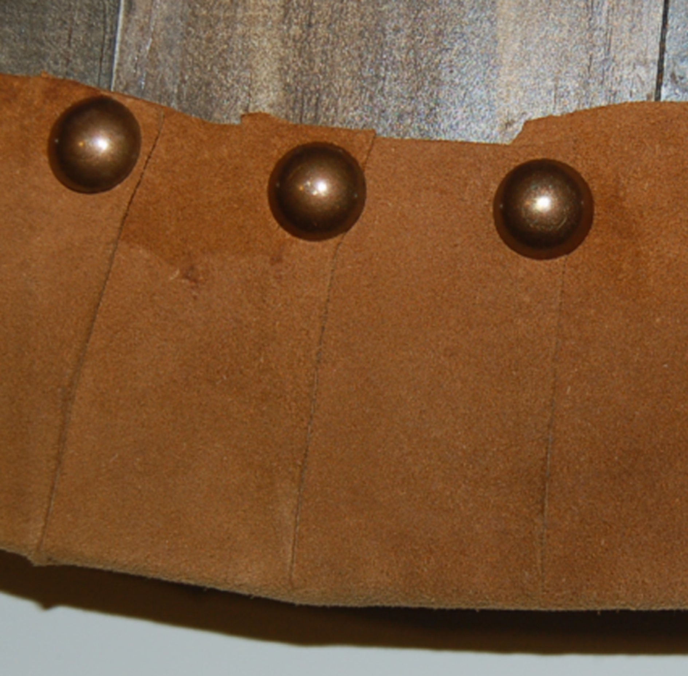
back. Drive an upholstery tack through the overlapping corners of the two tabs. Pull the next tab up and repeat the nailing, working your way around the targe until you have nailed down all 48 tabs. Drive the nails down to the head. If a nail bends, replace it with a new one. Inspect your work to make sure the leather is smooth across the face.

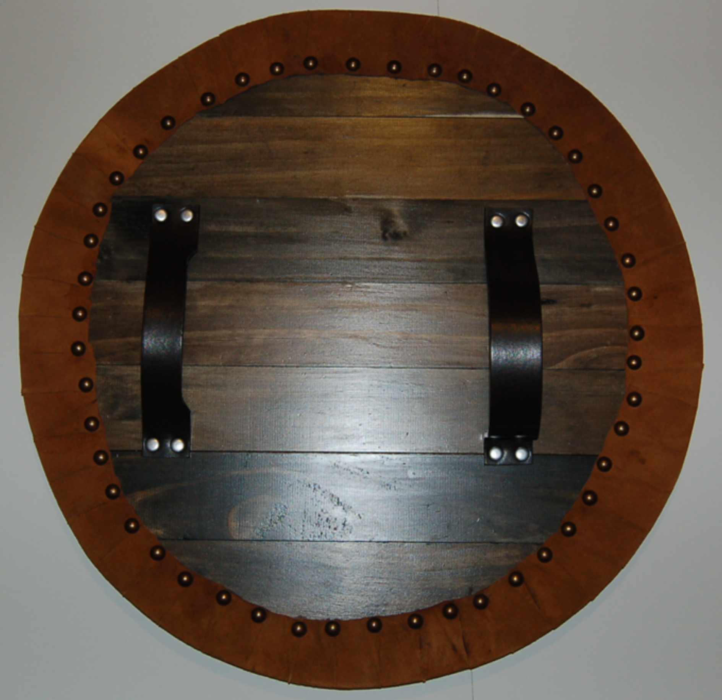
Rear view. Yes, the boards should run the other way.

Step. 4. Turn your targe face up. Support it on opposite sides by lengths of 2 x 4 so that face sits flat without the straps pushing it up. Place your tracing paper template on the targe face. Make sure your template design is aligned so the grip and arm sling are vertical. The template should also be centered so that the 19" ring lines up with the edge. Tape the paper down using blue painter's tape wrapped around the edge to the targe back. Drive your tacks right through the tracing paper, but leave them floating about 1/8" above the surface. When you have driven in all the tacks, tear off the tracing paper and tape. Drive all your tacks home.

If you bend a tack, replace it with a new one. If the replacement bends, drill out the hole with a very small bit held in a pin vise, but skip that tack until the paper is removed. Put a small dab of epoxy (not Crazy Glue) on the shaft before driving it in. Save a few bent tacks. The shaft can be removed from the head, and the head may be useful for special trim pieces (see below).

Step. 5. A boss in the center of your targe is an easy detail to add. I use the drip pans from brass candle holders made in India. The parts of these are screwed together, and can be taken apart by hand. The nearly flat drip pan under the candle spike is the part we want. Pound small dents into the pan's edge with a hammer and a small nail close to the edge at 3, 6, 9 and 12 o'clock. Drill through each dent using a 1/64" drill. Mount on the targe face in the center using 1/2" brass escutcheon pins or other small brass brads. The head of a bent tack remounted on longer brass brad through the center can be used to cover the hole in the disk's center. Historic targes had bosses with a higher dome, but this makes a good symbolic representation.

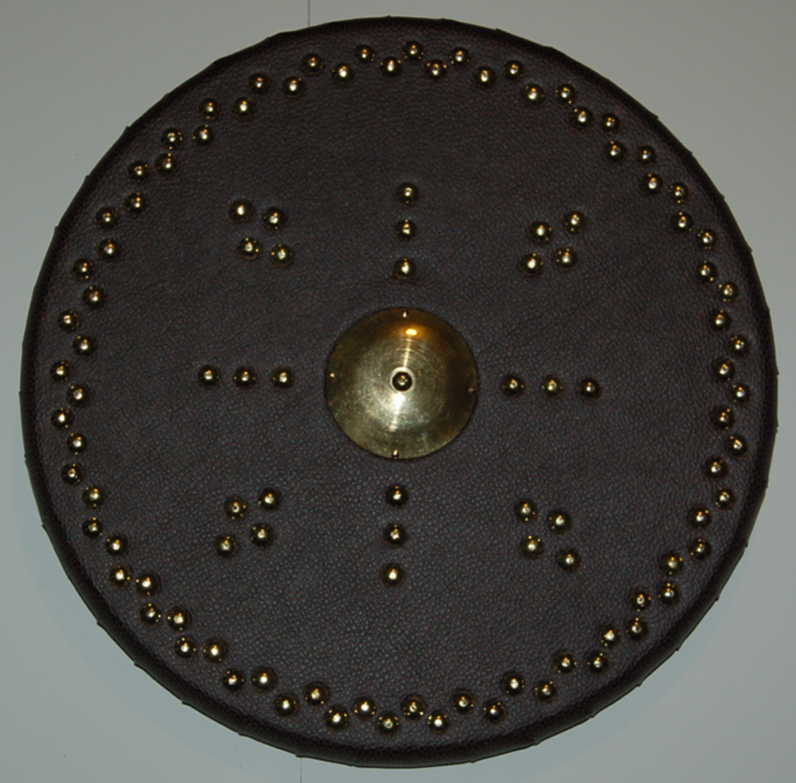

BIBLIOGRAPHY AND WEB RESOURCES

BOOKS

Drummond, James. ANCIENT SCOTTISH WEAPONS and HIGHLAND TARGETS AND SHIELDS: Scotdisc D-642. Scotdisc, 2004. Both titles are also available in original print editions through libraries.

Heath, Ian. THE IRISH WARS, 1485-1603. Oxford: Osprey, 1993.

Rothero, Christopher. THE SCOTTISH AND WELSH WARS 1250-1400. Oxford: Osprey, 1984.

Sadler, John. FLODDEN 1513, SCOTLAND'S GREATEST DEFEAT. Oxford: Osprey, 2006.

WEB RESOURCES

CELTIC TARGE. Search "celtic targe tandy leather factory" for a link to this PDF document. Provides complete instructions for a simple gentleman's targe. Some ideas could be used with my design.

ELECTRIC SCOTLAND. http://www.electricscotland.com/lifestyle/targes.htm . This page includes views of some really beautiful gentlemen's targes, including a detailed view of one back.

HIGHLAND TARGE. http://www.highlandtarge.com/ . Mike Pruette of South Carolina crafts beautiful gentlemen's targes in three designs.

HIGHLAND-TARGE.com. http://www.highland-targe.com . Scot Rab Cairney offers a range of beautifully tooled gentlemen's targes. He can equip his targes with an optional blunt "dress spike".

TARGEMAKER TARGES. http://www.targemaker.co.uk . Targemaker Joe Lindsay claims descent from William Lindsay of Perth who built targes for the Jacobite army in 1745. He offers an extensive range of gentlemen's targes, simplified targes without leather tooling, and 12" bucklers.

SCOTTISH TARGEMAKER MALCOLM McNEILL. http://www.scottishtargemaker.co.uk/ Malcolm McNeill offers a range of nine targes, from fairly simple to extremely complicated.

SCOTTISH WEAPONRY. http://sites.scran.ac.uk/weapon/index.html This really cool site has virtual images of a Jacobite targe and a Pictish buckler. Either can be turned and viewed from different angles.
------
Copyright 2012 by Garth G. Groff, <ggg9y at virginia.edu>. Permission is granted for republication in SCA-related publications, provided the author is credited. Addresses change, but a reasonable attempt should be made to ensure that the author is notified of the publication and if possible receives a copy.

If this article is reprinted in a publication, I would appreciate a notice in the publication that you found this article in the Florilegium. I would also appreciate an email to myself, so that I can track which articles are being reprinted. Thanks. -Stefan.

<the end>

