BB-Wdn-Shelds-art - 9/17/17

"Building Better Wooden Shields" by Centurion Micolay Haiduk.

NOTE: See also the files: shields-msg, Shield-Balanc-art, W-T-Shields-art, wood-msg, wood-finishes-msg, heraldry-msg, Stndrds-Banrs-art.

************************************************************************
NOTICE -

This article was added to this set of files, called Stefan's Florilegium, with the permission of the author.

These files are available on the Internet at: http://www.florilegium.org

Copyright to the contents of this file remains with the author or translator.

While the author will likely give permission for this work to be reprinted in SCA type publications, please check with the author first or check for any permissions granted at the end of this file.

Thank you,
Mark S. Harris...AKA:..Stefan li Rous
stefan at florilegium.org
************************************************************************

Building Better Wooden Shields
by Centurion Micolay Haiduk

Materials:

- Baltic Birch Plywood (1/2" for flat shields, 2 pieces of 1/4" for curved shields)
- Titebond II wood glue
- Burlap Fabric
- Paint
- Various colored wood stains
- 2" wide Rawhide strips
- Carpet Tacks or Cut Tacks #14 (about 3⁄4"long)
- 1" oak dowel
- Shield boss
- Aerosol Oil
- Nails or Rivets for attaching the handle
- Washers that fit snuggly over the nails or rivets
- Wipe on polyurethane

Tools:

- Straight Edge
- Shield Press
- Ratchet straps
- Jig saw
- Router with 1/2" round over bit
- Sand paper
- Old paint brush
- Disposable gloves
- Flat Faced Hammer
- Pliers
- Drill with Drill bit.
- Ballpeen Hammer
- Dremel or Angle Grinder with a cutoff wheel

Process:

Begin by measuring and marking the layout for the faux planks on one side of the plywood. Score the wood along the planks using a straight edge and something sharp like an awl, screwdriver, or nail.

If making a curved shield, follow the directions in this paragraph. If making a flat shield, skip ahead to cutting the shield out. Mark the center of each board on each end. Place the board with the plank marks face down on the shield press. Apply a thin layer of glue over the entire board. Place the second board on top. Align the centers of both boards and the shield press to make sure the curve is symmetrical. Place stringer boards on top of the plywood. Use ratchet straps centered over the ribs of the shield press to bend the plywood down to match the shield press. It's easiest to tighten each strap a little at a time until they are all snug. Leave the shield in the press to dry at least 24hrs. Undo the ratchet straps.

Draw or trace the shield shape and an opening for the shield boss. Cut the shape out with a jigsaw. Use a router with a 1⁄2" round-over bit to bevel all the edges. Use a pencil or fine tip sharpie to color-in the score marks made for the planks earlier. Lightly sand the back of the shield for a smooth finish. Using different colored stains, stain each of the planks a slightly different color than the one next to it. This adds contrast that makes each plank look like it is made from a separate piece of wood. Let the stain dry according to the directions on the packaging.

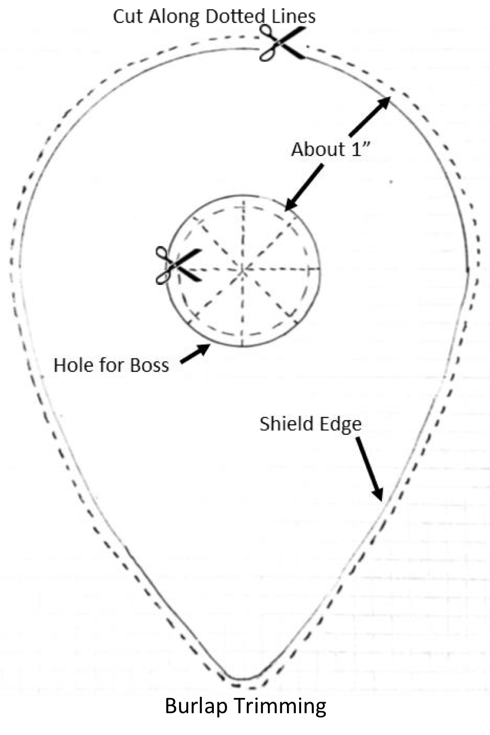

Cut a piece of burlap to a size and shape so that it hangs several inches over all the edges of the shield. If necessary, iron the burlap to remove any creases or large wrinkles. Water down the Titebond to the ratio of about 8 parts Titebond to 1 part water. I generally need between 12 and 16 oz. to do a normal sized shield. Use an old paint brush to mix the water and glue. Starting in the middle and working outwards towards the edges, dollop glue on the canvas and spread evenly using the old paintbrush. When the glue has soaked through the burlap, the fabric will begin to stick to the wood. Smooth down any wrinkles or places the burlap is not sticking to the shield. While the glue is still wet, trim the burlap about 1" wider than the edge of the shield. If you have a hole for a shield boss, slice the burlap into eight or more even pieces as you would slice a pizza and then trim each piece to about 1" away from the edge (See diagram). Using your hands (latex gloves help here), apply glue to the burlap hanging over the edges and start to smooth it over the edges and around to the backside. Continue doing this around the entire shield and along the inside of the shield boss hole. At first the burlap will not stick and will spring back, but continue pressing the burlap to the wood all around and as the glue begins to dry it will start to stick. Once the burlap has adhered to the edges and back, let the shield dry for several hours. I generally balance the shield on two paint cans to keep it from sticking to my workbench.

Once the glue is dry, do a light sanding of the burlap. This will remove any loose strings and give a better surface for painting. This is the best time to paint the background color of the shield. I generally do all of my painting at this point, unless the design has elements that come very close to the edge that I want to make sure aren't covered by the rawhide. Be sure to paint the background color all the way around the edges, as some rawhide has a bit of transparency to it. Just about any kind of paint will work. I use Valspar Latex Enamel for primary colors and latex house paint from Home Depot if I need a specific color matched. Both are easily cleaned up with soap and water and are relatively inexpensive. Follow the directions on the paint for dry times.

Burlap Trimming

Before attaching the rawhide, figure out where you want the seams to be. I try to use one piece of rawhide, but if more than one are needed I try to place the seams symmetrically and in place that are hit less frequently. Make sure to overlap the seams by at least an inch, as the rawhide will shrink as it dries which could leave gaps. Also make sure to leave the rawhide strip(s) longer than needed until they have been nailed down. The rawhide needs to soak in water for several hours before attaching it. Don't let the rawhide soak for more than a day or so, or it will begin to turn into hide glue. This happens even faster if the rawhide is very thin. Begin by nailing the raw hide to the front side of the shield, spacing the tacks about every 3-4". Start at one end of the rawhide strip and work towards the other end stretching the rawhide tight as you go. Be sure that the rawhide is centered over the edge with even amounts showing on the front and back. Flip the shield over and bend over the ends of the nails sticking out the back. Clinching them this way does two things. First it keeps the nails from working their way loose during use, and second it keeps sharp points from scratching or catching on skin, garb, armour, etc. Now apply a small bead of Gorilla Glue along the edge, between the wood and the inside of the rawhide. Gorilla glue expands as it cures which fills any gaps in the wood and the space under the rawhide, making for a more solid edge that last longer.

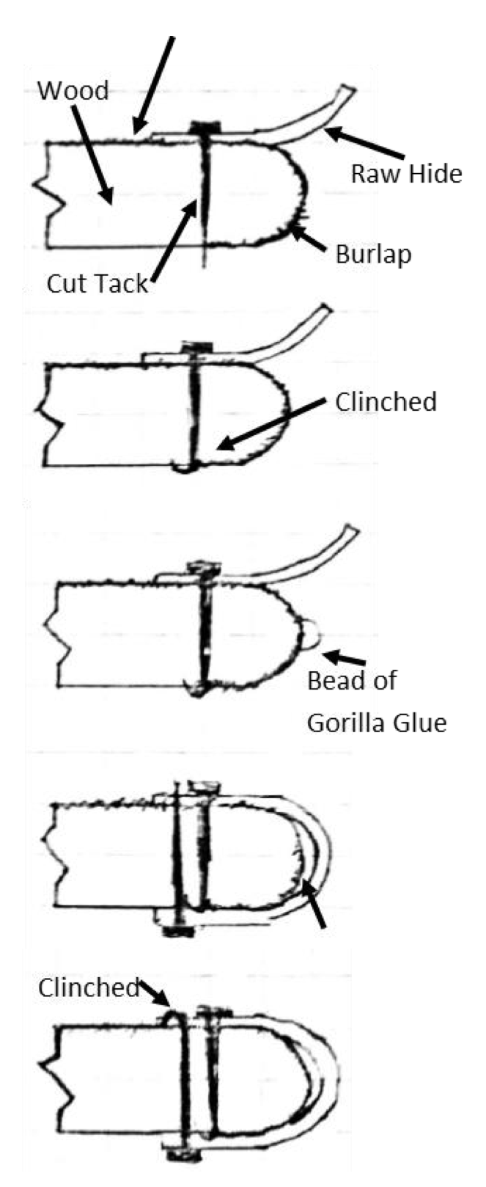

Do a small section at a time to keep it from dripping everywhere. Fold the rawhide over the edge and the glue to the backside and pull it snug while you nail it down. Continue this around the rest of the shield. Turn the shield back over and clinch the nails on the front side, which can be tricky as the nails will be under the rawhide. Put the head of the nail on a hard surface and gently hammer the rawhide where the nail is located. The raw hide will squish as you hammer allowing the hammer to still fold the tip of the nail over. If the raw hide is puckered in any place, use clamps or a board and something heavy to press them flat as they dry. Dry time is usually a day but can be longer depending on the thickness of the rawhide, room temperature, and humidity.

Now is a good time to put several coats of wipe-on polyurethane over the entire shield including the rawhide. This will add a level of protection from moisture getting into both the rawhide and the wood. It will also help keep the face of the shield from getting as scratched.

I normally make the handles for my shields out of 1" oak dowels that I have cut in half lengthwise. This gives me a flat edge to attach to the back of the shield. I then add wood and tape to the grip to make it more comfortable. Stain the handle to match the shield.
I like to oil blacken my shield bosses to give them some rust protection. First, I clean the boss with a green scrubby, dish soap, and hot water. I then place it on a BBQ grill and let it heat up for about 30 minutes. This can be done in the oven, but I like to do it outside as the next step is messy. Once the boss is nice and hot I take it off the grill with a pair of pliers and immediately spray it down with an aerosol oil of some kind (like WD40 or Pam cooking spray). The boss will turn a nice dark black color. Once it has cooled, I use saw dust from my shop to absorb any leftover oil or sticky residue, then give it a quick wipe down with WD40.

I attach the handle and the boss by using common nails and washers as rivets. Position the handle and boss where they should go and mark and drill holes. The holes through the wood should be a snug enough fit for the nails that they have to be tapped through with a hammer. Insert nails from the front to the back and put a washer on the backside. Using a dremel or angle grinder with a cutoff wheel, trim the nail to be longer than the washer by about 1⁄2 of the diameter of the nail. Backing the face of the nail against something hard, peen the nails down tight over the washer.

Other thoughts:

The biggest enemy of these types of shields is moisture. Never leave one out in the rain. If possible, avoid leaving them in dew covered grass for long periods of time. The rawhide will soak up water becoming soft again which doesn't provide any protection for the wood underneath. If the shield does get wet, don't use it to fight. Set it out to dry and the rawhide will snug backup tight again, as it dries.

Instead of using nails to attach the rawhide, it can be stitched on using linen thread or artificial sinew. Simply drill holes through the wood around the edge before attaching the rawhide. Use an awl to pierce the raw hide over the holes. Use a saddle stitch, and snug everything as tight as possible.

If a shield edge needs to be reinforced, (either because Baltic birch couldn't be found, or a particular corner takes a lot of shots) adjustable metal shelving tracks can be used. These are the vertical pieces of closet shelving that are attached to the wall. They can be commonly found at the big box stores. Look for the ones that are half an inch wide. Use a dremel to cut notches along the sides to allow the metal to curve. It can be held on with a few screws and then covered with rawhide.

Where to get supplies:

Baltic Birch plywood is probably the hardest material to find. If you live in a large city that has a Woodcraft® store, they sell Baltic birch plywood in small pieces. The biggest they sell is 30" by 48". Good lumberyards will sometimes carry it. You will know you have found the right stuff if they are selling it in 5' by 5' sheets. Local cabinet makers will probably also have a source. http://www.woodcraft.com/Stores/Default.aspx

Shield Bosses can be ordered online. I normally use the GDFB shield bosses that come in three sizes. The large works well if using a gauntlet behind the shield. The mediums work well otherwise. The smalls are not dished very deep and I don't think they are very useful. I've found them for the best price at Kult of Athena. They may be out of stock temporarily, but they generally restock fairly quickly. http://www.kultofathena.com/shields.asp

Rawhide strips can be ordered precut from Viking Leather Crafts. They generally have a good selection of lengths in stock. Tandy sells shoulders of rawhide that can be cut into smaller strips. I order a side of rawhide from wherever I can find the best deal and cut my own strips. A last resort would be to use a large dog chew toy, but I find this method messy and hard to get a smooth piece of hide. http://www.vikingleathercrafts.com/rawhide-strips.html https://www.tandyleather.com/en/product/rawhide-bends

Most everything else can be purchased at any hardware or home improvement store.

------
Copyright 2016 by Brendan Haiduk. <bhaiduk at gmail.com>. Permission is granted for republication in SCA-related publications, provided the author is credited. Addresses change, but a reasonable attempt should be made to ensure that the author is notified of the publication and if possible receives a copy.

If this article is reprinted in a publication, please place a notice in the publication that you found this article in the Florilegium. I would also appreciate an email to myself, so that I can track which articles are being reprinted. Thanks. -Stefan.

<the end>

