cl-12C-Woman-art - 1/20/07

"The Wardrobe of a 12th Century Frankish Noblewoman" by Mistress Roheisa Le Sarjent.

NOTE: See also the files: bliauts-msg, costuming-lnks, p-shoes-msg, underwear-lnks, Normans-msg, jewelry-msg, veils-msg, headgear-msg, hair-msg.

************************************************************************
NOTICE -

This article was submitted to me by the author for inclusion in this set of files, called Stefan's Florilegium.

These files are available on the Internet at: http://www.florilegium.org

Copyright to the contents of this file remains with the author or translator.

While the author will likely give permission for this work to be reprinted in SCA type publications, please check with the author first or check for any permissions granted at the end of this file.

Thank you,
Mark S. Harris...AKA:..Stefan li Rous
stefan at florilegium.org
************************************************************************

The Wardrobe of a 12th Century Frankish Noblewoman
by Mistress Roheisa Le Sarjent

The following article will look at the clothing of a French-speaking lady of noble birth. Costume writers differ as to the time period for which these comments would be valid, but my main source, Eunice Goddard’s Women’s Costume, quotes literary sources from throughout the 12th century.

A lack of existing garments or lifelike illustrations from this period makes reproducing 12th century clothing somewhat difficult. The artwork is often unclear and confusing. Thankfully, the French literature of the 12th century, with its frequent references to women’s clothing, helps fill in some of the blanks.

Clothing terms, and the styles which to which they refer, do not remain static thus, for example, the cote of the 12th century is still an outer garment 200 years later, but the cut has changed. Items of clothing tend to pick up the names of the fabrics of which they are made, and keep those names even when the fabric changes. A modern example is the item commonly known as “denims”. Many writers have ignored these tendencies and as a result confused themselves and us with regard to 12th century clothing.

Eunice Goddard’s thesis, published in 1927, re-examined the literature with regard to costuming terms, and highlighted many of the previous (and much-copied) errors. Her book is rather hard to get hold of, so what follows is a distilled and annotated version of her study, aimed at those wishing to re-create the style of the 12th century.

Chemise: Underdress

The first item of dress was the chemise, which was worn next to the skin. It was sometimes used as a nightgown, but the nobility usually slept naked. If it was hot a man might strip down to chemise, braies (pants) and chauces (stockings), but a lady was decidedly under-dressed if she was only wearing a chemise; she needed an over-garment to be decent.

The fashionable chemise was white and made of chainsil (a kind of fine linen), chanvre (hemp) or cendal (fine silk). The fashionable sort was laced at the sides, had extremely long narrow sleeves, much longer than the arm, which, when pushed up, sat in tight folds along the forearm. It also had a very wide skirt, often crisply pleated. Some authors suggest these pleats were ironed in, but from experience, wringing the chemise out by hand and leaving it tightly twisted while drying produces the same effect without the hassle. (This was apparently done in Viking underdresses).

The lady’s chemise was long, usually down to the feet, the man’s somewhat shorter. The neckline was high, covering the collarbone, with an opening in front that was closed by a button or brooch. The less fashionable chemise was simpler in cut, without the lacing or pleating, but still with the high neckline and tight sleeves. The chemise of a lower class person was likely to be made of a coarser linen or hemp.

Chauces: Hoses

Literary evidence suggests that tailored stockings, held up by garters or cross garters, may have been worn under the chemise. The information is sketchy, but such stockings were certainly worn by men and, since much of the clothing in this period is unisex, the use of hose by women seems reasonable.

Sollars: Shoes

“Sollars” is a general term for shoes. Shoes were made from leather or cloth, and even fish skin was used. (It’s the new hot trend in shoes today.) Ladies’ shoes are described as slender and well fitted, pointed at the toe, embroidered, and fastened with a button. “Coadovan” was both a type of leather and a shoe made from that leather. An “eschapin” was a lightweight house shoe or slipper that may have had the heavier leather shoe or “bote” (boot) slipped over it when venturing outside.

Bliaut: Court Dress

The bliaut, worn over the chemise, was, to quote Eunice Goddard:

“… an elaborate dress, of the costliest materials, with bands of embroidery at the high neck and at the wrists of the long sleeves, often lined with fur, cut in two parts as a rule, with a skirt (gironee) very long and full, and long waisted bodice (le cors), adjusted closely to the figure by means of lacings (laz) at the sides. The sleeves vary in style from sleeves so wide and long that they almost touch the ground, to sleeves so tight that they have to be sewed over the forearm every time the dress is put on.”

The bliaut is one of those garments which took its name from the fabric of which it was originally made, namely a fine imported stuff of silk, possibly satin or velvet, called “bliauz” or “bliaut”. As a garment it was the court dress of young noblewomen and showed off every curve of the fashionably slim figure. Older women and lower class women wore the cote, or chainse (see below) but not the bliaut.

Goddard does not specifically talk about the colours worn, but the quotes she gives mention green and sanguine, with vermilion as the most common colour. Sometimes the fabric was apparently printed or embroidered in a spangled pattern of crosses or stars. Broad horizontal stripes of gold, as seen on some of the Chartres statues, are also mentioned in the literature.

The style features an elaborate and expensive form of embroidery, using lots of gold and jewels, called “orfrois”. This was used at the cuff of the sleeve, and to cover the seams on the upper arm and the waist. Its greatest use was in the “chevecaille”, or collar, of the dress. The neckline of the bliaut was round and sat at the base of the neck, only slightly lower than the line of the chemise. The “emingant” (split at the front) allowed room for the garment to go over the head. The chevecaille was a wide, usually keyhole-shaped outer facing, thickly embroidered with orfrois, and sometimes so large it covered most of the chest. The emingant was usually closed with an elaborate brooch called an “afiche”, “fermail” or “nosche”.

I disagree with Goddard’s conclusion that “as a rule” the bliaut was cut in two parts. The literature seems to indicate that sometimes it was, and occasionally the artwork shows an obvious line of braid at the waist, which might, logically, cover a waist seam. But, more often, this is not the case leading me to think that both one and two-piece constructions are probably valid.

The bodice of the bliaut was laced at either side, under the armpit, forming wrinkles and folds in the fabric where it pulled tightly over the torso. Goddard quotes, in Medieval French, a passage were a woman is criticised for having “ arms and ribs so tightly laced she can hardly bend”. There is no evidence in the literature to support the “body belt” construction of the bliaut proposed by some writers. To the contrary, there are repeated references to the “cors” (bodice) of the dress being joined to a pleated “gironee” (skirt) and “estroit” (tightly fitted) by means of “laz” (lacing) at the sides.

The man’s bliaut was also a fashionable court garment of the finest fabric, of varying length, from the ankle-length style of kings and older nobles, to the knee-length style of courtiers and active young knights. It was similar to the woman’s bliaut in most other respects, but the skirt was sometime split front and back for extra movement. Men’s bliauts of less than the finest fabrics are only referred to when worn by knights doing penance, under armour, or occasionally by clerks.

It’s possible that the term “chainse” is used for women’s dresses in the bliaut style but of lesser fabrics. Some writers have confused the terms “chainse” (an outer dress) and ”chainsil” (a fine linen used for chemises), concluding that “chainse” is another term for chemise. Goddard says the literature does not support this, and is explicit that although usually made of hardwearing washable fabric, such as linen, and sometimes white or pale in colour, the chainse was worn over a chemise in place of a bliaut or cote. It was sometimes pleated, and sometimes laced like the fine chemise or the bliaut, but did not have the elaborate embroidery and is not mentioned as belted. It is worn at court and as a work dress by noblewomen and the bourgeoisie, but is not mentioned with regard to poorer women or men of any class.

Ceinture: Knotted Belt

A fabric belt of silk or other fine stuff, decorated with orfrois, was often, but not always, worn with the bliaut. It was usually wrapped twice around and tied with long hanging tassels in front. The name is apparently specific to this style of belt. The leather belt worn more often with the cote or pelice was called a “corroie” or “baudre”.

Mantle: Cloak

Worn over the bliaut or cote, a mantle was important to complete the court dress, and was a garment reserved to the nobility. To quote Goddard again:

“Towards the end of the twelfth century the mantel was removed in the presence of a person of higher rank, … and for a noble of considerable station to appear without the mantel was considered as a sign of negligence and lack of dignity”

The mantle was a half-circle cloak (or larger), made of fine fabric, embroidered along the outer facing with gold and jewels, and lined with rich furs. The cope of Roger of Sicily is a surviving example. Mantles were equipped with two highly decorated and jewelled “tassels” (clasp-like objects). “Ataches” (ribbons) ran between the tassels to hold the mantle in place (or to choke you if anyone stepped on your train).

Mantles were worn in various ways, draped simply over the shoulders, with one or other corner resting over a raised forearm, or even over the head like a giant veil. One of the carvings at Chartres shows both corners of the mantle resting over raised forearms, and I believe this to be the origin of the curious dressing gown-style garment Herbert Norris calls an “oriental surcoat”. No such garment is described in the literature but in this carving the mantle sure looks a lot like a dressing gown … until you look closely.

Trecheure: Braids

The fashion was for a woman’s hair to be “en tresse” (braided) in “trecheure” (braids, normally two). “Galoner” means to braid the hair with a ribbon of gold or silk as the third strand, and this style appears frequently in statues and illustrations. “Fouriaus” are sheaths, which were added to extend the braids. Braided hair was usually worn with a circlet or wimple, or both.

Cercle: Circlet

The cercle is sometimes a simple gold band, a ribbon or piece of orfrois, sometimes a wreath of real flowers, elaborate metalwork shaped like flowers or a jewelled coronet. Goddard tells us that ladies of high rank wore them, and does not specify further. The terms “chapel” and “chapelet” sometimes mean a circlet, but also mean a wreath of flowers, a helmet, or a lady’s hat worn for protection from the sun especially when riding. An illustration from William of Tyre’s History depicting the death of King Fulk shows Queen Melisande wearing such a hat; it looks just like a typical modern straw sunhat.

Guimple: Wimple

Goddard says:

The guimple was a kind of woman’s headdress, consisting of a piece of linen or silk wound around the head and neck in such a way that it could be drawn over the face: the guimple also meant a pennant on a lance, or a band by which a shield is hung.

The literature confirms that, as a lady’s headdress, the guimple was generally white, but the references are less detailed and less frequent in the 12th century than in the thirteenth and the exact design and means of wearing the earlier wimple are unclear. Carvings and illustrations from the period show a great deal of variety, from turban-like draping to the more typical SCA styles. At this time the word “veil” refers specifically to the headdress of nuns.

Cote: Overdress

The cote was worn by both sexes and all classes, and gradually replaced the bliaut as the primary court dress by the 13th century. It was of simpler cut, and without the lacing or embroidery. Illustrations show it to be essentially a T-tunic, but as it is seldom described in detail, Goddard concludes that it was of less distinct cut and varied somewhat over time. The men’s cote is worn by peasants, sergeants, monks, merchants, lepers, courtiers, noblemen, youths and children. A king wears one while hunting, and when doing penance. It is also worn under armour, and the lower-class version sometime has a hood. Child nurses, prisoners, travellers, servants, queens and women of a pious persuasion wear the lady’s cote. The cote is worn over a chemise, with a mantle if worn at court, or else with a pelice or chape (see below). A cote is never worn with a bliaut, only in place of one. The terms “gone” and “gonele” are used for a similar long, loose garment worn by nuns and monks.

Pelice/ Peliçon: Overcoat

This term is related to the modern French word “pelage”, meaning an animal’s coat, and indicates a furred garment. The fur, whether it was ermine, vair or some common stuff such as rabbit or sheepskin, was worn on the inside, with cloth on the outside. The pelice was most commonly a sort of outer garment, worn over the cote (or bliaut), especially in cold weather or outdoors. When worn by a noble, the mantle was sometimes worn on top. Occasionally the pelice was the only garment worn over the chemise, and sometime it was worn under another dress, in which case the pelice was probably fur edged, rather than fully lined. The cut is not clear and seems to have varied according to use and period. Sleeves were narrow, broad, or absent. The pelice so seldom appears in the artwork that it’s difficult to identify precisely (how many times do you see modern overcoats in portraits and illustrations?) but it seems likely that the sleeveless pelice was a precursor to the sideless surcoat the side closures gradually losing their laces, then being cut wider and wider.

Chape: Cape

Goddard tells us that:

The chape was a wide cape with a hood, worn by both sexes and all classes on a journey and for protection against the weather. [It was also] a costly ecclesiastical garment … Monks wear the chape as a wrap, as well as a liturgical garment.

The chape was the mantle of the lower classes, worn by thieves, soldiers and pilgrims, but also by the nobility when roughing it. Chevaliers wear them for travel and a king wears one on a sea voyage. They are of hard-wearing fabric, sometimes lined, and the “chape a pluie” (rain cape) was possibly even waterproofed to some extent. They always had a “chaperon” (hood) and from the illustrations they seem generally longer in the cape part than the chaperon of the 14th century. The chape is occasionally worn over a mantle, and commonly worn over a pelice.

Jewellery and accessories

Other than the “afiche” (brooch), the “tassels” (mantel clasps) and “cercle” (circlet) already mentioned, the only jewellery worn was the “anel” or finger ring. Necklaces and bracelets are not worn in this period, and earrings are worn only by foreigners such as Saracen slaves. “Boutons” (buttons) of gold or jewels were used individually as fastenings, but also as decoration. An “aumosniere” (pouch or purse) was worn on the belt, especially on the “corroie” (leather belt) towards the end of the 12th century and into the 13th. “Gants” were gloves and “moufles” were mittens. Both were made of skin or fur, often trimmed with another kind of fur, or with orfrois.

Goddard’s examination of the literature does not tell us how many of each of these garments a noblewoman might own, and it is unlikely that records of this still exist. For re-enactment purposes, I would want, at least, one full set of court garments: chemise, hose, bliaut, ceinture, guimple and mantle, and two full sets of house clothes: two chemises, two pairs hoses, two cotes, two guimples and two pelices (one light and one heavy), with one chape, gants, a corroie and an ausmosniere.

Bibliography:

Goddard, Eunice R. Women’s Costume in French Texts of the Eleventh and Twelfth Centuries, Johns Hopkins University 1927. Johnson reprint Corp. New York 1973.

Barton, Lucy. Historic Costume for the Stage, Adam and Charles Black, London, 1937.

Evans, Joan. Dress in Medieval France, Clarendon Press, Oxford 1952.

Norris, Herbert. Costume and Fashion Vol.2, J.M. Dent & Sons, London 1927.

Prawer, Joshua. The World of the Crusaders, Weidenfeld & Nicolson, Jerusalem, 1972.

Sauerlander, Willibald Gothic Sculpture in France 1140-1270, Thames & Hudson, London 1972.

Sibly, Belinda. The Bliaut: A Reconstruction Based on Primary Source Material, Tournaments Illuminated #109, Winter 1993.

Stoddard, Whitney S. Sculptors of the West Portals of Chartres Cathedral, Norton, New York, 1987.

Vitalis, Ordericus Ecclesiastical History of England and Normandy Translated by Thomas Forrester. Republished by A.M.S. Press 1968.

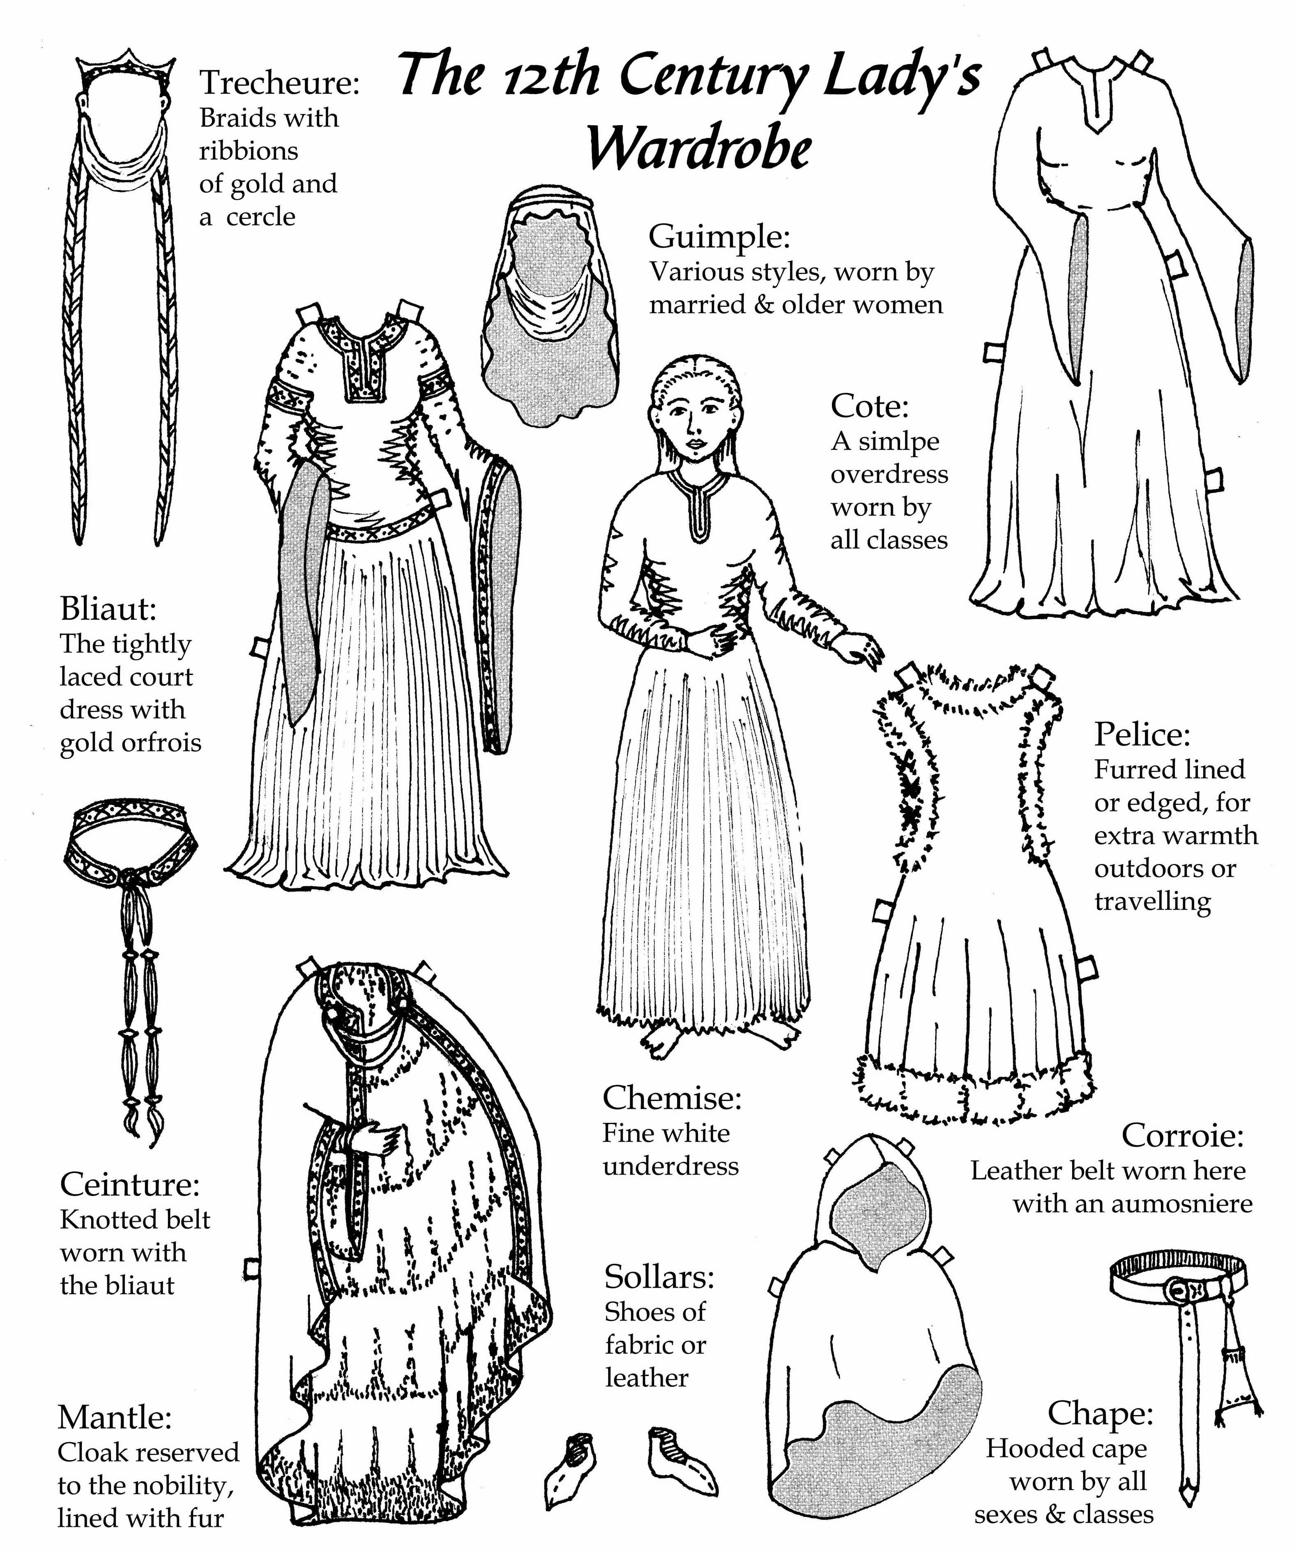
------
Copyright 2002 by Belinda Sibly, <bsibly at paradise.net.nz>. Permission is granted for republication in SCA-related publications, provided the author is credited. Addresses change, but a reasonable attempt should be made to ensure that the author receives a copy.

If this article is reprinted in a publication, I would appreciate a notice in the publication that you found this article in the Florilegium. I would also appreciate an email to myself, so that I can track which articles are being reprinted. Thanks. -Stefan.

<the end>

