India-Costum-art - 10/27/15

"Survey of Indian Costume" by Baroness Anastasia Alexandrovana Andreeva (OL).

NOTE: See also the files: Indian-Sari-art, Moghul-India-msg, fd-India-msg, India-lnks, cotton-msg, silk-msg.

************************************************************************
NOTICE -

This article was submitted to me by the author for inclusion in this set of files, called Stefan's Florilegium.

These files are available on the Internet at: http://www.florilegium.org

Copyright to the contents of this file remains with the author or translator.

While the author will likely give permission for this work to be reprinted in SCA type publications, please check with the author first or check for any permissions granted at the end of this file.

Thank you,
Mark S. Harris...AKA:..Stefan li Rous
stefan at florilegium.org
************************************************************************

Survey of Indian Costume
by Baroness Anastasia Alexandrovna Andreeva (OL)

October 2009

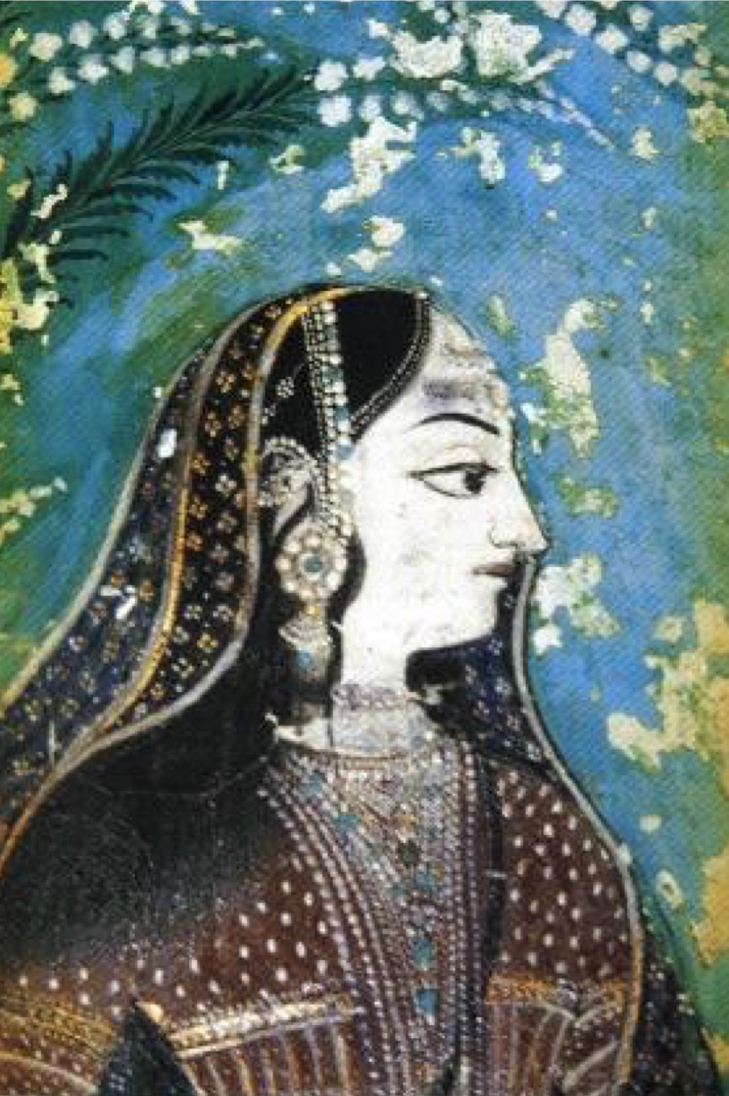
17th C. Rajestahan Lady

Most of the information on Indian clothing comes from the literature of the day, sculptures, and from wall paintings. There are no early period examples of garb or fabric. The best I have is some 16th century examples. The garments were used for quilting once they became rags, so there is no trace of these ancient garments anywhere.

The main literature that has mention of clothing is the Vedas.

The four Vedas, Rigveda, Yajurveda, Samaveda and Athrvaveda, form the fundamental basis of Hindu philosophy and religion. These are the earliest existing texts of mankind. These deal with the knowledge of the Creator, His Creation, and His Creatures. They have provided a national identity to Hindus through the ages. The Vedic mantras are recited on occasions, happy and sad. In spite of Myriads of Gods worshipped, the basic mantras, about installation, about various rituals, and for common welfare remain the same, throughout the country. The mantras are in archaic Sanskrit.

Generally the climate of Indian subcontinent is warm and humid.

Women's Clothing

The Aryans are believed to be of Central Asian origin who descended into the plains of India through the mountain passes of present day Afghanistan. The Aryans entered directly, bypassing Western Asia and Iran. They first spent a few generations in Afghanistan before finally descending into the plains. This is substantiated by the Vedas, which do not mention West Asia or Iran, but do mention the names of some of the rivers of Afghanistan. With the decline of the Indus Valley Civilization the Aryans became the dominant civilization of the region. The period is 1200 to 600 BC.

This is too early for SCA purposes but it will help you understand the evolution of costume in this region.

The History of India is so confusing and the empires changed every hundred years or so; it is best to just pick the year you want and go from there. One of the things that you need to know is that the Muslims conquered at the end of the 12th century AD. That made for fashion change.

By the Aryan period, women wore one very long piece of cloth an unstitched garment called a sari, that they wrapped around themselves in different ways. The word "sari" comes from a Sanskrit word that just means cloth. Saris are first mentioned in the Vedas, about 600 BC.

There were many different ways of draping saris – to dress up women wore them like skirts with a top part thrown over their shoulder or worn over their heads as a veil. Working women often pulled their sari up between their legs to make a sort of pants.

Women who were fighting with the army tucked in the top part of the sari in the back, to free up their arms for fighting. Most saris were five or six yards long, although some saris were nine yards.

Styles in wearing the sari vary from region to region. Gujarat style and Bengali style are different. So are Mangalorean, Kannadiga, Kodava, Tamilian, Malayali, etc. The Saree is worn in at least 10 to 15 styles throughout the India, In Maharashtra and North Karnataka region, wearing a nine yard saree (without a petticoat -- long underskirt --which was superfluous) was in vogue till 20th century

Some people think that Indian saree is influenced by Greek or Roman toga, which we see on ancient statues. This is not correct. Saree is essentially Indian and designed to suit local conditions. Younger women generally wore brightly colored saris, but widows and other women in mourning wore only white ones.

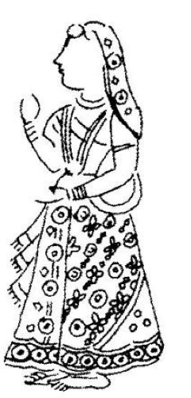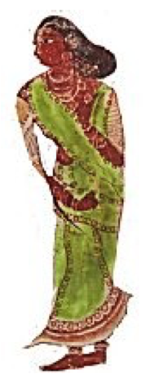
Lady from Gandhar period 600BC-1100AD 14th c. wall painting

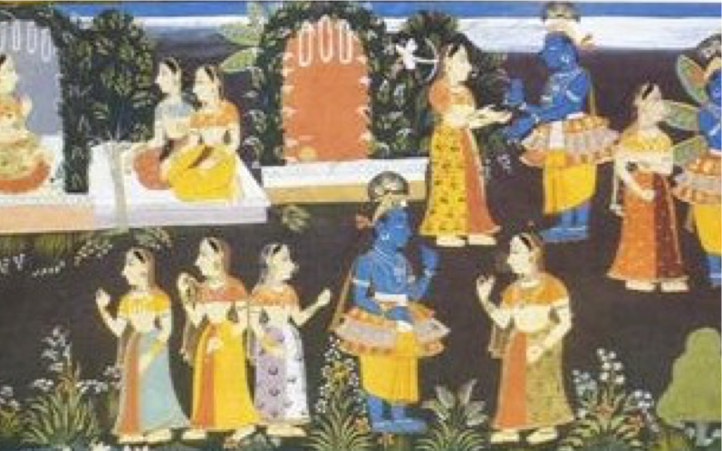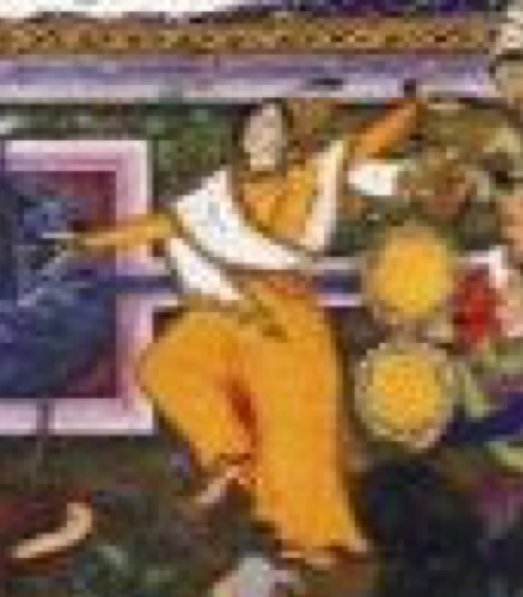
1590 paintings

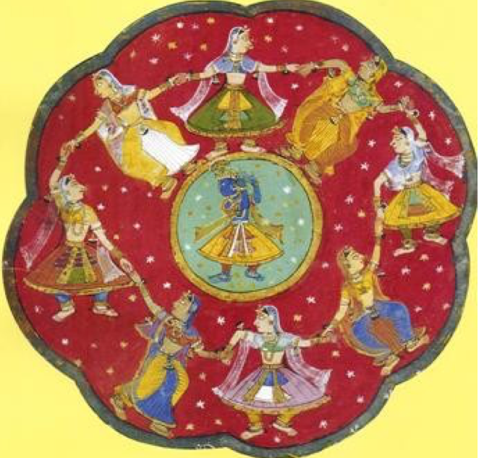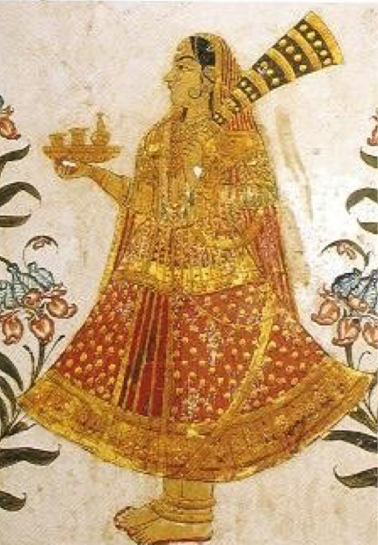
17th C. painting 12th C.wall painting

Choli

So under the Saree we have a choli, originaaly it was a band of fabric tied into a knot in the back. It later became a short sleeved short midriff top that was worn under the sari.and still is today.

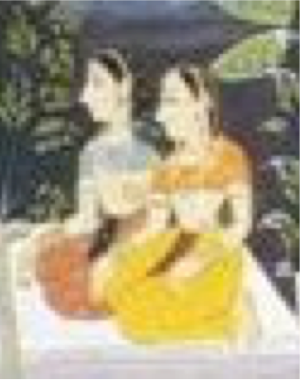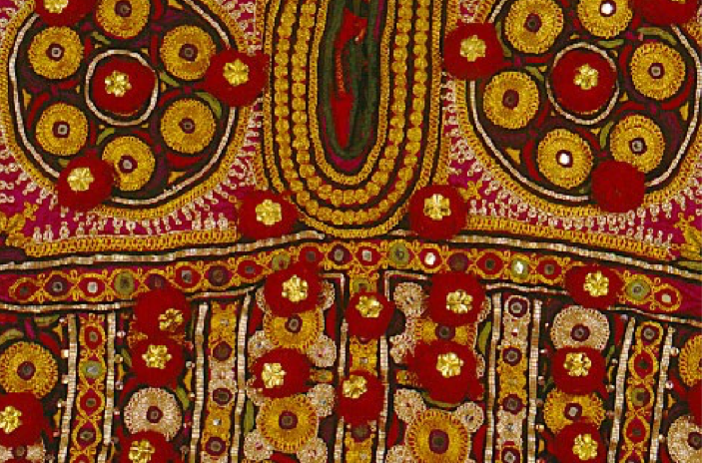
Plain choli's and detail of an embroidered Choli

Petticoat

This garment is a panel skirt not very wide that is drawn at the waist. It is usually the same color as the background color of the saree. Example, if you are wearing a red print sari you will wear a red petticoat.

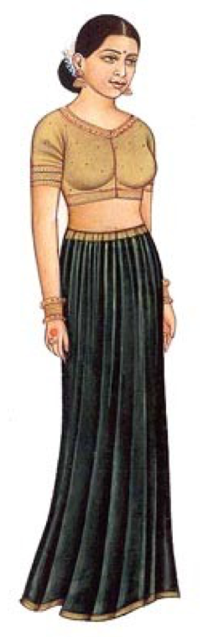
There are no extant examples of this garment, only the literature of the period mention it.
This makes it hard to document but as it is a basic logical garment I think few will dispute its use.

Salwar Kameez

(also spelled shalwar kameez or shalwar qameez) is a traditional dress worn by both women and men in South Asia. Salvars or shalvars are loose pajama-like trousers. The legs are wide at the top, and narrow at the bottom. The kameez is a long shirt or tunic. The side seams (known as the chaak) are left open below the waist-line, which gives the wearer greater freedom of movement. In Afghanistan and Pakistan and India, the garment is worn by both sexes. In Bangladesh and Sri Lanka, it is most commonly a woman's garment, albeit still worn by some men. Another garment is the Churidar, that is a tight pants worn under the Kameez but it would appear to only be later and out of period.

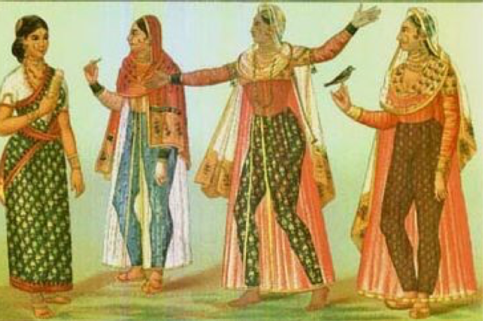
19th century

With the Islamic Invasions of around 1000 AD, Persian fashions in clothing entered India and became popular especially in the north, though they never replaced the sari or the dhoti. Both women and men began to sometimes wear trousers with long tunics over them down to their knees. Women generally wore the "suits" with a long veil or scarf over it.
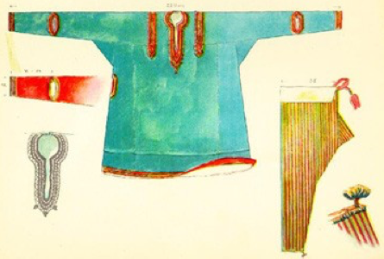
From Max Tilke

Lengha Choli

When the Mughals invaded India in early BC, they brought this skirt and blouse with them. This attire has usually hand-decorated traditional embroidery works such as zardosi and soonf. This style could be way back in the 4th cent BC In the peak of Indian royalty, real gold, silver and expensive stones were used to make these designs.

From the Rajasthan Utsav Sarees presents the traditional and ethnic saga of womanhood through these lenghas, gaghra cholis, ghagara, lehenga cholis. The oldest dress of Gujaratis is chaniya choli, very similar to lehnga choli. Women in villages of put on 'chaniyo' the coloured petticoat often embroidered with 'abhala' or glass pieces, a similarly embroidered blouse or bodice called as 'choli' or 'polku' along with 'odhani', a coloured piece of coarse cloth covering the body and the head. A ghagra is a pleated skirt and is worn with a long or short, stitched and fitted blouse (the choli). The ghagra is secured at the waist. Ghagra choli is also worn with a dupatta, a 2.5 meters of light transparent material usually georgette. The dupatta is worn like a scarf or veil.

This is basically what it looks like, there are no extant pieces.

This is all embroidered.

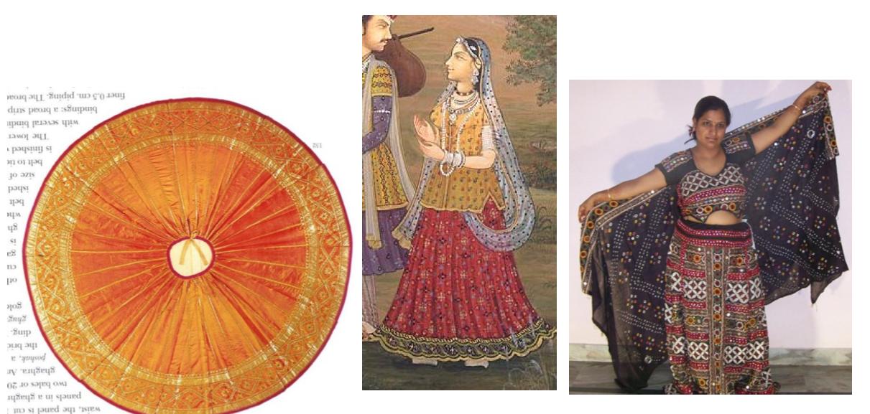

Men's Clothing

Men had few pieces. They wore the Dhoti which is basically a sari made into pants. Therse were usually white. Many Hero-stones (memorials for dead heroes) show the dhoti worn like breeches or shorts with Veeragachche; dagger and other weapons were tucked in dhoti folds.

Then we have the kaftan, or Jama. this is Persian, Turkish ,Mughal, it is basically made the same way as other kaftans of the period. The difference is the often rounded opening in the front. Most of them were side closure, but they could be open down the front as well. The examples are a man's extant kaftan, a mughal emperor 1537 and men from a 16th century manuscript. The main difference in periods, classes and regions was in the turbans. There are too many to go into here, it would be best to pick your region and period and research on your own. Sashes were usually worn with Kaftans. Men also wore the Shalwar and Kurtas, the suit.

Below are two 16th C. men' quilted and stitched caps that were also worn, mostly at home as the Turbans designated your region and religion.

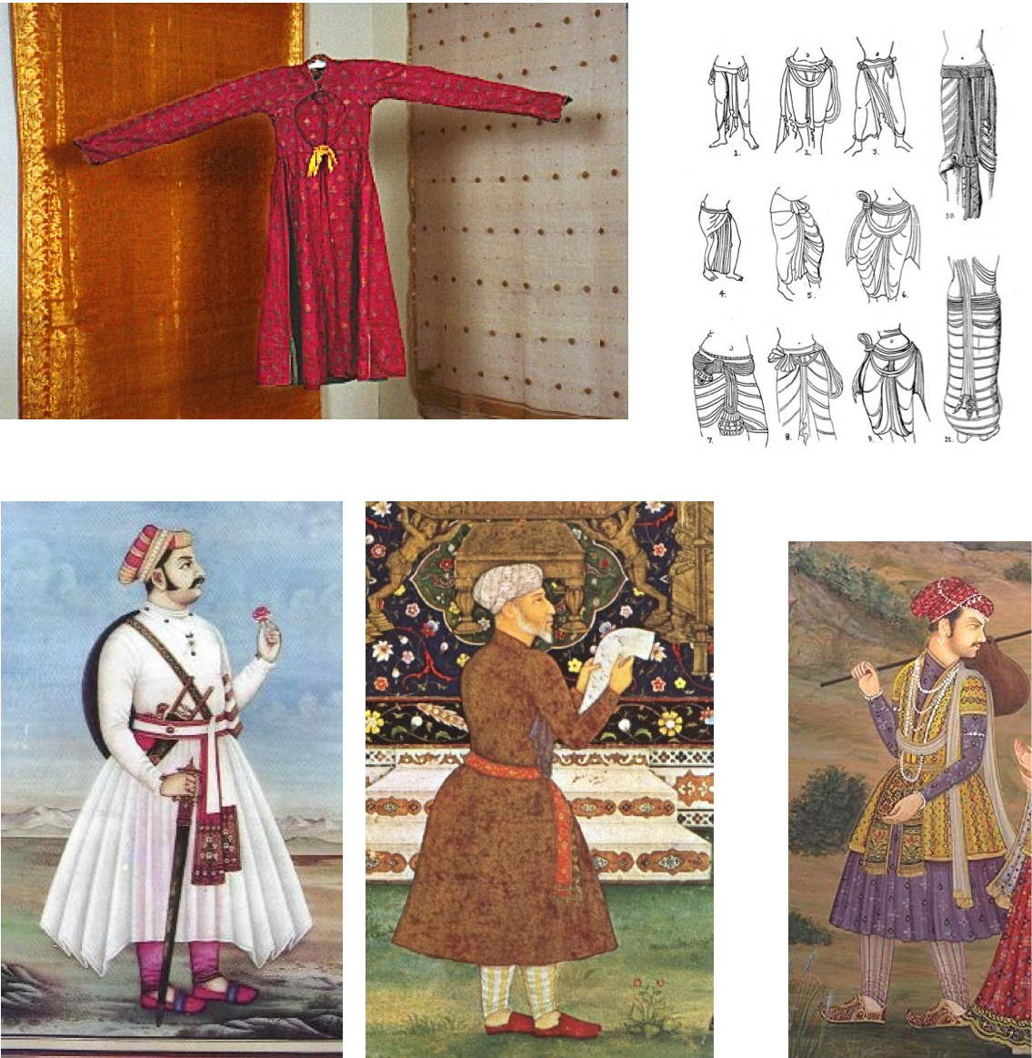

Jewelry

The Indian Women wore lots of jewelry unlike many periods in Western and Northern Europe. If you like to wear jewelry, then this is the persona for you!

Bracelets, rings, toe rings, nose rings, Head and forehead ornaments, kneclaces, chokers, anklets, everything. Gold was more in the South of India and was more intricate and delicate, Silver was worn in the North and tended to be more tribal looking. The picture is not period but is an example of a Banjara Gypsy woman and her jewelry. The jewelry is the same as it was in period, little has changed except that pure metals are not used as much as they were.
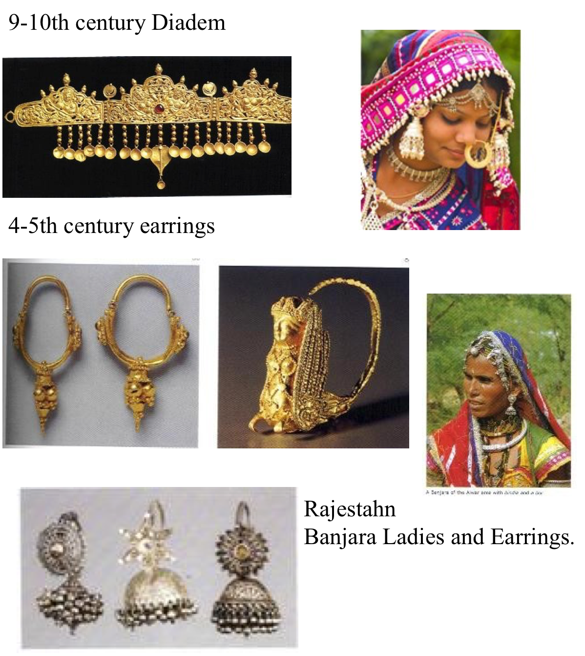

Fabrics

Cotton was cultivated in India centuries before Alexander the Great landed on the borders of India and Indian cloth (chira or Saree) was a wonder to Greek eyes. In fact, Herodotus and other ancient western historians thought there were cloth-growing trees in India!

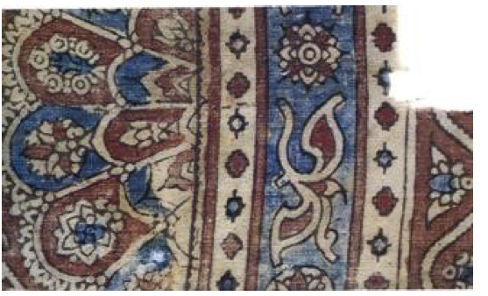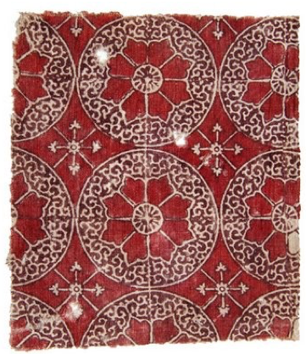

These are 16th century cotton Indian textiles and the only examples I have found. Most fabrics, sari's whatever were used up to the point of rags, then the rags were piled together and made into quilts.

Block printing has been done since ancient times and is still done the same way today. The natural pigments are put on with a wooden carved block.

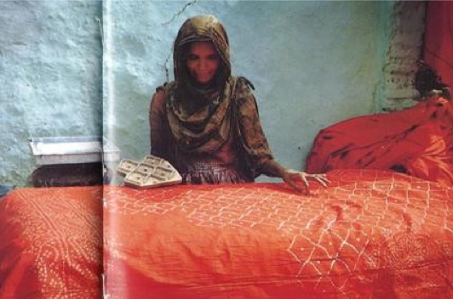

Tie dying was also done in ancient times up to the present, it is done in different areas of India.

Silk was used since early times as well, they cultivated it certain kinds of silk are native to certain parts of India, such as those produced by the "castor oil" and the muga silkworms of Assam; but the chief of the wild silks is the tussore silk, which is found in the jungles nearly throughout India. Large quantities of comparatively coarse silk are made from silk so produced The Persian name for this is pairahan and the Arabic kamis, whence "chemise." This kurta is the equivalent for the shirt of Europe. It is usually of white cotton and has the opening or gala in front, at the back, or on either side indifferently. It was formerly fastened with strings, but now with the ghundi (the old form of button) and tukmah or loop.

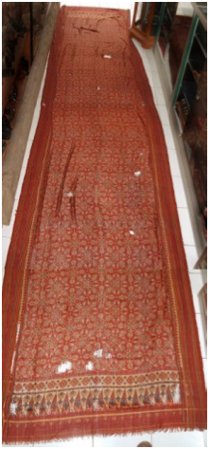

Needlework, Beads, and Sequins

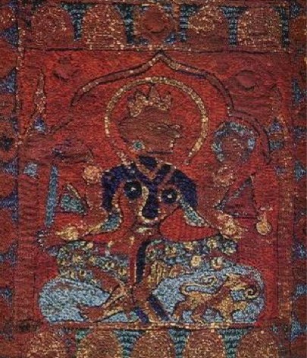

Zardozi is prevalent from the Rig Veda time. However the Zardozi is a combination of two Persian words. Zar meaning gold and dozi meaning embroidery is a form of Persian embroidery. The various forms of Indian embroidery are appliqué, Kinari, Zardozi, Mirror work, Bagh, Phulkari, Chiaknkari, Kantha, Chamba Rumals, Crewel, Banjara and Kasuti.

15-16th century embroidery

Zardozi refers to the glittering work, which is woven with gold and silver thread. Clothes made of Zardozi were mostly worn by kings and people from well to do families in the former days. Other than Delhi, this form of Indian embroidery is widely predominant in Rajasthan, Kashmir and Uttar Pradesh.

Zardozi is a fabulous metal work, where metal blocks are melted and pressed through steel sheets in order to convert it into wires. They are then pressed with hammers to get the desired thinness. Badla refers to the plain wire and when it is woven with a thread it is known as the kasav. Different designs are made namely the sitara and mukaish. Pearls and precious gems are also studded with the Zardozi to make it more attractive and elegant.

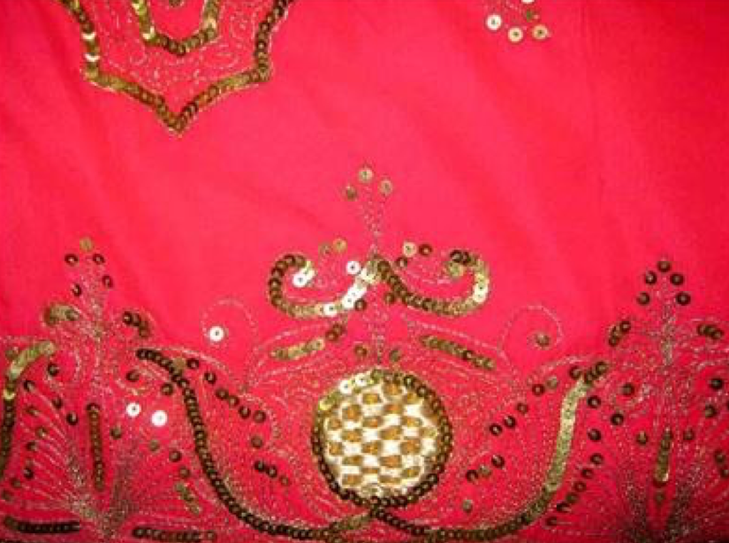
Example of Zardozi metal work

Kinari is an embroidery work, which is prevalent in the Indian states of Gujarat, Orissa and Rajasthan. Kinari is widely practiced by the Muslim craftsmen and was introduced by the Muslim rulers, during their rule in India. Delhi culture gives a glimpse of the Muslim culture as it was long ruled by them. Kinari and Zardozi are appliqué designs, which mainly dominate Delhi embroidery. Both Gota and Kinari are varied forms of appliqué designs enriching Indian embroidery, which are admired throughout the world.

Appliqué is a form of needlework, where the cloth is decorated by overlying the fabrics on each other. The corners or the edges of the cloth are hand sown with thread and needle to create a unique design. Sometimes mirror work is also done with Kinari. The designs vary in shapes and sizes and follow geometrical and floral patterns.

Phulkari, an embroidery technique from the Punjab in India, literally means flower working, which was at one time used as the word for embroidery, but in time the word "Phulkari" became restricted to embroidered shawls and head scarfs.

Some scholars feel that the art of Phulkari came from Iran where it is known as "Gukari". Some feel it came from Central Asia along with Jat tribes who migrated to India and settled in Punjab, Haryana and Gujarat There is reference of Phulkari in Vedas,Mharhat, and folk songs of Punjab. In its present form, phulkari embroidery has been popular since the 15th century.

The main characteristics of Phulkari embroidery are use of darn stitch on the wrong side of coarse cotton cloth with coloured silken thread. Punjabi women created innumerable alluring and interesting designs and patterns by their skilful manipulation of the
darn stitch.

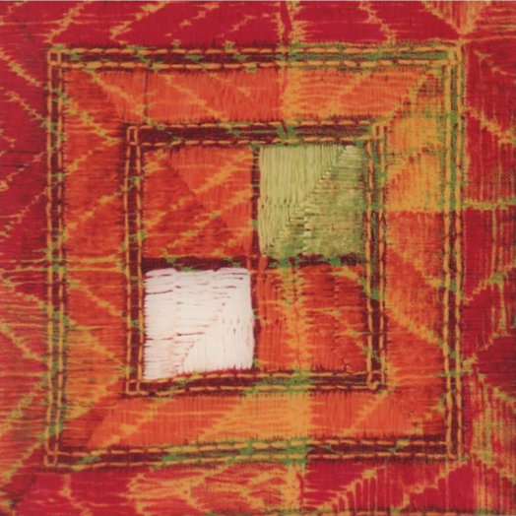

Shoes and Footwear

The most common foot wear for India is bare feet. Throughout the centuries there are more pics of bare feet with red henna soles, lots of ankle jewelry and henna tattoos. This is the earliest known footwear found, around 200 BC.
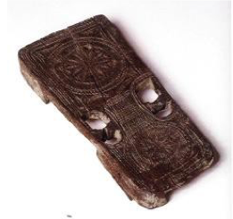

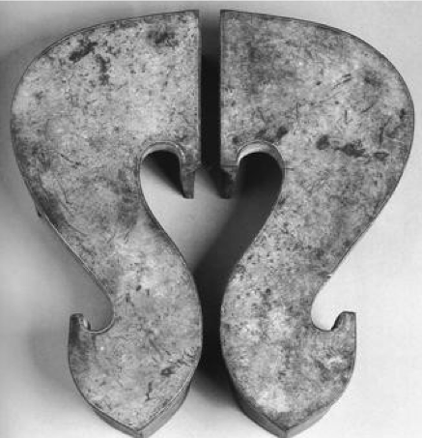
16th century Paduka's. these are ornaments in a brides trousseau, and serve as ritual objects of venation for a devotee, or become votive offerings from the faithful. They are usually associated with the holy jmen who travel from village to village.

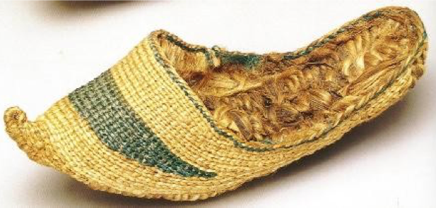
Vegetable fiber shoes made of lambchua grass.

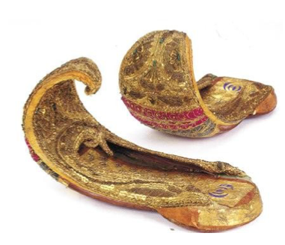
Leather and textile Mojaris. The men's shoes below are the same as women's shoes. They can have backs or be mules with no backs. They were usually made of leather and textiles with embroidery and goldwork.
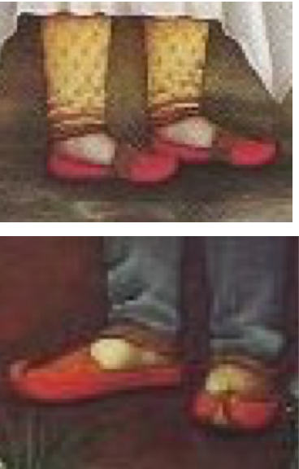

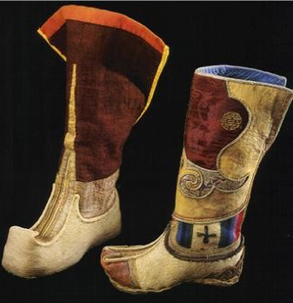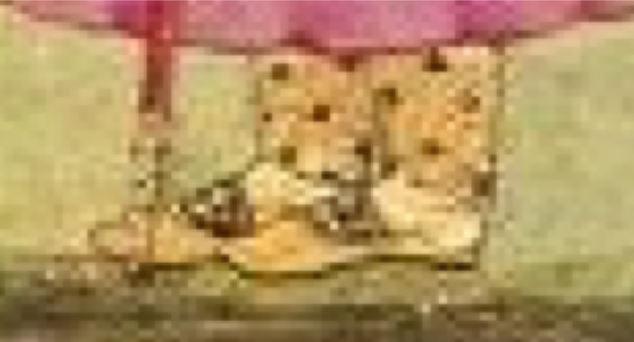
Near the Border they wear the Indo-Tibetan boots they, look like the Mongolian/Central Asian boot.

Selected Sources

Bhandari, Vandana. Costume, Textiles and Jewellery of India Traditions in Rajastahn Mercury books London 2004

Bhushan, Jamila Brij. The Costumes and Textiles of India. Taraporevala's Treasure house of books Bombay 1958

Ganguly, Waltraud. Earring Ornamental Identity and Beauty in India. B.R. Publishing corporation 2007

Gupta, S.P. doctor. Costumes textiles cosmetics and coiffure in ancient and mediaval India. Oriental Publishres 1973

Irwin, John and Margaet Hall. Indian Embroideries Volume II Historic Textiles of India at the Calico Museum Published by S.R Bastiker 1973

Jain-Neubauer, Jutta. Feet and Footwear in Indian Culture The Bata Shoe museum, Toronto 2000

Mathur, AshaRani. Woven Wonder the tradition of Indian Textiles. Rupa and Co. 2002

Reed, Elizabeth A. Hindu Literature or the ancient books of India. Chicago Scott, Foresman and Co 1907

Neeraj, Jai Singh. Splendour of Rajasthani Painting Abhinav Publications 1991

------
Copyright 2009 by Marilee Humason <stasiwa at yahoo.com>. Permission is granted for republication in SCA-related publications, provided the author is credited. Addresses change, but a reasonable attempt should be made to ensure that the author is notified of the publication and if possible receives a copy.

If this article is reprinted in a publication, please place a notice in the publication that you found this article in the Florilegium. I would also appreciate an email to myself, so that I can track which articles are being reprinted. Thanks. -Stefan.

<the end>

