E-Irish-Wn-Dr-art - 10/7/15

"Re-Examining the Evidence - A Study of Medieval Irish Women’s Dress between 750 and 900 CE" by Sadb an Fheadha. (thesis)

NOTE: See also the files: cl-Ireland-msg, 16C-Irsh-Dres-art, Irish-Brat-art, Ireland-lnks, Ireland-msg, fd-Ireland-msg, Vikg-n-Irelnd-art.

************************************************************************
NOTICE -

This article was added to this set of files, called Stefan's Florilegium, with the permission of the author.

These files are available on the Internet at: http://www.florilegium.org

Copyright to the contents of this file remains with the author or translator.

While the author will likely give permission for this work to be reprinted in SCA type publications, please check with the author first or check for any permissions granted at the end of this file.

Thank you,
Mark S. Harris...AKA:..Stefan li Rous
stefan at florilegium.org
************************************************************************

Re-Examining the Evidence -
A Study of Medieval Irish Women’s Dress between 750 and 900 CE
by Sadb an Fheadha

A THESIS
Presented to the Oregon State University Honors College in partial fulfillment of the requirements for the degree of Honors Baccalaureate of Science in Electrical and Computer Engineering (Honors Associate).

1 Abstract

Researching and replicating historical clothing is a practice that has enhanced our modern understanding of how the people of times past lived and worked, and can strengthen ties between modern people and their ancestors. Reenactment and recreation groups have been instrumental in this practice, and their efforts have given a living dimension to the study of historical cultures. Inevitably, there are places and times in history where our evidence or understanding is lacking. This study brings together historical, cultural, and artistic aspects of Ireland and the surrounding areas to construct a hypothesis on what Irish women of the Early Middle Ages may have worn and presents this hypothesis for further testing by both medieval reenactors and the communities of historians and archaeologists.

Keywords: Early Medieval Period, Ireland, Dress, Women

Contents

1 Abstract

2 Introduction

2.1 Purpose of Study
2.2 Research Questions
2.3 Hypothesis
2.4 Assumptions
2.5 Definition of Terms

3 Fashion and the Body
3.1 The Zeitgeist

4 The Anglo-Saxons and the Irish
4.1 Fashion Trends in Anglo-Saxon English Dress
4.2 Dress and Fashion Details

5 The Viking Age Scandinavians
5.1 Dress
5.2 Fashion Trends
5.3 Case Study: The Skjoldehamn Tunic
5.4 Case Study: Viking Age Scandinavian settlements in Ireland

6 The Irish
6.1 History
6.2 Laws and customs
6.3 Women in Irish Society
6.4 Dress in Irish Art

7 The Finished Outfit
7.1 Overview of Findings
7.2 Dress
7.3 Fashion Details

References

List of Figures

- Approximate map of Britain circa 802 CE[21]
- An approximation of what Anglo-Saxon dress would have looked like in the Early Middle Ages [15]
- The Viking raid paths and settlements in overview [3]
- A timeline of Viking Age depictions of Scandinavian women’s dress. From
Left to right: 8th-9thc.,9th-10thc.,and10thc. And later.
- Reconstruction of the Skjoldehamn Tunic Pattern [19]
- Replica of the 6th century gilt bronze plaque found at Athlone, Westmeath[11]
- The St. Mark Plate from the Lichfield Gospels[11]
- The Virgin Mary Plate from the Book of Kells [6]
- Source of the tunic base pattern[10]
- Detail of the Madonna and Child plate
- The original card woven belt found in Cambridge
- Reconstruction of the Cambridge Band
- The completed gown replica.
- The veil, made of plain white linen, worn like Mary’s from the Book of Kells. The veil is secured by pinning it to a headband that is tied tight to the head under the veil
- The neckline, square after the Virgin Mary’s neckline from the Book of Kells, and finished with tablet-woven trim after an Anglo-Saxon belt fragment.
- The Drumaco on Bog Shoe[8]
- The replica Drumaco on Shoes
- Seams found in Scandinavaian settlements in York, Oslo, and Haithabu[2].
- A standard seam. Whipstitch (middle) prevents tearing and running stitch (edges) finishes the raw edges.

2 Introduction

Any culture that is not isolated is impacted by its neighbors, and fashion does not exist in a void. Early Medieval Ireland was in close contact with a number of cultures, the most predominant of which were the Anglo-Saxons of England and the Vikings of Scandinavia. By examining historical patterns, the culture and art of Ireland, and the dress of the Vikings and the Anglo-Saxons, this study revealed an image of what Early Medieval Irish women most likely wore during the time between 750 and 900 CE.

This study was based on the principle of zeitgeist, or "spirit of the times." By under- standing the religion, life and art of a culture and a time we can form an estimation of what the clothing might be like when there are no artifacts to be found. Before Christianity came to Ireland, pagan religion was prevalent on the island. Beliefs and customs were such that the Irish dead were buried with wealth and clothing that represented who they were in life. After the conversion of Ireland, burial customs changed such that fewer belongings were interred and fewer things survived the centuries as beliefs discouraged ostentation and self-ornamentation. As a result of this trend, almost all physical evidence of what the Irish wore in this era has been lost to time. The original purpose of this research was to discover the evidence that existed on what Irish women wore during the few centuries between Irish conversion to Christianity and what we now call the High Middle Ages. However, heavy research revealed very little that shed direct light on this dark area in our knowledge. Thus, it became necessary to use a more indirect approach.

Anglo-Saxon fashion followed the styles of continental Europe closely. While they were not as close with the rest of Europe as they were during later periods, the styles of the Anglo-Saxons followed Frankish and Saxon aesthetic more than the styles of the Viking. In the Early Middle ages after the rise of Christianity, popular women’s dress consisted of a semi-loose tunic over a tighter undertunic, often a loose coat, and a veil held in place by a fillet for most mature women. Main pieces were often trimmed with tablet-woven bands.

Viking fashion was somewhat less related to the popular fashion of Europe than the Anglo-Saxon styles. Evidence of Vikings has been found as far south as Byzantium and they were known throughout Europe, but while the cultures of Scandinavia were ex- posed to other styles, the Vikings were more likely to adapt imported garments to their own styles rather than change their dress to fit other fashions. Women’s dress at the height of the Viking age (within the time period 750-900 CE) primarily consisted of an undertunic that was visible underneath a linen or wool apron dress, which was fastened with two tortoise brooches and rarely belted. Quite often a string of beads was hung from the brooches along with tools.

Ireland had quite different relationships with the Anglo-Saxons and the Vikings. Anglo-Saxon England was more of a trade partner to Ireland than an enemy, and they not only shared a geographic area but also a religion. In addition, they had a common enemy in the Vikings. The Vikings were known throughout Europe as fierce raiders with vast reach, and this notoriety persists a millenium later. These talented mariners were capable of crossing great distances over water, and the design of their ships meant that they could travel both over seas and along rivers. Eventually, Vikings began to settle in these raided lands and formed communities with Scandinavian identities, dress, and languages. As one can imagine, Irish culture seems to follow that of the Anglo-Saxons much more closely than that of the Vikings due to the differences in their respective relationships.

My reconstruction of Irish dress is based primarily on the Anglo-Saxon styles, with details that come from the Vikings and Irish art and literature. The sleeves are slim but Anglo-Saxon, with a standard Early Medieval European cut pattern. There are Viking- style pleats on the sleeve hems of the undertunic. The color of the tunic, a deep blue, may have been restricted to the upper classes in England but was a common color for apron dresses in Scandinavia, being derived primarily from woad that was readily avail- able. The shaping of the tunic is slim compared to the Anglo-Saxon and Viking styles to show a transition to the tight clothing of 1000 CE and later. The tunic is trimmed and belted with tablet-woven bands, a trend that was common to both the Anglo-Saxons and the Vikings. The stitches and hems used are ones found on fabric scraps and small finds in both Viking Dublin and Viking York. The outfit includes a veil and fillet as seen in both Anglo-Saxon dress and in plates from Irish gospels like the Book of Kells.

2.1 Purpose of Study

The purpose of this study was to gather the available evidence and to produce a clear, reliable picture of what the Irish people, particularly Irish women, wore at the time. There is a gap in current research regarding the dress and fashion of Ireland in the post- conversion, pre-Norman era, which translates to roughly 750 to 900 CE. While many grave-goods have been found from the ages bookending this one, and there are examples of fashion from this era from surrounding cultures, the availability of evidence in Ireland during this time is so small that there are very few reliable constructions of what Irish dress was like at this time.

2.2 Research Questions

- What has been discovered of the fashions of Medieval Ireland from the era between 750 and 900 CE?

- What did the Anglo-Saxons wear during this era?

- What did the Viking Age Scandinavians wear during this era?

- To what extent did Anglo-Saxons in England and Viking Age Scandinavian cultures influence dress of women in Irieland?

- How did Irish women dress between 750 and 900CE?

2.3 Hypothesis

The dress of the Anglo-Saxons in England and the Viking Age Scandinavians influenced Irish dress.

2.4 Assumptions

- The clothing and other accoutrements found in graves and in some drawings, paint- ings, and sculptures is representative of dress that was actually worn in the area, either everyday dress or higher quality than what would regularly be worn.

- The materials and techniques known in Europe in the Early Middle Ages were also mostly known in Ireland.

- The cultures of the Anglo-Saxons in England and the Viking Age Scandinavians were predominant cultures that influenced Irish dress.

2.5 Definition of Terms

Some of the following terms have many interpretations, especially among the scholarly community. In the interest of readability, I have chosen a common definition close to my meaning as written by the Merriam-Webster dictionary. Where relevant, I have included my own interpretation.

- Boaire: Irish. A commoner or common man[23].

- Cumal: Irish. A unit used to measure worth equal to one female slave, or the highest unit of value used to indicate a man’s honor-price. One cumal was equal to six sets, and a set is understood to have been equal to one heifer or one half of a milk(milch) cow[23].

- Druid: An orally-trained religious professional who kept the druidic religion[23] and acted as a revered and neutral mediary among groups that followed druidism[12].

- Fad: A "miniature fashion[25]." Fads last a shorter time than even trends in design details. Because of their tendency to disappear quickly and leave little behind, they are disregarded in this thesis

- Fashion: "A popular way of dressing during a particular time or among a particular group of people" [20].

- Filid: Irish. An orally-trained professional who remembered genealogy and history, often in an embellished fashion. They often also filled the related role of poet and/or seer to wealthy individuals [23].

- Free-Client: Soer-Chélle in Irish. A free commoner in a contract with a lord for use of the land[23]. Similar, though far from identical, to a serf of the feudal system.

- Gown: "A loose flowing outer garment formerly worn by men; a woman’s dress." [20] Sometimes used interchangeably with tunic in the context of ankle-length medieval garments.

- Grave-good: "Objects (as weapons, ornaments, tools) that are found buried with the dead in prehistoric graves" [20].

- Honor-Price: In Irish, a man’s worth measured in material[23].

- Jurist: In early Irish culture, an orally-trained professional who was educated in the law or certain aspects of the law. The jurist provided advice and passed judgment on cases brought before him [23].

- Léine: A linen tunic worn by the Irish though the seventeenth or eighteenth cen- turies. Used in the Tain bo Cualinge (The Cattle Raid of Cooley) and popularized in the twentieth century by McClintock. Avoided in this paper due to its associa- tion with McClintock’s works.

- Soer-Chélle: Irish. See: free-client.

- Style: "A characteristic mode of presentation that typifies several similar objects of the same category or class" [25].

- Trend: The direction a new fashion is taking[25].

- Tunic: "A simple slip-on garment made with or without sleeves and usually knee- length or longer, belted at the waist, and worn as an under or outer garment by men and women of ancient Greece or Rome." [20] Sometimes used interchangeably with gown in the context of ankl-length medieval garments. My favored term for such clothing.

3 Fashion and the Body

"While it is true to say that we are influenced by the current ideal, this is not just a modern phenomenon. The nature of the ideal may have changed, but individuals have always aspired to whatever the particular ideal of their time has happened to be." [5]

The concept of fashion will play a significant role in later sections. This examination relies on established ideas of how humans interact with fashion as a species, and consequently applies them heavily. As such, the following list presents the Fundamental Principles of Fashion[25], followed by terms that will be used to refer to the principles in later sections.

The Fundamental Principles of Fashion

- New fashions are invented by many sources, not just fashion designers (multiplicity of sources).

- New fashions evolve from past fashions and are not dramatically different from them (historical continuity).

- Fashions are determined by external forces: our culture, society, lifestyle, history, economy, and marketing system, and therefore serve as a reflection of their time and place (the zeitgeist).

- Many different fashion trends exist simultaneously, in different groups of the con- sumer population (subculture fashion).

- Individuality and conformity are opposing forces that join together to influence fashion creation and adoption (individuality and conformity).

- Fashions have life cycles (life cycle of fashion).

- All fashions end (limit of life cycle).

Fashion as we know it is not a new concept. From the time humans started wearing clothes, there has been fashion. Times change, ideals change, and the speed at which change happens becomes faster or slower, but fashion is always present. The relationship between people and clothing is complex and multifaceted, and the emphasis on clothing and fashion changes with the culture, time, and individual, but there is always the common thread of selfing, the process of expressing oneself through external appearance [5]. Evidence has shown that the Anglo-Saxons near the turn of the first millenium flaunted their wealth (or the appearance of wealth) by wearing expensive silks, which may not have been as rare in the British Isles as previously thought[9]. The presence of Vikings has been documented throughout Europe down into Byzantium, and yet Viking women maintained a style that is rarely seen outside Scandinavia and Germany. Why would they choose to continue wearing their native style when so many other options were available to them? It could have been due to the harsh Northern climate, certainly, but it seems unlikely that environment would be the only reason. I would argue that the expression of a cultural identity played a far larger role in these women’s choice of fashion than any truly pragmatic cause.

3.1 The Zeitgeist

The Zeitgeist is built upon a number of sociological theories and is known as the response to modernity, or "the spirit of the times," and is a term used to express how a culture conforms to the time in which it exists. In this examination, the idea of the zeitgeist will be used alongside archaeological and artistic evidence to evaluate plausibility and influences on the fashion of Scandinavia, Anglo-Saxon England, and Ireland.

4 The Anglo-Saxons and the Irish

The Anglo-Saxon culture occupied what is known as England in the modern day, with some forays into what is today considered Scotland by way of Northumbria, which around 802 CE extended as far north as the Forth of Firth and approximately as far west as modern-day Lanarkshire, Dumfriesshire, Cumberland, and Westmorland in the north[1], as far west as Wales north of the Bristol Channel, and from the North Sea to the Celtic Sea in the South, excluding Kent[21][28]. Anglo-Saxon England itself was, of course, not a homogeneous area: in it were various groups, most notably the Angles, the Saxons, and the Jutes[21]. For the purposes of this paper, we will address the area of Anglo-Saxon England as the geographical areas occupied by the Angles and the Saxons and exclude Kent, which was the area occupied by the Jutes.

Kent occupies a relatively small geographic area. On its northern border is the Thames river and on its southern shore lies the vital city of Dover, where the Roman fleet first landed in the sixth decade BCE[12], and as such it could only have been a lively and important area. However, the unique characteristics of many of the clothes and pieces of jewelry found there[24] mean that the generalized nature of this study must disregard the contributions of the Kentish Jutes to the fashion and dress of the time.

Within the time period covered by this paper, much of Britain would be brought under the Danelaw, i.e. occupied by the Danes of Jutland (Denmark)[22]. Undoubtedly there was a cultural impact, but the Scandinavians in Britain appear to have kept their own traditions while the Angles and Saxons kept theirs, and burials of this time reflect little cultural exchange[24]. Ireland at the time was dealing with its own problems regarding Scandinavian settlements, which will be discussed later. For now, the cultural separation seen in the case of the Danelaw in Britain will be taken as an example of how residents of the British Isles did or did not incorporate the conquering culture into their own.

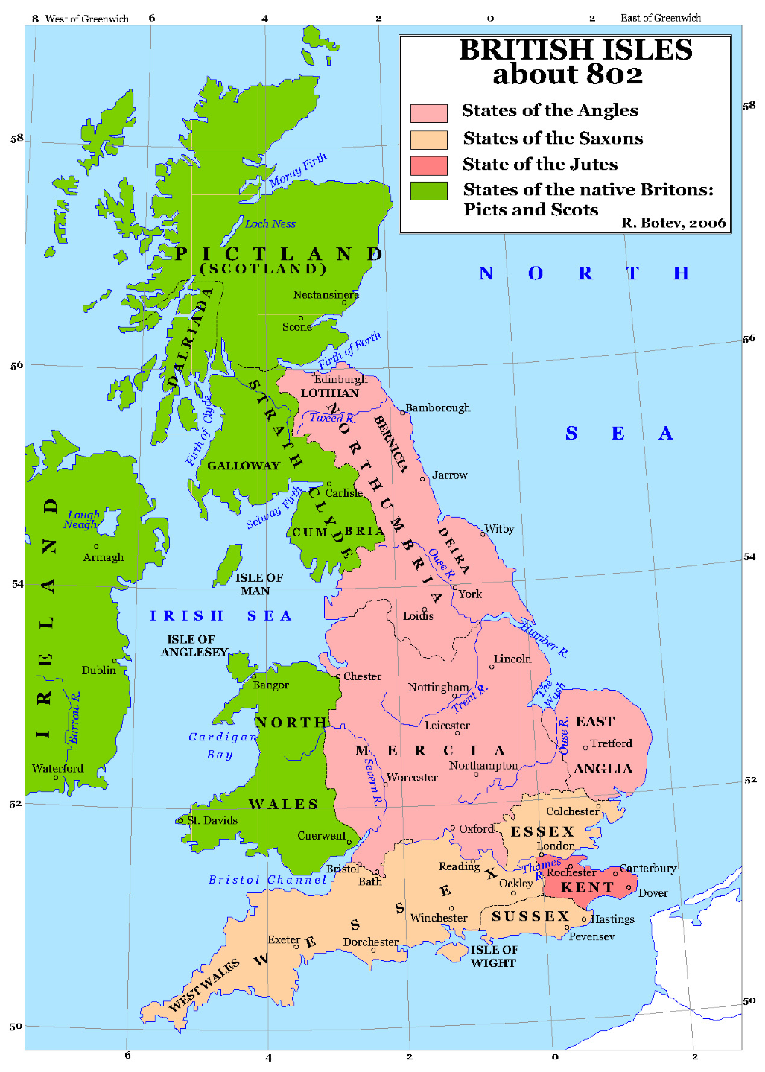
Figure 1: Approximate map of Britain circa 802 CE[21]

4.1 Fashion Trends in Anglo-Saxon English Dress

While trends have changed over time, the list of garments an Anglo-Saxon woman might have worn in the Early Middle Ages has remained approximately the same. This list consists of a tunic, an undertunic, a belt, a veil or headdress, brooches or pins shoes, a cloak, and a jacket or coat[24]. These would usually, though not always, be accompanied by jewelry of some sort, be it a festoon, a necklace, armlets, anklets, or rings. There is evidence that earrings existed in the area, but little evidence that they were actually worn on the ears. They have been found in graves in locations that suggest they were originally contained within a bag or box, but they have not been found near the head. Possibly they were used for their value as bartering tender or as trinkets[24].

4.2 Dress and Fashion Details

The tunic took one of two general forms for an early Anglo-Saxon: a peplos-style gown or tunic, or a sleeved garment resembling a dress. The form of the garment likely determined the style of covering worn with it. The peplos was a baggy garment worn by many early European peoples, from the southern tip of the Roman empire to the Northern tip of what is now Scotland. It generally consisted of a wide tube of linen or wool that, for women and wealthy men, could reach down to the feet. It was open at the top and then pinned at the shoulders with either decora- tive brooches or simple pins. Sometimes these were matched and sometimes they were individual. The belt would wrap around the outside of the peplos and cinch it at the waist, reducing the bulk and making it easier to wear. The undertunic took a similar form, though its pins would have a low profile so as not to interfere with the outer pins and it would generally be made of linen, which was more comfortable than wool when worn next to the skin.

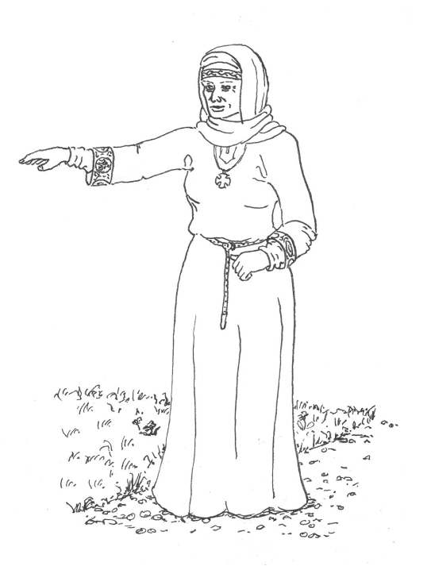
Figure 2: An approximation of what Anglo-Saxon dress would have looked like in the Early Middle Ages[15].

The sleeved gown was a more complicated affair. Though it likely reduced fabric usage, it required more tailoring and was often closed with more brooches in the pre-Christian era[24]. This may have marked it a garment worn by more affluent members of society, as the extra brooches would have been more expensive than the extra fabric required for a peplos. The early versions were still simple, often lacking the complex gores and gussets of later times, but the presence of brooches at the neckline could indicate that it was open at the front and pinned closed to allow the head through the opening but keep a close neckline[24]. It was made to fit the shoulders so the sleeves would stay put, but made wider or slashed at the bottom to allow better movement. While archaeological evidence for the bottom of the sleeved gown is more sparse than evidence for the top, the consensus is that a widening at the bottom would have been necessary to allow the wearer to walk properly[24].There are similar problems noted with the Viking apron dress, and there is debate as to how the base of it would have been made[24][26]. If no gores were used, there must have been some way in which the gown was widened at the bottom to allow its wearer to move about with relative ease.

5 The Viking Age Scandinavians

The Vikings, on the whole, had a tumultuous relationship with Ireland and Britain to say the least. The Viking attack on the monastery at Lindisfarne was only the first of what would be centuries of raids by sailors from across the North Sea. These raiders would loot, kill, and burn settlements they found in the British Isles, and holy sites were not spared because the Vikings did not consider them sacred. Eventually, Viking Age Scandinavians began settling in parts of England, Scotland, and Ireland, but archaeological evidence suggests there was little cultural exchange for quite some time[24]. Burial sites of Scandinavians in England and the Anglo-Saxons in the same areas have much different layouts, and the consensus is that there was exchange of material goods (based on metalware and jewelry found in graves) but cultural customs were distinct for quite some time[24].

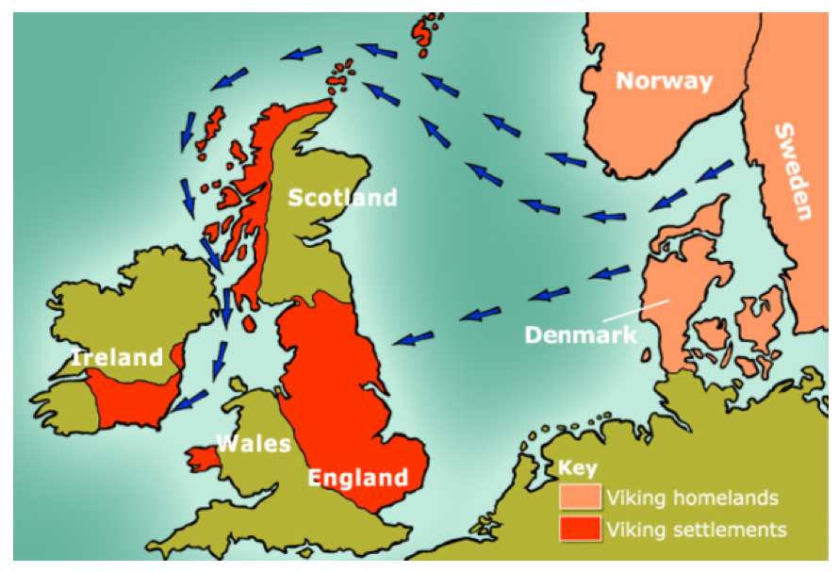
Figure 3: The Viking raid paths and settlements in overview[3]

5.1 Dress

Viking Age Scandinavian dress had a simple base and wide variety. Excavations of Scandinavians graves have revealed that Scandinavians had access to many different materials for clothing and personal ornamentation[26], likely due to the wide-ranging raiders and well-established trade routes. The most characteristic of Scandinavian women’s garments is the apron dress. This tubular garment is quintessential to Scandinavian dress, and was evidently quite versatile. There is debate over exactly how it was worn, as graves often have deteriorated to such a degree that there are almost no surviving examples of what the bottom of an apron dress looked like. Figures in jewelry and artwork provide indicators, but these have also deteriorated and any paint has been worn away, leaving only outlines. The consensus is that apron dresses were constructed as closed tubes at the top, likely with a number of gores around the base. It would have been tight around the bosom and would have been held up by two straps connected to loops on the dress by large pins or tortoise brooches. The apron dress and its undergown could have been made of wool or linen, and many examples of both have been found. Trim is commonly found around the top of the dress, particularly between the brooches, and is found made of linen, wool, and silk[26]. Between the brooches, glass beads on strings are often found that would have hung over the chest. Loops for tools are also commonly found along the top, but belts are only rarely found in women’s graves[26]. Sometimes, generally in richer graves, tunics are found with extensive pleating around the top of the tunic or undertunic[26]. Occasionally, hats or kerchiefs are found, but they do not appear to have been required, as head coverings became required for Christian women starting around this time[24].

5.2 Fashion Trends

The images shown in Figure 4 come from Rebecca Lucas’s research on triangular shawls. The shape portrayed in these figures shows something of how an ideal woman may have been shaped when each of these was made. The shape of the garment moves from a form-fitting gown and shawl in the 8th and 9th centuries to a remarkably different, bulkier gown and cloak in the 10th century and later. Most of the Viking images depict characters from legend: people or mythological figures who would have lived before the time in which the image was created [26]. Sometimes, figures are depicted in such a way that the image is less realistic than it is artistic: the artist conveys the idea while sacrificing reality for clarity[24]. Therefore, the clothing shown may not have been consistent with contemporary fashion, like the Renaissance paintings of Classical figures.

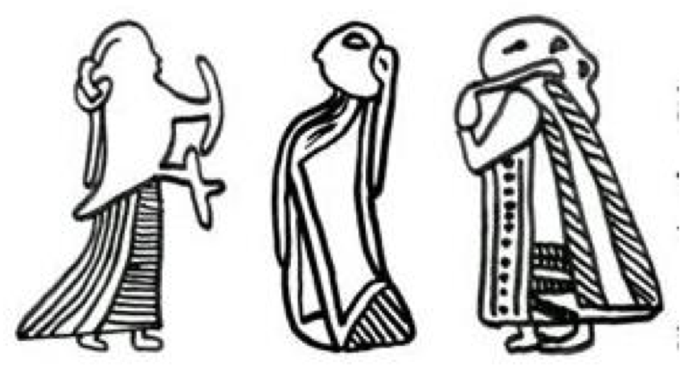
Figure 4: A timeline of Viking Age depictions of Scandinavian women’s dress.

While these images are not guaranteed to represent people who lived during the time when they were made, they do convey a silhouette or shape that can be used to deter- mine what a possible "ideal" was for the women of Viking Scandinavia in each of the three time periods.

5.3 Case Study: The Skjoldehamn Tunic

The Skjoldehamn tunic was found on a body in Skjold Harbor, Norway in a remarkably preserved state, which allowed for extensive study of the body’s clothing. There has been much debate on the period and culture of origin of the Skjoldehamn find, but the most recent findings, dated using radiocarbon methods places it somewhere in the 11th century

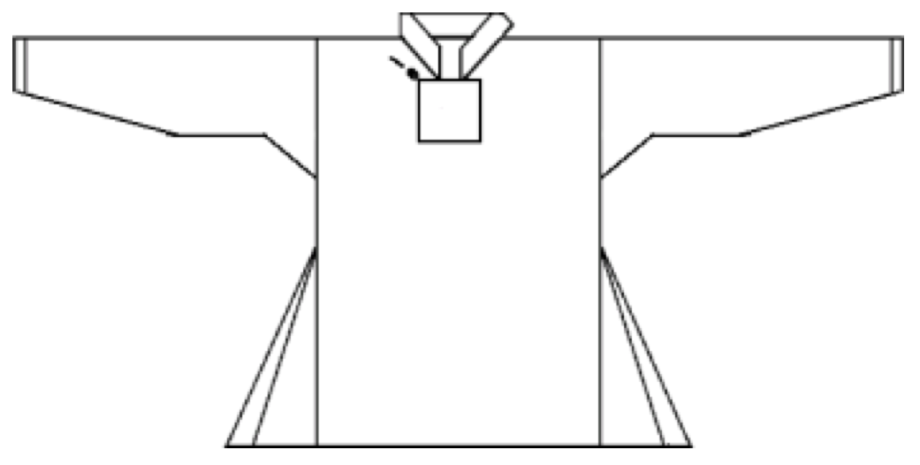
Figure 5: Reconstruction of the Skjoldehamn Tunic Pattern [19]

From left to right: 8th-9th c., 9th-10th c., and 10th c. and later CE, or during "the transition between Viking and Medieval times"[16]. The culture of origin of the outfit is still somewhat debated, but Lovlid suggests that it came from the Sami people, and not the prominent Viking Age cultures as many originally thought. While it is true that this study focuses primarily on the time period encompassing the centuries before the 11th century, the Skjoldehamn find provides a somewhat rare look into the transiting period in Scandinavia between the Viking Age and a more typical medieval culture. In addition, one might assert that with the exception of some more ethnic Sami details, the outfit could provide a good perspective on what more main- stream Scandinavians may have been wearing at the time, and how their clothing was changing from their Viking Age dress to the medieval dress. The changes seen in the Skjoldehamn find provides insight into what was and was not acceptable to change at this time. Even more notably, the Irish people had undergone a similar transition during the period of this study. Comparing the Skjoldehamn find with older, more traditional Viking Age Scandinavian dress can highlight the changes that may have been acceptable not only to Viking Age Scandinavians in the 11th century CE, but also to the Irish in the 8th, 9th, and possibly 10th centuries as well.

5.4 Case Study: Viking Age Scandinavian settlements in Ireland

As was the case in England, Viking raids on Ireland were destructive of local settlements and monasteries. When Scandinavians came to settle in Ireland, there was tension between the two groups. Monks wrote extensively on the subject of interactions with both the settlers and the raiders, so we have a well-documented history of this time. From around 800 CE to 902 CE, the Scandinavian influx and onslaught raised tensions and skirmishes were fought. After 881, records of actual Viking attacks are fewer, but by then the Scandinavian settlements in Ireland had become towns, and had been growing since 830[23]. Records of a "Dublin Gaill" appear near the end of the 9th century, which appear to refer to the people of the Scandinavian town of Dublin. They were, according to the monks who wrote the records, handily defeated by a combined Irish force in 902 CE in a battle that marked the start of an extended and violent conflict that would last for decades[23].

These monastic records tell of a rocky relationship between the Irish and the Scandinavians that does not imply free and peaceful trade. Since the monks did not record such things in detail and the archaeological record is sparse, we will use the example of how the Anglo-Saxons interacted with the Scandinavian settlers. In England, there is evidence of material trade, but not cultural trade and the consensus is that the two groups kept separate cultures, especially in the late eighth century and early ninth century when the Scandinavians were still essentially an immigrant community in England[24]. It can then be said with some certainty that Irish and Scandinavian settlements interacted in a similar way: occasionally exhanging goods but for the most part keeping to their own areas whenever possible. In this case, we can only say with certainty that the cloth- ing, jewelry, and other artifacts found in Scandinavian settlements were indicative of the technologies and materials available in Ireland, but larger Irish fashion trends and culture should not be inferred from Scandinavian settlements.

6 The Irish

Finally, we arrive at the Irish themselves. This section will immerse the reader in Irish culture by discussing the history, laws, and customs of Ireland in the period between 750CE and 900CE as well as the periods immediately following 900 and immediately preceding 750 as is relevant for context. The section will finish with an overview of women in Early Medieval Irish society and what can be gleaned from the art of Ireland during this time.

6.1 History

If England had been considered "The Island at the Edge of the World" by some[12], then one might assume that Ireland was almost completely insular[23]. This certainly may have been the case during the time of the Roman Empire, since Ireland was primarily known to the rest of the world as raiders that plagued the shores of Brittania[12]. As the centuries passed, Ireland became better known in more parts of continental Europe and monks carrying Irish knowledge and books left their names as far south as France in the 9th century via John Scotus Eriugena, who arrived in the court of Charles the Bald, Holy Roman Emperor, circa 845 CE[7].

It is well-known that there were a multitude of Irish monasteries established on the European continent, particularly in the areas now occupied by Germany and France, and that some of these religious communities became so large that they could be better described as universities[11]. Indeed, these communities became so diverse in study and occupation that some came to think of them more as worldly sites than religious ones[11]. Evidence of these large and complex "monastic cities[11]" can be traced as far back as the eighth century CE[11], which suggests that during our period of study, there was quite an influx of both cultural and intellectual ideas from the continent into Ireland.

Whether these ideas had a great impact on the lives of common Irish is less clear, but historical trends suggest that it would have taken much longer for the ideas and values of the continent to impact the common culture of Ireland than the "literati[23]," or learned classes, in Ireland. If the trends of other early medieval cultures can be applied to Irish medieval culture, then there was a large cultural divide between the learned classes and the common folk of Ireland. Certainly, the monasteries provided a market for material goods and services that drew craftsmen and merchants to them, but it is likely that the greatest means of cultural exchange between the two levels of society were through the teachings of the monks through sermons and through the material goods their trades brought into the local communities.

These learned classes were those mostly associated with the monasteries and the de-facto Irish universities, and it is logical to think that the schools of thought within the monasteries were drawing from the same well of knowledge. At the monastery at Toomregan in Ireland, the poet Cenn Fealad was brought to the abbot’s house, and Fealad described its location in detail: ’the three streets meet between the houses of the three professors, as there were three schools in that monastery, one school of Latin Studies, one of Irish law, and one of Irish poetry[11]."

6.2 Laws and customs

"Irish civilization in the tenth century probably still had much in common with that of the Gaulish Celts before the Romans arrived[23]."

The classification of Irish culture in the first millenium has proven to be a challenge. On one side, they were never part of the Roman Empire[12] and never seem to have enjoyed the benefits of Romanization, unless it was by looting Roman Brittania when the opportunity arose[12]. This primarily occurred in the 4th and 5th centuries CE[23]. On the other hand, the extent of Irish literacy, the renown of Irish religious figures, and the intricacy of Irish artwork[7] tells of a sophisticated culture with enough time and wealth for certain members of the culture to dedicate themselves to artistic, literary, and spiritual pursuits. In addition, there is evidence of a somewhat complex legal system and, of course, a rich oral tradition kept by filids (poet-historians), jurists(judges), and druids[23]. Ireland seems to have been, as some might say, its own animal. It was an "entirely decentralized society[23]" with a complex culture unlike that of continental, Romanized Europe.

One of the best pieces of documentation available on Ireland at this time is a legal document dated to the early 8th century CE called the Críth Gablach[23]. This docu- ment provides details on the relationship between a "free-client" soer-chélle and the lord, or the owner of the land. These free-clients were regarded as a typical free-commoner (mruigfher) and, according to the Críth Gablach, had quite a few rights[23]. This is counter to the common-knowledge image of a serf working his lord’s land in the feudal system, in which the serf was certainly not free. Certainly, there were slaves in Early Medieval Ireland, and the Críth Gablach details the worth of men in terms of a cumal, or one female slave. Men of each status were designated an honor-price based on how much property they owned among other factors, and this honor-price became a measure of that man’s status. It would affect his testimonial in a trial, his compensation should his property be destroyed, and the price he should be paid should he become a base-client (doer-chélle), or a man who paid rent on his land to the lord and was bound to the land more closely than the free-client or free-commoner. While he paid a high rent to his lord, the free commoner was quite proserous and was defined as having "land worth twenty-one cumals stocked with twenty milch cows, two bulls, six oxen, twenty pigs, twenty sheep, four boars, two brood sows, and a horse[23]." In addition, this free-commoner had tools, a farm kitchen, and many other things that made his life quite comfortable. Essentially the only thing distinguishing this free-commoner from a nobleman was his honor-price and his lack of both a retinue (aire tuise) and tenants of his own.

As one can see from the evidence gleaned from the Críth Gablach, social classes were very well-defined and were tied tightly to material ownership of land, livestock, and similar goods. It is not apparent how much social mobility there was in practice, but there seems to be no evidence against the possibility of upward movement by common men to higher classes.

6.3 Women in Irish Society

"European Barbarians, including the early medieval Irish, never bothered formally to articulate definitions of sexes and genders. [...] In a culture obsessed with precise calculations of social status, constantly worried about reproductive success, quite openly appreciative of sexual pleasures, and yet ambivalent, at best towards women, [...] Probably everyone pondered, at some time in his or her life, the nature of the opposite sex. No doubt each individual responded with a different, quite personal answer."
-Lisa M. Bitel, "Do Not Marry the Fat Short one": The Early Irish Wisdom on Women

Women in Ireland held an interesting place in Irish society, if not one that was wholly different from the positions held by women on the European continent. It is certain that, like their contemporaries on the continent, the Irish were preoccupied with women in their capacity to bear and responsibility to raise children. However, while the literate Irish were almost always learned men, such as monks, "Secular tales reveal a vivid array of seductive, exemplary, pathetic, comic, and terrifying female figures[4]." These were not the women of the poems of courtly love: objects of desire to be idealized and sought after. Rather, they were treated as having something of their own agency, and are viewed as a whole as being similar to men, while at the same time holding a mystique that made them strange and otherworldly[4]. Some women held enough power that they were capable of being canonized, as in Saint Birgitte[7], while others were relegated to a farm in the countryside and a home of mud and wood. In Lisa Bitel’s words, "Early Ireland, like the rest of barbarian Europe, hosted a set of gender ideologies and gender relations every bit as intricate, flexible, and difficult for outsiders to grasp as our own[4]." This is not to say that these women held as much power as a typical woman of the 21st century (in fact, women as a group almost certainly held less power than they do today[4]), but to pretend to completely understand their full and varied roles in 8th to 10th century Irish society would be to vastly oversimplify the situation.

Despite the multitude of roles early medieval Irish women surely filled, we must by necessity characterize a typical Irish woman of this era. Legally, a woman did not own herself. Instead, she was under the charge of a series of men and/or organizations that changed as she went through her life[4]. However, ownership de jure and ownership de facto are very different things. Contradictions in these legal texts are commonplace, and divorce laws in 7th and 8th century Ireland were such that a woman could rid herself of a husband who fell short of certain expectations. It is reported that women could divorce their husbands for a range of issues ranging from physical abuse to failure to perform his intimate duties[4]. Between the contradictions and the actual freedoms permitted to women, it is easily seen that women exercised more power over themselves and their own lives than one might initially believe[4]. Early laws and stories attempt to categorize women in many ways, almost all of which can be categorized as one of three traits: non- male, beastly, and otherworldly. Women were not considered legally non-male until they essentially failed to grow up to be an adult male at the age of fourteen. Because they had failed to become men, they retained the honor-price they had as children, that of half of their father, until they married. At this point their honor-price would be one-half that of their husband[4].

6.4 Dress in Irish Art

Early Medieval Irish art, like Viking Age Scandinavian art, is a stylized representation of figures that are primarily legendary in origin. In Ireland after conversion to Christianity, these figure are often well-known religious figures like Christ, the Virgin Mary, and various saints. Depending on the artist’s intentions, these figures can be dressed in rich clothes or poor clothes, but in almost all cases the style of dress of the early Christian figures is similar: a loose garment hanging to the ground or the ankles with a square bottom hem. This is the case for most of the major plates in the Book of Kells, the Gospels of Lichfield, and figures on stone and metal that are not military figures. Some of these may be ecclesiastical garments instead of secular garments, but the principal remains the same.

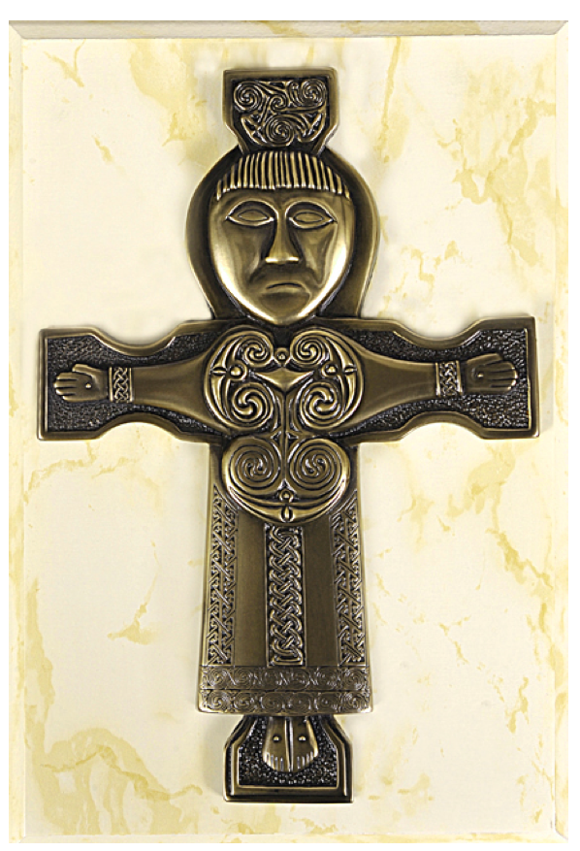
Figure 6: Replica of the 6th century gilt bronze plaque found at Athlone, Westmeath[11]

On the St. John’s Cross gilt bronze plaue (Figure 6), a Christlike figure wears a loose flowing garment with trim at the bottom hem and cuffs and has narrow sleeves. The garment comes down to his ankles and his head is bare. St Mark in the Lichfield Gospels (Figure 7) also wears an ornate, loose, and flowing robe and his head is bare, but his robe also has many different colors in it. This garment looks very rich and voluminous and could represent religious ceremonial clothing. In the Book of Kells, the Virgin Mary wears a long, flowing overgown but at her cuffs another, tighter gown can be seen. Whether this is a true undergown or a standard gown covered with a robe is ambiguous, but the undergown also has trim at the cuffs and at the bottom hem, but there does not seem to be any trim on the body of the gown itself and it is all the same color. It is safe to assume that what the Virgin Mary wears in this plate is closer to what women would have been wearing in the 8th century, when the plaque was made, and that the garments seen in the gilt bronze plaque and the St. Mark’s plate would have been closer to men’s rich or ecclesiastical clothing. Since it is by far the most detailed representation of women’s clothing found from Early Medieval Ireland, it is this plate that will be the primary basis for analysis here.
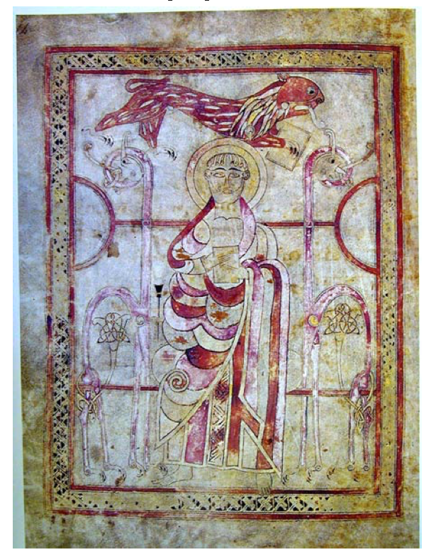
Figure 7: The St. Mark Plate from the Lichfield Gospels[11]

In Figure 8, Mary’s gown is a rich purple color, though it could have been a different color when it was painted. The trim on the gown is gold and does not appear ornate except for at the neckline and possibly at the cuffs. The neckline is by far the most intricate piece of trim, with the pattern forming a complex and elegant knot. She wears a single diamond brooch at her shoulder, possibly to hold her outer garment together. She wears a veil of uncertain design that completely conceals her hair and wraps around her neck below the neckline of her gown. The purple gown appears to have a hood of some sort that is pulled over Mary’s head under her veil, but it could also be a garment that happens to match her gown.

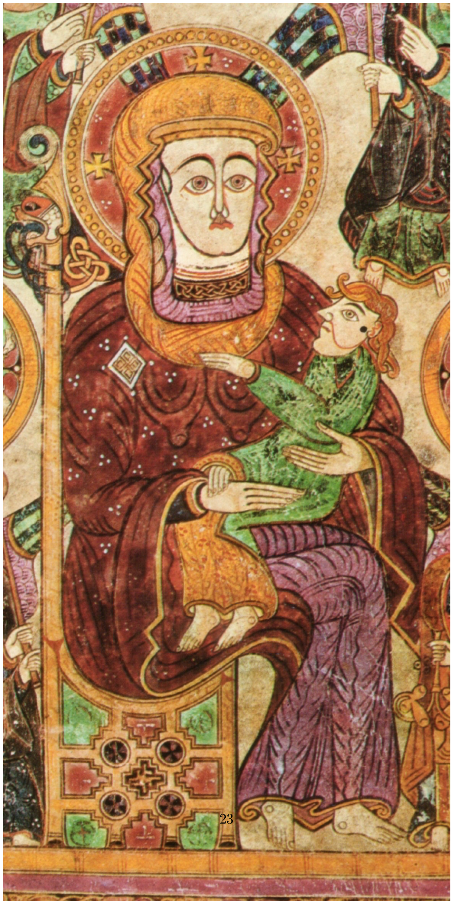
Figure 8: The Virgin Mary Plate from the Book of Kells[6].

7 The Finished Outfit

7.1 Overview of Findings

Ireland in the Early Middle Ages was a place that was realizing its potential as a literary and religious hub of Europe. In the midst of this age of knowledge, foreign raiders descended upon the island and began to settle it, causing tension with the native Irish whose religious sites the raiders had sacked. Ireland also had very close ties to England and the Anglo-Saxons and after the majority of Ireland had converted to Christianity, it began to take on many of the cultural patterns of Anglo-Saxon England. Because of this difference in cultural ties, the finished outfit is based much more closely on Anglo- Saxon patterns than Viking Age Scandinavian ones. Only close details, such as seam type and coloring, are modeled after fabric fragments found in Scandinavian settlements in Ireland and England, as an example of the technologies, techniques, and resources that were available in the British Isles at the time when Scandinavian settlements were taking hold. There is no doubt that the culture of Ireland was very different coming out of the ninth century than it was in the middle of the eighth, so I have chosen to replicate a later garment rather than an earlier one. This gown recalls an Anglo-Saxon gown and displays a slim silhouette closer to the tight garments found in the tenth and eleventh centuries than the loose and billowing gown that belongs to an earlier time.

7.2 Dress

The pattern in Figure 9 was designed to mimic the construction of an Anglo-Saxon tunic. Although the author admits that the front and back gores were likely not used in standard Anglo-Saxon garments, Bury’s reconstruction of a Viking tunic includes them. Owen-Crocker does not discuss gores. While making the tunic I discovered that the front gore was quite unnecessary since the tunic was already very wide around the bottom hem and I did not think the extra gore would add anything. Also, having no other evidence of piece 11 (the neckline piece), I omitted it in favor of a cut and hemmed neckline with trim, after the style seen in many of the Irish-made gospels (Figure 10). For the same reason, trim was added at the sleeve hems. The square gussets at the sleeves were kept because they are seen in a number of other sources, including the Skjoldehamn tunic discussed in the Viking section.

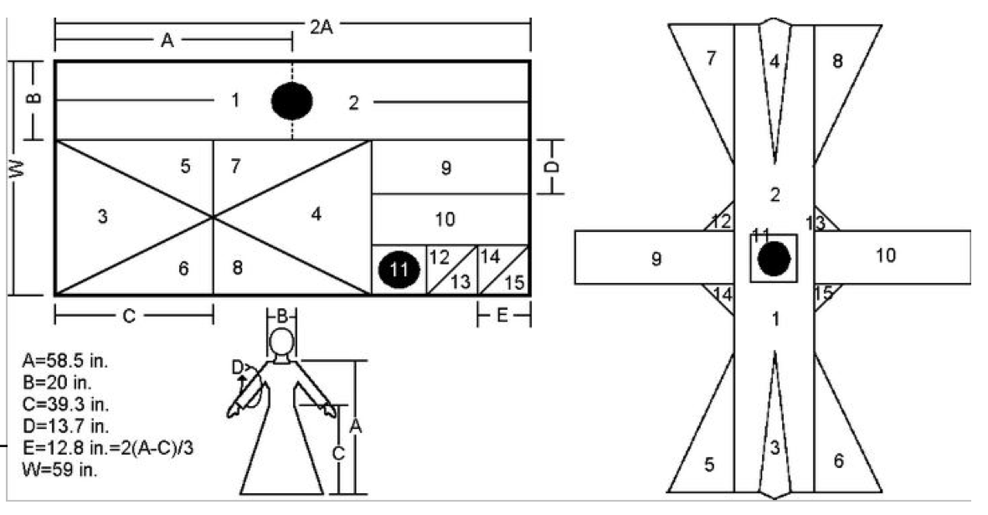
Figure 9: Source of the tunic base pattern[10]

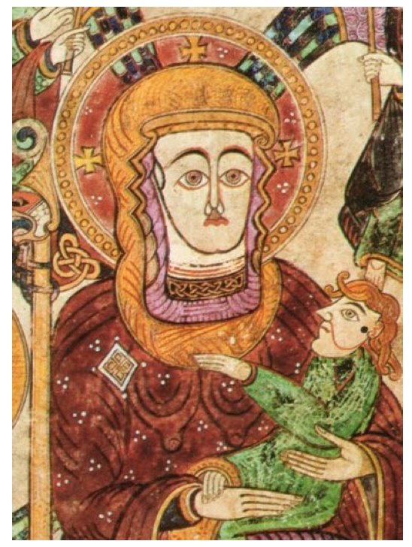
Figure 10: Detail of the Madonna and Child plate

The undertunic is generally accepted as having the same basic construction as the overtunic, so my undertunic follows this same pattern but with more modifications. The undertunic is never seen in the Irish gospels, so I assumed that meant it was not designed to be seen. Therefore, it would likely have shorter hems than the overtunic. Due to lack of fabric, the back and front gores were also omitted.

The lack of fabric posed a problem for the sleeves, and an adjustment had to be made. The purpose of most undertunics in Germanic cultures was to protect the overgarments from sweat, oils, and other substances that would make the tunic dirtier more quickly. Eliminating the sleeves would have defeated part of this purpose, as it would have left the underarms in contact with the overtunic. Therefore, the undertunic has elbow-length sleeves that conserve fabric and protect the overtunic from underarm sweat, and also are not visible from the outside. These elbow-length sleeves are gathered at the cuff after Viking pleats and to keep the sleeve long by pre- venting it from bunching at the shoulder. Instead of using the two-piece square gusset shown in the Anglo-Saxon pattern, I opted for a single piece to take advantage of the fabric’s increased elasticity when stretched on the bias. This makes the undertunic more flexible in the underarm and has the added benefits of both reducing seam bulk under the arm and making for a cleaner-looking gusset.

The neckline of the undertunic is deliberately lower than that of the outer tunic to prevent it from showing above the decorated neckline of the overtunic. The undertunic is made of light, undyed linen because it is an unseen, next-to-the-skin garment that is designed to be frequently cleaned. Making it undyed means that bleach (made from urine before the invention of chemical bleach[27]) or a day in the sun can be used to maintain its brightness rather than another trip to a dyebath.

The overtunic uses the same pattern, but makes adjustments to better match the known construction of the Skjoldehamn tunic. This design mimics the gores of Skjolde- hamn by using a three-piece gore at the side seam rather than incorporating front and back gores. I have found that the side gores that are cut on the bias also add extra length to the garment from the edge to the bottom point of the gore. Placing these gores at the sides rather than at the front and back keeps the front shorter by a very small amount. This adjustment has the effect of keeping the tunic’s hem at ground level without tripping up the wearer and without causing a need for learning how to "wear" the tunic, as is necessary for some other designs in a manner similar to learning to walk in high-heeled shoes.

7.3 Fashion Details

The two outside pieces of the gores (the ones next to the body of the tunic) are right triangles made from pieces 5, 6, 7, and 8 of the Anglo-Saxon pattern. The central portion is made from pieces 3 and 4. As in the undertunic, the two-piece underarm gussets are replaced by a single-piece square gusset.

The overtunic is made of deep blue (woad-look), medium-weight linen and is edged by card woven trim based on an Anglo-Saxon belt pattern (Figure 11)[14]. This trim is based on a pattern derived from a tablet-woven belt found in St. John’s Cricket Field in Cambridge and is attributed to the Anglo-Saxon period. As far as medieval belt weaving goes, a diamond pattern is very simple, but this pattern uses techniques known to originate in the Early Middle Ages. A reconstruction of the band is shown in Figure 12. While weaving this band (Figure ??) in linen, wool, or silk would have been ideal, price constraints made it necessary to use a standard crochet cotton instead. The intensity of the color and the inclusion of gold-look thread for sheen is intended to be reminiscient of a silk band. Given better resources and
tablet-weaving skills, this band would have been silk.

The choice to make the band out of red, blue, and white was a personal one and in- tended to compliment the blue of the rest of the tunic. In keeping with the decoration proposed in this paper, a strip of trim will be sewn down the front center of the tunic, from the base of the neckline to the bottom hem. However, the dark-light-dark scheme of the original has been carried through to the new band.

Blue garments may or may not have been accessible to people of lower rank in seventh and eighth century Ireland, as in one text blue and purple are reserved for the "sons of kings"[13], but it is known that woad was readily available and that Viking apron dresses were often a dark blue[26]. The neckline is square, a known neckline shape, and has trim only along the bottom edge to reflect decoration seen in the Book of Kells’s Virgin Mary plate[6], where the Virgin’s tunic only shows trim at the bottom edge of the neckline.

It is possible that trim was, in other cases, used for the entirety of the neckline, but at this point it is a stylistic choice and evidence cannot support one method or the other. In sewing the tunic, the temptation was to trim the bottom hem to produce a hemline that was, at all points, parallel to the ground. However all archaeological evidence, including that presented in many of the figures in this paper, suggested that an even hemline was not necessarily desirable. It is almost certain that Early Medieval tailors and dressmakers would not have had the dress forms we consider so common today, so sewing an even hemline may have been not just unnecessary, but impractical as well. For these reasons, the hemline follows the same approximate line of the original fabric edge at the base of the tunic. To have a tunic that reached the floor and no further, approximately six inches of fabric was incorporated into the hem for a three inch hem.

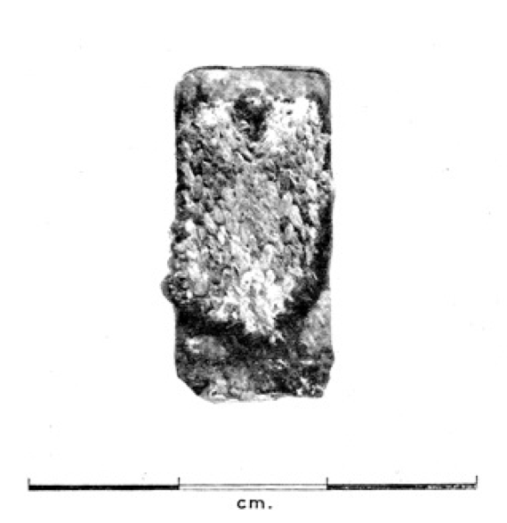
Figure 11: The original card-woven belt found in Cambridge

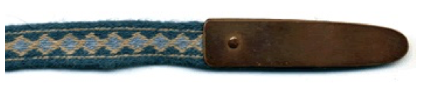
Figure 12: Reconstruction of the Cambridge Band

Structural seams on both tunics use backstitch while hems use whipstitch. Seams that are not expected to bear weight use running stitch, as this is the most common stitch found in the archaeological evidence[2]. In reality, there is very little evidence of the backstitch being used (though it was known in Dublin during the Viking age), but due to the relative fragility of the cotton thread available in modern times, the back- stitch is less likely to break the thread than a plain running stitch. All raw edges are folded over twice to completely conceal the raw edge because linen fabric has a tendency to ravel. Evidence suggests this was also done by the Vikings in both Scandinavia and Ireland as well as the Anglo-Saxons. Seams are either butted or rolled depending on their placement on the garment and the best way to make the finished seam lie flat. Shoes included in this outfit are from the pattern Drumacoon Irish Shoe (Figure 16), a pattern from a shoe found in a bog that was dated to the tenth century, but the pattern was undoubtedly known in the eighth and ninth centuries.

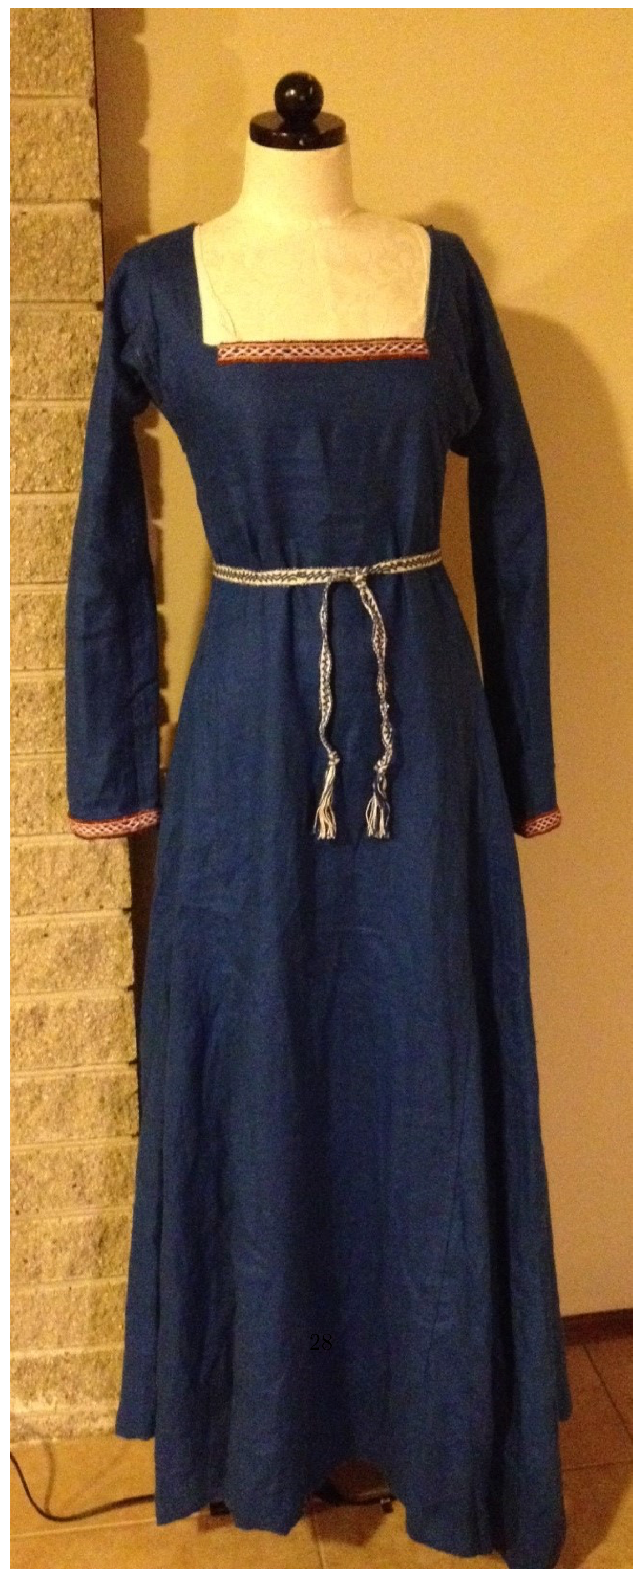
Figure 13: The completed gown replica.

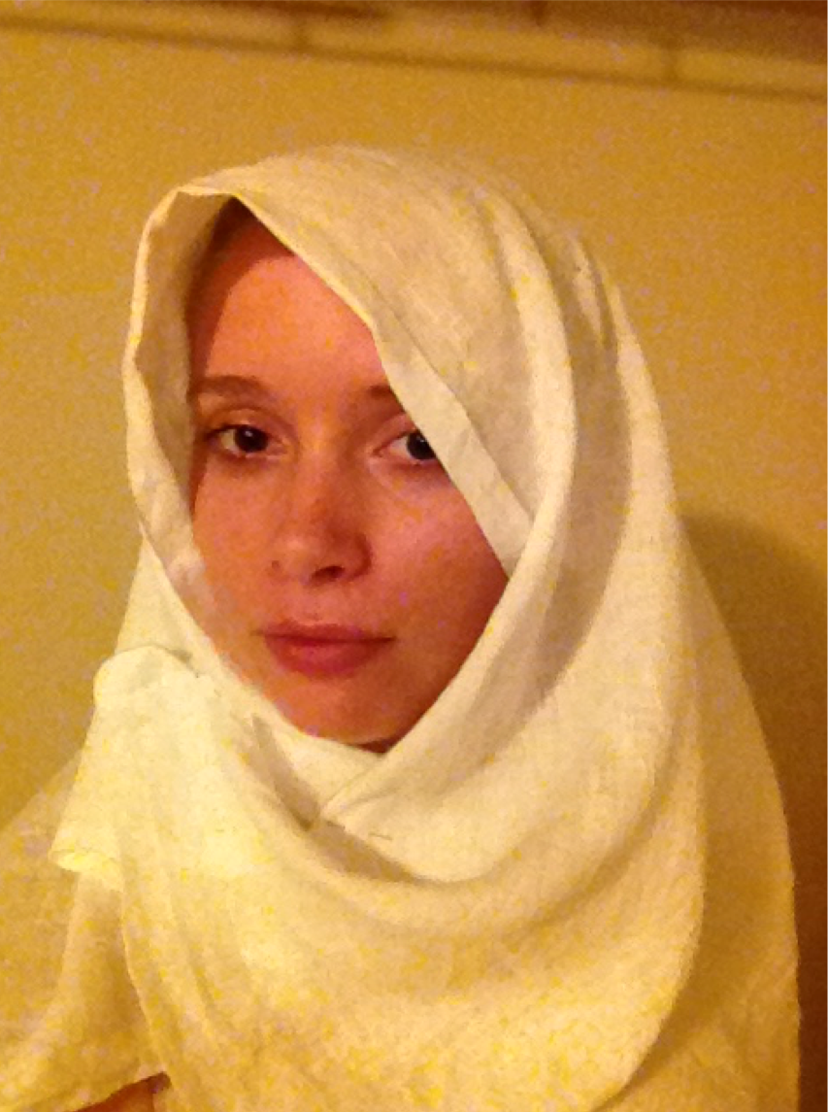
Figure 14: The veil, made of plain white linen, worn like Mary’s from the Book of Kells. The veil is secured by pinning it to a headband that is tied tight to the head under the veil.

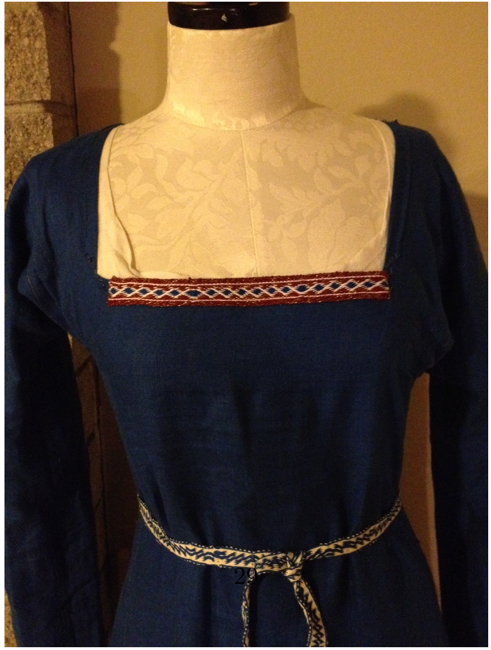
Figure 15: The neckline, square after the Virgin Mary’s neckline from the Book of Kells, and finished with tablet-woven trim after an Anglo-Saxon belt fragment.

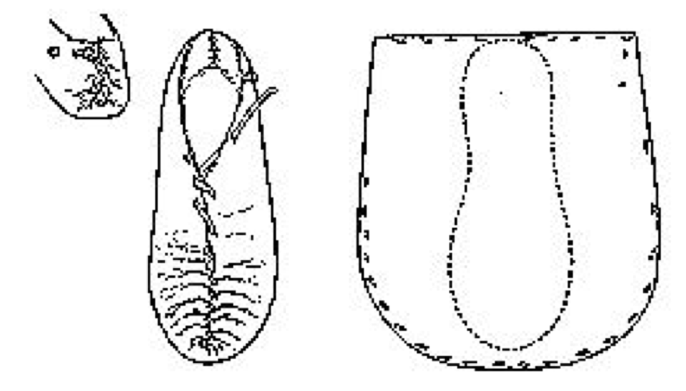
Figure 16: The Drumacoon Bog Shoe[8]

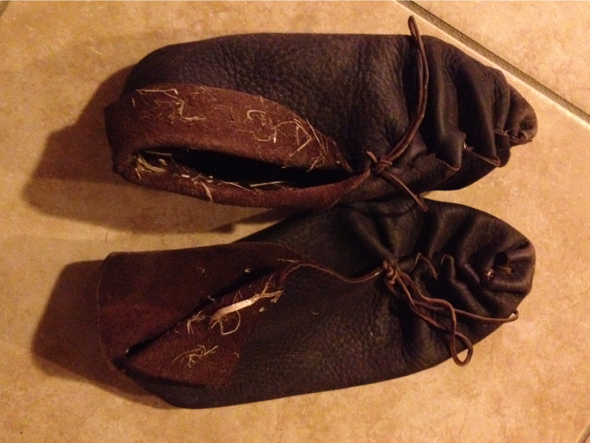
Figure 17: The replica Drumacoon Shoes

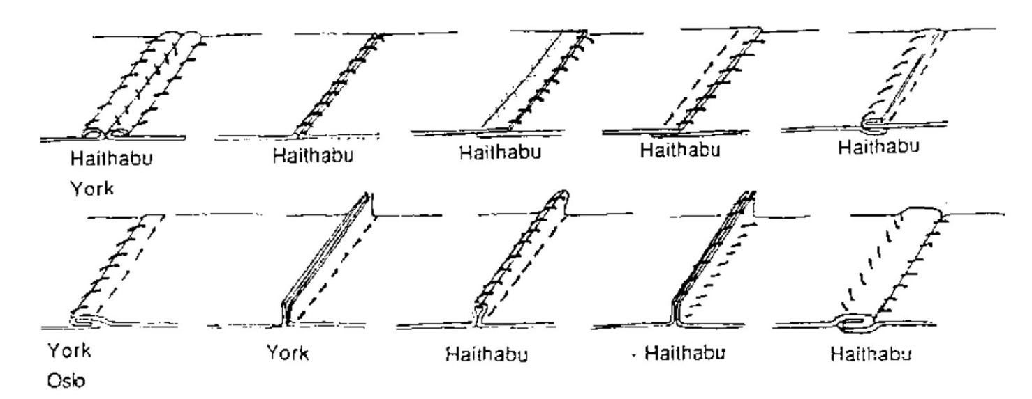
Figure 18: Seams found in Scandinavaian settlements in York, Oslo, and Haithabu[2].

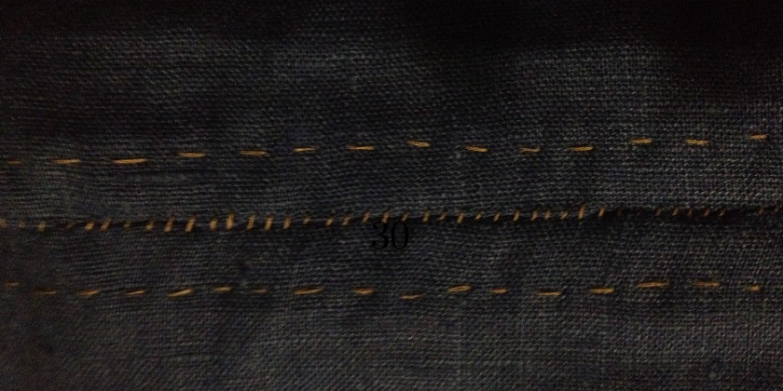
Figure 19: A standard seam. Whipstitch (middle) prevents tearing and running stitch (edges) finishes the raw edges.

References

[1] The Association of British Counties. The Counties of Great Britain and Northern Ireland. 24 June 2014 http://county-wise.org.uk/counties/

[2] Jennifer Baker. Stitches and Seam Techniques: Age / Medieval Garments in Various Museum http://nvg.org.au/documents/other/stitches.pdf

[3] Vikings: Who were the Vikings? Map of and Settlements. BBC Primary History. 2014. http://downloads.bbc.co.uk/rmhttp/schools/primaryhistory/images/vikings/who _were_the_vikings/vk_map_whowerethey.jpg

[4] Lisa M. Bitel. "Do not Marry the Fat Short One": The Early Irish Wisdom on Women. Journal of Women’s History, Volume 6, Number 4/Volume 7, Number 1. Winter/Spring 1995, pp 137-159. The Johns Hopkins University Press.

[5] Anne Boutwood and Robert Jerrard. Ambivalence, and its Relation to Fashion and the Body. Fashion Theory. Volume 4, Issue 3, pp. 301-322. 2000.

[6] Peter Brown. The Book of Kells: 48 pages and details in colour from the manuscript in Trinity College Dublin. Thames and Hudson. London, UK. 1989.

[7] Thomas Cahill. How the Irish Saved Civilization: The Untold Story of Ireland’s Heroic Role from the Fall of Rome to the Rise of Medieval Europe. First Anchor Books: a Division of Random House, Inc. New York, NY. 1995.

[8] Marc Carlson. Footwear of the Middle Ages: Irish Slipper (pre-10th century?) Lu- cas Type 3, Drumacoon Bog Shoe. 1998.
http://www.personal.utulsa.edu/ marc- carlson/shoe/SHOES/SHOE55.HTM

[9] Robin Fleming. Acquiring, Flaunting, and destroying silk in late Anglo-Saxon Eng- land. Early Medieval Europe. 2007. Blackwell Publishing Ltd.

[10] Maggie Forest. ’T-tunic’ - The Period Way. June 1999. http://forest.gen.nz/Medieval/articles/Tunics/TUNICS.HTML

[11] Francoise Henry. Irish Art in the Early Christian Period (to 800 A.D.). Cornell University Press. Ithaca, New York. 1965,

[12] Jamie Jeffers, PhD[Creator and Host]. The British History Podcast(Podcast). May 28, 2011 - July 7, 2014. http://www.itunes.com/apple.

[13] Desiree G. Koslin and Janet E. Snyder. Encountering Medieval Textiles and Dress: Objects, Texts, Images Palgrave Macmillan. New York, NY. First Edition. Dec 2002.

[14] Shelagh Lewins. Anglo-Saxon Belt Weaving Instructions. 2008. http://www.shelaghlewins.com/tablet_weaving/saxon_belt/saxon_belt.htm

[15] Shelagh Lewins. A Reconstructed Saxon Woman’s Outfit. 2012. http://www.shelaghlewins.com/reenactment/saxon_womans_outfit/saxon _womans_outfit.htm

[16] Dan Halvard Lovlid. The Skjoldehamn Find in the Light of New Knowledge. 2010. Translated from Norwegian by Carol Lynn, 2011. http://www.ceilingpress.com/Resources/SkjoldehamnFindInLightofNewKnowledge.pdf

[17] Carol Lynn. New Thoughts on the Skjoldehamn Find. 2009. Written after translat- ing Dan Halvard Lovlid’s 2009 thesis of the same name. http://www.expo-conv- svcs.com/Pennsic40/SkjoldehamnClassHandout.pdf

[18] Rebecca Lucas. A "Triangular" Shawl Style for the Viking Age? January 2012. http://www.medieval-baltic.us/vendelshawl.html

[19] Rebecca Lucas. A Tunic and Hood from Skjold Harbour. 2012. http://www.medieval-baltic.us/skjold.html

[20] Merriam-Webster Online Dictionary. Encyclopedia Brittanica Group. 2014. http://www.merriam-webster.com/

[21] The New World Encyclopedia. Britain about the year 802, showing the Anglo- Saxon kingdoms in red/orange and the Celtic kingdoms in green. 9 Dec 2008. http://www.newworldencyclopedia.org/entry/File:Britain_802.jpg

[22] The New World Encyclopedia. Britain about the year 886, showing the Danish kingdoms in purple, Anglo-Saxon kingdoms in orange, and Celtic kingdoms in green. 9 Dec 2008. http://www.newworldencyclopedia.org/entry/File:Britain_886.jpg

[23] A.J. Otway-Ruthven. A History of Medieval Ireland. 1980. St. Martin’s Press. New York, NY.

[24] Gale R. Owen-Crocker. Dress in Anglo-Saxon England. CPI Antony Rowe Ltd, Chippenham and Eastbourne. Great Britain. 2004.

[25] George B. Sproles and Leslie Davis Burns. Changing Appearances: Understanding Dress in Contemporary Society. 1994. Fairchild Publications, New York NY.

[26] Hilde Thunem. Viking Women: Aprondress. February 2104. http://urd.priv.no/viking/smokkr.html

[27] Jeffrey R. Wiegelsworth. Science and Technology in Medieval Eu- ropean Life. Greenwood Publishing Group. 2006. May 5, 2014. http://books.google.com/books/about/Science_and_Technology_in_Medieval _Europ.html?id=VPDqnGGHpHYC

[28] WorldAtlas. United Kingdom (UK).
http://www.worldatlas.com/webimage/ countrys/europe/uk.htm
------
Copyright 2014 by Alex McConnell, <mcconnell.alex.j at gmail.com>. Permission is granted for republication in SCA-related publications, provided the author is credited. Addresses change, but a reasonable attempt should be made to ensure that the author is notified of the publication and if possible receives a copy.

If this article is reprinted in a publication, please place a notice in the publication that you found this article in the Florilegium. I would also appreciate an email to myself, so that I can track which articles are being reprinted. Thanks. -Stefan.

<the end>

