Cotehardies-art - 6/16/15

"Four Panel Cotehardies: History and Construction" by Lady Rosalie Langmod of Calontir.

NOTE: See also the files: cotehardies-msg, Elzabethn-Gwn-art, Fabric-Buttns-art, Houppelande-art, underwear-msg, Esy-Itn-Rn-Gn-art, Ball-Buttons-art, Atachng-Butns-art.

************************************************************************
NOTICE -

This article was submitted to me by the author for inclusion in this set of files, called Stefan's Florilegium.

These files are available on the Internet at: http://www.florilegium.org

Copyright to the contents of this file remains with the author or translator.

While the author will likely give permission for this work to be reprinted in SCA type publications, please check with the author first or check for any permissions granted at the end of this file.

Thank you,
Mark S. Harris...AKA:..Stefan li Rous
stefan at florilegium.org
************************************************************************

Four Panel Cotehardies:
History and Construction
by Lady Rosalie Langmod of Calontir

Distributed to the class by the same name at
Clothier's Seminar. (February 1, 2014, Gregorian.)

Historical OVERVIEW:

The garment commonly referred to as the "cotehardie" in the Society for Creative Anachronism remained popular for men and women for roughly two hundred years, from the early 1300s to the end of the 1400s throughout Europe. For this reason, I like to refer to the cotehardie as the "little black dress" of the Middle Ages. It co-existed with houpellandes and Burgundian gowns, it could be laced up the front, the back, the side, it came in a solid-color, parti-colored, plaid, and woodblock printed, and could be made with tippets or without. All you have to do is put on a wimple and veil to be in the in the court of Edward III or wear a henin to mourn the murder of the Princes in the Tower.

Despite their popularity, however, the closest thing to a cotehardie that remains today is Empress Margaret's Uppsala Gown which she wore on her wedding day at the age of 12, and a fragment of a gown found in a bog in Ireland (Moy Bog Gown) forcing us to base much of our interpretation upon extant art work, which seldom depicts seams until the end of the 15th century.

A second persistent confusion lies in the terminology: some have argued that the fitted garment men wore was called the cotehardie, whereas women wore kyrtles. Personally, I think the evidence suggests that both genders wore garments called "surcotes" which comprised both what is contemporarily called the "cotehardie" and the "side-less surcote," but the focus of this handout is not the terminology, but the history and the construction. HOWEVER, for the sake of coherence, the garments referenced will be called, as follows:

Smock: inner most layer of clothing, a t-tunic style garment with fairly fitted sleeves. (This garment will not be discussed in-depth in this booklet, but if you would like advice on construction, flag me down at an event or email me at the address provided on the cover page.)

Cote/Kyrtle: Middle-layer of clothing. Tightly fitted and laced up either the front, the back, or the sides. The sleeves were tightly fitted and fastened with laces or buttons. (This garment is commonly confused with the "cotehardie.") Sleeves were usually seen under the Surcote/Cotehardie. This garment was almost definitely only fastened by laces or by being sewn into the garment because buttons down the front would not only create bulk under the cotehardie, they would be a waste of expensive buttons.

Surcote/Cotehardie: Outer most layer of clothing. Slightly less fitted than the Cote/Kyrtle. Sleeves ranged from fitted, full sleeves to pendant sleeves, "three-quarter" sleeves, or tippets. Earlier in period (1300-1350), the neckline is a shallow, boat neckline, but it deepens toward and into the 15th century. Note: While the Church seems to have been quite disturbed by how radically women's necklines lowered during this period, I've found no artistic evidence to suggest they plunged nearly as much as we tend to portray in the current middle ages.

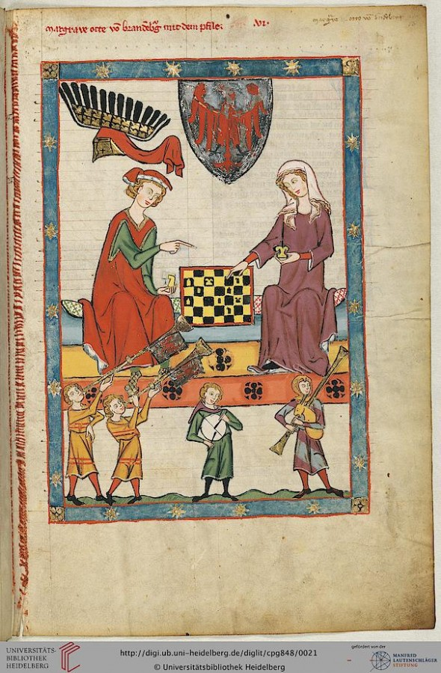
The Manesse Codex, Germany 1300-1315 AD. The Woman on the right is wearing a sleeved-surcote, an early rendition of the Cotehardie. It is important to note, in the 13th Century, German fashions tended to be more loose while other fashions were very fitted. (ie, the Bliaut.) I think a garment following the Bliaut may have been nearly as fitted in France, Italy, and England.

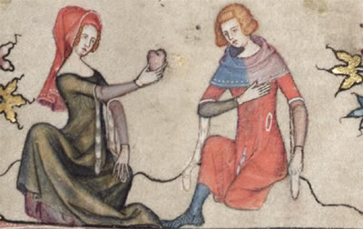
The Romance of Alexander, 1338-44. The detail is brilliant, but also shows the rapid changes in fashion in the 14th century. (Note that the Cotehardie is fitted but still not skin-tight.)

In this painting, both man and woman are wearing Surcotes with tippets. Hers are lined in vair (squirrel fur) and his look to be some kind of fur. The fitchets are another accessory that allowed the wearer to access the pouch on their belt without having it visible to the world, preventing theft. (I think this cotehardie better represents the fit of European clothing during the earlier part of the century than the Manesse Codex.) The man is wearing a parti-colored Cote beneath his Surcote/Cotehardie.

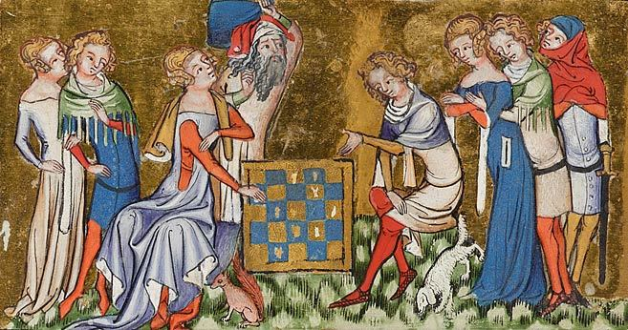
Vows of the Peacock, 1350. France. The women appear to be wearing off-the-shoulder kyrtles and surcotes, but are also flat-chested. (This attribute, or lack-thereof, seems to be prominent in art until about 1365.) It is interesting to note the variations in tippets in this painting.]

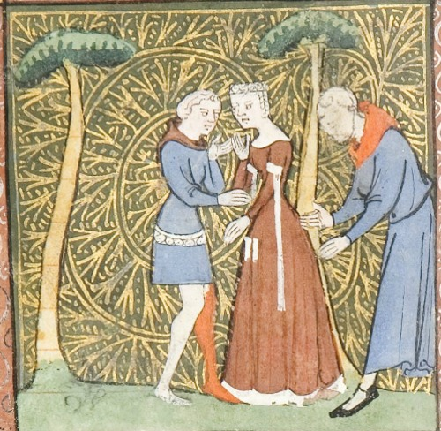
1365, France, women have developed curves… and the men have filled out nicely too! Prior to this, the tippets have been integral, but in this painting, they are attached. (I'll explain later.)
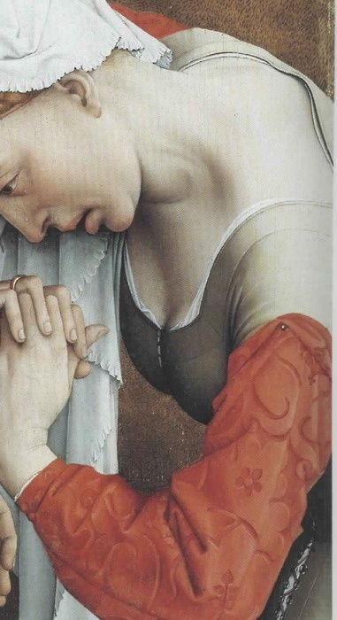
1430-35, Belgium. Rogier van der Weydon, detail from Descent from the Cross. For posterity, this is the LOWEST neckline I've seen in my research and this is more supportive than revealing. This is also a beautiful detail of velvet damask.

Buttons, and Pendants, and Tippets, Oh My!

There are essentially four types of sleeves a Surcote/Cotehardie can sport.

The first is the most basic: a full, fitted sleeve to the first knuckle. (This sleeve is the only option for a Kyrtle/Cote.) The seam runs along the back side of the arm, from the back of your shoulder rather than along the inside from your under-arm, and is fastened from the elbow to wrist either by lacing or (most popular) buttons. In the 14th century, Europe was going through a mini-Ice-Age, so men and women were layering their clothing and lining garments with fur or wool in the winter and linen in the summer. Temperatures would fluctuate, so they would sometimes leave the buttons undone along the sleeves. The white fur or vair that lined the sleeves would show and, through that, the pendant sleeve was born would later which give birth to the tippet. All of these sleeve-styles coexisted.

The second is a three quarter sleeve ending just at or just below the elbow.

The third is the aforementioned pendant sleeve, which opened just at the elbow to form the sleeve.

The fourth, is the three-quarter sleeve with tippets. Note on tippets: We have no historical evidence that they were anything but attached, either as an integral part of the garment (white lined tippet, with a turned up lined sleeve) or added to the sleeve. I do not believe a tippet was featured on a full sleeve, but I wasn't there and there is no evidence to solidly prove either theory, but the prevailing deduction is that tippets were attached, not pinned. Also, one late period wedding shows the bride wearing orange tippets. Another style was to line the tippets (and probably the sleeve) in ermine.

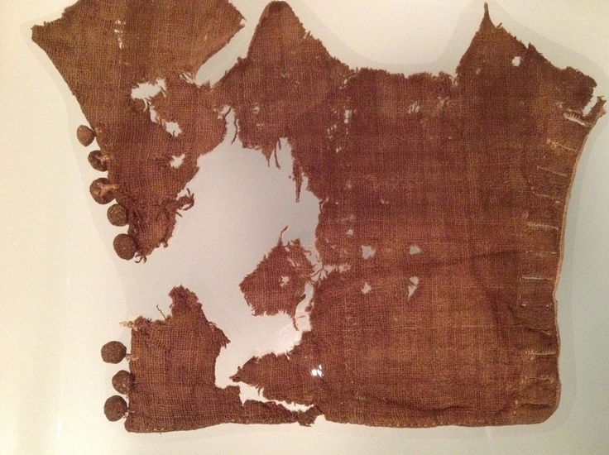
Most of at 14th Century Sleeve (probably 1325-50), displayed in the Museum of London, London. Also featured in Textiles and Clothing 1150-1450. by Elizabeth Crowfoot, Frances Pritchard, and Kay Staniland. Boydell Press, ISBN: 1843832399. –Sleeves like this also appear in the Manesse Codex.

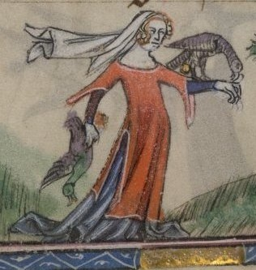
Taymouth Hours, 1325-40. England. Here we see a surcote more fitted than those found in the Manesse Codex. The gather of the skirt implies the use of gores and the slit at the side allows for mobility while she hunts. The Surcote/Cotehardie has pendant sleeves.

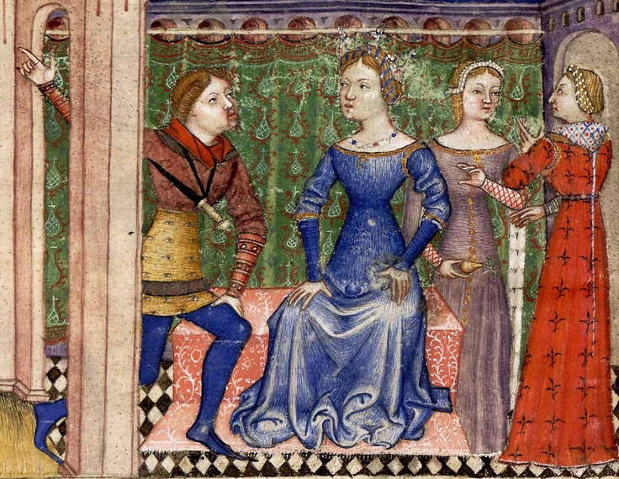
1380-85, Queste del Saint Graal. Italy. Here we see ermine tippets and woodblock printing (I'll explain in the next section), as well as three-quarter sleeves.) (Note: the man with the moustache that looks like a nosebleed is wearing bracers, hence the strange fore-arms.)

Choosing Your Fabric:

Yes: Solid linens, wools, silks, velvets, plaids, and damasks. Damasks should be a solid color. If you can find velvet damask with patterns cut into the threads, you've made a beautiful find.

No: Oriental fabrics, very heavily embroidered damasks with various colors (if the fabric is from a natural fiber, however, you can dye it so that it is a solid color), but, mostly, use your instinct.

During this period, woodblock printing made patterns more accessible on fabric, resulting in some lovely vine patterns and Fleur de Lis, and even some contrast in colors, but nothing too outrageous. (Plaids were also extremely popular through this period.) Also weaving techniques allowed for variations in patterns as well, like the checked sleeve in the Queste de Saint Graal. The further towards and into the 15th century you go, the more elaborate the designs will be. Heraldic embellishments would probably have been appliqued onto the garment having either been cut from fabric or embroidered and appliqued. Embroidery especially took a lot of time, so it was seldom sewn directly onto the garment, although embroidery was common on hoods and pouches. By couching down a separate piece, the owner could remove it and put it on a new garment when the old had worn out.

Wool was the most common and accessible fabric during the Middle Ages because sheep were everywhere. Linen would have been worn by someone very wealthy and usually served as a smock, but in these current Middle Ages it is by far the most comfortable fabric because it both wicks and breathes well. Silk was available, but costly and does not breathe. Cotton was rare, pricey, and does not breathe nearly as well as linen. (As you can see, some things stay the same, some have completely changed!)

It was also not uncommon to sew a sleeve out of costly fabric and pin it to one's kyrtle to give the illusion of that a finer garment lay beneath the Surcote/Cotehardie, or to pin nicer sleeves to one's Surcote/Cotehardie as seen in the detail from Rogier van der Whedon.

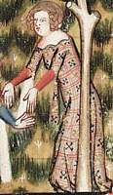
Above: The Romance of Alexander, 1338-44. An example of woodblock printing on fabric.

Where to buy wool and linen fabric? JoAnn fabrics charges a fortune for a wool/polyester blend and their selection of linen is also scant, but they do sell linen/rayon blends that are often %40 off at $6.99/yrd. Rayon is a natural fiber so, like linen, it will take dye very well. Fabricstore.com is the best place to find a good variety and decent pricing on linen. (I have yet to find prices to rival theirs.) For wool, fashionfabrics.com, sells 100% wool suiting for $10.95/yrd and they often have good sales. I have used fabric from both websites provided and been exceedingly pleased with the outcome and quality. If you are going to war, be sure to visit Carolina Calicos for great deals on period fabric.

I also recently found a great way of estimating how many yards you'll need purchase, posted by Cerridwen Verch Iorward (MKA Jamie Pience) at: http://cerridwencreations.weebly.com/uploads/1/0/5/6/10561349/making_a_tailored_cotehardie_website.pdf

The one thing I found amiss with her method was that she doesn't consider fabric width. If your fabric width is equal to or greater than your desired length, you can go with your panel measurements. I will elaborate further in the measuring section.

Measurements:

SA=Seam Allowance. The usual allowance is 1/2 -1". You may want to add more if you're using a French Seam on a sewing machine. (To hand-finish your seams, a rolled hem for linen and flat fell for wool are both period, but not the only techniques.)

Buying Fabric:

Section 1:

· Measure your bust, waist, and hips. The widest of these measurements (+seam allowance) will be W. ______________

· Measure from your shoulder to where you want your hemline. (This can be from your ankle to floor. It can even end at mid-calf if you're wearing a kyrtle beneath.) This measurement (+SA) will be, L. _________________

Section 2:

· Length of arm (with bent elbow) + SA: Y_________ (Note, if your armscye is greater than 24" around, I don't recommend purchasing fabric with a width less than 50". You'll have to buy at least ten yards of fabric.)
Option B:

· If the length of your arm is less than the width of the fabric, but greater than your Armscye (+SA), measure your Armscye and enter it for section 2. X________ (Depending on your desired length, you may need to add this measurement twice, I can usually cut the panel in half.)

Section 3:

· Hip to floor/desired length +SA, H__________

Conclusion:

If your desired length is equal two or less than the width of the fabric and your arms/desired sleeves are less than half the width, measure W+X+H+18" ÷36. (For me, that measurement is 40+15+36+18" ÷36=3yrds.) If the width is shorter, then measure L+Y+H+18" ÷36. (For me, that measurement is 55+24+36+18" ÷36= 3.7yrds.) If the width of the fabric is less than your width, multiply L by 2. (110+24+36+18÷36=5.2 yards.)

Measuring out Pieces:

Body:

· Measure your bust, waist, and hips. The widest of these measurements (÷ 4 + seam allowance) will be W. ______________

· Measure from your shoulder to where you want your hemline. (This can be from your ankle to floor. It can even end at mid-calf if you're wearing a kyrtle beneath.) This measurement (+SA) will be, L. _________________

Sleeves:

· Armscye (Measure around your shoulder and arm-pit with your arm down at your side.) +SA (give ample SA for this measurment.) X: _________________

· Length of arm (with bent elbow)/desired sleeve length (+ SA) will be Y: __________________

(Remember: In period, a full sleeve on a cote would go to the first knuckle of your hand. )

Gores:

· Hip to desired Length, (+SA) H________________

Cutting out the Pieces:

After pre-washing and ironing fabric, lay it out on a flat surface. Begin by cutting out four panels the width of measurement W and the length of L.

Next, cut out your sleeves. You may use one panel the width of X and cut it in half, or cut two panels the width of X. (So far, so good?)

Finally, cut out a panel along the width of your fabric that is as long as H. Fold that in half along the width and cut an equilateral triangle (that means all sides and angles are equal if you've been out of high school longer than I have) out of the middle. The result will be three full triangles and two right angle triangles. (You can sew the right angle triangles together along the straight edge and use them at the front, or you can leave them for facing.)

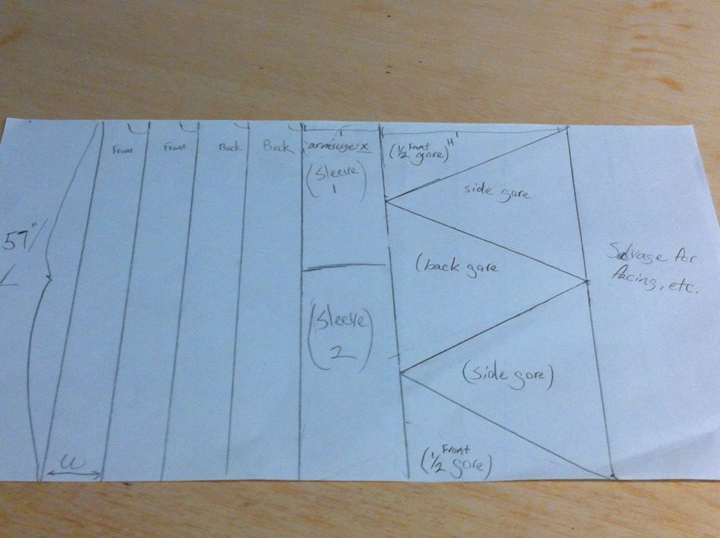
[Panel Diagram, option 1.]

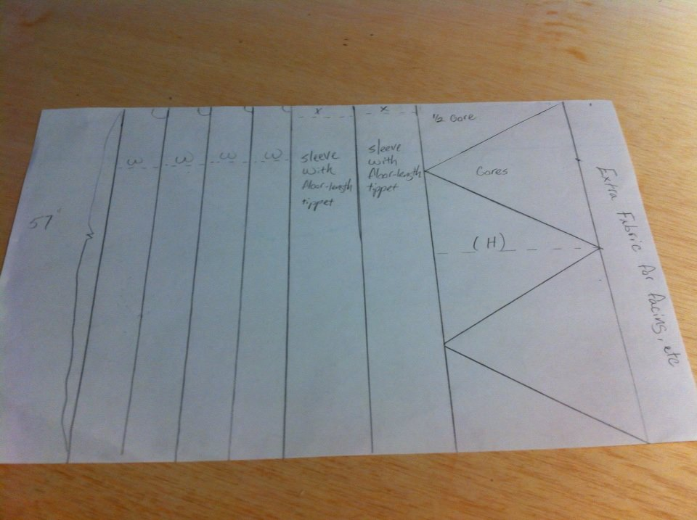
[Panel Diagram Option 2. This is for floor-length tippets.]

If you want tippets, but don't want to use that much fabric, here is a third option, that allows you to follow Diagram 1.

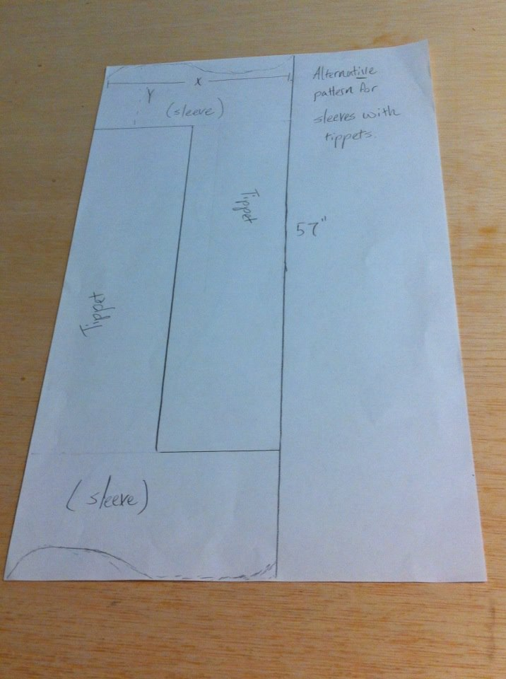

Fitting the bodice:

The best way to fit the bodice is to drape the four panels and fit it to your figure, but when you don't possess a dress-form it can be tricky to pin yourself if there is excess fabric. Also, it means you have to pin yourself into every kyrtle or cotehardie you make which is time-consuming when you are preparing for war and have to mass-produce garments.

What I did to pattern my cotes/surcotes was to do a little geometry and play "connect the dots".

Step 1: Write down the measurements for the start of your bust, your bust, bra-line, waist, and hips, then divide each measurement by four, finally add your SA to each measurement. (I actually add 2" to be safe and I pin and sew to fit.)

- Start of bust /4________

- Bust /4 _________

- Bra-line /4____________

- Waist /4 _____________

- Hips /4 ______________

Step 2: Measure the distances from:

- Your shoulder seam to the start of your bust. (That is, your chest along your sternum where the cup of your brassiere begins.) _______________

- Measure from the start of your bust to your areola (where the bust is usually widest around.) _________

- From your areola to your bra-line (where your brassiere ends.) __________

- From your bra-line to your waist. ______________

- From your waist to your hips. _________________

On a vertical line or grid-paper, measure out the distances between the points in Step 2, then take a ruler and measure for each point in Step 1 horizontally.

Finally, you'll connect the dots to create your bust.

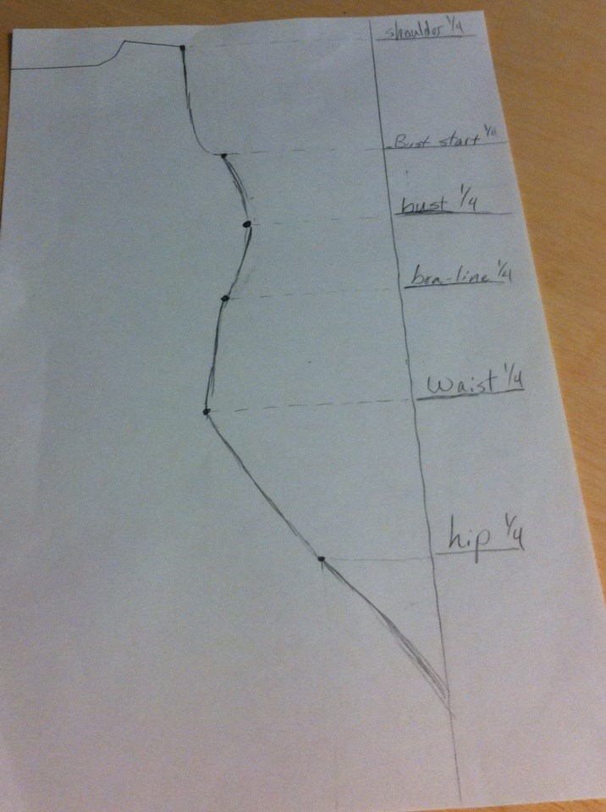
[Fitted Cotehardie, Diagram.]

Important note! When fitting your kyrtle/cote or surcote/cotehardie, you want to be very careful that you are both well supported (ideally, you shouldn't even need a brassiere), but have also created a flattering silhouette. My lord Günther's torso, for example, tapers at the bottom of his diaphragm, expands at his waist, and, finally, becomes drastically smaller at his hips. When I made him a fitted surcote, he was very uncomfortable with this line, so from that time forward, I left the bodice looser to create a clean line from his rib-cage downward.
Fitting Your Kyrtle/Cote (with a partner):

These instructions are adapted from La Cotte Simple's instructions (which neglect seam allowance along the shoulder seams) and private instruction from Lady Maegwynn Verch Bleddyns (MKA, Meg Brandt.)

To make a tight-fitted kyrtle-cote (or later period Surcote/Cotehardie), the help of a friend is, well… helpful.

1. Take mock up fabric and cut four panels the desired width of your cote-panels, but only as long as the length of your shoulder to your hips.

2. Pin, sew, or baste the shoulders so that you have seam allowance. Do the same for the front seam.

3. Put on the mock up and pin, staple, or baste the side seams, remembering to keep the flattering silhouette we discussed earlier.

4. Fit the small of the back. (Cut excess fabric as you go, but be careful.)

5. Lay down and push your bosom up so that it is within the "shelf" provided by the fit.

Take off the mock up, mark the seams with a marker, cut excess fabric, but be sure to have seam allowance up to one inch outside of the lines created by the seams. Remove the thread, staples, or pins.

Fitting Sleeves:

Now that you've already got your Armscye, all you need is the circumference of your bicep for short sleeves or tippeted sleeves. For full-length sleeves, measure your bicep, bent elbow, wrist, closed fist, and the distances between each point. Divide the measurements by 2, then fold the fabric in half and play connect-the-dots like you did with the bodice pattern.

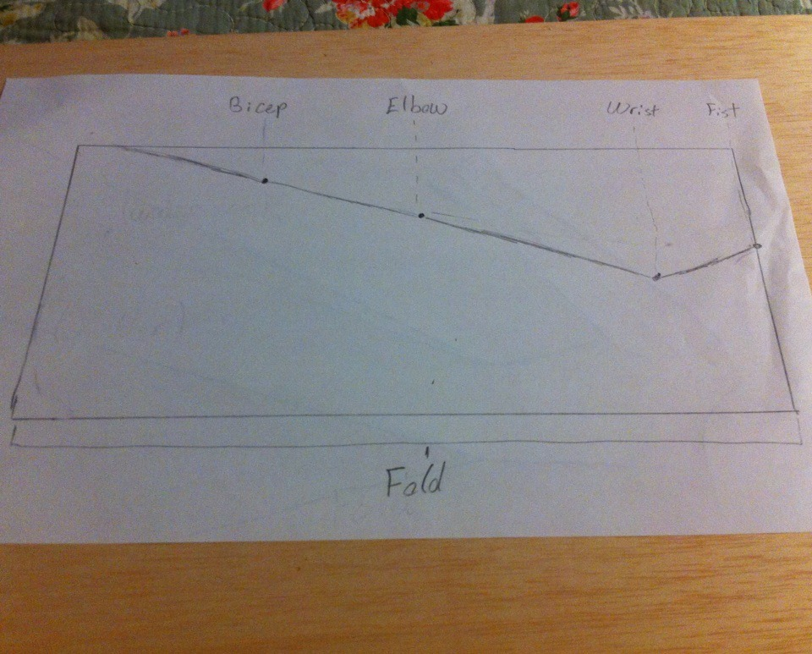

Next, you'll need to cut out the armscye. There are two ways I have found to do this: the first is trial and error with muslin or patterning fabric, the second is to cut along the armscye of your dress.

Lay the sleeve beneath the garment with the top of the sleeve in line with the bottom of the armscye. (You should have four raw edges lined up.) Cut out the sleeve along the line armscye and, voila!

Ultimately, your finished sleeve should look like the one below.

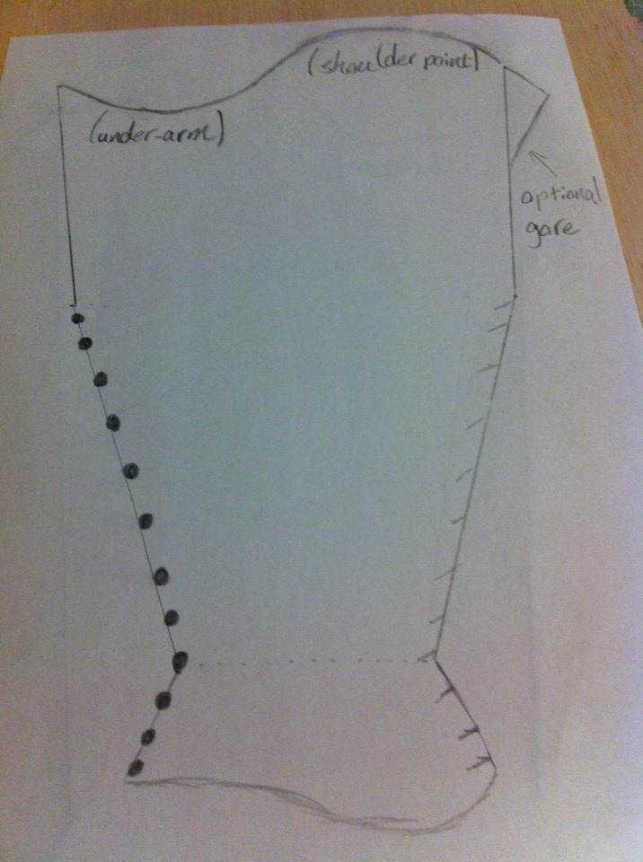

Assembling Your Garment:

There are only two things to remember in assembling your cotehardie:

Sew the gores bias to straight edge and set the sleeve with the seam along the back of the arm (middle of your shoulder-blade),

Some people sew the gores before setting the bodice-seams, some prefer to set the gores by hand. Either way works, in fact, as long as you're careful, you can set the gores by machine after you've sewn the bodice seams. (Note: hand-sewn seams hold better than machine seams and, if you have the time and physical capacity, I recommend setting both the gores and sleeves by hand.)

Cotehardies can be lined or unlined. (There is physical and artistic evidence of both.) Lining can be white or a contrasting color, just remember the rule for sleeves we discussed earlier. In period, people would line their garments with wool or fur in the winter, and change it out for linen in the summer. You can line the garment by sewing the lining with each piece, or make a second, identical garment and stitch the edges of each garments seams together. If you wear a kyrtle or smock, this shouldn't be necessary when it comes to the life-span of the garment so if money or being comfortable in 90 degree weather are a concern, do not stress about this. However, it is recommended that kyrtles, the most supportive garment, be lined, at least through the torso.

Bibliography:

I hope that this handout is informative and helpful. Because my knowledge is gleaned from tertiary sources, an annotated bibliography is not applicable; however, here is a list of websites and books I recommend for further references.

La Cotte Simple. Cottesimple.com

Houston, Mary G. Medieval Costume in England and France, New York: Dover Publications.

Crowfroot, Pritchard, Staniland, Textiles and Clothing, 1150-1450. Boydell Press, ISBN: 1843832399.

Thursfield, Sarah, The Medieval Tailor's Assistant. Hollywood: Costume & Fashion Press.

Terms to look up for reference and inspiration:

Moy Bog Gown/Dress. Manesse Codex

Uppsala Gown Taymouth Hours

Herjolfnes Gown Luttrell Psalter

------
Copyright 2013 by Kali Jackson. <rosaliethecelt at hotmail.com> or <rosalie.edain at facebook.com>. Permission is granted for republication in SCA-related publications, provided the author is credited. Addresses change, but a reasonable attempt should be made to ensure that the author is notified of the publication and if possible receives a copy.

If this article is reprinted in a publication, please place a notice in the publication that you found this article in the Florilegium. I would also appreciate an email to myself, so that I can track which articles are being reprinted. Thanks. -Stefan.

<the end>

