Attch-Aiglets-art - 9/25/18

"Attaching Aiglets" by Ld. Gerald Loosehelm.

NOTE: See also the files: Ball-Buttons-art, Buttonholes-art, dagging-art, Fabric-Buttns-art, ruffs-msg, trim-msg, pouches-msg, jewelry-msg, combs-info-art.

************************************************************************
NOTICE -

This article was added to this set of files, called Stefan's Florilegium, with the permission of the author.

These files are available on the Internet at: http://www.florilegium.org

Copyright to the contents of this file remains with the author or translator.

While the author will likely give permission for this work to be reprinted in SCA type publications, please check with the author first or check for any permissions granted at the end of this file.

Thank you,
Mark S. Harris...AKA:..Stefan li Rous
stefan at florilegium.org
************************************************************************

For more work by this author, see his website at: www.livingstonjewelers.com/aiglets.html

Attaching Aiglets
by Ld. Gerald Loosehelm

This covers attaching aiglets with at least two holes for either rivets or sewing.

The first step in attaching your aiglets is to prepare your cords. There is evidence that some aiglets have residues of what may be adhesives remaining inside so it is not a long stretch to assume that, at the very least, some sort of adhesive or paste was used to stiffen the end of the cord so it would be less likely to unravel, resulting in the loss of your aiglet. It may have also been used to help hold the aiglet on the end of the cord. You will want to purchase some fabric glue. This glue is water resistant and has a bit of flexibility when dry. If you want to be historically accurate, you will want to use cheese glue1.

Lay out a sheet of newspaper to protect your tabletop and on this lay you cords, aiglets, some steel T-pins, glue, and an old towel to wipe glue off of your hands as you work.

1. Start by taking some glue and putting into a small container. The lid of a soda bottle works well.

2. Dip one end of a cord into the glue and work this into the cord.

3. While twisting, work the end of the cord into an aiglet as far as you can.

4. Once you have the cord worked into the aiglet as far as possible, take a T-pin and push through the holes in the side of the aiglet. This will let you have space for the sewing needle or rivet once the glue is dry.

5. If the aiglets you purchased or made have triangular tabs at the top, this is when you want to use a small wooden stick to push the points into the cord. A set of disposable chopsticks work well for this as you can just throw them out when you are done.

Sewing Aiglets to Cords:

There is very little evidence for sewing aiglets to cords or leather straps but this is the method used the most by reenactors as it does not involve the use of specialized tools.

6. Once the adhesive has had time to set, use gentle pressure to twist the T-pin back and forth to release it from the aiglet.

7. Take a piece of button thread and thread it into a needle. Run this through the hole in the aiglet but leave about 3 inches.

8. Loop around the aiglet and run the needle through the aiglet hole again. Loop around the other side of the aiglet and do this at least three or four times.

9. Take your loose end of the thread and tie a sliding knot in the thread. Pull this very carefully into the aiglet as you tighten it as much as possible.

10. Use a toothpick and put a drop of glue on each side of the hole in the aiglet and lay the cord aside.

11. When dry, trim the thread as close as you can to the metal.

12. Continue until all of the aiglets have been attached.

Below is an image showing what your aiglets should look like when properly added to your cord. On the left is an aiglet that was riveted and the one on the right side was sewn.

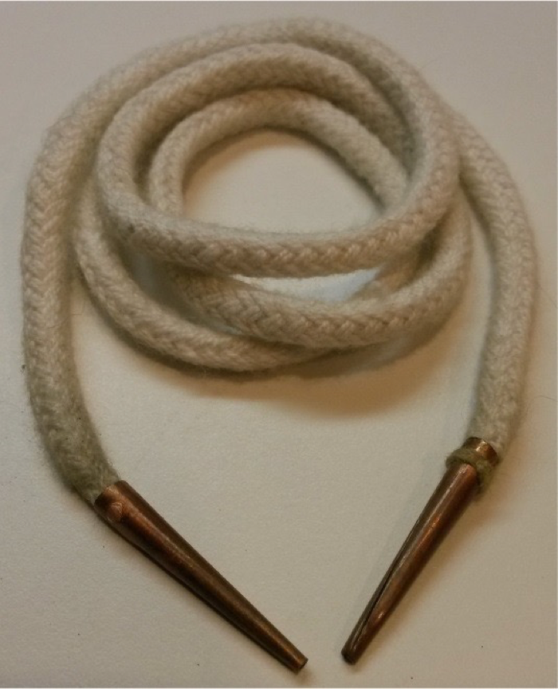

Riveting Aiglets to Cords:

There is plenty of evidence showing that rivets were used to attach aiglets to cords. The rivets can be soft iron or any number of copper alloys. This means copper, brass, and bronze. Some silver and gold aiglets have been found that have silver and gold rivets but these are very rare.

I have found that a good size to use is 22 gauge copper or brass wire that has been annealed to be as soft as possible. If you are using rivets, you will need a very small hammer. A wire cutter to clip the rivet to the correct length, a file to flatten the end of the rivet and a block of steel or a small anvil to hammer on. I leave up to you to find the wire you need. You will want to find 22 gauge wire in either soft iron, copper or brass. You may want to look for 22 gauge “headpins” at larger hobby supply stores. The wire should fit tightly in the holes of the aiglets.

6. Once the adhesive has had time to set, use gentle pressure to twist the T-pin back and forth to release it from the aiglet.

7. Take a short piece of wire and file one end flat.

8. Place this wire in the hole of the aiglet so it just barely extends past the surface (about 1mm).

9. Using a metal scribe, mark a point just past the surface of the aiglet on side (about 1mm).

10. Clip this wire and then file the end of the wire flat.

11. When you are done, put this back into the aiglet and make sure it extends just past the metal on both sides of the aiglet. If not, you will have to cut another rivet.

12. Place the aiglet up on a steel block and raise it just slightly off of the metal. Using a very lightweight riveting hammer, gently tap the end of the rivet to start flaring the end.

13. Turn the aiglet over and repeat step 12.

14. Repeat steps 12 and 13 as many times as needed to flare the ends of the rivets to hold the aiglet in place.

15. File any sharp spots off of the rivet so that it will not catch on the fabric of the eyelets.

16. Continue until all of the aiglets have been attached.

Notes:

• You may want to use a 22 gauge headpin. You will not have to worry quite so much about the rivet ends flaring evenly as it already has one finished before you start. If plated, you may want to sand the plating off of one to see if the metal is actually copper, nickel or brass before using these.

• You may also want to just clip off the T-pins and file the ends flat to use those as the rivets. Seeing that they are already glued into place, but make sure you do not use steel. Get the cheaper sort as they will be softer iron and can be peened over.

• If you use a smaller diameter wire the 22 gauge, be prepared for some of the rivets to bend inside the aiglet and not peen over correctly. If you use a larger diameter wire, you may have to enlarge the holes in the aiglets to fit. Be cautious as this may make it hard to peen the rivet over enough to hold securely in the aiglet.

• I would suggest hand washing your points when they need cleaned. Being metal they will scratch the inside of you washer and dryer causing them to rust. Worse, they may stick in the drainage holes of the drum and require a visit by a plumber to remove them. It they make it past the seals on the washer or dryer they can cause mechanical failure and fire. So hand wash them, ok?

• Do not use these for attaching armor or when there is the chance they may be driven into your body! While the metal is thin it is very stiff after being shaped, filled with fabric, glue, and rivets. You do not want to have an aiglet driven into your body! YOU HAVE BEEN WARNED.

• For additional information, you can find me on FaceBook at https://www.facebook.com/gerald.loosehelm

Footnotes:

[1] Heath, Maya. 2007. A Practical Guide to Medieval Adhesives. Milpitas, CA: Society for Creative Anachronism. Pages 12-16.

------
Copyright 2015 by Gerald Livings. <loosehelm at yahoo.com>. Permission is granted for republication in SCA-related publications, provided the author is credited. Addresses change, but a reasonable attempt should be made to ensure that the author is notified of the publication and if possible receives a copy.

If this article is reprinted in a publication, please place a notice in the publication that you found this article in the Florilegium. I would also appreciate an email to myself, so that I can track which articles are being reprinted. Thanks. -Stefan.

<the end>

