Cookng-Platfm-art - 6/29/17

"Clan Black Stag Cooking Platform" by Seitheach Earnan Mac Bearach.

NOTE: See also the files: firepits-msg, DFofH-Firepit-art, Cmpfre-Safety-art, camp-kitchens-msg, Camping-Sink-art, camp-showers-msg, camp-ovens-msg, Fire-Book-art.

************************************************************************
NOTICE -

This article was added to this set of files, called Stefan's Florilegium, with the permission of the author.

These files are available on the Internet at: http://www.florilegium.org

Copyright to the contents of this file remains with the author or translator.

While the author will likely give permission for this work to be reprinted in SCA type publications, please check with the author first or check for any permissions granted at the end of this file.

Thank you,
Mark S. Harris...AKA:..Stefan li Rous
stefan at florilegium.org
************************************************************************

Clan Black Stag Cooking Platform designed and built
by Seitheach Earnan Mac Bearach
Clan Black Stag Clan Chief

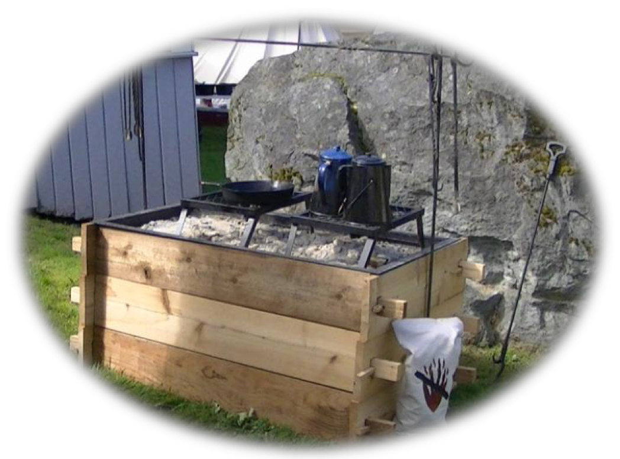

The History and Inspiration

Prior to 2013 (We met at June Faire in 2008) my wife and I either had to cook over a fire pit or my second in command would bring his large fire pit that had the ability for us to cook on. In late 2012 I decided that we needed something a little more period and that would be easy for our cooks to use. Here in An Tir we are restricted as to what we can do in many areas. Ideally I would prefer to dig a hole in the ground and cook that way, however fire regulations as well as site rules make this impossible to do so far. After a search that lasted about 2-3 weeks time permitting I narrowed down my ideas to a two handful that I saw other groups using. Having limited time to build a new cooking area due to school and work I needed it to have certain criteria met.

- Easy and simple to make.
- Easy to assemble, in case my wife or any other household member needed to.
- Sturdy in case children or others bumped into it accidently.
- Able to cook while keeping other food items warm.
- Ease of use for my wife and others. This meant height was a consideration.

With these criteria in mind I proceeded to build this cooking area. In deciding the height and length of it I actively sought my wife's input since she would be one of the main users of this cooking area. My wife stands 5'4" so the height was built to her comfort level. You may wish to keep that in mind when building this cooking area. All components of this cooking area should be easily bought from your local hardware store and blacksmith (We use Edward the Blacksmith exclusively) except for the metal tray which was custom built for us by a local metal shop. The secret to the sturdiness of this platform is found on the inside of which I will go into more detail latter on in these plans.

Materials needed for building:

1 metal tray
24-40 each 1⁄2" metal pipe straps (they can be found in the plumbing section)
8-10 stakes -----24" x 3⁄4"
1 Box of screws for the metal pipe straps. We used 8 x 3⁄4 screws
6 each boards @ 8' x1" x 7 1⁄2". We used cedar because I happen to like working with it. It can be pricey so keep that in mind.
1-2 cans "High Heat" black spray paint.

Instructions:

Step 1: For a cooking station this size cut the boards so that you have 6 boards at 53" and 6 boards at 28". With an 8' board I was only able to get one 53" and 1 28" sections. This left about a 15" piece left over per board. Keep this in mind while cutting your boards and before getting your tray made.

Step 2: Cut out your mortise and tenon's as instructed with Images 1-2.
Step 3: Cut out holes in the tenon's for the wedges. I use wedges about half the width of the tenon and about 1" in width.. Images 6-7.

Step 4: Assemble all 12 pieces and screw the pipe straps into place as instructed with Images 3- 5.
Step 6: Make your final measurements of the top board for your cooking tray. This will be width x length minus about 1⁄2 -1" per side to keep the edges of the tray away from the boards.

Image 1: End piece
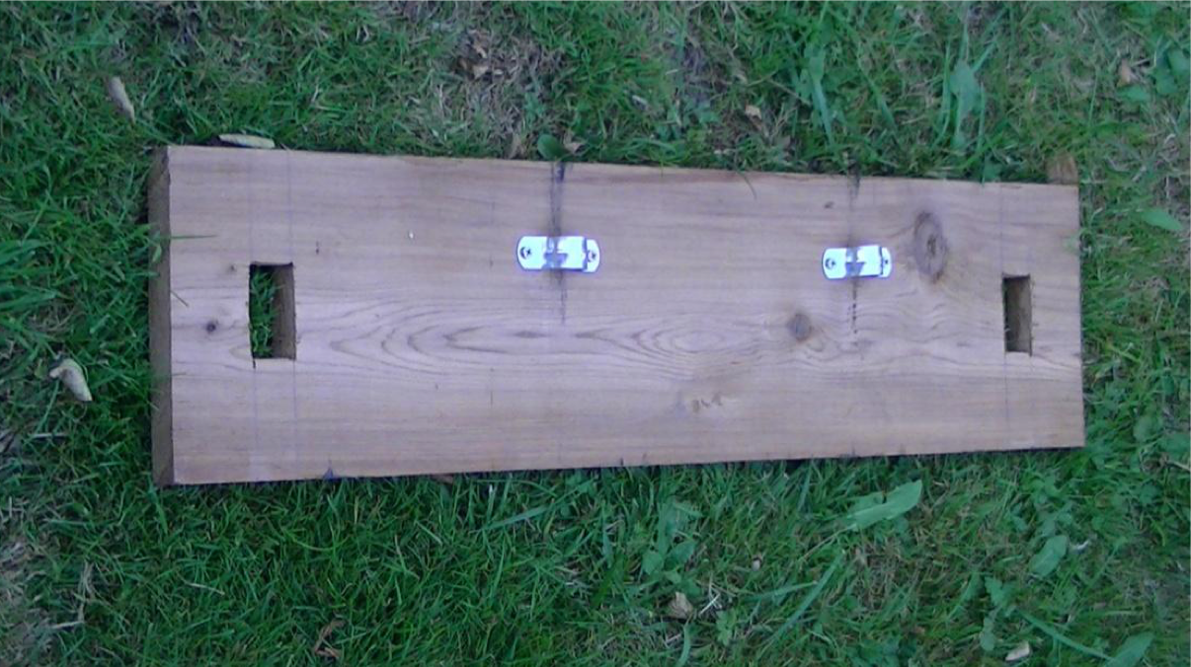

Mortise is 2" from the board end and measures 1 1/8" x 2". Make sure that the mortise is measured and cut so that the distance is the same between the top and bottom of the mortise to the board edges.

Image 2: Side piece
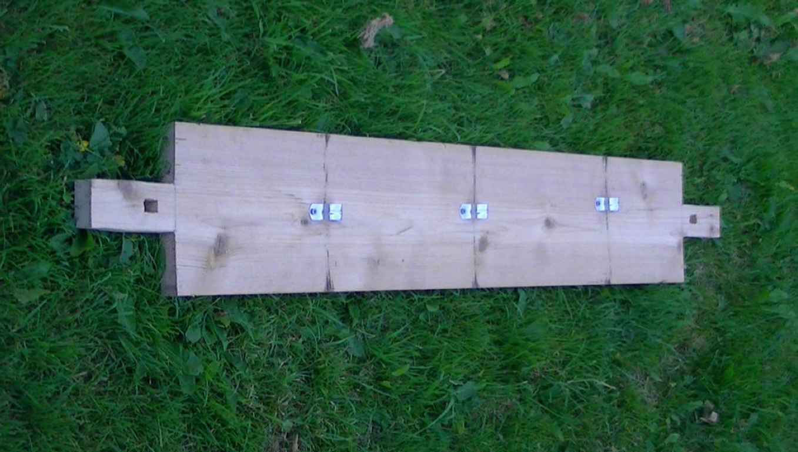

Once you have cut out your mortise measure and cut the tenon so that it is the same size as your mortise. On this one I cut 2 1⁄2" x 4 3⁄4" off of each side. This left the tenon 2" x 4 3⁄4". Once again make sure that you have the same distance between the edges of the mortise to the edges of the board sides.

NOTE: It is important to have all boards the same width so that each layer will sit flush with the next. This also helps with the sturdiness of the platform as a whole.

As each piece is cut and made to fit you might want to consider numbering the pieces somehow. I did this with ours so anyone can put it together if I am busy with other things in setting up camp or if I am delayed by a day or two for events like Autumn War.

Image 3
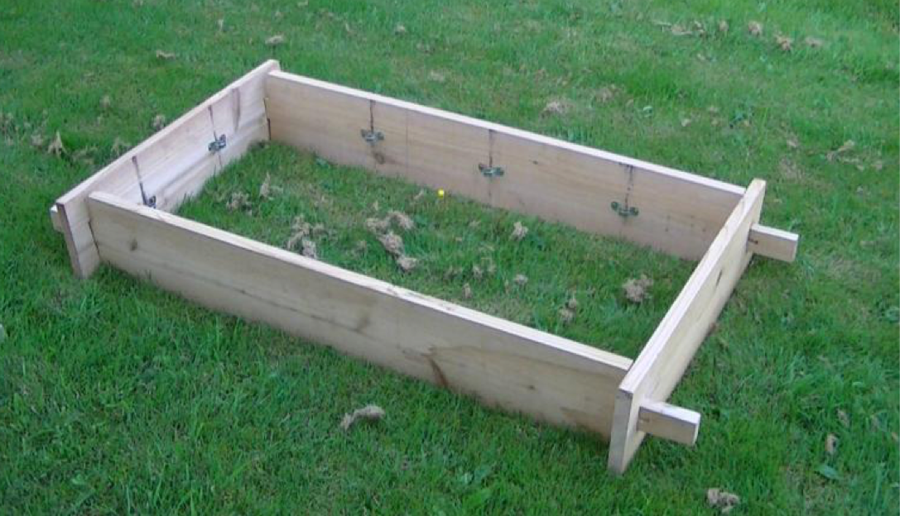

Stakes and stake guides. We have young kids in our household so I beefed this up a bit. I used 3 each of the metal pipe straps on each of the side boards and 2each on each end board. However it is possible that the sides may only need two each of the metal pipe straps. Keep in mind that this is hidden from view and was put in place to guarantee stability. I can dance on the thing once assembled and it won't move.

Once every piece has been cut and made to fit assemble the unit and stack all pieces like you saw in Image 5. Drive the stakes into the ground where you want them placed at. Placing them equal distance from the ends and each other works best.

Next mark the locations where the pipe straps will go. For the bottom two layers, halfway between the top and bottom of the board will work. For the top layer placing the pipe straps about 1⁄4 ways up from the bottom is best as it leaves room for the stakes to extend above the straps while leaving room for the tray to set into the top part of the base.

Once you have the locations marked put the straps into place using the 8 X 3⁄4" screws.

Note: If you are limber enough or have someone who is limber enough, you can secure the straps into place while it is assembled and the stakes are in place.

Image 4: Assembled side pieces of one side of the base.
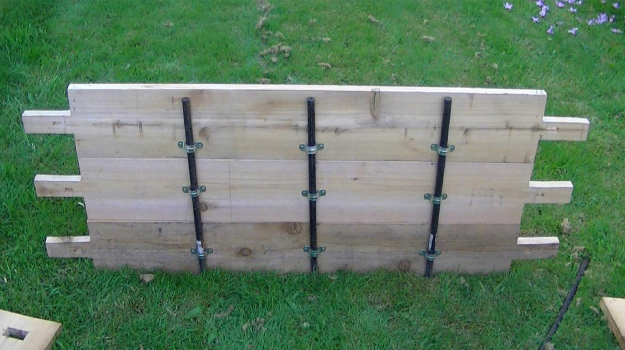

Image 5: This is what the unit should look like prior to driving the stakes to the required height for placement of the tray.
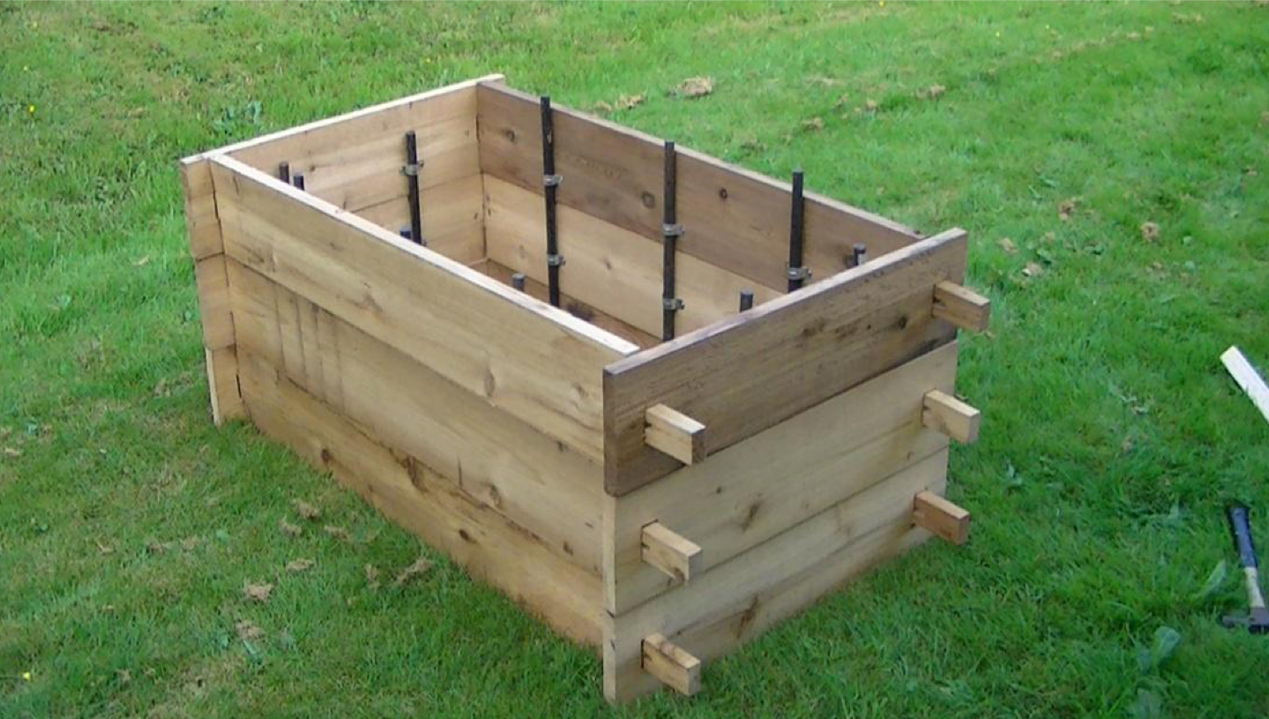

Image 6: Close up view of mortise and tenon.
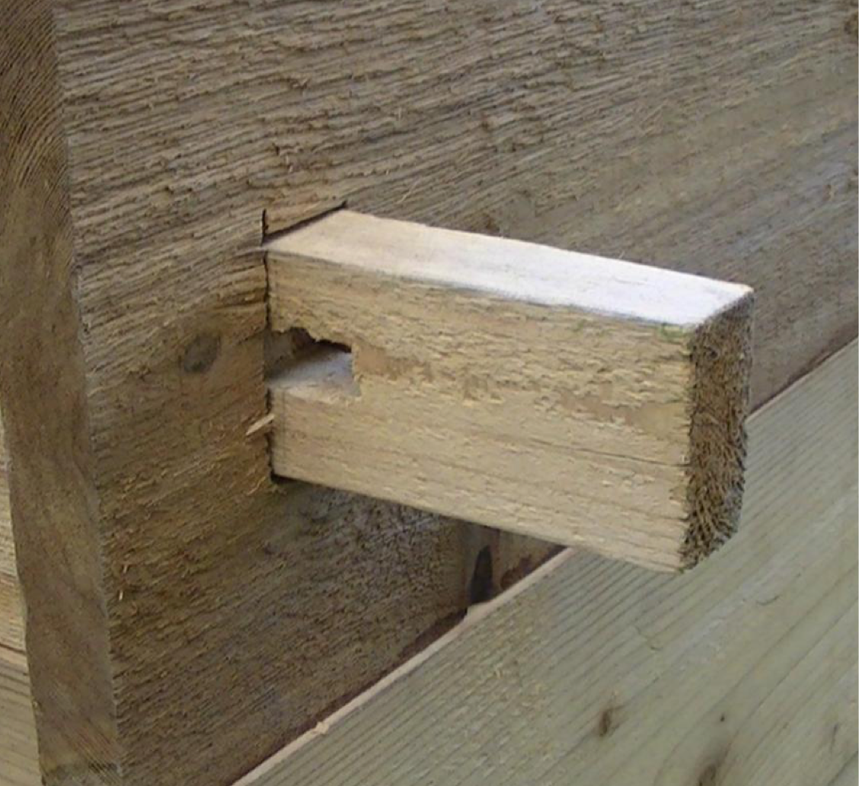

Image 7: Mortise and tenon with wedge in place.
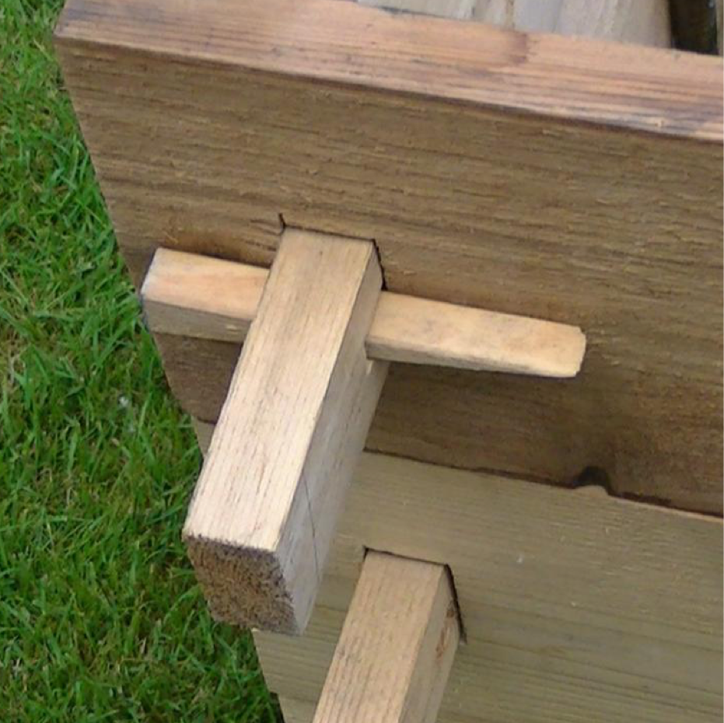

Metal Tray:

Dimensions of this tray are as follows: Depth: 2 1⁄2"
Metal thickness: 1/8"
Total length and width: 45 3⁄4" x 24 1⁄4" Inside dimensions: 21 1⁄4" x 42 3⁄4"

Lip width: 3" all the way around

Tray preparation: Sand the tray down as needed then spray with a "High Heat Black Spray paint". I think I did sprayed 2 coats on to protect the tray from rust. This will be the type used on BBQ grills and can be found at hardware stores.

Image 8: Close up of tray lip.
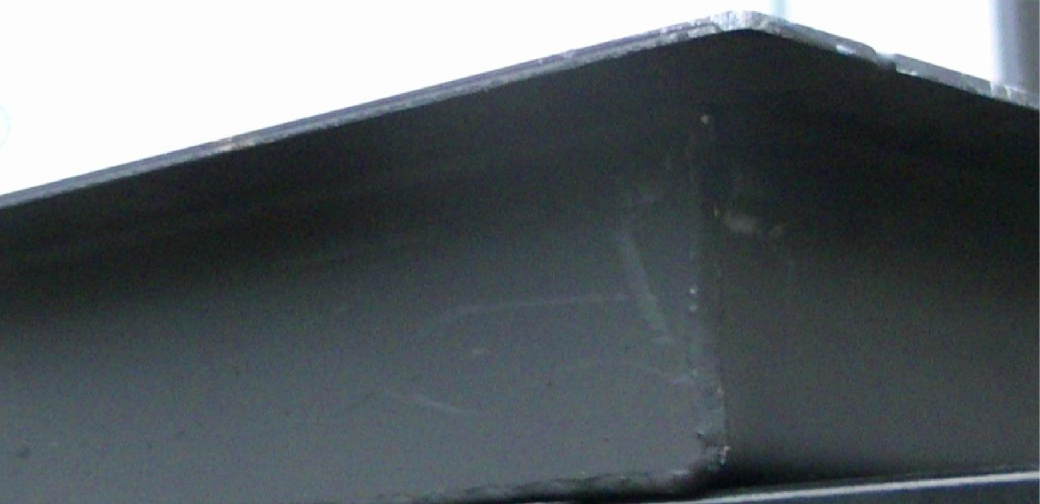

Image 9: Close up of tray showing a corner and the lip.
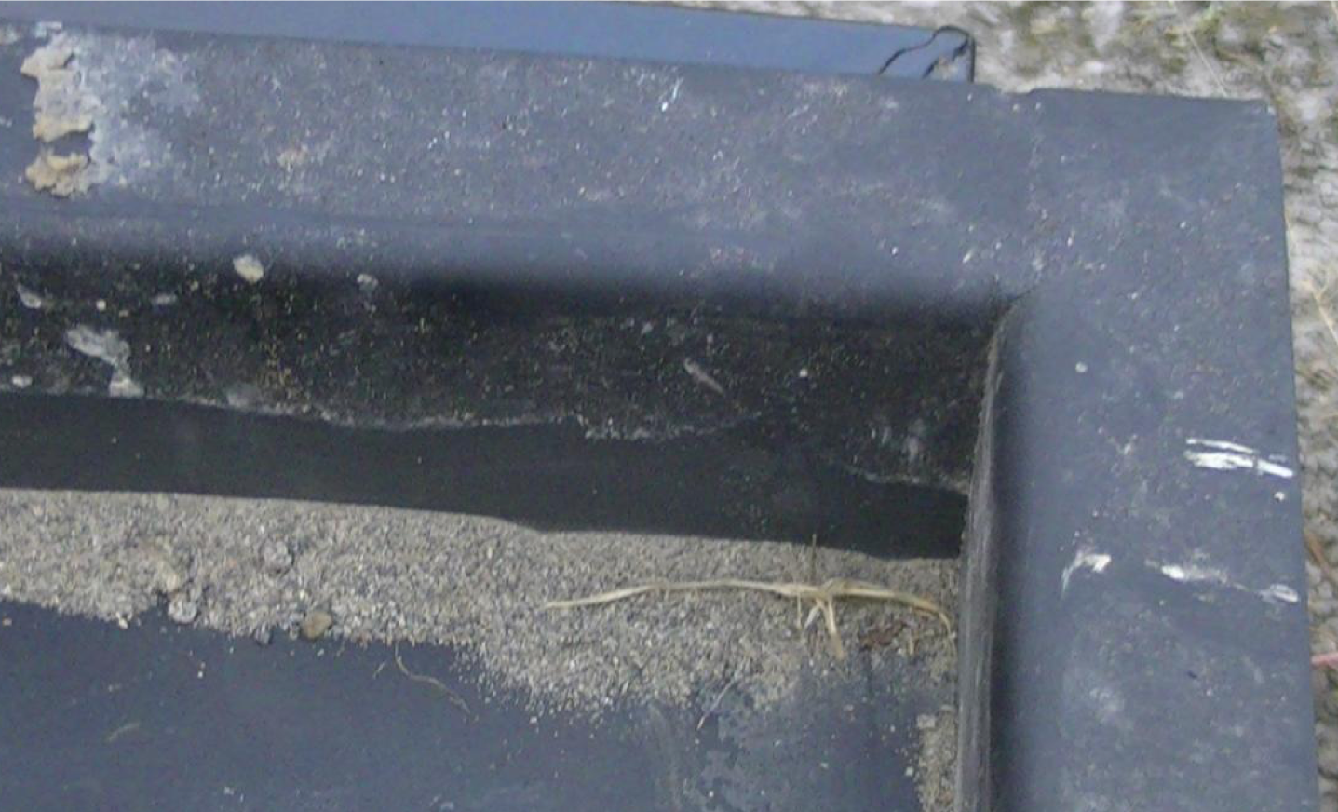

Set up:

We have found it best to number the corners as you construct each layer. This makes it easier to reassemble at a later date especially if you have someone helping you. Stack the 1st 2 layers then drive your stakes in the required depth. Marking them in some fashion on the initial setup can make this task easier when setting up again in the future. Finally install the last layer. You may or may not need help depending on how aligned your pipe straps are.

Image 10: Partial setup
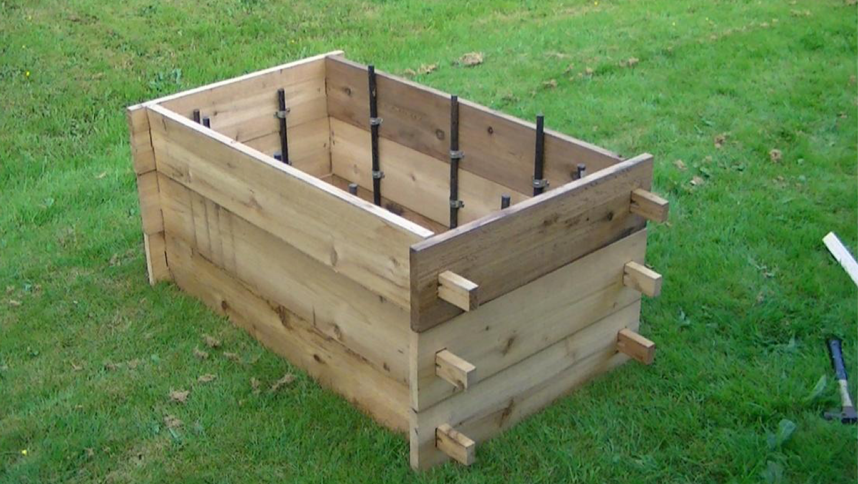

This is what it should look like finished and prior to any accessories being used. Stakes and pipe straps are hidden from view.

NOTE: If your tray is built similar to ours you may need to have a second person help place it and then lift it when taking it down. It can be heavy so be careful of your back, save it for the fighting.

Image 11: Full setup without the ironwork.
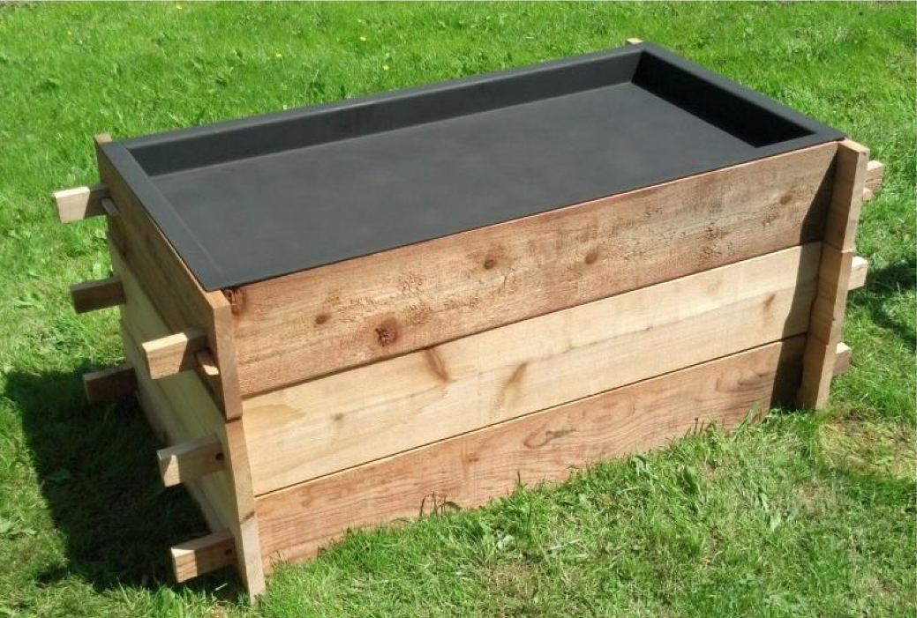

Setup with accessories:
Grills are small folding camp grills. This particular tray can hold 3 of them. The canvas bag holds a fire extinguisher for that just in case. It's required for us. However since I don't want it visible yet need it accessible this is the solution. We had a fire marshal stop in on the second night of this event and he was satisfied with the accessibility of them. Coffee pots aren't period but in our encampment if there no coffee things may get ugly in the morning.

Image 12: Full setup in use.
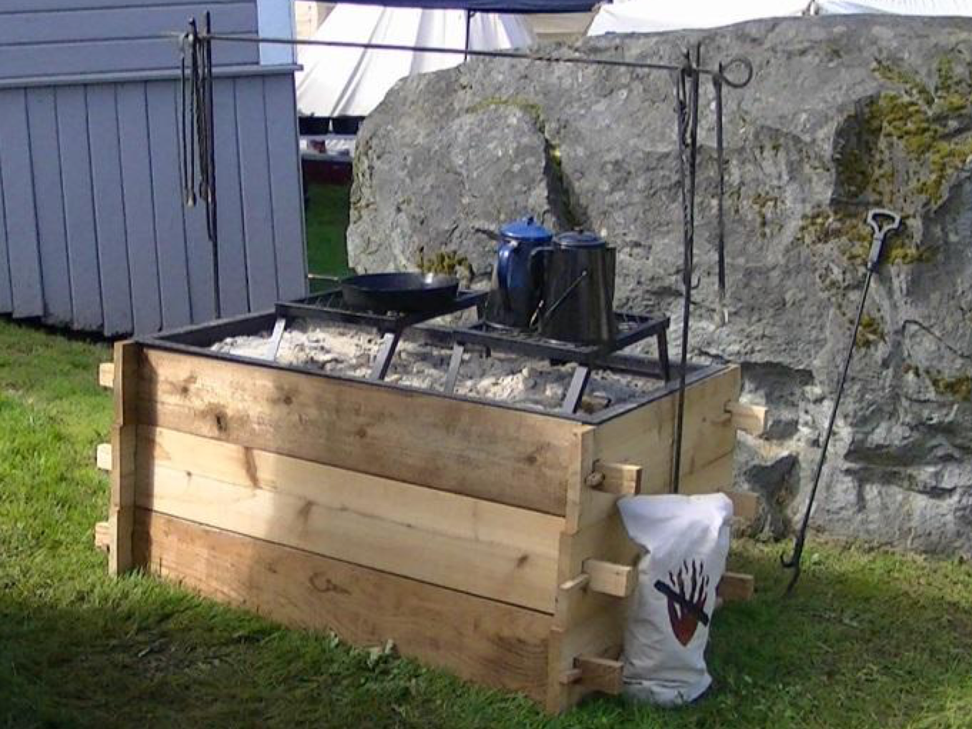

Use:

We use play sand. It can typically be bought in plastic bags at a hardware store. I highly recommend that you keep it in the bag or a plastic bucket. After 3 days of use we tossed our sand. We highly recommend wetting the ground underneath prior to placement of the tray. Prior to the lighting a fire, wet the sand down, this helps keep the ground from drying out. We also wet the sand along the edges during use. A flat level surface is highly recommended if at all possible. As a fuel source we used charcoal briquettes and wood chunks. Next year we are going to try apple wood to see how that works when cooking meat.

Accessories:

Check with your local blacksmith they may have something similar. Or if you are a blacksmith, Have Fun!

Image 13: Briquette tongues
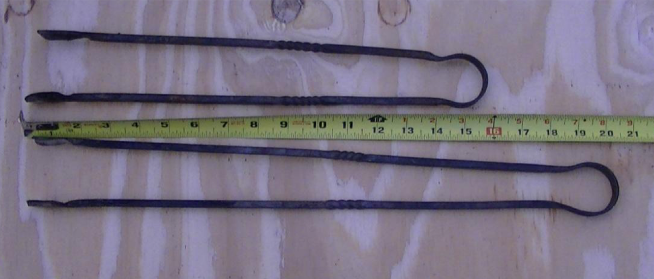

Image 14: Meat hooks
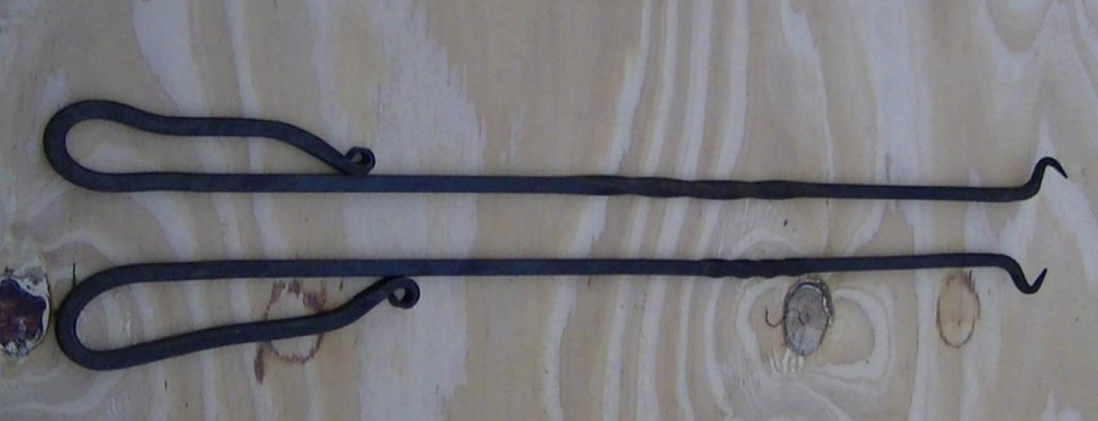

Image 15: Tripod
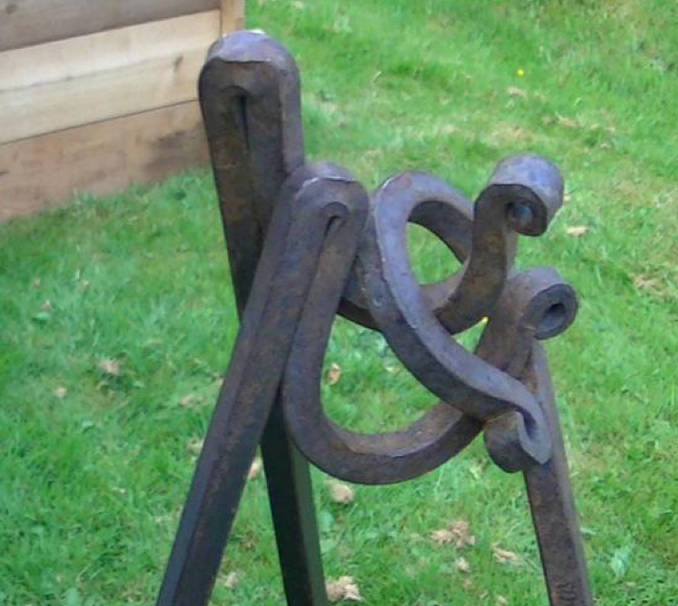

Image 16: Tripod.
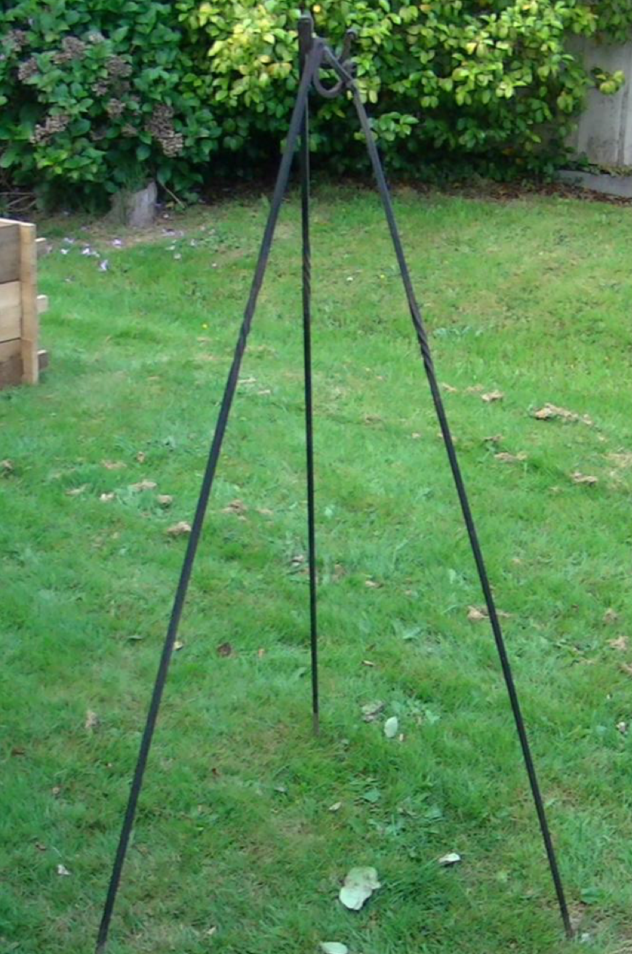

Note: This is what we use for the formation of the spit.

Several of the cooking areas that I looked at prior to settling on the one I made.

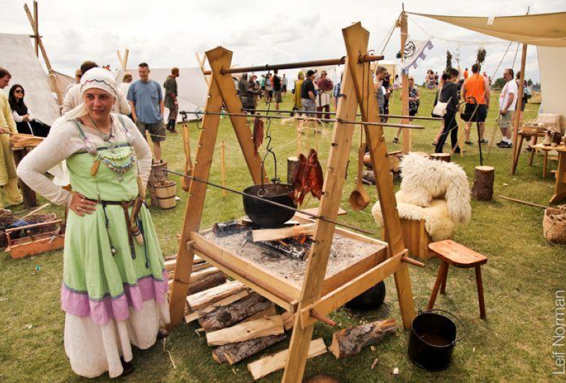
http://www.pinterest.com/pin/282460207852526742/

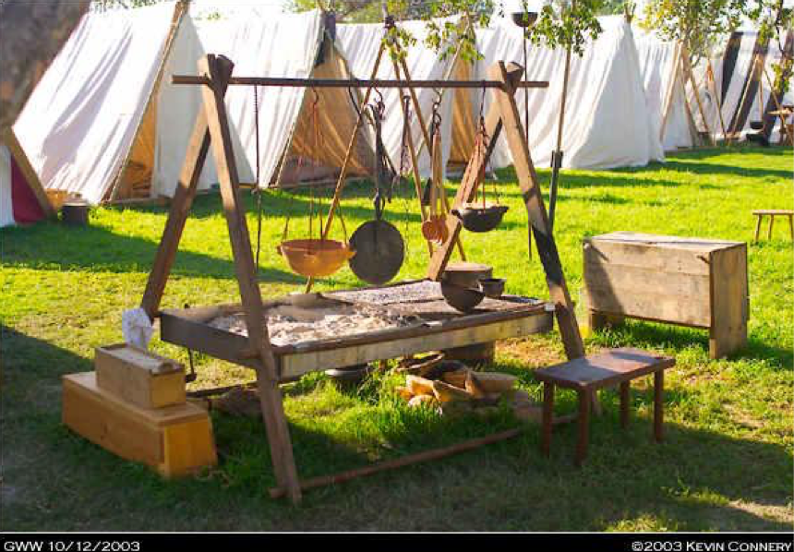
http://research.fibergeek.com/2010/05/26/firepit/

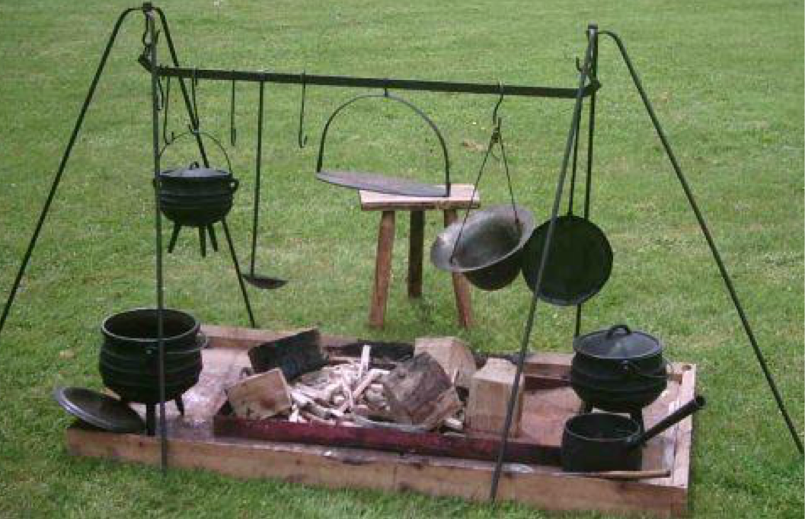
http://www.historicsaltire.com/livhist.html

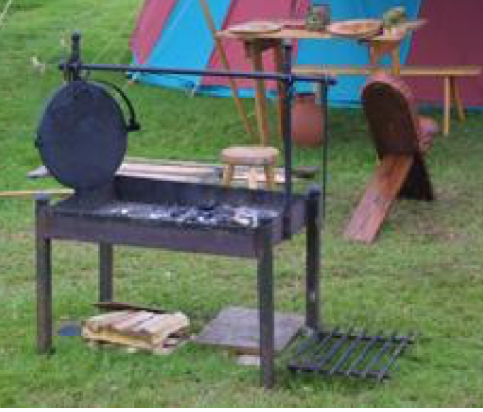
http://www.history.uk.com/recipes/cooking-over-an-open-fire-jess-dyde/

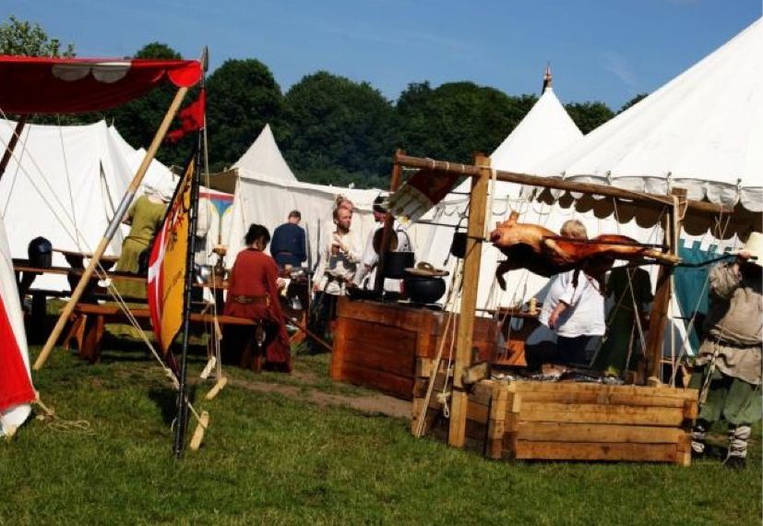
http://emilsa.deviantart.com/art/Inside-the-medieval-war-camp-296396003

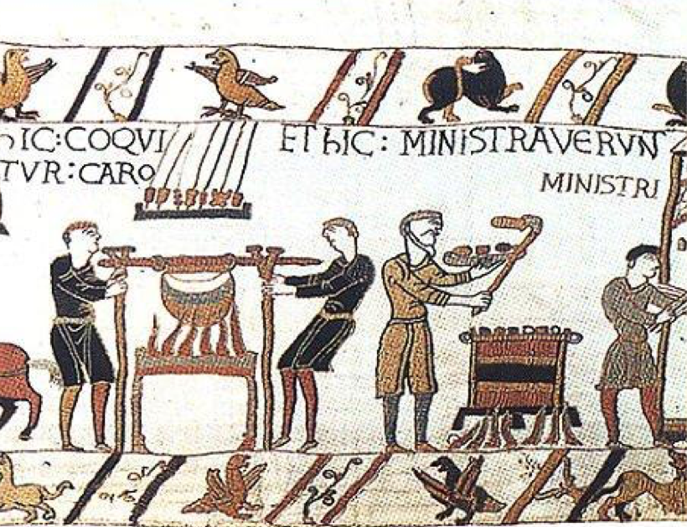
http://www.3owls.org/sca/cook/medievalbraai.htm

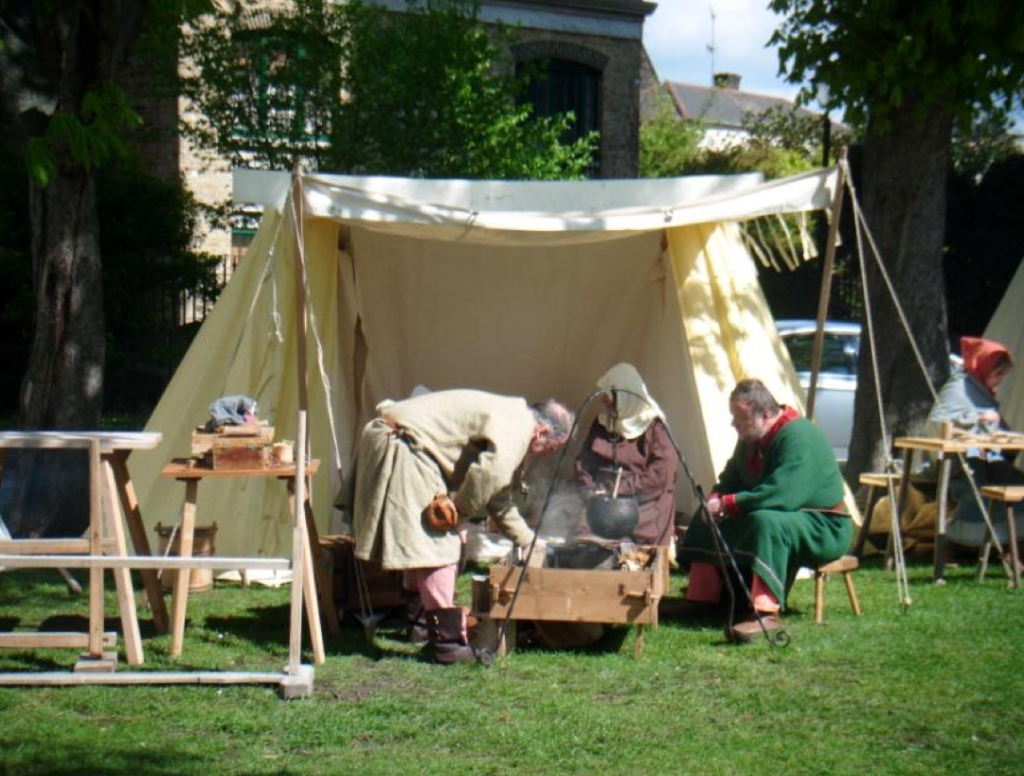
http://www.thegreenwichphantom.co.uk/wp-content/uploads/2012/04/low-a-vikings-cooking- pot.jpg

This was one of two photos that I got my idea from. I have been unable to find the second one.
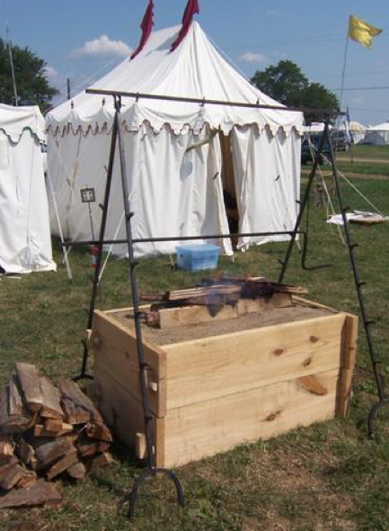

------
Copyright 2014 by Eric Olsen. <ericolsen1967 at gmail.com>. Permission is granted for republication in SCA-related publications, provided the author is credited. Addresses change, but a reasonable attempt should be made to ensure that the author is notified of the publication and if possible receives a copy.

If this article is reprinted in a publication, please place a notice in the publication that you found this article in the Florilegium. I would also appreciate an email to myself, so that I can track which articles are being reprinted. Thanks. -Stefan.

<the end>

