Vintng-Proces-art - 4/12/09

"A Vineyard Experiment - Appendix 2: Winemaking, a personal experience." by Baron Damon Hroarsson.

NOTE: See also the files: Vintng-Harvst-art, Vintng-Tools-art, wine-msg, Eiswein-msg, yeasts-msg, brewing-msg, grapes-msg, beverages-msg, coopering-msg.

************************************************************************
NOTICE -

This article was submitted to me by the author for inclusion in this set of files, called Stefan's Florilegium.

These files are available on the Internet at: http://www.florilegium.org

Copyright to the contents of this file remains with the author or translator.

While the author will likely give permission for this work to be reprinted in SCA type publications, please check with the author first or check for any permissions granted at the end of this file.

Thank you,
Mark S. Harris...AKA:..Stefan li Rous
stefan at florilegium.org
************************************************************************

This paper was originally entered in the Kingdom of Ansteorra Arts & Sciences Competition in 2008.

Synopsis:
This is a collection of several documents written by Damon Hroarsson to outline multiple aspects of the vintners' trade as was done in period, the method, and the process by which Damon reproduces those methods.

The first document is a paper outlining a research project done to obtain an understanding of the labor required to harvest a commercially viable vineyard. This is then contrasted with data from a still extant period vineyard site which Damon visited to acquire data.
(Available in the Florilegium as Vintng-Harvst-art,
http://www.florilegium.org/files/BEVERAGES/Vintng-Harvst-art.html )

The first appendix examines surviving winemaking tools from the period.
(Available in the Florilegium as Vintng-Tools-art,
http://www.florilegium.org/files/BEVERAGES/Vintng-Tools-art.html )

The second appendix documents the winemaking process as carried out by Damon with comparisons to period methodology and materials.
(This file, Vintng-Proces-art)

HE Damon Hroarsson, The Baron Borrendöhl



Personae:
Damon Hroarsson was born second son to the Yarl of Hedeby's shipwright during the middle of the 10th. Century. This took him to sea and eventual command of his own ship the Vindanser. Given land and title to Burg Borrendöhl in Frankonia by Otto I, Damon tears his receding hair out trying to take care of his fief, learn the wine trade, and spend time with his former hostage, now wife, Ismet.

Hugh Niewoehner is an Electrical Engineer who designs flight simulators for training pilots of corporate and commercial aircraft. "Born and raised" in the Barony of Three Rivers in the fall of 1977 he was given a firm basis in the ideals of The Society by a number of the founding characters of the region which became Calontir. Relocated to Tulsa (Northkeep) in '87, Damon has tried to contribute to the continued growth and activity of his Barony and Kingdom.

A Vineyard Experiment
by Baron Damon Hroarsson

Appendix 2: Winemaking, a personal experience.

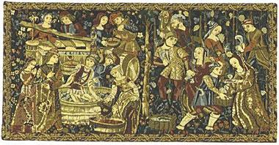

Vin du Chateau
The house wine of Burg Borrendöhl

From Vine to Wine

The red wine documented here represents the culmination of over fifteen years of cultivation and vinting refinement. The wine was crafted from grapes raised on the Burg Borrendöhl property in urban Tulsa, Oklahoma and was intended to represent traditional red wines common throughout the period from Burgundia, France.

The grapes used were harvested in the summer of the year, fermented, and aged a minimum of six months, then bottled in the month and year on the label. This paper will outline the specifics of grape cultivation and wine production used to create this entry with special emphasis given on the period aspects of each. Though some modern adaptations have been used, reasonable efforts have been taken to preserve the traditional aspects of the project.

While numerous sources exist for recipes with spices, fruits, etc. it is has been difficult to locate a recipe or even mention of the simplest of the vintners beverages. Take grapes, squeeze, ferment, drink. The product you are drinking is the result of just such a process. There are no spices, fruits, sweeteners, resins or other additives to modify the flavor of the end product.

This paper has been compiled from numerous written sources and from direct discussions with family members of a number of the old European winemaking families. Most are more than willing to talk shop and share "family secrets" and traditions with anyone who asks. Unfortunately, usually, nothing is written down. It is just part of the 'family history' making it difficult for the SCA vintner to document the "periodness" of the beverage or technique.

Hersir Damon Hroarsson
Baron Borrendöhl

From Vine to Wine

Archeological evidence and writings surviving from as far back as the Roman empire indicate that the family of grapes known today as the Pinot Noir have been used in wine making throughout France. [Ancient Wine p27]. Other varieties in use then, which are still in use today, are the Gamay, Auxerre (Malbec), and Tempranillo. [Personal discussions] A reference to the gamay being used in period is not altogether favorable. In "July 1395 Philip the Bold, Duke of Burgundy issued an order that the gamay was 'a very bad' plant, repugnant to law and custom and ordered that the gamay not be grown or used in the wines of the region. He believed it caused the results to be quite bitter. None the less it retained a presence and was used to make a wine called passetousgrains." [Short History of Wine, p. 98 ]

In the 1800's much of the western European grape crop was devastated by the unintended importation of the Phyloxera from the United States. Fortunately, much of the California vineyards had been planted with vine cultivars from Europe. To resurrect their crops these vines were then re-imported to Europe to give us the crops you see today. In this way, although not specifically the same plants, the grape crops of Burgundy, and Bordeaux are still descendants of those original vines.

Grapes of similar types will vary widely in quality and flavor based upon the soils they are cultivated in and the predominant weather patterns where they are grown. Most of the grape types which thrive so well in Europe and California do not survive well in Oklahoma. The heavy clay soil, the hot summer days which do not cool off at night, and prevalent plant diseases of the area render them non-productive.

The wine you are drinking was made using a blend of Concord, Mars, St. Ives, Chambourcin, and Cynthiana grapes. These are either native to North America, or hybrids thereof. These grapes do well in clay soils and have been cultured for this climate. Though the Concord is nominally a grape used for jellies and jams, it does well at bringing a lot of sugar to the must and is readily available to the home gardener. The St. Ives, Chambourcin, and Cynthiana grapes are varieties specifically bred for wine making use. The Cynthiana in particular is desirable in this growing area as it has a very high resistance to most grape diseases. Blending grape varieties was also common in the Clos De Vougeot, (Burgundy) one of the earliest experimental vineyards known to man. [Wine p. 193] The Clos De Vougeot was founded in the early 12th Century. (A discussion of the Clos De Vougeot takes place in the main body of this document.)

The Vineyard
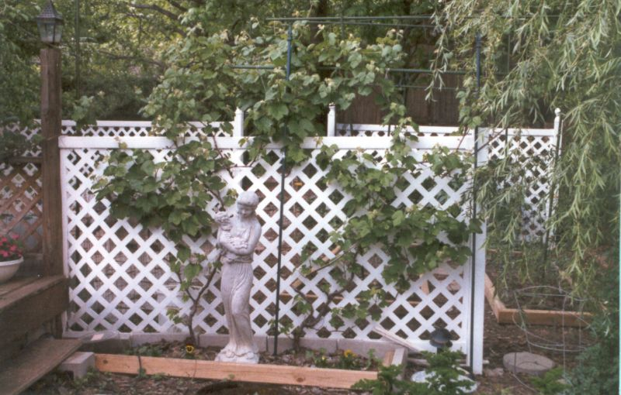

The photo at left is a picture of two of my vines.
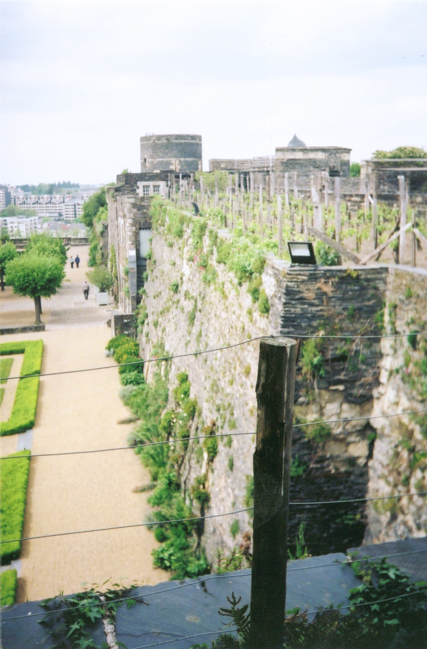

As you tour Europe you will see vines planted on every available piece of soil, pots on patios, and roadside planters with the vine trained up the sides of buildings. Paintings and tapestries surviving from period show vines grown in all sorts of manners: trellised, up trees, fences, the interior walls and tops of castles (as seen in the picture of Angers Castle seen here). [When the walls of the castle were thickened in the 15th C. due to improvements in artillery the garrison decided to put the new expanse to work.] This chaotic planting and vine growth all serve to reduce the quality and quantity of the vines' yield. My yard, being so small, has required me to place plants wherever I can put them. This means less than ideal spacing, etc. I now have approximately 20 vines which produce. From these I harvest around 90 pounds of fruit resulting in just 6 gallons of wine. Under ideal conditions I would expect to harvest 75 to 90 pounds per vine.

In the case of the European vineyards, the destruction caused by the phyloxera plague from the US was viewed by the European vineyards as a prime time to adopt more effective trellising which improved both quality and yield. From these improvements we have the great wines available in quantity today but much more difficult to obtain in period.

From the following passage though we get a good picture of the state of viticulture in period:

"The demands of the viticultural year are set out in the eleventh-century charter of the Abbey of Muri, southwest of Zurich. It described the essential activities like loosening the soil around the base of the vines so that rainwater would soak in deeper, fertilizing the vines with manure, pruning, tying up the shoots, loosening the soil again before midsummer, and removing the leaves that shaded the clusters from the sun. Once picked, grapes were crushed initially by foot and then pressed, although those destined for better-quality white wine were probably processed first. Wine-presses, particularly of the screw-type, became larger as the volume of the grapes involved increased. Small proprietors, including peasants, could not afford their own presses and instead used those of their lords or wealthier neighbors, usually for payment in wine. Once the juice had been extracted, it was transferred to wooden barrels for fermentation and later transportation. Barrels were generally made out of oak and their size varied by region." [A Short History of Wine, p97].

The Viticultural process is one of periods of intense activity interspersed with periods where it is best to leave things alone. This has not changed much since prehistory.

Given an extant vineyard, the yearlong process is as follows:

Beginning in the spring the vines get pruned. If trimmed too early in the year it may not be easy to identify those canes which have suffered freeze damage. This may result in leaving dead or damaged canes attached and removing good growing stock. Also, something about the pruning process causes the vine to emerge from dormancy. If one prunes too early it can cause the buds to break from their protective cover prior to the last hard freeze causing the young shoots to be frozen. However, if one waits too long, the buds will break out along the entire length of the canes creating a much bigger task controlling the plants growth. Another problem of late pruning is that the areas where buds are removed leave a small wound on the cane. These wounds provide a means for disease to attack the vine until they heal. To compound the threat, this time of year is the worst period for the development of several major vine diseases. This is not so much of a factor in the warmer, dryer period of summer. In Oklahoma the window is basically the last two weeks of March.

Once growth has begun the vineyard is only tended for watering, disease checks etc. for several weeks. The vine shoots are 'trained' along trellises, wires, fences, whatever you have, to support the canopy of the developing vine. When the vine starts to bloom the vineyard master starts to control vine growth by selective pruning. The vine will either produce more vine or fruit. If left untended, the pollinated flowers will simply fall off as the vine directs it's energy to expansion. Enough vine must be removed to redirect the vine into developing the fruit while leaving enough foliage to support the existing plant. At the same time the number of developing clusters is evaluated. If it appears the vine is over producing, the number of clusters should be reduced to give the surviving fruit more of the plants resources. This improves the quality of the yield. The vine will continue to put out new shoots all summer. These are removed periodically until harvest time.

The vineyard master will examine the developing grape clusters and the surrounding canopy. Sunlight and airflow are critical to a good healthy yield. If moisture is allowed to remain in the canopy (particularly that which is in contact with the fruit) mold, fungus and mildew will develop. Therefore, leaves which shade the grapes are removed so that the air will dry the fruit as quickly after a rain as possible. Also, direct sunlight on the fruit helps the development of sugars in the fruit and creates a more even ripening cycle.

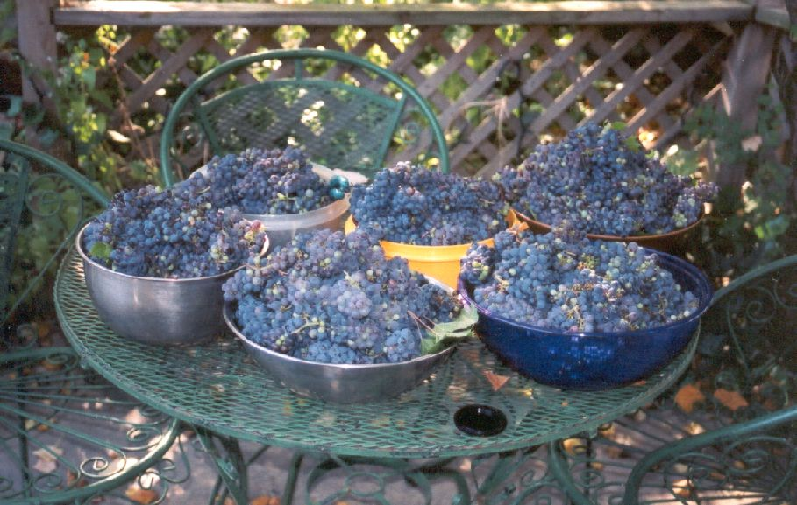
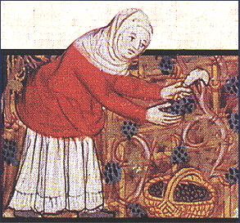

With the ripening of the fruit, the vineyard has basically 2 to 3 days to harvest the fruit for highest quality. Vineyards in both Europe and the US have found that birds and animals will typically only eat the fruit in the first few rows around the edges of a field. Once the picking starts the animals move inward with the progress of the pickers. The race is on to pick the fields faster than the animals can eat.

Once picking is complete, the vineyard is prepared for winter. This is a simple process of spreading mulch, manure, or leaves around the base of the vine to help protect the root ball from freezing. At this time plant food is given to encourage root growth while the plant canopy goes into dormancy.

As you can see this process is manpower intensive. This is the reason so many of the surviving wineries which can trace their existence into our period of interest are centered around monasteries, cloisters, and the like. These institutions had the manpower available to perform these 'pulses' of activity when required and a formal means to pass down accumulated knowledge. For example: "In 1136 the Cistercians founded a monastery at Eberbach. In the 12th and 13th centuries the monastery became Europe's largest wine producer." [Wine pp46.] Charlemagne further encouraged this by passing a law allowing the monastery's to keep 10% of the taxes collected from their sales.

General practice has found that 4-6 acres of vine is about the most that can be successfully attended by two people. This small of a vineyard will barely yield sufficient wine to be used for commercial production. Wineries of today view anything of less than 20 acres under production as generating only enough yield for 'hobby' purposes, not enough to support the costs of operation.

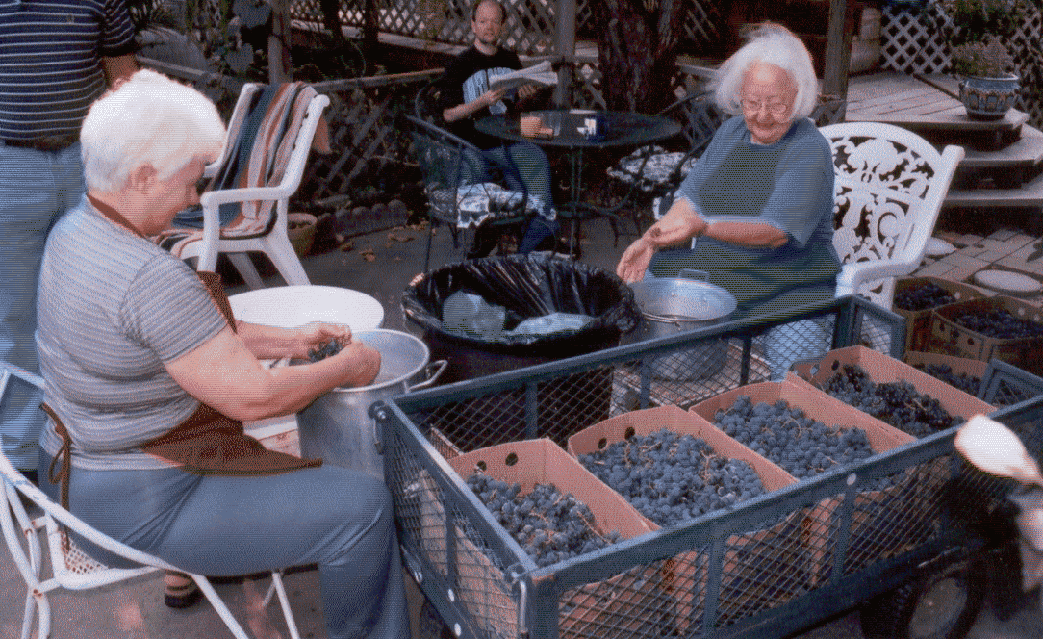

The Crush and Primary Ferment
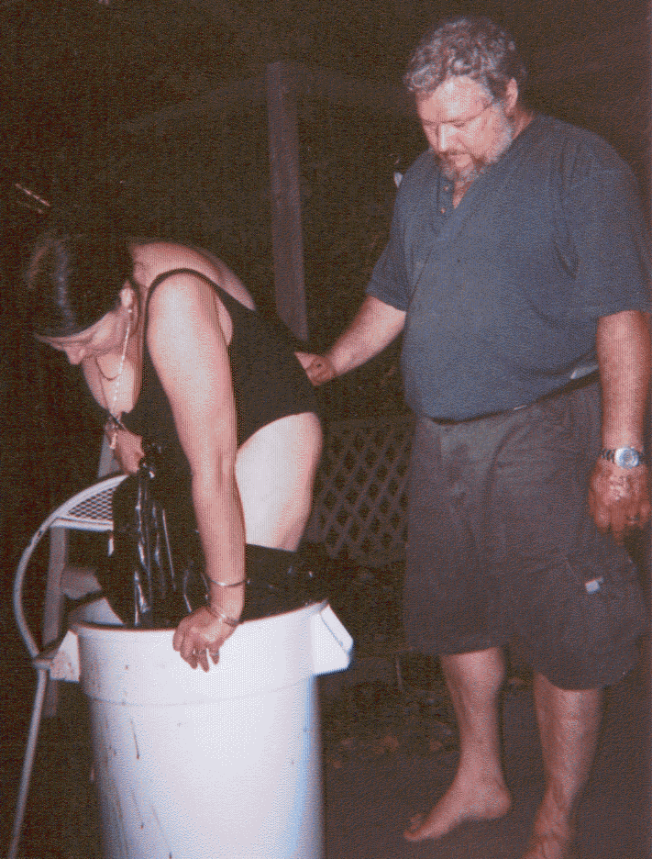
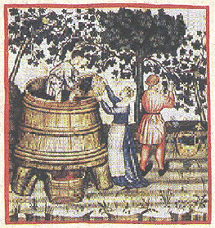

The fruit from the vineyard is picked, collected, and brought to be crushed. The crushing process permits the yeast to penetrate to the interior of the fruit. In the case of white wines the fruit then goes directly to the press to have the juice separated from the skins. Red wines will be permitted to ferment for a brief period with the skins in contact with the must. Woodcuts and tapestries from the 15th century depict large open top barrels or stone pits with people inside walking on the grapes. Near the end of period, machines using spaced wooden rollers were developed. A few examples of these still exist in museums in Europe.

In most of the illustrations from period we really cannot determine if the fruit was de-stemmed prior to fermentation. The stems contain tannins which can give the wine a very strong 'aspirin' flavor. Few existing descriptions say anything about the wine being bitter though the archeological record is inconclusive. With the wine you are sampling, the grapes were gathered, rinsed, and then de-stemmed by hand as I have a significant allergy to high tannin wines. Modern de-stemming machines will remove as much as 80% of the stems. The fruit was then placed in a large vessel. My wife put a trash bag over each leg for sanitary reasons. She then proceeded to crush the fruit.

The yeast bacteria required for fermentation naturally grows on and in the skins of the grapes. Unfortunately, the quality and consistency of the product made from these 'natural' yeasts cannot be gauged well prior to the harvest without significant laboratory facilities or direct experimentation. I've now done 4 batches of wine using only the yeast on the skins, both with and without modern chemical additives. Only one has come out drinkable. If I were trying to live off this success rate I'd have given up long ago. It gives me a lot of sympathy for the period vintner trying to produce something he could sell to provide a living.

A period vintner might have collected the lees from a production run which worked out well and used that as the starter for subsequent runs. However, without freezing, dehydration, or similar techniques there is no reliable method of making certain you are going to get the same results. Still, a successful run would be good reason for a vintner to retain the lees in order to continue to develop a good yeast lineage. While visiting Germany, we were told of the practice of wine from previous batches being saved aside as a starter for the subsequent year. This is an example of the yeast culturing which yielded the modern yeasts we use today. The yeast used to produce this wine is one of several readily available under the Lalvin product name. According to Dr. Clayton Cone, Director of the Lallemand Inc. laboratories, the majority of the yeasts produced under this label are products which were isolated and identified by various French institutes from the regions of Bordeaux, Burgundy, Champagne, and the Rhône. Although they have been cultivated to produce specific characteristics they are, in effect, the descendants of the yeast used by those whom we in the SCA are 'recreating'.

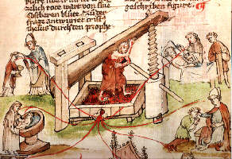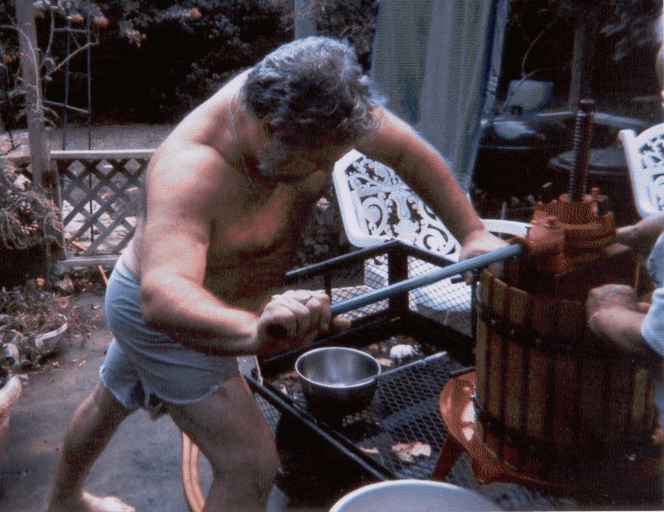
Left: Mystic press. Fifteenth-century manuscript. The Ribeaupierre Bible. Surrounding the press are illustrations of the wine used in sacrament. Public Library of Colmar. Right: Damon operating the press.
The Pressing.

After approximately five days the fruit is separated from the juice (now called the "must"). Although I have not found period texts giving an exact duration for leaving the juice on the must, I have found that going more than 5 days tends to yield an unpleasant, bitter flavor which is difficult to overcome. Less than three days, will not give much color extraction and result in a rosé with very light body. This has been affirmed to me by professional winemakers in Germany, France, and the U.S. I suspect the period vintner arrived at a similar finding either by instruction or practice. This would then encourage development of regional traditions such as the rosé's of Anjou, etc.

When the time comes to separate the skins from the must, the vintner looked for a press in order to extract as much of the juice from the pulp as possible.

As cited previously "Wine-presses, particularly of the screw-type, became larger as the volume of the grapes involved increased. Small proprietors, including peasants, could not afford their own presses and instead used those of their lords or wealthier neighbors, usually for payment in wine. Once the juice had been extracted, it was transferred to wooden barrels for fermentation and later transportation." [A Short History of Wine p. 97]

Presses have been found in several forms. In Greece and Italy stone vats with heavy structures to lower a heavy weight onto the grapes have been found in ancient digs. Holes around the base of the vat allowed the juice from the pressing to be collected into channels and routed into barrels, etc. for fermentation. In France and Germany similar presses made of wood still exist in museums. Some of the most impressive being in the possession of local villages where they were considered community property.

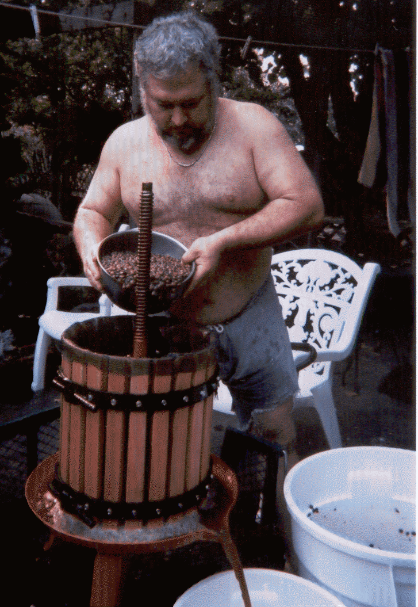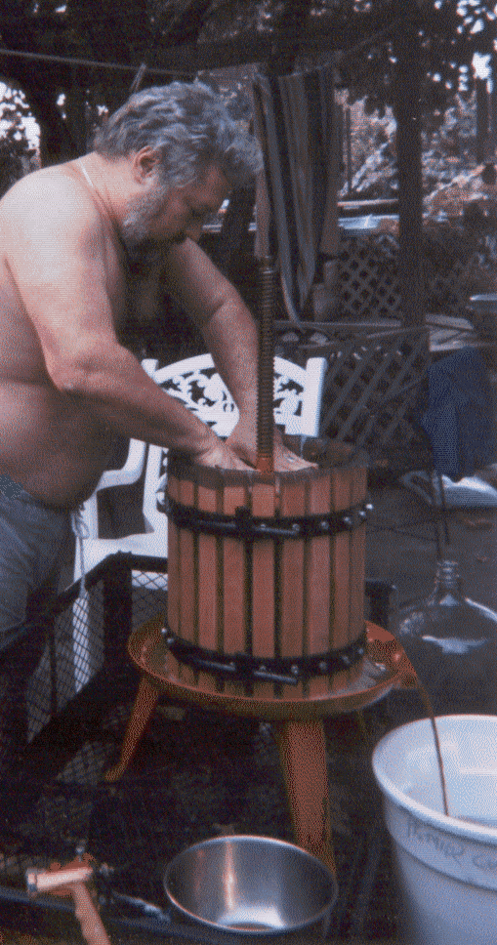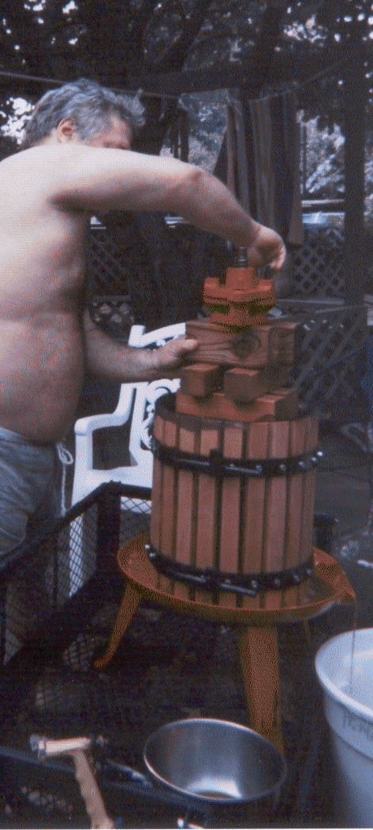
In these photo's the fruit is being transferred into the press basket. The wood press blocks are then placed on top of the fruit and the press head installed.

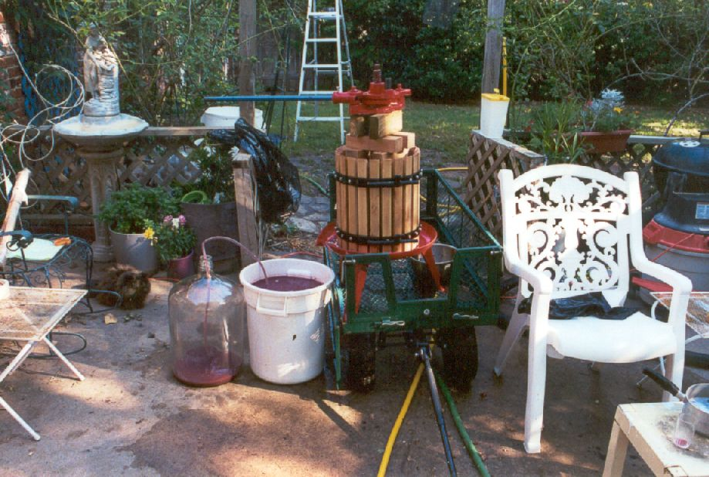
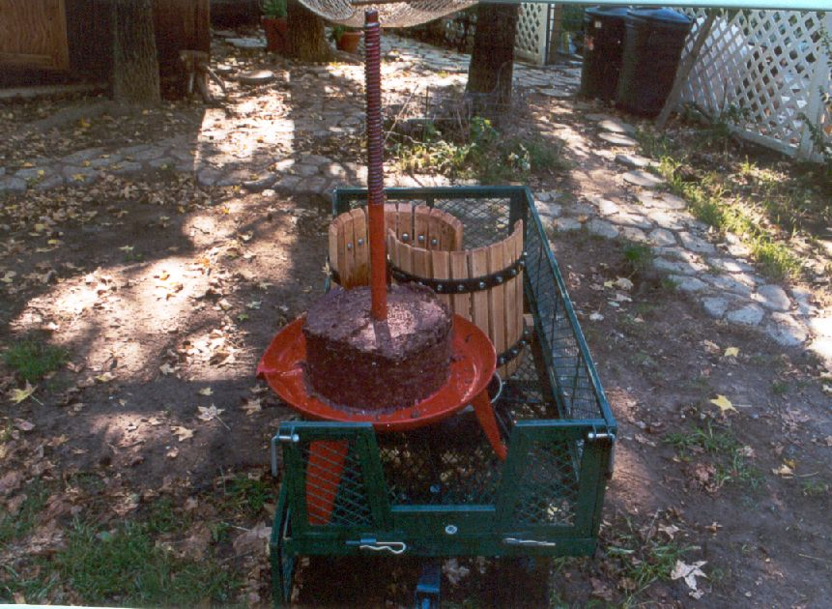
The press I use is representative of many seen in late period. The basket consists of vertical oak slats spaced to permit fluid to flow out but not the pulp. I use a nylon mesh to line the interior of the basket as an additional restraint for the pulp. The must and pulp is transferred out of the primary and into the press. An oak disk is placed atop the filled basket and pressed down on the fruit by turning the screw or a press-head which rotates on a fixed screw. The fluid flows out into a clean secondary. The period container would have been oak casks or ceramic amphorae. With the pressing complete, all that remains is seeds and skins. The cake is broken up and tilled into the soil to break down and provide nutrients for the vineyard.

In the photo's above, the grapes have been pressed and the must collected into the white bucket. The must is in the process of being siphoned out of the catch bucket into a glass carboy for aging and clearing. The photo at right is the press cake with the press basket disassembled. This is all that remains of the 90 pounds of grapes that went into the wine.

The seeds could be processed to extract grapeseed oil but that is well beyond my capabilities and intent at this time.
In Northern Europe the must would traditionally be stored in oak kegs for aging. For the first several times the barrel is used, the aging must will extract tannins and flavor elements from the wood. In time, with continued use, the impact would be greatly reduced. Aging in ceramics causes less impact on the flavor but making ceramic vessels of great capacity is difficult due to the weight of the contents.

During the fermentation period it is important to keep bugs, dirt, and other foreign substances out of the must. From discussions with European winemakers I've been told of their ancient predecessors using everything from simple leather covers and wood disks covering the mouths of the fermentation vessels to pouring a layer of olive oil over the top of the must. Given a cool environment (such as in a cavern) it would keep the oil from going rancid. As you tour wineries in Europe many of those who claim to a long lineage are built at or near to cavern complexes. Due to the lack of temperature control, I am not willing to try the oil method. However, the modern winemaker finds the equivalent of the leather flap in the modern fermentation lock. It permits gasses inside the vessel to escape while preventing dirt, insects, etc. from entering the must.

Once the juice has been separated from the fruit the next factor in winemaking is time. During this period the flavors of the wine are developing and suspended particles are settling out of the must. Cooling the must will accelerate the process. 'Chill proofing' is still the most common in use today. Once active fermentation is complete, the wine is moved to a cool environment where the lower temperature fluids are not capable of sustaining materials in suspension. Again, the Europeans took advantage of a countryside riddled with caves to store and process their products. For example, Veuve Amiot of St. Hilaire, France (just outside Saumur) has over 18 hectares of tunnels running through the sandstone of the Loire river valley. The establishment claims to have existed since the 1400's. The temperature stability of the caves is also ideal for the aging and long term storage of the wines.

Le Menagier de Paris, a work written in the late fourteenth century, possibly by a knight in the service of the Duke of Berry is one source which mentions the use of egg white used as a fining agent to speed clarification of the wine. [Short History of Wine, p 110] Some modern vintners continue the practice but most choose to use any of a number of commercially available clearing agents. These do not involve as many risks or impact the flavor of the finished product. I have worked with several of these clearing agents and found them to be satisfactory but less than ideal. I will often finish with a .5 micron sterile filter, which provides stellar clarity and will remove over 80% of active yeast organisms preventing spoilage, burst bottles, etc.

There are some conditions under which the wine will not clear. For example, a haze created by pectin's or proteins suspended in the must. Generally these require the intervention of modern chemistry and technology to overcome. In the case of a pectin haze, it does not adversely affect the flavor the wine, the wine just won't be clear. I've had several batches where my wife and I just decided to put the wine in a large beverage crock in the kitchen and drink it anyway. Without modern chemistry the period winemaker would be limited to a similar choice.

The choice of vessels in which to age, store, and ship wines is one all winemakers need to address. Wood barrels are convenient for handling and shipping. Additionally many wines benefit from extraction of flavors and tannins from the wood. When a merchant shipped his wines in barrels there was no special handling required other than making certain the bung remained in place. Unfortunately, barrels are costly and reuse is risky. Any spoilage bacteria which gets into the barrel will find a good home in the pores of the wood making the barrel unusable for anything more than a planter. Ceramics are easier to clean but they are both fragile and heavy compared to their capacity. Moving ceramics about requires a good deal of careful handling. And yet, archeologists have found numerous examples in digs and sunken wrecks. It would appear that many merchants believed the amphorae to be dependable. For a brief period I used an amphora made for me by my wife which had been coated with a food-safe glaze. After a few years it started to develop minute cracks in the glazing so I have retired it. For ease of use and sanitation I have chosen to use food grade plastic for my primary fermenter and glass for the secondary. I use glass wine bottles for storage and transport for ease of storage. The size is also about right for responsible consumption.

Once the wine had reached the point where the winemaker decided it was time to send his wines to market, the barrels would be pulled from the caves and shipped throughout Europe. The Duke of Burgundy came to be known in the 1500's as 'the king of wine' due to the richness of the lands and the demand for the wines from his domain.

The amount of time required for aging the wine is varied. Many of your drier wines grow increasingly better with time. In certain regions, such as England, the preferences were for sweet wines so many wines were consumed young. Wines similar to Beaujolais were in high demand in London during the 1400's. Sweet wines of this character tend to have a short shelf life. This led to merchants who found themselves with quantities of wine past their time. They added spices, pitch, and other ingredients to cover the spoilage. In 1456, records from the Mayor of London found, for example, that the Lombard wine merchants had adulterated their sweet wines to cover the wines short comings and ordered 150 barrels to be staved in. [A short history of Wine. p109]

This, then, could lead into a discussion about the wine trade and its position in the politics and economy of Europe, but that is beyond the scope of this paper.

In Summary.
The wine described here, while modernly produced, would not be out of place on the table of any European living from Imperial Rome to the Renascence.

I have produced wines using completely period ingredients (just grapes, no chemistry, no cultured yeast) and period style vessels (ceramic amphora), and quasi-period handling (no filtering, etc.) but found the spoilage rate was prohibitive. Given a cave or cool room for greater environmental control I might consider doing it again. However, given my current situation, I prefer to use what is available to keep the odds in my favor.

Much more could be said about wine types and the styles and preferences of different regions, anecdotes and comments by European vintners we've spoken with, etc. but that is, again, well beyond the scope of this document.

Damon Hroarsson
Weinzer, Burg Borrendöhl
------
Copyright 2008 by Hugh Niewoehner, 6931 S. 73rd. East Ave., Tulsa OK, 74133. <burgborrendohl at valornet dot com>. Permission is granted for republication in SCA-related publications, provided the author is credited. Addresses change, but a reasonable attempt should be made to ensure that the author is notified of the publication and if possible receives a copy.

If this article is reprinted in a publication, I would appreciate a notice in the publication that you found this article in the Florilegium. I would also appreciate an email to myself, so that I can track which articles are being reprinted. Thanks. -Stefan.

<the end>

