Bottle-Labels-art - 10/27/10

"'Labels? We don't need no stinking labels.' Yes you do!" by HL Rory McGowen.

NOTE: See also the files: bev-labels-art, brewing-msg, Hist-of-Mead-art, p-bottles-msg, wine-msg, cider-msg, ale-msg, bev-distilled-msg, kumiss-msg, beer-msg.

************************************************************************
NOTICE -

This article was submitted to me by the author for inclusion in this set of files, called Stefan's Florilegium.

These files are available on the Internet at: http://www.florilegium.org

Copyright to the contents of this file remains with the author or translator.

While the author will likely give permission for this work to be reprinted in SCA type publications, please check with the author first or check for any permissions granted at the end of this file.

Thank you,
Mark S. Harris...AKA:..Stefan li Rous
stefan at florilegium.org
************************************************************************

You can find more articles by this author elsewhere in the Florilegium and on the Medieval Brewers Home Page at http://forgottensea.org/medievalbrewers/

'Labels? We don't need no stinking labels.'
Yes you do!

by HL Rory McGowen

Presentation is everything. And nowhere is that more true than in brewing.

I can't begin to tell you the number of times I have been handed a bottle with no label on it. I couldn't have told you if it was cider, wine, mead, or the "warm apple juice" from outside Pavel's tent without tasting it, and then, as Merlin told Arthur in the 80's version of Excaliber, it's too late.
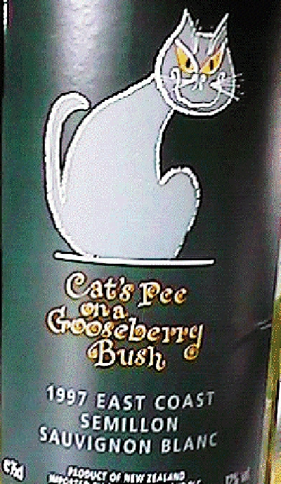
And sitting around a smoky firepit or in a group of fighters after a war doesn't help. The last thing you can smell is the beverage!

Besides, what happens when your King takes your bottle and tries to give it to another King? You think it doesn't happen. . . It's happened to me more than once! You would be surprised where your bottles might end up. NSTIW, walking through a war once, on the complete opposite side of the campgrounds from where we were camped, and there, on a table in a camp I didn't recognize, was a bottle of my mead. If you are brewing long enough, it will happen.

The thing you have to remember is that the first thing people see about your beverage, is the bottle. They see whether the bottle is clean or not. They see if the label is clear and distinct and marks not only what's inside, but who made it. They look at the cork or cap. All this happens within just a second or two of handing them the bottle.

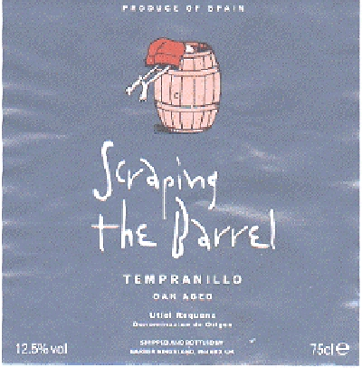

One of the things that bugs me, and I've done it, but it still bugs me, is to get into such a rush that you don't think you have time for labels so you initial the cork or the cap with two initials that you hope will make sense later. Only later you can't tell if "MM" stands for Mulberry Mead or Maple Mead. So you hold the bottle up to the light, and hope that you can tell the color of the contents through the dark glass.

When with just a few extra seconds, you could have included a label that not only identifies your beverage, but represents you. And folks, masking tape is not a label.

Okay, so how do you get a label and what should be on it? The answers are fairly easy, and I have as many answers as you have excuses. . . ; -)

First, what do you put on the label? The information you should always provide is:
1. What is in the bottle?
- Who produced the bottle?
- When was it bottled?

I always recommend adding the qualifier "Contains No Sulfites" to let people know that even people with sulfite allergies can drink my stuff safely. If you use sulfites, you should definitely label your bottles to reflect that. Those are the big ones. If you get really ambitious, you might include an ingredient list. You should also use an ingredient list if you use exotic or unusual ingredients, or ingredients that are common allergens, like nuts or sage.

But what else? Well, do you have a device? Put that on it. Like this:

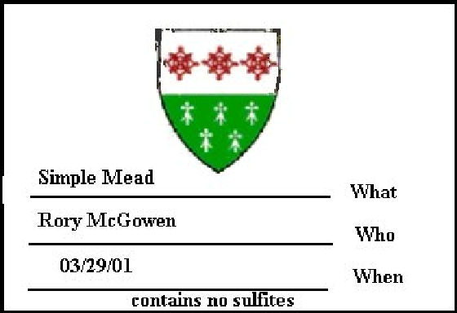

If not, do you have a badge that you use often?

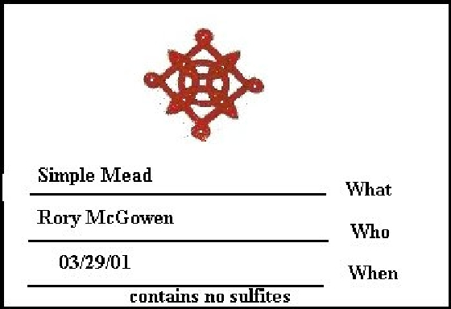

Or failing that, just use your name, like this:

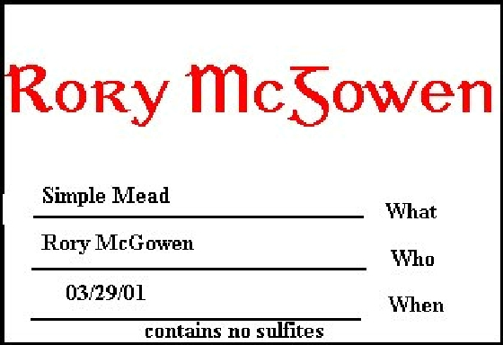

If you have a device, and depending on the Kingdom, you might want to add supporters and flair. The following label is the one that I am currently using:

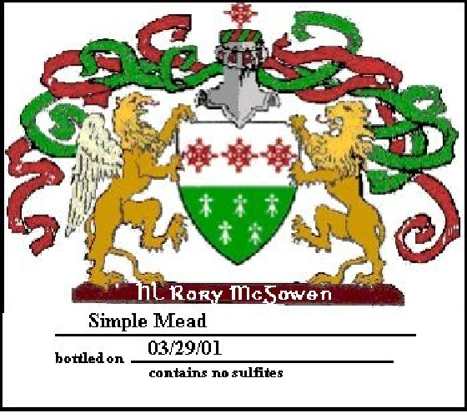

But what's it mean? Well, Calontir, the SCA Kingdom that I live in, doesn't regulate heraldic sumptuary very much, so I get away with being a little presumptuous. The Lion in Dexter (on the right) represents my Knight (father). The Red ribbons represent my belt (squire). The green ribbons usually would represent an apprentice relationship, but since I am not apprenticed to anyone, I use them because they are the second primary color of my device. The griffin on the left, doesn't really represent anything, but the lion was lonely and off balance without him. The helm represents someone who is armigeous. (Different helms represent different things)

Now you're going to tell me that you don't have a computer, right? Or perhaps your printer is broke.

. . Nice try. Handwrite it with a felt pen like this:

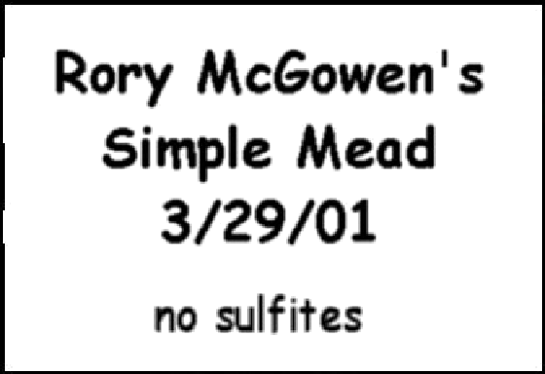

Which materials do you use? Well, in today's modern world of supermarkets, print stores, and WalMarts, your choices are nearly endless. Avery Labels sells a "label" sticker sheet that most word processors can utilize. That makes everything real simple. Or failing to find those, most larger chain stores carry full sheet (8 1/2 x 11) sticker sheets. I use these and then cut out the labels I want. The *ultimate* in printing labels is a color laser printer, but most of us don't have one of those. A regular laser printer is nice, but that limits you to grayscale designs. Most of us have ink jet printers at home. And while they print real nice, the ink is water soluble, and comes off very easily. And that can make a mess. I have found that spraying my ink jet labels with a clear paint sealer (like I use for my miniatures) helps a little. But the best trick is to print out one full sheet exactly the way you want it, and then take it and your blank label sheets to a copy store and color photocopy your color printout onto the blank label sheets. It cost a little bit more to do it this way, but the results are very professional looking and will say to everyone seeing your labels that you care to go the extra mile.
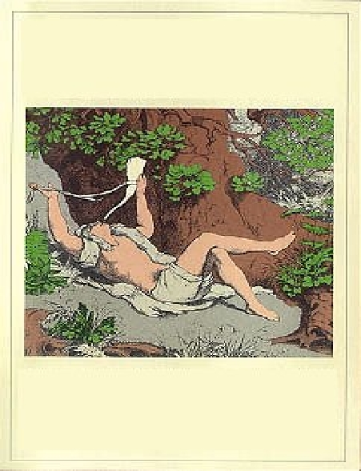

Of course, you could just buy your labels directly from a brew shop pre-printed and all you have to do is write in your information on the lines provided. But then the label isn't distinctly you.

The idea behind a label is to scream to the would-be drinker that you made this. Consistency in your labels will eventually equate the design with you. And eventually, when your King hands your bottle off to another King from halfway around the Knowne Worlde, and the second King just looks at the label and says, "Yes, I've tasted this person's work before; It's fantastic." And then makes off with the bottle. . . You will know why labels are important.

HL Rory McGowen
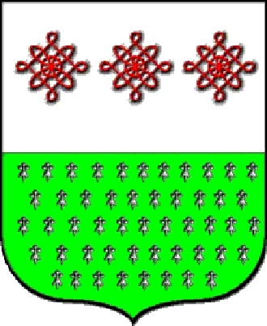
------
Copyright 2001 by Paul Fry. <rory at forgottensea.org>. Permission is granted for republication in SCA-related publications, provided the author is credited. Addresses change, but a reasonable attempt should be made to ensure that the author is notified of the publication and if possible receives a copy.

If this article is reprinted in a publication, I would appreciate a notice in the publication that you found this article in the Florilegium. I would also appreciate an email to myself, so that I can track which articles are being reprinted. Thanks. -Stefan.

<the end>

