16thC-Beer-p1-art - 5/12/18

"Brewing with Grandpa I: The Malt" by Master Magnus hvalmagi. Recreating a 16th Century Scandinavian Beer, With Some Help.

NOTE: See also the files: Malthouse-art, ale-msg, Basic-Beer-art, beer-msg, bev-labels-art, Brew-w-Gruit-art, I-Guid-Brewng-art, Warm-Beere-art, Malt-Acorns-1-art.

************************************************************************
NOTICE -

This article was added to this set of files, called Stefan's Florilegium, with the permission of the author.

These files are available on the Internet at: http://www.florilegium.org

Copyright to the contents of this file remains with the author or translator.

While the author will likely give permission for this work to be reprinted in SCA type publications, please check with the author first or check for any permissions granted at the end of this file.

Thank you,
Mark S. Harris...AKA:..Stefan li Rous
stefan at florilegium.org
************************************************************************

K&Q A&S, A.S. L
Brewing with Grandpa
Recreating a 16th Century Scandinavian Beer, With Some Help
by Master Magnus hvalmagi

OVERVIEW

In 1555, the Swedish archbishop Olaus Magnus published Historia de Gentibus Septentrionalibus (History of the Northern Peoples), an encyclopedic work detailing all facets of existence in mid-16th-century Scandinavia. Included in the text are writings about the production of malt and beer, but they lack the detail needed to readily redact the recipes.

Using supporting information gleaned from contemporary rural Norwegian farmhouse brewing - the kind that grandpa and great-grandpa would've done in the Old Country - as well as numerous other sources, I fill in the gaps and attempt to establish plausible connections that allow the contemporary to inform the period practice, in order to take my best shot at recreating the infrastructure and process indicated in the text.

The project is broken into 3 parts: Part I, the recreation of the malt (including a malting kiln); Part II, the reconstruction of a rotary hand quern; Part III, the development of a coherent recipe and subsequent beer.

Brewing with Grandpa I:
THE MALT

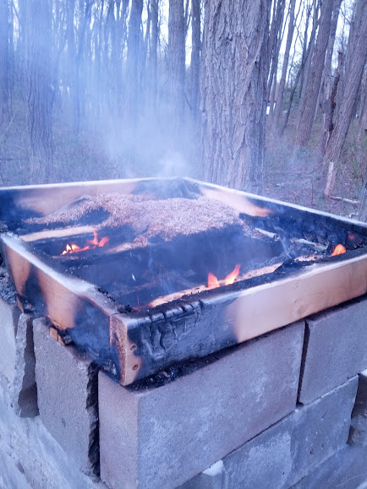
Fig 1. Apparently there's a learning curve.

INTRODUCTION

The majority of Olaus Magnus' (OM) text regarding beer production describes the preparation of grain for subsequent brewing. We call this process "malting" in modern brewing parlance. OM's description is sparse, and additional sources were employed in order to plausibly reconstruct the process and subsequently the product, starting with modernly-available six-row barley and about a half-ton of concrete blocks.

The Method

The text describes a malting process employed in mid-16th century Scandinavia [1, 13:26]:
They choose a floor of boards, long and wide, on which they place 10 rugghi, or seven and a half bushels or more, of barley, sprinkle it with water, and keep turning it repeatedly. As a result in a night and a day it becomes soft and swells. It is then turned a second and third time in the same fashion, whereupon it appears almost to put out roots and sprout, so that when the grains are squeezed into balls by the handfuls the stuff is at once ready to form lumps. It is now spread over the floor for three days and left to dry out. When you observe that is has done so, you get ready a fairly big oven. Over its broad surface you spread thin cloths, light a slow fire beneath it and bring the barley to be spread about and scorched, for from that heating it assumes a wonderful sweetness, so that it seems to have the flavour of honey.

7.5 bushels is roughly 280 pounds of grain. That's a lot. For this reconstruction, I aimed for much less - 50 pounds. That's manageable. For certain values of "manageable."

Selecting the Grain

The barley employed is known as "six-rowed" barley. The text identifies this as the type most readily employed for brewing in Scandinavia [1, 13:8]:

Corn of this sort [referring to barley described earlier in the passage] has six rows of grain in the ear, yet they are smaller than the common kind, and are utilized very conveniently for brewing beer.

Barley is not the only appropriate choice for brewing. The text also indicates that oats and/or wheat may be employed as well - but rarely rye, which OM alleges is used mostly for food (1, 13:26):

A similar preparation is made with wheat and oats, but seldom with rye, which is kept specially for baking loaves, being the corn that gives the tastiest nourishment of all.

In general, there are two broad classifications of barley: two-row and six-row varieties. Two-row varieties tend to grow larger kernels with a lower protein and higher starch content; in modern brewing, two-row is most commonly used for malt, as it provides a greater potential sugar yield per unit of mass than does six-row. Six-rowed barleys tend to be more heat and drought resistant, and are well-adapted to a variety of climates [2].

A particular six-row variety called Bere, native to northern Scotland, is allegedly traceable to an 8th century origin [3].

Unfortunately, Bere grain is not available for purchase in quantities useful for malting (though growing my own to a sufficient quantity is a very eventual goal). A variety called Robust is available for purchase in usable quantities, its growth characteristics are similar to Bere, and it can be harvested in a timeframe similar to that indicated by OM (40 days, compared to 36 indicated by OM) [4].

I purchased a 50 lb sack of Robust barley for use in malting.

II. Building the "Oven"

OM's description of the "oven" leaves much to be desired. It is simply described as "fairly big." Two woodcuts from the text (see fig. 2 and fig. 3) provide the only clues as to any possible construction or configuration, and those are extremely limited in use. Nowhere in the text can we find a description of an oven or of its construction techniques. Awesome.
Analysis of the existing woodcuts, as well as the implications of the general use of an oven, seem to indicate that they are likely constructed of stone or some other fireproof material.

OM describes the general types of stone in the north [1, 12:2], ranging from natural to manufactured, and describes a multitude of purposes for their use.

Another late 16th century brewing text, albeit an English one, describes the construction of a "kiln" or "ost" that fulfills the same purpose that OM describes. He describes modern kilns as
"being framed of brick, ashlar, or other fire stone" [5, p. 186].

Odd Nordland describes and depicts a multitude of rural Norwegian farmhouse brewing kilns [6, pp. 23 - 31], including a description of a method from the "old times" involving a stone oven with a stone top covered with a thin insulating cloth. This description seems very similar to the method described by OM, and could plausibly reflect a conserved tradition.

Lars Garshol documents several modern kilns in modern rural Norway, most of which appear to be large and constructed of standard masonry units, in a manner much the same as described by Nordland [7]. An example of an all-stone drier can be found in figure 4.

Taking this information together, I endeavored to construct a reasonably-sized stone kiln. Real stone is pricey, but I had access to standard concrete masonry units (cinder blocks) in great quantity for free. Most of the ovens depicted by Garshol were quite large, roughly 6 feet long and 4 feet wide. This would provide drying surface sufficient to contain the aforementioned "7.5 bushels" of grain indicated by OM.

My math indicated that such an oven would weigh roughly 2600 pounds if constructed of cinder blocks, and since I was the one moving it, and since I don't actually own the property* on which I would be constructing said oven, and because I'd have to one day tear it apart and move the stupid thing, I decided to make it smaller. Since a standard CMU is 8" x 16", I made a kiln whose footprint was 32" x 32". This required approximately half a ton of cinder blocks and an uninjured back, and would give me enough drying area for approximately 60 pounds of grain.

I dry-fitted (no mortar) the concrete blocks together in an alternating pattern up to a height of 48". In order to create a food-safe surface, I used 8" x 8" unglazed ceramic quarry with a metal support lattice [fig. 5]. This initial lattice proved sub-par, and was improved upon [fig 6].

My very first experiment in drying grain on this oven did not use a stone top - I instead used a wooden "drying frame" as described by both Nordland and Garshol. The results were less than desirable [fig. 1], and so a stone top was employed. Upon reflection, the stone top is probably a more accurate and intelligent interpretation of OM's text. Oops.

*In an utterly unexpected development, I asked my landlady if I could build a half-ton concrete oven on her property, and she said "yes". I still don't understand why.

III. Malting and Drying the Grain

OM's description of malting is fairly thorough, though some specifics are confusing given the woodcut depictions. He indicates that the maltsters select a "floor of boards," but the woodcut depiction [fig 2] that seems to map to this does not seem to be a floor or a construction of boards. It seems to be a stone bin, though it could also conceivably be a depiction of wood planking.

Nordland describes the process of malting, including various "malting bins" in good detail [6, pp. 18 - 22]. One such malting bin [fig 7] appears to be a shallow wooden box on legs. This item seems as though it could be what is depicted in the aforementioned woodcut [fig 2], and an examination of the original Latin ("Elegunt pavimentum tabulatum") shows other senses beyond the standard sense of "floor," which might include "a low surface of wood planking." The woodcut also appears to depict water running from underneath this surface, perhaps implying that the material had to be capable of permitting drainage, and that it was elevated.

I constructed a wooden "malting bin" (fig 8) consisting of common pine 2 x 4 (because they're super cheap) available at my local Home Depot. I aimed for a 24" x 48" configuration with 2" x 4" walls. This shallow bin allowed me to hold at least 50 pounds of grain during malting. It's also damn heavy.

I filled the bin with heaped up dry Robust barley. Using a large plastic spray bottle, I saturated the grain with water while constantly turning it by hand. The pile of wet grain was allowed to sit in the bin overnight.

For the next two days, I turned and watered the grain in the evening in the same manner as before. By the end of the third day, the grain was soft, swollen, and formed lumps when squeezed. Some grains appeared to have nub-like rootlets.

The grain was spread out evenly in the bin and allowed to sit for 3 more days. At that point, the surface of the grain was dry to the touch, and the grain had sprouted more. I intended to dry the grain on the kiln at this point (after the prescribed length of malting from the text), but unfortunately, it was raining profusely on the day that I was supposed to dry the grain. The grain sat in the bin for the next 5 days until the next available weekend day, at which point I transported it to the kiln, put it on some undyed wool cloth on top of the kiln (I switched to burlap on day 3), and lit a gentle fire to dry the grain [fig 9]. Drying took a total of at least 30 hours over the course of three days - I stopped counting at some point.

References

- Magnus, O. A Description of the Northern Peoples. Foote P.G. ed. Fisher P and Higgins H trans. 3 volumes. The Hakluyt Society. London; 1996. Cited in text as (Book:Chapter). Latin text from 1555 edition available at: http://runeberg.org/olmagnus/
- Schwarz P and Horsley R. "A Comparison of North American Two-Row and Six-Row Malting Barley." The Brewer's Marketing Guide Online. 1997. Accessed 12/26/15. Available at: http://morebeer.com/brewingtechniques/bmg/schwarz.html
- The Scottish Government. "Bere Barley." Science and Advice for Scottish Agriculture (SASA). Accessed 12/26/15. Available at: http://www.sasa.gov.uk/plant-variety-testing/scottish-landraces/scottish-landrace-protection-scheme-slps/bere-barley
- CC Grow. "Barley Robust." In Phytotheca. Accessed 12/26/15. Available at: http://ccgrow.com/phytotheca/barley-robust/
- The English Housewife, G. Markham, Best, M. ed., 1986 McGill-Queen's Press. (originally published 1615, 1623, and 1631.) 2008 edition
- Nordland, Odd. Beer and Brewing Traditions in Norway. Universitetesforlaget. Oslo; 1969.
- Garshol, L. "Alstadberger." Larsblog. 2014. http://www.garshol.priv.no/blog/298.html

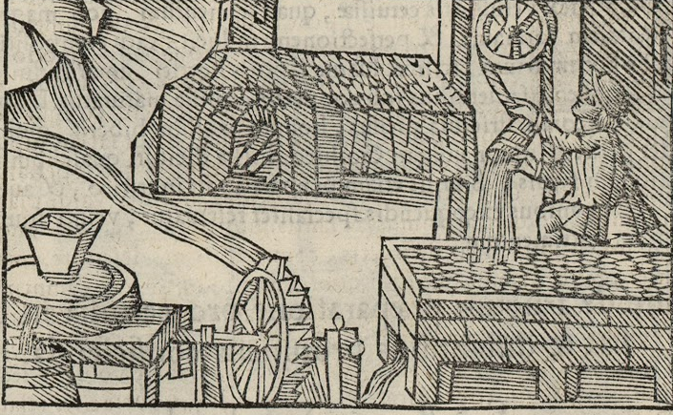
Figure 2: Woodcut from OM 13:26

This woodcut appears to depict many of the stages that Olaus Magnus indicates in his text. The lower right drawing appears to depict the malting process; the oval shapes are likely depictions of grains. As you can see, there does not appear to be a "floor of boards" in the conventional sense. The structure is drawn more like brickwork, but this could conceivably also be a manner of depicting wooden planks. Notice the little stream that appears to be flowing out from underneath the structure at an angle opposite the stream powering the mill.

The hearth structure at the top of the page appears very similar to the hearth depicted in Figure 3, save for the additional broad surface. We can see more ovals on that flat surface (again, likely grain), and it even appears as though the surface is covered with cloth.

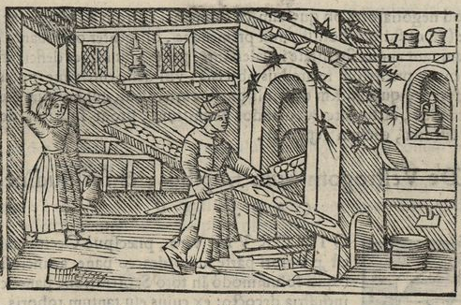
Figure 3: Woodcut from OM 13:13

This is the second fairly unhelpful woodcut depicting some sort of hearth or oven used for baking bread. OM does not go into any detail at all about the construction of said hearth. However, given the general construction of the scene, it seems likely that it's constructed of stone or some sort of earth work.

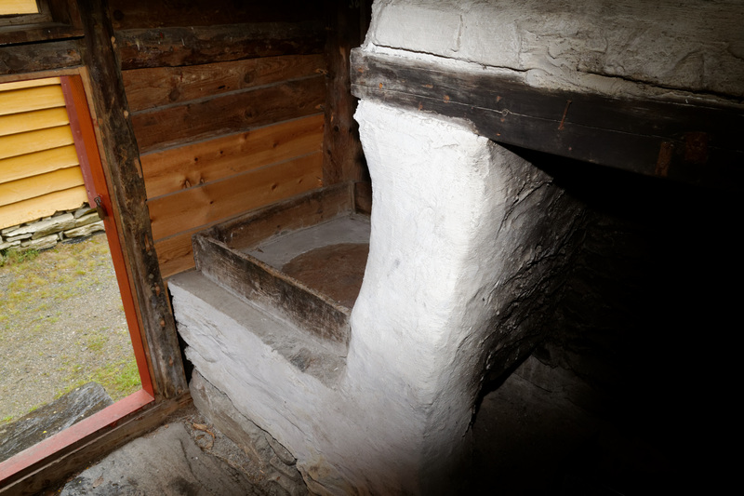
Figure 4: Stone Malt Drier in Norway (photo credit: Lars Garshol)

This is a stone malt-drying oven documented by Lars Garshol in 2015, still being actively used in modern Norway. In profile, it strongly resembles what I believe to be the "fairly big oven" depicted in figure 2. Construction is completely unknown. Seems to resemble plaster?

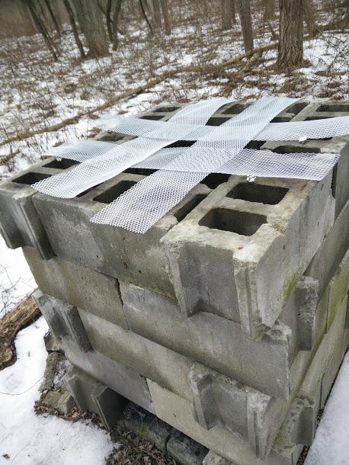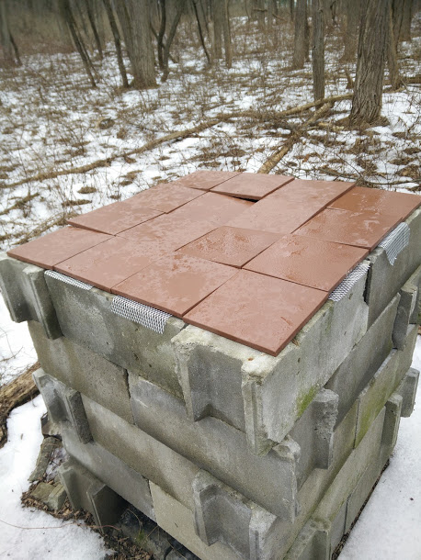
Figure 5: Lattice the First

This is the initial support lattice structure. As you can see, it doesn't really support even tile placement. It's also far flimsier than desired, and lacks the airspace to heat all the tiles. My first round of drying did not go as smoothly as desired.

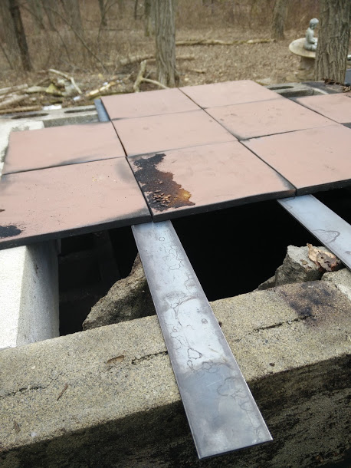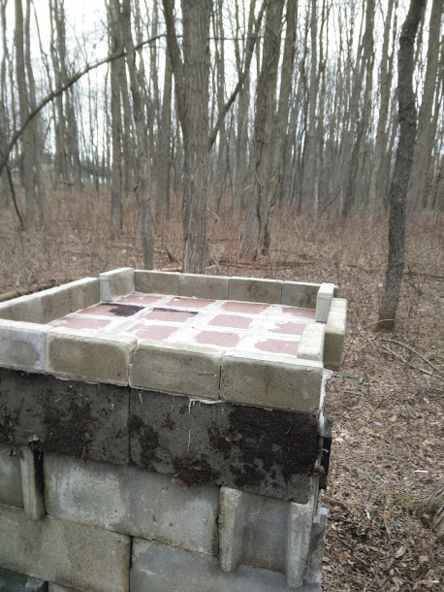
Figure 6: Lattice the Second

Instead of flimsy wire mesh, I opted for 2" wide flat bar stock. Supports a much more even drying surface.

I re-installed an upper layer of half-height blocks to open up airspace beneath the perimeter tiles, as they were not being adequately heated in round one.

I also used furnace cement to close air gaps, as the previous iteration was creating lines of intense heat along the gaps between tiles, charring the wool. No bueno. This second round of drying went much more smoothly. Burlap was eventually employed, as the wool was providing too much of a buffer between the grain and the heat. The grain seemed to dry most efficiently when it was turned frequently and completely, in a process somewhat akin to tumble drying.

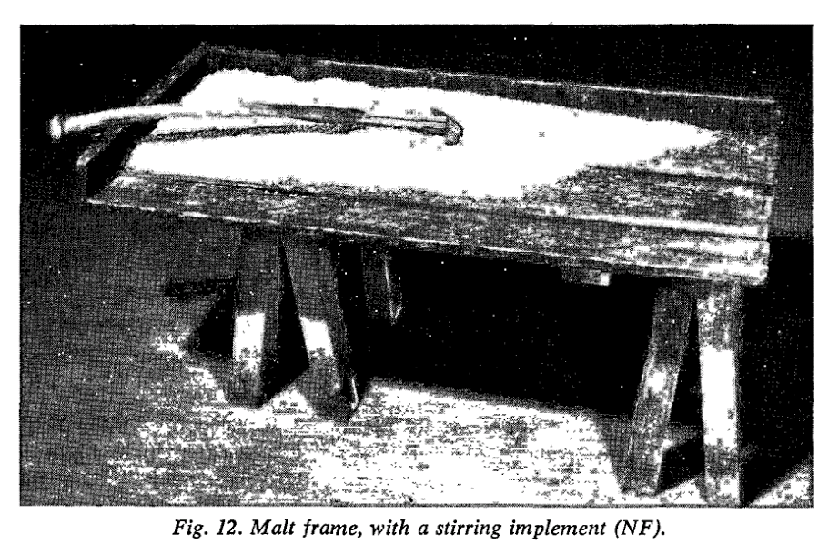
Figure 7: A Malt Bin in Norway

Bringing you the finest in low-quality compressions of low-quality scans of low-quality photos - an image of a Norwegian malt bin documented by Nordland. An interesting take on the "floor of boards" called out by OM and a possible explanation of the depiction in the woodcut.

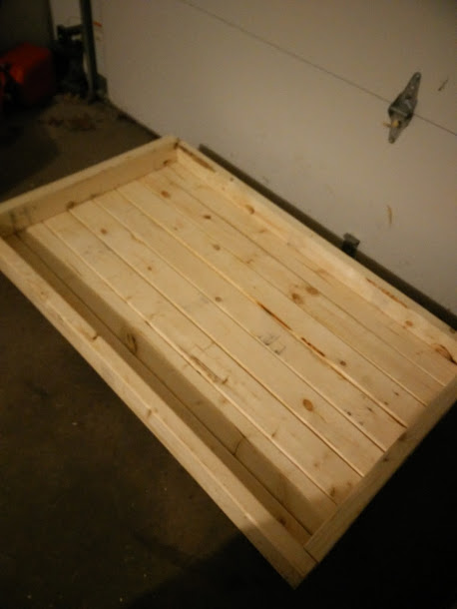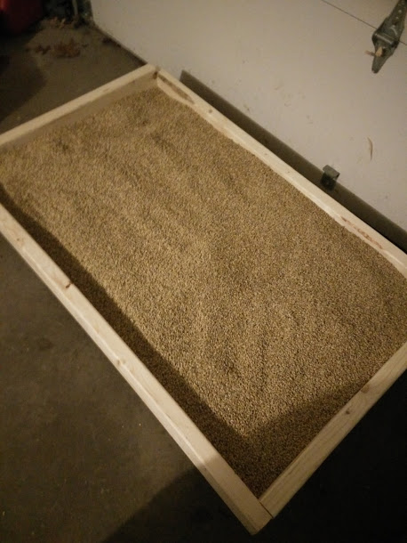
Figure 8: A Malt Bin in New York

Using culled 2x4 lumber, I constructed a pretty rough malt bin - not that it's a terribly fancy thing to begin with. While they're not visible in these photos, there are 2x4 "feet" elevating the bin. As you can see, it can comfortably fit 50 lbs of barley seed. The grain didn't malt as much as I expected, as this was done in my garage and it was pretty cold the entire time. If you want to build one, I'd use something lighter than 2x4 - this thing is hefty.
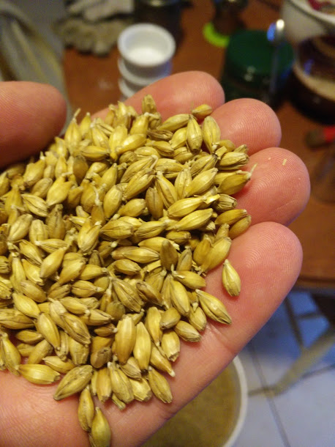

Despite an unintended delay in processing timeline, the grain did not sprout excessively - you can see many small rootlets are evident.

The initial kiln layout (lower left) made for a very smoky affair. However, despite the intense and persistent smoke, the grain did not acquire appreciable smoke character. The wool fabric appears to have buffered the grain exceptionally well. However, it may have done the job too well - I switched to burlap for the third day of drying, to permit more heat into the grain.

The third iteration of the kiln surface (lower right) boasts a more even layer, a lack of air gaps, and a significant reduction in smoke output.

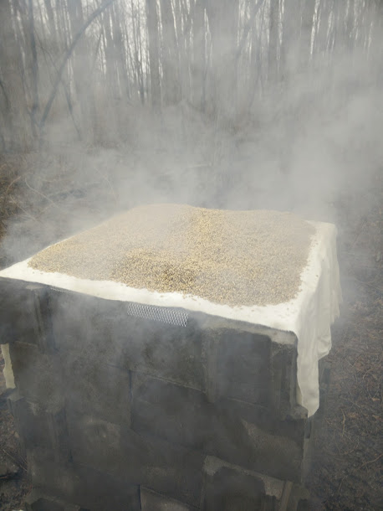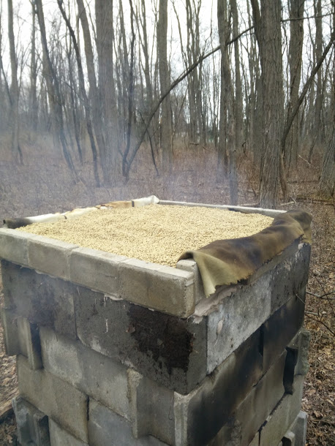
Figure 9: Watching Grass Dry

------
Copyright 2016 by Peter Olsen. <thewhaleshark [at] frontrowcrew.com>. Permission is granted for republication in SCA-related publications, provided the author is credited. Addresses change, but a reasonable attempt should be made to ensure that the author is notified of the publication and if possible receives a copy.

If this article is reprinted in a publication, please place a notice in the publication that you found this article in the Florilegium. I would also appreciate an email to myself, so that I can track which articles are being reprinted. Thanks. -Stefan.

<the end>

