Simple-Wimple-art - 2/23/12

"How to make a simple medieval wimple" by Lady Wenyeva atte grene

NOTE: See also the files: headgear-msg, veils-msg, snoods-cauls-msg, Liripipe-Hood-art, wearng-cornts-msg, chasity-belts-msg, coronets-msg, Stool-ball-art.

************************************************************************
NOTICE -

This article was submitted to me by the author for inclusion in this set of files, called Stefan's Florilegium.

These files are available on the Internet at: http://www.florilegium.org

Copyright to the contents of this file remains with the author or translator.

While the author will likely give permission for this work to be reprinted in SCA type publications, please check with the author first or check for any permissions granted at the end of this file.

Thank you,
Mark S. Harris...AKA:..Stefan li Rous
stefan at florilegium.org
************************************************************************

Find more work by this author on her website at: http://slumberland.org/sca/

How to make a simple medieval wimple
by Lady Wenyeva atte grene

A wimple is a useful item of clothing for medieval recreationists. It covers modern hair, it covers the neck and upper chest (preventing sunburn), and it gives you something to pin a veil to. Pretty handy!

This handout will show you how to make a pattern for your own wimple. The result is a funnel-like wimple that you can just pull on over your head. Whether wimples were actually made this way in period, I don’t know—but the look is good for for the 13th-14th centuries, and they are easy to make and wear.

You need about a yard of fabric. Lightweight linen is good and is most likely what would have been used in period. Muslin works fine if you can’t get linen. You also need a measuring tape, and the usual sewing supplies—thread, sewing machine unless sewing by hand, etc.

Measure all the way around your head just behind your face (see left). Add 1/2” seam allowance, and then write the total measurement down here:

A:

Measure from your chin down to where you want the wimple to end on your chest (see left). Add 1/2” seam allowance, and then write the total measurement down here:

B:

Measure from your forehead over the top of your head, down to where you want the wimple to end on your back (see left). Add 1/2” seam allowance, and then write the total measurement down here:

C:

Measure all the way around your collarbone or possibly shoulders, to make sure the wimple is as big around as you would like it to be (see left). This sizing is up to you. If you are going to wear the wimple tucked in to your neckline, you probably don’t want to make it too large here as it will add a lot of bulk under your tunic. But if you are making something that you want to look like a nun’s habit, with the wimple coming down low onto the chest, you’ll need to make it large enough that it won’t bind your shoulders. Add 1/2” seam allowance, and then write the total measurement down here:

D:

Now, a very important warning! Do not miss this, or your wimple might end up too tight around your chin and you won’t be able to eat or talk while wearing it!

MAKE SURE YOU ADD A SEAM ALLOWANCE TO EACH MEASUREMENT!!

OK! Here goes. Lay out your pattern on your fabric as follows (the drawing is a little rough and not to scale):
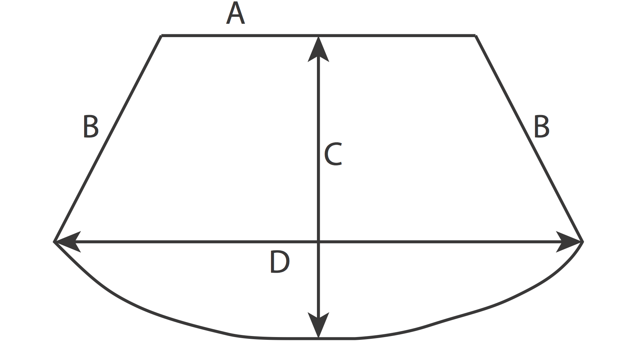

The curve at the bottom is something you’ll have to draw freehand, but it’s not too hard since you’re just connecting the ends of the B lines on the sides with the D line in the center.

You added your seam allowance, right? If you did, you are ready to cut your fabric.

Once you have cut the wimple out, sew up the B edges, which will leave you with a tube or funnel shape. Don’t sew up the A or curved edges, or you won’t be able to wear it! Just sew up the edges that are marked B in the diagram.

Next, you will need to hem the large opening at the bottom (curved edge) with the method of your choice.

Then, hem the small opening (the A edge). You can also bind the edge with bias tape or something similar.

Voila! You now have a simple wimple! The one I am wearing in the photograph was made with this pattern. You wear it by putting it over your head with your face showing through the smaller opening. Very easy!

I hope you found this useful! If you make a wimple with this pattern, I’d love to see it!

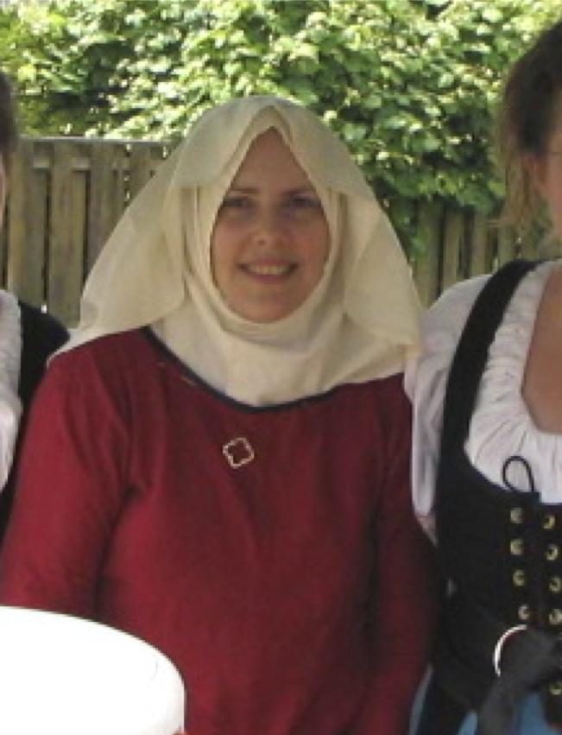
Lady Wenyeva atte grene

------
Copyright 2010 by Wendi Dunlap, Seattle, WA. <wd-sca at slumberland.org>. Please contact me for permission to use in publications, classes, etc.

If this article is reprinted in a publication, I would appreciate a notice in the publication that you found this article in the Florilegium. I would also appreciate an email to myself, so that I can track which articles are being reprinted. Thanks. -Stefan.

<the end>

