Russian-Tffia-art - 1/25/15

"Russian 16th Century Men's Taffia (Skull cap)" by Baroness Anastasia Alexandrovana Andreeva (OL).

NOTE: See also the files: cl-Russia-msg, Rus-Handbook-art, Russia-msg, Russia-bib, E-Period-Hats-art, fur-msg, headgear-msg, Liripipe-Hood-art.

************************************************************************
NOTICE -

This article was submitted to me by the author for inclusion in this set of files, called Stefan's Florilegium.

These files are available on the Internet at: http://www.florilegium.org

Copyright to the contents of this file remains with the author or translator.

While the author will likely give permission for this work to be reprinted in SCA type publications, please check with the author first or check for any permissions granted at the end of this file.

Thank you,
Mark S. Harris...AKA:..Stefan li Rous
stefan at florilegium.org
************************************************************************

Russian 16th Century Men's Taffia (Skull cap)

by Baroness Anastasia Alexandrovna Andreeva (OL)

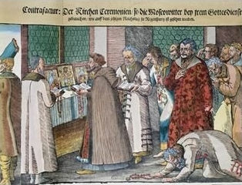

The Great Embassy of Ivan the IV of Russia
to the Holy Roman Emperor at Regensburg , 1576

Principality of Tir Righ
Arts and Sciences Championship
November 22, 2008

Not much is known about this particular accessory, so of course I have to make one!

Based on the readings from the primary sources available, the men's skull cap was a regular accessory that was worn indoors but covered by the large fur hats when outdoors or when hats were in order.

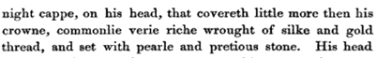

Giles Fletcher 1591

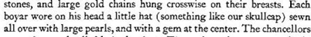

Olearius in Russia 1633

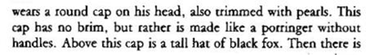

Jacques Margaret 1606

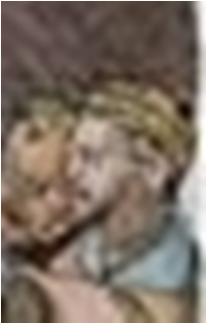

This is a detail of the picture on the front. It is similar to the style on the left.

The drawing is from the Ukrainian Costume book that all us Russian personas love and adore, the History of Costume. I have a translation of the 16th century chapters.

Irena Turnau's History of Dress in Central and Eastern Europe from the Sixteenth to the Eighteenth century also sights this same author for the Russian Taffia.

As you can see the cap I have made is very similar to the period hats which are 5 or six 'petal' shaped pieces sewn together to make the round top.

This may or may not be accurate as the following examples are more similar to the Elizabethan style of 'nightcap.'

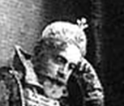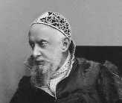

Alexi Zahkarovitch Hitrovo 1903 Ivan Alexandrovich Vsevolozhsky 1903

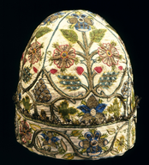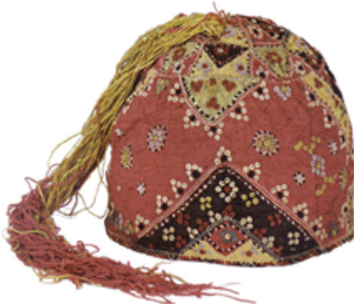

English Men's Cap 1600 14th Century Mamluk Cap

The Royal Company of the Sable Rose (Argent) of An Tir
The Royal Company of the Sable Rose, Argent was founded on the concept that pageantry, spectacle, chivalry, and authentic representations are integral to the recreation of Historical Tournaments. Furthermore a consistent ambience of Courtly Love is intertwined in this presentation of homage to the Ladies of the Rose in a grand Company of the Sable Rose Emprise once a year and at the Romancing the Rose Rapier tourneys throughout the year.
The Company was awarded Royal status in the year AS XLI, being 2006 Gregorian, by King Amalric and Queen Caia of An Tir.

I am the Premier Noble Patroness of the Royal Company of the Sable Rose Argent of An Tir. My husband is the official Exchequer for the Company.

I like to make what I call "Sable Rose Clothes" to further glorify the Company and give it more visibility.

I am making this Taffia for my husband to go with the outfit I am making him for 12th night.

Although the Sable Rose Company is SCA, it is based on Medieval concepts and ideals. Therefore this is not an item that is being replicated from a museum, but a labor of love for the Royal Company that I try to proudly represent.

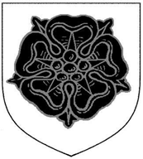

Designs

The Tudor Rose is the one that is used for all the Rose Companies. However, I wanted to make a Russian taffia and therefore I wanted an appropriate rose on it. I am using the Turkish Damask Rose motif that was prevalent in the Middle East during my time period and would have been found on ceramics and textiles that were imported from Persia and Turkey to Russia.

\Damask Roses are from a hybridization between R. gallica and R. phœnicia which occurred in Asia Minor and became distributed throughout Syria and the Near East and Middle East generally.



Rose, Ibn Sina, known as Avicenna in the West,
from his famous medical journal Al-Qanun 1020 ad.

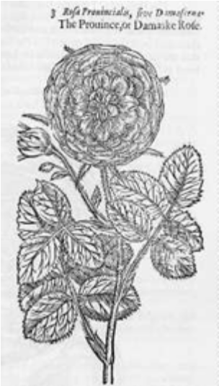

Rosa Damascena from Gerard's Herbal 1596


Damask Rose
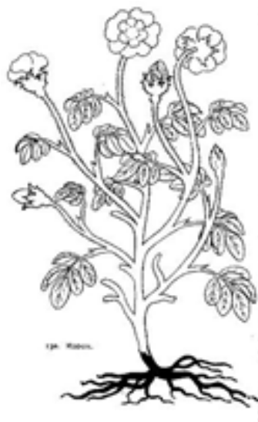
Dioscorides Rose 1000 ad

Most Arabic manuscripts started with
Dioscorides, Russian herbals also use
His manuscript as a starting place

This is the motif I copied for my Taffia. It is a Rose from a Turkish ceramic Spandral 1566

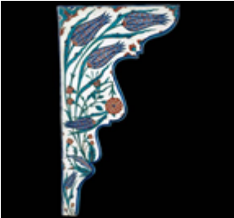
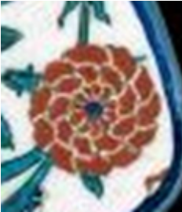

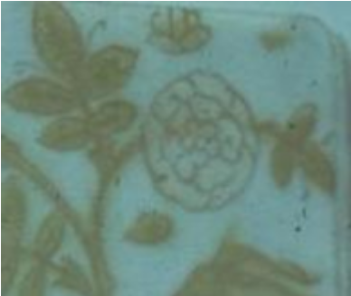
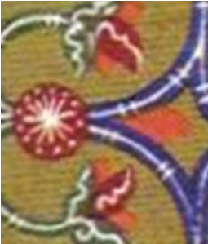

Kara Memi illumination , from the From a Russian Medieval
Divanimuhibbi, detail of the Rose, 1566 illumination, 16th century

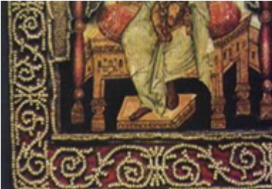
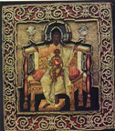

16th Century Russian Phelonion Detail of Pearl work

Fragment of embroidery from the Vladimir region 10-13th Century

I haven't found an actual appliqué item for Russia during our time period, but this is a piece of 12th century embroidery from Vladimir that could very well have been considered for appliqué.

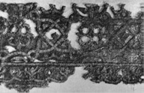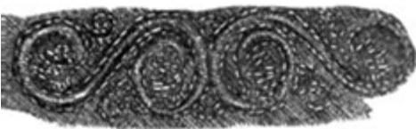

13. An embroidery from Chersonese. XII century

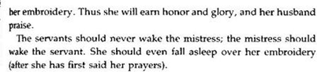

Domostroi 1556

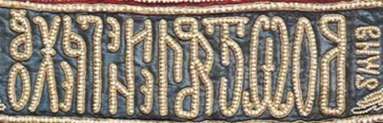

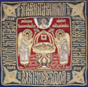
16th Century Russian Church Veil
Above is the couched and beaded detail

Materials

I have made my Taffia out of silk satin interlined with silk taffeta and lined with linen.
The Primary sources don't say what color the hat was, but they do mention the materials.

Giles Fletcher 1598

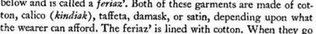

Jacques Margaret, 1606

The Tsar had a corner on the market for everything and often bought everything up and then resold to his own store owners. Russia was a true destination of the silk road.

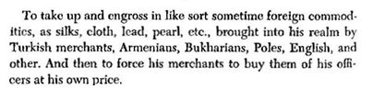
Margaret, 1606

Boris Godunov and other Tsars gave gifts to ambassadors who would visit.

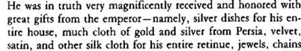

Jacques Margaret , 1606

Because Moscow was the capital during this time period, everything flowed into the city and had to go through the Tsar first. It would appear from the period sources that the Boyars wives had many fine fabrics and threads to sew with.

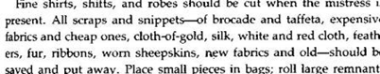

Domostroi 1556

Pearls came from the Volga and from China, the round ones were the most sought after and were used for the ecclesiastical pieces. Every lady, from the Tsarina down to the merchant class, had workrooms for everything. One for making clothing, one for embroidery, one for Church embroidery. It was thought to be the wife's duty to contribute to the church .

Most of the embroidery included heavy use of gold and silver thread, bullion and other gold and silver cords of different sizes. I have used only black and silver on my taffia but most of Russian embroidery uses polychrome threads. It showed the wealth and availability of the materials. The raw silk threads were often imported and then dyed by the housewife for her needs. Some were already dyed but were more expensive.

The black would have been an ochre, or an oxide, also black walnut, but these tended to eat the thread or material that it was dyed with, so there are few examples of black garments or black embroidered items. The ones that have survived often have turned brown. The nineteenth century had created aniline dyes, most of the examples are from this time period.

The metal threads were silk wrapped with thin metal strips pounded thin. Some threads were taken off of embroidered items and melted down to make other things or more thread.

I am using a silver braid to finish the brim and a soutache braid to decorate the hat.

Michael in Chernigov (XII century). In the inventory it is spoken, that on a breast there were «pieces of a silk fabric, of woven gold, decorated by a narrow braid with ornaments from fine metal plaques, into some of them are inserted green and yellow glass pieces.». Most of the pieces I have found seem to use braids of some kind as decoration.

Embroidery in 16th Century Russia

Most of the examples of Russian Embroidery are ecclesiastical in nature and very little domestic embroidery of this period can be found in books.

The primary stitches in Russia were similar to those used in other areas of the East and in Europe as well. Mostly outline stitch, brick stitch chain stitch couching, satin stitch and cross-stitch.

I am using the couching stitch and the satin stitch.

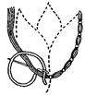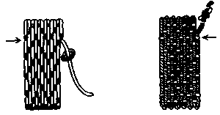

Medieval Couching stitch Satin Stitch

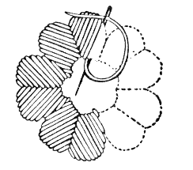

Sources Used
Primary Sources

Baron, Samuel H. Translated and Edited. The Travels of Olearius in Seventeenth Century Russia.1636 Stanford University Press Stanford, CA 1967

Dunning, Chester S. L. Translated and Edited. Jacques Margaret The Russian Empire and Grand Duchy of Moscovy A 17th century French account. 1606 University of Pittsburgh Press. 1983

Fletcher, Giles Of the Russe Commonwealth 1591 Facsimile Edition with Variants Harvard University Press Cambridge, Massachusetts 1966

Gerard, John. The Herbal or General History of Plants Enlarged and revised by Thomas Johnson Dover Publications 1975

Gunther, Robert T. The Greek Herbal of Dioscorides. Hafner publishing company New York, 1959

Pouncy, Carolyn Johnston, editor and translator. The Domostroi Rules for Russian Households in the Time of Ivan the Terrible. 1556 Cornell University Press Ithaca and London 1994

Staden, Heinrich von. The Land and Government of Muscovy. A Sixteenth century account. Translated and Edited by Thomas Esper. Stanford University Press Standford Ca. 1967

Secondary Sources

Costume Ball in the Winter Palace in two volumes album of phoographs with biographical references. Publishing house Russky antiquariat Moscow 2003

Early Russian Embroidery in the Zagorsk Museum Collection. Moscow 1983

Klimova, Nina T. Folk Embroidery of the USSR Scientific Research Industrial Arts Institute, Moscow Van Nostrand Reinhold Company New York 1981

Moscow Museum of Art and Industry. Medieval Russian Ornament in Full Color from Illuminated Manuscripts. Dover Publications, Inc. New York, 1994

XVIIIth International Congress of Byzantinists Medieval Pictorial Embroidery Byzantium Balkans Russia. Catalogue of the Exhibition Moscow, August 8-15 1991

Stamerov, K.K. An Illustrated History of Costume. Publishing House
Avenger" Kiev, 1978 (in Ukrainian)

The Museum of Folk Art Moscow. Russian Embroidery: Traditional Motifs. Moscow Sovetskaya Rossiya Bpublishers 1990

Treasures from the Kremlin. Metropolitan Museum of Art., New York, Harry N. Abrams, publisher 1979

Turnau, Irena. History of Dress in Central and Eastern Europe from the Sixteenth to the Eighteenth Century. Institute of the History of Material Culture Polish Academy of Sciences. Warszawa 1991

Articles:
Leonid A Beliaev and Alexei Chernetsov the Eastern Contribution to Medieval Russian Culture. Muqarnas, Volume 16 [ages 97-124 1999

Lectures on history of sewing

Е. Ю. Катасонова, Золотное шитье домонгольской Руси.X–XIII

E.J.Katasonova Golden Sewing of Pre-Mongol Russia. X–XIII centuries

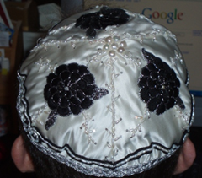

------
Copyright 2008 by Marilee Humason <stasiwa at yahoo.com>. Permission is granted for republication in SCA-related publications, provided the author is credited. Addresses change, but a reasonable attempt should be made to ensure that the author is notified of the publication and if possible receives a copy.

If this article is reprinted in a publication, I would appreciate a notice in the publication that you found this article in the Florilegium. I would also appreciate an email to myself, so that I can track which articles are being reprinted. Thanks. -Stefan.

<the end>

