Paded-Roll-Hg-art - 3/18/18

"15th Century Padded Roll Headwear" by HL Giraude Benet.

NOTE: See also the files: 13C-W-Headger-art, 2-Norse-Hoods-art, Cloth-Circlet-art, headgear-msg, Kolpac-art, Ldys-Headgear-art, Russian-Tffia-art.

************************************************************************
NOTICE -

This article was added to this set of files, called Stefan's Florilegium, with the permission of the author.

These files are available on the Internet at: http://www.florilegium.org

Copyright to the contents of this file remains with the author or translator.

While the author will likely give permission for this work to be reprinted in SCA type publications, please check with the author first or check for any permissions granted at the end of this file.

Thank you,
Mark S. Harris...AKA:..Stefan li Rous
stefan at florilegium.org
************************************************************************

15th Century Padded Roll Headwear
by HL Giraude Benet

Padded‐roll type headwear began at some point in the 14th century as the ubiquitous hood, worn by both men and women, began to be worn in a cap‐ or hat‐like fashion by placing the top of the head through the face opening and letting the cape and liripipe of the hood hang down on either side of the head. The face opening could be rolled, and the cape and hood could be arranged in different ways to suit the style of the wearer.

Eventually the roll became very large and prominent, and the "cockscomb" and liripipe became stylized decorations. Padded roll headwear was popular among noble men and women, as seen in period art such as the Très Riches Heures du Duc de Berry (1412‐1416), paintings by Rogier van der Weyden (mid 1400s), and figures from the tomb of Isabella of Bourbon (ca 1475). Portraits of Philip the Good, Duke of Burgundy show him wearing an especially large padded roll hat, or chaperon. The style was popular throughout Europe in the 15th century but eventually passed out of high fashion in most countries by the end of the century.

Many costume texts explain that the padded roll for this type of headwear is made by stuffing a tube of fabric, then sewing the ends together to form a base that can be further embellished. While this can result in a very wearable hat, I speculate that it is more plausible that in the 15th century this type of hat was made either by covering a roll of less expensive (possibly recycled) "filler" fabric with a more expensive, fashionable fabric. Hats made using extremely large rolls might possibly have been constructed by covering a constructed framework with fashionable fabric and stitching it into place.

Images:

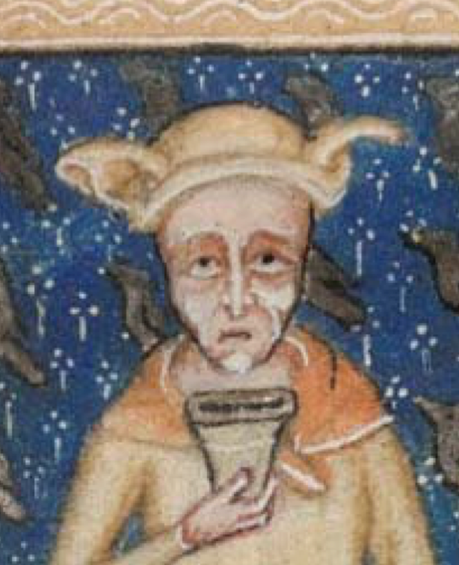
Man wearing hood as "chaperone." From the Lutrell Psalter, c. 1325‐1335

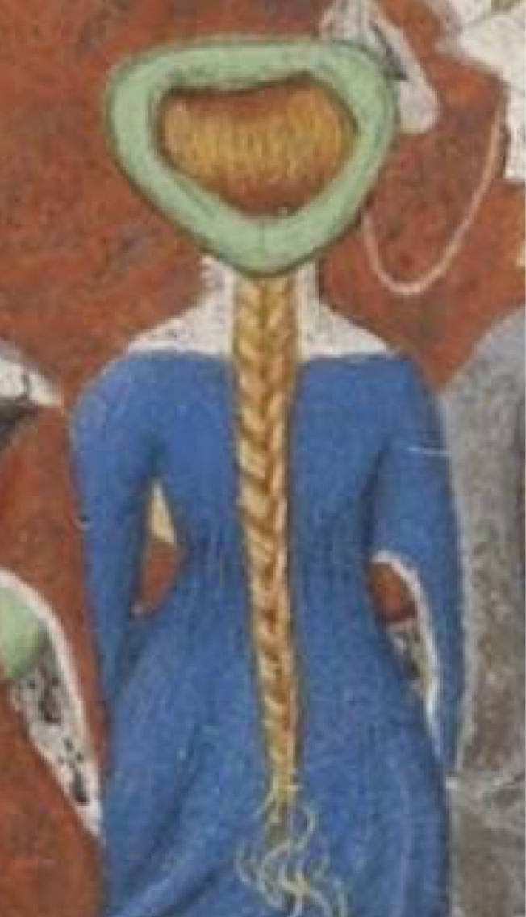
From "La Cité des Dames," Christine de Pisan, 1412

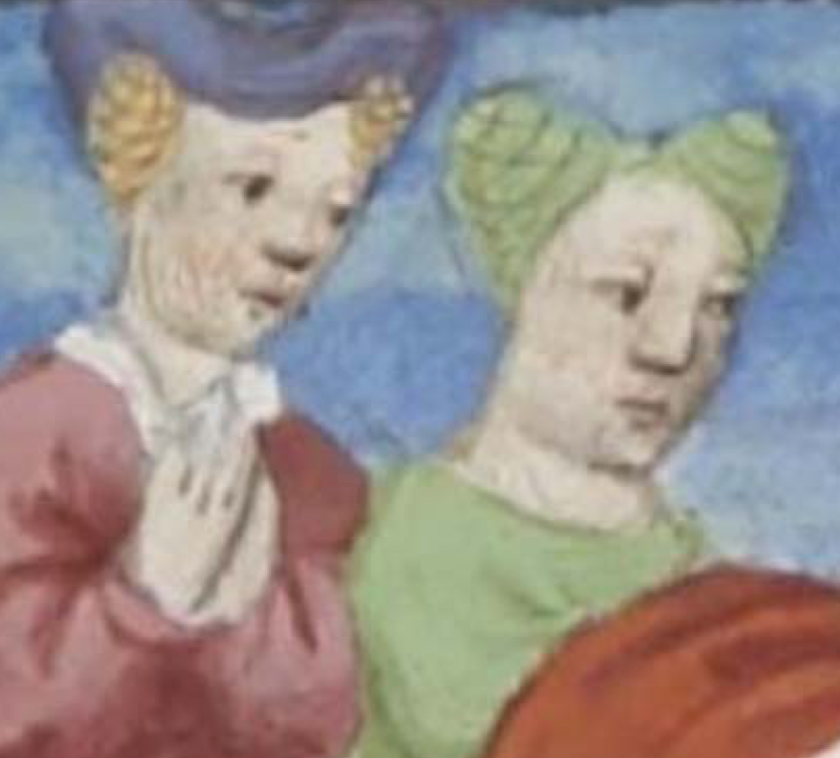
From "The Decameron," Bocaccio, (traslation of-Laurent de Premierfait) 1425-50

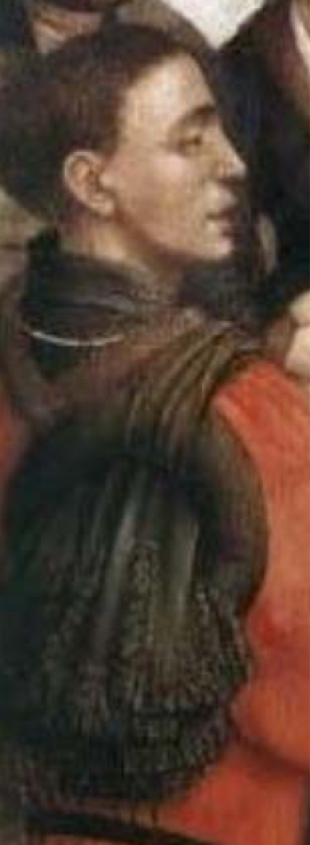
Detail of the "Seven Sacraments" Altarpiece,
Rogier van der Weyden 1445‐1450

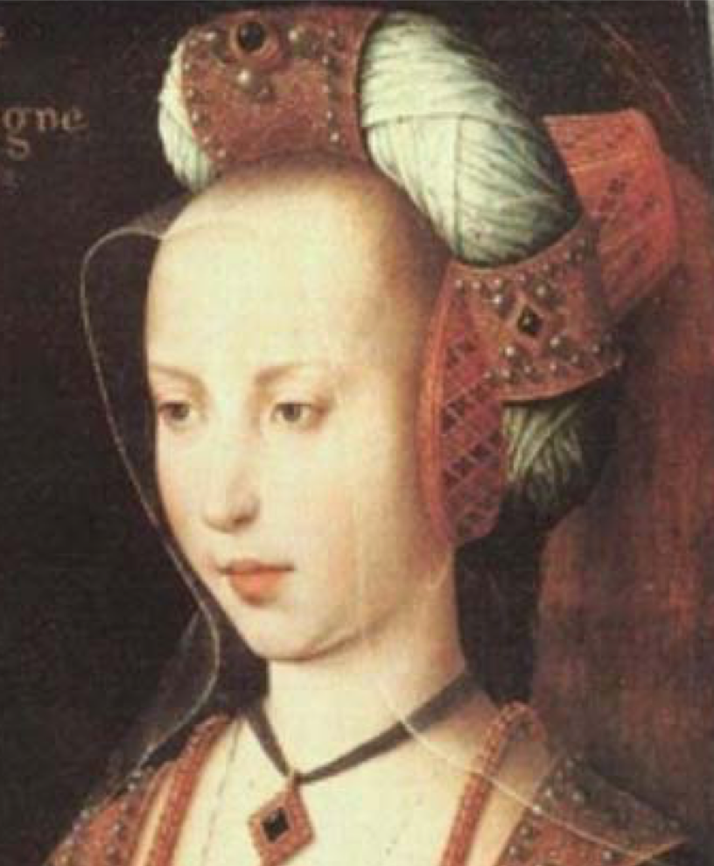
Portrait said to be Mary of Burgundy, late 15th Century

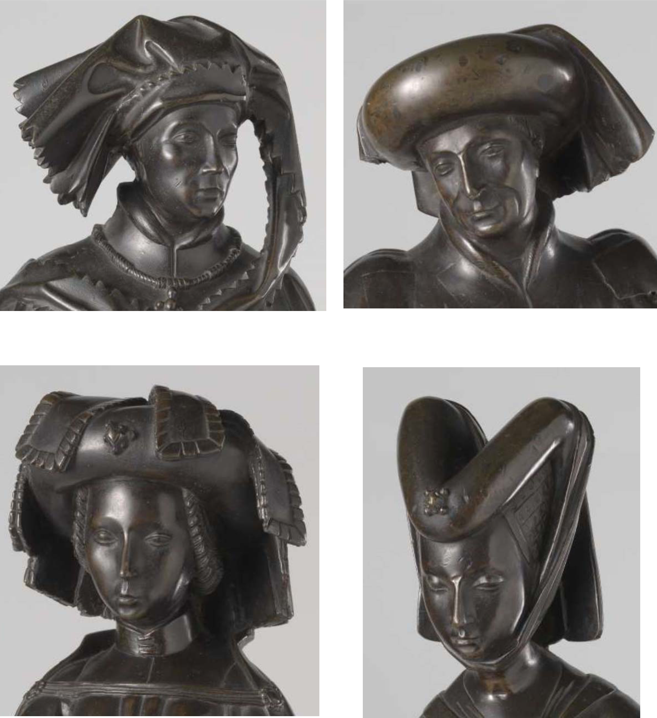
"Pleurants" from the tomb of Isabella of Bourton by Renier van Thienen, ca. 1475 ‐ ca. 1476

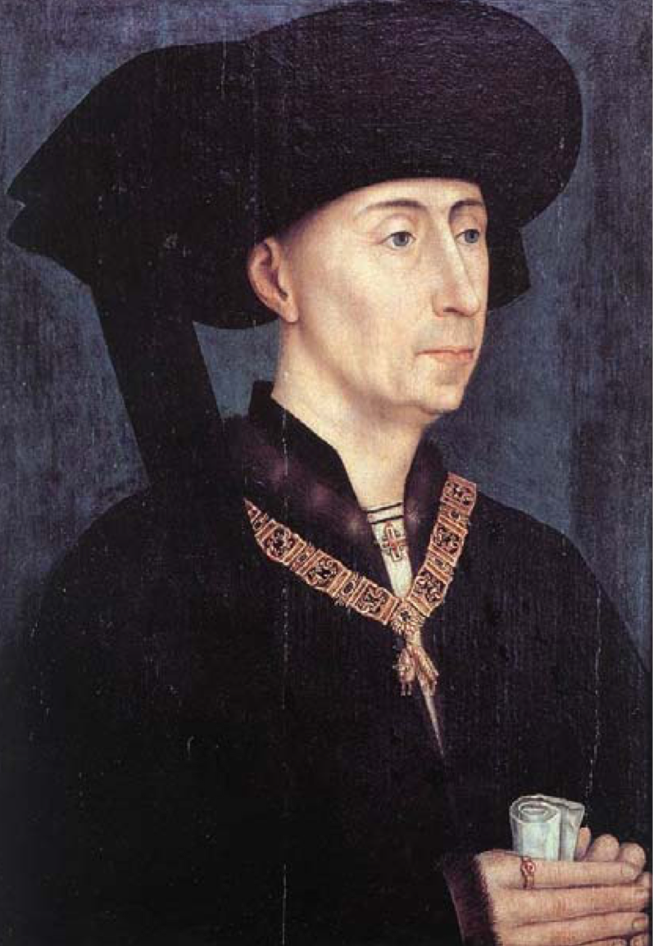
Philip the Good c. 1450

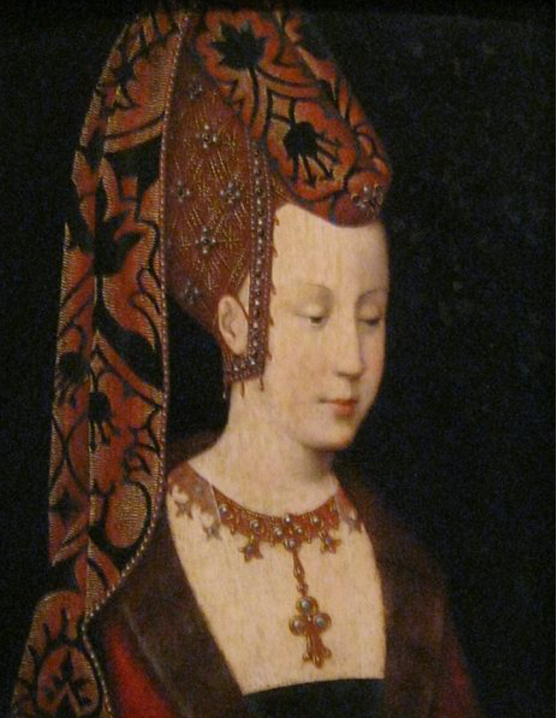
Isabella of Portugal c. 1500

------
Copyright 2018 by Jill Sibley. <giraudebenet at hotmail.com>. Permission is granted for republication in SCA-related publications, provided the author is credited. Addresses change, but a reasonable attempt should be made to ensure that the author is notified of the publication and if possible receives a copy.

If this article is reprinted in a publication, please place a notice in the publication that you found this article in the Florilegium. I would also appreciate an email to myself, so that I can track which articles are being reprinted. Thanks. -Stefan.

<the end>

