Market-Wallet-art - 12/4/16

"The Market Wallet - A Canterbury Faire token" inspired by Lady Jeneur le Geline, notes by katherine kerr. (A period carrying sack)

NOTE: See also the files: netting-msg, pouches-msg, Backpak-Basket-art, p-backpacks-msg, basketweaving-msg, leather-msg, linen-msg.

************************************************************************
NOTICE -

This article was added to this set of files, called Stefan's Florilegium, with the permission of the author.

These files are available on the Internet at: http://www.florilegium.org

Copyright to the contents of this file remains with the author or translator.

While the author will likely give permission for this work to be reprinted in SCA type publications, please check with the author first or check for any permissions granted at the end of this file.

Thank you,
Mark S. Harris...AKA:..Stefan li Rous
stefan at florilegium.org
************************************************************************

You can find more from this author at:
http://webcentre.co.nz/kk

The Market Wallet
A Canterbury Faire token inspired by Lady Jeneur le Geline, notes by katherine kerr

The Inspiration

At Rowany Festival AS50, Lady Jeneur le Geline ran a very interesting class on the "fassing" or market wallet, which inspired an idea for a most excellent, and relatively simple, Canterbury Faire giveaway. Lady Jeneur has kindly given me permission to plunder her documentation and patterns to produce this, huzzah!

At CF, we have done the common canvas tote bags with screen-printed logos a number of times, and they've always felt obtrusively mundane to me. When I saw the undeniably period market wallet and realised how easy they would be to produce, it seemed like a very good substitute. When THL Aveline Goupil put in a bid for Faire, I suggested a small market wallet as the token with possibly larger ones available for purchase. So umpteen metres of calico later….

The History

Market wallets go by a number of terms: the Martebo sack, fussing, stuffed sack, shoulder sacks. These all refer to a simple rectangular cloth bag with a central slit, used for the carriage of small goods such as market items (whether for sale or purchased), books, food and so forth. They appear in pretty much unchanged form throughout Europe – with a slight bias towards Scandinavia – from at least the 13th century, in illuminations of monks, pilgrims, labourers and washerwomen, right on up to 20th-century photos of travelling salesmen.

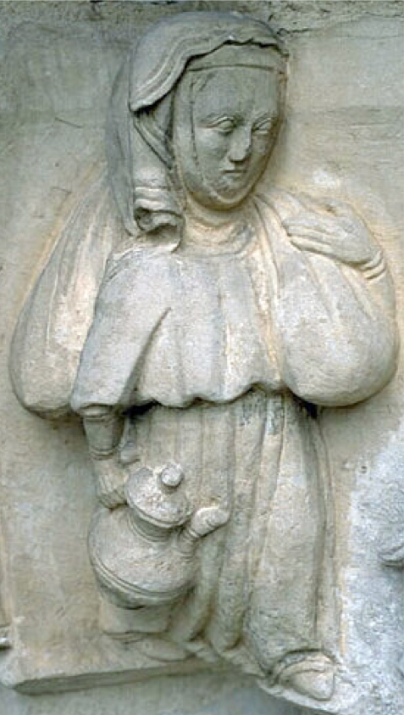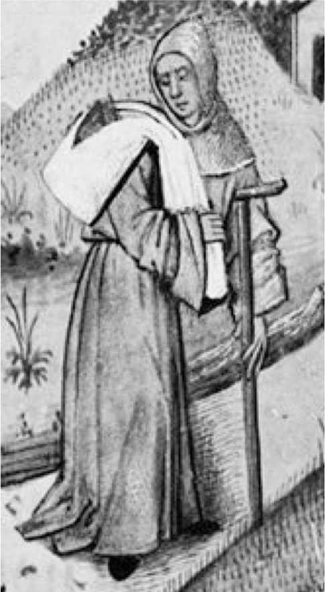

The depictions show the sacks typically carried around the neck and sitting forward over each shoulder, or slung lengthwise over one shoulder, but there are plenty of examples of the sack's transportational versatility with it variously shown tied to a staff, slung across a donkey, carried in one hand, flung over a tree branch. Even humanesque beasties found them handy!

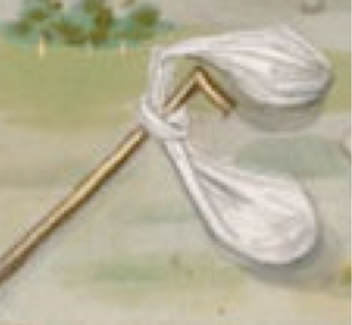

Making a Market Wallet

Looking at the proportions of the market wallets compared to the human carrying them provides an indication of the general size, with them appearing to be around 60-80cm wide by roughly 100-140cm in length. Lady Jeneur had examined a lot of different depictions as well as various patterns, and identified six different versions, all based on simple rectangles of fabric folded at both ends and sewn to have a central slit.

Different illuminations show two main approaches to the central slit, with one version running parallel to the long side (I'd call this horizontal) and the other crossing the fabric vertically from short side to short side. According to Lady Jeneur, based on the evidence currently available, the most common pattern appears to be the horizontal central slit. She also says that it seems to be easier to use, allowing greater access and is more amenable to being twisted to secure the slit's closure when slung or carried.

Ever one to reduce unnecessary workload, I chose to buy calico which had a width such that I could fold the selvedges in to create a no-sew vertical slit. Fabric of 120cm width was suitable for making up 240 of these as giveaway tokens for Canterbury Faire 2017; these market wallets are smaller than the usual, but still large enough to carry a book, your lunch, and a craft project.

For the full-size wallets, calico of 240cm was a goodly size, producing wallets of 120cm in length. Plenty room enough in each pouch for a chicken (cooked or live), a cloak, or a couple of wine sacks.

As for decoration, all the illustrations show them as plain white fabric, most likely linen. No decorations at all. For the Faire ones, we hand-stamped them with a mix of Canterbury Crosses and other stamps in baronial colours, mainly so that people could tell their wallets apart.

The pattern used for the Canterbury Faire market wallet:
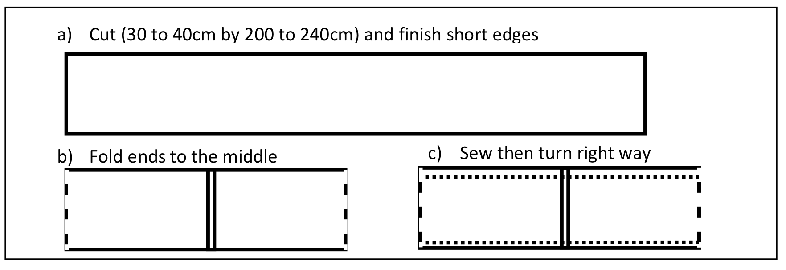

According to Lady Jeneur based on the evidence currently available, a more common pattern appears to be this one with a horizontal central slit:
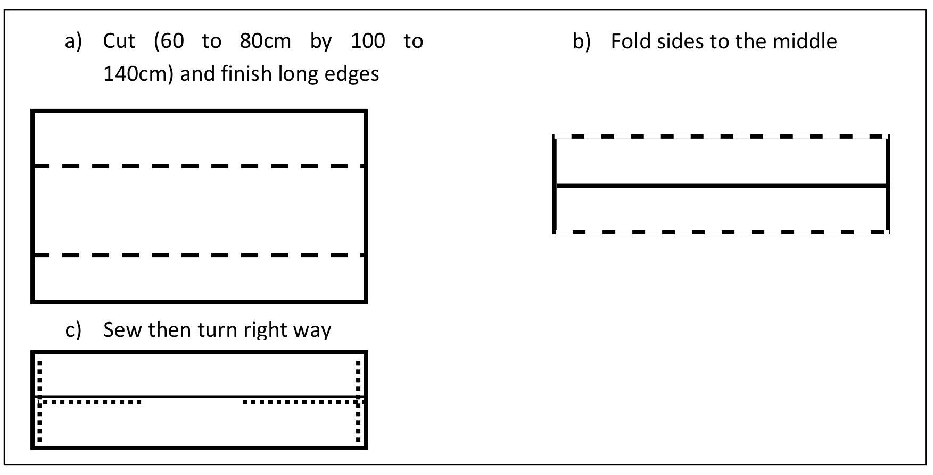

Experimenting with the various patterns and sizes, Lady Jeneur recommends the above pattern as
the best to use, because the slit position makes it easier to access items inside the sack. It also is more amenable to being twisted to secure the slit’s closure.

References:

Out and About with all Your Stuff:
https://themedievalhunt.com/2015/03/03/out-and-about-with-all-your-stuff/

Teffania's page on market wallets:
http://teffania.blogspot.co.nz/2016/04/wallets.html

Whilja's Corner: F ässing – the Shoulder Bag: https://whiljascorner.wordpress.com/2014/02/06/fassing-the-shoulder-bag/

Wallets and Shoulder-Sacks:
http://www.larsdatter.com/wallets.htm

Illustrations:

Martebo Sack: 14th C Sweden: http://albrechts.se/carrysack-from-martebo/

Sack with book: 15th C France, Le Roman de la Rose, Bodleian Library: MS. Douce 195, fol. 086v, roll 175A, frame 64
http://bodley30.bodley.ox.ac.uk:8180/luna/servlet/s/521ezl

Sack onna Stick: 1470-1480 France Fortune and Poverty in De casibus (BNF Fr. 132, fol. 42v):
http://visualiseur.bnf.fr/ConsulterElementNum?O=IFN-08101008&E=JPEG&Deb=4&Fin=4&Param=C

Sack over Shoulder: 16th C France: http://visualiseur.bnf.fr/ConsulterElementNum?O=IFN-8100118&E=JPEG&Deb=5&Fin=5&Param=C

Sack onna Stick: English Psalter 1265-1270: http://www.bl.uk/manuscripts/Viewer.aspx?ref=add_ms_50000_f013r

Sack in hand: Boccacio's Decameron, 1401-1500 France; Bibliothèque nationale de France:
http://gallica.bnf.fr/ark:/12148/btv1b7100018t/f485.item.zoom

Sack inna tree: 1415-1430, France; Hours of Charlotte of Savoy; Pierpont Morgan Library, MS M.1004, fol. 003v: http://corsair.morganlibrary.org/icaimages/1/m1004.003va.jpg

Beastie with Sack: 1415-1430, France, Hours of Charlotte of Savoy; Pierpont Morgan Library, MS M.1004, fol. 39r:
http://corsair.morganlibrary.org/icaimages/1/m1004.039ra.jpg
------
Copyright 2016 by Vicki Hyde. vicki at webcentre.co.nz . Permission is granted for republication in SCA-related publications, provided the author is credited. Addresses change, but a reasonable attempt should be made to ensure that the author is notified of the publication and if possible receives a copy.

If this article is reprinted in a publication, please place a notice in the publication that you found this article in the Florilegium. I would also appreciate an email to myself, so that I can track which articles are being reprinted. Thanks. -Stefan.

<the end>

