Kyvian-Ru-hat-art - 7/16/15

"Kyvian Rus Hat" by Mistress Kataryna Tkach, O.L.

NOTE: See also the files: Kolpac-art, Russian-Tffia-art, Irsh-Onion-Ht-art, E-Period-Hats-art, 13C-W-Headger-art, headgear-msg, Ldys-Headgear-art.

************************************************************************
NOTICE -

This article was submitted to me by the author for inclusion in this set of files, called Stefan's Florilegium.

These files are available on the Internet at: http://www.florilegium.org

Copyright to the contents of this file remains with the author or translator.

While the author will likely give permission for this work to be reprinted in SCA type publications, please check with the author first or check for any permissions granted at the end of this file.

Thank you,
Mark S. Harris...AKA:..Stefan li Rous
stefan at florilegium.org
************************************************************************

Kyvian Rus Hat
by Mistress Kataryna Tkach, O.L.

Silverwolf A&S Competition Borealis (Edmonton) June 2014

Contents

Table of Figures
A Discussion of Ukrainian and Russian Terminology for the Hat
About the Hat
Making the Hat
Bibliography

Table of Figures

Figure 1: 10-13th century Old Ukrainian terms for Kyivian Rus Hats a) Chola/nachil'nyk b) vinets’ c)ubrus d)hat over ubrus, e)povoynyk. (Tkach, 1986) (Ніколаєва, 1996)

Figure 2: 15-17th century Old Ukrainian terms for Kyivian Rus Hats. a) namitka, b-e)types of ochipok f) shapkopobidni. (Tkach, 1986) (Ніколаєва, 1996)

Figure 3: Noble women’s clothing 10-13th century. (Ніколаєва, 1996)

Figure 4: Sofya la Rus' depections of Kolchin kokoshniks. (Колчин (Kolchin), 1997) (la Rus, 2007)

Figure 5: a-b) artists depiction of vinets (васіна (Vasina), 2003),
c) Image of Vladimir-Volyn I Yaropolk and Princess Irene. Fragment of a miniature in the Trier Psalter.
d) Woman xii century frescoes. Demetrius Cathedral Vladimir (васіна (Vasina), 2003).
e) Twelfth century fresco of vobrazhennya at the Holy Church nativity near Novgorod (васіна (Vasina), 2003)
f) The Frescoes of the Church of the Transfiguration of the Savior in Kovalevo (1380) (Waugh, 2000)

Figure 6: a) Amulet symbol reflecting cosmogonical presentation and incantatory magic, pendants with solar symbols 23-Novgorod Settlement, 24-Knyazhaya mountain (Колчин (Kolchin), 1997)-pg338.
b) Bracelet decoration 12 - early 13th century. Imitating the princes and boyars pieces, 20, 25, 26 – Novgorod; 22-Pinsk; 23-Grodno (Колчин (Kolchin), 1997)-pg 306.
c) Formed glass beads (1-69) (Колчин (Kolchin), 1997)-pg 308

Figure 7: Silk Basted onto the canvas, trying to decide on beading pattern of final hat

Figure 8: Setting up the Leather and back to stitch everything together

Figure 9: Finished Hat

Figure 10: Hat worn with simple ubrus

A Discussion of Ukrainian and Russian Terminology for the Hat

There is a variety of hats and caps in Kyvian Rus thought to be worn between the 10th and the 13th centuries. During that time the people spoke Old East Slavic, a dialect that is considered by three different cultural groups as the predecessor of each of their languages Old Russian, Old Ukrainian, and Old Belarussian languages. This leads to some naming difficulties for this hat.

The Russian term коко ник (kokoshnik) is probably the one most people who study Slavic culture are familiar with, but it refers to a head piece from the Northern area of Russia that was used between the 16th and 19th centuries. The word stems from Kokosh, which means hen or cockerell. (Wikipedia).

The Ukrainian term апкоподібні (shapkopodibni) translates from old Ukrainian into Hard hat (Ніколаєва, 1996). In some texts this is also called a vinets’ or garland (Tkach, 1986). This is different from the scarf (Ubrus 10-13th century term, or Namitka – 15-17th century term),or the soft cap (povoynyk - 10-13th century term, Ochipok – 15-17th century term). (Ніколаєва, 1996), (Tkach, 1986). (Figure 1) (Figure 2)

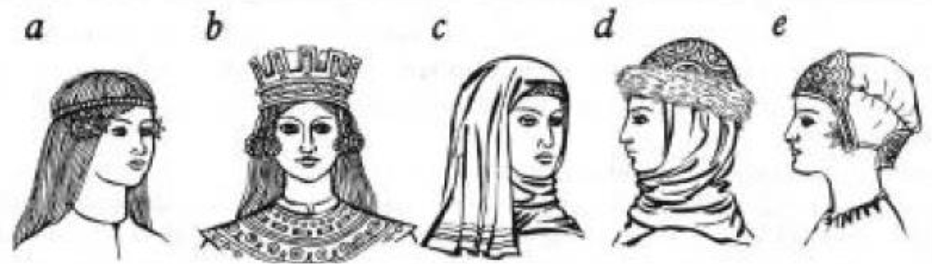
Figure 1: 10-13th century Old Ukrainian terms for Kyivian Rus Hats a) Chola/nachil'nyk b) vinets’ c)ubrus d)hat over ubrus, e)povoynyk. (Tkach, 1986) (Ніколаєва, 1996)

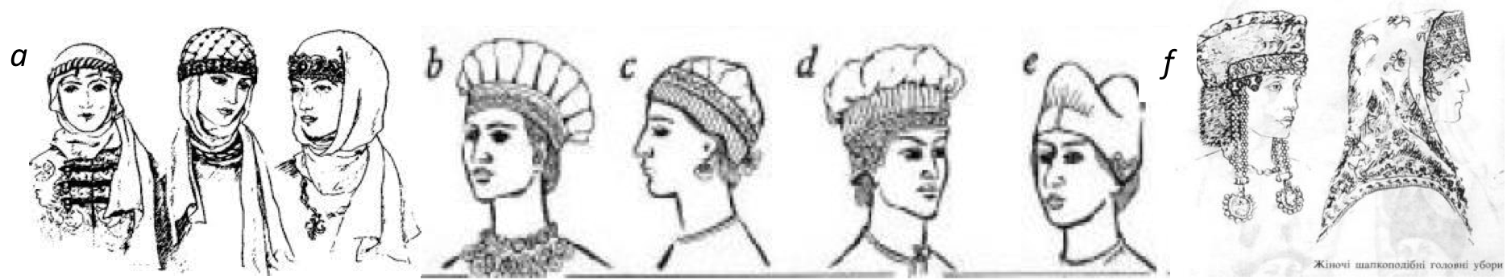
Figure 2: 15-17th century Old Ukrainian terms for Kyivian Rus Hats. a) namitka, b-e)types of ochipok f) shapkopobidni. (Tkach, 1986) (Ніколаєва, 1996)

About the Hat

The vinets or shapkopodibni started as a Chola/nachil’nyk, which was an embroidered headband worn under the head scarf (Ubrus). It was slowly made larger over time, and became more decorated, especially among the wealthy. The front also became taller and more decorated as did the top edges and became more crown like as time progressed.

Kolty were hung over the ears, and small bells, beads, and metal pendants were hung from the bottom edge. (Tkach, 1986) The fabric used to make them was diverse with silk or gold fabric being used by the wealthy, often stretched over leather, bast, birch, or metal to make them stiff. (Tkach, 1986)(Figure 3).

It was common for women to plait their hair under the Shapkopodibni in a single braid and later in the 15th – 17th centuries multiple complex braids were developed (Tkach, 1986). These hats become traditional wedding head-dresses in 15th – 17th century Ukraine (Tkach, 1986).

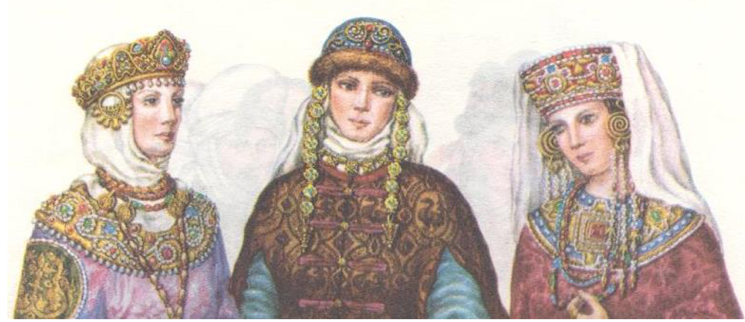
Figure 3: Noble women’s clothing 10-13th century. (Ніколаєва, 1996)

There are depictions of these head dresses in Kolchin, which are identified as kokoshniks (Колчин (Kolchin), 1997), Sofya la Rus has produced and digitized drawings of these on her website. (la Rus, 2007).

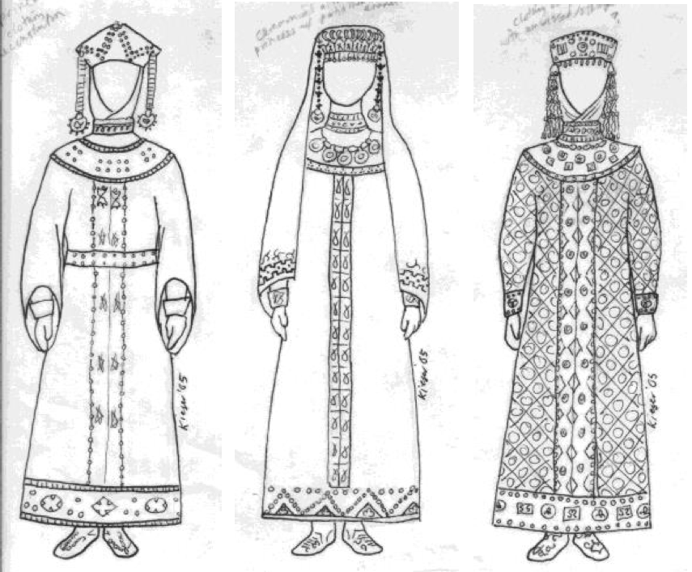
Figure 4: Sofya la Rus' depections of Kolchin kokoshniks. (Колчин (Kolchin), 1997) (la Rus, 2007)

Depictions of similar hats are also found in Ukrainian chronicle of clothing, along with extant depictions from frescoes. (васіна (Vasina), 2003) (Figure 5).

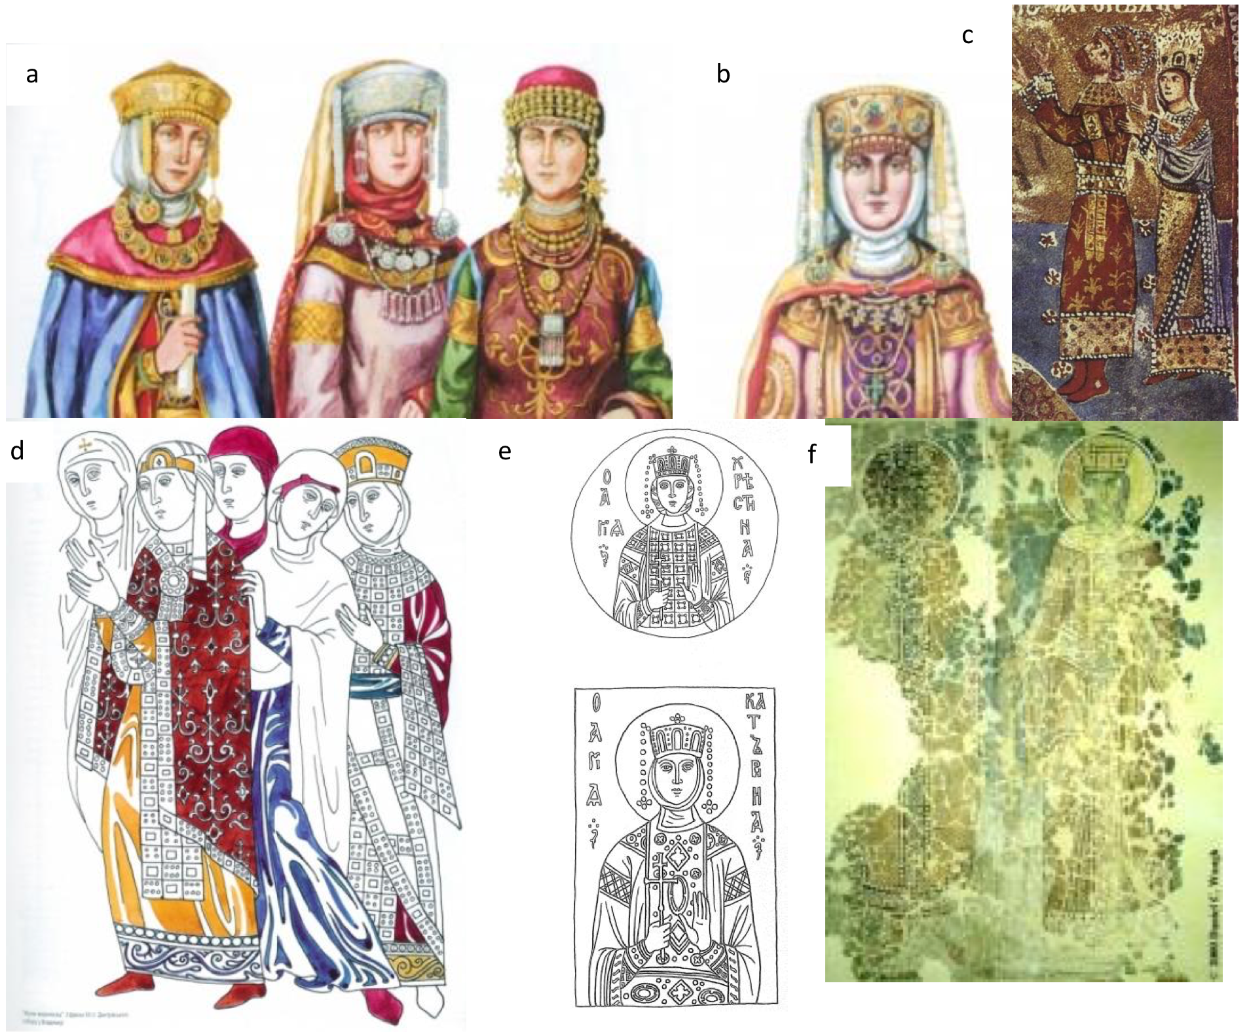
Figure 5: a-b) artists depiction of vinets (васіна (Vasina), 2003), , c) Image of Vladimir-Volyn I Yaropolk and Princess Irene. Fragment of a miniature in the Trier Psalter. d) Woman xii century frescoes. Demetrius Cathedral Vladimir (васіна (Vasina), 2003). e) Twelfth century fresco of vobrazhennya at the Holy Church nativity near Novgorod (васіна (Vasina), 2003) f) The Frescoes of the Church of the Transfiguration of the Savior in Kovalevo (1380) (Waugh, 2000).

Kolchin’s pages of decorative metal elements and beads and the luck of finding the circular metallic pendants inspired the choice of decoration used for the hat, (Figure 6).

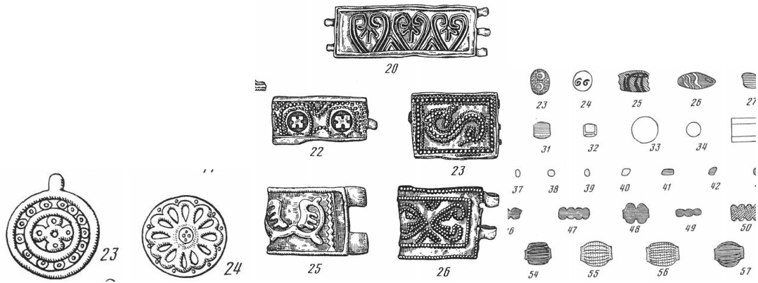
Figure 6: a) Amulet symbol reflecting cosmogonical presentation and incantatory magic, pendants with solar symbols 23-Novgorod Settlement, 24-Knyazhaya mountain (Колчин (Kolchin), 1997)-pg338. b) Bracelet decoration 12 - early 13th century. Imitating the princes and boyars pieces, 20, 25, 26 – Novgorod; 22-Pinsk; 23-Grodno (Колчин (Kolchin), 1997)-pg 306. c) Formed glass beads (1-69) (Колчин (Kolchin), 1997)-pg 308

Making the Hat

I determined a pattern, with help from Slava, and cut out the shape on parchment paper. Using the pattern I cut out the pattern from 2 pieces of silk, a piece of heavy canvas, and one piece of leather. I looked at motifs from early Kyvian Rus, (Колчин (Kolchin), 1997), and worked out a pleasing geometric pattern with the glass pearls, beads and enameled metal pieces I had.

I basted the canvas and one piece of silk together to form the exterior of the hat and sewed on each bead, pearl and enameled metal piece. I then ran a thread through all the pearls to stabilize the lines of beads. Experience has taught me to sew on each bead individually.

I have had rows on non-independently stitched beads break and lost a whole row rather than one bead (Figure 7). The metal discs were stabilized in two spots, one on the outer edge of the disk and the other in the center with a small bead. To provide a little bit more stability a little dab of white glue was placed on the top edge of the disk, simply to hold it in place.

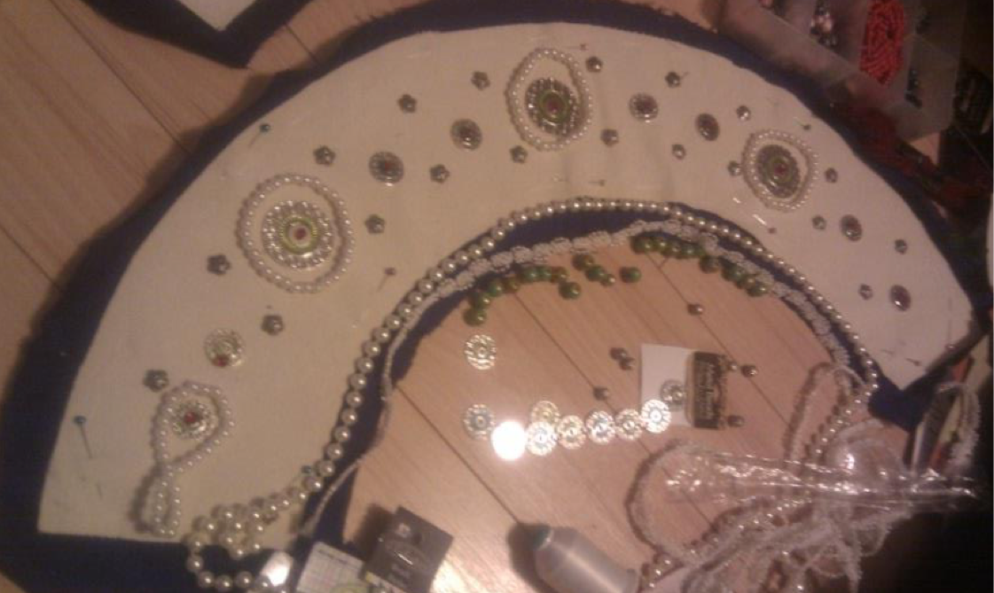
Figure 7: Silk Basted onto the canvas, trying to decide on beading pattern of final hat.

After the beads were sewn on, I pinned it to the heavy leather, placed the second silk piece on to the back, and sewed the silk pieces to each other, sandwiching the leather between them together. That way the cloth fit as tightly as possible over the leather without skewing the line of the beads at the top. The two ends ere sewn together at the same time the cloth and its back were sewn onto the leather.

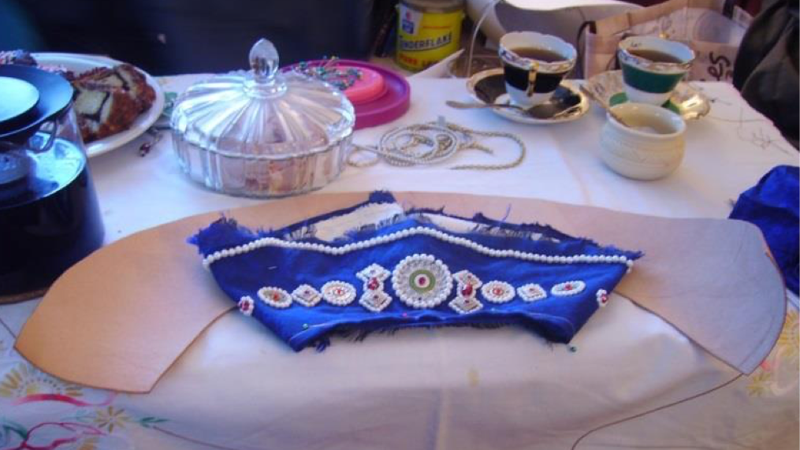
Figure 8: Setting up the Leather and back to stitch everything together.

The beads at the bottom edge were sewn on after the fabric layers were joined, because of their dangling nature.

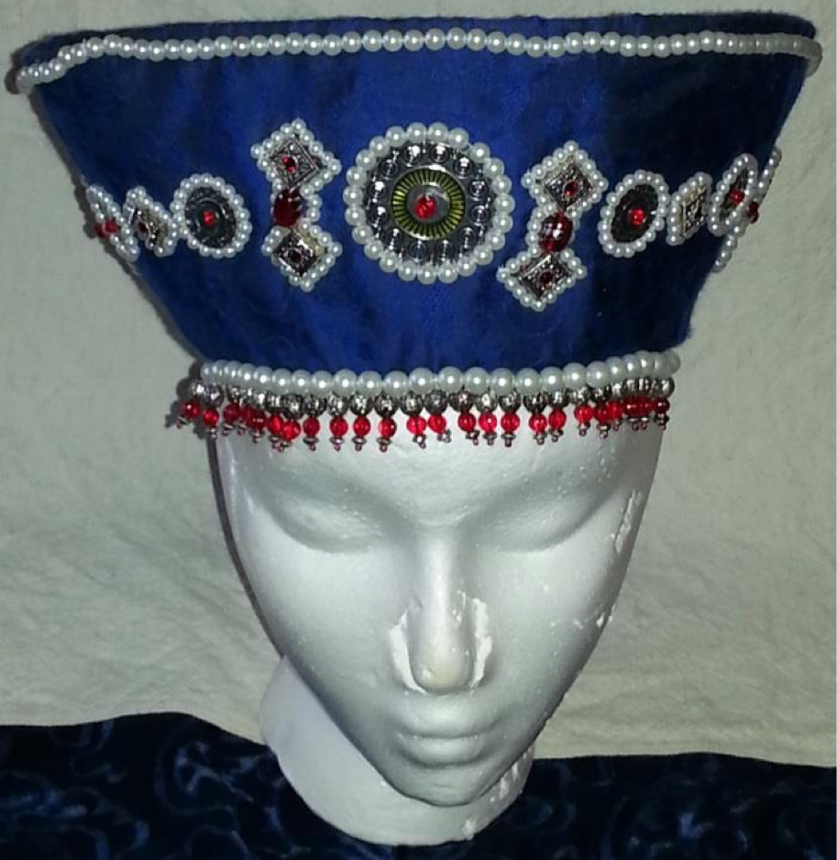
Figure 9: Finished Hat

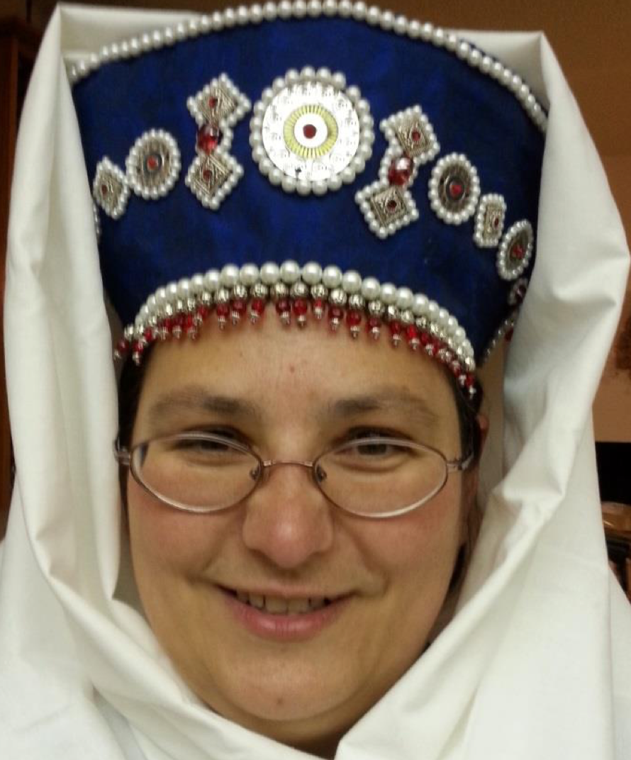
Figure 10: Hat worn with simple ubrus.

Bibliography

la Rus, S. (2007, April 7). Examples of Women's Clothing in Kievan Rus based on Kolchin. Retrieved from Sofya la Rus 13th-14th Century Medieval Russian Life: http://www.strangelove.net/~kieser/Russia/examples2.html

Tkach, Y. (1986). History of Ukrainian Costume from the Scythian Period to the Late 17th Century. Melbourne: Bayda Books.

Waugh, D. C. (2000, October 29). Novgorod Churches and Their Frescoes. Retrieved from Novgorod Resources: http://faculty.washington.edu/dwaugh/rus/novgorod/novgch.html

Wikipedia. (n.d.). Kokoshnik. Retrieved June 15, 2014, from Wikipedia: http://en.wikipedia.org/wiki/Kokoshnik

васіна (Vasina), з. (2003). український літопис вбрання (Ukrainian chronicle of clothing) (Vol. 1). Kiev: Mystectvo.

Колчин (Kolchin), Б. (1997). Археология Древняя Русь Быт и культура (Archaeology of Ancient Rus life and culture). Moscow: Наука.

Ніколаєва, Т. (1996). Історія українського костюма. Ky v: ybid.

------
Copyright 2014 by Susan Koziel. <kataryna_dragonweaver at yahoo.com>. Permission is granted for republication in SCA-related publications, provided the author is credited. Addresses change, but a reasonable attempt should be made to ensure that the author is notified of the publication and if possible receives a copy.

If this article is reprinted in a publication, please place a notice in the publication that you found this article in the Florilegium. I would also appreciate an email to myself, so that I can track which articles are being reprinted. Thanks. -Stefan.

<the end>

