Irsh-Onion-Ht-art - 6/4/15

"16th c Irish 'Onion Hat'" by The Honorable Lady Ceara Shionnach.

NOTE: See also the files: E-Period-Hats-art, headgear-msg, Kolpac-art, Ldys-Headgear-art, Russian-Tffia-art, hds-liripipes-msg, Cloth-Circlet-art.

************************************************************************
NOTICE -

This article was submitted to me by the author for inclusion in this set of files, called Stefan's Florilegium.

These files are available on the Internet at: http://www.florilegium.org

Copyright to the contents of this file remains with the author or translator.

While the author will likely give permission for this work to be reprinted in SCA type publications, please check with the author first or check for any permissions granted at the end of this file.

Thank you,
Mark S. Harris...AKA:..Stefan li Rous
stefan at florilegium.org
************************************************************************

More articles by this author can be found on her blog at: https://cearashionnach.wordpress.com

16th c Irish 'Onion Hat'
by The Honorable Lady Ceara Shionnach

Introduction

I wanted to make a hat that I could wear with my Irish-style fencing jacket (https://cearashionnach.wordpress.com/2014-2/fencing-jacket-16th-century-irish-style/).

One of my favourite things about researching into 16th century Irish attire has been looking through images, and reading descriptions, of unique, odd, brightly coloured pieces of clothing and accessories.

The hat I dub 'the Onion Hat' is one of these colourful, unique and odd things that I observed in my research.

Over the years, I have come across three images containing four individuals sporting an Onion Hat; two females wearing versions made out of textiles (see Figures 1 and 2), and two males wearing a helmet in a similar hat to these women (see Figures 1 and 3).

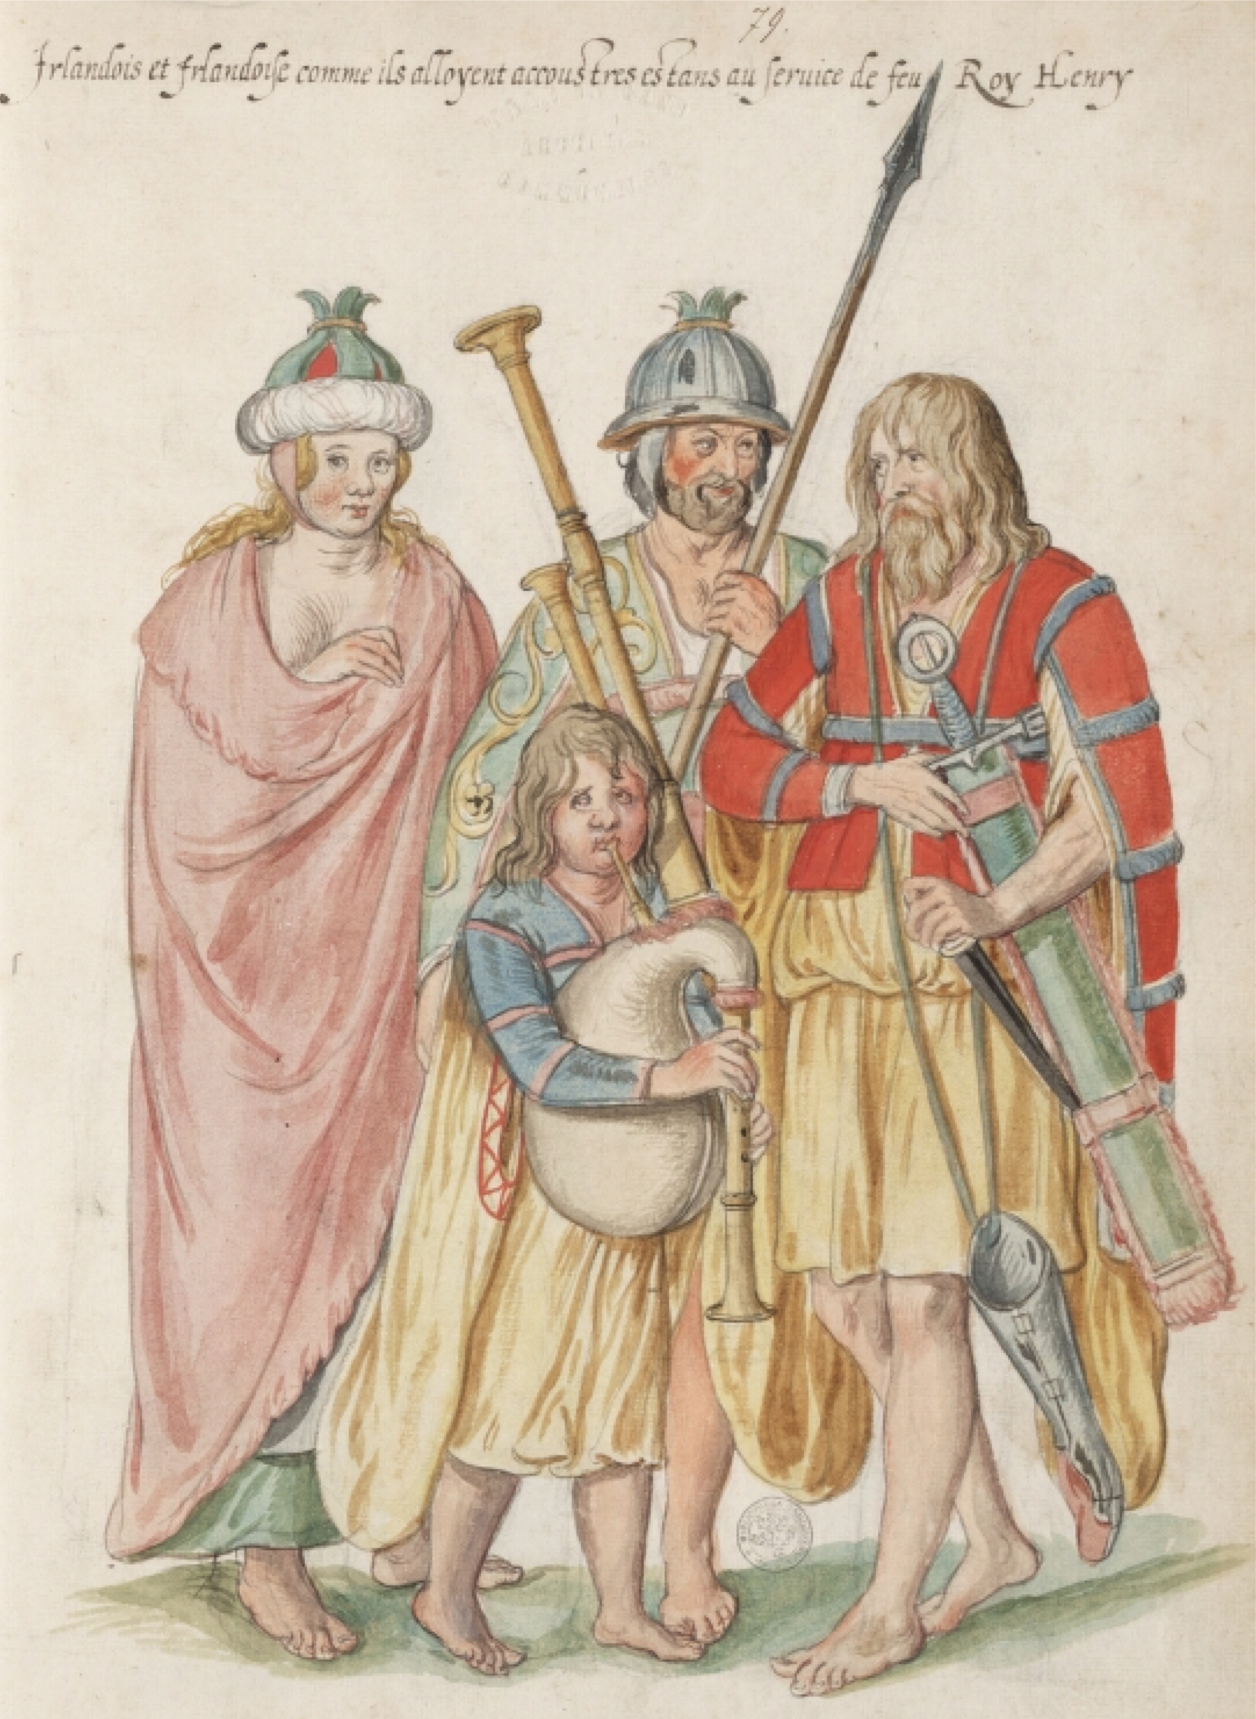

Figure 1: Irish people depicted in watercolours by Lucas de Heere (ca 1575).

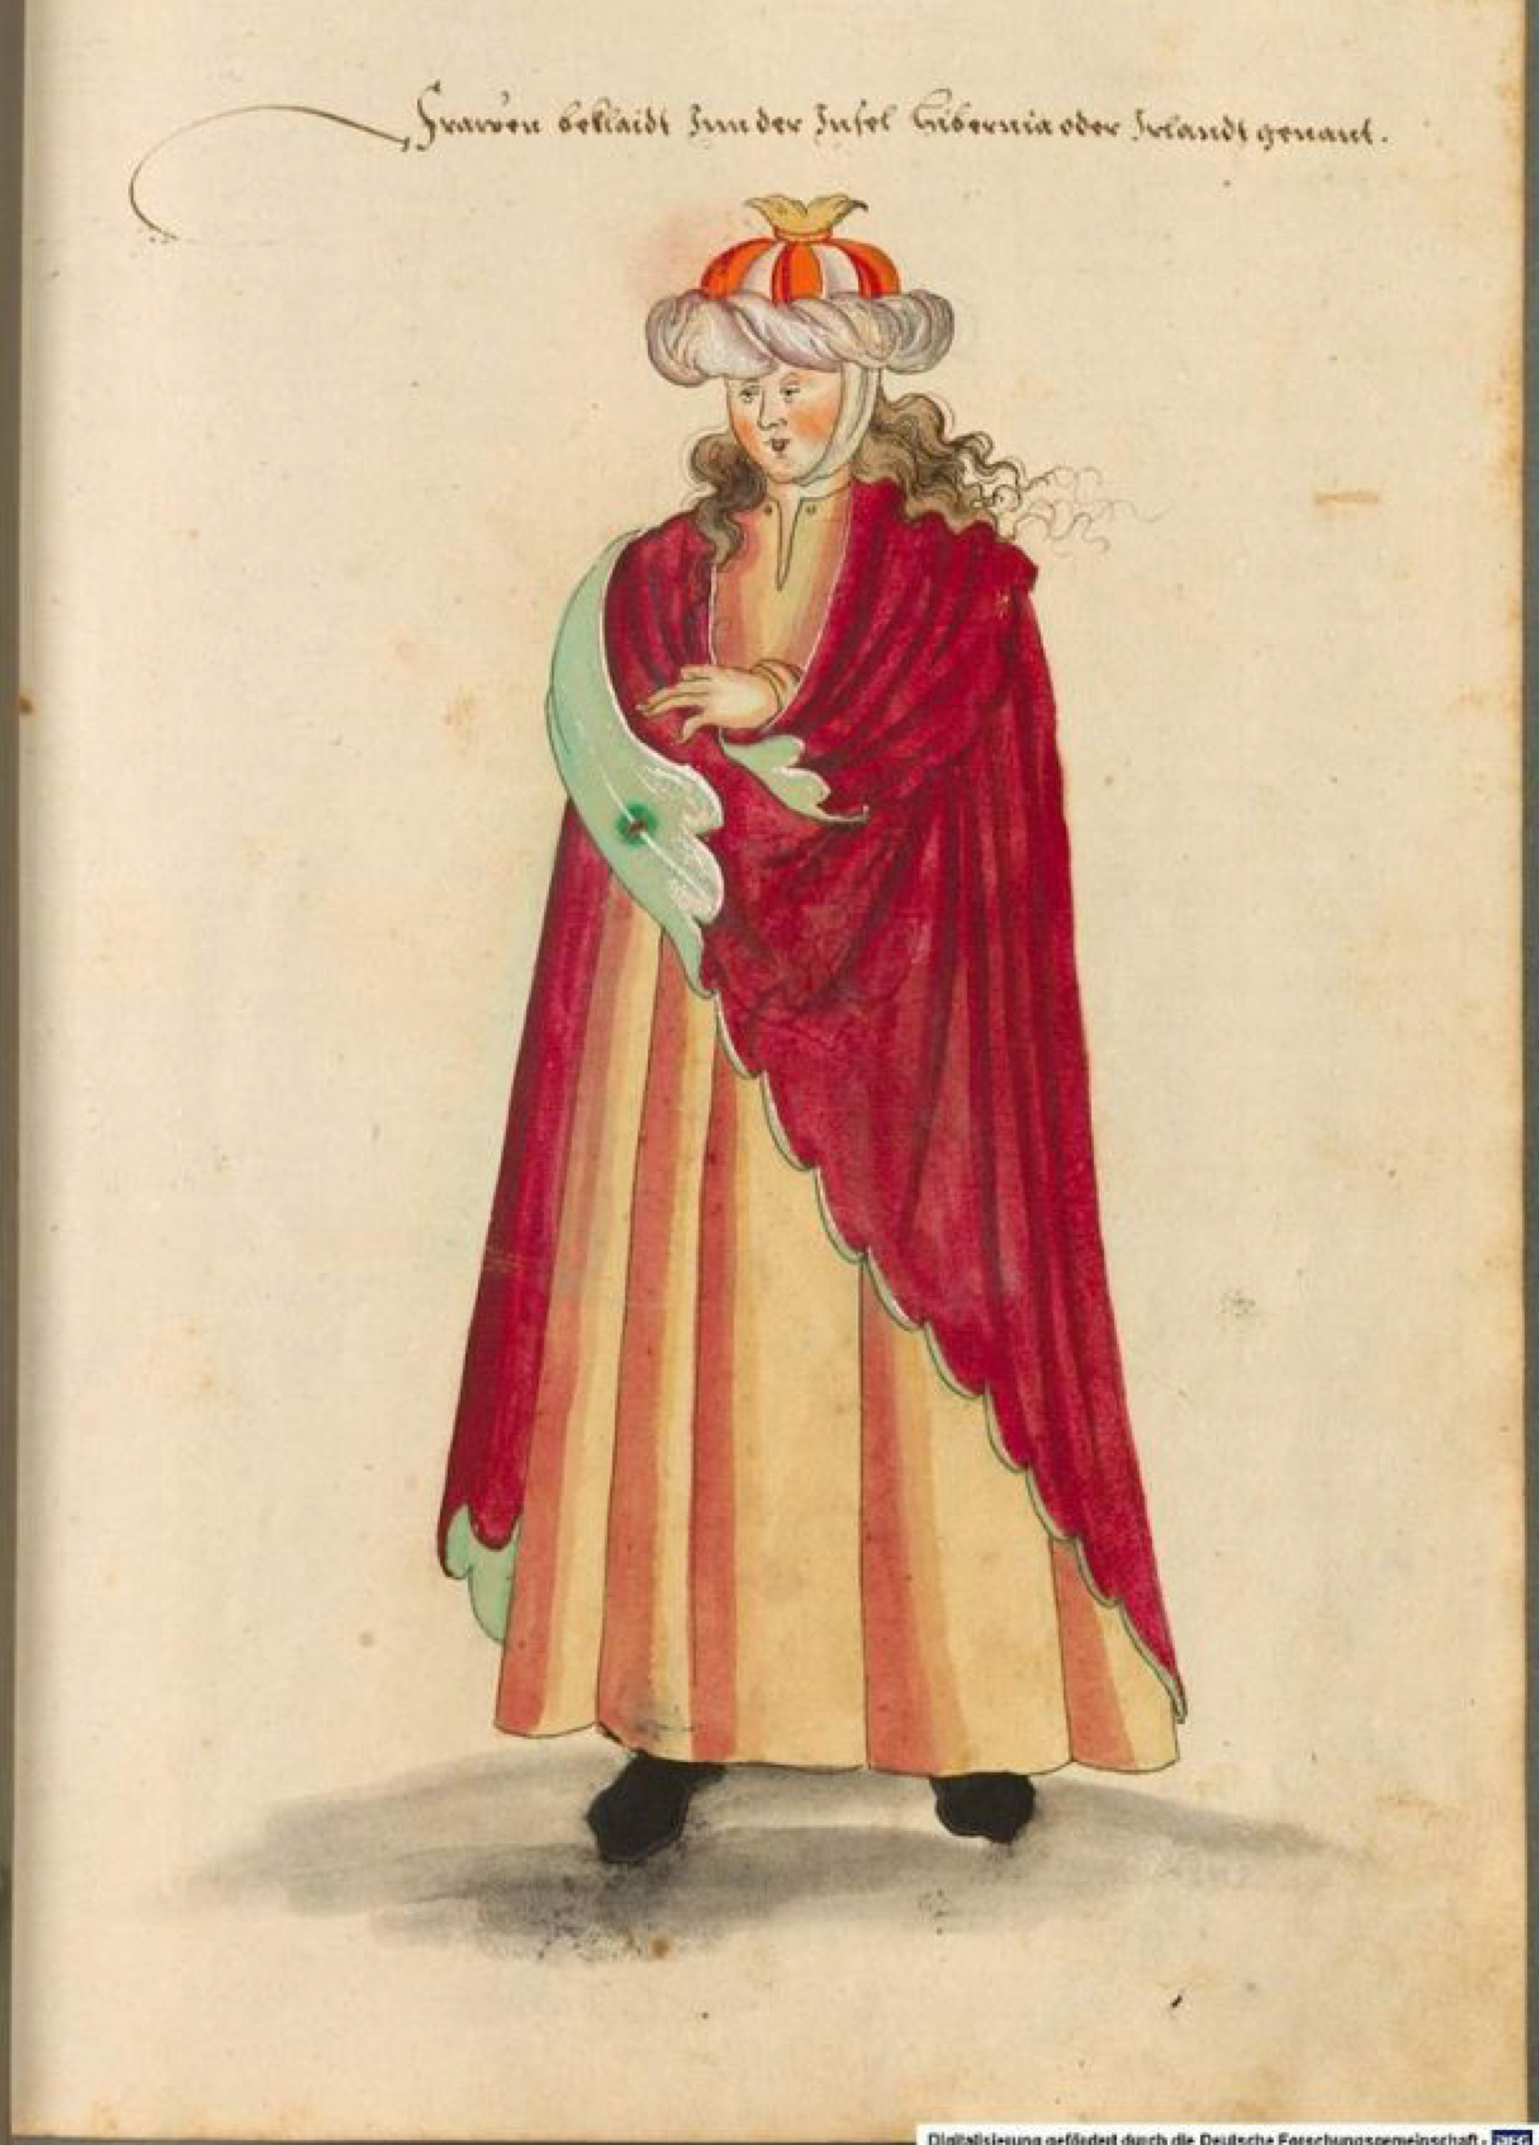

Figure 2: Watercolour of an Irish woman by an anonymous author (Bavarian State Library, originally published ca1500)

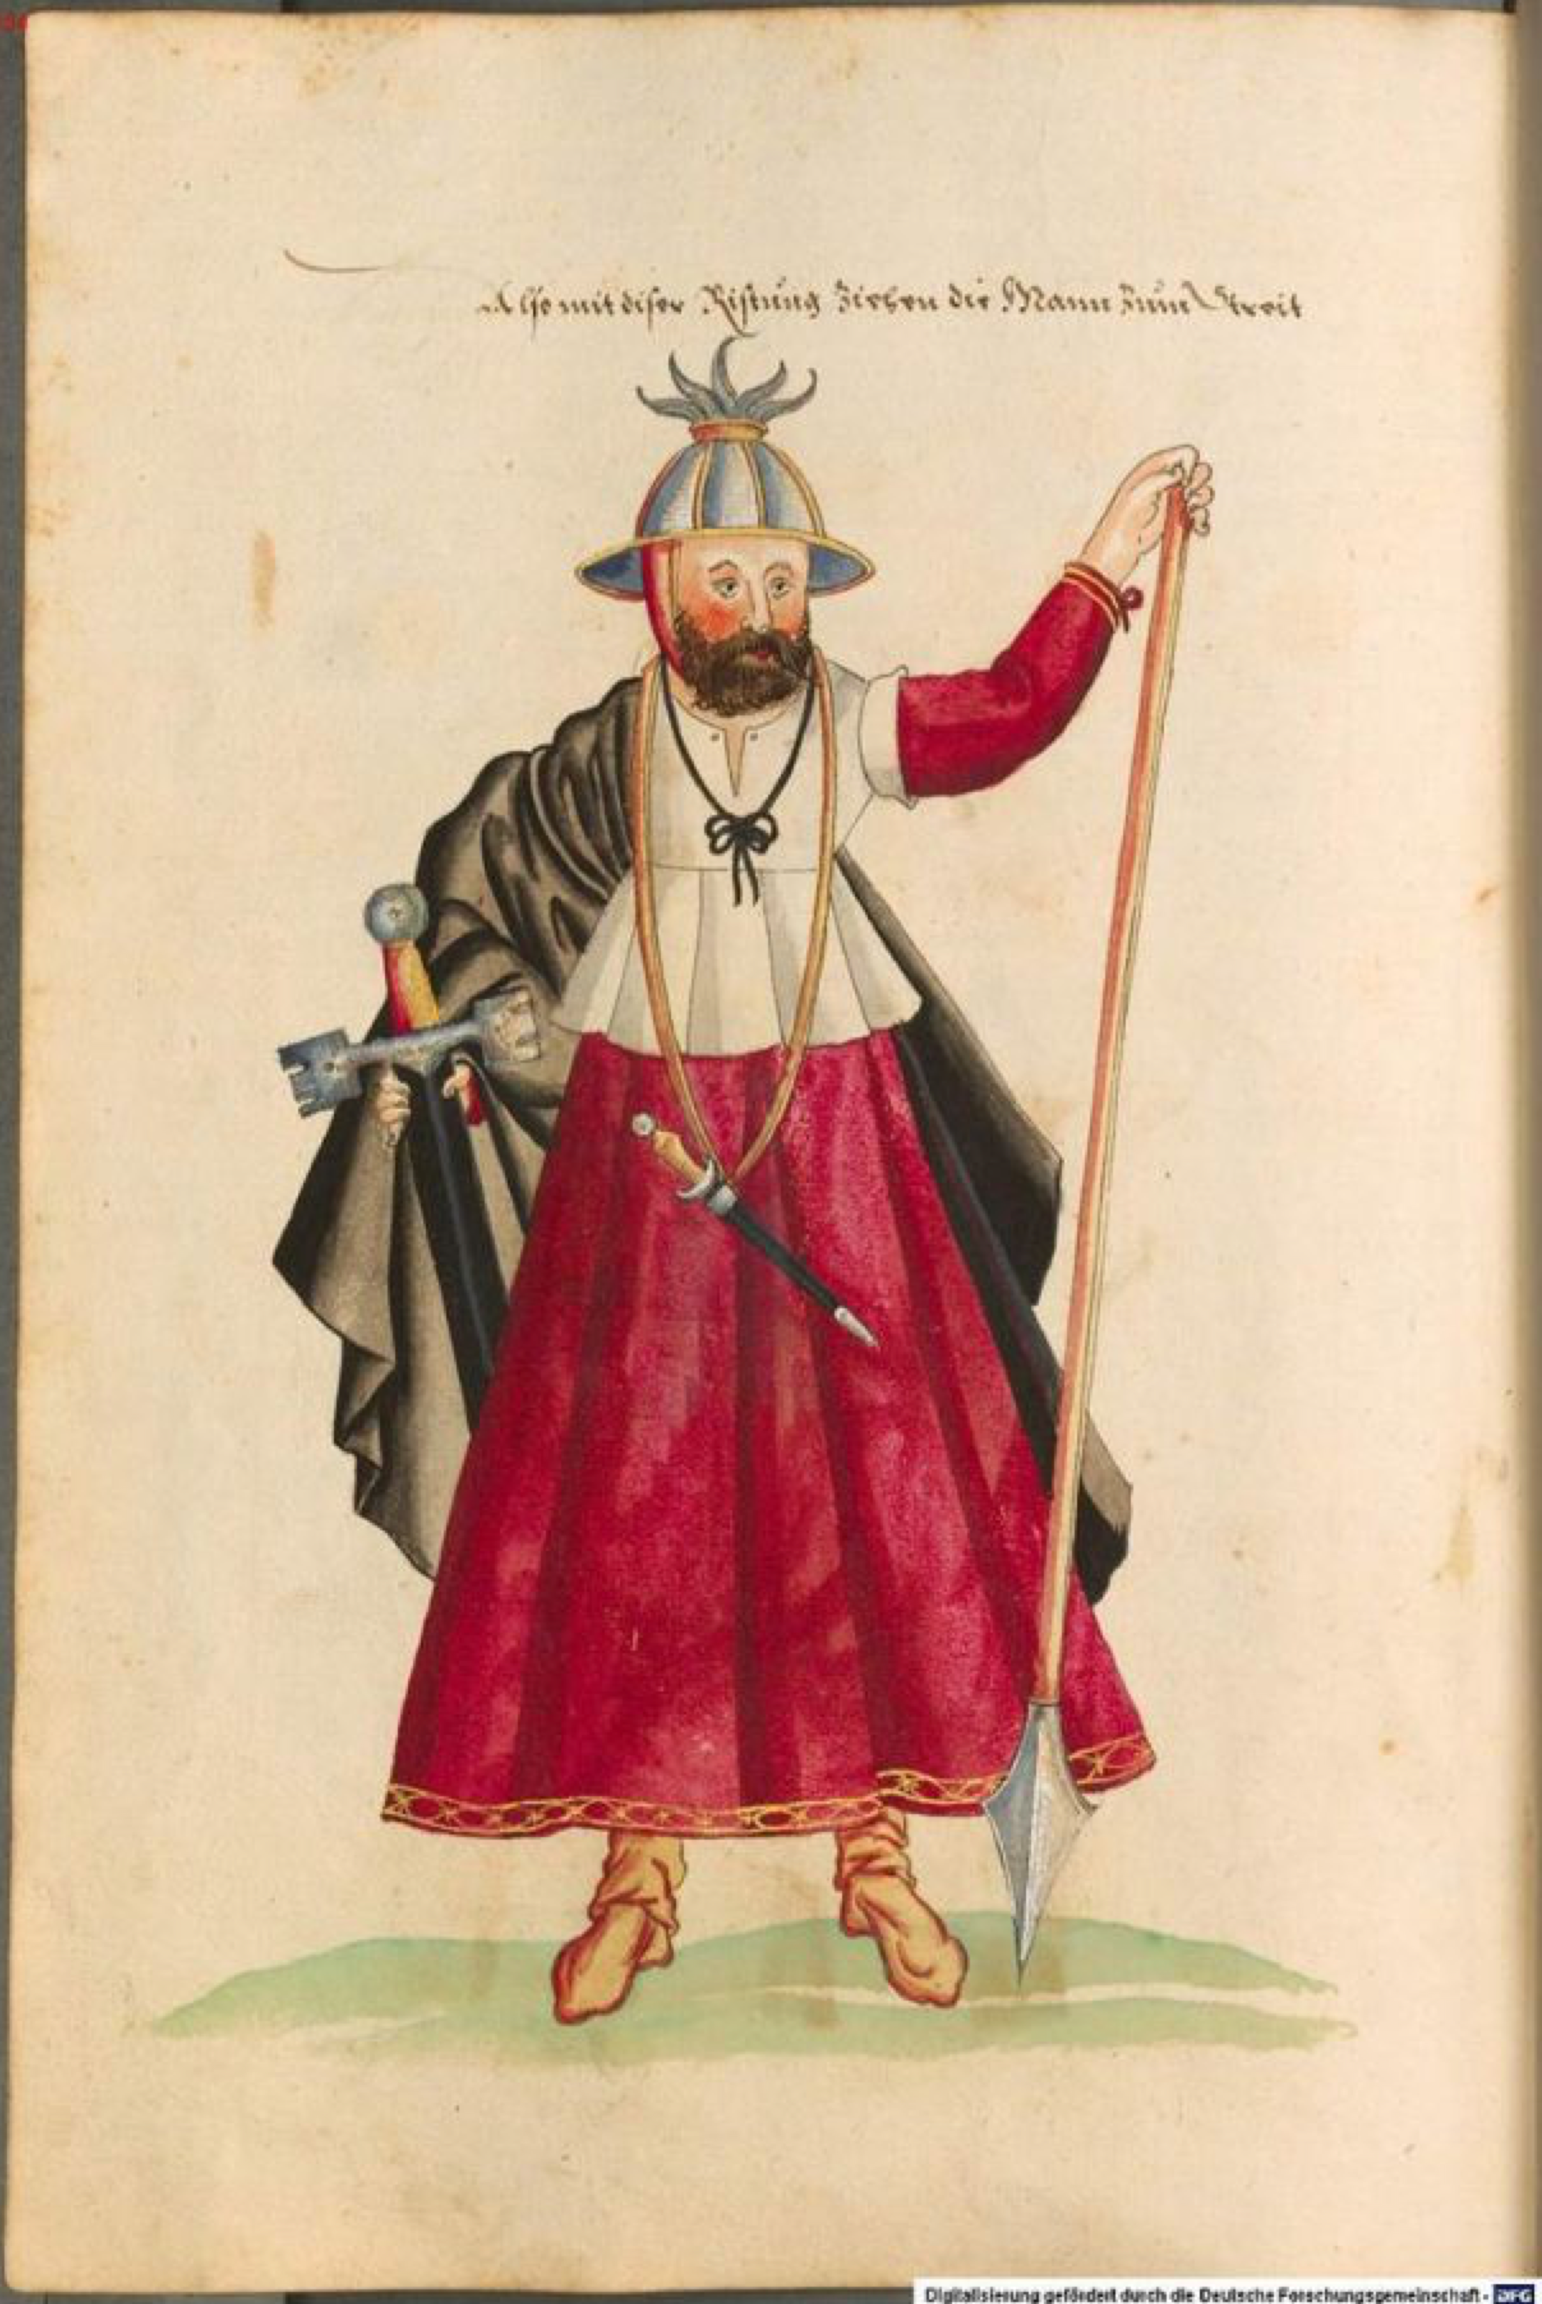

Figure 3: Watercolour of an Irish man by an anonymous author (Bavarian State Library, originally published ca1500)

Each of these four examples of this shape of hat appear to be slightly different in materials and construction, but the overall styles are strikingly similar.

I have not come across any other resources for this particular style of hat, nor have I seen any reproductions around the place. As such, I had to make up a pattern myself using skills I have, and use my knowledge of 16th century Ireland to infer what materials these hats might have been made from.

I also felt that, as the general shape of this hat was observed on both men and women in this period, it would be a nice cross-over between the facts that I am a female wearing male fencing garb.

On Class

Much of what is known about 16th century Ireland is through written accounts by the English. They all seem to refer to three different classes of Irish society: the poor where known as the 'Wilde Irish', the middle-class were known as the 'Townspeople' and the rich nobles were referred to as the 'Civil Irish'. These different classes seem to be distinguished by their relative wealth, residence and by their dress.

Of these three classes, it is evident from looking through various images and descriptions of Irish dress that the women in Figures 1 and 2 would be considered to belong to the 'Wilde Irish' class, according to the English. It would therefore be unlikely that these women would be particularly wealthy or noble.

On Textiles

The wealthy in Ireland tended to adopt English fashions, including the fabrics that the English were wearing in his period. Silk, satin, velvet and damask were imported and used by those who could afford it. Linen and wool was also used and many also trimmed or lined their luxurious clothing with a variety of furs, including lambskin, wolf, fox, squirrel, marten, otter and rabbit. (Dunlevy, Pp 43-64, 1989; McClintock, Pp 30-118, 1950).

Flax and sheep were plentiful in Ireland during this time and with this in mind it is no surprise to find that the townspeople and the poor tended to wear a lot of linen and wool (Morrison, c1600 from McClintock, 1950). Both black and white breeds of sheep were available, however, from the twelfth century onwards a higher value was attached to the white-wool sheep thanks to English influences (Duffy, Pp 8, 2005).

Therefore, given that the two textile versions of these hats are depicted on 'Wilde Irish' women, I extrapolated that the hats were likely constructed using wool and/or linen.

Construction of my Onion Hat

I decided to make a hat as similar in appearance to that on the woman in Figure 1 as was possible, because the colours and shape appealed to me most. A close-up of the detail on her Onion Hat is visible in Figure 4.

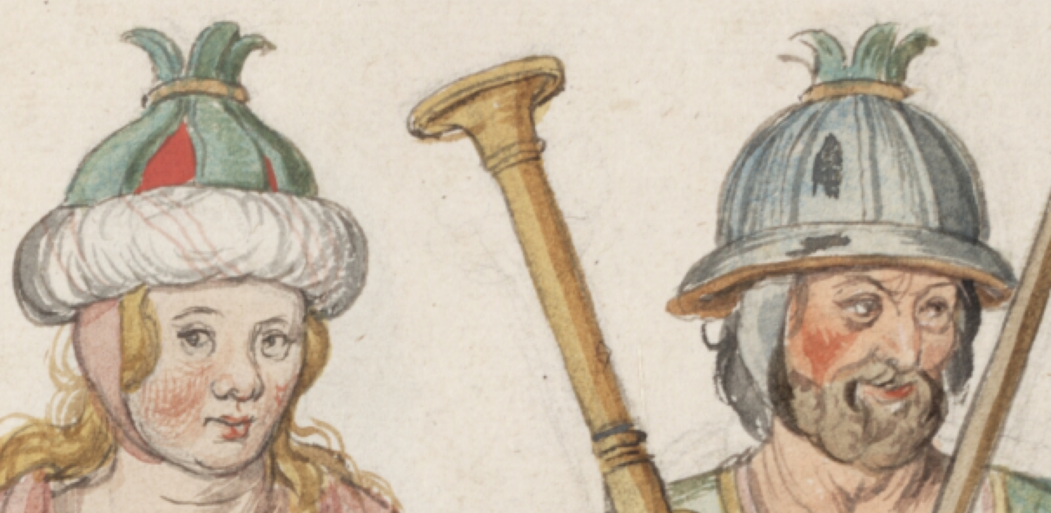

Figure 4: Detail of the hats on Irish people depicted in watercolours by Lucas de Heere (ca 1575).

I started by making a skullcap of four triangular pieces of linen sewn together to make the base of the hat (Figure 5). As a quick aside, more information about the history of skullcaps (http://www.dieter- philippi.de/files/literatur/1968_antonio_hernandez_-_history_of_the_skullcap.pdf) can be found online, as can images of 16th century skullcaps on Pinterest (https://www.pinterest.com/search/pins/?q=skullcap%2016th%20century). The red linen was kindly donated by my friend, Baroness Ginevra Lucia di Namoraza (thank you!).

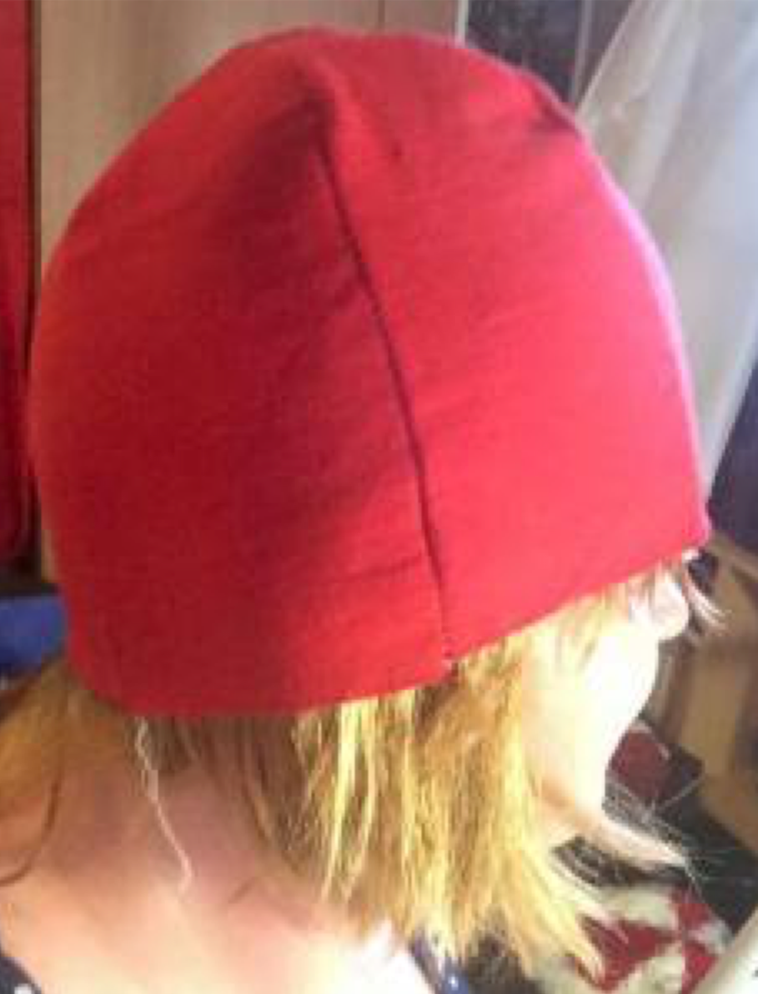

Figure 5: Four-panel skullcap in red linen by THL Ceara Shionnach, Jan-Feb 2015.

Given that three panels are clearly evident in Figure 4, and that this likely represented about half of the hat, I decided to go with six green panels to make the 'leafy' bits on top of the skullcap. I chose wool for this because I figured it would be stiff enough for the ends to stand up on the top of the crown. The vibrant green wool I used was a kind gift from Mistress Heilwich Gheerts (thank you, too!).

After cutting six panels out of wool, I whip-stitched the bases of the triangles to the base of the skullcap (Figure 6), and then used buttonhole stitch around the edges of the panels to keep them from fraying into the future.

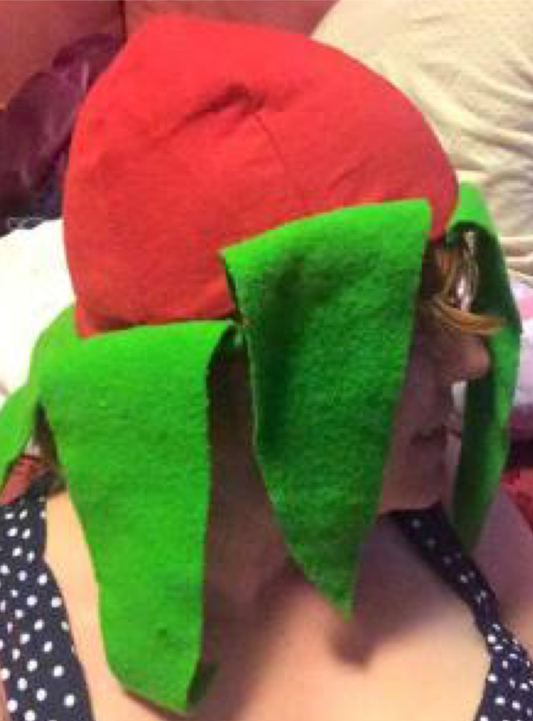

Figure 6: Six, green, triangular panels were cut out of wool and attached to the skullcap

The doughnut-shaped part of the hat in Figure 4 reminded me of the padded rolls used in Italian balzos. As such, I asked Mistress Francesca Cellini (thank you for the help!) about how she makes her balzo rolls and replicated that technique myself. Following these instructions, I made a ring out of wire that was a few centimetres bigger in diameter than that of the skullcap base. Then, I cut 5cm strips of padding and spiral-wrapped it around the wire ring. For the padding, I chose cotton batting from the local quilting supplies store, though it would have been more likely in period to have been stuffed with wool.

Next, I cut a strip of white linen on the bias that was slightly wider than the diameter of the thickness of the padded roll I had made around the wire, and slightly longer than the furthest distance around the entire doughnut shape. I pinned this bias-cut linen onto the padded roll, adjusting the tension as I went to get it as smooth as possible, and used it to entirely cover the doughnut. Finally, using stem stitch, I embroidered three parallel red spirals around the padded roll (Figure 7).

I have not found any references to Irish embroidery in the 16th century, however, stem stitch is common throughout period and definitely in nearby English society in this time. I chose it for this reason, and because of the speed and ease in which I could apply it to the padded roll.

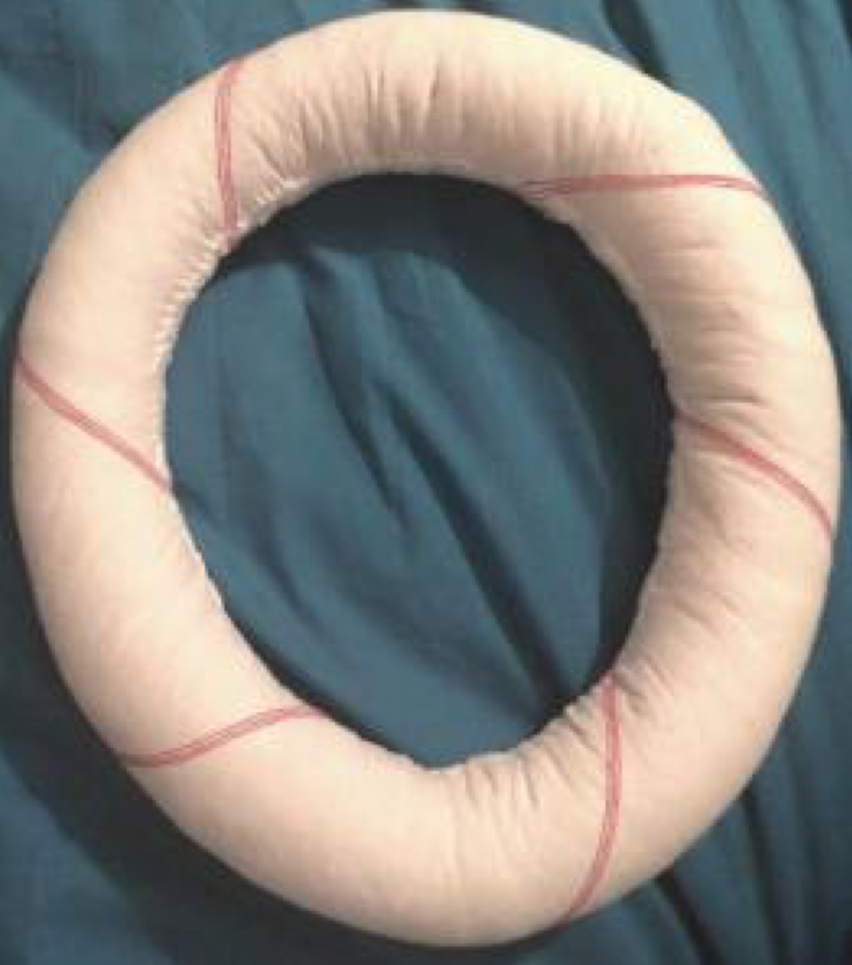

Figure 7: The finished padded roll by THL Ceara Shionnach, Jan-Feb 2015.

Next, I whip-stitched the padded roll to the base of the skullcap. Then, I needed a way to attach the six green panels at the top of the crown. Figure 4 depicts some kind of gold-coloured ring, seemingly used for this purpose. So, I found some gold hoop earrings and pulled them apart, stitching the top sixth of the green panels to the ring in order to hold them up. I finished the hat off by using my hair straightener to curl the ends of the green wool panels.

The final result (Figures 8 and 9) is a relatively similar shape/colour to the hat observed in Figure 4.

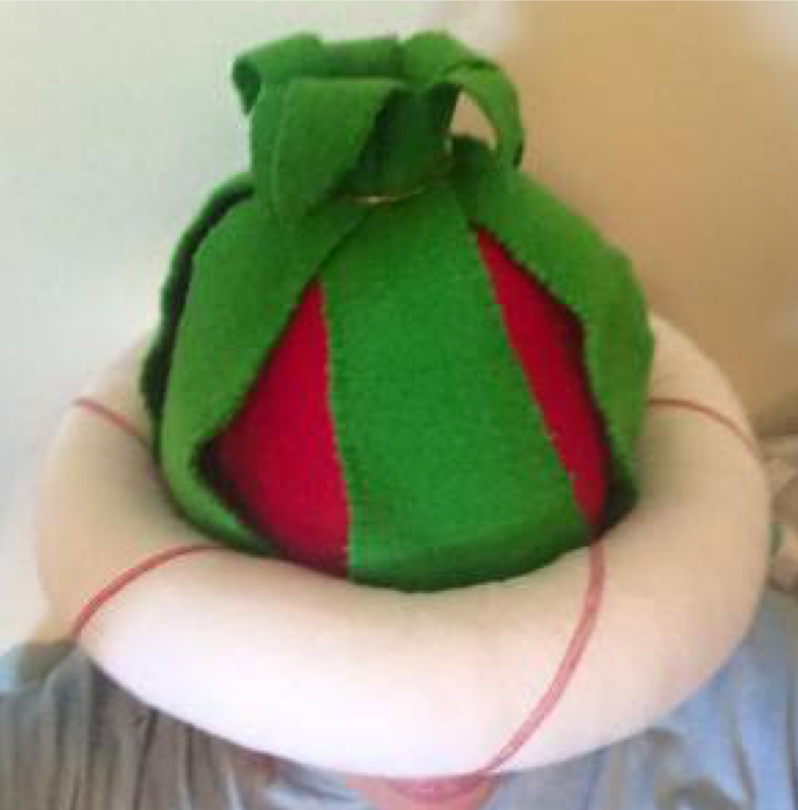

Figure 8: Side view of the completed Onion Hat

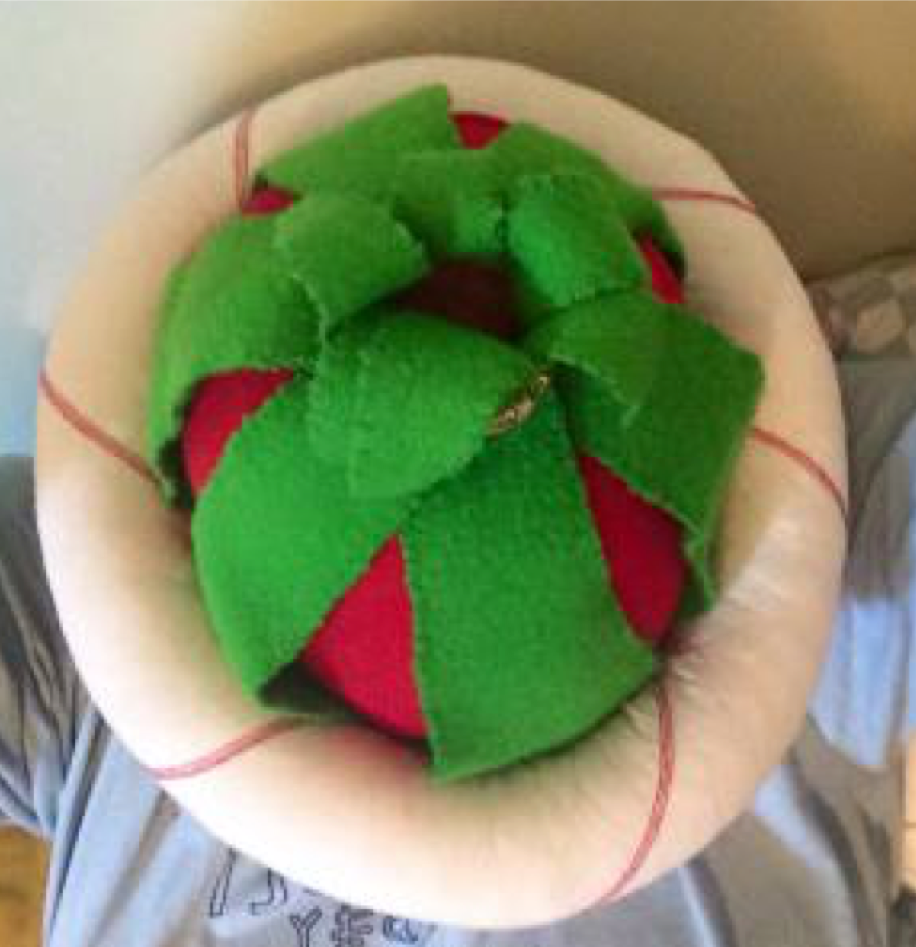

Figure 9: Top view of the completed Onion Hat

References

Duffy, Sean (editor, 2005). Medieval Ireland, An Encyclopedia. Routledge, New York and London. Pp8, 114, 251-254.

Dunlevy, Mairead (1989). Dress in Ireland: A History. The Collins Press. Pp 27-90. (Dunlevy, Pp 43-64, 1989; McClintock, Pp 30-118, 1950).

McClintock, H.F. (1950). Old Irish and Highland Dress. Dundalgan Press. Pp 30-118.

Figure 1: Plate 81 – 'Irish as they stand accoutered being at the service of the late King Henry', by Lucas d'Heere, ca. 1575, as published in "Theater of all peoples and nations of the earth with their clothes and various ornaments, both ancient and modern" (http://adore.ugent.be/OpenURL/app? id=archive.ugent.be:1EEACAD8-B1E8-11DF-966C-0D0679F64438&type=carousel&scrollto=80), as published online by the Ghent University, Belgium.

Figure 2: Irish woman illustration, from "Kostüme der Männer und Frauen in Augsburg und Nürnberg, Deutschland, Europa, Orient und Afrika" (http://bildsuche.digitale- sammlungen.de/index.html?c=band_segmente&bandnummer=bsb00011752&pimage=00092&l=en), pg 43o, as published online by the Bavarian State Library, Germany.

Figure 3: Irish man illustration, from "Kostüme der Männer und Frauen in Augsburg und Nürnberg, Deutschland, Europa, Orient und Afrika" (http://bildsuche.digitale-sammlungen.de/index.html? c=band_segmente&bandnummer=bsb00011752&pimage=00092&l=en), pg 43o, as published online by the Bavarian State Library, Germany.

More Information

If you'd like more information on Irish 16th century attire (men and women alike), you might like to look at my:

Research Project on 16th Century Irish Women's Attire (https://cearashionnach.wordpress.com/2011-2/research-project-16th-century-irish-attire/), Fencing Jacket – 16th Century Irish Style (https://cearashionnach.wordpress.com/2014- 2/fencing-jacket-16th-century-irish-style/), and

Pinterest album on ca-16th Century clothing (https://www.pinterest.com/u4122747/images-of- pre-17th-century-irish-clothing/) (60+ images, men and women, covering a variety of examples and sources).

------
Copyright 2015 by Brooke Perkins. <u4122747 at anu.edu.au>. Permission is granted for republication in SCA-related publications, provided the author is credited. Addresses change, but a reasonable attempt should be made to ensure that the author is notified of the publication and if possible receives a copy.

If this article is reprinted in a publication, please place a notice in the publication that you found this article in the Florilegium. I would also appreciate an email to myself, so that I can track which articles are being reprinted. Thanks. -Stefan.

<the end>

