Fur-L-H-Hood-art - 6/25/18

"Fur lined Hunting Hood" by Baroness Anastasia Alexandrovna Andreeva, OL.

NOTE: See also the files: fur-msg, hds-liripipes-msg, headgear-msg, Ldys-Headgear-art, 13C-W-Headger-art, hunting-msg, Russian-Tffia-art, Kolpac-art.

************************************************************************
NOTICE -

This article was submitted to me by the author for inclusion in this set of files, called Stefan's Florilegium.

These files are available on the Internet at: http://www.florilegium.org

Copyright to the contents of this file remains with the author or translator.

While the author will likely give permission for this work to be reprinted in SCA type publications, please check with the author first or check for any permissions granted at the end of this file.

Thank you,
Mark S. Harris...AKA:..Stefan li Rous
stefan at florilegium.org
************************************************************************

Fur lined Hunting Hood
by Baroness Anastasia Alexandrovna Andreeva (OL)

Recently I entered the Hunt Guild Challenges and did all three levels together. It was pretty intensive, but worthwhile. I entered this hood in the Aquaterra Championships before the summer hunt so it would be ready for my challenges.

My Hunting persona is a Baroness of the late 14th early 15th Century England. She is an elite and privileged Lady so she hunts with a falcon for sport.

The account of Robert Selles tailor to John Duke of Normandy, the Kings eldest son, mentioned 5 hoods in this account, three are of fine violet velvet, two for the Queen and one for her sister in law called in this entry Madame de Beaumont but probably Isabella duchess of Bourbon. (Newton, page 26)

I belong to the Royal Company of the Sable Rose Argent of Am Tir; I am also a companion to the Laurel. This hood is white linen with black mink and the Sable Rose device with a silver Laurel Wreath on the two corners.

Materials and Colors

The hood would have been out of a medium or heavy weight linen.

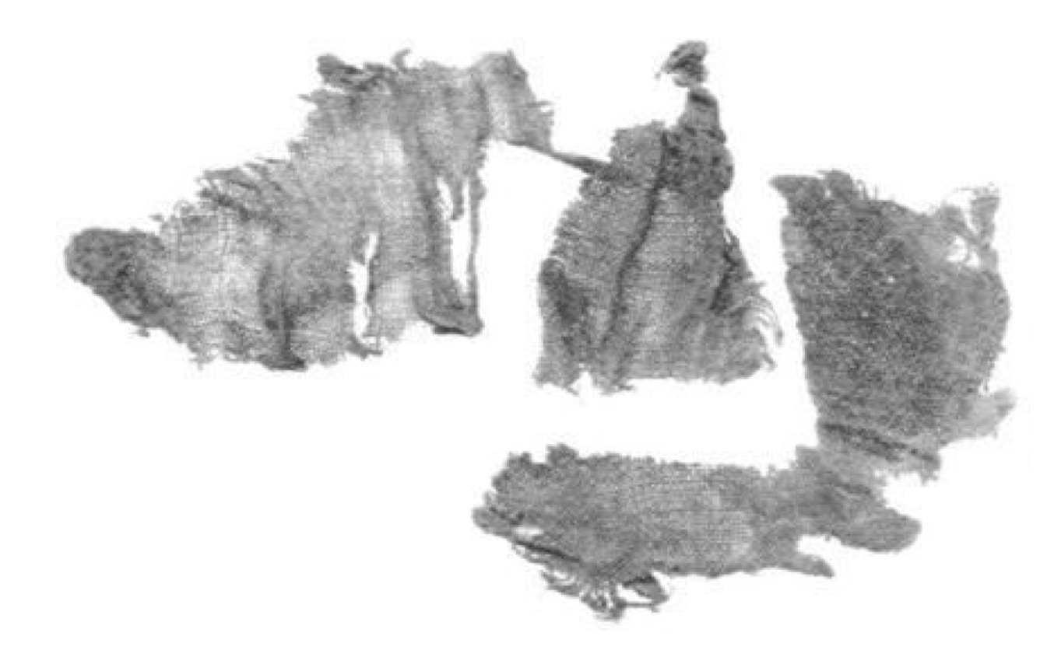
Extant Linen fragments early 15th century

Although not particularly common to have a white hood,
In Ghent the citizens were recognizable by the white hoods. (Newton 73)

Fur was mostly used on the inside as a lining. Inventories show that even in France and England fur lined coats and hoods were common. Fur linings were ordered and given for cloaks and for hoods, ready for putting right into the garments. (Newton 61)

A fashion in men's clothing for the dark furs sable and marten arose around 1380, and squirrel fur was thereafter relegated to formal ceremonial wear. It is not mentioned if women used the dark furs or not.

Martens are related to minks and there were minks in Europe, not just Russia and Central Asia.
I chose black mink as it would not have been as exclusive as the sable and marten. This was a lesser fur on the scale of coveted pelts, and I chose black as it is the colors of the Company

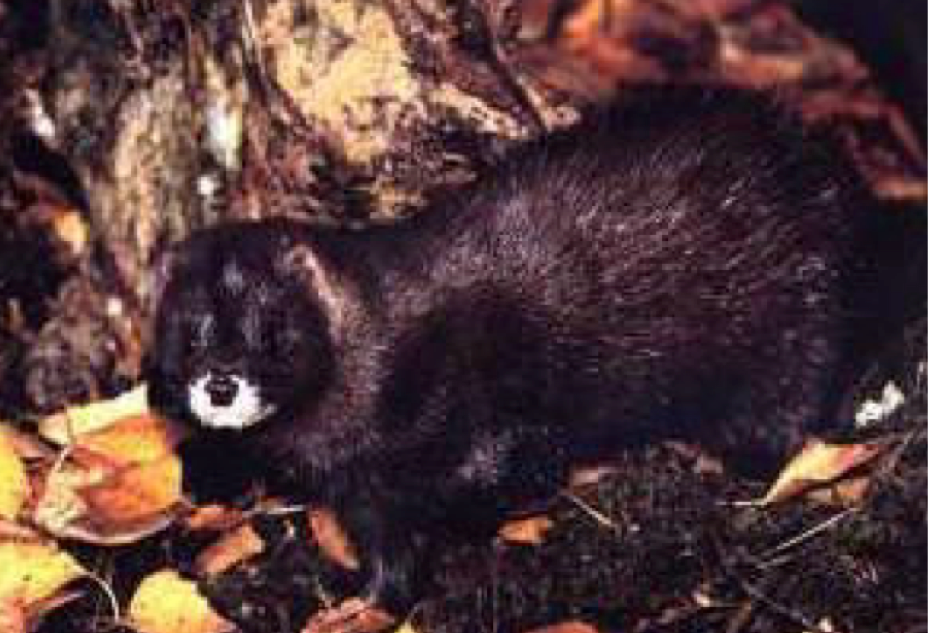
European Mink

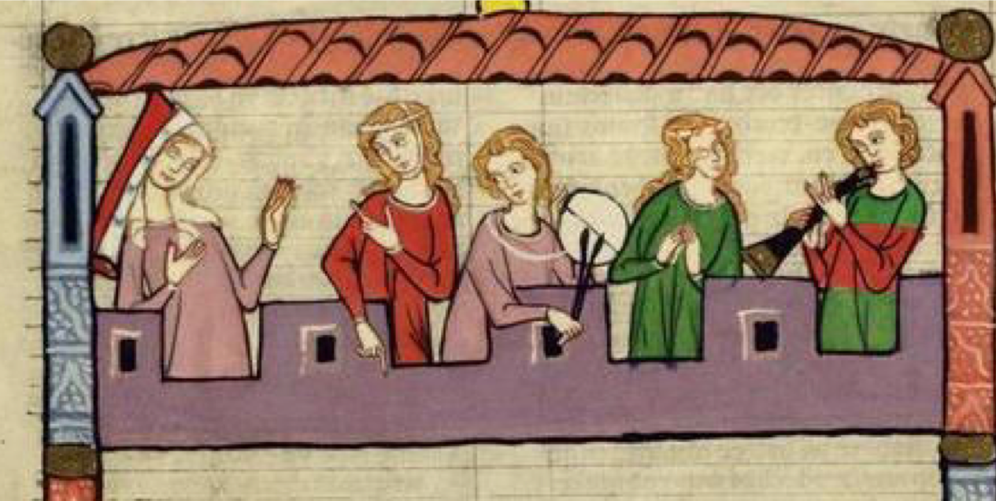
Fur lined hood, Manesse Codex

Design
I used a basic design for the hood. I chose not to put a long liripipe on it as it would get in my way. This design was from extant fragments and calculations.

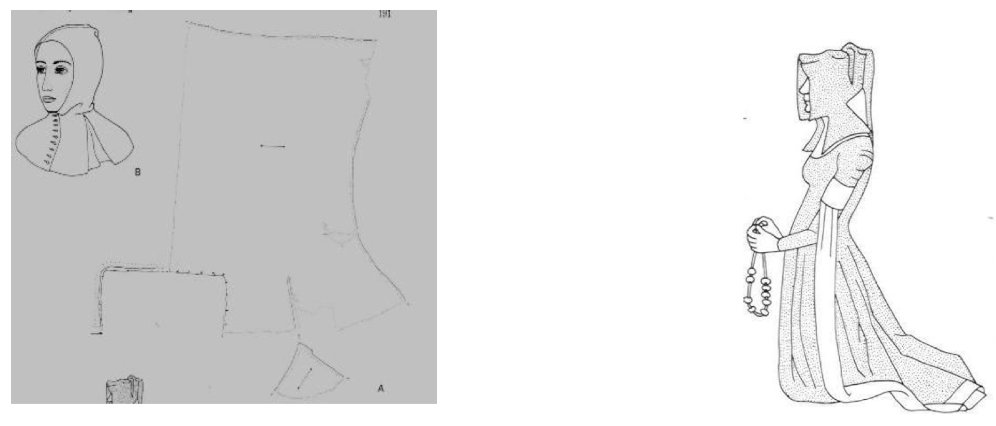
Crowfoot and Pritchard

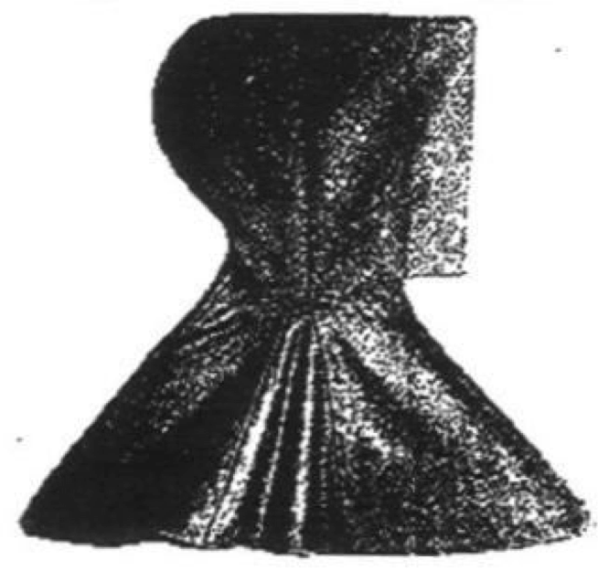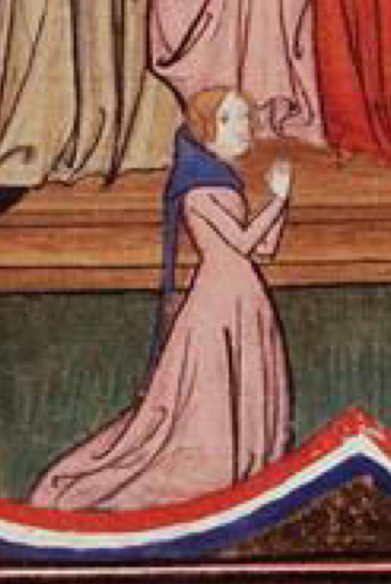
The Sunndjord Hood 1390

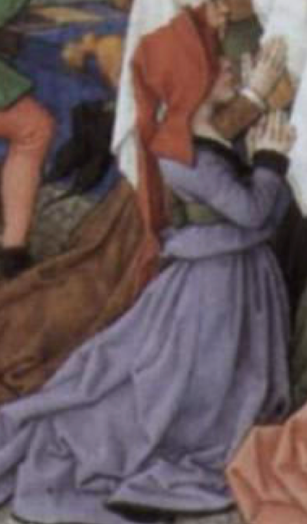
1460 hood very similar in style

My pattern was made for me by my Apprentice Crinoch as I do not draft my own patterns.

Stitches Used

The thread most commonly used at this time was linen. A couple of textile fragments of the period show a bit of linen thread left. This would have been used on the seams and hems. Most all the clothing and domestic sewing would have used linen thread. Therefore, I have sewed my hood with linen thread.

The seams would have been done with a running stitch and a back stitch, both of which I used.

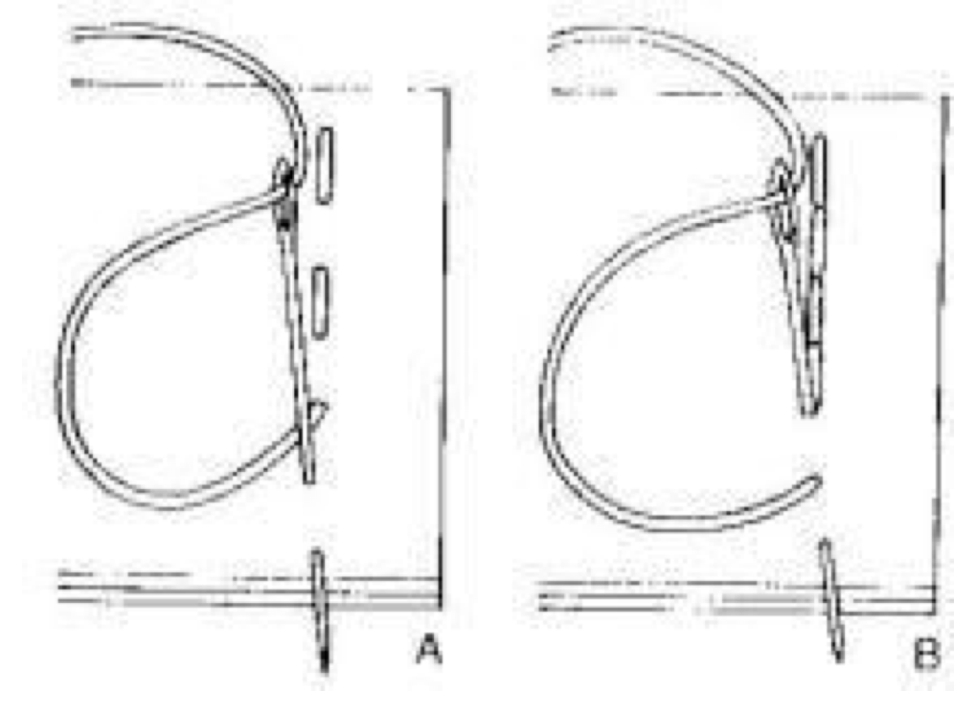
As I lined the hood I did not need a hem stitch. I used a glovers needle to sew the lining
into the hood.

I made my own buttonholes, usually a linen facing was used to further stabilize the holes. I have done this as the fur would make it difficult to make holes in it. These stitches would be buttonhole and satin.

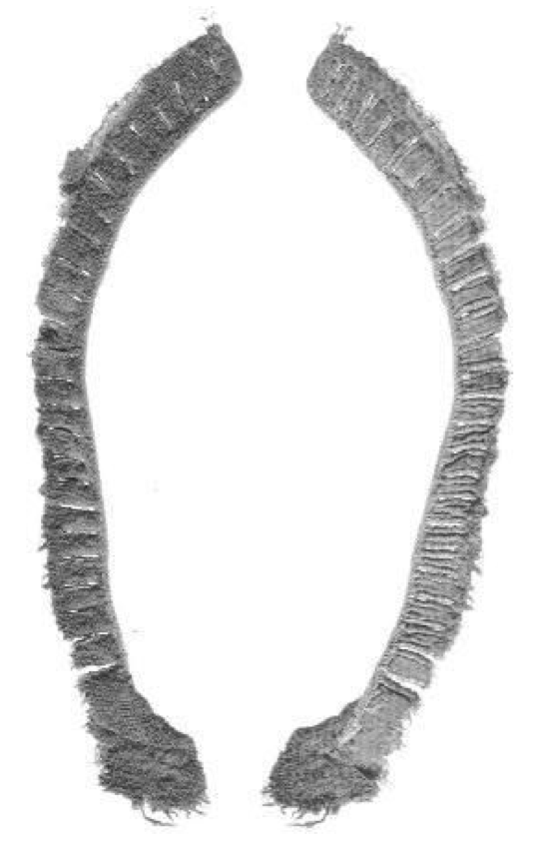
Crowfoot and Pritchard

The rose and Laurel wreath are done with satin stitch, outline or stem stitch and attaching pearls.

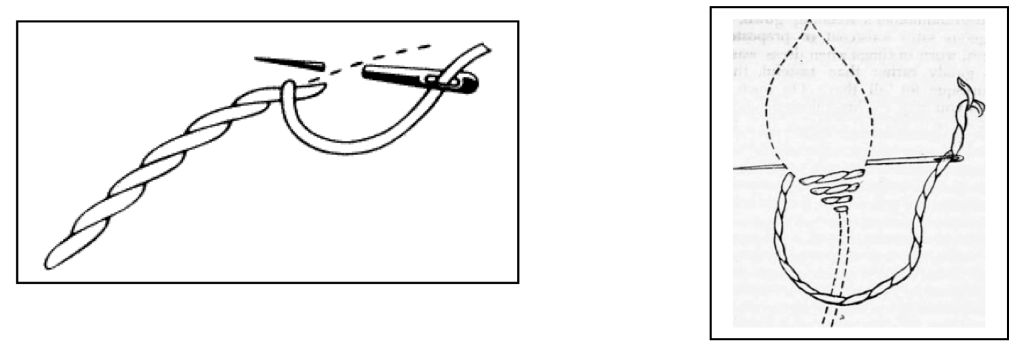

Decoration and Buttons

I have embroidered the Royal Company’s Sable Rose onto the corners of the front of the hood. I have used freshwater pearls for the centers.

Writing in the year 1356 the Continuateur of the de Nangis chronicle reported that extravagance in dress had greatly increased among nobles and knights they decorated their hood and belts with pearls and precious stones to such a degree that the price of pearls rose steeply. (Newton 31)
The rose we use for the Company is a Tudor Rose, but as you can see the rose motif was used throughout history.

I found Rose buttons for the hood. I used Silver thread to embroider the Laurel Wreath.

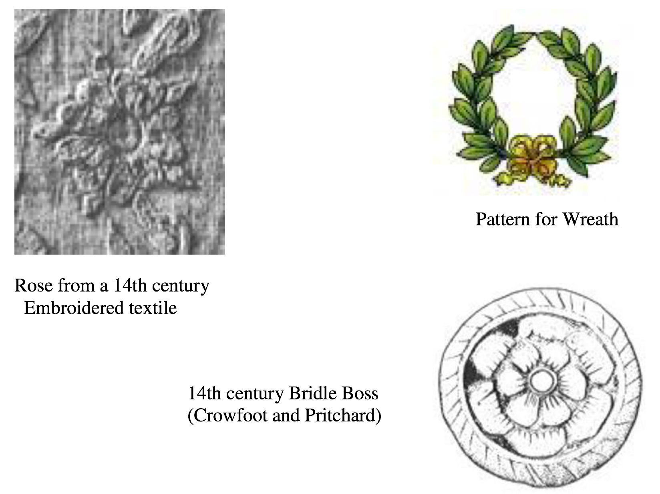

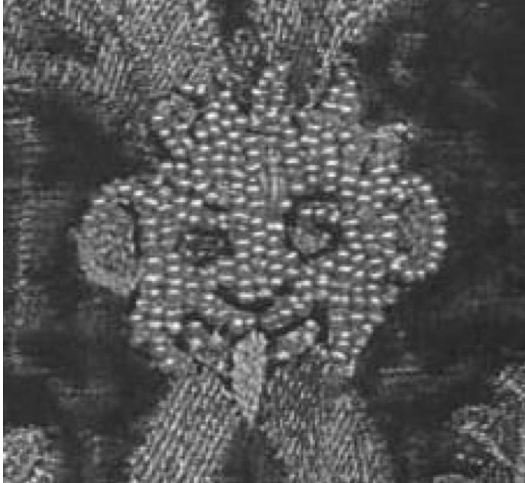
Detail from the upper register of the Butler-Bowdon Cope of 1330-40 showing tiny pearls enriching the lion-masks.

Process

The making of a hood is relatively simple, but the lining with fur is the difficult part.
I was lucky to have a full black mink coat. I traced the pattern on the inside, and then cut out the lining using an exacto knife. If I was starting from the pelts I would have to cut them and sewn them into strips, exactly like how the coat was done. You can see how many pelts it took to make the coat.

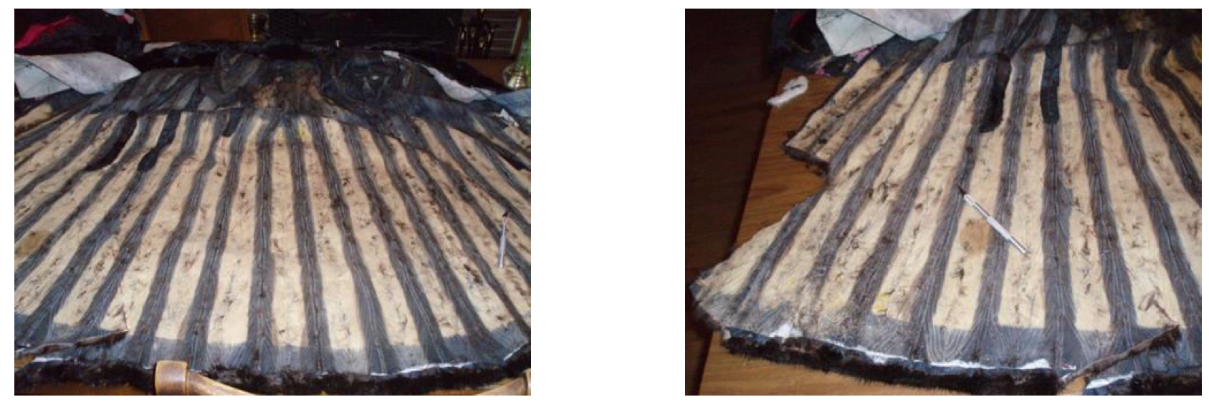

I traced the pattern onto the back making sure I remembered to flip the pattern. The liripipe would not have been lined. It would have been a waste of fur and way too bulky.

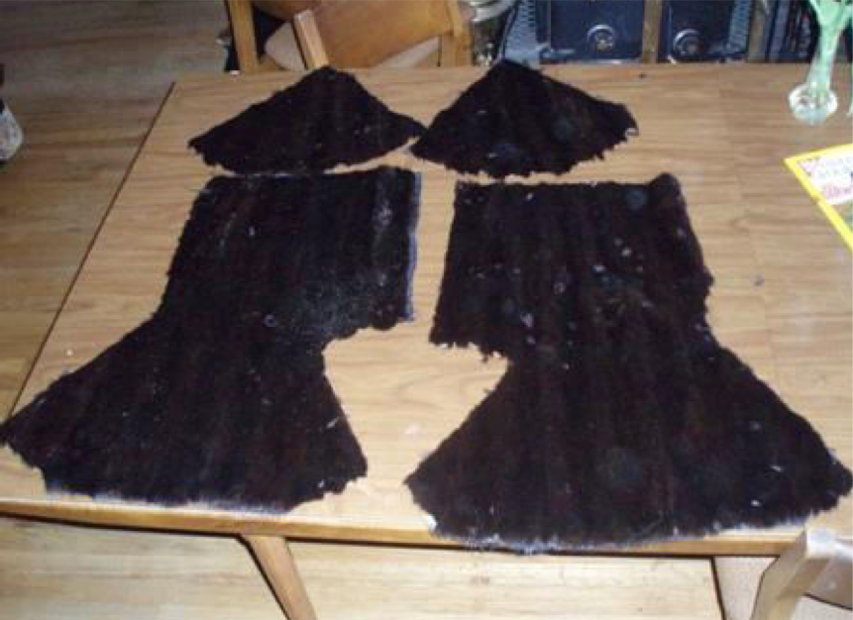
These are the finished pieces.

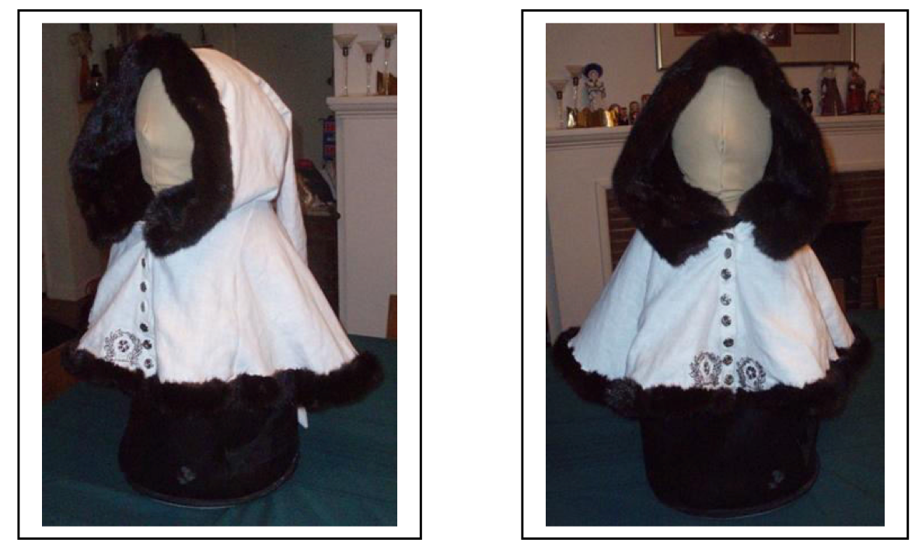
This is the finished hood

I had to sew the fur together to make the full lining. Then it could go into the Linen hood. These were also sewn with linen thread using a buttonhole stitch.

Women Hunting and Women Wearing Hoods

Although these pictures do not always show women wearing g hoods while hunting, there are only a few pictures depicting women in hunting scenarios anyway, that certainly does not preclude them from wearing hoods as men obviously did.

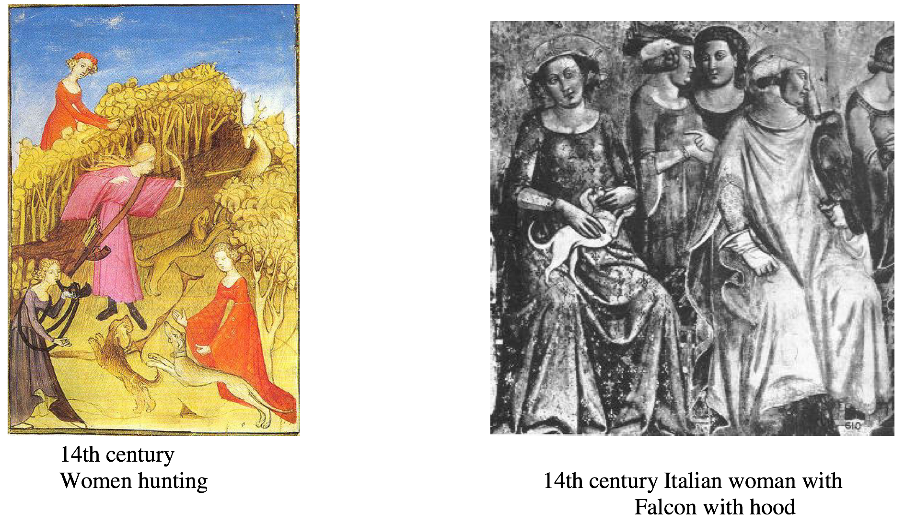

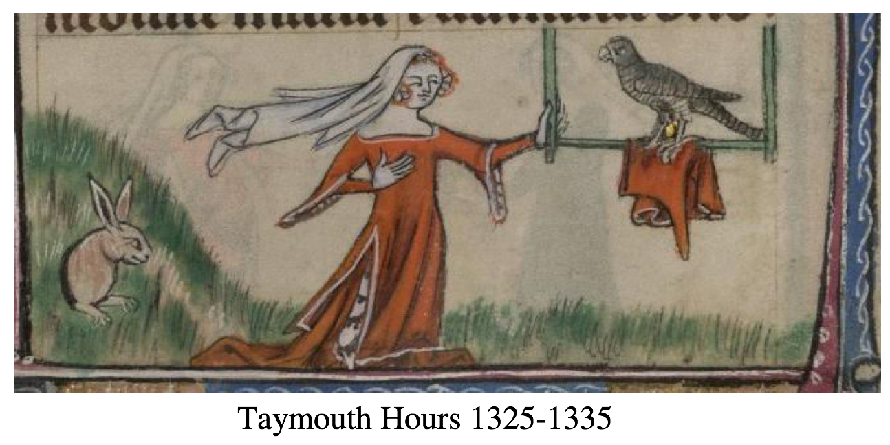

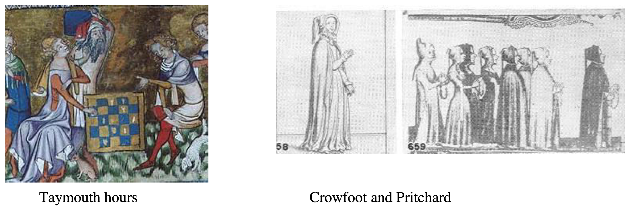

Bibliography

Ashdown, Mrs. Charles H. British Costume from Earliest Times to 1820 General publishing ltd. Inc. 2001

Baines, Patricia. Flax and Linen Shire album, Shire Publications 1985
Boucher, Francois. 20,000 Years of Fashion Harry N. Abrams, Inc Publishers 1987

Clark, John. The Medieval Horse and its Equipment 1150-1450. Medieval finds from Excavations in London 5. Boydell press 2004

Crowfoot, Elisabeth, Frances Pritchard Kay Staniland. Textiles and Clothing 1150-1450 Medieval finds from Excavations in London: 4 Boydell Press 2001

Davenport, Millia. The Book of Costume Crown publishers, Inc. New York 1976
Egan Geoff and Frances Pritchard. Dress Accessories 1150-1450 (Medieval finds from
Excavations in London: 3 The Boydell Press 2001
Grew and Margrethe de Neergaard Shoes and Pattens Medieval finds from Excavations in
London: 2 The Boydell Press 2001
Labarge Margaret Wade. A Baronial Household of the Thirteenth Century Barnes and Noble
Books 1980

Newton, Stella Mary. Fashion In the Age of the Black Prince. A study of the years 1340-1365. Boydell Press 1980

Miscellaneous 14th-Century Manuscripts

Bodleian Library Oxford, England http://www.bodley.ox.ac.uk/dept/scwmss/wmss/medieval/mss/misc/14th.htm A 14th century Belgian book of Arthurian legends (BNF Fr. 122), 1344http://www.larsdatter.com/hoods.htm

De mulieribus claris (BNF Fr. 598), beginning of the 15th century Tacuinum Sanitatis, 14th and 15th century 1390-1400
The Taymouth Hours (British Library,) Yates Thompson 13, c. 1325-1335 The Romance of Alexander (Bodl. 264), 1338-1344:
Manesse Codex (UBH Cod. Pal. germ. 848), 1300-1330

Websites

http://www.larsdatter.com/hoods.htm

Medieval and Renaissance material culture
http://moas.atlantia.sca.org/wsnlinks/index.php?action=displaycat&catid=281
Kingdom of Atlantia A&S links

http://www.personal.utulsa.edu/~marc-carlson/cloth/hoods.html

Hoods, Chaperons and Liripipes
http://vieuxchamps.com/persona/

------
Copyright 2009 by Marilee Humason <stasiwa at yahoo.com>. Permission is granted for republication in SCA-related publications, provided the author is credited. Addresses change, but a reasonable attempt should be made to ensure that the author is notified of the publication and if possible receives a copy.

If this article is reprinted in a publication, I would appreciate a notice in the publication that you found this article in the Florilegium. I would also appreciate an email to myself, so that I can track which articles are being reprinted. Thanks. -Stefan.

<the end>

