E-Period-Hats-art - 3/2/14

"Early Period Hats" by Kurios Halfdan 'Two Bears' Ôzurrson.

NOTE: See also the files: headgear-msg, hds-liripipes-msg, Liripipe-Hood-art, Simple-Wimple-art, turbans-msg, coronets-msg, feathers-msg.

************************************************************************

NOTICE -

This article was submitted to me by the author for inclusion in this set of files, called Stefan's Florilegium.

These files are available on the Internet at: http://www.florilegium.org

Copyright to the contents of this file remains with the author or translator.

While the author will likely give permission for this work to be reprinted in SCA type publications, please check with the author first or check for any permissions granted at the end of this file.

Thank you,
Mark S. Harris...AKA:..Stefan li Rous
stefan at florilegium.org

************************************************************************

This article was first published in the October 2012 issue of "The Dragon Tale", Barony of Selviergard, Principality of Oertha in the Kingdom of the West.

Early Period Hats
by Kurios Halfdan 'Two Bears' Ôzurrson

The hat; probably the most forgotten piece of clothing in the Society right next to period footwear. Hats were used primarily for protection from inclement weather and occasionally as ways to show off the wealth or status of the person wearing the hat. Hats also have the ability to demonstrate to others what culture your persona comes from or had contact with.

In preparation for the upcoming Arts and Sciences competitions at Selviergard's next event, the following is a small compilation of possible hats for your project. Resources for these types of hats can be hard to find, and finding extant examples of the hats, either in actual finds or period images, is even harder. However, that shouldn't stop you from entering into the competition and creating something that will help keep you warm in the upcoming winter months.

The Paneled Hat

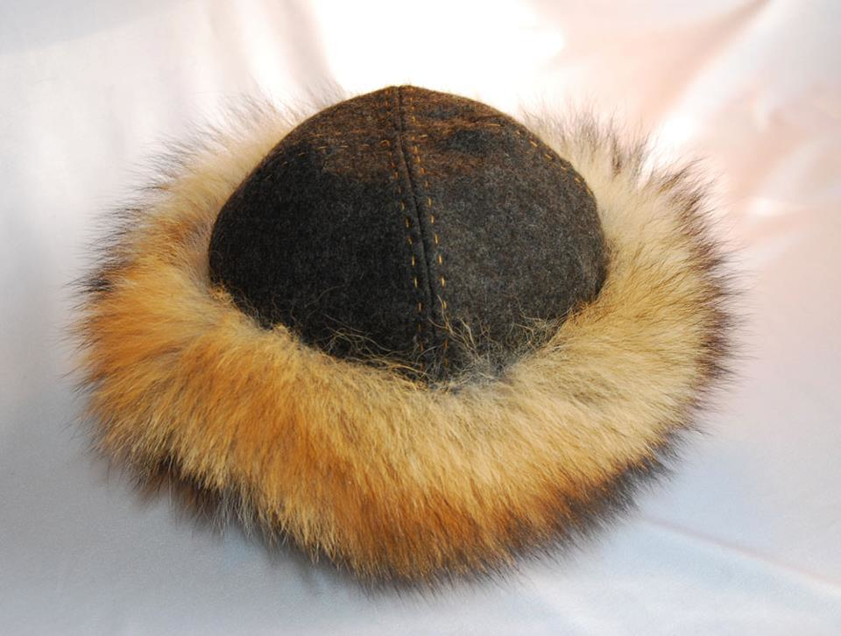

Commonly referred to as the Viking Rus hat; the paneled hat comes in two different varieties: the four-paneled hat and the six-paneled hat. While there is no real cultural difference between the two, some people feel that a six-paneled hat fits better to the head as opposed to the other option.

A variant of the paneled hat is a "Mongolian" style in which the top of the hat comes to a point rather than laying flat against the wearer's head. The additions of a tassel, horsehair, or metal ornaments are often common throughout the Society.

Step-by-step instructions on creating the paneled hat can be found online at the Costume Wardrobe blog. http://costumewardrobe.blogspot.com/2005/02/rus-hat_10.html

The Phrygian Cap

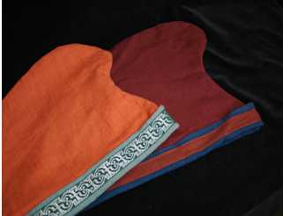

One of the most popular hats of all time throughout the scope of the Society is what is called the Phrygian cap. The Phrygian cap can be seen in multiple depictions of art throughout history; mostly in the Mediterranean world. However, the Saxons, the Gauls, the Franks, and even the French were known to wear this stylish hat as well. Indeed, the famed Varangian Guard have been depicted wearing these hats in Byzantine manuscripts and mosaics that survive today.

The variant of the common Phrygian cap is one that covers the back of the neck and the ears in addition to the pointed top. However, this version of the cap is rarely seen in the Society.

Instructions on creating the Phrygian cap can be found online at House Barra's website. http://www.housebarra.com/EP/ep06/16cap.html

The Pillbox Hat

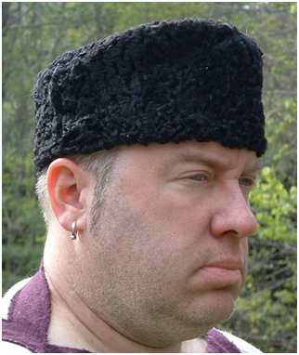

The Pillbox hat, commonly thought of as only a women's headdress in post-period fashion, is quite common in the ancient world as a men's hat. Often referred to as a Pannonian Hat, this simple hat can be dated back to the 4th century in Roman times and is often seen as a soldier's cap.

According to some re-enactors, the hat should be made of sheared fleece or felted wool and several artistic depictions from period show that this hypothesis could be true. Additionally, it has been inferred that higher classes, especially nobility, could have expensively decorated pillbox hats; usually with gems or embroidery.

Step-by-step instructions on creating a Pillbox style can be found online at The Slapdash Sewist's blog. http://theslapdashsewist.blogspot.com/2009/11/retro-air-hostess-pillbox-hat-tutorial.html

The Birka Hat

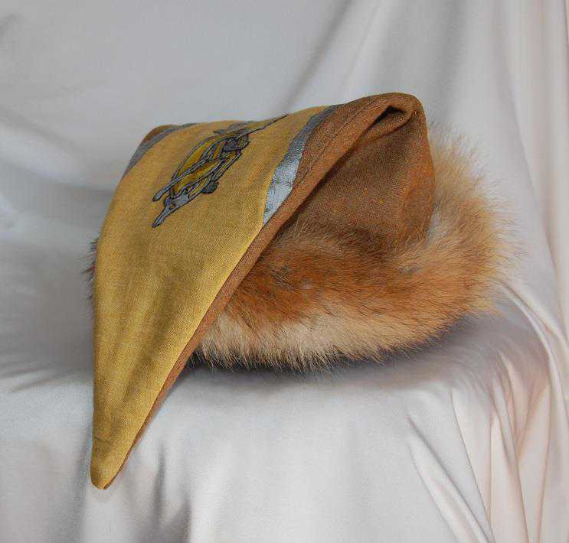

The Birka hat is, perhaps, the hardest hat to document. Finds in several Birka graves have partial extant finds, but no definitive or concise details for this hat. However, through some research and some creativity people have developed useful patterns.

Often trimmed with fur and decorated; the Birka hat can also have a metal ornament or tassel attached to the tip to help weigh it down over one side of the head.

Instructions on creating the Birka cap can be found online at House Barra's website. http://www.housebarra.com/EP/ep06/16cap.html
------
Copyright 2013 by Travis Abe-Thomas, PO Box 2254, Palmer, AK 99645. Thomassorngrym at yahoo.com. Permission is granted for republication in SCA-related publications, provided the author is credited. Addresses change, but a reasonable attempt should be made to ensure that the author is notified of the publication and if possible receives a copy.

If this article is reprinted in a publication, please place a notice in the publication that you found this article in the Florilegium. I would also appreciate an email to myself, so that I can track which articles are being reprinted. Thanks. -Stefan.

<the end>

