AS-Glass-Beads-art - 9/9/17

"Anglo-Saxon Glass Beads" by Beatrix Alfray.

NOTE: See also the files: amber-msg, Herbal-Beads-art, pearls-msg, jewelry-msg, Rubies-Spphrs-art, Semi-Pre-Gems-art, Viking-Beads-art, Emeralds-art.

************************************************************************
NOTICE -

This article was added to this set of files, called Stefan's Florilegium, with the permission of the author.

These files are available on the Internet at: http://www.florilegium.org

Copyright to the contents of this file remains with the author or translator.

While the author will likely give permission for this work to be reprinted in SCA type publications, please check with the author first or check for any permissions granted at the end of this file.

Thank you,
Mark S. Harris...AKA:..Stefan li Rous
stefan at florilegium.org
************************************************************************

Anglo-Saxon Glass Beads
by Beatrix Alfray

The focus of this class will be on glass beads found in Anglo‐Saxon England in c.AD 400‐700.
Most people are already familiar with beaded festoons worn between brooches, however, strands of beads worn as full necklaces, bracelets, and even belts have been found in Anglo Saxon gravesites. Larger numbers of beads are most commonly found in the graves of women, and there have been discoveries of glass beads found in men's grave as well. Male beads were usually worn as pendants, or as sword fittings and are often referred to as "sword beads". Beads found in the male graves tended to be larger.

Although most bead strands included at least a few glass beads, early Anglo Saxon jewelry often included rock crystal, amethyst, bone, teeth, and Amber. Metal findings are found on early bead strands, but are usually found as rings, stoppers at the end of strings, or pendants. Metal beads become more common in gravesites dating in the 7th century.

There is evidence of glass bead manufacture in the surrounding regions from Roman times and continuing into 8th century and later. These sites are identified by remnants of manufacture such as scrap glass, rod pieces, and broken beads. Locations include Trier, dating from the 5th Century, and in the Netherlands dating to around the 6th century. Perhaps one of the best known sites for bead makers is in Ribe.

Bead Shapes:

The bead shapes common to the Anglo Saxon glass bead maker were very similar to the Roman beads of the premigration period, but there are differences that appear unique to their culture.

Annular Bead

The most common shape was the Annular bead. This shape was found in almost every color of glass available to the bead maker in this time. Most often it was made in undecorated monochromatic glass. It is best described as a round disk shaped bead with as smooth edge, although there are some examples of this bead shape with scalloped edges. These shaped edges would have been created either by rolling the bead across a grooved marver, or by "nicking" the bead with a flat utensil, like a knife.

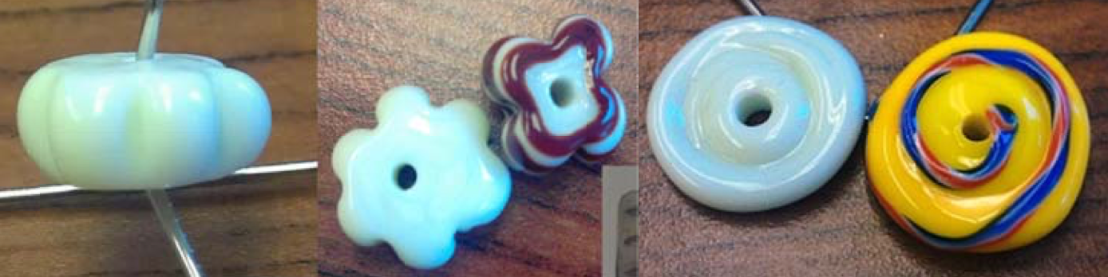

Planoconvex

Planoconvex shaped beads are similar to annular beads however they are more bun shaped, with a dome shaped top and flat bottom. The bottom is not decorated and the top can be decorated with "wave" patterns, spirals, or sometimes just glass scribbles.

The planoconvex beads, of this time period and region, were most commonly made with a "black" glass base and decorated with contrasting opaque designs. The designs were sometimes done with twisted canes most often of two colors. Along with the Biconvex beads, these are often found in burials with swords or as part of the belt found on women. Some researchers believe that they may have been used as amulets against illness and injury. It is also believed that they may have been used as spindle whorls, and I have made some that have functioned quite well in that fashion. These beads are usually larger than those found in necklace or bracelets, sometimes measuring up to an inch and a half to two inches across.

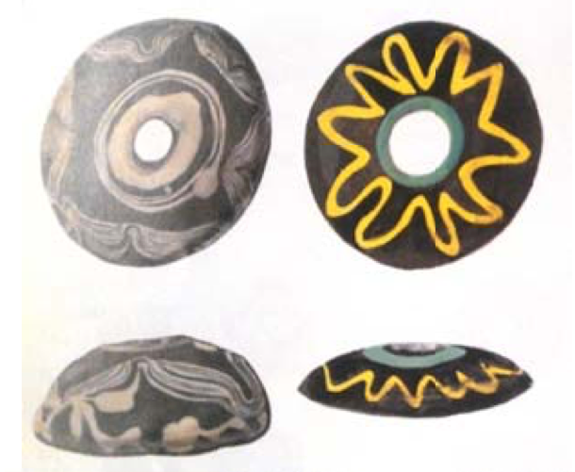
Planoconvex beads from the The Glass Beads of Anglo Saxon England c.AD 400‐700 by Margaret Guido

Biconvex

Biconvex beads are shaped much like the Planoconvex and annular beads except that they are domed on both sides of the bead. They are also decorated on both sides of the bead. Based on the archeological evidence, it is believed they served much the same function as the planoconvex bead and are similar in size, coloration and decoration as well.

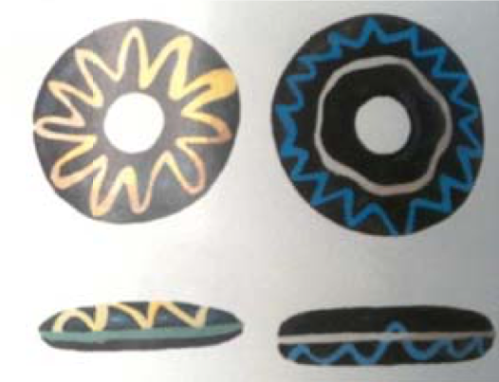
Biconvex beads from the The Glass Beads of Anglo Saxon England c.AD 400‐700 by Margaret Guido

Round

When researching the beads of Early Anglo Saxon England, I frequently came across the description "globular". I compared the description to the pictures and decided that was the term for "round" beads. (Or at least roughly spherical in shape, at any rate) Round beads were often decorated with dots, single waves, crisscrossed waves, single or twisted multi colored bands around the equator of the bead and even with frit (crumbs of glass).

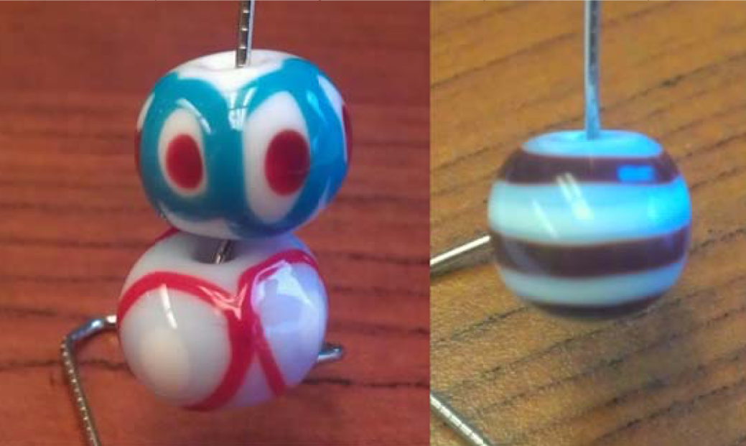

Stubby Bicone

The short, or stubby, bicone and regular bicone shapes are made by marvering the ends of a round or barrel shaped bead. This shape is commonly found in this region and timeframe. The distinctive Herringbone beads of the Anglo Saxons were frequently done in this shape. Decorations are similar to those found on the round, or globular beads and the color ranges are as broad.
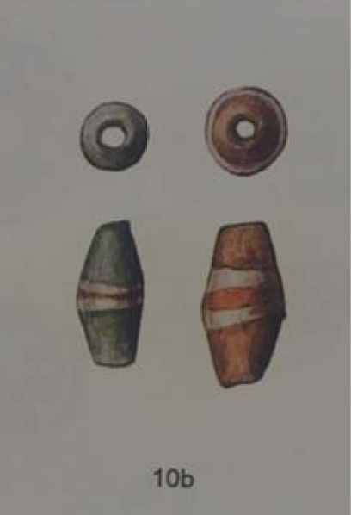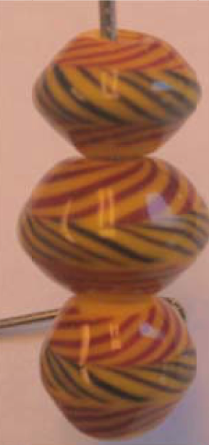

Stubby Bicone beads from the The Glass Beads of Anglo Saxon England c.AD 400‐700 by Margaret Guido And my attempt at reproducing them

Drum

Drum shaped beads are described as round beads that have been slightly marvered around the equator to somewhat straighten the sides. These differ from short cylinder beads in the retention of the curve of the sides and a tendency to be thicker than the cylinder bead. Decorations are similar, and include, all patterns and designs that could be found on round or stubby bicones and the color ranges are as broad.

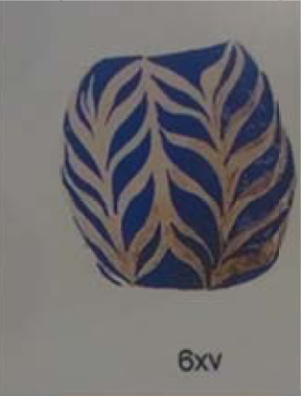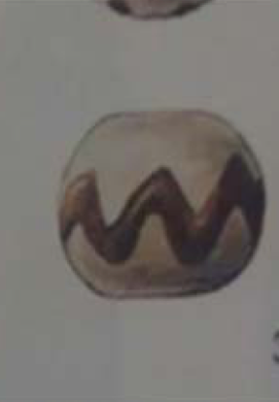
Drum beads from the The Glass Beads of Anglo Saxon England c.AD 400‐700
by Margaret Guido

Cylinder Beads

Cylinder beads can be found in both long and short. They are also sometimes marvered, or cold worked to have flat edges. Another form of working this bead was to roll it on a grooved marver to create segment or diagonal patterning. They are found both as decorated and undecorated and in all colors of glass popular in the region.

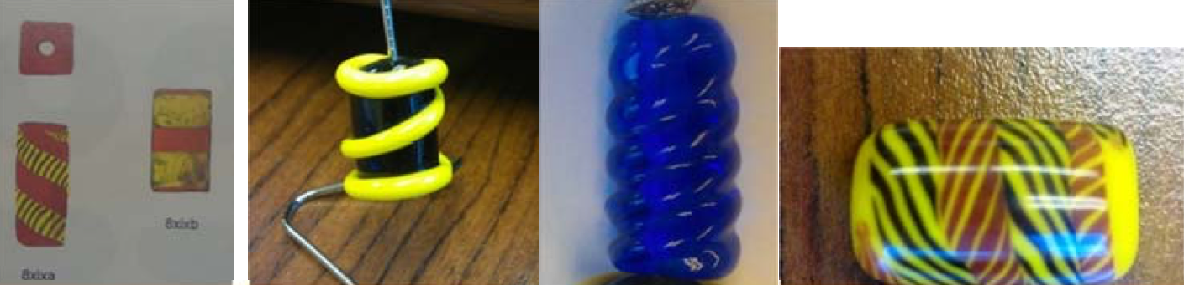
Barrel beads from the The Glass Beads of Anglo Saxon England c.AD 400‐700 by Margaret Guido And my attempt at reproductions

Common Colors:

Yellow‐ This color is pervasive in the Anglo‐Saxon finds. I have only ever seen it as an opaque

Red‐ The red commonly found in Anglo Saxon Beads is more of a terracotta color. It is very rarely a bright or crimson red. It is theorized that the bright reds that are found were made using reclaimed Roman glass.

Black‐ True black glass was not known in the ancient glass world. Most glass that appears black is really a very dense transparent brown, green, blue or purple glass. Often this can only be determined by looking at broken beads or flakes from known samples.

Blue‐ Blues were found in both opaque and transparent glass. Opaque blues range from a very milky light blue through opaque dark navy blues. The most common blue was a dark turquoise. The transparent blue ranged from a light, almost clear blue, to cobalt blue and even darker to an almost black color.

Green‐ Greens were found in both opaque and transparent and ranged from an almost clear light green to a green so dark that it often appears as black.

White‐ Is a very common color used both as a base and accent color. Brown‐ Usually found as a very dark, almost black transparent.

***This is not an exhaustive list! This is just a list of commonly found colors.

Making a few of the Beads:

Barrel Beads:
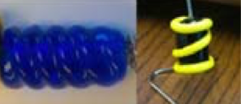

1. First make two spacer size bead on the mandrel to mark the size of the barrel you want to make
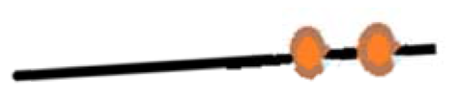
2. Next fill in the area between the two starter beads
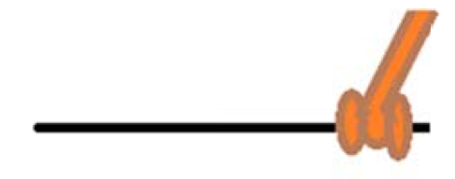

3. To make the blue bead above, heat the surface of the bead to a soft glow and lightly roll across the textured marver
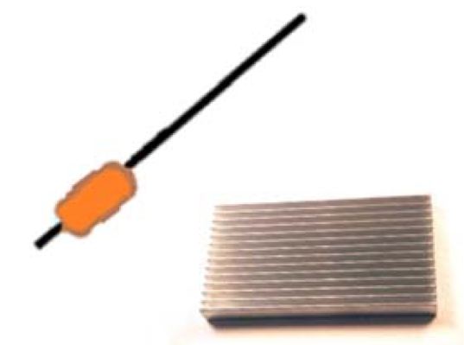

****TIP‐ you can get textured marvers from broken computers, the aluminum heat sink is great for this!***

4. To make the Blue and yellow above, take a contrasting colored stringer and make a winding wrap starting at the bottom and winding completely around the bead and ending at the top

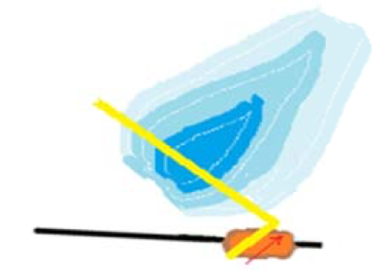

5. Take the contrasting stringer and make a wrap around each end, be sure to cover the ends of the first wrap
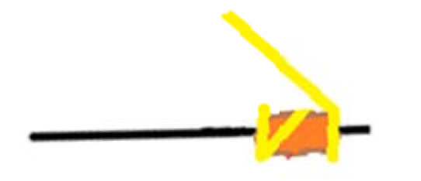

****TIP‐remember that keeping the main bead under the flame and the stringer in or next to the inside cone, will help you have consistency with your stringer. Giving the bead a good heating before you start applying the stringer also gives you more time to work ***

Annular Beads:
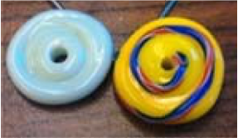

1. Make a small bead to create a "footprint". This bead should be as almost as wide the finished bead will be
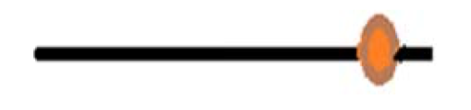

2. Keeping the small bead warm, get a small gather on the glass rod

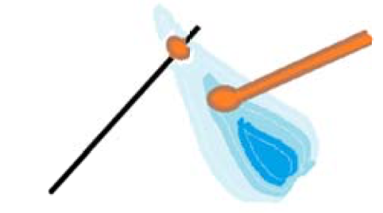

3. Now make a wrap around the small base bead
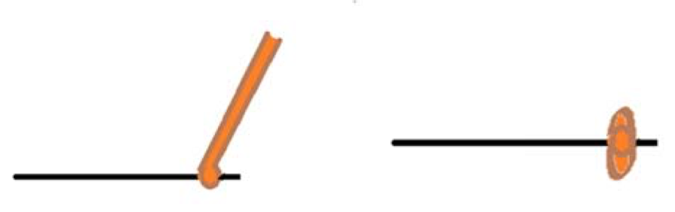

4. Keeping the beginning of the disk bead warm, repeat step 2 and three until the basic disk bead is the desired size. Try to direct most of the heat to the front and back of the disk, to prevent the bead from going round

***TIP‐ You can use a marver to gently move the disk on the mandrel***

Wavy Beads:
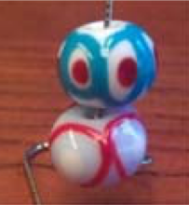

1. Make a basic round bead.
2. Place dots around the equator of the bead. Try to keep them evenly spaced. You can do as many dots as you want, I recommend starting with just 4
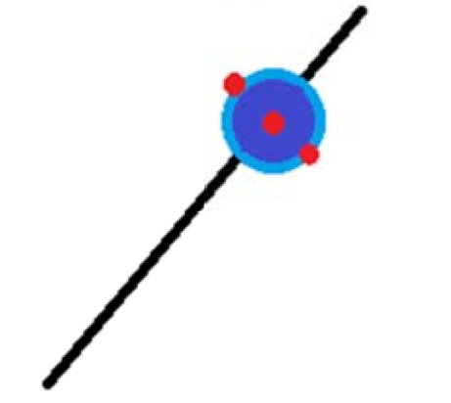

3. Take the stringer that you want to use for your waves and starting between two dots go over and under the dots all the way around the bead
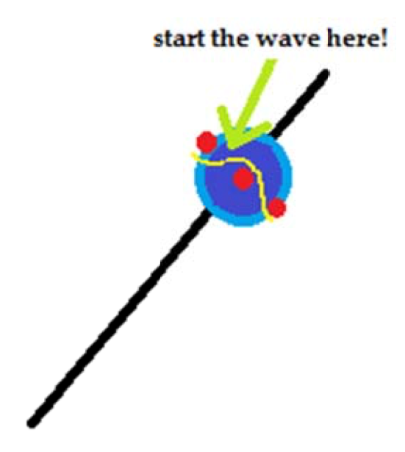
4. Using the same stringer (or even a different colored one!) start the wave between two dots and repeat the over under design on the opposite side
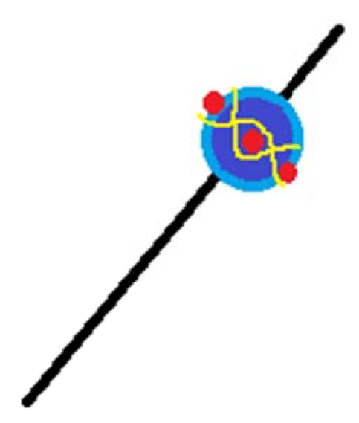
****TIP‐ If you don't want a contrasting dot, you can use the same color glass to do the dots as you do on the base bead, just don't melt them in***

Herringbone Beads:
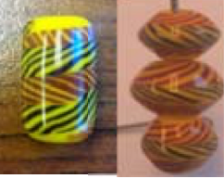

This bead requires the ability to make twisties of consistent thickness and twist
1. Make two twisties in red and yellow. These need to be slightly thicker than commercial stringer
2. Make one twisty in black and yellow twisted in the opposite direction that you used to make the red and yellow twisties

***TIP‐ to verify that this was done correctly, lay the stringers next to each other and you should see the herringbone patter***

3. Make your base bead slightly smaller than you want the final bead to end up
4. Lay the first red and yellow twisty on the outer edge of the bead, being careful to push the stringer down and not to pull it. Pulling the stringer can cause the twisty to stretch out and lose the pattern
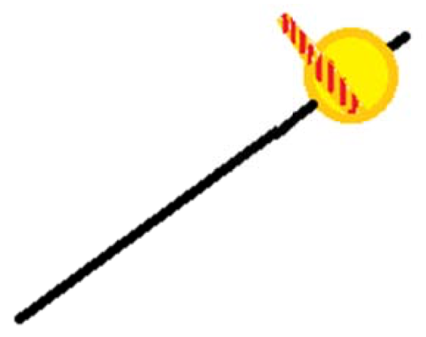
5. Add the second red and yellow twisty to the opposite side of the bead
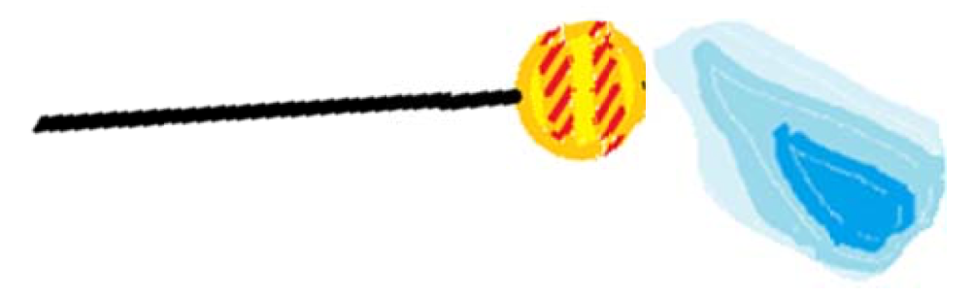
6. Melt the two twisties in almost, but not quite, completely into the bead. Make sure to direct heat towards the ends of the bead to "pull" the design to the end of the bead.

7. Once the red and yellow twisties are melted almost into the base, lay your black and yellow around the middle of the bead.
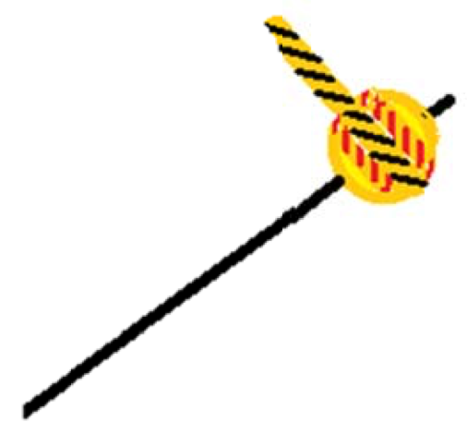

------
Copyright 2016 by Laura Meissner. <lost.sol.beads at gmail.com>. Permission is granted for republication in SCA-related publications, provided the author is credited. Addresses change, but a reasonable attempt should be made to ensure that the author is notified of the publication and if possible receives a copy.

If this article is reprinted in a publication, please place a notice in the publication that you found this article in the Florilegium. I would also appreciate an email to myself, so that I can track which articles are being reprinted. Thanks. -Stefan.

<the end>

